**Kathmandu University**

**Department of Computer Science and Engineering**

**Dhulikhel, Kavre**



A Report on ‘**Lab Work 2** [COMP 306]

**Half Adder and Full Adder**

**Submitted by:**

Chandan Kumar Mahato (31)

III-year, II semester

**Submitted to**:

Prof. Dr. Sudan Jha

Department of Computer Science and Engineering

**Submission Date**: April 21, 2023

***Qlab1***

1. ***Design Half Adder and Full Adder using proteus simulation.***

**Objective:**

To Design Half Adder and Full Adder

**Components Required**:

* Probe
* Wire
* Gates (AND, XOR, OR)
* Digital Constant

**Circuit Diagram**

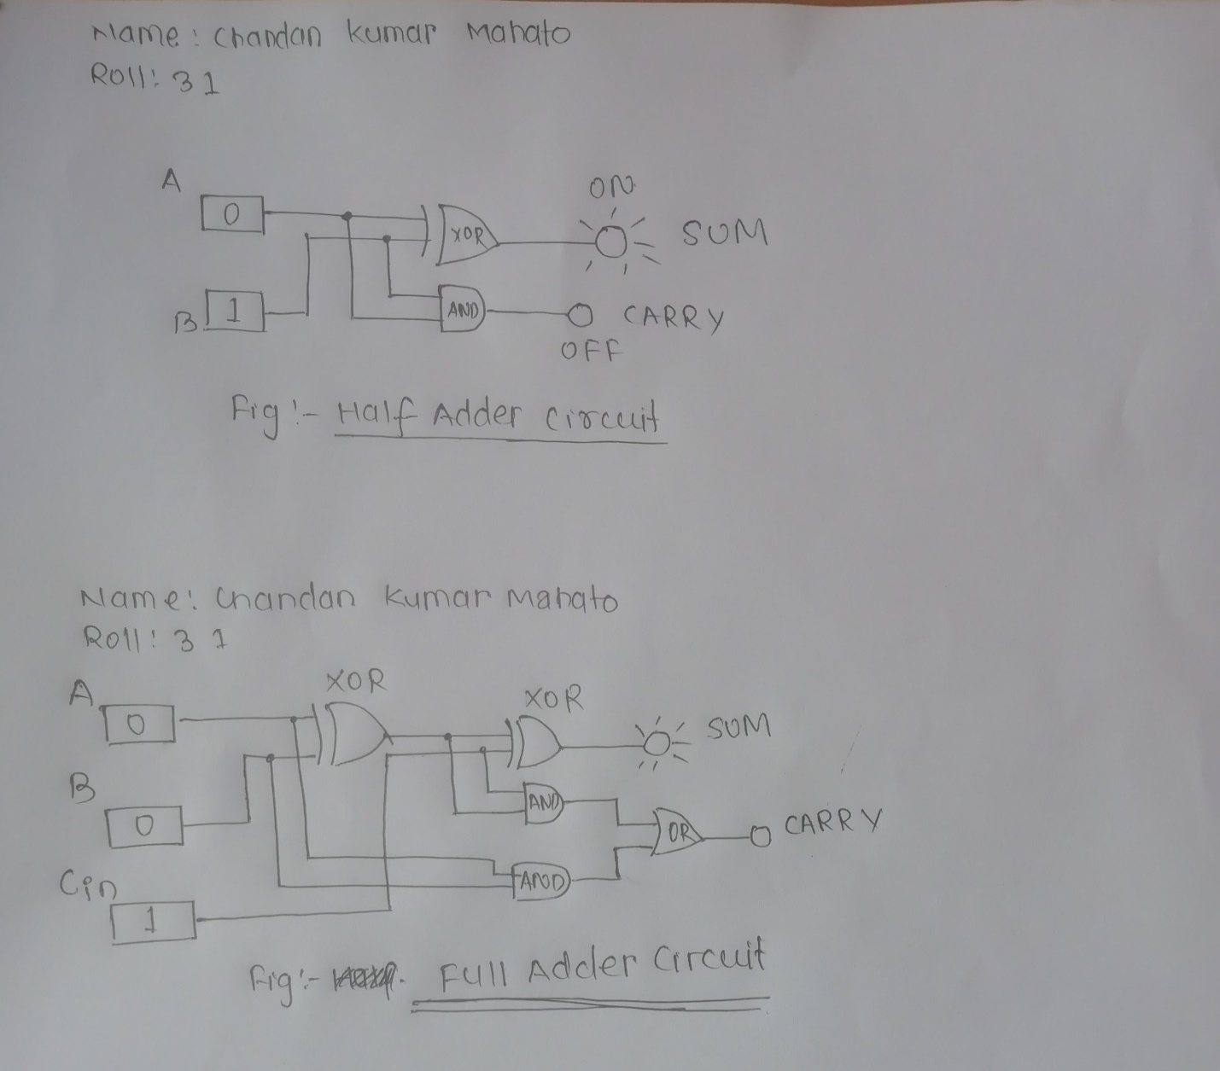

*Fig 1: Half-Adder Circuit*

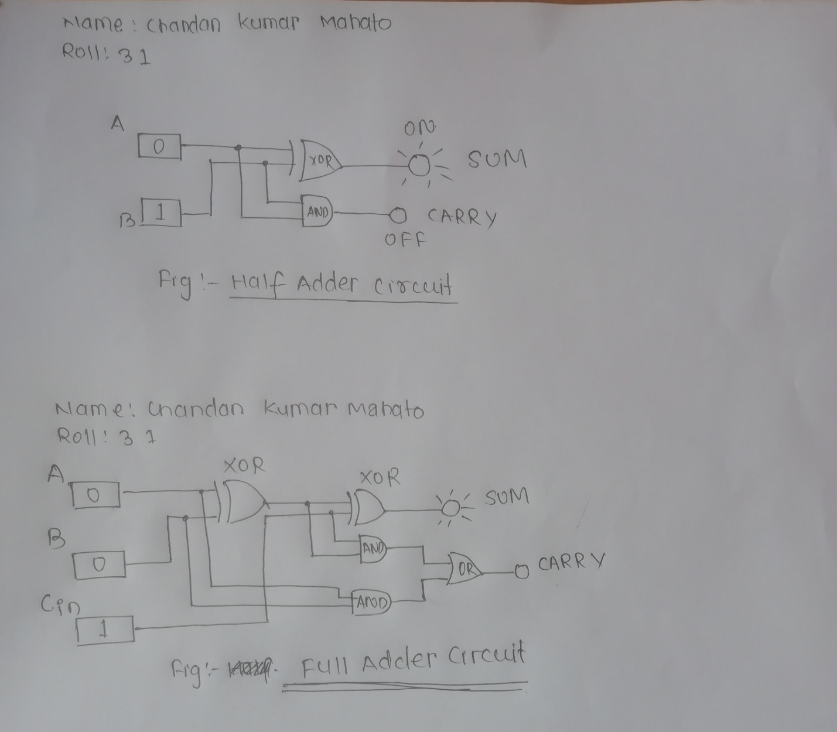

*Fig 2: Full-Adder Circuit*

**Truth Table:**

The truth table obtained for the Half Adder and Full Adder after varying their input parameters during simulation are shown in the table below:

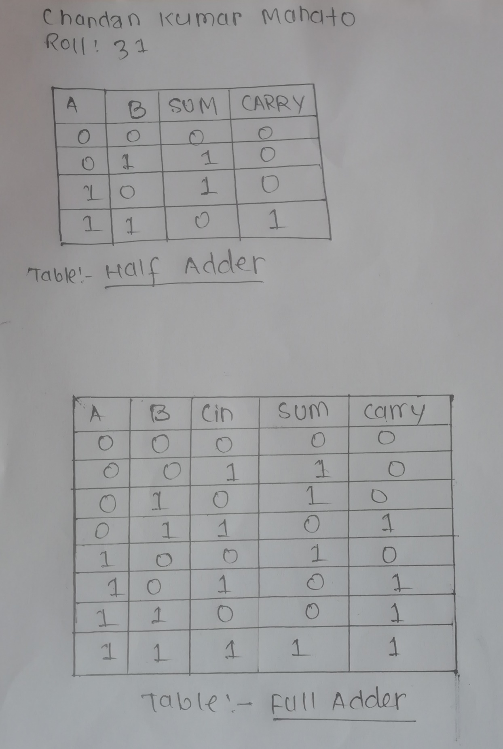

*Fig 3: Truth Table Half-Adder*

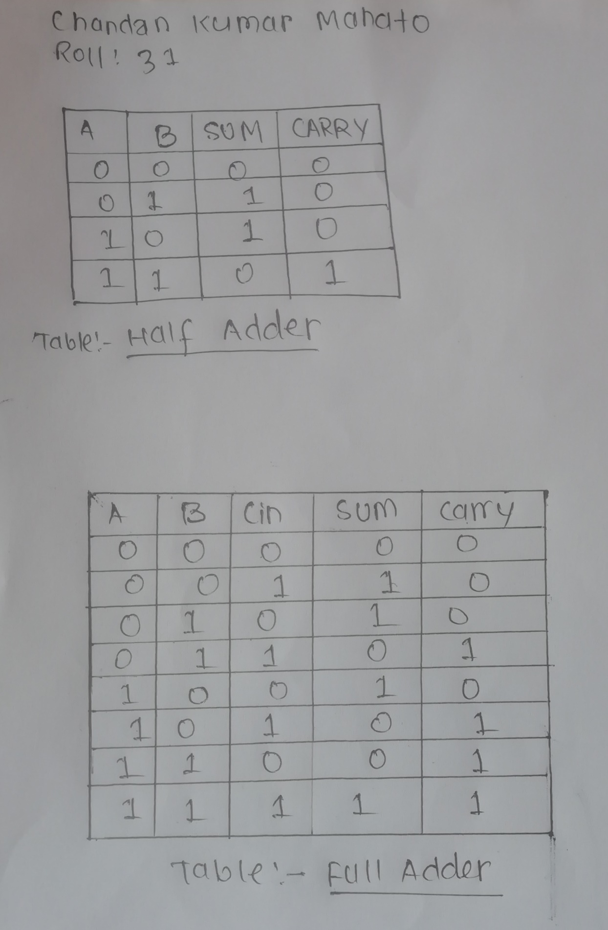

*Fig 4: Truth Table Full-Adder*

**Conclusion:**

Both Half Adder and Full Adder were successfully simulated using Proteus Simulation and the truth tables were determined by checking multiple combinations of inputs and their effects on the probe.

*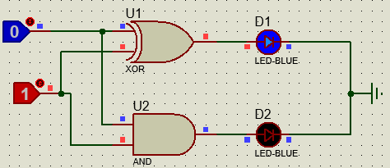***Screenshots:**

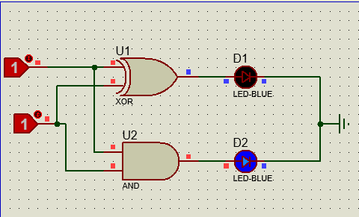

*Fig 5:**half-adder Circuit*

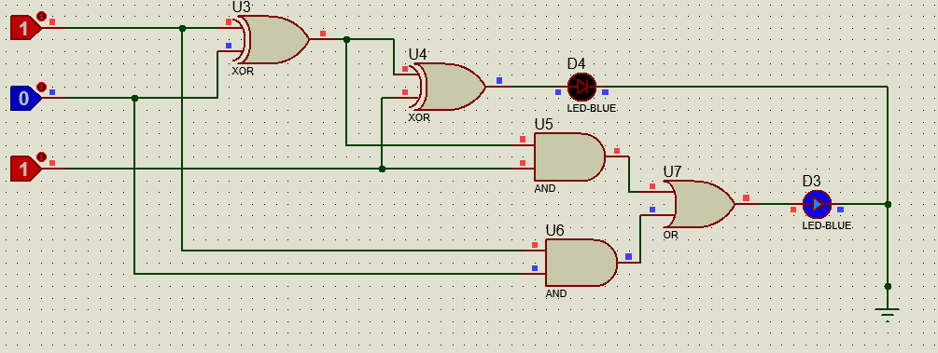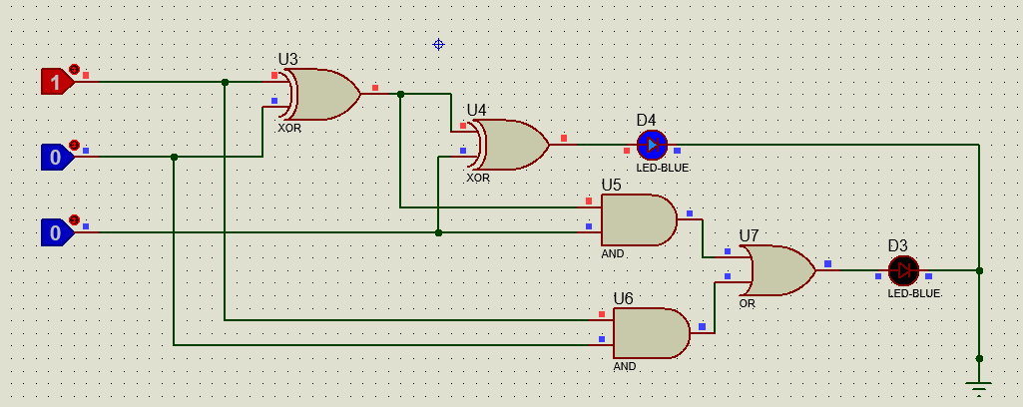

*Fig 6: Full-adder Circuit*