# Kathmandu University

**Department of Computer Science and Engineering Dhulikhel, Kavre**



## COMP[306]

A Report on ‘**Lab Work 3’**

**Home Automation System**

# Submitted by:

# Chandan Kumar Mahato (31)

# III-year, II semester

**Submitted to**: Prof. Dr. Sudan Jha

## Department of Computer Science and Engineering

**Submission Date**: May 3, 2023

***Qlab3***

1. ***Using microcontroller, half adder, full adder, and logic gates, choose any one of the following and simulate using Proteus Simulation Software.***
   * ***Home automation System:*** *Design a home automation system using an embedded system. Use sensors and actuators to control various home appliances such as lights, fans, and doors. Implement the control logic using a microcontroller and simulate the system in Proteus.*

# Objective:

To Design a Home Automation System

# Components Required:

* Logic-state
* Arduino Uno
* Sensors

1. DHT11 b. MQ-2
2. PIR sensor d. LDR sensor

* Output Devices

1. LM016L – 16 X 2 Alphanumeric LCD c. LED
2. MOTOR d. BUZZER

* Virtual Terminal
* Components

a. NPN Transistor b. Relay c. Grounds

d. Power e. Resistors f. wire)

# Logic:

This home automation system works on the works based on some logic which are given

below:

* If the temperature of the room exceeds 30 degrees Celsius, the fan will automatically turn on and conversely, when the temperature falls below 30 degrees, the fan will automatically turn off.
* If the LDR sensor values drop below 60 (Simulating nighttime), the bulb will automatically turn on and if it is greater than 60, bulb will automatically turn off.
* If the Gas sensor detects any smoke, it will automatically turn on the buzzer and notify the user.
* If any motion is detected by the motion sensor, it will automatically notify the user.
* All of the outputs will be displayed on the output terminal and LCD for the user’s convenience.

# Circuit Diagram and Screenshots

The following circuit diagrams are exported from proteus simulation:

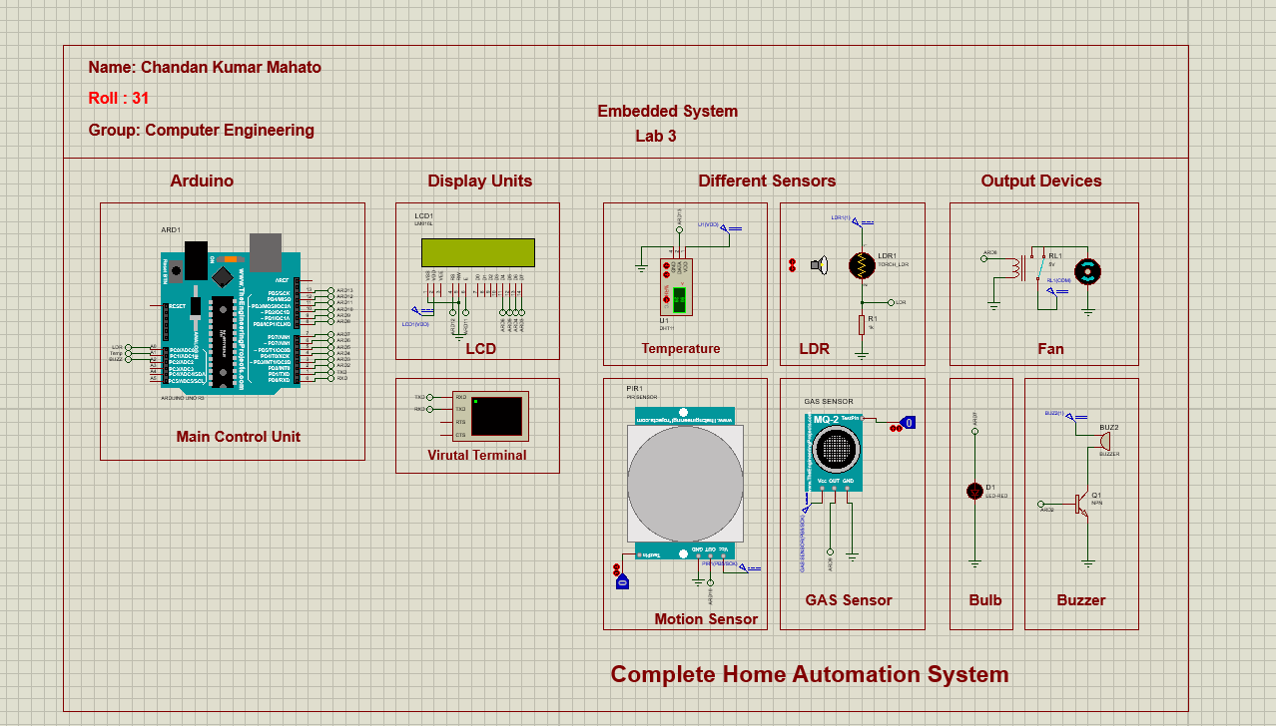

**Fig: Overall Circuit diagram**

# Source code for Arduino

#include <LiquidCrystal.h>

#include <DHT.h>

DHT dht(13,DHT11)

const int rs = 12, en = 11, d4 = 6, d5 = 5, d6 = 4, d7 = 3; LiquidCrystal lcd(rs, en, d4, d5, d6, d7);

int GasSensor = 9;

int ledPin = 7;

int fan = 8; int buzzer = 2;

int LdrSensor = A0; int TempSensor = 13;

int PIRSensor = 10;

int pirState = LOW;

int gasState = LOW;

int val = 0;

int val1 = 0;

float val2 = 0; float temp = 0; float humidity = 0;

boolean replaytemp = true; boolean replayldr = true; boolean replaysmoke = true; boolean replaymotion = true;

void setup()

{

Serial.begin(9600); dht.begin();

Serial.println("Home automation system by Chandan Mahato."); Serial.println(" ");

lcd.begin(16, 2); lcd.clear();

pinMode (GasSensor, INPUT);

pinMode (TempSensor, INPUT);

pinMode(ledPin, OUTPUT);

pinMode(fan, OUTPUT); pinMode(buzzer, OUTPUT);

pinMode(PIRSensor, INPUT);

lcd.setCursor(0, 0);

lcd.print("Embedded Lab"); lcd.setCursor(0, 1); lcd.print("Chandan Mahato"); delay(1000);

lcd.clear(); lcd.setCursor(1, 0); lcd.print("Home Automation"); lcd.setCursor(5, 1); lcd.print("System"); delay(500);

lcd.clear();

}

void loop()

{

tempSensor(); ldrSensor(); pirSensor();

gasSensor();

}

void pirSensor() {

val = digitalRead(PIRSensor);

if (val == HIGH ) {

if (pirState == LOW)

{

Serial.println("Motion Detected."); Serial.println(""); lcd.setCursor(0, 1); lcd.print("Motion detected!"); delay(1000);

lcd.clear(); pirState = HIGH;

}

} else {

if (pirState == HIGH){ Serial.println("No Motion Detected"); Serial.println("");

delay(500); pirState = LOW;

}

}

}

void gasSensor() {

val1 = digitalRead(GasSensor);

if (val1 == HIGH ) {

if (gasState == LOW)

{

Serial.println("Smoke Detected"); Serial.println("Turning Buzzer on."); Serial.println("");

replaysmoke = false; lcd.setCursor(0, 1); lcd.print("Smoke detected!"); digitalWrite(buzzer, HIGH);

delay(1000); lcd.clear();

digitalWrite(buzzer, LOW); delay(500);

gasState = HIGH;

}

} else {

if (gasState == HIGH){ Serial.println("No Smoke Detected"); Serial.println("Its safe now."); Serial.println(""); digitalWrite(buzzer, LOW); delay(500);

gasState = LOW;

}

}

}

void tempSensor(){

temp = dht.readTemperature(); humidity = dht.readHumidity();

lcd.setCursor(0, 0); lcd.print("Temp: "); lcd.print(temp); lcd.print("C"); lcd.setCursor(0, 1); lcd.print("Hum: "); lcd.print(humidity); lcd.print("%");

if (temp > 30){ digitalWrite(fan, HIGH); if(replaytemp == true){

Serial.println("Temperature is greater than 30 degree."); Serial.println("Turning Fan on.");

Serial.println(""); replaytemp = false;

}

}

else{

digitalWrite(fan, LOW); if(replaytemp == false){

Serial.println("Temperature is less than 30 degree."); Serial.println("Turning Fan off."); Serial.println("");

replaytemp = true;

}

}

}

void ldrSensor (){

int ldrvalue = analogRead(LdrSensor); lcd.setCursor(0, 0);

if(ldrvalue < 60){ digitalWrite(ledPin, HIGH); if(replayldr == true){

Serial.println("It's night time."); Serial.println("Turning LED on."); Serial.println("");

replayldr = false;

}

}

else {

digitalWrite(ledPin, LOW); if(replayldr == false){

Serial.println("It's day time."); Serial.println("Turning LED off."); Serial.println("");

replayldr = true;

}

}

}

**Conclusion:**

Using the proteus software, this full home automation system was created. The circuit could carry out all of the mentioned logic, after developing and modeling the circuit. Overall, I had fun and learned a lot working on this project, which helped me learn more about circuit design and simulation.