**Kathmandu University**

**Department of Computer Science and Engineering**

**Dhulikhel, Kavre**



A Report on ‘**Lab Work 5’** [COMP 342]

**Submitted by:**

Chandan Kumar Mahato (31)

III-year, II semester

**Submitted to**:

Mr. Dhiraj Shrestha

Department of Computer Science and Engineering

**Submission Date**: May 11, 2023

***Qlab5***

1. ***Implement Cohen Sutherland Line Clipping algorithm***
2. ***Implement Sutherland Hodgeman Polygon Clipping algorithm***
3. ***Write a Program to Implement:***
   1. ***3D Translation***
   2. ***3D Rotation***
   3. ***3D Scaling***

***Solution:***

<https://ckmwebgl.netlify.app>

I have used JavaScript as the programming language and WebGL as the graphics library. **JavaScript** is a popular programming language that is used for web development and has the capability of creating interactive graphics and animations on the web. **WebGL** is a graphics library that enables high-performance 3D graphics library that enables high-performance 3D graphics rendering in web browser using JavaScript. These technologies provide a powerful platform for creating engaging and interactive graphics, which is essential for my lab work.

The code snippets for setting graphics environment in my chosen graphics library and programming language and display system resolution are as follow:

**Source Code**

[**https://github.com/ChandankMahato/Graphics_Lab_6th_Sem**](https://github.com/ChandankMahato/Graphics_Lab_6th_Sem)

**Cohen Sutherland Line Clipping:**

*function* cohenSutherland(*P1*, *P2*, *Xw_min*, *Yw_min*, *Xw_max*, *Yw_max*) {

*let* x0 = *P1*[0];

*let* y0 = *P1*[1];

*let* x1 = *P2*[0];

*let* y1 = *P2*[1];

*let* vertexData = [];

*let* P1_new = [...*P1*];

*let* P2_new = [...*P2*];

*let* m = (y1 - y0) / (x1 - x0);

*let* regionCodeP1 = computeRegionCode(x0, y0, *Xw_min*, *Yw_min*, *Xw_max*, *Yw_max*);

*let* regionCodeP2 = computeRegionCode(x1, y1, *Xw_min*, *Yw_min*, *Xw_max*, *Yw_max*);

  while (true) {

    if ((regionCodeP1 | regionCodeP2) === 0) {

      vertexData.push(...P1_new, ...P2_new);

      DrawObject(gl.LINES, 2, Green, vertexData, 0, vertexData.length);

      console.log(vertexData);

      vertexData = [];

      vertexData.push(...*P1*, ...P1_new, ...*P2*, ...P2_new);

      DrawObject(gl.LINES, 2, Red, vertexData, 0, vertexData.length);

      return;

    } else if ((regionCodeP1 & regionCodeP2) !== 0) {

      vertexData.push(...*P1*, ...*P2*);

      DrawObject(gl.LINES, 2, Red, vertexData, 0, vertexData.length);

      return null;

    } else {

*let* x, y;

*let* regionCode = regionCodeP1 !== 0 ? regionCodeP1 : regionCodeP2;

      if ((regionCode & 1) !== 0) {

        x = *Xw_min*;

        y = y1 + m * (x - x1);

      } else if ((regionCode & 2) !== 0) {

        x = *Xw_max*;

        y = y1 + m * (x - x1);

      } else if ((regionCode & 4) !== 0) {

        y = *Yw_min*;

        x = x1 + (y - y1) / m;

      } else if ((regionCode & 8) !== 0) {

        y = *Yw_max*;

        x = x1 + (y - y1) / m;

      }

      if (regionCode === regionCodeP1) {

        regionCodeP1 = computeRegionCode(x, y, *Xw_min*, *Yw_min*, *Xw_max*, *Yw_max*);

        P1_new = [];

        P1_new = [x, y, 0];

      } else {

        regionCodeP2 = computeRegionCode(x, y, *Xw_min*, *Yw_min*, *Xw_max*, *Yw_max*);

        P2_new = [];

        P2_new = [x, y, 0];

      }

    }

  }

}

*function* computeRegionCode(*x*, *y*, *Xw_min*, *Yw_min*, *Xw_max*, *Yw_max*) {

*let* code = 0;

  if (*x* < *Xw_min*) {

    code |= 1;

  } else if (*x* > *Xw_max*) {

    code |= 2;

  }

  if (*y* < *Yw_min*) {

    code |= 4;

  } else if (*y* > *Yw_max*) {

    code |= 8;

  }

  return code;

}

**Sutherland Hodgemann:**

*function* sutherLandHodgemann(*Xw_min*, *Yw_min*, *Xw_max*, *Yw_max*) {

*let* vertexData = [];

*let* P1 = [-0.6, -0.7, 0];

*let* P2 = [0.9, 0.6, 0];

*let* P3 = [0.4, 0.7, 0];

*let* P4 = [-0.2, 0.6, 0];

*let* P5 = [-0.4, 0.2, 0];

  vertexData.push(...P1,...P2,...P2,...P3,...P3,...P4,...P4,...P5,...P5);

  cohenSutherland(P1, P2, *Xw_min*, *Yw_min*, *Xw_max*, *Yw_max*);

  GLINIT();

  cohenSutherland(P2, P3, *Xw_min*, *Yw_min*, *Xw_max*, *Yw_max*);

  GLINIT();

  cohenSutherland(P3, P4, *Xw_min*, *Yw_min*, *Xw_max*, *Yw_max*);

  GLINIT();

  cohenSutherland(P4, P5, *Xw_min*, *Yw_min*, *Xw_max*, *Yw_max*);

  GLINIT();

  cohenSutherland(P5, P1, *Xw_min*, *Yw_min*, *Xw_max*, *Yw_max*);

  GLINIT();

}

**Draw 3D Object:**

*let* FrontFace, BackFace, LeftFace, RightFace, TopFace, BottomFace = [];

*function* DrawCube() {

  DrawObject(gl.TRIANGLES, 3, Yellow, BackFace, 0, BackFace.length);

  DrawObject(gl.TRIANGLES, 3, White, LeftFace, 0, BackFace.length);

  DrawObject(gl.TRIANGLES, 3, Gray, BottomFace, 0, BackFace.length);

  DrawObject(gl.TRIANGLES, 3, Red, FrontFace, 0, FrontFace.length);

  DrawObject(gl.TRIANGLES, 3, Green, RightFace, 0, RightFace.length);

  DrawObject(gl.TRIANGLES, 3, Blue, TopFace, 0, TopFace.length);

}

**3D object Logic:**

*function* draw3DObject(*O*, *H*, *W*, *L*) {

  // P2 P4

  // P1 P3

*let* [x, y] = [*O*[0], *O*[1]];

*let* P1 = [x, y, 1];

*let* P2 = [x, y + *H*, 1];

*let* P3 = [x + *L*, y, 1];

*let* P4 = [x + *L*, y + *H*, 1];

*let* P5 = createVertex(P3, *W* / 2, *W* / 2);

*let* P6 = createVertex(P4, *W* / 2, *W* / 2);

*let* P7 = createVertex(P2, *W* / 2, *W* / 2);

  FrontFace = [...P1, ...P2, ...P3, ...P2, ...P3, ...P4];

  BackFace = translateObject(FrontFace, *W* / 1.75, *W* / 2.4);

  RightFace = [...P3, ...P4, ...P5, ...P4, ...P5, ...P6];

  LeftFace = translateObject(RightFace, -*L*, 0);

  TopFace = [...P2, ...P4, ...P7, ...P4, ...P6, ...P7];

  BottomFace = translateObject(TopFace, 0, -*H*);

  DrawCube();

}

*function* createVertex(*A*, *Tx*, *Ty*) {

*let* vertexData = [...translateObject(rotateObject(-Math.PI / 20,

        translateObject(translateObject(*A*, *Tx*, *Ty*), -*A*[0], -*A*[1])

      ),

*A*[0],*A*[1]

    ),

  ];

  return vertexData;

}

**3D Translation:**

*function* translate3DObject(*Tx*, *Ty*) {

  FrontFace = translateObject(FrontFace, *Tx*, *Ty*);

  BackFace = translateObject(BackFace, *Tx*, *Ty*);

  TopFace = translateObject(TopFace, *Tx*, *Ty*);

  BottomFace = translateObject(BottomFace, *Tx*, *Ty*);

  RightFace = translateObject(RightFace, *Tx*, *Ty*);

  LeftFace = translateObject(LeftFace, *Tx*, *Ty*);

  DrawCube();

}

**3D Rotation:**

*function* rotate3DObject(*angle*) {

  FrontFace = rotateObject(*angle*, FrontFace);

  BackFace = rotateObject(*angle*, BackFace);

  TopFace = rotateObject(*angle*, TopFace);

  BottomFace = rotateObject(*angle*, BottomFace);

  RightFace = rotateObject(*angle*, RightFace);

  LeftFace = rotateObject(*angle*, LeftFace);

  DrawCube();

}

**3D Scaling:**

*function* scale3DObject(*Sx*, *Sy*) {

  FrontFace = scaleObject(FrontFace, *Sx*, *Sy*);

  BackFace = scaleObject(BackFace, *Sx*, *Sy*);

  TopFace = scaleObject(TopFace, *Sx*, *Sy*);

  BottomFace = scaleObject(BottomFace, *Sx*, *Sy*);

  RightFace = scaleObject(RightFace, *Sx*, *Sy*);

  LeftFace = scaleObject(LeftFace, *Sx*, *Sy*);

  DrawCube();

}

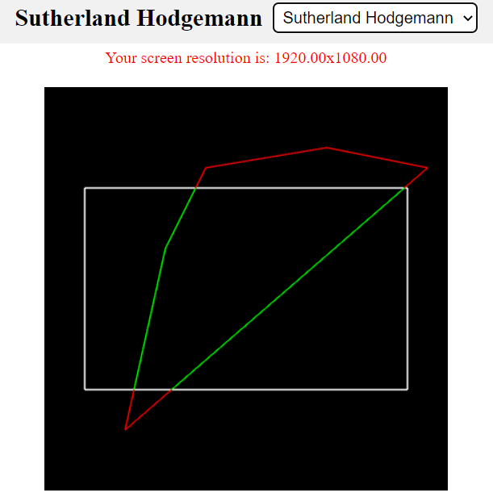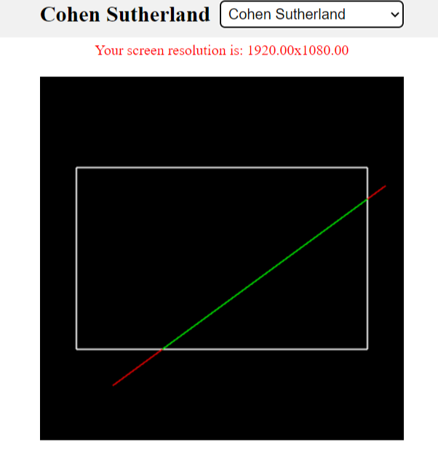**Output and Screenshots:**

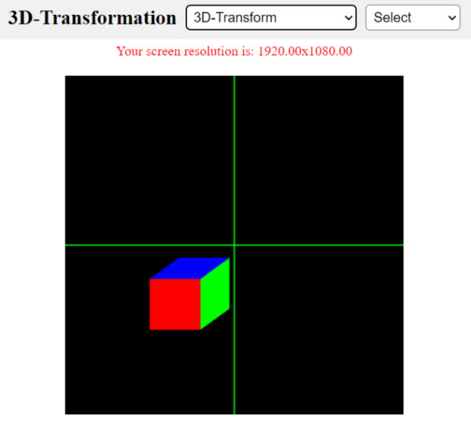**Fig 1: Cohen Sutherland Fig 2: Sutherland Hodgemann**

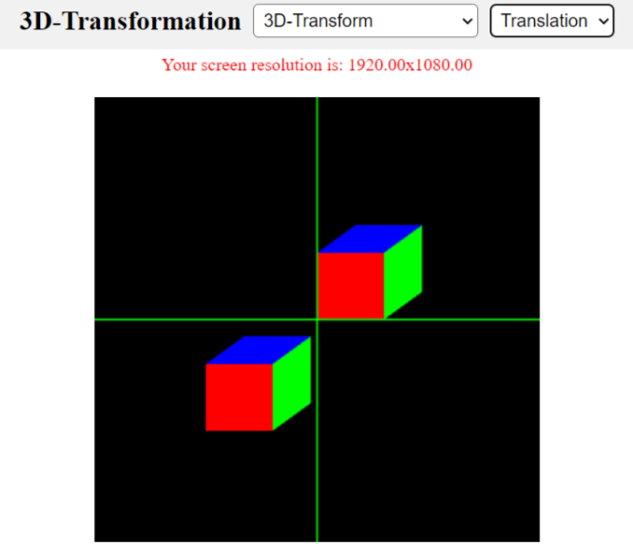

**Fig 1: 3D Cube Fig 2: 3D Rotation**

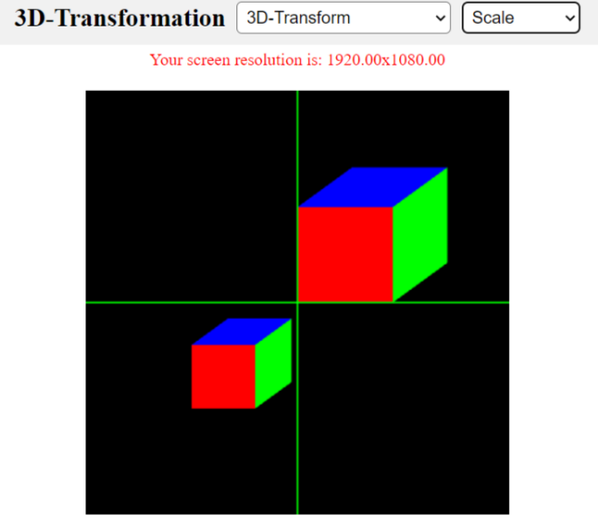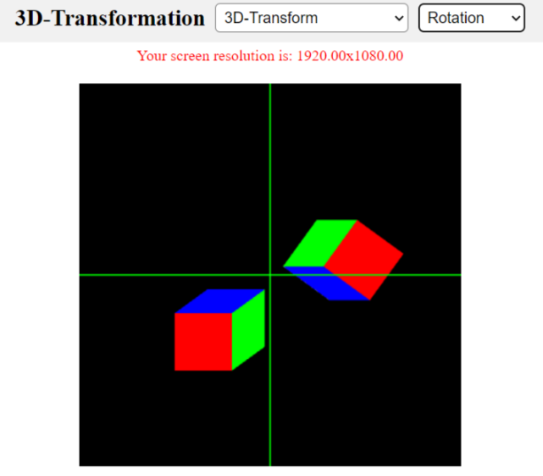

**Fig 1: 3D Rotation Fig 2: 3D Scaling**

**Conclusion**

After implementing the Cohen Sutherland algorithm and Sutherland Hodgeman Algorithm and 3D Translation, Rotation, and Scaling programs, I have gained a deeper understanding of the fundamental concepts of computer graphics. By utilizing matrix transformations and basic mathematical operations, I was able to clip the line and polygon, also able to manipulate and transform 3D objects in various ways.

This exercise has helped me to develop a better understanding of the concepts involved line clipping and 3D graphics transformations and how to implement them using programming languages. Overall, this exercise has enhanced my skills in computer graphics.