BUSINESS INTELLIGENCE &
CUSTOMER ANALYTICS SYSTEM
Complete End-to-End Project Report
Excel • MySQL / SQL • Power BI • DAX
Prepared By
CHANDANKUMAR S B
Portfolio / Data Analytics Project

Table of Contents
1. Executive Project Summary
2. Business Problem
3. Project Objectives
4. Business Requirements & Questions
5. Technology Stack
6. Dataset Overview
7. Data Architecture & Data Model
8. Excel Data Preparation
9. MySQL Database
10. SQL Data Import & Validation
11. SQL Business Analysis
12. Customer & RFM Analytics
13. Power BI Data Connection & Model
14. DAX Measures & Calculations
15. Power BI Dashboard
16. Dashboard Interactivity
17. Business Insights
18. Recommended Business Actions
19. End-to-End Validation
20. Refresh & Reusability
21. Final Project Results
22. Technical Skills Demonstrated
23. Conclusion

1. Executive Project Summary
The Business Intelligence & Customer Analytics System is an end-to-end analytics solution that transforms structured business transaction data into actionable business intelligence. The workflow covers Excel preparation and validation, MySQL database management, SQL analysis, Power BI data modeling, DAX calculations, interactive dashboards, business insights and recommended actions.
The solution analyzes business performance, customers, products, geography, transaction status, sales channels, payment methods and time-based trends. Customer analytics is extended through purchase-frequency analysis, customer revenue segmentation and RFM (Recency, Frequency, Monetary) segmentation.
The final Power BI report contains five analytical pages: Executive Overview, Customer Analytics, Product/Service Analytics, Regional Analytics, and Time & Trend Analysis.

2. Business Problem
- Large transaction data is difficult to analyze manually.
- Management needs centralized visibility into revenue, cost and profitability.
- Customer purchasing behavior and customer value need structured analysis.
- Product and category performance need comparison.
- Regional performance needs comparison at region, state and city levels.
- Time-based trends and growth need monitoring.
- Returns and cancellations require operational visibility.
- Business findings need to be translated into recommended actions.

3. Project Objectives

3.1 Business Objectives
- Measure revenue, cost, profit and profitability.
- Understand customer behavior and customer value.
- Identify high-performing products and categories.
- Compare regional, state and city performance.
- Analyze monthly, quarterly and yearly trends.
- Segment customers using RFM.
- Identify risks and opportunities.
- Provide evidence-based recommended business actions.

3.2 Technical Objectives
- Prepare and validate data in Excel.
- Design and populate a relational MySQL database.
- Perform business analysis using SQL.
- Build a Power BI star-schema model.
- Develop reusable DAX measures.
- Build an interactive five-page dashboard.
- Reconcile SQL and Power BI results.
- Demonstrate a refreshable reporting workflow.

4. Business Requirements & Questions
Area | Key Questions
Business Performance | How is the business performing? What are revenue, cost, profit, margin and AOV?
Customer Analytics | Who are the customers? How frequently do they purchase? Which customers need attention?
Product Analytics | Which categories/products generate the strongest revenue, profit and margins?
Regional Analytics | Which regions, states and cities perform best?
Time & Trend Analysis | How does performance change over time? What are the strongest periods and growth trends?

5. Technology Stack
Technology | Purpose
Excel | Data preparation, calculations and validation
MySQL | Relational database and storage
SQL | Import, validation, business analysis and RFM
Power BI | Data modeling and interactive reporting
DAX | KPI, time, customer and RFM calculations

6. Dataset Overview
Final dataset period: January 2024 – December 2026.
Table | Records
dim_customer | 7,500
dim_product | 150
dim_geography | 121
dim_date | 1,096
fact_transaction | 100,000

7. Data Architecture & Data Model
Raw Business Data
↓
Excel Preparation & Validation
↓
CSV / Structured Data
↓
MySQL Database
↓
SQL Validation & Business Analysis
↓
Power BI Data Model
↓
DAX
↓
Interactive Dashboard
↓
Business Insights & Actions
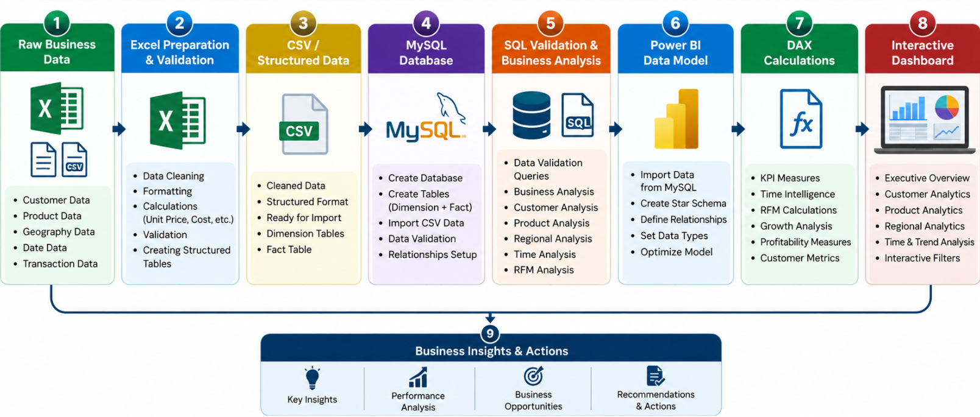
Figure 1. System Architecture of the Business Intelligence & Customer Analytics System

7.1 Star Schema
dim_customer
│
dim_product ─── fact_transaction ─── dim_geography
│
dim_date
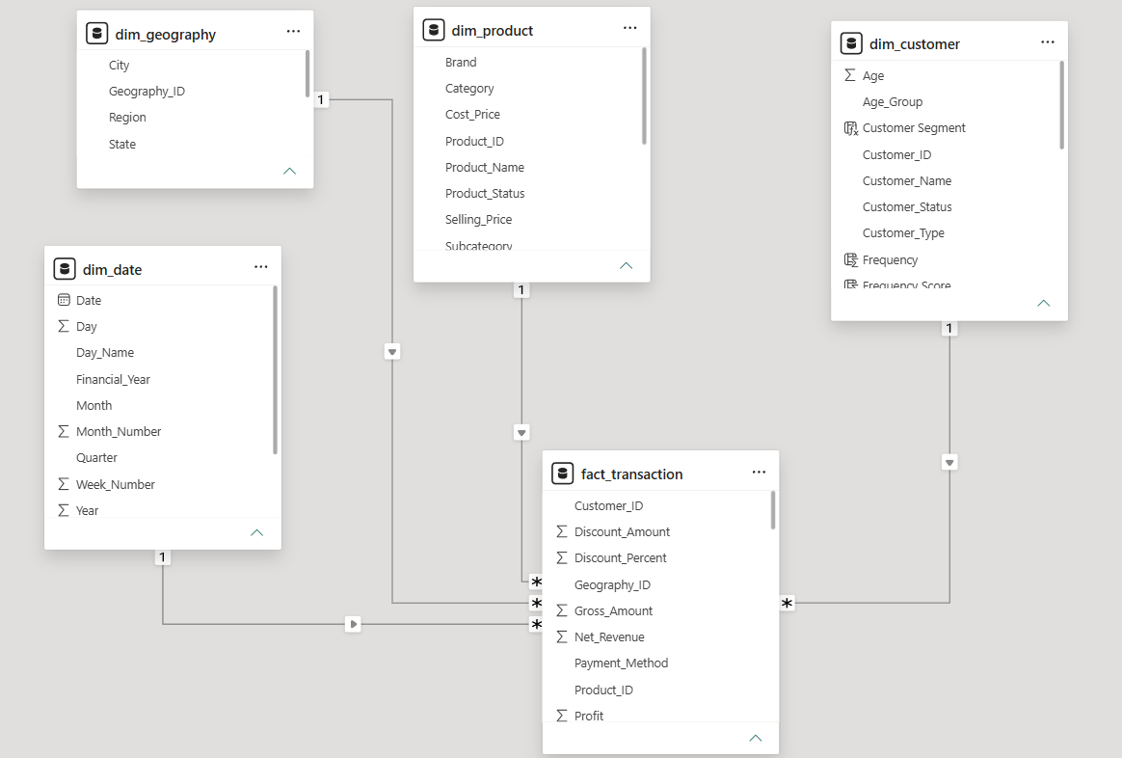
Figure 2. Power BI Star Schema showing Dimension and Fact Table Relationships

7.2 Relationships
Dimension | Fact | Cardinality | Direction
dim_customer | fact_transaction | 1 : Many | Single
dim_product | fact_transaction | 1 : Many | Single
dim_geography | fact_transaction | 1 : Many | Single
dim_date | fact_transaction | 1 : Many | Single

7.3 Main Fields
Table | Important Fields
dim_customer | Customer_ID, Customer_Name, Gender, Age, Age_Group, Join_Date, Customer_Type, Geography_ID, Customer_Status
dim_product | Product_ID, Product_Name, Category, Subcategory, Brand, Cost_Price, Selling_Price, Product_Status
dim_geography | Geography_ID, City, State, Region
dim_date | Date, Day, Day_Name, Week_Number, Month, Month_Number, Quarter, Year, Year_Month, Financial_Year
fact_transaction | Transaction_ID, Transaction_Date, Customer_ID, Product_ID, Geography_ID, Quantity, Unit_Price, Discount_Percent, Discount_Amount, Gross_Amount, Net_Revenue, Unit_Cost, Total_Cost, Profit, Profit_Margin, Payment_Method, Sales_Channel, Transaction_Status

8. Excel Data Preparation
The initial preparation and inspection layer was Excel. The working sheets were converted into structured Excel Tables.
Excel Table | Purpose
tbl_customer | Customer master
tbl_product | Product master
tbl_geography | Geography master
tbl_date | Date dimension
tbl_transaction | Transaction fact
- Date formatting and type checks
- Financial/accounting formatting
- Percentage formatting
- ID consistency
- Duplicate checks
- Missing-value checks
- Calculation checks
- Reference validation
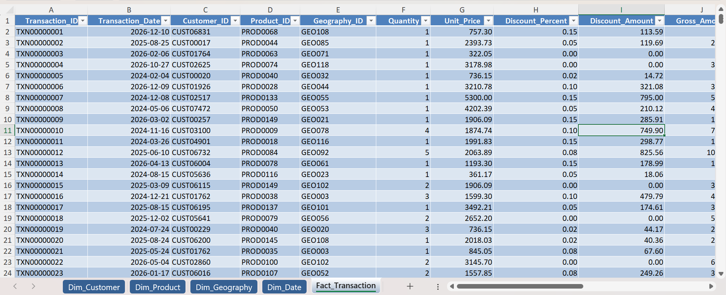

Figure 3. Prepared Excel Transaction Data Structure

9. MySQL Database
CREATE SCHEMA Project1_BusinessAnalytics;
USE Project1_BusinessAnalytics;

9.1 Tables
- dim_customer
- dim_product
- dim_geography
- dim_date
- fact_transaction

9.2 Data Types
Type | Use
VARCHAR | IDs and descriptive fields
INT | Age, quantity and date-part numbers
DATE | Join/transaction/calendar dates
DECIMAL | Financial and precise percentage values
-- Example financial storage
DECIMAL(12,2)
DECIMAL(14,2)
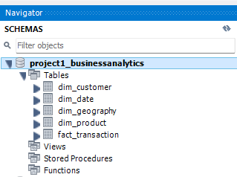
Figure 4. MySQL Database Schema and Project Tables

10. SQL Data Import & Validation
- Excel → CSV preparation
- Date-format correction for date CSVs
- MySQL table creation
- CSV import / Table Data Import Wizard
- Row-count verification
- Integrity and calculation validation
Table | Rows
dim_customer | 7,500
dim_product | 150
dim_geography | 121
dim_date | 1,096
fact_transaction | 100,000

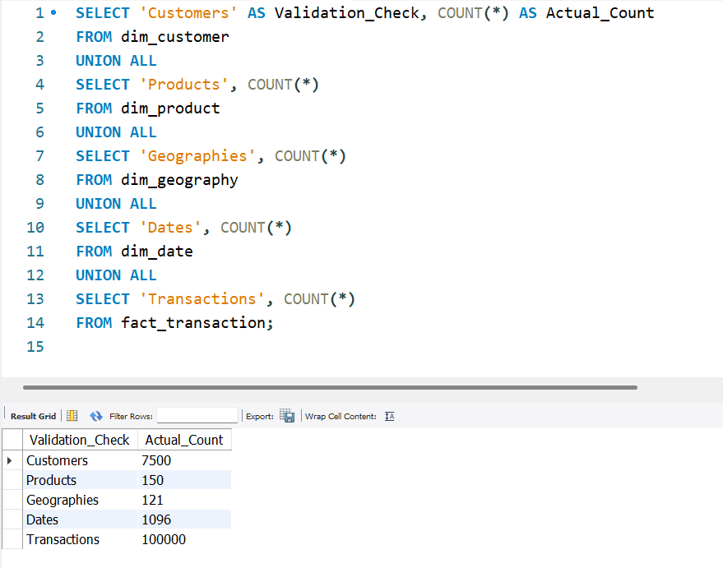

Figure 5. SQL Data Validation Results

10.1 Financial Reconciliation
Metric | Result
Revenue | ₹412,829,960.96
Cost | ₹326,765,369.15
Profit | ₹86,064,591.81
Average Order Value | ₹4,128.30
Overall Margin | 20.85%

11. SQL Business Analysis
- Overall business performance
- Transaction status
- Customer behavior and value
- Purchase frequency
- Customer revenue segmentation
- RFM segmentation
- Product/category performance
- Region/state/city performance
- Sales channel
- Payment method
- Monthly, quarterly and yearly trends
- MoM and YoY growth

11.1 Representative Management Query
SELECT
COUNT(*) AS Total_Transactions,
COUNT(DISTINCT Customer_ID) AS Unique_Customers,
ROUND(SUM(Net_Revenue), 2) AS Total_Revenue,
ROUND(SUM(Total_Cost), 2) AS Total_Cost,
ROUND(SUM(Profit), 2) AS Total_Profit,
ROUND(AVG(Net_Revenue), 2) AS Average_Order_Value,
ROUND((SUM(Profit) / SUM(Net_Revenue)) * 100, 2)
AS Overall_Profit_Margin
FROM fact_transaction;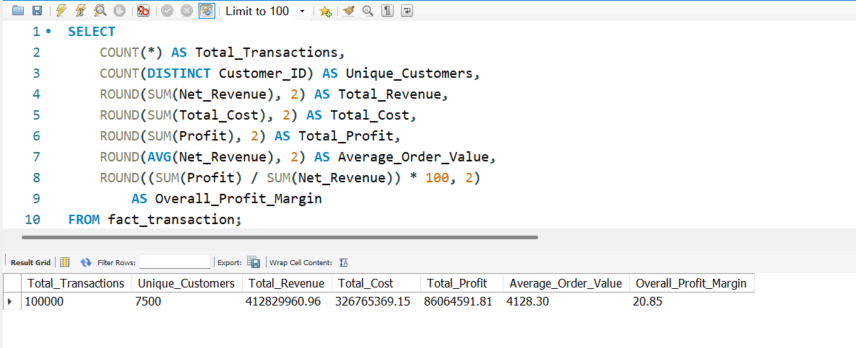
Figure 6. SQL Business Analysis — Management Summary Results

12. Customer & RFM Analytics
Metric | Result
Unique Customers | 7,500
New Customers | 3,754
Existing Customers | 3,746
Repeat Customers | 7,500 (modeled dataset)
Revenue per Customer | ₹55,043.99
Transactions per Customer | 13.33
The repeat-customer result reflects the modeled dataset and indicates recurring transaction activity during the analysis period.

12.1 Purchase Frequency
Band | Customers
2–5 | 63
6–10 | 1,635
11–20 | 5,569
20+ | 233

12.2 Customer Revenue Segmentation
Segment | Customers
Below 25K | 355
25K–50K | 2,936
50K–100K | 4,020
100K–150K | 187
Above 150K | 2

12.3 RFM Method
- Recency: how recently a customer purchased.
- Frequency: how frequently a customer purchased.
- Monetary: how much revenue a customer generated.
- Deterministic ranking uses Customer_ID as a tie-breaker so SQL and Power BI produce matching buckets.

12.4 Final RFM Segmentation
Segment | Customers | Share
Loyal Customers | 3,321 | 44.28%
Potential Customers | 2,381 | 31.75%
At Risk | 1,185 | 15.80%
Low Engagement | 538 | 7.17%
Champions | 75 | 1.00%

12.5 RFM Financial Contribution
Segment | Revenue | Profit
Loyal Customers | ₹21.33 Cr | ₹4.47 Cr
Potential Customers | ₹11.71 Cr | ₹2.42 Cr
At Risk | ₹5.17 Cr | ₹1.07 Cr
Low Engagement | ₹2.41 Cr | ₹0.50 Cr
Champions | ₹0.67 Cr | ₹0.14 Cr

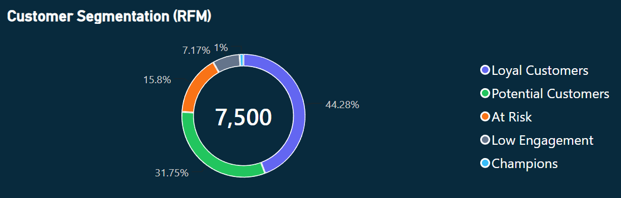
Figure 7. RFM Customer Segmentation Analysis

13. Power BI Data Connection & Model
The validated MySQL database was connected to Power BI Desktop. The five project tables were loaded and relationships were configured as active 1-to-many relationships from dimensions to fact_transaction.
Figure 8. Power BI Data Model and Table Relationships

14. DAX Measures & Calculations

14.1 Core KPI Measures
Total Revenue =
SUM(fact_transaction[Net_Revenue])

Total Profit =
SUM(fact_transaction[Profit])

Total Transactions =
COUNTROWS(fact_transaction)

Average Order Value =
AVERAGE(fact_transaction[Net_Revenue])

Overall Profit Margin =
DIVIDE([Total Profit], [Total Revenue], 0)

Unique Customers =
DISTINCTCOUNT(fact_transaction[Customer_ID])

14.2 Customer Measures
Revenue per Customer =
DIVIDE([Total Revenue], [Unique Customers], 0)

Profit per Customer =
DIVIDE([Total Profit], [Unique Customers], 0)

Transactions per Customer =
DIVIDE([Total Transactions], [Unique Customers], 0)

14.3 Transaction Measures
Returned Transactions =
CALCULATE(
COUNTROWS(fact_transaction),
fact_transaction[Transaction_Status] = "Returned"
)

Cancelled Transactions =
CALCULATE(
COUNTROWS(fact_transaction),
fact_transaction[Transaction_Status] = "Cancelled"
)

Return Rate =
DIVIDE([Returned Transactions], [Total Transactions], 0)

Cancellation Rate =
DIVIDE([Cancelled Transactions], [Total Transactions], 0)

14.4 Time Intelligence
YTD Revenue =
TOTALYTD([Total Revenue], dim_date[Date])

Revenue YoY % =
VAR PreviousYearRevenue =
CALCULATE(
[Total Revenue],
DATEADD(dim_date[Date], -1, YEAR)
)
RETURN
DIVIDE(
[Total Revenue] - PreviousYearRevenue,
PreviousYearRevenue,
0
) * 100

14.5 RFM DAX
- Recency, Frequency and Monetary customer columns.
- Deterministic scoring with Customer_ID tie-breaker.
- RFM Score combining the three component scores.
- Customer Segment assignment.
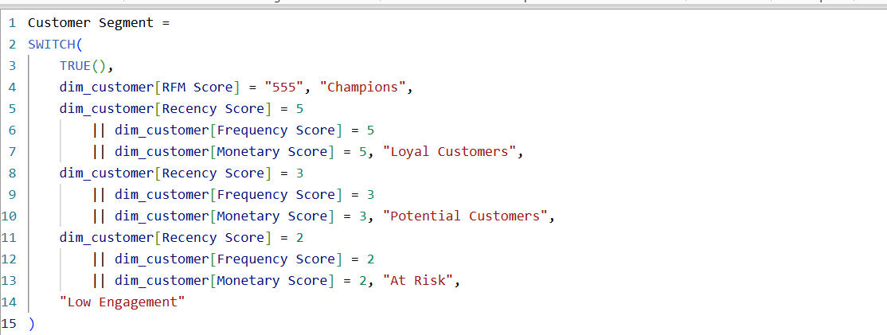

Figure 9A. DAX RFM Customer Segmentation Calculation

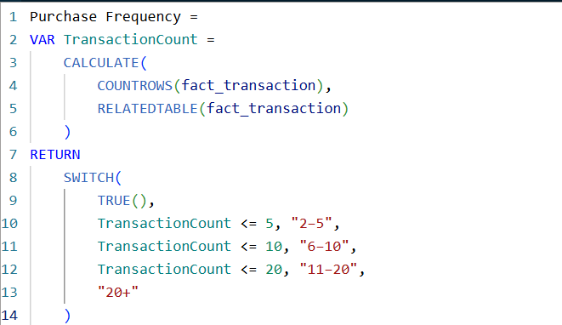

Figure 9B. DAX RFM Purchase Frequency Calculation

15. Power BI Dashboard
The dashboard uses a consistent professional dark theme with sidebar navigation, KPI cards, interactive slicers, analytical visuals and insight/action cards.

15.1 Executive Overview

KPIs
- Total Transactions
- Total Revenue
- Total Cost
- Total Profit
- AOV
- Overall Profit Margin

Visuals
- Monthly Revenue & Profit
- Transaction Status
- Top 5 Products
- Regional Performance
- Top 5 Customers
- Category Sales

Key Insights
- Total revenue is ₹41.28 Cr, with total profit of ₹8.61 Cr.
- Overall profit margin is 20.85%.
- South is the leading region, contributing ₹13.61 Cr in revenue.
- Customers contribute recurring business with 7,500 customers and 13.33 transactions per customer.

Recommended Actions
- Protect the current profit margin while pursuing profitable growth.
- Identify the drivers behind South's strong performance and replicate them in weaker regions.
- Strengthen customer retention and increase customer value through repeat purchases.

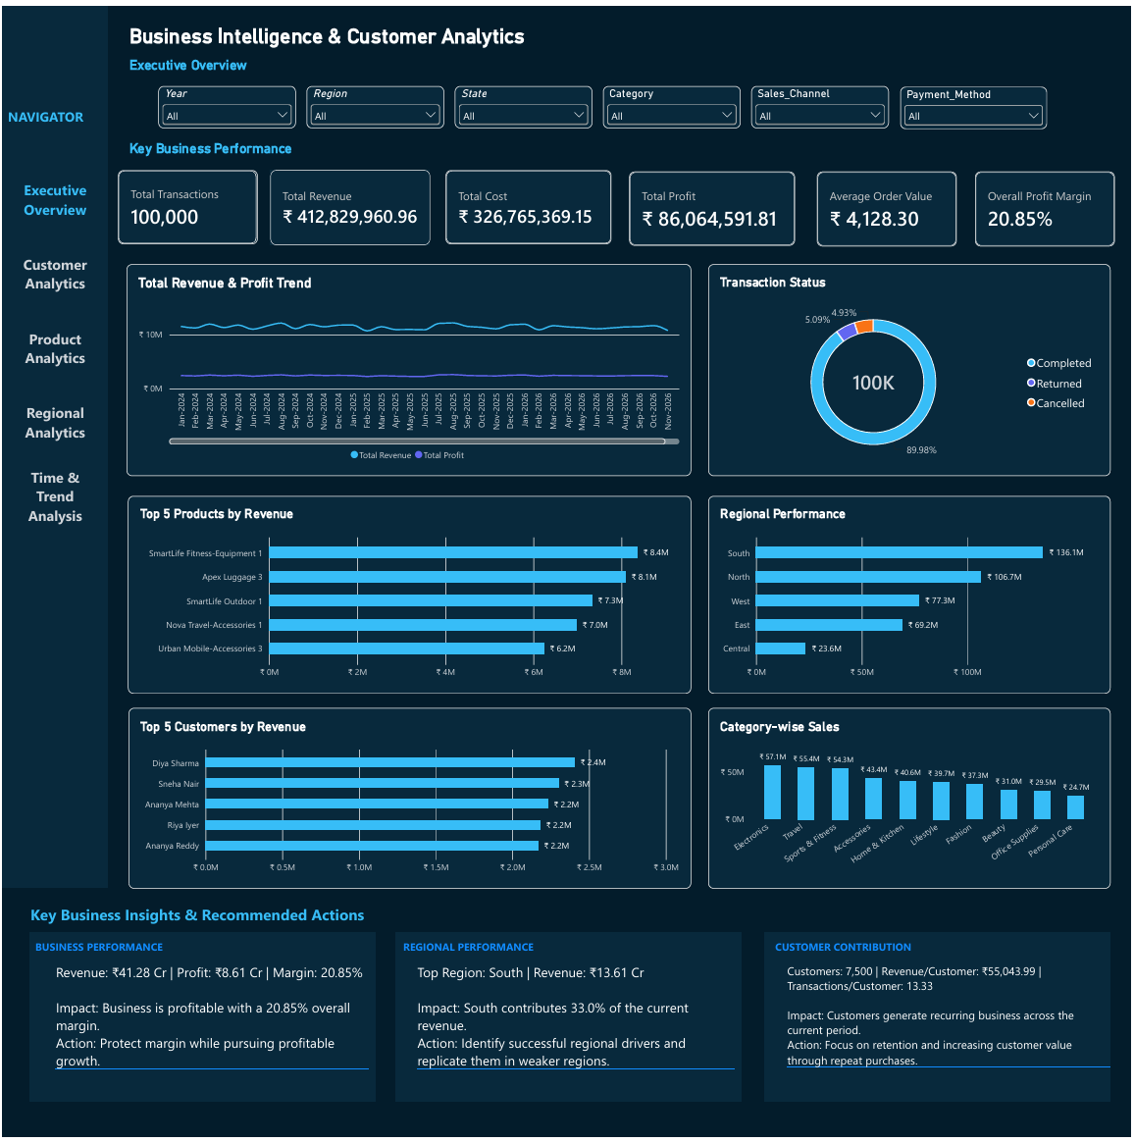

Figure 10. Executive Overview Dashboard

15.2 Customer Analytics

KPIs
- Unique Customers
- New Customers
- Existing Customers
- Repeat Customers
- Revenue per Customer
- Transactions per Customer

Visuals
- New vs Existing
- Purchase Frequency
- Customer Revenue Segments
- Top 10 Customers Revenue
- Top 10 Customers Profit
- RFM Segmentation
- Segment Revenue & Profit

Key Insights
- The business has 7,500 unique customers.
- Revenue per customer is ₹55,043.99.
- Average transactions per customer are 13.33.
- 3,321 customers (44.28%) are classified as Loyal Customers.
- 2,381 customers (31.75%) are Potential Customers.
- Champions represent 75 customers (1%).

Recommended Actions
- Focus on retaining the large Loyal Customer segment.
- Convert Potential Customers into Loyal Customers through targeted engagement.
- Develop reactivation strategies for At Risk customers.
- Increase customer value through repeat purchases and personalized offers.

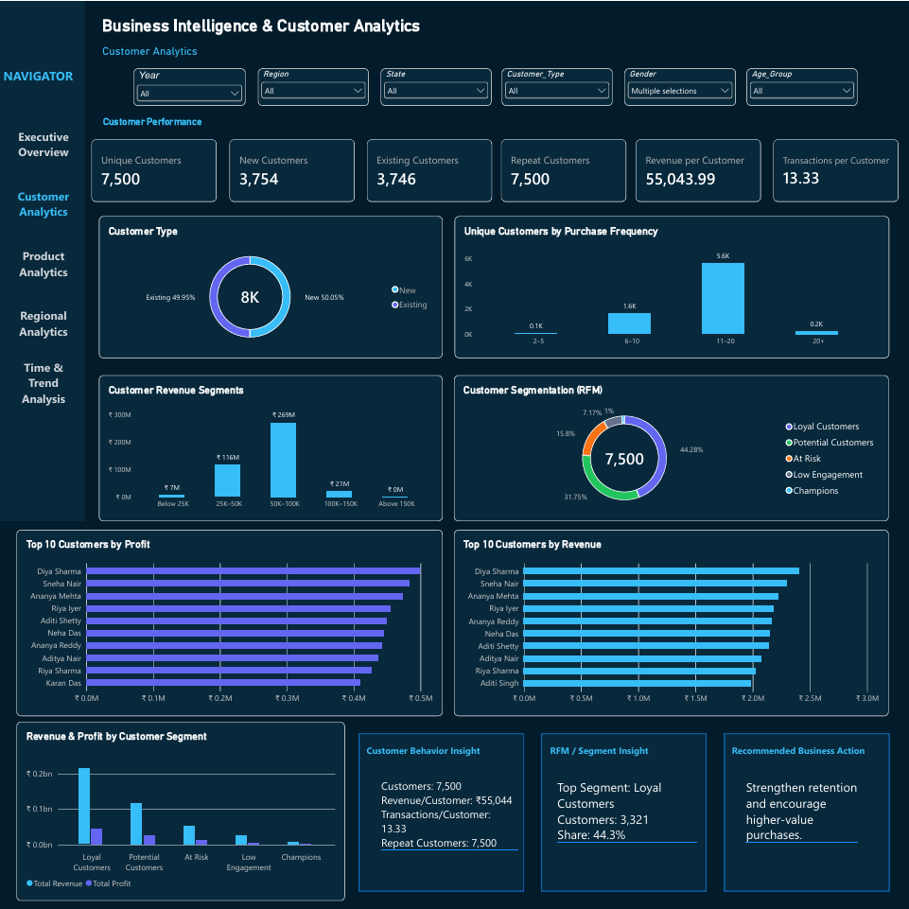

Figure 11. Customer Analytics Dashboard

15.3 Product/Service Analytics

KPIs
- Total Products
- Active Products
- Revenue
- Profit
- Average Selling Price
- Average Product Margin

Visuals
- Category Revenue
- Category Profit
- Top 10 Products Revenue
- Top 10 Products Profit
- Product Margin
- Subcategory Performance

Key Insights
- The business contains 150 products, all currently active.
- Total revenue is ₹41.28 Cr and total profit is ₹8.61 Cr.
- Average selling price is ₹2,395.12.
- Average product margin is 24.39%.
- Electronics is the leading category by revenue at approximately ₹5.71 Cr.

Recommended Actions
- Protect and expand high-performing product categories.
- Prioritize products with strong profitability rather than revenue alone.
- Review low-performing products and subcategories for improvement opportunities.
- Maintain a healthy product mix with strong-margin products.

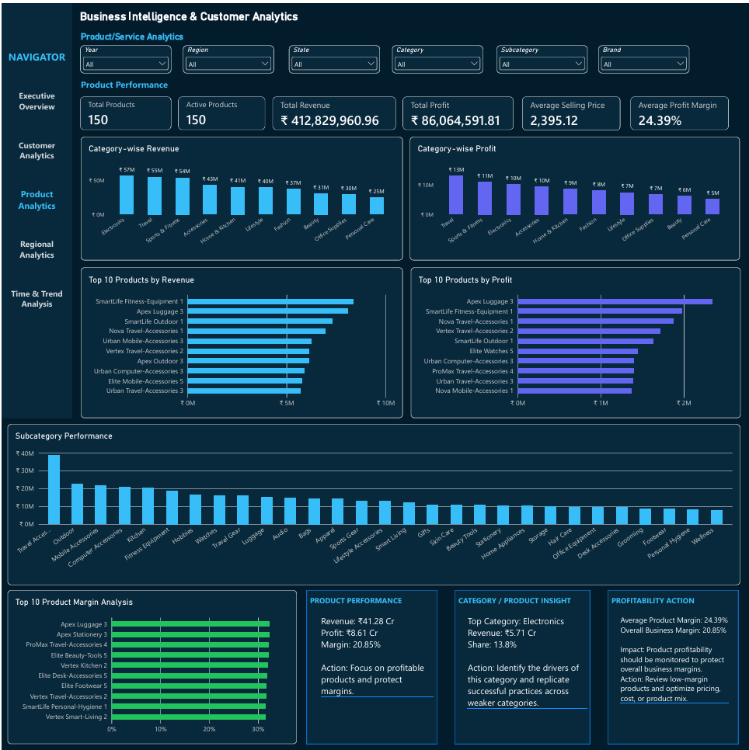

Figure 12. Product/Service Analytics Dashboard

15.4 Regional Analytics

KPIs
- Total Regions
- Total States
- Total Cities
- Revenue
- Profit
- Margin

Visuals
- Regional Revenue
- Regional Profit
- Top 10 States Revenue
- Top 10 States Profit
- Top 10 Cities Revenue
- Regional Margin

Key Insights
- The business operates across 5 regions, 19 states and 121 cities.
- South is the top region with ₹13.61 Cr revenue, contributing approximately 33% of total revenue.
- Karnataka is the leading state with ₹3.82 Cr revenue.
- East records the highest regional profit margin at approximately 20.98%.

Recommended Actions
- Replicate the successful drivers of South in weaker regions.
- Strengthen operations and customer acquisition in high-potential states.
- Investigate regional margin differences to identify efficiency opportunities.

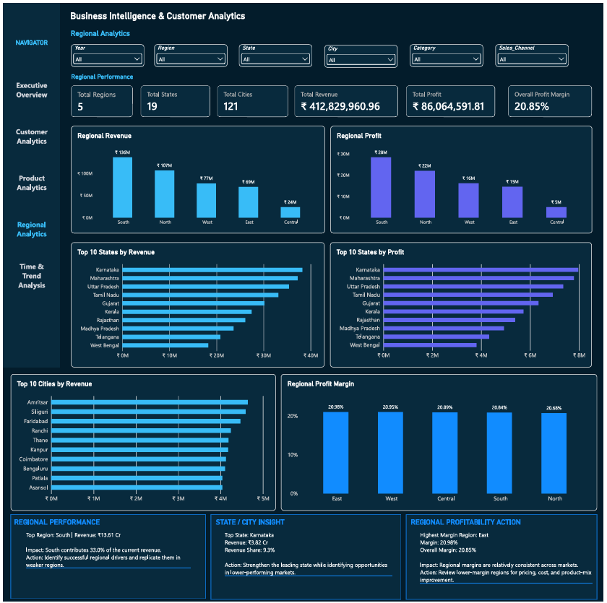

Figure 13. Regional Analytics Dashboard

15.5 Time & Trend Analysis

KPIs
- Revenue
- Profit
- Revenue Growth
- Profit Growth
- YTD Revenue
- YTD Profit

Visuals
- Monthly Revenue & Profit
- Monthly Growth
- Yearly Revenue & Profit
- Monthly Transactions
- Quarterly Revenue
- YoY Revenue Growth

Key Insights
- 2024 was the strongest year with approximately ₹13.91 Cr revenue and ₹2.90 Cr profit.
- Current revenue growth is approximately 2.82%.
- Current profit growth is approximately 2.87%.
- August 2025 was the strongest month with approximately ₹1.22 Cr revenue.

Recommended Actions
- Monitor monthly and quarterly trends to identify seasonal patterns.
- Investigate the drivers behind high-performing periods.
- Use growth trends to support future sales and resource planning.
- Maintain focus on profitable growth rather than revenue growth alone.

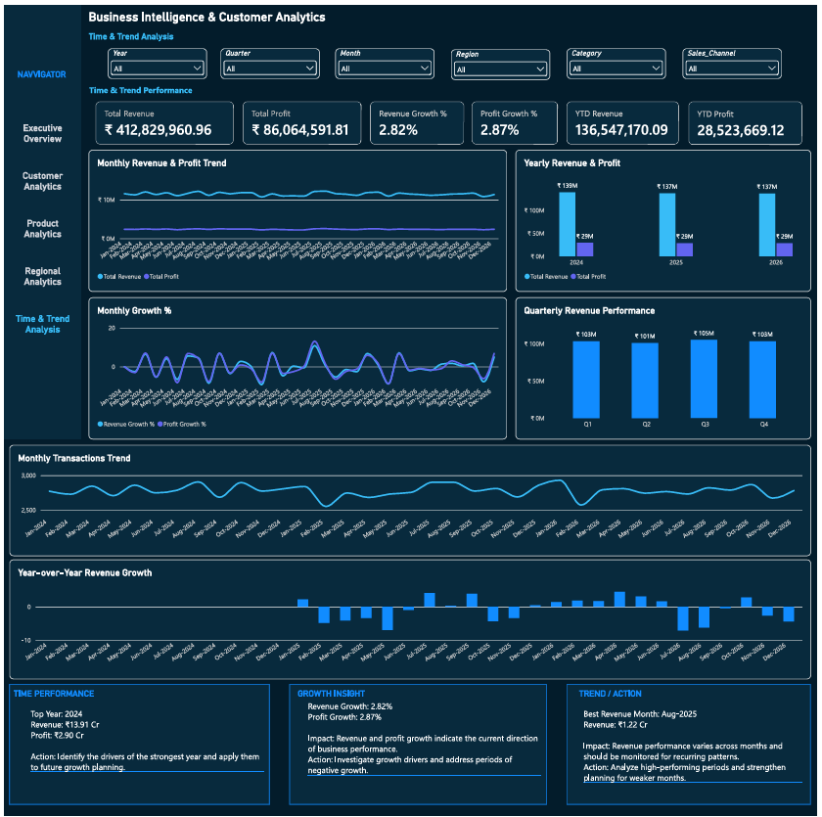

Figure 14. Time & Trend Analysis Dashboard

16. Dashboard Interactivity
- Slicers
- Cross-filtering
- Page navigation
- Drill-down
- Drill-through
- Tooltips
- Dynamic DAX calculations

16.1 Major Slicers
Year, Region, State, City, Category, Subcategory, Brand, Sales Channel, Payment Method, Customer Type, Gender, Age Group, Quarter and Month, as applicable to each page.
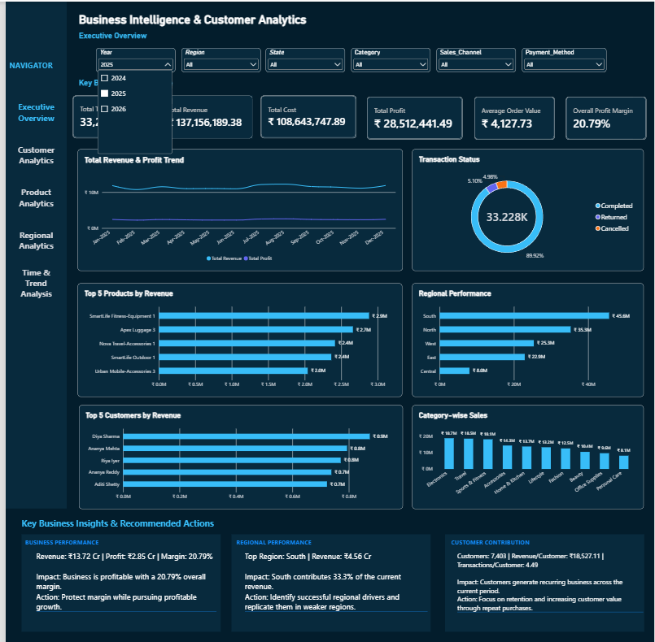
Figure 15. Power BI Dashboard Interactivity with Active Filters

17. Business Insights
Area | Observation | Impact | Recommended Action
Overall Performance | ₹41.28 Cr revenue; ₹8.61 Cr profit; 20.85% margin. | Modeled business is profitable. | Protect margin while pursuing profitable growth.
Customer Behavior | 7,500 customers; ₹55,043.99 revenue/customer; 13.33 transactions/customer. | Recurring activity is present in the modeled dataset. | Strengthen retention and increase customer value.
RFM | Loyal 3,321 (44.28%); At Risk 1,185 (15.80%). | Segments have different engagement and financial contribution. | Retain Loyal/Champions; convert Potential; re-engage At Risk/Low Engagement.
Product | Electronics is top revenue category at ₹5.71 Cr (13.8%). | Important revenue contributor. | Identify successful drivers and replicate where appropriate.
Region | South ₹13.61 Cr, about 33.0% of revenue; Karnataka ₹3.82 Cr. | Leading markets contribute meaningful revenue. | Identify successful drivers and evaluate weaker markets.
Time | 2024 revenue ₹13.91 Cr; August 2025 about ₹1.22 Cr. | Performance varies across periods. | Investigate strong-period drivers and use them for planning.
Transaction Quality | 5.09% returned; 4.93% cancelled. | Operational areas require investigation. | Analyze drivers by product, channel and geography.

18. Recommended Business Actions
Area | Focus | Recommended Action | Expected Benefit
Customer Retention | Loyal/Champions | Retention offers and loyalty engagement | Protect recurring revenue
Customer Re-engagement | At Risk/Low Engagement | Targeted campaigns and activity investigation | Recover customer activity
Potential Customers | Large Potential segment | Targeted offers to increase frequency/value | Move customers toward stronger-value segments
Product Strategy | High-performing products | Prioritize profitable products and optimize mix | Support profitable growth
Regional Strategy | Leading regions/states | Identify and replicate successful drivers | Expand successful practices
Operations | Returns/cancellations | Analyze drivers by product/channel/geography | Improve transaction quality
Time Planning | Strong/weak periods | Investigate period drivers and plan resources | Improve planning
Decision framework: Finding → Business Impact → Investigation Area → Recommended Action → Expected Benefit.

19. End-to-End Validation
Layer | Checks | Result
Excel | IDs, missing values, references, calculations | Passed
MySQL | Row counts, PKs, NULLs, references, calculations, date range | Passed
SQL → Power BI | Revenue, cost, profit, transactions, customers | Reconciled
Power BI | Relationships, DAX, KPIs, slicers, charts, navigation, refresh | Passed

Figure 16. Final Power BI KPI Validation Against SQL Baseline

20. Refresh & Reusability
Updated Source Data
↓
Data Source / MySQL
↓
Power BI Refresh
↓
Model + DAX Recalculation
↓
Updated Dashboard
The solution is designed as a reusable reporting workflow rather than a one-time static analysis.
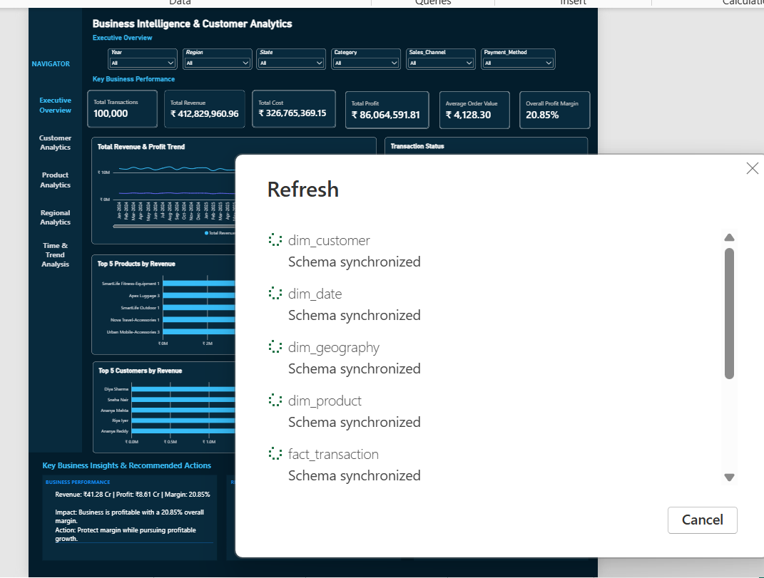

Figure 17. Successful Power BI Data Refresh and Schema Synchronization

21. Final Project Results
KPI | Final Value
Transactions | 100,000
Customers | 7,500
Revenue | ₹41.28 Cr
Cost | ₹32.68 Cr
Profit | ₹8.61 Cr
AOV | ₹4,128.30
Profit Margin | 20.85%
Products | 150
Regions | 5
States | 19
Cities | 121

22. Technical Skills Demonstrated
Area | Skills
Excel | Data preparation, Excel Tables, validation, financial/business calculations
SQL / MySQL | Database creation, table design, data types, import, joins, aggregations, CASE, CTEs, window functions, RFM, validation
Power BI | MySQL connectivity, star schema, relationships, slicers, dashboards, drill-down, drill-through, tooltips
DAX | KPI measures, CALCULATE, DIVIDE, DISTINCTCOUNT, FILTER, RELATEDTABLE, DATEADD, DATESMTD, TOTALYTD, RFM and dynamic insights
Business Analysis | Performance, customer, product, regional, trend analysis and recommended actions

23. Conclusion
The Business Intelligence & Customer Analytics System successfully demonstrates an end-to-end business intelligence and data analytics workflow. The project transforms structured business transaction data into meaningful insights using Excel, MySQL/SQL, Power BI, and DAX.
The solution covers business performance, customer behavior, product performance, regional analysis, and time-based trends. Customer analytics is further enhanced through purchase-frequency analysis, customer revenue segmentation, and RFM customer segmentation.
The final Power BI solution provides an interactive five-page dashboard with KPIs, analytical visuals, slicers, navigation, and business insight/action sections. SQL and Power BI results were reconciled to validate the accuracy of the reporting outputs, and the refresh workflow was successfully tested.
Overall, the project demonstrates practical skills in data preparation, SQL analysis, relational data modeling, Power BI dashboard development, DAX calculations, customer analytics, business analysis, and evidence-based decision-making. It provides a reusable foundation for transforming business data into actionable information for management.

