**IOT :[Internet Of Things]**

A network of Internet connected objects able to collect and exchange data.

IOT is playing prominent role in automation with minimal or no human intervention for completing the tasks.

Basically to explain the IOT let us take the example of smart home. We know how objects in home are connected for automation and pleasure of human like,

* security monitoring capabilities,
* temperature modulation,
* lighting controls,
* Sound modulation,
* Visual monitoring and modulation,
* Entertainment etc

IOT is used in every field these days, from local to international levels.

It is that useful and broader in the modernized world.

As India is truly agricultural based and 69% of it is villages, It is phenomenal to use IOT in agriculture. IOT can be used in agriculture for higher reliability and minimal human intervention of farmers. Many test cases are discussed in the next section. IoT monitoring technology allows farmers to continuously track resources, monitor water, fuel and feed tanks and improve upon crop and agriculture asset health, labour , and time costs.

IoT in agriculture consists of sensors, processing, connectivity, gateway and cloud solutions optimized in their working according to specific use cases.to get the maximum productivity of crops soil and the environment need to be monitored for humidity and temperature. It is important not only to monitor not only absolute humidity and temperature but the change over a shorter and longer period of time. This data can be correlated with ideal profile for the crop. This monitoring also helps to identify when and how much pesticides and fertilizer need to be used to minimize their usage.

**Problem statement for IOT in agriculture:**

Sensors in the fields can ensure the optimal use of available **water**resources. There are many resources available for the agriculture but for their optimal use IOT is necessary.

The following are some of them where IOT can be used,

* Weather forecast to get the weather conditions of the following days
* The level of water and time of flow of water from the dams to canals also needs sensors so that farmers get alerts on time
* **Fertilizer's sensors** can sense and alert farmers if the crop requires more fertilizer or they are less in the soil.
* Sensors can help in detecting crop diseases prior to damage
* The **water motors** can be connected with mobiles.
* The use of environmental sensors to predict weather forecasts can help the farmers in activities like sowing, irrigation, and harvesting.
* Environmental sensors can detect smoke and start the water sprinklers and avoid huge losses.

By these ways we can utilize IOT for betterment of the agriculture.

In our project we want to use the IOT mainly for irrigation purpose, that is usage of sensors to find the temperature,humidity,moisture of the environment of the field.

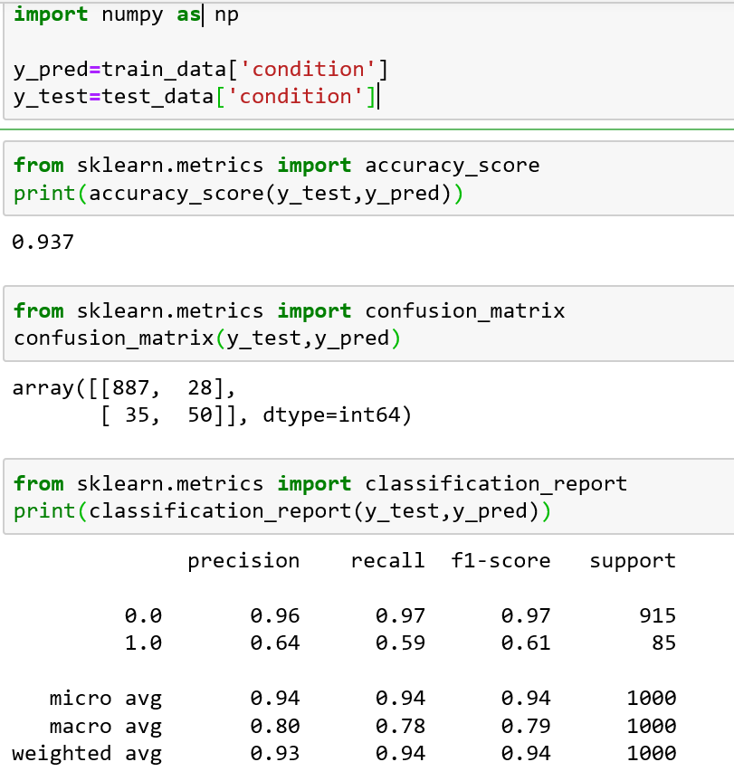

I the beginning we given the train data output column and test data output column to the couple of variables.

Second step is to import the accuracy score from sklearn.metrics

* To find the accuracy score
* Print the calculated accuracy score

Third step is to import the confusion matric from sklearn.metrics

* To find the confusion matrix
* To print the accuracy matrix

Fourth step is to import classification report from sklearn.metrics

* To find the classification report
* To print the report

By all these calculation on our data we got to know that ,

* Accuracy score is 93.7 percent
* Confusion matrix is

array([[887, 28], [ 35, 50]], dtype=int64)

* Classification report is

precision recall f1-score support 0.0 0.96 0.97 0.97 915 1.0 0.64 0.59 0.61 85 micro avg 0.94 0.94 0.94 1000 macro avg 0.80 0.78 0.79 1000 weighted avg 0.93 0.94 0.94 1000

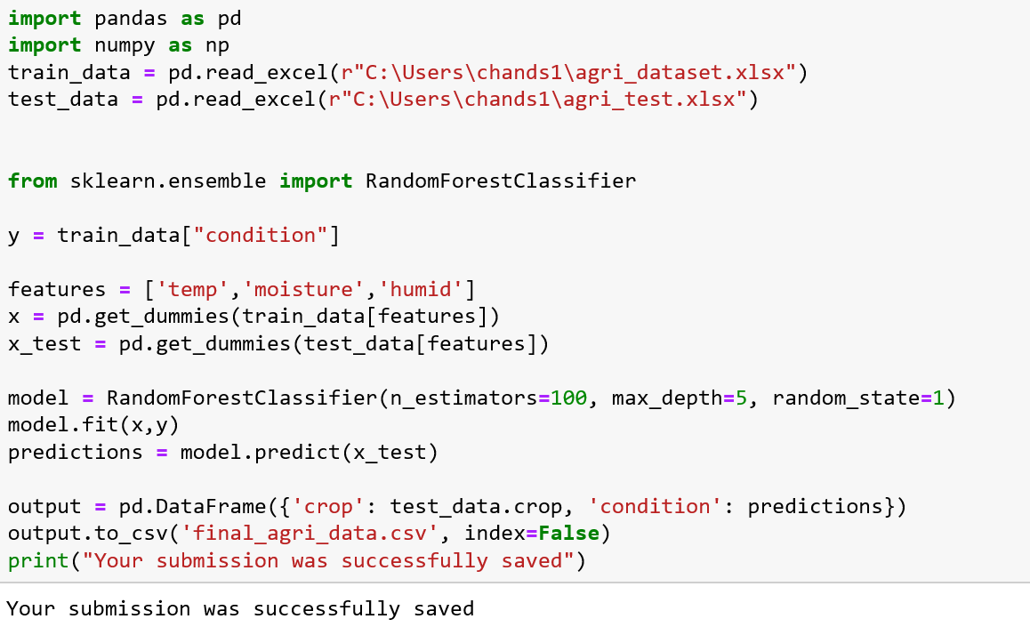

Code:

import pandas as pd

import numpy as np

train_data = pd.read_excel(r"C:\Users\chands1\agri_dataset.xlsx")

test_data = pd.read_excel(r"C:\Users\chands1\agri_test.xlsx")

from sklearn.ensemble import RandomForestClassifier

y = train_data["condition"]

features = ['temp','moisture','humid']

x = pd.get_dummies(train_data[features])

x_test = pd.get_dummies(test_data[features])

model = RandomForestClassifier(n_estimators=100, max_depth=5, random_state=1)

model.fit(x,y)

predictions = model.predict(x_test)

output = pd.DataFrame({'crop': test_data.crop, 'condition': predictions})

output.to_csv('final_agri_data.csv', index=False)

print("Your submission was successfully saved")