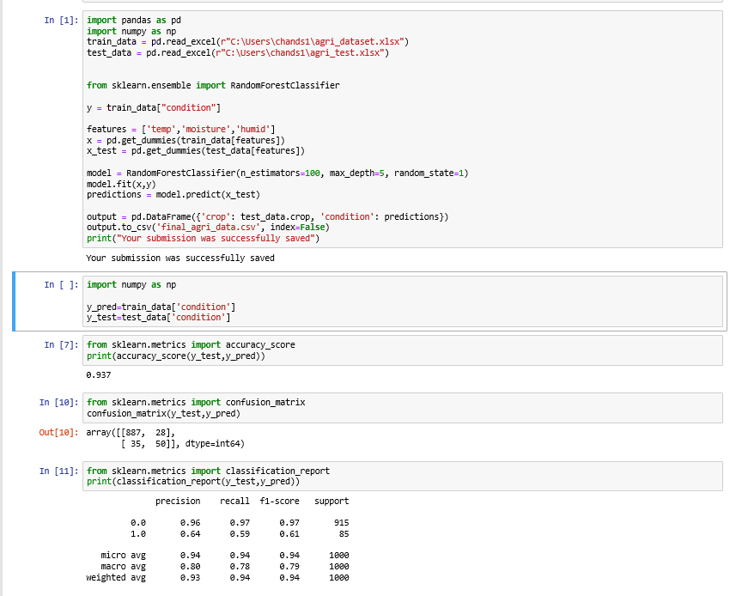

Introduction

Agriculture, as all of us know it is the occupation which is highly practiced by families of India. It requires plenty of hardwork and time for its best output. It even needs the better planning and execution in terms of growing crops in certain seasons. Minimum requirements of it are water, soil and seeds. Maximum requirement is not limited. Latest technologies have brought many drastic developments. Modernization in agriculture is optimizing the agricultural needs. Chemical fertilizers, soil quality testing are providing the essential nutrients to the soil. Pesticides, fungicides are helping crops to grow in a protective environment from many kinds of disease causing pests and fungus. This way agriculture is improved day by day.

Dependence of Indian farmers on monsoons and electricity has increased but its optimal use is not being concentrated. Farmers are required to go to fields everyday for looking up to crops. They will many times spend even in the nights . The flow of water will be more or less sometimes. In the either cases it will reduce the crops yield. For this optimal flow of water is required. As observed till now there are no such methods which will use all the aspects of environment to flow the water automatically. So our project aims at using all the aspects such as humidity, moisture, temperatures for it. We are using humidity, moisture and temperatures sensors for getting the data. By getting these data from the agricultural fields data processing and training are done. Using some standard procedures to get the final output.

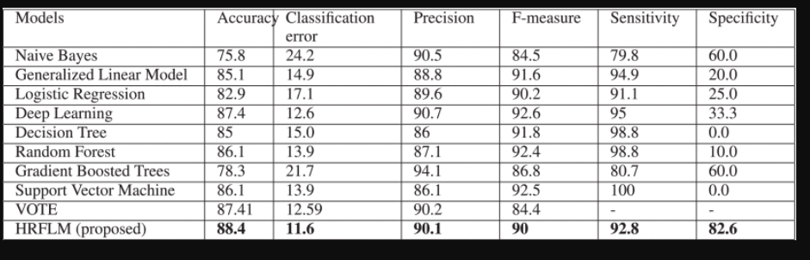

∑n0F(n)=∑n0F(0)=d+m1x1+m2x2+....+mnxnGain+∑n0wixi(14)(15)

|  |  |  |  |
| --- | --- | --- | --- |
| crop | humidity | temperature | moisture |
| potato | 800 | 800 | 800 |
| tomato | 1200 | 1000 | 987 |

|  |  |  |  |
| --- | --- | --- | --- |
| total | 2000 | 1800 | 1787 |

Architecture: Test dataset

Train datase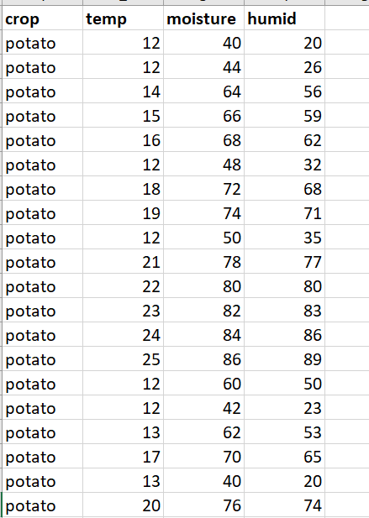 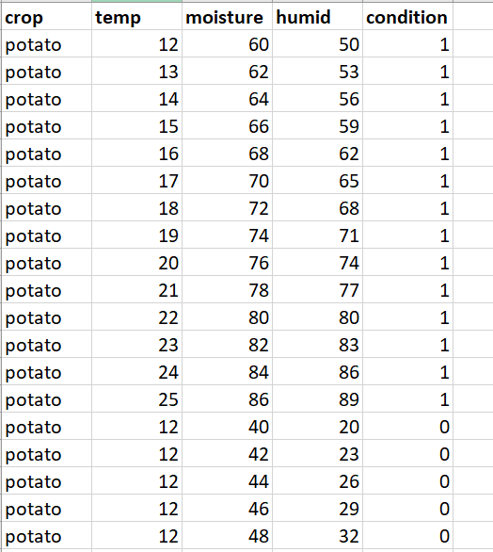

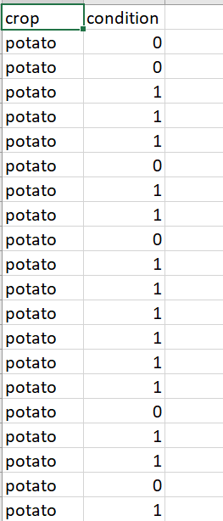

Collection of data from fields: Data from the fields are collected from temperature, humidity and moisture sensors into a exel or csv file with column headers having a crop column in it. Crop details will be stored by the program into excel and the input to the program should be given by the user.

Data pre-processing- The data which is collected should be processed, cleaned and redundancies must be removed. So the program will take the data remove the extra decimal values of sensors , delete the redundancies and place the data back into excel.

Training model: Training model will be prepared from the standard and optimal conditions for a particular plant from online resources or agricultural departments. A column is created for flag values whether the condition is optimal or not.

Testing model: The data is given to the final code which takes the data and prepares the test model which has the predicted values optimal flag values.This dataset will be used for further use.

Output: Output of the test dataset will be stored in separate csv file.

Measure accuracy model: By using the train and test dataset we will calculate accuracy matrix,classification report confusion matrix.

Methodology:

**Training model**

**Data Pre-processing**

**Collection of data from fields.**

**Testing model**

**Output**

**Measure accuracy model accuracy**