PIZZA SALES SQL QUERIES
A. KPI’s
1. TOTAL REVENUE:
SELECT SUM(total_price) AS Total_Revenue
FROM pizza_sales;
OUTPUT
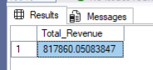
2. AVERAGE ORDER VALUE:
SELECT SUM(total_price)/ COUNT(DISTINCT order_id) AS Avg_Order_Value
FROM pizza_sales;
OUTPUT
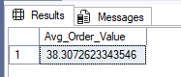
3. TOTAL PIZZA SOLD:
SELECT SUM(quantity) AS Total_Pizza_Sold
FROM pizza_sales;
OUTPUT
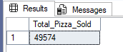
4. TOTAL ORDER:
SELECT COUNT(DISTINCT order_id) AS Total_Order
FROM pizza_sales;
OUTPUT
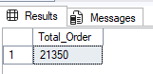
5. AVERAGE PIZZA PER ORDER:
SELECT CAST(CAST(SUM(quantity) AS DECIMAL(10,2)) /
CAST(COUNT(DISTINCT order_id) AS DECIMAL(10,2)) AS DECIMAL(10,2)) AS Avg_Pizzas_Per_Order
FROM pizza_sales;
OUTPUT
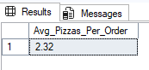

B. Daily Trend For Total Ordesr:
SELECT DATENAME(DW, order_date) AS Order_day, COUNT(DISTINCT order_id) AS Total_orders
FROM pizza_sales
GROUP BY DATENAME(DW, order_date);
OUTPUT
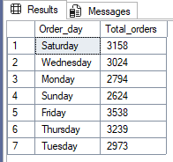

C. Hourly Trend For Total Orders:
SELECT DATEPART(HOUR, order_time) AS Order_Hour, COUNT(DISTINCT order_id) AS Total_orders
FROM pizza_sales
GROUP BY DATEPART(HOUR, order_time)
ORDER BY DATEPART(HOUR, order_time);
OUTPUT

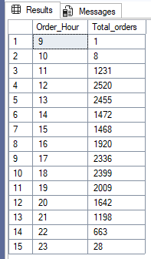

D. Percentage Of Sales By Pizza Category:
SELECT pizza_category, CAST(SUM(total_price) AS DECIMAL(10,2)) as total_revenue,
CAST(SUM(total_price) * 100 / (SELECT SUM(total_price) from pizza_sales) AS DECIMAL(10,2)) AS PCT
FROM pizza_sales
GROUP BY pizza_category;
OUTPUT
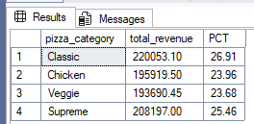

E. Percentage Of Sales By Pizza Size:
SELECT pizza_size, CAST(SUM(total_price) AS DECIMAL(10,2)) as total_revenue,
CAST(SUM(total_price) * 100 / (SELECT SUM(total_price) from pizza_sales) AS DECIMAL(10,2)) AS PCT
FROM pizza_sales
GROUP BY pizza_size
ORDER BY pizza_size;
OUTPUT
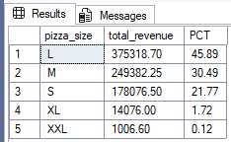

F. Total Pizza Sold By Pizza Category:
SELECT pizza_category, SUM(quantity) AS Total_Pizzas_Sold
FROM pizza_sales
GROUP BY pizza_category;
OUTPUT
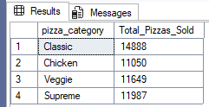

G. Top 5 Best Sellers By Total Pizzas Sold:
SELECT TOP 5 pizza_name, SUM(quantity) AS Total_Pizza_Sold
FROM pizza_sales
GROUP BY pizza_name
ORDER BY SUM(quantity) DESC;
OUTPUT
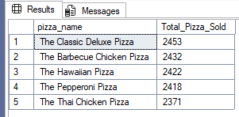

H. Bottom 5 Worst Sellers By Total Pizza Sold:
SELECT TOP 5 pizza_name, SUM(quantity) AS Total_Pizza_Sold
FROM pizza_sales
GROUP BY pizza_name
ORDER BY SUM(quantity) ASC;
OUTPUT
