ALGORITHMS ANALYSIS AND DESIGN LAB
ETCS 351

Sudha Narang
(Faculty Instructor)
Chander Jindal
06514802719
5C4



Maharaja Agrasen Institute of Technology,
PSP area, Sector – 22, Rohini, New Delhi – 110085
( Affiliated to Guru Gobind Singh Indraprastha University, New Delhi )


MAHARAJA AGRASEN INSTITUTE OF TECHNOLOGY

VISION
To nurture young minds in a learning environment of high academic value and imbibe spiritual and ethical values with technological and management competence.
MISSION
The Institute shall endeavor to incorporate the following basic missions in the teaching methodology:
Engineering Hardware – Software Symbiosis
Practical exercises in all Engineering and Management disciplines shall be carried out by Hardware equipment as well as the related software enabling deeper understanding of basic concepts and encouraging inquisitive nature.
Life – Long Learning
The Institute strives to match technological advancements and encourage students to keep updating their knowledge for enhancing their skills and inculcating their habit of continuous learning.
Liberalization and Globalization
The Institute endeavors to enhance technical and management skills of students so that they are intellectually capable and competent professionals with Industrial Aptitude to face the challenges of globalization.
Diversification
The Engineering, Technology and Management disciplines have diverse fields of studies with different attributes. The aim is to create a synergy of the above attributes by encouraging analytical thinking.
Digitization of Learning Processes
The Institute provides seamless opportunities for innovative learning in all Engineering and Management disciplines through digitization of learning processes using analysis, synthesis, simulation, graphics, tutorials and related tools to create a platform for multi-disciplinary approach.
Entrepreneurship
The Institute strives to develop potential Engineers and Managers by enhancing their skills and research capabilities so that they become successful entrepreneurs and responsible citizens.
MAHARAJA AGRASEN INSTITUTE OF TECHNOLOGY

COMPUTER SCIENCE & ENGINEERING DEPARTMENT
VISION
To Produce “Critical thinkers of Innovative Technology”
MISSION
To provide an excellent learning environment across the computer science discipline to inculcate professional behaviour, strong ethical values, innovative research capabilities and leadership abilities which enable them to become successful entrepreneurs in this globalized world.

- To nurture an excellent learning environment that helps students to enhance their problem solving skills and to prepare students to be lifelong learners by offering a solid theoretical foundation with applied computing experiences and educating them about their professional, and ethical responsibilities.
- To establish Industry-Institute Interaction, making students ready for the industrial environment and be successful in their professional lives.
- To promote research activities in the emerging areas of technology convergence.
- To build engineers who can look into technical aspects of an engineering solution thereby setting a ground for producing successful entrepreneur.

ADA LAB Course Outcomes

S.NO | Course Outcomes
ETCS351.1 | Analyze the time and space complexity of incremental algorithms.
ETCS351.2 | Analyze and use the asymptotic behavior of Divide and Conquer approach in designing algorithms
ETCS351.3 | Apply concept of Dynamic Programming and Greedy approach to develop various algorithms.
ETCS351.4 | Apply different designing strategies to solve Graph Problems.
ETCS351.5 | Understand and develop various String-Matching Algorithms

Index

S.No. | Experiment No. | Date | Remarks | Signature/ Seen On
1 | To implement following algorithm using array as a data structure and analyse its time complexity.  Merge sort  Quick sort  Bubble sort  Bucket sort  Radix sort  Shell sort  Selection sort  Heap sort | 17/09/2021
2 | To implement Linear search and Binary search and analyse its time complexity. | 24/09/2021
3 | To implement Matrix Multiplication and analyse its time complexity. | 01/10/2021
4 | To implement Longest Common Subsequence problem and analyse its time complexity. | 08/10/2021
5 | To implement Optimal Binary Search Tree problem and analyse its time complexity. | 29/10/2021
6 | To implement Huffman Coding and analyse its time complexity. | 05/11/2021
7 | To implement Dijkstra’s algorithm and analyse its time complexity. | 12/11/2021
8 | To implement Bellman Ford algorithm and analyse its time complexity. | 19/11/2021

Experiment 1
Aim: To implement following algorithm using array as a data structure and analyse its time complexity.
Merge sort
Instructions:
Conceptually, a merge sort works as follows:
- Divide the unsorted list into n subsists, each containing 1 element (a list of 1 element is considered sorted).
- Repeatedly merge subsists to produce new sorted subsists until there is only 1 subsist remaining. This will be the sorted list.

Pseudo code:
Let A be an input array in which p is its lower bound and q is its upper bound. Function MERGE-SORT is called recursively, and it also call function MERGE which merges two unsorted arrays into a single sorted array.
MERGE-SORT (A, p, r)
- If p < r
- q = [(p + q) /2]
- MERGE-SORT (A, p, q)
- MERGE-SORT (A, q+1, r)
- MERGE (A, p, q, r)
MERGE (A, p, q, r)
- n₁ = q – p +1
- n₂ = r – q
- let L [1... n₁ + 1] and L [1... n₂ + 1] be new arrays
- for i=1 to n₁
- L [i] = A [ p + i -1]
- for j=1 to n₂
- R [j] =A [ q + j]
- L [n₁ + 1]= ∞
- R [n₂ + 1]= ∞
- i = 1
- j = 1
- for k = p to r
- if L [i] < R [ j]
- A [k] = L [i]
- i = i + 1
- else A [k] = R [ j]
- j = j + 1

#Code
#include <bits/stdc++.h>

using namespace std;

#define pb push_back
#define limit 100000
typedef vector<int> VI;

void printer(VI vect){
for (int i = 0; i < vect.size(); i++)
cout << vect[i] << " ";
}

VI mergeSort(VI &vect){
if(vect.size() < 2)
return vect;
int mid = vect.size()/2;
VI R_vect , L_vect;
for(int i =0;i<mid;i++)
L_vect.pb(vect[i]);

for(int i =mid;i<vect.size();i++)
R_vect.pb(vect[i]);
L_vect = mergeSort(L_vect);
R_vect = mergeSort(R_vect);
int l = 0,r = 0,m = 0;
while (l < L_vect.size() && r < R_vect.size()){
if(L_vect[l] < R_vect[r]){
vect[m] = L_vect[l];
++l;
}else{
vect[m] = R_vect[r];
++r;
}
++m;
}
while (l < L_vect.size()){
vect[m] = L_vect[l];
++l;
++m;
}
while (r < R_vect.size()){
vect[m] = R_vect[r];
++r;
++m;
}
return vect;
}

VI rand_VI(int n){
VI vect;
vect.reserve(n);
for(int i = 0 ; i < n;i++)
vect.pb(rand()%limit);
return vect;
}

VI asc_VI(int n){
VI vect;
vect.reserve(n);
for(int i = 0 ; i < n;i++)
vect.pb(i);
return vect;
}
VI dec_VI(int n){
VI vect;
vect.reserve(n);
for(int i = n-1 ; i >= 0;i--)
vect.pb(i);
return vect;
}

int main(){
srand(time(0));
int n = rand()%limit;
if(n<10000){
n += 10000;
}
cout<<"For n = "<<n<<", in Merge Sort the time for the following arrays is:"<<endl;
VI vect = rand_VI(n);
clock_t time_taken = clock();
mergeSort(vect);
time_taken = clock() - time_taken;
cout<<"For Random array sorting : "<<(float)time_taken/CLOCKS_PER_SEC<<endl;
vect = asc_VI(n);
time_taken = clock();
mergeSort(vect);
time_taken = clock() - time_taken;
cout<<"For ascending sorted array sorting : "<<(float)time_taken/CLOCKS_PER_SEC<<endl;
vect = dec_VI(n);
time_taken = clock();
mergeSort(vect);
time_taken = clock() - time_taken;
cout<<"For descending sorted array sorting : "<<(float)time_taken/CLOCKS_PER_SEC<<endl;
return 0;
}
//This Code is made by Chander Jindal

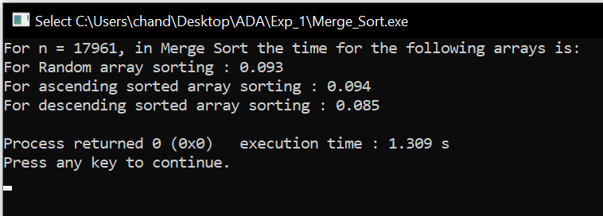

Result and Analysis:
The unordered list of elements gets sorted but additional space is used for merging.
The list of size N is divided into a max of logN parts, and the merging of all sub lists into a single list takes O(N) time. Time complexity of Merge Sort is O (nlogn) in all 3 cases (worst, average and best) as merge sort always divides the array in two halves and take linear time to merge two halves. The recurrence equation used is:T(n) = 2T(n/2) + O(n)

Quick sort

Instructions:
The basic steps in this sort are:
Divide: The array A [p… r] is partitioned (rearranged) into two nonempty sub arrays A [p... q] and A [q + 1... r] such that each element of A [p . . q] is less than or equal to each element of A [q + 1... r]. The index q is computed as part of this partitioning procedure.
Conquer: The two sub arrays A [p… q] and A [q + 1… r] are sorted by recursive calls to quick sort.
Combine: Since the sub arrays are sorted in place, no work is needed to combine them: the entire array A [p.. r] is now sorted.
Pseudo code:
The following procedure implements quick sort. It takes A as input array which has p as its lower bound and r as its upper bound.
QUICKSORT (A, p, r)
1 if p<r
2 then qPARTITION (A, p, r)
3 QUICKSORT (A, p, q)
4 QUICKSORT (A, q + 1, r)
To sort an entire array A, the initial call is QUICKSORT (A, 1, length[A]).

Partitioning the array:

The key to the algorithm is the PARTITION procedure, which rearranges the sub array A [p.. r] in place.
PARTITION (A,p,r)
1 xA[p]
2 ip - 1
3 jr + 1
4 while TRUE
5 do repeat jj - 1
6 until A[j] x
7 repeat ii + 1
8 until A[i] x
9 if i<j
10 then exchange A[i] A[j]
11 else return j
#Code
#include <bits/stdc++.h>
using namespace std;
#define pb push_back
#define limit 10000
typedef vector<int> VI;
void printer(VI vect){
for (int i = 0; i < vect.size(); i++)
cout << vect[i] << " ";
}
int partition_ (VI &vect, int low, int high){
int pivot = vect[high];
int i = (low - 1);
for (int j = low; j <= high - 1; j++){
if (vect[j] < pivot){
i++;
swap(vect[i], vect[j]);
}
}
swap(vect[i + 1], vect[high]);
return (i + 1);
}
void quickSort(VI &vect, int low, int high){
if (low < high){
int pi = partition_(vect, low, high);
quickSort(vect, low, pi - 1);
quickSort(vect, pi + 1, high);
}
return;
}
VI rand_VI(int n){
VI vect;
vect.reserve(n);
for(int i = 0 ; i < n;i++)
vect.pb(rand()%limit);
return vect;
}
VI asc_VI(int n){
VI vect;
vect.reserve(n);
for(int i = 0 ; i < n;i++)
vect.pb(i);
return vect;
}
VI dec_VI(int n){
VI vect;
vect.reserve(n);
for(int i = n-1 ; i >= 0;i--)
vect.pb(i);
return vect;
}
int main(){
srand(time(0));
int n = rand()%limit;
if(n<1000){
n += 1000;
}
cout<<"For n = "<<n<<", in Quick Sort the time for the following arrays is:"<<endl;
VI vect = rand_VI(n);
clock_t time_taken = clock();
quickSort(vect,0,n-1);
time_taken = clock() - time_taken;
cout<<"For Random array sorting : "<<(float)time_taken/CLOCKS_PER_SEC<<endl;
vect = asc_VI(n);
time_taken = clock();
quickSort(vect,0,n-1);
time_taken = clock() - time_taken;
cout<<"For ascending sorted array sorting : "<<(float)time_taken/CLOCKS_PER_SEC<<endl;
vect = dec_VI(n);
time_taken = clock();
quickSort(vect,0,n-1);
time_taken = clock() - time_taken;
cout<<"For descending sorted array sorting : "<<(float)time_taken/CLOCKS_PER_SEC<<endl;
return 0;
}
//This Code is made by Chander Jindal

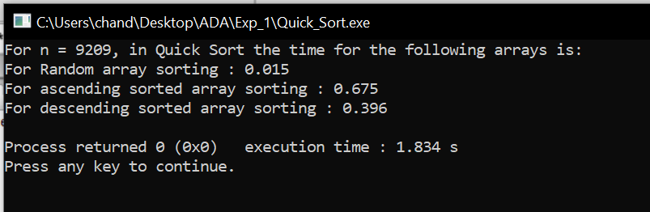
It has partitioned the array in such a way that elements less than equal to pivot comes on its left side and elements greater than pivot are on its right side. This procedure is recursively called in the subarrays.
Result and Analysis:
The running time of Quick sort depends whether Partition is balanced or not.
Best case Partitioning:
If the procedure 'Partition' produces two regions of size n/2. The recurrence relation is then
T (n) = T(n/2) + T(n/2) + (n)
= 2T(n/2) + (n)
And from case 2 of Master Theorem. T (n) = (n lg n)
Worst case Partitioning:
The worst-case occurs if given array A [1... n] is already sorted. The PARTITION (A, p, r) call always return p so successive calls to partition will split arrays of length n, n-1, n-2, . . ., 2 and running time proportional to n + (n-1) + (n-2) + . . . + 2 = [(n+2) (n-1)]/2 = (n²). The worst-case also occurs if A [1... n] starts out in reverse order.
Bubble sort
Instructions:
This sorting algorithm is comparison-based algorithm in which each pair of adjacent elements is compared, and the elements are swapped if they are not in order.

Pseudo code:
We assume list is an array of n elements. We further assume that swap function swaps the values of the given array elements.
begin BubbleSort (list)
for all elements of list
if list[i] > list[i+1]
swap (list[i], list [i+1])
end if
end for
return list
end BubbleSort

#Code
#include <bits/stdc++.h>
using namespace std;

#define pb push_back
#define limit 10000
typedef vector<int> VI;

void printer(VI vect){
for (int i = 0; i < vect.size(); i++)
cout << vect[i] << " ";
}

void bubbleSort(VI &vect){
for (int i = 0; i < vect.size()-1; i++)
for (int j = 0; j < vect.size()-i-1; j++)
if (vect[j] > vect[j+1])
swap(vect[j], vect[j+1]);
}

VI rand_VI(int n){
VI vect;
vect.reserve(n);
for(int i = 0 ; i < n;i++)
vect.pb(rand()%limit);
return vect;
}

VI asc_VI(int n){
VI vect;
vect.reserve(n);
for(int i = 0 ; i < n;i++)
vect.pb(i);
return vect;
}
VI dec_VI(int n){
VI vect;
vect.reserve(n);
for(int i = n-1 ; i >= 0;i--)
vect.pb(i);
return vect;
}
int main(){
srand(time(0));
int n = rand()%limit;
if(n<1000){
n += 1000;
}
cout<<"For n = "<<n<<", in Bubble Sort the time for the following arrays is:"<<endl;
VI vect = rand_VI(n);
clock_t time_taken = clock();
bubbleSort(vect);
time_taken = clock() - time_taken;
cout<<"For Random array sorting : "<<(float)time_taken/CLOCKS_PER_SEC<<endl;
vect = asc_VI(n);
time_taken = clock();
bubbleSort(vect);
time_taken = clock() - time_taken;
cout<<"For ascending sorted array sorting : "<<(float)time_taken/CLOCKS_PER_SEC<<endl;
vect = dec_VI(n);
time_taken = clock();
bubbleSort(vect);
time_taken = clock() - time_taken;
cout<<"For descending sorted array sorting : "<<(float)time_taken/CLOCKS_PER_SEC<<endl;
return 0;
}
//This Code is made by Chander Jindal
Sample Example:
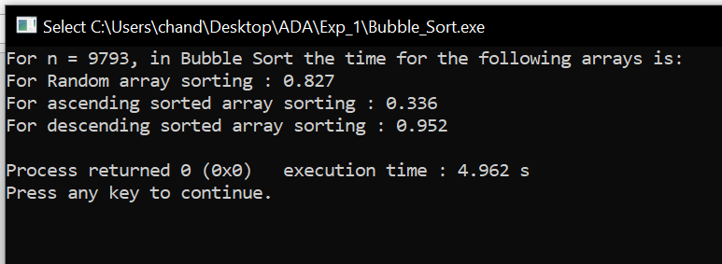

Result and Analysis:
Worst and Average Case Time Complexity: O (n*n). Worst case occurs when array is reverse sorted and its time complexity is O (n*n) and Best case occurs when array is already sorted and its time complexity is O (n) (linear time). This sort takes just O (1) extra space.

Bucket sort
Instructions:
Bucket sort, or bin sort, is a sorting algorithm that works by distributing the elements of an array into a number of buckets. Each bucket is then sorted individually, either using a different sorting algorithm, or by recursively applying the bucket sorting algorithm. It is a distribution sort, a generalization of pigeonhole sort, and is a cousin of radix sort in the most-to-least significant digit flavour. Bucket sort can be implemented with comparisons and therefore can also be considered a comparison sort algorithm.
It works as follows:
- Set up an array of initially empty "buckets".
- Scatter: Go over the original array, putting each object in its bucket.
- Sort each non-empty bucket.
- Gather: Visit the buckets in order and put all elements back into the original array.
Pseudo code:
The code assumes that input is an n-element array A and each element in A satisfies 0 ≤ A[i] ≤ 1. We also need an auxiliary array B [0 . . n -1] for linked-lists (buckets).
BUCKET SORT (A)
1. n ← length [A]
2. For i =1 to n do
3. Insert A[i]into list B [A[i]/b] where b is the bucket size
4. For i =0 to n-1do
5. Sort list B with Insertion sort
6. Concatenate the lists B [0], B [1] ... B [n-1] together in order.

#Code
#include <bits/stdc++.h>

using namespace std;

#define pb push_back
#define limit1 100000
#define limit2 1000000

typedef vector<int> VI;

void printer(VI vect){
for (int i = 0; i < vect.size(); i++)
cout << vect[i] << " ";
}

void bucketSort(VI &vect){
int max_val = *max_element(vect.begin(), vect.end());
int bucket[max_val+1];
memset(bucket,0,sizeof(bucket));
for(int i = 0; i < vect.size(); i++)
bucket[vect[i]]++;
for(int i = 0, j = 0; i <= max_val; i++){
while (bucket[i] > 0){
vect[j++] = i;
bucket[i]--;
}
}
return;
}

VI rand_VI(int n){
VI vect;
vect.reserve(n);
for(int i = 0 ; i < n;i++)
vect.pb(rand()%limit2);
return vect;
}

VI asc_VI(int n){
VI vect;
vect.reserve(n);
for(int i = 0 ; i < n;i++)
vect.pb(i);
return vect;
}
VI dec_VI(int n){
VI vect;
vect.reserve(n);
for(int i = n-1 ; i >= 0;i--)
vect.pb(i);
return vect;
}

int main(){
srand(time(0));
int n = rand()%limit2;
if(n<limit1){
n += limit1;
}
cout<<"For n = "<<n<<", in Bucket Sort the time for the following arrays is:"<<endl;
VI vect = rand_VI(n);
clock_t time_taken = clock();
bucketSort(vect);
time_taken = clock() - time_taken;
cout<<"For Random array sorting : "<<(float)time_taken/CLOCKS_PER_SEC<<endl;
vect = asc_VI(n);
time_taken = clock();
bucketSort(vect);
time_taken = clock() - time_taken;
cout<<"For ascending sorted array sorting : "<<(float)time_taken/CLOCKS_PER_SEC<<endl;
vect = dec_VI(n);
time_taken = clock();
bucketSort(vect);
time_taken = clock() - time_taken;
cout<<"For descending sorted array sorting : "<<(float)time_taken/CLOCKS_PER_SEC<<endl;
return 0;
}
//This Code is made by Chander Jindal

Sample Example:
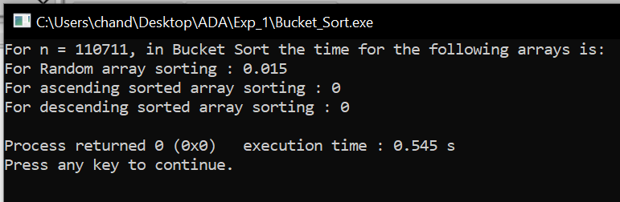

Result and Analysis:
In the above Bucket sort algorithm, we observe in the best case, the algorithm distributes the elements uniformly between buckets, a few elements are placed on each bucket and sorting the buckets is O (1). Rearranging the elements is one more run through the initial list.
T (n) = [time to insert n elements in array A] + [time to go through auxiliary array B [0 . . . n-1] * (Sort by INSERTION_SORT)
= O (n) + (n-1) (n)
= O (n)
In the worst case, the elements are sent all to the same bucket, making the process take O (n^2).

Radix sort
Instructions:
Radix Sort is a non-comparative sorting algorithm. It is one of the most efficient and fastest linear sorting algorithms. In radix sort, we first sort the elements based on last digit (least significant digit). Then the result is again sorted by second digit, continue this process for all digits until we reach most significant digit. We use counting sort to sort elements of every digit.
Let A be an array and d be number of digits.
Pseudo code:

Radix-Sort(A, d)
//It works same as counting sort for d number of passes.
//Each key in A [1...n] is a d-digit integer.
// (Digits are numbered 1 to d from right to left.)
for j = 1 to d do
//A[]-- Initial Array to Sort
intcount[10] = {0};
//Store the count of "keys" in count[]
//key- it is number at digit place j
for i = 0 to n do
count[key of(A[i]) in pass j]++

fork = 1 to 10 do
count[k] = count[k] + count[k-1]

//Build the resulting array by checking
//new position of A[i] from count[k]
for i = n-1 down to 0 do
result[ count[key of(A[i])] ] = A[j]
count[key of(A[i])]--

//Now main array A[] contains sorted numbers
//according to current digit place
for i=0 to n do
A[i] = result[i]

end for(j)
end func

#Code
#include <bits/stdc++.h>

using namespace std;

#define pb push_back
#define limit 100000000 // 1e8

typedef vector<int> VI;

void printer(VI vect){
for (int i = 0; i < vect.size(); i++)
cout << vect[i] << " ";
}

VI countSort(VI vect2, int exp){
VI vect;
vect.reserve(vect2.size());
int count[10];
memset(count,0,sizeof(count));

for (int i = 0; i < vect2.size(); i++)
count[(vect2[i] / exp) % 10]++;

for (int i = 1; i < 10; i++)
count[i] += count[i - 1];

for (int i = vect2.size() - 1; i >= 0; i--) {
vect[count[(vect2[i] / exp) % 10] - 1] = vect2[i];
count[(vect2[i] / exp) % 10]--;
}
return vect;

}

void radixsort(VI &vect){
int m = *max_element(vect.begin(),vect.end());

for (int exp = 1; m / exp > 0; exp *= 10)
vect = countSort(vect, exp);
}

VI rand_VI(int n){
VI vect;
vect.reserve(n);
for(int i = 0 ; i < n;i++)
vect.pb(rand()%limit);
return vect;
}

VI asc_VI(int n){
VI vect;
vect.reserve(n);
for(int i = 0 ; i < n;i++)
vect.pb(i);
return vect;
}
VI dec_VI(int n){
VI vect;
vect.reserve(n);
for(int i = n-1 ; i >= 0;i--)
vect.pb(i);
return vect;
}

int main(){
srand(time(0));
int n = rand()%limit;
if(n<10000000){ // 1e7
n += 10000000;
}
cout<<"For n = "<<n<<", in Radix Sort the time for the following arrays is:"<<endl;
VI vect = rand_VI(n);
clock_t time_taken = clock();
radixsort(vect);
time_taken = clock() - time_taken;
cout<<"For Random array sorting : "<<(float)time_taken/CLOCKS_PER_SEC<<endl;
vect = asc_VI(n);
time_taken = clock();
radixsort(vect);
time_taken = clock() - time_taken;
cout<<"For ascending sorted array sorting : "<<(float)time_taken/CLOCKS_PER_SEC<<endl;
vect = dec_VI(n);
time_taken = clock();
radixsort(vect);
time_taken = clock() - time_taken;
cout<<"For descending sorted array sorting : "<<(float)time_taken/CLOCKS_PER_SEC<<endl;
return 0;
}
//This Code is made by Chander Jindal

Sample Example:
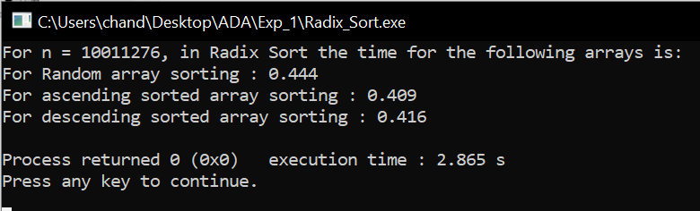

Result and Analysis:
In this algorithm running time depends on intermediate sorting algorithm which is counting sort. If the range of digits is from 1 to k, then counting sort time complexity is O (n+k). There are d passes i.e. counting sort is called d time, so total time complexity is O (nd+nk) =O (nd). As k=O (n) and d is constant, so radix sort runs in linear time. It performs the same way for best case as well

Shell sort
Instructions:
It is a generalized version of insertion sort. It is an in–place comparison sort. It is also known as diminishing increment sort; it is one of the oldest sorting algorithms invented by Donald L. Shell (1959.)This algorithm uses insertion sort on the large interval of elements to sort. Then the interval of sorting keeps on decreasing in a sequence until the interval reaches 1. These intervals are known as gap sequence.
Increment Sequences:

Shell’s original sequence: N/2 , N/4 , …, 1 (repeatedly divide by 2);
Hibbard’s increments: 1, 3, 7, …, 2^{k} – 1 ;
Knuth’s increments: 1, 4, 13, …, (3^{k} – 1) / 2 ;
Sedge wick’s increments: 1, 5, 19, 41, 109…

Here interval is calculated based on Knuth's formula as −
Knuth's Formula
h = h * 3 + 1, where ->h is interval with initial value 1

Pseudo code:
Procedure shellSort ()
A: array of items
/* calculate interval*/
while interval < A. length /3 do:
interval = interval * 3 + 1
end while

while interval > 0 do:
for outer = interval; outer < A. length; outer ++ do:
/* select value to be inserted */
ValueToInsert = A[outer]
inner = outer;
/*shift element towards right*/
while inner > interval -1 &&A [inner - interval] >= valueToInsert do:
A[inner] = A [inner - interval]
inner = inner - interval
end while
/* insert the number at hole position */
A[inner] = valueToInsert
end for
/* calculate interval*/
interval = (interval -1) /3;
end while
end procedure

#Code
#include <bits/stdc++.h>

using namespace std;

#define pb push_back
#define limit 100000000 // 1e8

typedef vector<int> VI;

void printer(VI vect){
for (int i = 0; i < vect.size(); i++)
cout << vect[i] << " ";
}

void shellSort(VI &vect) {
for (int interval = vect.size() / 2; interval > 0; interval /= 2) {
for (int i = interval; i < vect.size(); i += 1) {
int temp = vect[i];
int j;
for (j = i; j >= interval && vect[j - interval] > temp; j -= interval) {
vect[j] = vect[j - interval];
}
vect[j] = temp;
}
}
}

VI rand_VI(int n){
VI vect;
vect.reserve(n);
for(int i = 0 ; i < n;i++)
vect.pb(rand()%limit);
return vect;
}

VI asc_VI(int n){
VI vect;
vect.reserve(n);
for(int i = 0 ; i < n;i++)
vect.pb(i);
return vect;
}
VI dec_VI(int n){
VI vect;
vect.reserve(n);
for(int i = n-1 ; i >= 0;i--)
vect.pb(i);
return vect;
}

int main(){
srand(time(0));
int n = rand()%limit;
if(n<10000000){ // 1e7
n += 10000000;
}
cout<<"For n = "<<n<<", in Shell Sort the time for the following arrays is:"<<endl;
VI vect = rand_VI(n);
clock_t time_taken = clock();
shellSort(vect);
time_taken = clock() - time_taken;
cout<<"For Random array sorting : "<<(float)time_taken/CLOCKS_PER_SEC<<endl;
vect = asc_VI(n);
time_taken = clock();
shellSort(vect);
time_taken = clock() - time_taken;
cout<<"For ascending sorted array sorting : "<<(float)time_taken/CLOCKS_PER_SEC<<endl;
vect = dec_VI(n);
time_taken = clock();
shellSort(vect);
time_taken = clock() - time_taken;
cout<<"For descending sorted array sorting : "<<(float)time_taken/CLOCKS_PER_SEC<<endl;
return 0;
}
//This Code is made by Chander Jindal

Sample Example:

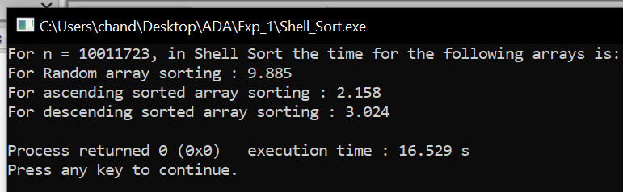

Result and Analysis:

Since in this algorithm insertion sort is applied in the large interval of elements and then interval reduces in a sequence, therefore the running time of Shell sort is heavily dependent on the gap sequence it uses. So in worst case time complexity is O (n²) and in Average Case time complexity depends on gap sequence while in Best Case Time complexity is O(n*log n).

Selection sort
Instructions:
Selection sort is a simple sorting algorithm. This sorting algorithm is an in-place comparison-based algorithm in which the list is divided into two parts, the sorted part at the left end and the unsorted part at the right end. Initially, the sorted part is empty and the unsorted part is the entire list. The smallest element is selected from the unsorted array and swapped with the leftmost element, and that element becomes a part of the sorted array. This process continues moving unsorted array boundary by one element to the right.
Pseudo code:
Procedure selection sort
list: array of items
n: size of list
for i = 1 to n - 1
/* set current element as minimum*/
min = i
/* check the element to be minimum */
for j = i+1 to n
if list[j] < list [min] then
min = j;
end if
end for
/* swap the minimum element with the current element*/
if indexMin != i then
swap list[min] and list[i]
end if
end for
end procedure:

#Code
#include <bits/stdc++.h>
using namespace std;
#define pb push_back
#define limit 10000
typedef vector<int> VI;
void printer(VI vect){
for (int i = 0; i < vect.size(); i++)
cout << vect[i] << " ";}
void selectionSort(VI &vect){
int min_idx;
for (int i = 0; i < vect.size()-1; i++){
min_idx = i;
for (int j = i+1; j < vect.size(); j++)
if (vect[j] < vect[min_idx])
min_idx = j;
swap(vect[min_idx], vect[i]);}
return;}
VI rand_VI(int n){
VI vect;
vect.reserve(n);
for(int i = 0 ; i < n;i++)
vect.pb(rand()%limit);
return vect;
}
VI asc_VI(int n){
VI vect;
vect.reserve(n);
for(int i = 0 ; i < n;i++)
vect.pb(i);
return vect;
}
VI dec_VI(int n){
VI vect;
vect.reserve(n);
for(int i = n-1 ; i >= 0;i--)
vect.pb(i);
return vect;
}
int main(){
srand(time(0));
int n = rand()%limit;
if(n<1000){
n += 1000;
}
cout<<"For n = "<<n<<", in Selection Sort the time for the following arrays is:"<<endl;
VI vect = rand_VI(n);
clock_t time_taken = clock();
selectionSort(vect);
time_taken = clock() - time_taken;
cout<<"For Random array sorting : "<<(float)time_taken/CLOCKS_PER_SEC<<endl;
vect = asc_VI(n);
time_taken = clock();
selectionSort(vect);
time_taken = clock() - time_taken;
cout<<"For ascending sorted array sorting : "<<(float)time_taken/CLOCKS_PER_SEC<<endl;
vect = dec_VI(n);
time_taken = clock();
selectionSort(vect);
time_taken = clock() - time_taken;
cout<<"For descending sorted array sorting : "<<(float)time_taken/CLOCKS_PER_SEC<<endl;
return 0;
}
//This Code is made by Chander Jindal
Sample Example:
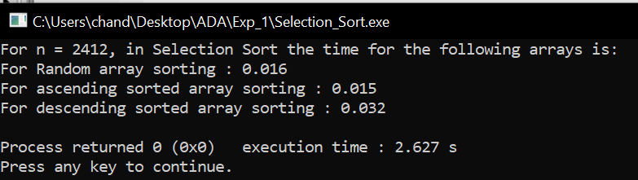

Result and Analysis:

To find the minimum element from the array of N elements, N−1 comparisons are required. After putting the minimum element in its proper position, the size of an unsorted array reduces to N−1 and then N−2 comparisons are required to find the minimum in the unsorted array. Therefore (N−1) + (N−2) + ....... + 1 = (N (N−1))/2 comparisons and N swaps result in the overall complexity of O (N2).
Heap sort
Instructions:
This algorithm is divided into two basic parts:
- Creating a Heap of the unsorted list.
- Then a sorted array is created by repeatedly removing the largest/smallest element from the heap, and inserting it into the array. The heap is reconstructed after each removal.

What is a heap?

Heap is a special tree-based data structure, which satisfies the following special heap properties:

Shape Property: Heap data structure is always a Complete Binary Tree, which means all levels of the tree are fully filled.

Heap Property: All nodes are either [greater than or equal to] or [less than or equal to] each of its children. If the parent nodes are greater than their children, heap is called a Max-Heap, and if the parent nodes are smaller than their child nodes, heap is called Min-Heap.

Initially on receiving an unsorted list, the first step in heap sort is to create a Heap data structure (Max-Heap or Min-Heap). Once heap is built, the first element of the Heap is either largest or smallest (depending upon Max-Heap or Min-Heap), so we put the first element of the heap in our array. Then we again make heap using the remaining elements, to again pick the first element of the heap and put it into the array. We keep on doing the same repeatedly until we have the complete sorted list in our array.
Pseudo code:
Heapsort (A) {
BuildHeap(A)
for i <- length (A) downto 2 {
exchange A [1] <-> A[i]
heapsize <- heapsize -1
Heapify(A, 1)
}

BuildHeap (A) {
heapsize <- length (A)
for i <- floor (length/2) downto 1
Heapify (A, i)
}

Heapify (A, i) {
le <- left (i)
ri <- right(i)
if (le<=heapsize) and (A[le]>A[i])
largest <- le
else
largest <- i
if (ri<=heapsize) and (A[ri]>A[largest])
largest <- ri
if (largest != i) {
exchange A[i] <-> A[largest]
Heapify(A, largest)
}
}

#Code
#include <bits/stdc++.h>
using namespace std;
#define pb push_back
#define limit 10000
typedef vector<int> VI;

void printer(VI vect){
for (int i = 0; i < vect.size(); i++)
cout << vect[i] << " ";
}

void heapify(VI vect, int n, int i){
int largest = i;
int l = 2 * i + 1;
int r = 2 * i + 2;

if (l < n && vect[l] > vect[largest])
largest = l;

if (r < n && vect[r] > vect[largest])
largest = r;

if (largest != i) {
swap(vect[i], vect[largest]);

heapify(vect, n, largest);
}
}

void heapSort(VI &vect, int n){
for (int i = n / 2 - 1; i >= 0; i--)
heapify(vect, n, i);

for (int i = n - 1; i > 0; i--) {
swap(vect[0], vect[i]);
heapify(vect, i, 0);
}
}

VI rand_VI(int n){
VI vect;
vect.reserve(n);
for(int i = 0 ; i < n;i++)
vect.pb(rand()%limit);
return vect;
}

VI asc_VI(int n){
VI vect;
vect.reserve(n);
for(int i = 0 ; i < n;i++)
vect.pb(i);
return vect;
}
VI dec_VI(int n){
VI vect;
vect.reserve(n);
for(int i = n-1 ; i >= 0;i--)
vect.pb(i);
return vect;
}

int main(){
srand(time(0));
int n = rand()%limit;
if(n<1000){
n += 1000;
}
cout<<"For n = "<<n<<", in Heap Sort the time for the following arrays is:"<<endl;
VI vect = rand_VI(n);
clock_t time_taken = clock();
heapSort(vect,vect.size());
time_taken = clock() - time_taken;
cout<<"For Random array sorting : "<<(float)time_taken/CLOCKS_PER_SEC<<endl;
vect = asc_VI(n);
time_taken = clock();
heapSort(vect,vect.size());
time_taken = clock() - time_taken;
cout<<"For ascending sorted array sorting : "<<(float)time_taken/CLOCKS_PER_SEC<<endl;
vect = dec_VI(n);
time_taken = clock();
heapSort(vect,vect.size());
time_taken = clock() - time_taken;
cout<<"For descending sorted array sorting : "<<(float)time_taken/CLOCKS_PER_SEC<<endl;
return 0;
}
//This Code is made by Chander Jindal

Sample Example:
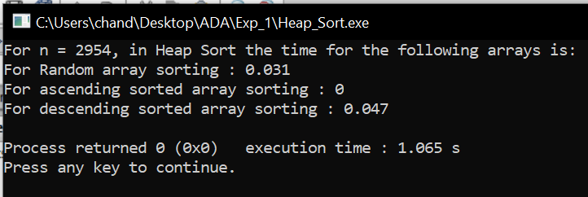

Result and Analysis:
Heap sort has the best possible worst case running time complexity of O (n Log n).It doesn't need any extra storage and that makes it good for situations where array size is large. Heapify runs in time O (h) and there are at most n=2^{h+1}-1 nodes in an almost complete binary tree of height h, so Heapify runs in time O (ln n). Build-Heap calls Heapify n/2 times, so it takes O (n h) = O (n ln n).
Experiment 2
Aim: To implement Linear search and Binary search and analyse its time complexity.
Instructions:
The search operation can be done in the following two ways:
Linear search:
It’s a sequential search is made over all items one by one. Every item is checked and if a match is found then that particular item is returned, otherwise the search continues till the end of the data collection.
Binary search:
This search algorithm works on the principle of divide and conquers. For this algorithm, the data collection should be in the sorted form. Binary search looks for a particular item by comparing the middle most item of the collection. If a match occurs, then the index of item is returned. If the middle item is greater than the item, then the item is searched in the sub-array to the left of the middle item. Otherwise, the item is searched for in the sub-array to the right of the middle item. This process continues on the sub-array as well until the size of the sub array reduces to zero.

Pseudo code for linear search:
Procedure linear_search (list, value)
for each item in the list
if match item == value
return the item's location
end if
end for
end procedure

Pseudo code for Binary search:
BinarySearch (A [0...N-1], value)
{
low = 0
high = N - 1
while (low <= high) {
// invariants: value > A[i] for all i < low
value < A[i] for all i > high
mid = (low + high) / 2
if (A[mid] > value)
high = mid - 1
else if (A[mid] < value)
low = mid + 1
else
return mid
}
return not_found // value would be inserted at index "low"
}

#Code
#include <bits/stdc++.h>
using namespace std;
#define pb push_back
#define limit1 10000000
#define limit2 100000000
typedef vector<int> VI;
int Linear_search(VI vect, int item){
for(int i = 0; i < vect.size(); i++)
if (vect[i] == item)
return i;
return -1;}
int Binary_search(VI vect, int l, int r, int item){
if (r >= l) {
int mid = l + (r - l) / 2;
if (vect[mid] == item)
return mid;
if (vect[mid] > item)
return Binary_search(vect, l, mid - 1, item);
return Binary_search(vect, mid + 1, r, item);}}
VI make_vector(int n){
VI vect;
vect.reserve(n);
for(int i = 0 ; i < n;i++)
vect.pb(rand()%limit2);
return vect;}
int main(){
srand(time(0));
int n = rand()%limit2;
if(n<limit1)
n += limit1;
VI vect = make_vector(n);
cout<<"For n = "<<n<<", for Linear Search, time taken:"<<endl;
clock_t time_taken = clock();
Linear_search(vect,vect[0]);
time_taken = clock() - time_taken;
cout<<"For First element in array : "<<(float)time_taken/CLOCKS_PER_SEC<<endl;
time_taken = clock();
Linear_search(vect,vect[n/2]);
time_taken = clock() - time_taken;
cout<<"For Middle element in array : "<<(float)time_taken/CLOCKS_PER_SEC<<endl;
time_taken = clock();
Linear_search(vect,vect[n-1]);
time_taken = clock() - time_taken;
cout<<"For Last element in array : "<<(float)time_taken/CLOCKS_PER_SEC<<endl;
time_taken = clock();
Linear_search(vect,limit2);
time_taken = clock() - time_taken;
cout<<"For Non-existing element in array : "<<(float)time_taken/CLOCKS_PER_SEC<<endl;
cout<<"\n\n"<<endl;
cout<<"For n = "<<n<<", for Binary Search, time taken:"<<endl;
time_taken = clock();
Binary_search(vect,0,n-1,vect[0]);
time_taken = clock() - time_taken;
cout<<"For First element in array : "<<(float)time_taken/CLOCKS_PER_SEC<<endl;
time_taken = clock();
Binary_search(vect,0,n-1,vect[n/2]);
time_taken = clock() - time_taken;
cout<<"For Middle element in array : "<<(float)time_taken/CLOCKS_PER_SEC<<endl;
time_taken = clock();
Binary_search(vect,0,n-1,vect[n-1]);
time_taken = clock() - time_taken;
cout<<"For Last element in array : "<<(float)time_taken/CLOCKS_PER_SEC<<endl;
time_taken = clock();
Binary_search(vect,0,n-1,limit2);
time_taken = clock() - time_taken;
cout<<"For Non-existing element in array : "<<(float)time_taken/CLOCKS_PER_SEC<<endl;
return 0;}
//This Code is made by Chander Jindal
Sample Example:
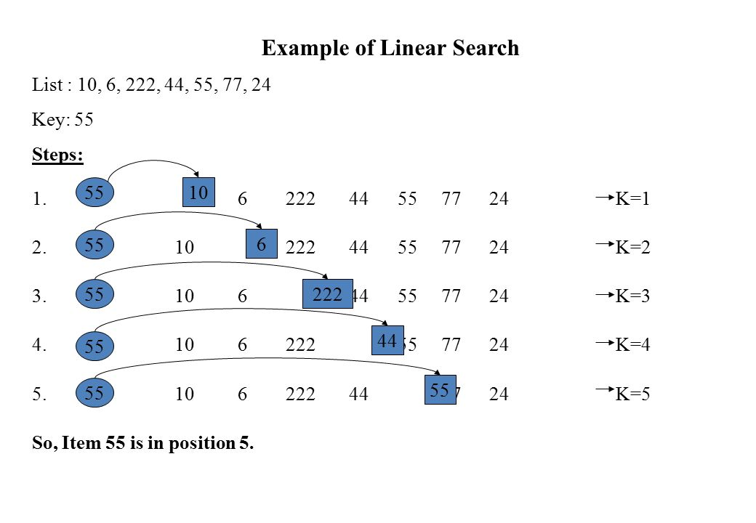
Example of Binary Search:
A sorted array is taken as input. The mid value is found out recursively.
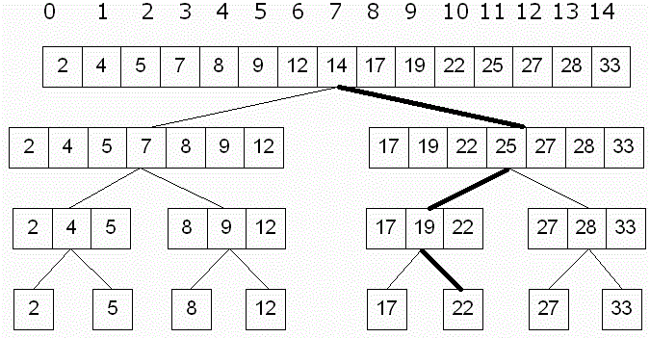
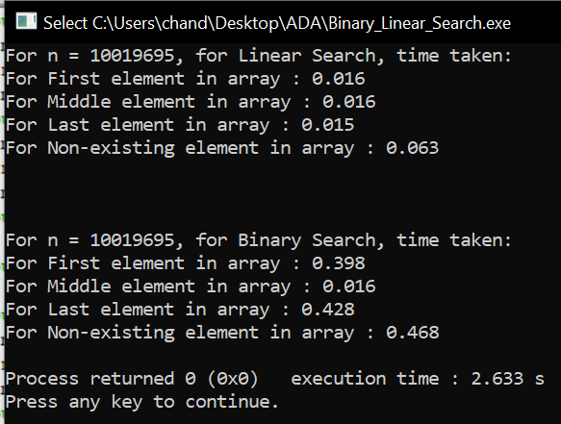

Result and Analysis:
Input data needs to be sorted in Binary Search and not in Linear Search and it does the sequential access whereas Binary search access data randomly. So, time complexity of linear search is O (n) while Binary search has time complexity O (log n) as search is done to either half of the given list.

Experiment 3
Aim: To implement Matrix chain Multiplication and analyse its time complexity.
Problem: Given a sequence of matrices A1, A2… An, insert parentheses so that the product of the matrices, in order, is unambiguous and needs the minimal number of multiplication

Matrix multiplication is associative: A1 (A2A3) = (A1A2) A3

A product is unambiguous if no factor is multiplied on both the left and the right and all factors are either a single matrix or an unambiguous product.
Multiplying an i×j and a j×k matrix requires ijk multiplications. Each element of the product requires j multiplications, and there are ik elements

Number of Parenthesizations
Given the matrices A1,A2,A3, A4. Assume the dimensions of A1=d0×d1, etc. Below are the five possible parenthesizations of these arrays, along with the number of multiplications:
    - (A1A2)(A3A4):d0d1d2+d2d3d4+d0d2d4
    - ((A1A2)A3)A4:d0d1d2+d0d2d3+d0d3d4
    - (A1(A2A3))A4:d1d2d3+d0d1d3+d0d3d4
    - A1((A2A3)A4):d1d2d3+d1d3d4+d0d1d4
    - A1(A2(A3A4)):d2d3d4+d1d2d4+d0d1d4
The number of parenthesizations is at least T(n)≥T(n−1)+T(n−1).Since the number with the first element removed is T(n−1), which is also the number with the last removed. Thus the number of parenthesizations is Ω(2n). The number is actually T (n)=n−1∑k=1T(k)T(n−k) which is related to the Catalan numbers.This is because the original product can be split into 2 sub products in k places. Each split is to be parenthesized optimally.This recurrence is related to the Catalan numbers.

Characterizing the Optimal Parenthesization
An optimal parenthesization of A1…An must break the product into two expressions, each of which is parenthesized or is a single array. Assume the break occurs at position k. In the optimal solution, the solution to the product A1…Ak must be optimal otherwise, we could improve A1…An by improving A1…Ak but the solution to A1…An is known to be optimal.This is a contradiction.Thus the solution to A1…An is known to be optimal.

Principle of Optimality
This problem exhibits the Principle of Optimality. The optimal solution to product A1…An contains the optimal solution to two sub products. Thus we can use Dynamic Programming. Consider a recursive solution
Then improve its performance with memoization or by rewriting bottom up

Matrix Dimensions
Consider matrix product A1×⋯×An. Let the dimensions of matrix Ai be di−1×di.
Thus the dimensions of matrix product Ai×⋯×Aj are di−1×dj.

Recursive Solution
Let M [i,j] represent the number of multiplications required for matrix product Ai×⋯×Aj. For 1≤i≤j<n : M [i,i]=0 since no product is required

The optimal solution of Ai×Aj must break at some point, k, with i≤k<j
Thus, M [i,j]=M[i,k] + M[k+1,j] + di−1dkdj

Thus, M[i,j]={0 if i=j and min i≤k<j{M[i,k]+M[k+1,j]+di−1dkdj}if i<j

Pseudo code:
// Matrix Ai has dimension p[i-1] x p[i] for i = 1..n

MATRIX-CHAIN-ORDER (p)
n←length [p]-1
for i←1 to n
do m[i,i]←0
for l←2to n
do for i←1 to n-l+1
do j←i+l-1
m[i,j]←∞
for k←ito j-1
do q←m[i,k] + m[k+1,j]+p_{i-1}p_{k}p_{j}
if q< m[i,j]
then m[i,j] ←q
s[i,j] ←k
return m and s

PRINT-OPTIMAL-PARENS (s, i, j)
if i=j
then print “A_{i}”
else print “ ( “
PRINT-OPTIMAL-PARENS (s, i, s[i,j])
PRINT-OPTIMAL-PARENS (s, s[i,j]+1, j)
print “ ) ”

#Code
(Matrix Chain Multiplication)
#include <bits/stdc++.h>
using namespace std;
#define limit1 10
#define limit2 100
#define pb push_back
typedef vector<int> VI;
int dp[limit1][limit1];
int Matrix_Chain_Multiplication(VI vect, int i, int j){
if (i == j)
return 0;
if (dp[i][j] != -1)
return dp[i][j];
dp[i][j] = INT_MAX;
for (int k = i; k < j; k++){
dp[i][j] = min(dp[i][j],
Matrix_Chain_Multiplication(vect, i, k)+ Matrix_Chain_Multiplication(vect, k + 1, j)+ vect[i - 1] * vect[k] * vect[j]);
}
return dp[i][j];
}
VI make_vector(int n){
VI vect;
vect.reserve(n);
for(int i = 0 ; i < n;i++)
vect.pb(rand()%limit2);
return vect;
}
void print_vector(VI vect){
for(int i =0;i<vect.size();i++)
cout<<vect[i]<<" ";
cout<<endl;
return;
}
int main(){
srand(time(0));
int n = rand()%limit1;
VI vect = make_vector(n);
memset(dp, -1, sizeof dp);
cout<<"For size of Matrices as follows:\n";
print_vector(vect);
cout << "Minimum number of multiplications required is "<< Matrix_Chain_Multiplication(vect,1, n-1);
}
//This Code is made by Chander Jindal
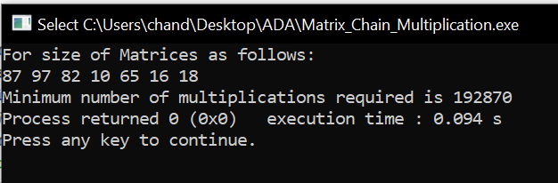

#Code
(Matrix Chain Order Parenthesis)
#include <bits/stdc++.h>
#define limit1 10
#define limit2 100
#define pb push_back
using namespace std;
typedef vector<int> VI;
void printParenthesis(int i, int j, int n, int* bracket,char& name){
if (i == j) {
cout<<name++;
return;
}
cout<<"(";
printParenthesis(i, *((bracket + i * n) + j), n,bracket, name);
printParenthesis(*((bracket + i * n) + j) + 1, j, n,bracket, name);
cout<<")";
}
void matrixChainOrder(VI vect){
int m[vect.size()][vect.size()];
int bracket[vect.size()][vect.size()];
for (int i = 1; i < vect.size(); i++)
m[i][i] = 0;
for (int L = 2; L < vect.size(); L++){
for (int i = 1; i < vect.size() - L + 1; i++){
int j = i + L - 1;
m[i][j] = INT_MAX;
for (int k = i; k <= j - 1; k++){
int q = m[i][k] + m[k + 1][j]+ vect[i - 1] * vect[k] * vect[j];
if (q < m[i][j]){
m[i][j] = q;
bracket[i][j] = k;
}
}
}
}
char name = 'A';
cout<<"Optimal Parenthesization is : ";
printParenthesis(1, vect.size() - 1, vect.size(), (int*)bracket, name);
cout<<"\nOptimal Cost is : " << m[1][vect.size() - 1]<<endl;
}
VI make_vector(int n){
VI vect;
vect.reserve(n);
for(int i = 0 ; i < n;i++)
vect.pb(rand()%limit2);
return vect;
}
void print_vector(VI vect){
for(int i =0;i<vect.size();i++)
cout<<vect[i]<<" ";
cout<<endl;
return;
}
int main(){
srand(time(0));
int n = rand()%limit1;
VI vect = make_vector(n);
cout<<"For size of Matrices as follows:\n";
print_vector(vect);
matrixChainOrder(vect);
}
//This Code is made by Chander Jindal
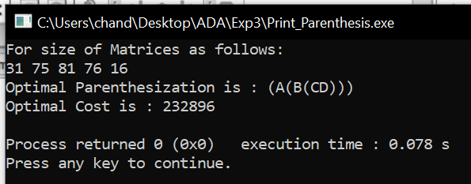

Result and Analysis:
Clearly, the space complexity of this procedure is Ο (n²). Since the tables m and s require Ο (n²) space. As far as the time complexity is concern, a simple inspection of the for-loop(s) structures gives us a running time of the procedure. Since, the three for-loops are nested three deep, and each one of them iterates at most n times (that is to say indices L, i, and j takes on at most n − 1 values). Therefore, the running time of this procedure is Ο (n³).

Experiment 4
Aim: To implement Longest Common Subsequence problem and analyse its time complexity.
Instructions:
The longest common subsequence problem is finding the longest sequence which exists in both the given strings.
Subsequence:
Let us consider a sequence S = <s₁, s₂, s₃, s₄, …,s_{n}>. A sequence Z = <z₁, z₂, z₃, z₄, …,z_{m}> over S is called a subsequence of S, if and only if it can be derived from S deletion of some elements.
Common Subsequence:
Suppose, X and Y are two sequences over a finite set of elements. We can say that Z is a common subsequence of X and Y, if Z is a subsequence of both Xand Y.
Longest Common Subsequence:
If a set of sequences are given, the longest common subsequence problem is to find a common subsequence of all the sequences that is of maximal length. It is a classic computer science problem, the basis of data comparison programs such as the diff-utility, and has applications in bioinformatics.
Naïve Method:
Let X be a sequence of length m and Y a sequence of length n. Check for every subsequence of X whether it is a subsequence of Y, and return the longest common subsequence found. There are 2^{m} subsequences of X. Testing sequences whether or not it is a subsequence of Y takes O(n) time. Thus, the naïve algorithm would take O(n2^{m}) time.
Dynamic Programming:
Let X = < x₁, x₂, x₃,…, x_{m} > and Y = < y₁, y₂, y₃,…, y_{n} > be the sequences. To compute the length of an element the following algorithm is used. In this procedure, table C[m, n] is computed in row major order and another table B[m,n] is computed to construct optimal solution.
Recursive Equation:
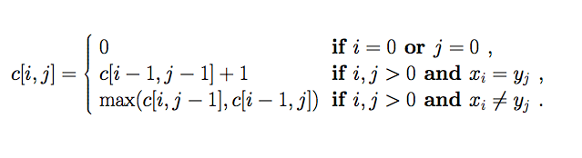
Pseudo code:
Let X and Y are Sequences whose LCS has to be found.
LCS-Length-Table-Formulation (X, Y)
m := length(X)
n := length(Y)
for i = 1 to m do
C [i, 0] := 0
for j = 1 to n do
C [0, j] := 0
for i = 1 to m do
for j = 1 to n do
if x_{i} = y_{j}
C [i, j] := C [i - 1, j - 1] + 1
B [i, j] := ‘D’
else
if C [i -1, j] ≥ C [i, j -1]
C [i, j] := C [i - 1, j] + 1
B [i, j] := ‘U’
else
C [i, j] := C [i, j - 1] + 1
B [i, j] := ‘L’
return C and B

Algorithm: Print-LCS (B, X, i, j)
if i = 0 and j = 0
return
if B[i, j] = ‘D’
Print-LCS(B, X, i-1, j-1)
Print(x_{i})
else if B[i, j] = ‘U’
Print-LCS(B, X, i-1, j)
else
Print-LCS(B, X, i, j-1)

#Code
#include <bits/stdc++.h>
#define limit 50
using namespace std;
int lcs_Naive(string x, string y, int m, int n){
if (m == 0 || n == 0)
return 0;
if (x[m - 1] == y[n - 1])
return 1 + lcs_Naive(x, y, m - 1, n - 1);
else
return max(lcs_Naive(x, y, m, n - 1), lcs_Naive(x, y, m - 1, n));
}
int lcs_DP(string x, string y, int m, int n){
int L[m + 1][n + 1];
memset(L,0,sizeof(L));
for (int i = 0; i <= m; i++) {
for (int j = 0; j <= n; j++) {
if (i == 0 || j == 0)
L[i][j] = 0;
else if (x[i - 1] == y[j - 1])
L[i][j] = L[i - 1][j - 1] + 1;
else
L[i][j] = max(L[i - 1][j], L[i][j - 1]);
}
}
return L[m][n];
}
string rand_str(int n){
string str = "";
while (n-->0){
char ch = 'A' + rand()%26;
str = str + ch;
}
return str;
}
int main(){
srand(time(0));
int n = rand()%limit, m = rand()%limit;
string s1 = rand_str(n), s2 = rand_str(m);
cout<<"Finding Longest Common Subsequence of Strings"<<endl;
cout<<"String One:\nString - "<<s1<<"\nLength - "<<n<<endl;
cout<<"String Two:\nString - "<<s2<<"\nLength - "<<m<<endl;
cout<<"Naive method\nTime Taken = ";
clock_t time_taken = clock();
int length = lcs_Naive(s1,s2,n,m);
time_taken = clock() - time_taken;
cout<<(float)time_taken/CLOCKS_PER_SEC<<"\nLength of longest common subsequence = "<<length<<endl;
cout<<"Dynamic Programming method\nTime Taken = ";
time_taken = clock();
length = lcs_DP(s1,s2,n,m);
time_taken = clock() - time_taken;
cout<<(float)time_taken/CLOCKS_PER_SEC<<"\nLength of longest common subsequence = "<<length<<endl;
return 0;
}
//This Code is made by Chander Jindal

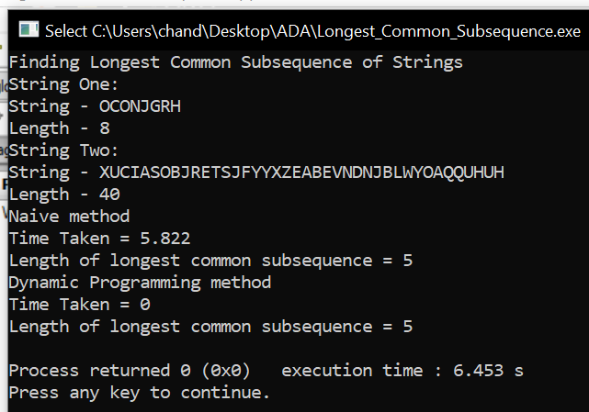

Result and Analysis:
To populate the table, the outer for loop iterates m times and the inner for loop iterates n times. Hence, the complexity of the algorithm is O (m, n), where m and n are the length of two strings.
Experiment 5
Aim: To implement Optimal Binary Search Tree problem and analyse its time complexity.
Instructions:
In computer science, an optimal binary search tree (OBST), sometimes called a weight-balanced binary tree, is a binary search tree which provides the smallest possible search time for a given sequence of accesses (or access probabilities). Optimal BSTs are generally divided into two types: static and dynamic.
In the static optimality problem, the tree cannot be modified after it has been constructed. In this case, there exists some particular layout of the nodes of the tree which provides the smallest expected search time for the given access probabilities. Various algorithms exist to construct or approximate the statically optimal tree given the information on the access probabilities of the elements.
- OBST is one special kind of advanced tree.
- It focus on how to reduce the cost of the search of the BST.
- It may not have the lowest height !
- It needs 3 tables to record probabilities, cost, and root.
- It has n keys (representation k₁,k₂,…,k_{n}) in sorted order (so that k₁<k₂<…<k_{n}), and we wish to build a binary search tree from these keys. For each k_{i} ,we have a probability p_{i} that a search will be for k_{i}.
- In contrast of, some searches may be for values not in k_{i}, and so we also have n+1 “dummy keys” d₀,d₁,…,d_{n} representing not in k_{i}.
- In particular, d₀ represents all values less than k₁, and d_{n} represents all values greater than k_{n}, and for i=1,2,…,n-1, the dummy key d_{i} represents all values between k_{i} and k_{i+1}.
＊The dummy keys are leaves (external nodes), and the data keys mean internal nodes.
Step1:The structure of an OBST
To characterize the optimal substructure of OBST, we start with an observation about sub trees. Consider any sub tree of a BST. It must contain keys in a contiguous range ki,…,kj, for some 1≦i ≦j ≦n. In addition, a sub tree that contains keys ki,…,kj must also have as its leaves the dummy keys d_{i-1} ,…, d_{j}

- We need to use the optimal substructure to show that we can construct an optimal solution to the problem from optimal solutions to sub problems. Given keys k_{i} ,…, k_{j}, one of these keys, say k_{r} (I ≦r ≦j), will be the root of an optimal sub tree containing these keys. The left sub tree of the root k_{r} will contain the keys (k_{i} ,…, k_{r-1}) and the dummy keys( d_{i-1} ,…, d_{r-1}), and the right sub tree will contain the keys (k_{r+1} ,…, k_{j}) and the dummy keys( d_{r} ,…, d_{j}). As long as we examine all candidate roots k_{r}, whereI ≦r ≦j, and we determine all optimal binary search trees containing k_{i} ,…, k_{r-1} and those containing k_{r+1} ,…, k_{j} , we are guaranteed that we will find an OBST.
- There is one detail worth nothing about “empty” sub trees. Suppose that in a sub tree with keys k_{i},...,k_{j}, we select k_{i} as the root. By the above argument, k_{i} ‘s left sub tree contains the keys k_{i},…, k_{i-1}. It is natural to interpret this sequence as containing no keys. It is easy to know that sub trees also contain dummy keys. The sequence has no actual keys but does contain the single dummy key d_{i-1}. Symmetrically, if we select k_{j} as the root, then k_{j}‘s right sub tree contains the keys, k_{j+1} …,k_{j}; this right sub tree contains no actual keys, but it does contain the dummy key d_{j}.
Step2: A recursive solution
- We need to define the value of an optimal solution recursively. We pick our sub problem domain as finding an OBST containing the keys k_{i},…,k_{j}, where i≧1, j ≦n, and j ≧ i-1. (It is when j=i-1 that there are no actual keys; we have just the dummy key d_{i-1}.)
- Let us define e [i,j] as the expected cost of searching an OBST containing the keys k_{i},…, k_{j}. Ultimately, we wish to compute e[1,n].
- The easy case occurs when j=i-1. Then we have just the dummy key d_{i-1}. The expected search cost is e [i,i-1]= q_{i-1}.
- When j≧1, we need to select a root k_{r} from among k_{i},…,k_{j} and then make an OBST with keys k_{i},…,k_{r-1} its left sub tree and an OBST with keys k_{r+1},…,k_{j} its right sub tree. By the time, what happens to the expected search cost of a sub tree when it becomes a sub tree of a node? The answer is that the depth of each node in the sub tree increases by 1.
- By the second statement, the excepted search cost of this sub tree increases by the sum of all the probabilities in the sub tree. For a sub tree with keys k_{i},…,k_{j} let us denote this sum of probabilities as
w (i , j) = (l=i~j) ∑ p_{l} + (l=i-1~j) ∑ q_{l}
Thus, if k_{r} is the root of an optimal sub tree containing keys k_{i},…,k_{j}, we have
E[i,j]= p_{r} + (e[i,r-1]+w(i,r-1))+(e[r+1,j]+w(r+1,j))
Nothing that w (i , j) = w(i,r-1)+ p_{r} +w(r+1,j)
- We rewrite e[i,j] as
e[i,j]= e[i,r-1] + e[r+1,j]+w(i,j)
The recursive equation as above assumes that we know which node k_{r} to use as the root. We choose the root that gives the lowest expected search cost, giving us our final recursive formulation:
E[i,j]=
case1: if i≦j,i≦r≦j
E[i,j]=min{e[i,r-1]+e[r+1,j]+w(i,j)}
case2: if j=i-1; E[i,j]= q_{i-1}
- The e[i,j] values give the expected search costs in OBST. To help us keep track of the structure of OBST, we define root[i,j], for 1≦i≦j≦n, to be the index r for which k_{r} is the root of an OBST containing keys k_{i},…,k_{j}.
Step3: Computing the expected search cost of an OBST
- We store the e[i.j] values in a table e[1..n+1, 0..n]. The first index needs to run to n+1rather than n because in order to have a sub tree containing only the dummy key d_{n}, we will need to compute and store e[n+1,n]. The second index needs to start from 0 because in order to have a sub tree containing only the dummy key d₀, we will need to compute and store e[1,0]. We will use only the entries e[i,j] for which j≧i-1. we also use a table root[i,j], for recording the root of the sub tree containing keys k_{i},…, k_{j}. This table uses only the entries for which 1≦i≦j≦n.
- We will need one other table for efficiency. Rather than compute the value of w(i,j) from scratch every time we are computing e[i,j] . We keep these values in a table w[1..n+1,0..n]. For the base case, we compute w [i,i-1] = q_{i-1} for 1≦i ≦n.
- For j≧I, we compute :
Ww[i,j]=w[i,j-1]+p_{i+}q_{i}
Pseudo code:
OPTIMAL—BST(p,q,n)
For i 1 to n+1
do e[i,i-1] <- q_{i-1}
do w[i,i-1] <- q_{i-1}
For l 1 to n
do for i <- 1 to n-l +1
do j <- i+l-1
e[i,j] <- ∞
w[i,j] <- w[i,j-1]+p_{j+}q_{j}
For r <- i to j
do t <- e[i,r-1]+e[r+1,j]+w[i,j]
if t<e[i,j]
then e[i,j] <- t
root [i,j] <- r
Return e and root

#Code
#include <bits/stdc++.h>
#define pb push_back
#define lli long long int
using namespace std;
typedef vector<int> VI;
lli minCostBST(VI key,VI freq, int n) {
lli cost[n][n];
memset(cost,0,sizeof(cost));
for (int i = 0; i < n; i++)
cost[i][i] = freq[i];
for(int length=2; length<=n; length++){
for(int i=0; i<=n-length+1; i++){
int j = i+length-1;
cost[i][j] = INT_MAX;
for(int r=i; r<=j; r++){
lli c = ((r > i)?cost[i][r-1]:0)+((r < j)?cost[r+1][j]:0)+accumulate(freq.begin()+i,freq.end()+j+1,0);
if(c < cost[i][j])
cost[i][j] = c;
}
}
}
return cost[0][n-1];
}VI make_vector(int n){
VI vect;
vect.reserve(n);
for(int i = 0 ; i < n;i++)
vect.pb(rand()%10);
return vect;}
void printer(VI vect){
for(auto it=vect.begin();it!=vect.end();it++)
cout<<*it<<" ";
cout<<endl;}
int main(){
srand(time(0));
int n = rand()%5;
VI key = make_vector(n),freq = make_vector(n);
cout<<"The Keys :\n";
printer(key);
cout<<"\nThe Frequency :\n";
printer(freq);
cout<<"\nThe resultant Cost of Optimal BST is "<<minCostBST(key, freq, n)<<endl;
return 0;}
//This Code is made by Chander Jindal
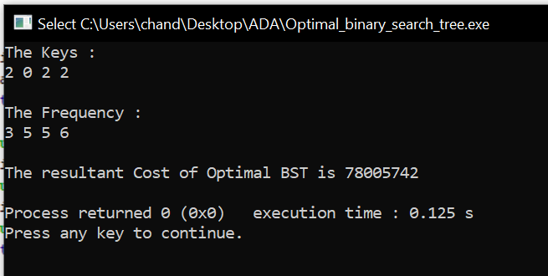

Sample Example:
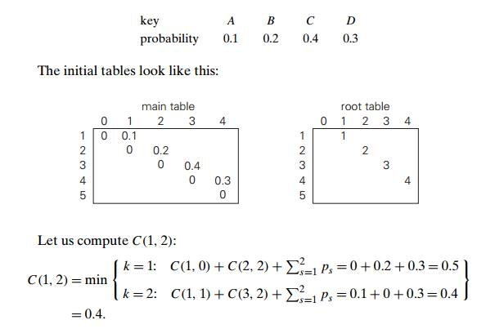
Thus, out of two possible binary trees containing the first two keys, A and B, the root of the optimal tree has index 2 (i.e., it contains B), and the average number of comparisons in a successful search in this tree is 0.4.
We will arrive at the following final tables using the recurrence equations:
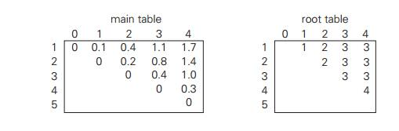
Thus, the average number of key comparisons in the optimal tree is equal to 1.7. Since R(1, 4) = 3, the root of the optimal tree contains the third key, i.e., C. Its left sub tree is made up of keys A and B, and its right sub tree contains just key D. To find the specific structure of these sub trees, we find first their roots by consulting the root table again. Since R(1, 2) = 2, the root of the optimal tree containing A and B is B, with A being its left child (and the root of the one-node tree: R(1, 1) = 1). Since R (4, 4) = 4, the root of this one-node optimal tree is its only key D.
Result and Analysis:
Every time we work on an entry e[i, j] with j − i = k, we know that all the entries e[i 0 , j 0 ] with j 0 − i 0 < k have already been computed. Note that the recursive formula we use to compute e[i, j] only involves entries e[i 0 , j 0 ] with j 0 − i 0 < k. So they are all ready, and we can compute e[i, j] in time O(j − i). It is easy to check that the total running time is Θ (n 3 ).
Experiment 6
Aim: To implement Huffman Coding and analyze its time complexity.

Instructions:
Huffman coding is a lossless data compression algorithm. The idea is to assign variable-length codes to input characters; lengths of the assigned codes are based on the frequencies of corresponding characters. The most frequent character gets the smallest code and the least frequent character gets the largest code.
The variable-length codes assigned to input characters are Prefix Codes means the codes (bit sequences) are assigned in such a way that the code assigned to one character is not prefix of code assigned to any other character. This is how Huffman Coding makes sure that there is no ambiguity when decoding the generated bit stream.
Let us understand prefix codes with a counter example. Let there be four characters a, b, c and d, and their corresponding variable length codes be 00, 01, 0 and 1. This coding leads to ambiguity because code assigned to c is prefix of codes assigned to a and b. If the compressed bit stream is 0001, the de-compressed output may be “cccd” or “ccb” or “acd” or “ab”.

Pseudo code:
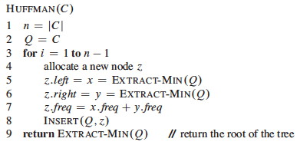

#Code
// C++(STL) program for Huffman Coding with STL
#include <bits/stdc++.h>
#define pb push_back
#define limit1 26
#define limit2 1000
using namespace std;
typedef vector<int> VI;
typedef vector<char> VC;

// huffman nodes
struct min_heap_node {
char data; // key / value
unsigned freq; // frequency
min_heap_node *left, *right; //children
min_heap_node(char data, unsigned freq){ //constructor type
left = right = NULL;
this->data = data;
this->freq = freq;
}
};
struct compare{ // compare function to be used for minheap nodes only
bool operator()(min_heap_node* l, min_heap_node* r){
return (l->freq > r->freq);
}
};
void print_huffman_code(struct min_heap_node* root, string str);
void Huffman_Code(VC data, VI freq, int size);
VI make_vector_int(int n);
VC make_vector_char(int n);
void print_VI(VI vect);
void print_VC(VC vect);

int main(){
srand(time(0));
int n = rand()%limit1;
VC vect_val = make_vector_char(n);
VI vect_freq = make_vector_int(n);
cout<<"For an array of values:\n";
print_VC(vect_val);
cout<<"And their frequencies:\n";
print_VI(vect_freq);
cout<<"\nTheir Huffman code is:\n";
Huffman_Code(vect_val, vect_freq, n);
return 0;
}

VI make_vector_int(int n){
VI vect,temp;
vect.reserve(n),temp.reserve(n);
for(int i = 0 ; i< limit2;i++)
temp.pb(i);
for(int i = 0 ; i < n;i++){
int idx = rand()%temp.size();
vect.pb( temp[idx] );
temp.erase(temp.begin()+idx);
}
return vect;
}
VC make_vector_char(int n){
VC vect;
VI temp;
temp.reserve(n);
vect.reserve(n);
for(int i = 0 ; i< limit1;i++)
temp.pb('A'+i);
for(int i = 0 ; i < n;i++){
int idx = rand()%temp.size();
vect.pb( temp[idx] );
temp.erase(temp.begin()+idx);
}
return vect;
}
void print_VI(VI vect){
for(auto it = vect.begin();it != vect.end();it++)
cout<<*it<<" ";
cout<<endl;
return;
}
void print_VC(VC vect){
for(auto it = vect.begin();it != vect.end();it++)
cout<<*it<<" ";
cout<<endl;
return;
}
void print_huffman_code(struct min_heap_node* root, string str){
if (!root)
return;

if (root->data != '#')
cout<<root->data<<": "<<str<<endl;

print_huffman_code(root->left, str + "0");
print_huffman_code(root->right, str + "1");
}
void Huffman_Code(VC data, VI freq, int size){
struct min_heap_node *left, *right, *top;
priority_queue<min_heap_node*, vector<min_heap_node*>, compare> minHeap;
//priority_queue type min_heap_node pointer, behaves like mine_heap_node pointer vector, with special comparator
for (int i = 0; i < size; ++i)
minHeap.push(new min_heap_node(data[i], freq[i]));
while (minHeap.size() != 1){
left = minHeap.top();
minHeap.pop();
right = minHeap.top();
minHeap.pop();
// took left and right element
// left is 2n + 0 , right is 2n + 1
top = new min_heap_node('#', left->freq + right->freq);
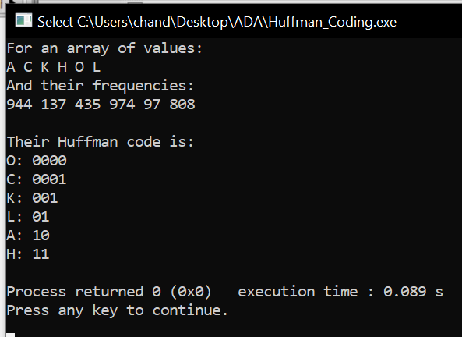
// mix of left and right, using '#' as empty key
top->left = left;
top->right = right;
minHeap.push(top);
}
// Print Huffman codes using
// the Huffman tree built above
print_huffman_code(minHeap.top(), "");
}
//This Code is made by Chander Jindal

Sample Example:

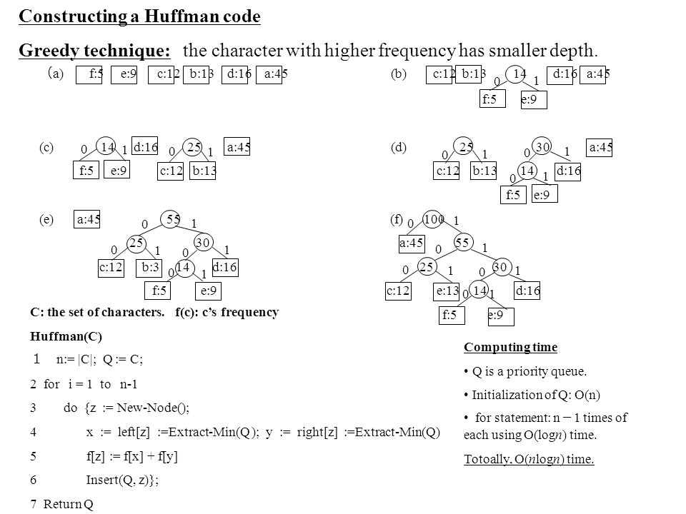

Result and Analysis:
If there are n nodes, extractMin() is called 2*(n – 1) times and extractMin() takes O(log n) time as it calls minHeapify(). So, overall complexity is O (n log n) where n specifies the number of unique characters.

Experiment 7
Aim: To implement Dijkstra’s algorithm and analyse its time complexity.
Instructions:
Dijkstra's algorithm solves the single-source shortest-paths problem on a weighted, directed graph G = (V, E) for the case in which all edge weights are non-negative. In this section, therefore, we assume that w(u, v) 0 for each edge (u, v) E.
This algorithm maintains a set S of vertices whose final shortest-path weights from the source s have already been determined. That is, for all vertices v S, we have d[v] = (s, v). The algorithm repeatedly selects the vertex u V - S with the minimum shortest-path estimate, inserts u into S, and relaxes all edges leaving u. In the following implementation, we maintain a priority queue Q that contains all the vertices in V - S, keyed by their d values. The implementation assumes that graph G is represented by adjacency lists.
Pseudo code:
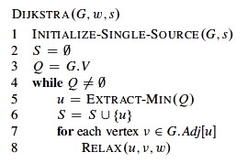
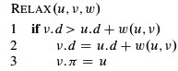

#Code
#include <bits/stdc++.h>
#define limit 100
using namespace std;

void DijkstrasTest();

int main() {
DijkstrasTest();
return 0;
}
class Node;
class Edge;

void Dijkstras();
vector<Node*>* AdjacentRemainingNodes(Node* node);
Node* ExtractSmallest(vector<Node*>& nodes);
int Distance(Node* node1, Node* node2);
bool Contains(vector<Node*>& nodes, Node* node);
void PrintShortestRouteTo(Node* destination);
void PrintGraph();
vector<Node*> nodes;
vector<Edge*> edges;

class Node {
public:
Node(char id)
: id(id), previous(NULL), distanceFromStart(INT_MAX) {
nodes.push_back(this);
}
public:
char id;
Node* previous;
int distanceFromStart;
};
class Edge{
public:
Edge(Node* node1, Node* node2, int distance)
: node1(node1), node2(node2), distance(distance){
edges.push_back(this);
}
bool Connects(Node* node1, Node* node2) {
return (
(node1 == this->node1 &&
node2 == this->node2) ||
(node1 == this->node2 &&
node2 == this->node1));
}
public:
Node* node1;
Node* node2;
int distance;
};

void DijkstrasTest() {
Node* a = new Node('A');
Node* b = new Node('B');
Node* c = new Node('C');
Node* d = new Node('D');
Node* e = new Node('E');
Node* f = new Node('F');
Node* g = new Node('G');
srand(time(0));
Edge* e1 = new Edge(a, c, rand()%limit);
Edge* e2 = new Edge(a, d, rand()%limit);
Edge* e3 = new Edge(b, c, rand()%limit);
Edge* e4 = new Edge(c, d, rand()%limit);
Edge* e5 = new Edge(b, f, rand()%limit);
Edge* e6 = new Edge(c, e, rand()%limit);
Edge* e7 = new Edge(e, f, rand()%limit);
Edge* e8 = new Edge(d, g, rand()%limit);
Edge* e9 = new Edge(g, f, rand()%limit);
PrintGraph();
a->distanceFromStart = 0; // set start node
Dijkstras();
PrintShortestRouteTo(f);
}

void PrintGraph(){
const int size_ = edges.size();
cout<<"The paths in the given graph are as following:\n";
for(int i = 0 ; i < size_ ; i++){
Edge* edge = edges[i];
cout<<edge->node1->id<<" to "<<edge->node2->id<<" has distance of "<<edge->distance<<"\n";
}
cout<<"\n";
return;
}
void Dijkstras(){
while (nodes.size() > 0) {
Node* smallest = ExtractSmallest(nodes);
vector<Node*>* adjacentNodes = AdjacentRemainingNodes(smallest);
const int size = adjacentNodes->size();
for (int i = 0; i < size; ++i) {
Node* adjacent = adjacentNodes->at(i);
int distance = Distance(smallest, adjacent) + smallest->distanceFromStart;
if (distance < adjacent->distanceFromStart)
adjacent->distanceFromStart = distance,adjacent->previous = smallest;
}
delete adjacentNodes;
}
}
// Find the node with the smallest distance,
// remove it, and return it.
Node* ExtractSmallest(vector<Node*>& nodes){
int size_ = nodes.size();
if (size_ == 0) return NULL;
int smallestPosition = 0;
Node* smallest = nodes.at(0);
for(int i = 1; i < size_; ++i){
Node* current = nodes.at(i);
if (current->distanceFromStart < smallest->distanceFromStart){
smallest = current;
smallestPosition = i;
}
}
nodes.erase(nodes.begin() + smallestPosition);
return smallest;
}
// Return all nodes adjacent to 'node' which are still in the 'nodes' collection.
vector<Node*>* AdjacentRemainingNodes(Node* node){
vector<Node*>* adjacentNodes = new vector<Node*>();
const int size_ = edges.size();
for (int i = 0; i < size_; ++i){
Edge* edge = edges.at(i);
Node* adjacent = NULL;
if (edge->node1 == node)
adjacent = edge->node2;
else if (edge->node2 == node)
adjacent = edge->node1;
if (adjacent && Contains(nodes, adjacent))
adjacentNodes->push_back(adjacent);
}
return adjacentNodes;
}
// Return distance between two connected nodes
int Distance(Node* node1, Node* node2) {
const int size = edges.size();
for (int i = 0; i < size; ++i) {
Edge* edge = edges.at(i);
if (edge->Connects(node1, node2)) {
return edge->distance;
}
}
return -1; // disconnected a.k.a. issue
}
// Does the 'nodes' vector contain 'node'
bool Contains(vector<Node*>& nodes, Node* node) {
const int size = nodes.size();
for (int i = 0; i < size; ++i) {
if (node == nodes.at(i)) {
return true;
}
}
return false;
}
void PrintShortestRouteTo(Node* destination) {
Node* previous = destination;
cout << "Distance from start: "
<< destination->distanceFromStart << endl;
while (previous) {
cout << previous->id << " ";
previous = previous->previous;
}
cout << endl;
}

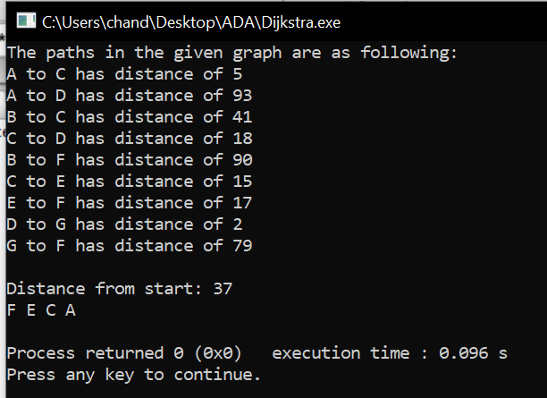

Sample Example:
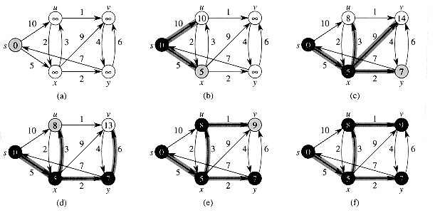
Result and Analysis:
Every time the main loop executes, one vertex is extracted from the queue. Assuming that there are V vertices in the graph, the queue may contain O(V) vertices. Therefore the total run time is O (V lg V + E lg V), which is O(E lg V) because V is O(E) assuming a connected graph.

Experiment 8
Aim: To implement Bellman Ford algorithm and analyse its time complexity.
Instructions:
The Bellman-Ford algorithm solves the single-source shortest-paths problem in the more general case in which edge weights can be negative. Given a weighted, directed graph G = (V, E) with source s and weight function w : E R , the Bellman-Ford algorithm returns a Boolean value indicating whether or not there is a negative-weight cycle that is reachable from the source. If there is such a cycle, the algorithm indicates that no solution exists. If there is no such cycle, the algorithm produces the shortest paths and their weights.
Like Dijkstra's algorithm, the Bellman-Ford algorithm uses the technique of relaxation, progressively decreasing an estimate d[v] on the weight of a shortest path from the source s to each vertex v V until it achieves the actual shortest-path weight (s, v). The algorithm returns TRUE if and only if the graph contains no negative-weight cycles that are reachable from the source.
Pseudo code:
BELLMAN-FORD(G,w,s)
1. INITIALIZE-SINGLE-SOURCE(G,s)
2. for i = 1 to |G.V|-1
3. for each edge (u,v) ∈ G.E
4. RELAX(u,v,w)
5. for each edge (u,v) ∈ G.E
6. if v.d > u.d + w(u,v)
7. return FALSE
8. return TRUE

INITIALIZE-SINGLE-SOURCE(G,s)
1. for each vertex v ∈ G.V
2. v.d = ∞
3. v.pi = NIL
4. s.d = 0

RELAX(u,v,w)
1. if v.d > u.d + w(u,v)
2. v.d = u.d + w(u,v)
3. v.pi = u

Sample Example:
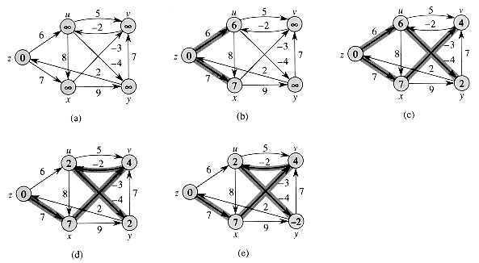
Result and Analysis:
Initialize d's, π's, and set s.d = 0 ⇒ O(V).Loop |V|-1 times through all edges checking the relaxation condition to compute minimum distances ⇒ (|V|-1) O(E) = O(VE). Loop through all edges checking for negative weight cycles which occurs if any of the relaxation conditions fail ⇒ O(E).The run time of the Bellman-Ford algorithm is O(V + VE + E) = O(VE). Note that if the graph is a DAG (and thus is known to not have any cycles), we can make Bellman-Ford more efficient by first topologically sorting G (O(V+E)), performing the same initialization (O(V)), and then simply looping through each vertex u in topological order relaxing only the edges in Adj [u] (O(E)). This method only takes O(V + E) time.

