ALGORITHMS ANALYSIS AND DESIGN LAB
ETCS 351

Sudha Narang
(Faculty Instructor)
Chander Jindal
06514802719
5C4



Maharaja Agrasen Institute of Technology,
PSP area, Sector – 22, Rohini, New Delhi – 110085
( Affiliated to Guru Gobind Singh Indraprastha University, New Delhi )


MAHARAJA AGRASEN INSTITUTE OF TECHNOLOGY

VISION
To nurture young minds in a learning environment of high academic value and imbibe spiritual and ethical values with technological and management competence.
MISSION
The Institute shall endeavor to incorporate the following basic missions in the teaching methodology:
Engineering Hardware – Software Symbiosis
Practical exercises in all Engineering and Management disciplines shall be carried out by Hardware equipment as well as the related software enabling deeper understanding of basic concepts and encouraging inquisitive nature.
Life – Long Learning
The Institute strives to match technological advancements and encourage students to keep updating their knowledge for enhancing their skills and inculcating their habit of continuous learning.
Liberalization and Globalization
The Institute endeavors to enhance technical and management skills of students so that they are intellectually capable and competent professionals with Industrial Aptitude to face the challenges of globalization.
Diversification
The Engineering, Technology and Management disciplines have diverse fields of studies with different attributes. The aim is to create a synergy of the above attributes by encouraging analytical thinking.
Digitization of Learning Processes
The Institute provides seamless opportunities for innovative learning in all Engineering and Management disciplines through digitization of learning processes using analysis, synthesis, simulation, graphics, tutorials and related tools to create a platform for multi-disciplinary approach.
Entrepreneurship
The Institute strives to develop potential Engineers and Managers by enhancing their skills and research capabilities so that they become successful entrepreneurs and responsible citizens.
MAHARAJA AGRASEN INSTITUTE OF TECHNOLOGY

COMPUTER SCIENCE & ENGINEERING DEPARTMENT
VISION
To Produce “Critical thinkers of Innovative Technology”
MISSION
To provide an excellent learning environment across the computer science discipline to inculcate professional behaviour, strong ethical values, innovative research capabilities and leadership abilities which enable them to become successful entrepreneurs in this globalized world.

- To nurture an excellent learning environment that helps students to enhance their problem solving skills and to prepare students to be lifelong learners by offering a solid theoretical foundation with applied computing experiences and educating them about their professional, and ethical responsibilities.
- To establish Industry-Institute Interaction, making students ready for the industrial environment and be successful in their professional lives.
- To promote research activities in the emerging areas of technology convergence.
- To build engineers who can look into technical aspects of an engineering solution thereby setting a ground for producing successful entrepreneur.

ADA LAB Course Outcomes

S.NO | Course Outcomes
ETCS351.1 | Analyze the time and space complexity of incremental algorithms.
ETCS351.2 | Analyze and use the asymptotic behavior of Divide and Conquer approach in designing algorithms
ETCS351.3 | Apply concept of Dynamic Programming and Greedy approach to develop various algorithms.
ETCS351.4 | Apply different designing strategies to solve Graph Problems.
ETCS351.5 | Understand and develop various String-Matching Algorithms

Index

S.No. | Experiment No. | Date | Remarks | Signature/ Seen On
1 | To implement following algorithm using array as a data structure and analyse its time complexity.  Merge sort  Quick sort  Bubble sort  Bucket sort  Radix sort  Shell sort  Selection sort  Heap sort | 17/09/2021
2 | To implement Linear search and Binary search and analyse its time complexity. | 24/09/2021
3 | To implement Matrix Multiplication and analyse its time complexity. | 01/10/2021
4 | To implement Longest Common Subsequence problem and analyse its time complexity. | 08/10/2021
5 | To implement Optimal Binary Search Tree problem and analyse its time complexity. | 29/10/2021
6 | To implement Huffman Coding and analyse its time complexity. | 05/11/2021
7 | To implement Dijkstra’s algorithm and analyse its time complexity. | 12/11/2021
8 | To implement Bellman Ford algorithm and analyse its time complexity. | 19/11/2021

Experiment 1
Aim: To implement following algorithm using array as a data structure and analyse its time complexity.
Merge sort
Instructions:
Conceptually, a merge sort works as follows:
- Divide the unsorted list into n subsists, each containing 1 element (a list of 1 element is considered sorted).
- Repeatedly merge subsists to produce new sorted subsists until there is only 1 subsist remaining. This will be the sorted list.

Pseudo code:
Let A be an input array in which p is its lower bound and q is its upper bound. Function MERGE-SORT is called recursively, and it also call function MERGE which merges two unsorted arrays into a single sorted array.
MERGE-SORT (A, p, r)
- If p < r
- q = [(p + q) /2]
- MERGE-SORT (A, p, q)
- MERGE-SORT (A, q+1, r)
- MERGE (A, p, q, r)
MERGE (A, p, q, r)
- n₁ = q – p +1
- n₂ = r – q
- let L [1... n₁ + 1] and L [1... n₂ + 1] be new arrays
- for i=1 to n₁
- L [i] = A [ p + i -1]
- for j=1 to n₂
- R [j] =A [ q + j]
- L [n₁ + 1]= ∞
- R [n₂ + 1]= ∞
- i = 1
- j = 1
- for k = p to r
- if L [i] < R [ j]
- A [k] = L [i]
- i = i + 1
- else A [k] = R [ j]
- j = j + 1

#Code
#include <bits/stdc++.h>

using namespace std;

#define pb push_back
#define limit 100000
typedef vector<int> VI;

void printer(VI vect){
for (int i = 0; i < vect.size(); i++)
cout << vect[i] << " ";
}

VI mergeSort(VI &vect){
if(vect.size() < 2)
return vect;
int mid = vect.size()/2;
VI R_vect , L_vect;
for(int i =0;i<mid;i++)
L_vect.pb(vect[i]);

for(int i =mid;i<vect.size();i++)
R_vect.pb(vect[i]);
L_vect = mergeSort(L_vect);
R_vect = mergeSort(R_vect);
int l = 0,r = 0,m = 0;
while (l < L_vect.size() && r < R_vect.size()){
if(L_vect[l] < R_vect[r]){
vect[m] = L_vect[l];
++l;
}else{
vect[m] = R_vect[r];
++r;
}
++m;
}
while (l < L_vect.size()){
vect[m] = L_vect[l];
++l;
++m;
}
while (r < R_vect.size()){
vect[m] = R_vect[r];
++r;
++m;
}
return vect;
}

VI rand_VI(int n){
VI vect;
vect.reserve(n);
for(int i = 0 ; i < n;i++)
vect.pb(rand()%limit);
return vect;
}

VI asc_VI(int n){
VI vect;
vect.reserve(n);
for(int i = 0 ; i < n;i++)
vect.pb(i);
return vect;
}
VI dec_VI(int n){
VI vect;
vect.reserve(n);
for(int i = n-1 ; i >= 0;i--)
vect.pb(i);
return vect;
}

int main(){
srand(time(0));
int n = rand()%limit;
if(n<10000){
n += 10000;
}
cout<<"For n = "<<n<<", in Merge Sort the time for the following arrays is:"<<endl;
VI vect = rand_VI(n);
clock_t time_taken = clock();
mergeSort(vect);
time_taken = clock() - time_taken;
cout<<"For Random array sorting : "<<(float)time_taken/CLOCKS_PER_SEC<<endl;
vect = asc_VI(n);
time_taken = clock();
mergeSort(vect);
time_taken = clock() - time_taken;
cout<<"For ascending sorted array sorting : "<<(float)time_taken/CLOCKS_PER_SEC<<endl;
vect = dec_VI(n);
time_taken = clock();
mergeSort(vect);
time_taken = clock() - time_taken;
cout<<"For descending sorted array sorting : "<<(float)time_taken/CLOCKS_PER_SEC<<endl;
return 0;
}
//This Code is made by Chander Jindal

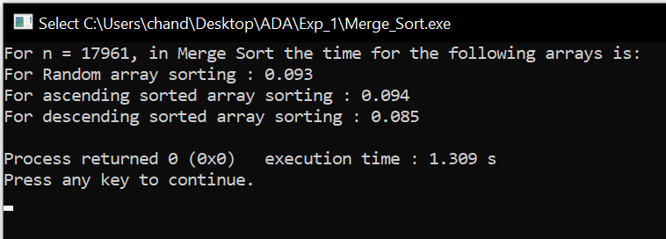

Result and Analysis:
The unordered list of elements gets sorted but additional space is used for merging.
The list of size N is divided into a max of logN parts, and the merging of all sub lists into a single list takes O(N) time. Time complexity of Merge Sort is O (nlogn) in all 3 cases (worst, average and best) as merge sort always divides the array in two halves and take linear time to merge two halves. The recurrence equation used is:T(n) = 2T(n/2) + O(n)

Quick sort

Instructions:
The basic steps in this sort are:
Divide: The array A [p… r] is partitioned (rearranged) into two nonempty sub arrays A [p... q] and A [q + 1... r] such that each element of A [p . . q] is less than or equal to each element of A [q + 1... r]. The index q is computed as part of this partitioning procedure.
Conquer: The two sub arrays A [p… q] and A [q + 1… r] are sorted by recursive calls to quick sort.
Combine: Since the sub arrays are sorted in place, no work is needed to combine them: the entire array A [p.. r] is now sorted.
Pseudo code:
The following procedure implements quick sort. It takes A as input array which has p as its lower bound and r as its upper bound.
QUICKSORT (A, p, r)
1 if p<r
2 then qPARTITION (A, p, r)
3 QUICKSORT (A, p, q)
4 QUICKSORT (A, q + 1, r)
To sort an entire array A, the initial call is QUICKSORT (A, 1, length[A]).

Partitioning the array:

The key to the algorithm is the PARTITION procedure, which rearranges the sub array A [p.. r] in place.
PARTITION (A,p,r)
1 xA[p]
2 ip - 1
3 jr + 1
4 while TRUE
5 do repeat jj - 1
6 until A[j] x
7 repeat ii + 1
8 until A[i] x
9 if i<j
10 then exchange A[i] A[j]
11 else return j
#Code
#include <bits/stdc++.h>
using namespace std;
#define pb push_back
#define limit 10000
typedef vector<int> VI;
void printer(VI vect){
for (int i = 0; i < vect.size(); i++)
cout << vect[i] << " ";
}
int partition_ (VI &vect, int low, int high){
int pivot = vect[high];
int i = (low - 1);
for (int j = low; j <= high - 1; j++){
if (vect[j] < pivot){
i++;
swap(vect[i], vect[j]);
}
}
swap(vect[i + 1], vect[high]);
return (i + 1);
}
void quickSort(VI &vect, int low, int high){
if (low < high){
int pi = partition_(vect, low, high);
quickSort(vect, low, pi - 1);
quickSort(vect, pi + 1, high);
}
return;
}
VI rand_VI(int n){
VI vect;
vect.reserve(n);
for(int i = 0 ; i < n;i++)
vect.pb(rand()%limit);
return vect;
}
VI asc_VI(int n){
VI vect;
vect.reserve(n);
for(int i = 0 ; i < n;i++)
vect.pb(i);
return vect;
}
VI dec_VI(int n){
VI vect;
vect.reserve(n);
for(int i = n-1 ; i >= 0;i--)
vect.pb(i);
return vect;
}
int main(){
srand(time(0));
int n = rand()%limit;
if(n<1000){
n += 1000;
}
cout<<"For n = "<<n<<", in Quick Sort the time for the following arrays is:"<<endl;
VI vect = rand_VI(n);
clock_t time_taken = clock();
quickSort(vect,0,n-1);
time_taken = clock() - time_taken;
cout<<"For Random array sorting : "<<(float)time_taken/CLOCKS_PER_SEC<<endl;
vect = asc_VI(n);
time_taken = clock();
quickSort(vect,0,n-1);
time_taken = clock() - time_taken;
cout<<"For ascending sorted array sorting : "<<(float)time_taken/CLOCKS_PER_SEC<<endl;
vect = dec_VI(n);
time_taken = clock();
quickSort(vect,0,n-1);
time_taken = clock() - time_taken;
cout<<"For descending sorted array sorting : "<<(float)time_taken/CLOCKS_PER_SEC<<endl;
return 0;
}
//This Code is made by Chander Jindal

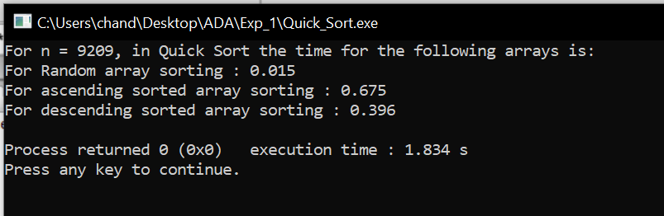
It has partitioned the array in such a way that elements less than equal to pivot comes on its left side and elements greater than pivot are on its right side. This procedure is recursively called in the subarrays.
Result and Analysis:
The running time of Quick sort depends whether Partition is balanced or not.
Best case Partitioning:
If the procedure 'Partition' produces two regions of size n/2. The recurrence relation is then
T (n) = T(n/2) + T(n/2) + (n)
= 2T(n/2) + (n)
And from case 2 of Master Theorem. T (n) = (n lg n)
Worst case Partitioning:
The worst-case occurs if given array A [1... n] is already sorted. The PARTITION (A, p, r) call always return p so successive calls to partition will split arrays of length n, n-1, n-2, . . ., 2 and running time proportional to n + (n-1) + (n-2) + . . . + 2 = [(n+2) (n-1)]/2 = (n²). The worst-case also occurs if A [1... n] starts out in reverse order.
Bubble sort
Instructions:
This sorting algorithm is comparison-based algorithm in which each pair of adjacent elements is compared, and the elements are swapped if they are not in order.

Pseudo code:
We assume list is an array of n elements. We further assume that swap function swaps the values of the given array elements.
begin BubbleSort (list)
for all elements of list
if list[i] > list[i+1]
swap (list[i], list [i+1])
end if
end for
return list
end BubbleSort

#Code
#include <bits/stdc++.h>
using namespace std;

#define pb push_back
#define limit 10000
typedef vector<int> VI;

void printer(VI vect){
for (int i = 0; i < vect.size(); i++)
cout << vect[i] << " ";
}

void bubbleSort(VI &vect){
for (int i = 0; i < vect.size()-1; i++)
for (int j = 0; j < vect.size()-i-1; j++)
if (vect[j] > vect[j+1])
swap(vect[j], vect[j+1]);
}

VI rand_VI(int n){
VI vect;
vect.reserve(n);
for(int i = 0 ; i < n;i++)
vect.pb(rand()%limit);
return vect;
}

VI asc_VI(int n){
VI vect;
vect.reserve(n);
for(int i = 0 ; i < n;i++)
vect.pb(i);
return vect;
}
VI dec_VI(int n){
VI vect;
vect.reserve(n);
for(int i = n-1 ; i >= 0;i--)
vect.pb(i);
return vect;
}
int main(){
srand(time(0));
int n = rand()%limit;
if(n<1000){
n += 1000;
}
cout<<"For n = "<<n<<", in Bubble Sort the time for the following arrays is:"<<endl;
VI vect = rand_VI(n);
clock_t time_taken = clock();
bubbleSort(vect);
time_taken = clock() - time_taken;
cout<<"For Random array sorting : "<<(float)time_taken/CLOCKS_PER_SEC<<endl;
vect = asc_VI(n);
time_taken = clock();
bubbleSort(vect);
time_taken = clock() - time_taken;
cout<<"For ascending sorted array sorting : "<<(float)time_taken/CLOCKS_PER_SEC<<endl;
vect = dec_VI(n);
time_taken = clock();
bubbleSort(vect);
time_taken = clock() - time_taken;
cout<<"For descending sorted array sorting : "<<(float)time_taken/CLOCKS_PER_SEC<<endl;
return 0;
}
//This Code is made by Chander Jindal
Sample Example:
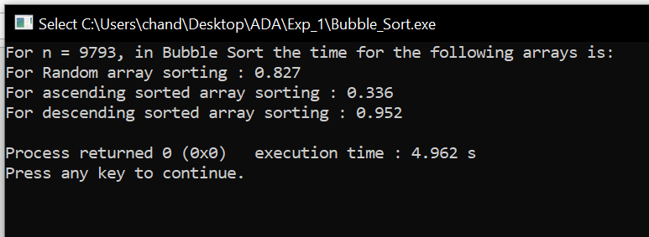

Result and Analysis:
Worst and Average Case Time Complexity: O (n*n). Worst case occurs when array is reverse sorted and its time complexity is O (n*n) and Best case occurs when array is already sorted and its time complexity is O (n) (linear time). This sort takes just O (1) extra space.

Bucket sort
Instructions:
Bucket sort, or bin sort, is a sorting algorithm that works by distributing the elements of an array into a number of buckets. Each bucket is then sorted individually, either using a different sorting algorithm, or by recursively applying the bucket sorting algorithm. It is a distribution sort, a generalization of pigeonhole sort, and is a cousin of radix sort in the most-to-least significant digit flavour. Bucket sort can be implemented with comparisons and therefore can also be considered a comparison sort algorithm.
It works as follows:
- Set up an array of initially empty "buckets".
- Scatter: Go over the original array, putting each object in its bucket.
- Sort each non-empty bucket.
- Gather: Visit the buckets in order and put all elements back into the original array.
Pseudo code:
The code assumes that input is an n-element array A and each element in A satisfies 0 ≤ A[i] ≤ 1. We also need an auxiliary array B [0 . . n -1] for linked-lists (buckets).
BUCKET SORT (A)
1. n ← length [A]
2. For i =1 to n do
3. Insert A[i]into list B [A[i]/b] where b is the bucket size
4. For i =0 to n-1do
5. Sort list B with Insertion sort
6. Concatenate the lists B [0], B [1] ... B [n-1] together in order.

#Code
#include <bits/stdc++.h>

using namespace std;

#define pb push_back
#define limit1 100000
#define limit2 1000000

typedef vector<int> VI;

void printer(VI vect){
for (int i = 0; i < vect.size(); i++)
cout << vect[i] << " ";
}

void bucketSort(VI &vect){
int max_val = *max_element(vect.begin(), vect.end());
int bucket[max_val+1];
memset(bucket,0,sizeof(bucket));
for(int i = 0; i < vect.size(); i++)
bucket[vect[i]]++;
for(int i = 0, j = 0; i <= max_val; i++){
while (bucket[i] > 0){
vect[j++] = i;
bucket[i]--;
}
}
return;
}

VI rand_VI(int n){
VI vect;
vect.reserve(n);
for(int i = 0 ; i < n;i++)
vect.pb(rand()%limit2);
return vect;
}

VI asc_VI(int n){
VI vect;
vect.reserve(n);
for(int i = 0 ; i < n;i++)
vect.pb(i);
return vect;
}
VI dec_VI(int n){
VI vect;
vect.reserve(n);
for(int i = n-1 ; i >= 0;i--)
vect.pb(i);
return vect;
}

int main(){
srand(time(0));
int n = rand()%limit2;
if(n<limit1){
n += limit1;
}
cout<<"For n = "<<n<<", in Bucket Sort the time for the following arrays is:"<<endl;
VI vect = rand_VI(n);
clock_t time_taken = clock();
bucketSort(vect);
time_taken = clock() - time_taken;
cout<<"For Random array sorting : "<<(float)time_taken/CLOCKS_PER_SEC<<endl;
vect = asc_VI(n);
time_taken = clock();
bucketSort(vect);
time_taken = clock() - time_taken;
cout<<"For ascending sorted array sorting : "<<(float)time_taken/CLOCKS_PER_SEC<<endl;
vect = dec_VI(n);
time_taken = clock();
bucketSort(vect);
time_taken = clock() - time_taken;
cout<<"For descending sorted array sorting : "<<(float)time_taken/CLOCKS_PER_SEC<<endl;
return 0;
}
//This Code is made by Chander Jindal

Sample Example:
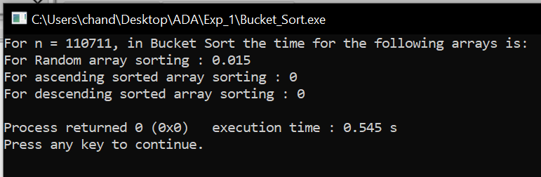

Result and Analysis:
In the above Bucket sort algorithm, we observe in the best case, the algorithm distributes the elements uniformly between buckets, a few elements are placed on each bucket and sorting the buckets is O (1). Rearranging the elements is one more run through the initial list.
T (n) = [time to insert n elements in array A] + [time to go through auxiliary array B [0 . . . n-1] * (Sort by INSERTION_SORT)
= O (n) + (n-1) (n)
= O (n)
In the worst case, the elements are sent all to the same bucket, making the process take O (n^2).

Radix sort
Instructions:
Radix Sort is a non-comparative sorting algorithm. It is one of the most efficient and fastest linear sorting algorithms. In radix sort, we first sort the elements based on last digit (least significant digit). Then the result is again sorted by second digit, continue this process for all digits until we reach most significant digit. We use counting sort to sort elements of every digit.
Let A be an array and d be number of digits.
Pseudo code:

Radix-Sort(A, d)
//It works same as counting sort for d number of passes.
//Each key in A [1...n] is a d-digit integer.
// (Digits are numbered 1 to d from right to left.)
for j = 1 to d do
//A[]-- Initial Array to Sort
intcount[10] = {0};
//Store the count of "keys" in count[]
//key- it is number at digit place j
for i = 0 to n do
count[key of(A[i]) in pass j]++

fork = 1 to 10 do
count[k] = count[k] + count[k-1]

//Build the resulting array by checking
//new position of A[i] from count[k]
for i = n-1 down to 0 do
result[ count[key of(A[i])] ] = A[j]
count[key of(A[i])]--

//Now main array A[] contains sorted numbers
//according to current digit place
for i=0 to n do
A[i] = result[i]

end for(j)
end func

#Code
#include <bits/stdc++.h>

using namespace std;

#define pb push_back
#define limit 100000000 // 1e8

typedef vector<int> VI;

void printer(VI vect){
for (int i = 0; i < vect.size(); i++)
cout << vect[i] << " ";
}

VI countSort(VI vect2, int exp){
VI vect;
vect.reserve(vect2.size());
int count[10];
memset(count,0,sizeof(count));

for (int i = 0; i < vect2.size(); i++)
count[(vect2[i] / exp) % 10]++;

for (int i = 1; i < 10; i++)
count[i] += count[i - 1];

for (int i = vect2.size() - 1; i >= 0; i--) {
vect[count[(vect2[i] / exp) % 10] - 1] = vect2[i];
count[(vect2[i] / exp) % 10]--;
}
return vect;

}

void radixsort(VI &vect){
int m = *max_element(vect.begin(),vect.end());

for (int exp = 1; m / exp > 0; exp *= 10)
vect = countSort(vect, exp);
}

VI rand_VI(int n){
VI vect;
vect.reserve(n);
for(int i = 0 ; i < n;i++)
vect.pb(rand()%limit);
return vect;
}

VI asc_VI(int n){
VI vect;
vect.reserve(n);
for(int i = 0 ; i < n;i++)
vect.pb(i);
return vect;
}
VI dec_VI(int n){
VI vect;
vect.reserve(n);
for(int i = n-1 ; i >= 0;i--)
vect.pb(i);
return vect;
}

int main(){
srand(time(0));
int n = rand()%limit;
if(n<10000000){ // 1e7
n += 10000000;
}
cout<<"For n = "<<n<<", in Radix Sort the time for the following arrays is:"<<endl;
VI vect = rand_VI(n);
clock_t time_taken = clock();
radixsort(vect);
time_taken = clock() - time_taken;
cout<<"For Random array sorting : "<<(float)time_taken/CLOCKS_PER_SEC<<endl;
vect = asc_VI(n);
time_taken = clock();
radixsort(vect);
time_taken = clock() - time_taken;
cout<<"For ascending sorted array sorting : "<<(float)time_taken/CLOCKS_PER_SEC<<endl;
vect = dec_VI(n);
time_taken = clock();
radixsort(vect);
time_taken = clock() - time_taken;
cout<<"For descending sorted array sorting : "<<(float)time_taken/CLOCKS_PER_SEC<<endl;
return 0;
}
//This Code is made by Chander Jindal

Sample Example:
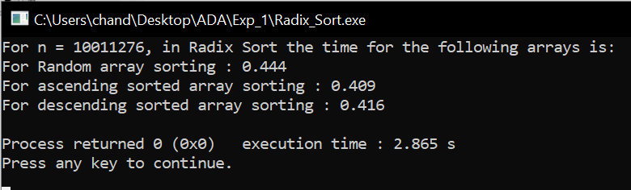

Result and Analysis:
In this algorithm running time depends on intermediate sorting algorithm which is counting sort. If the range of digits is from 1 to k, then counting sort time complexity is O (n+k). There are d passes i.e. counting sort is called d time, so total time complexity is O (nd+nk) =O (nd). As k=O (n) and d is constant, so radix sort runs in linear time. It performs the same way for best case as well

Shell sort
Instructions:
It is a generalized version of insertion sort. It is an in–place comparison sort. It is also known as diminishing increment sort; it is one of the oldest sorting algorithms invented by Donald L. Shell (1959.)This algorithm uses insertion sort on the large interval of elements to sort. Then the interval of sorting keeps on decreasing in a sequence until the interval reaches 1. These intervals are known as gap sequence.
Increment Sequences:

Shell’s original sequence: N/2 , N/4 , …, 1 (repeatedly divide by 2);
Hibbard’s increments: 1, 3, 7, …, 2^{k} – 1 ;
Knuth’s increments: 1, 4, 13, …, (3^{k} – 1) / 2 ;
Sedge wick’s increments: 1, 5, 19, 41, 109…

Here interval is calculated based on Knuth's formula as −
Knuth's Formula
h = h * 3 + 1, where ->h is interval with initial value 1

Pseudo code:
Procedure shellSort ()
A: array of items
/* calculate interval*/
while interval < A. length /3 do:
interval = interval * 3 + 1
end while

while interval > 0 do:
for outer = interval; outer < A. length; outer ++ do:
/* select value to be inserted */
ValueToInsert = A[outer]
inner = outer;
/*shift element towards right*/
while inner > interval -1 &&A [inner - interval] >= valueToInsert do:
A[inner] = A [inner - interval]
inner = inner - interval
end while
/* insert the number at hole position */
A[inner] = valueToInsert
end for
/* calculate interval*/
interval = (interval -1) /3;
end while
end procedure

#Code
#include <bits/stdc++.h>

using namespace std;

#define pb push_back
#define limit 100000000 // 1e8

typedef vector<int> VI;

void printer(VI vect){
for (int i = 0; i < vect.size(); i++)
cout << vect[i] << " ";
}

void shellSort(VI &vect) {
for (int interval = vect.size() / 2; interval > 0; interval /= 2) {
for (int i = interval; i < vect.size(); i += 1) {
int temp = vect[i];
int j;
for (j = i; j >= interval && vect[j - interval] > temp; j -= interval) {
vect[j] = vect[j - interval];
}
vect[j] = temp;
}
}
}

VI rand_VI(int n){
VI vect;
vect.reserve(n);
for(int i = 0 ; i < n;i++)
vect.pb(rand()%limit);
return vect;
}

VI asc_VI(int n){
VI vect;
vect.reserve(n);
for(int i = 0 ; i < n;i++)
vect.pb(i);
return vect;
}
VI dec_VI(int n){
VI vect;
vect.reserve(n);
for(int i = n-1 ; i >= 0;i--)
vect.pb(i);
return vect;
}

int main(){
srand(time(0));
int n = rand()%limit;
if(n<10000000){ // 1e7
n += 10000000;
}
cout<<"For n = "<<n<<", in Shell Sort the time for the following arrays is:"<<endl;
VI vect = rand_VI(n);
clock_t time_taken = clock();
shellSort(vect);
time_taken = clock() - time_taken;
cout<<"For Random array sorting : "<<(float)time_taken/CLOCKS_PER_SEC<<endl;
vect = asc_VI(n);
time_taken = clock();
shellSort(vect);
time_taken = clock() - time_taken;
cout<<"For ascending sorted array sorting : "<<(float)time_taken/CLOCKS_PER_SEC<<endl;
vect = dec_VI(n);
time_taken = clock();
shellSort(vect);
time_taken = clock() - time_taken;
cout<<"For descending sorted array sorting : "<<(float)time_taken/CLOCKS_PER_SEC<<endl;
return 0;
}
//This Code is made by Chander Jindal

Sample Example:

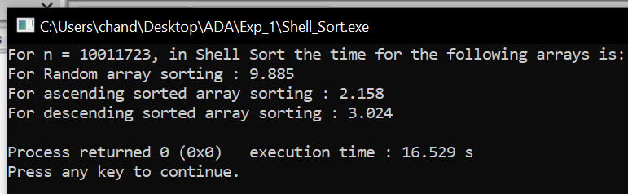

Result and Analysis:

Since in this algorithm insertion sort is applied in the large interval of elements and then interval reduces in a sequence, therefore the running time of Shell sort is heavily dependent on the gap sequence it uses. So in worst case time complexity is O (n²) and in Average Case time complexity depends on gap sequence while in Best Case Time complexity is O(n*log n).

Selection sort
Instructions:
Selection sort is a simple sorting algorithm. This sorting algorithm is an in-place comparison-based algorithm in which the list is divided into two parts, the sorted part at the left end and the unsorted part at the right end. Initially, the sorted part is empty and the unsorted part is the entire list. The smallest element is selected from the unsorted array and swapped with the leftmost element, and that element becomes a part of the sorted array. This process continues moving unsorted array boundary by one element to the right.
Pseudo code:
Procedure selection sort
list: array of items
n: size of list
for i = 1 to n - 1
/* set current element as minimum*/
min = i
/* check the element to be minimum */
for j = i+1 to n
if list[j] < list [min] then
min = j;
end if
end for
/* swap the minimum element with the current element*/
if indexMin != i then
swap list[min] and list[i]
end if
end for
end procedure:

#Code
#include <bits/stdc++.h>
using namespace std;
#define pb push_back
#define limit 10000
typedef vector<int> VI;
void printer(VI vect){
for (int i = 0; i < vect.size(); i++)
cout << vect[i] << " ";}
void selectionSort(VI &vect){
int min_idx;
for (int i = 0; i < vect.size()-1; i++){
min_idx = i;
for (int j = i+1; j < vect.size(); j++)
if (vect[j] < vect[min_idx])
min_idx = j;
swap(vect[min_idx], vect[i]);}
return;}
VI rand_VI(int n){
VI vect;
vect.reserve(n);
for(int i = 0 ; i < n;i++)
vect.pb(rand()%limit);
return vect;
}
VI asc_VI(int n){
VI vect;
vect.reserve(n);
for(int i = 0 ; i < n;i++)
vect.pb(i);
return vect;
}
VI dec_VI(int n){
VI vect;
vect.reserve(n);
for(int i = n-1 ; i >= 0;i--)
vect.pb(i);
return vect;
}
int main(){
srand(time(0));
int n = rand()%limit;
if(n<1000){
n += 1000;
}
cout<<"For n = "<<n<<", in Selection Sort the time for the following arrays is:"<<endl;
VI vect = rand_VI(n);
clock_t time_taken = clock();
selectionSort(vect);
time_taken = clock() - time_taken;
cout<<"For Random array sorting : "<<(float)time_taken/CLOCKS_PER_SEC<<endl;
vect = asc_VI(n);
time_taken = clock();
selectionSort(vect);
time_taken = clock() - time_taken;
cout<<"For ascending sorted array sorting : "<<(float)time_taken/CLOCKS_PER_SEC<<endl;
vect = dec_VI(n);
time_taken = clock();
selectionSort(vect);
time_taken = clock() - time_taken;
cout<<"For descending sorted array sorting : "<<(float)time_taken/CLOCKS_PER_SEC<<endl;
return 0;
}
//This Code is made by Chander Jindal
Sample Example:
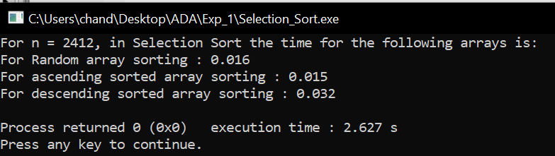

Result and Analysis:

To find the minimum element from the array of N elements, N−1 comparisons are required. After putting the minimum element in its proper position, the size of an unsorted array reduces to N−1 and then N−2 comparisons are required to find the minimum in the unsorted array. Therefore (N−1) + (N−2) + ....... + 1 = (N (N−1))/2 comparisons and N swaps result in the overall complexity of O (N2).
Heap sort
Instructions:
This algorithm is divided into two basic parts:
- Creating a Heap of the unsorted list.
- Then a sorted array is created by repeatedly removing the largest/smallest element from the heap, and inserting it into the array. The heap is reconstructed after each removal.

What is a heap?

Heap is a special tree-based data structure, which satisfies the following special heap properties:

Shape Property: Heap data structure is always a Complete Binary Tree, which means all levels of the tree are fully filled.

Heap Property: All nodes are either [greater than or equal to] or [less than or equal to] each of its children. If the parent nodes are greater than their children, heap is called a Max-Heap, and if the parent nodes are smaller than their child nodes, heap is called Min-Heap.

Initially on receiving an unsorted list, the first step in heap sort is to create a Heap data structure (Max-Heap or Min-Heap). Once heap is built, the first element of the Heap is either largest or smallest (depending upon Max-Heap or Min-Heap), so we put the first element of the heap in our array. Then we again make heap using the remaining elements, to again pick the first element of the heap and put it into the array. We keep on doing the same repeatedly until we have the complete sorted list in our array.
Pseudo code:
Heapsort (A) {
BuildHeap(A)
for i <- length (A) downto 2 {
exchange A [1] <-> A[i]
heapsize <- heapsize -1
Heapify(A, 1)
}

BuildHeap (A) {
heapsize <- length (A)
for i <- floor (length/2) downto 1
Heapify (A, i)
}

Heapify (A, i) {
le <- left (i)
ri <- right(i)
if (le<=heapsize) and (A[le]>A[i])
largest <- le
else
largest <- i
if (ri<=heapsize) and (A[ri]>A[largest])
largest <- ri
if (largest != i) {
exchange A[i] <-> A[largest]
Heapify(A, largest)
}
}

#Code
#include <bits/stdc++.h>
using namespace std;
#define pb push_back
#define limit 10000
typedef vector<int> VI;

void printer(VI vect){
for (int i = 0; i < vect.size(); i++)
cout << vect[i] << " ";
}

void heapify(VI vect, int n, int i){
int largest = i;
int l = 2 * i + 1;
int r = 2 * i + 2;

if (l < n && vect[l] > vect[largest])
largest = l;

if (r < n && vect[r] > vect[largest])
largest = r;

if (largest != i) {
swap(vect[i], vect[largest]);

heapify(vect, n, largest);
}
}

void heapSort(VI &vect, int n){
for (int i = n / 2 - 1; i >= 0; i--)
heapify(vect, n, i);

for (int i = n - 1; i > 0; i--) {
swap(vect[0], vect[i]);
heapify(vect, i, 0);
}
}

VI rand_VI(int n){
VI vect;
vect.reserve(n);
for(int i = 0 ; i < n;i++)
vect.pb(rand()%limit);
return vect;
}

VI asc_VI(int n){
VI vect;
vect.reserve(n);
for(int i = 0 ; i < n;i++)
vect.pb(i);
return vect;
}
VI dec_VI(int n){
VI vect;
vect.reserve(n);
for(int i = n-1 ; i >= 0;i--)
vect.pb(i);
return vect;
}

int main(){
srand(time(0));
int n = rand()%limit;
if(n<1000){
n += 1000;
}
cout<<"For n = "<<n<<", in Heap Sort the time for the following arrays is:"<<endl;
VI vect = rand_VI(n);
clock_t time_taken = clock();
heapSort(vect,vect.size());
time_taken = clock() - time_taken;
cout<<"For Random array sorting : "<<(float)time_taken/CLOCKS_PER_SEC<<endl;
vect = asc_VI(n);
time_taken = clock();
heapSort(vect,vect.size());
time_taken = clock() - time_taken;
cout<<"For ascending sorted array sorting : "<<(float)time_taken/CLOCKS_PER_SEC<<endl;
vect = dec_VI(n);
time_taken = clock();
heapSort(vect,vect.size());
time_taken = clock() - time_taken;
cout<<"For descending sorted array sorting : "<<(float)time_taken/CLOCKS_PER_SEC<<endl;
return 0;
}
//This Code is made by Chander Jindal

Sample Example:
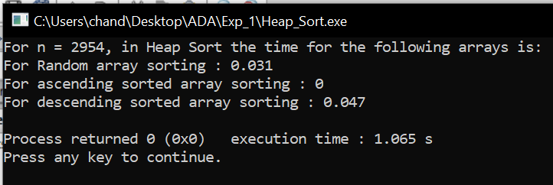

Result and Analysis:
Heap sort has the best possible worst case running time complexity of O (n Log n).It doesn't need any extra storage and that makes it good for situations where array size is large. Heapify runs in time O (h) and there are at most n=2^{h+1}-1 nodes in an almost complete binary tree of height h, so Heapify runs in time O (ln n). Build-Heap calls Heapify n/2 times, so it takes O (n h) = O (n ln n).
Experiment 2
Aim: To implement Linear search and Binary search and analyse its time complexity.
Instructions:
The search operation can be done in the following two ways:
Linear search:
It’s a sequential search is made over all items one by one. Every item is checked and if a match is found then that particular item is returned, otherwise the search continues till the end of the data collection.
Binary search:
This search algorithm works on the principle of divide and conquers. For this algorithm, the data collection should be in the sorted form. Binary search looks for a particular item by comparing the middle most item of the collection. If a match occurs, then the index of item is returned. If the middle item is greater than the item, then the item is searched in the sub-array to the left of the middle item. Otherwise, the item is searched for in the sub-array to the right of the middle item. This process continues on the sub-array as well until the size of the sub array reduces to zero.

Pseudo code for linear search:
Procedure linear_search (list, value)
for each item in the list
if match item == value
return the item's location
end if
end for
end procedure

Pseudo code for Binary search:
BinarySearch (A [0...N-1], value)
{
low = 0
high = N - 1
while (low <= high) {
// invariants: value > A[i] for all i < low
value < A[i] for all i > high
mid = (low + high) / 2
if (A[mid] > value)
high = mid - 1
else if (A[mid] < value)
low = mid + 1
else
return mid
}
return not_found // value would be inserted at index "low"
}

#Code
#include <bits/stdc++.h>
using namespace std;
#define pb push_back
#define limit1 10000000
#define limit2 100000000
typedef vector<int> VI;
int Linear_search(VI vect, int item){
for(int i = 0; i < vect.size(); i++)
if (vect[i] == item)
return i;
return -1;}
int Binary_search(VI vect, int l, int r, int item){
if (r >= l) {
int mid = l + (r - l) / 2;
if (vect[mid] == item)
return mid;
if (vect[mid] > item)
return Binary_search(vect, l, mid - 1, item);
return Binary_search(vect, mid + 1, r, item);}}
VI make_vector(int n){
VI vect;
vect.reserve(n);
for(int i = 0 ; i < n;i++)
vect.pb(rand()%limit2);
return vect;}
int main(){
srand(time(0));
int n = rand()%limit2;
if(n<limit1)
n += limit1;
VI vect = make_vector(n);
cout<<"For n = "<<n<<", for Linear Search, time taken:"<<endl;
clock_t time_taken = clock();
Linear_search(vect,vect[0]);
time_taken = clock() - time_taken;
cout<<"For First element in array : "<<(float)time_taken/CLOCKS_PER_SEC<<endl;
time_taken = clock();
Linear_search(vect,vect[n/2]);
time_taken = clock() - time_taken;
cout<<"For Middle element in array : "<<(float)time_taken/CLOCKS_PER_SEC<<endl;
time_taken = clock();
Linear_search(vect,vect[n-1]);
time_taken = clock() - time_taken;
cout<<"For Last element in array : "<<(float)time_taken/CLOCKS_PER_SEC<<endl;
time_taken = clock();
Linear_search(vect,limit2);
time_taken = clock() - time_taken;
cout<<"For Non-existing element in array : "<<(float)time_taken/CLOCKS_PER_SEC<<endl;
cout<<"\n\n"<<endl;
cout<<"For n = "<<n<<", for Binary Search, time taken:"<<endl;
time_taken = clock();
Binary_search(vect,0,n-1,vect[0]);
time_taken = clock() - time_taken;
cout<<"For First element in array : "<<(float)time_taken/CLOCKS_PER_SEC<<endl;
time_taken = clock();
Binary_search(vect,0,n-1,vect[n/2]);
time_taken = clock() - time_taken;
cout<<"For Middle element in array : "<<(float)time_taken/CLOCKS_PER_SEC<<endl;
time_taken = clock();
Binary_search(vect,0,n-1,vect[n-1]);
time_taken = clock() - time_taken;
cout<<"For Last element in array : "<<(float)time_taken/CLOCKS_PER_SEC<<endl;
time_taken = clock();
Binary_search(vect,0,n-1,limit2);
time_taken = clock() - time_taken;
cout<<"For Non-existing element in array : "<<(float)time_taken/CLOCKS_PER_SEC<<endl;
return 0;}
//This Code is made by Chander Jindal
Sample Example:
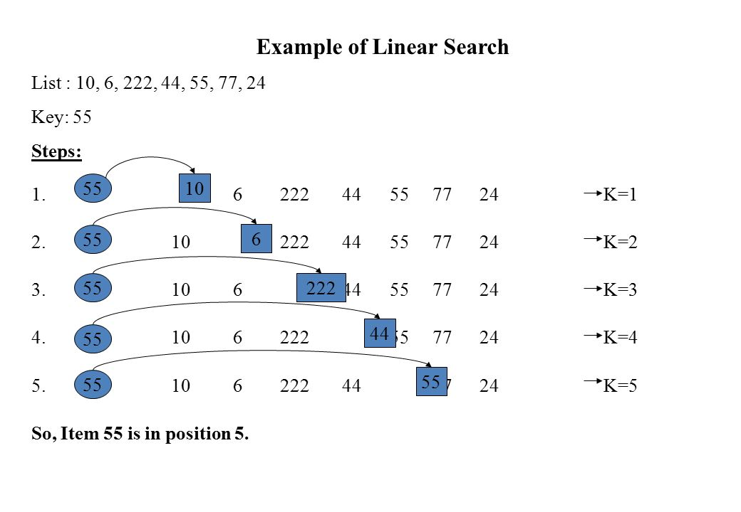
Example of Binary Search:
A sorted array is taken as input. The mid value is found out recursively.
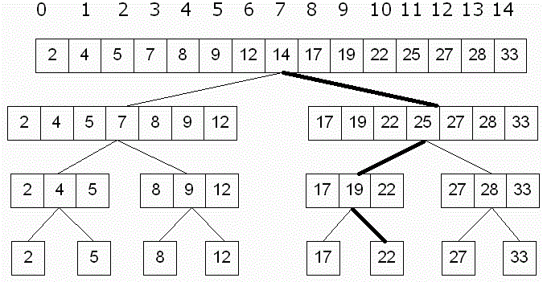
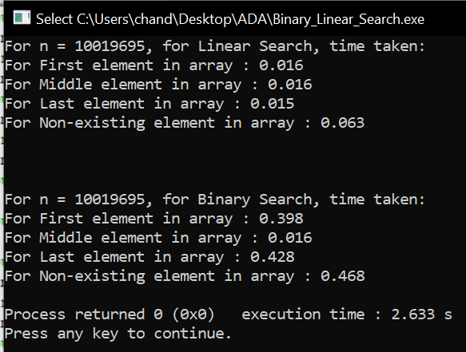

Result and Analysis:
Input data needs to be sorted in Binary Search and not in Linear Search and it does the sequential access whereas Binary search access data randomly. So, time complexity of linear search is O (n) while Binary search has time complexity O (log n) as search is done to either half of the given list.

Experiment 3
Aim: To implement Matrix chain Multiplication and analyse its time complexity.
Problem: Given a sequence of matrices A1, A2… An, insert parentheses so that the product of the matrices, in order, is unambiguous and needs the minimal number of multiplication

Matrix multiplication is associative: A1 (A2A3) = (A1A2) A3

A product is unambiguous if no factor is multiplied on both the left and the right and all factors are either a single matrix or an unambiguous product.
Multiplying an i×j and a j×k matrix requires ijk multiplications. Each element of the product requires j multiplications, and there are ik elements

Number of Parenthesizations
Given the matrices A1,A2,A3, A4. Assume the dimensions of A1=d0×d1, etc. Below are the five possible parenthesizations of these arrays, along with the number of multiplications:
    - (A1A2)(A3A4):d0d1d2+d2d3d4+d0d2d4
    - ((A1A2)A3)A4:d0d1d2+d0d2d3+d0d3d4
    - (A1(A2A3))A4:d1d2d3+d0d1d3+d0d3d4
    - A1((A2A3)A4):d1d2d3+d1d3d4+d0d1d4
    - A1(A2(A3A4)):d2d3d4+d1d2d4+d0d1d4
The number of parenthesizations is at least T(n)≥T(n−1)+T(n−1).Since the number with the first element removed is T(n−1), which is also the number with the last removed. Thus the number of parenthesizations is Ω(2n). The number is actually T (n)=n−1∑k=1T(k)T(n−k) which is related to the Catalan numbers.This is because the original product can be split into 2 sub products in k places. Each split is to be parenthesized optimally.This recurrence is related to the Catalan numbers.

Characterizing the Optimal Parenthesization
An optimal parenthesization of A1…An must break the product into two expressions, each of which is parenthesized or is a single array. Assume the break occurs at position k. In the optimal solution, the solution to the product A1…Ak must be optimal otherwise, we could improve A1…An by improving A1…Ak but the solution to A1…An is known to be optimal.This is a contradiction.Thus the solution to A1…An is known to be optimal.

Principle of Optimality
This problem exhibits the Principle of Optimality. The optimal solution to product A1…An contains the optimal solution to two sub products. Thus we can use Dynamic Programming. Consider a recursive solution
Then improve its performance with memoization or by rewriting bottom up

Matrix Dimensions
Consider matrix product A1×⋯×An. Let the dimensions of matrix Ai be di−1×di.
Thus the dimensions of matrix product Ai×⋯×Aj are di−1×dj.

Recursive Solution
Let M [i,j] represent the number of multiplications required for matrix product Ai×⋯×Aj. For 1≤i≤j<n : M [i,i]=0 since no product is required

The optimal solution of Ai×Aj must break at some point, k, with i≤k<j
Thus, M [i,j]=M[i,k] + M[k+1,j] + di−1dkdj

Thus, M[i,j]={0 if i=j and min i≤k<j{M[i,k]+M[k+1,j]+di−1dkdj}if i<j

Pseudo code:
// Matrix Ai has dimension p[i-1] x p[i] for i = 1..n

MATRIX-CHAIN-ORDER (p)
n←length [p]-1
for i←1 to n
do m[i,i]←0
for l←2to n
do for i←1 to n-l+1
do j←i+l-1
m[i,j]←∞
for k←ito j-1
do q←m[i,k] + m[k+1,j]+p_{i-1}p_{k}p_{j}
if q< m[i,j]
then m[i,j] ←q
s[i,j] ←k
return m and s

PRINT-OPTIMAL-PARENS (s, i, j)
if i=j
then print “A_{i}”
else print “ ( “
PRINT-OPTIMAL-PARENS (s, i, s[i,j])
PRINT-OPTIMAL-PARENS (s, s[i,j]+1, j)
print “ ) ”

#Code
(Matrix Chain Multiplication)
#include <bits/stdc++.h>
using namespace std;
#define limit1 10
#define limit2 100
#define pb push_back
typedef vector<int> VI;
int dp[limit1][limit1];
int Matrix_Chain_Multiplication(VI vect, int i, int j){
if (i == j)
return 0;
if (dp[i][j] != -1)
return dp[i][j];
dp[i][j] = INT_MAX;
for (int k = i; k < j; k++){
dp[i][j] = min(dp[i][j],
Matrix_Chain_Multiplication(vect, i, k)+ Matrix_Chain_Multiplication(vect, k + 1, j)+ vect[i - 1] * vect[k] * vect[j]);
}
return dp[i][j];
}
VI make_vector(int n){
VI vect;
vect.reserve(n);
for(int i = 0 ; i < n;i++)
vect.pb(rand()%limit2);
return vect;
}
void print_vector(VI vect){
for(int i =0;i<vect.size();i++)
cout<<vect[i]<<" ";
cout<<endl;
return;
}
int main(){
srand(time(0));
int n = rand()%limit1;
VI vect = make_vector(n);
memset(dp, -1, sizeof dp);
cout<<"For size of Matrices as follows:\n";
print_vector(vect);
cout << "Minimum number of multiplications required is "<< Matrix_Chain_Multiplication(vect,1, n-1);
}
//This Code is made by Chander Jindal
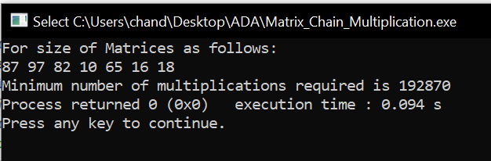

#Code
(Matrix Chain Order Parenthesis)
#include <bits/stdc++.h>
#define limit1 10
#define limit2 100
#define pb push_back
using namespace std;
typedef vector<int> VI;
void printParenthesis(int i, int j, int n, int* bracket,char& name){
if (i == j) {
cout<<name++;
return;
}
cout<<"(";
printParenthesis(i, *((bracket + i * n) + j), n,bracket, name);
printParenthesis(*((bracket + i * n) + j) + 1, j, n,bracket, name);
cout<<")";
}
void matrixChainOrder(VI vect){
int m[vect.size()][vect.size()];
int bracket[vect.size()][vect.size()];
for (int i = 1; i < vect.size(); i++)
m[i][i] = 0;
for (int L = 2; L < vect.size(); L++){
for (int i = 1; i < vect.size() - L + 1; i++){
int j = i + L - 1;
m[i][j] = INT_MAX;
for (int k = i; k <= j - 1; k++){
int q = m[i][k] + m[k + 1][j]+ vect[i - 1] * vect[k] * vect[j];
if (q < m[i][j]){
m[i][j] = q;
bracket[i][j] = k;
}
}
}
}
char name = 'A';
cout<<"Optimal Parenthesization is : ";
printParenthesis(1, vect.size() - 1, vect.size(), (int*)bracket, name);
cout<<"\nOptimal Cost is : " << m[1][vect.size() - 1]<<endl;
}
VI make_vector(int n){
VI vect;
vect.reserve(n);
for(int i = 0 ; i < n;i++)
vect.pb(rand()%limit2);
return vect;
}
void print_vector(VI vect){
for(int i =0;i<vect.size();i++)
cout<<vect[i]<<" ";
cout<<endl;
return;
}
int main(){
srand(time(0));
int n = rand()%limit1;
VI vect = make_vector(n);
cout<<"For size of Matrices as follows:\n";
print_vector(vect);
matrixChainOrder(vect);
}
//This Code is made by Chander Jindal
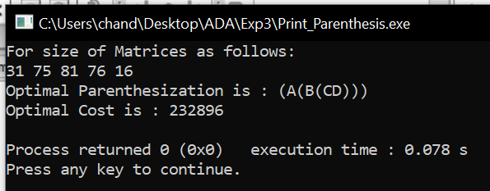

Result and Analysis:
Clearly, the space complexity of this procedure is Ο (n²). Since the tables m and s require Ο (n²) space. As far as the time complexity is concern, a simple inspection of the for-loop(s) structures gives us a running time of the procedure. Since, the three for-loops are nested three deep, and each one of them iterates at most n times (that is to say indices L, i, and j takes on at most n − 1 values). Therefore, the running time of this procedure is Ο (n³).

