***Analyzing and Rating Greenness of Nature-Inspired Algorithms  
(Supplementary)***

***Base Metrics***

***T#1.0 Base Main Result***

|  |  |  |  |  |
| --- | --- | --- | --- | --- |
| **ID** | **Accuracy** | **Time Taken (s)** | **Energy Used (J)** | **Equivalent CO2 Emission (mg)** |
| BASE-0001 | 92.89995389580452 | 3 | 9.8 | 2.313888888888889 |

***T#1.1 Base Energy Distribution***

|  |  |  |  |  |  |  |
| --- | --- | --- | --- | --- | --- | --- |
| **ID** | **Time Taken(s)** | **Total Energy(J)** | **CPU(J)** | **Monitor(J)** | **Disk(J)** | **Base(J)** |
| BASE-0001 | 3 | 9.8 | 5.4 | 0.0 | 0.0 | 4.5 |

***Algorithms Analyzed Are:-  
 ->Bat  
 ->Camel Algorithm  
 ->Cuckoo Search  
 ->Fire Fly  
 ->Particle Swarm***

**NIA Bat**

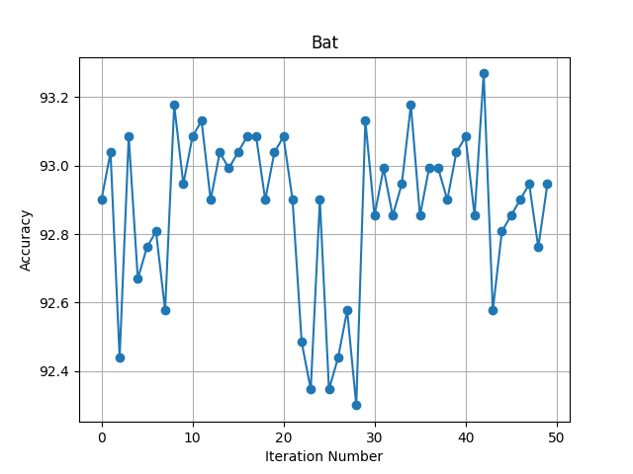

***Fig#1.0 Bat Iterations***

***T#2.0 Bat Main Result***

|  |  |  |  |  |
| --- | --- | --- | --- | --- |
| **ID** | **Accuracy** | **Time Taken (s)** | **Energy Used (J)** | **Equivalent CO2 Emission (mg)** |
| BAT-0000 | 92.89995389580452 | 163 | 531.8000000000002 | 125.56388888888893 |
| BAT-0001 | 93.03826648224988 | 72 | 233.4999999999999 | 55.131944444444414 |
| BAT-0002 | 92.43891194098664 | 259 | 832.6000000000007 | 196.58611111111128 |
| BAT-0003 | 93.08437067773168 | 306 | 980.2000000000008 | 231.4361111111113 |
| BAT-0004 | 92.66943291839556 | 19 | 63.6 | 15.016666666666667 |
| BAT-0005 | 92.76164130935916 | 100 | 322.1 | 76.05138888888888 |
| BAT-0006 | 92.80774550484094 | 34 | 110.59999999999998 | 26.113888888888884 |
| BAT-0007 | 92.577224527432 | 466 | 1500.1999999999982 | 354.21388888888845 |
| BAT-0008 | 93.17657906869525 | 76 | 247.1 | 58.34305555555555 |
| BAT-0009 | 92.94605809128632 | 56 | 183.2 | 43.25555555555555 |
| BAT-0010 | 93.08437067773168 | 88 | 283.2999999999999 | 66.89027777777775 |
| BAT-0011 | 93.13047487321346 | 78 | 251.7999999999999 | 59.45277777777776 |
| BAT-0012 | 92.89995389580452 | 91 | 291.8999999999999 | 68.9208333333333 |
| BAT-0013 | 93.03826648224988 | 13 | 43.10000000000001 | 10.17638888888889 |
| BAT-0014 | 92.99216228676808 | 30 | 98.29999999999998 | 23.20972222222222 |
| BAT-0015 | 93.03826648224988 | 67 | 219.9999999999999 | 51.944444444444414 |
| BAT-0016 | 93.08437067773168 | 115 | 371.60000000000014 | 87.73888888888892 |
| BAT-0017 | 93.08437067773168 | 533 | 1741.1 | 411.0930555555556 |
| BAT-0018 | 92.89995389580452 | 23 | 74.50000000000001 | 17.590277777777782 |
| BAT-0019 | 93.03826648224988 | 96 | 311.8999999999998 | 73.6430555555555 |
| BAT-0020 | 93.08437067773168 | 9 | 29.4 | 6.941666666666666 |
| BAT-0021 | 92.89995389580452 | 81 | 261.8 | 61.81388888888889 |
| BAT-0022 | 92.48501613646842 | 353 | 1133.0000000000011 | 267.51388888888914 |
| BAT-0023 | 92.34670355002304 | 591 | 1901.000000000001 | 448.84722222222246 |
| BAT-0024 | 92.89995389580452 | 155 | 497.5 | 117.46527777777776 |
| BAT-0025 | 92.34670355002304 | 591 | 1917.9999999999973 | 452.8611111111105 |
| BAT-0026 | 92.43891194098664 | 565 | 1816.4 | 428.8722222222221 |
| BAT-0027 | 92.577224527432 | 604 | 1940.0999999999983 | 458.0791666666663 |
| BAT-0028 | 92.30059935454128 | 170 | 547.0000000000002 | 129.15277777777783 |
| BAT-0029 | 93.13047487321346 | 230 | 761.9000000000007 | 179.89305555555572 |
| BAT-0030 | 92.85384970032273 | 40 | 129.4 | 30.552777777777777 |
| BAT-0031 | 92.99216228676808 | 43 | 139.99999999999997 | 33.05555555555555 |
| BAT-0032 | 92.85384970032273 | 37 | 119.79999999999998 | 28.286111111111108 |
| BAT-0033 | 92.94605809128632 | 478 | 1539.8 | 363.56388888888887 |
| BAT-0034 | 93.17657906869525 | 793 | 2728.300000000002 | 644.1819444444449 |
| BAT-0035 | 92.85384970032273 | 56 | 195.7 | 46.20694444444444 |
| BAT-0036 | 92.99216228676808 | 145 | 479.6000000000001 | 113.23888888888892 |
| BAT-0037 | 92.99216228676808 | 89 | 288.49999999999994 | 68.11805555555554 |
| BAT-0038 | 92.89995389580452 | 124 | 402.1 | 94.94027777777778 |
| BAT-0039 | 93.03826648224988 | 28 | 92.5 | 21.840277777777786 |
| BAT-0040 | 93.08437067773168 | 150 | 490.0000000000003 | 115.69444444444451 |
| BAT-0041 | 92.85384970032273 | 105 | 341.6999999999999 | 80.67916666666663 |
| BAT-0042 | 93.26878745965884 | 100 | 323.19999999999993 | 76.31111111111109 |
| BAT-0043 | 92.577224527432 | 70 | 225.8999999999999 | 53.33749999999997 |
| BAT-0044 | 92.80774550484094 | 38 | 124.0 | 29.27777777777778 |
| BAT-0045 | 92.85384970032273 | 9 | 29.1 | 6.870833333333334 |
| BAT-0046 | 92.89995389580452 | 67 | 220.29999999999995 | 52.01527777777776 |
| BAT-0047 | 92.94605809128632 | 618 | 1988.399999999997 | 469.4833333333326 |
| BAT-0048 | 92.76164130935916 | 129 | 421.8 | 99.59166666666664 |
| BAT-0049 | 92.94605809128632 | 12 | 40.1 | 9.468055555555557 |

***T#2.1 Bat Parameters***

|  |  |  |  |  |  |  |  |  |  |  |
| --- | --- | --- | --- | --- | --- | --- | --- | --- | --- | --- |
| **ID** | **population_size** | **loudness** | **pulse_rate** | **gamma** | **alpha** | **min_frequency** | **max_frequency** | **n_estimator** | **criterion** | **max_feature** |
| BAT-0000 | 45 | 0.4953294691693303 | 0.6002920007053112 | 0.1574105080560471 | 0.8917689509621813 | 9.21422629852615 | 78.4827738814337 | 528 | entropy | sqrt |
| BAT-0001 | 95 | 0.8614281821799779 | 0.796477014594362 | 0.1622299134734751 | 0.1279079854004264 | 6.31227604521258 | 69.61764669660025 | 233 | entropy | sqrt |
| BAT-0002 | 93 | 0.4978640123835224 | 0.5090871677180451 | 0.6405368411366579 | 0.9978071365524832 | 2.7311981207266167 | 72.36074137762624 | 231 | gini | nan |
| BAT-0003 | 28 | 0.191723735630543 | 0.2647039138571946 | 0.6652693727626408 | 0.3493085843715032 | 8.610417751508262 | 88.6826965509445 | 198 | entropy | nan |
| BAT-0004 | 37 | 0.3743900780349997 | 0.5345462018375161 | 0.6931028571396962 | 0.7495520167868096 | 4.301354431109951 | 41.81352364467864 | 125 | gini | log2 |
| BAT-0005 | 42 | 0.2644644623596952 | 0.3095966358709754 | 0.9872249661735412 | 0.1327065391291453 | 0.8656813233197913 | 82.96179218092723 | 391 | entropy | log2 |
| BAT-0006 | 84 | 0.9075516816611184 | 0.3722566072179196 | 0.2240818464269461 | 0.956301394092128 | 2.953998425463765 | 63.50183494975716 | 230 | gini | log2 |
| BAT-0007 | 86 | 0.2745576897508995 | 0.7247456603025114 | 0.2334964509928879 | 0.847376332746871 | 3.2690122425907098 | 58.24871547638601 | 413 | gini | nan |
| BAT-0008 | 18 | 0.943559675266398 | 0.4550992941131689 | 0.4526998610624483 | 0.730451281833682 | 2.8940862906654496 | 10.2795592623251 | 243 | entropy | sqrt |
| BAT-0009 | 86 | 0.9313760525356022 | 0.9558268591464496 | 0.5356075977122547 | 0.5224503667152683 | 7.632338519020548 | 62.88804963998271 | 179 | entropy | sqrt |
| BAT-0010 | 30 | 0.8217451290912786 | 0.6766779538683375 | 0.2901886951261252 | 0.6059828307794728 | 6.46126341665839 | 94.1030930820384 | 486 | gini | sqrt |
| BAT-0011 | 24 | 0.9514379964172044 | 0.9552037985857992 | 0.954979481081112 | 0.9832290651111284 | 9.267307256274538 | 49.37099501970248 | 252 | entropy | sqrt |
| BAT-0012 | 58 | 0.9591395464133698 | 0.7408573137407606 | 0.3644356852168029 | 0.2967467442313971 | 1.998412489993605 | 73.26024074396044 | 293 | entropy | sqrt |
| BAT-0013 | 28 | 0.2133188744693481 | 0.9272489708535614 | 0.996518494429931 | 0.2886065558874167 | 7.501941247213017 | 42.5505689402025 | 90 | gini | log2 |
| BAT-0014 | 62 | 0.7278026364168874 | 0.3948473872865461 | 0.9309400307782966 | 0.8987533396817095 | 7.254370861165908 | 22.576738510818863 | 162 | gini | sqrt |
| BAT-0015 | 57 | 0.4279958124362516 | 0.3661934531039721 | 0.984428257858398 | 0.3244649557446211 | 1.9856261652856844 | 98.96539614378602 | 217 | entropy | sqrt |
| BAT-0016 | 66 | 0.1687960748614853 | 0.6611076113128105 | 0.7283612980269232 | 0.8016841188373117 | 9.490899170058189 | 84.74082131200986 | 446 | entropy | log2 |
| BAT-0017 | 42 | 0.6208195110875413 | 0.2649418632853156 | 0.5607603348986903 | 0.6666040383273526 | 3.109389058576816 | 55.69594158010473 | 342 | entropy | nan |
| BAT-0018 | 77 | 0.4434027834873446 | 0.2136016495205439 | 0.3872207589298518 | 0.1783390552515336 | 5.153788730438005 | 80.18130928889885 | 154 | gini | log2 |
| BAT-0019 | 18 | 0.5162230059330248 | 0.6644478861681289 | 0.6647033831174985 | 0.8390631936804084 | 1.8408124595895317 | 96.49468050716096 | 371 | entropy | log2 |
| BAT-0020 | 79 | 0.8295089967508756 | 0.2198340178255869 | 0.3962679129092186 | 0.6090452814909574 | 4.361669193659439 | 14.99869539380345 | 62 | gini | log2 |
| BAT-0021 | 38 | 0.1866942147781303 | 0.6800599092280869 | 0.6065996164688351 | 0.3245820304957759 | 6.853741091069763 | 61.49632082357167 | 548 | gini | log2 |
| BAT-0022 | 70 | 0.4261897009635769 | 0.5147014833649249 | 0.8794303093684457 | 0.4112341124769498 | 7.149174732910839 | 84.96864557194183 | 312 | gini | nan |
| BAT-0023 | 97 | 0.9438204041366876 | 0.396522923244772 | 0.4146905428757267 | 0.5522537806491677 | 2.7311627730694776 | 28.57121461763877 | 526 | gini | nan |
| BAT-0024 | 31 | 0.7834359412097152 | 0.6560579552300403 | 0.3513365922862705 | 0.389137313630459 | 6.986187724201986 | 40.74557088909562 | 100 | entropy | nan |
| BAT-0025 | 59 | 0.5113189889790577 | 0.8724472759760682 | 0.3442555897010584 | 0.4285103223276988 | 2.935810101656824 | 76.00583555874913 | 525 | gini | nan |
| BAT-0026 | 48 | 0.5510684224375982 | 0.9916425559013072 | 0.2850307278295682 | 0.493878374099693 | 1.9421330802475167 | 87.29566367063187 | 502 | gini | nan |
| BAT-0027 | 87 | 0.5514650862130996 | 0.4302035654023899 | 0.7519909622090749 | 0.1921541927960391 | 4.849942382453071 | 93.85206702237484 | 536 | gini | nan |
| BAT-0028 | 22 | 0.4471843203722451 | 0.9893366905166878 | 0.557994608463538 | 0.9789733323749332 | 7.985802467045852 | 95.5339012410722 | 151 | gini | nan |
| BAT-0029 | 34 | 0.5402185450894988 | 0.2257580187098109 | 0.5491954406464407 | 0.9317165861243726 | 7.794124570577695 | 86.87230045164576 | 147 | entropy | nan |
| BAT-0030 | 77 | 0.4050042914285511 | 0.8805672101028759 | 0.5678179196974483 | 0.7160913497937218 | 3.545830887564101 | 14.876206429419115 | 128 | entropy | sqrt |
| BAT-0031 | 51 | 0.8594035075272777 | 0.5766929570405519 | 0.6698730192198146 | 0.3326802884659725 | 8.333117161938947 | 18.096051831957595 | 139 | entropy | sqrt |
| BAT-0032 | 83 | 0.3263882179735297 | 0.618094862669746 | 0.9988797583649928 | 0.1305142770262983 | 8.035092387918034 | 57.02979122201562 | 119 | entropy | sqrt |
| BAT-0033 | 39 | 0.7154766811386368 | 0.59313855013097 | 0.8689894447143621 | 0.962996304447218 | 1.8461442142447737 | 18.68264629945117 | 309 | entropy | nan |
| BAT-0034 | 59 | 0.1045009312555751 | 0.954570441954226 | 0.3187595810321446 | 0.3443622237400129 | 7.394612003804263 | 52.76033902090396 | 490 | entropy | nan |
| BAT-0035 | 43 | 0.4008086187454959 | 0.7634873928283312 | 0.6478955208513529 | 0.6793373761615064 | 5.727610090599553 | 59.26329780815977 | 300 | gini | sqrt |
| BAT-0036 | 65 | 0.5152574067731476 | 0.5821280001876377 | 0.587595068237799 | 0.7619400210089619 | 1.6199968179224755 | 64.60604749074813 | 462 | entropy | sqrt |
| BAT-0037 | 91 | 0.8913680549015369 | 0.3756356840602375 | 0.5552988897118324 | 0.7983762811673834 | 5.041635035198087 | 64.35322747328385 | 286 | entropy | sqrt |
| BAT-0038 | 74 | 0.1543318041920763 | 0.6553812378048784 | 0.8689265937549328 | 0.3654588012770043 | 3.318600090692476 | 78.68686109833916 | 484 | entropy | log2 |
| BAT-0039 | 71 | 0.9026144847091192 | 0.542949983058037 | 0.1663012583787997 | 0.3577010490585364 | 4.764237138888693 | 88.94162521744933 | 154 | gini | sqrt |
| BAT-0040 | 18 | 0.8089776908366232 | 0.9038273843656044 | 0.404860211447162 | 0.8844349061713712 | 5.266911965588118 | 13.66342068222656 | 586 | entropy | log2 |
| BAT-0041 | 58 | 0.7453414454309494 | 0.5906065023865308 | 0.2276841298417471 | 0.8444603697216936 | 3.579237298356669 | 32.30850226210738 | 573 | gini | sqrt |
| BAT-0042 | 26 | 0.2116577168633995 | 0.1338017174949213 | 0.5132955650717262 | 0.4385770398507839 | 5.906439656740357 | 26.932789860419994 | 321 | entropy | sqrt |
| BAT-0043 | 98 | 0.1620250793876899 | 0.7148662079685199 | 0.5098202571739955 | 0.2766591676913609 | 1.833454870483072 | 56.605941637707154 | 274 | entropy | log2 |
| BAT-0044 | 65 | 0.2600000929071908 | 0.3513421243099005 | 0.3169772647360689 | 0.1174567250981445 | 5.561795853990093 | 82.85267792199589 | 260 | gini | log2 |
| BAT-0045 | 24 | 0.4496242594869295 | 0.6806630659350815 | 0.8052782780205264 | 0.9875157091402692 | 3.926773395485732 | 37.38012885481116 | 57 | gini | log2 |
| BAT-0046 | 53 | 0.4774751649615241 | 0.2034510190674378 | 0.8137366730155703 | 0.4635211741147196 | 3.969038743300066 | 43.26179928189517 | 368 | gini | sqrt |
| BAT-0047 | 39 | 0.8569248863083163 | 0.4997621312809945 | 0.8039239186906227 | 0.8124028325898209 | 6.8928096808732775 | 65.79864720940319 | 399 | entropy | nan |
| BAT-0048 | 41 | 0.9094800396763316 | 0.7450846003340303 | 0.3974039298668095 | 0.4064877301333206 | 3.779412612809452 | 12.87583832708724 | 503 | entropy | log2 |
| BAT-0049 | 35 | 0.7121235451887695 | 0.8394778524659626 | 0.4980097722491564 | 0.5658609040087879 | 4.073624445651803 | 86.1730213244021 | 45 | entropy | log2 |

***T#2.2 Bat Energy Distribution***

|  |  |  |  |  |  |  |
| --- | --- | --- | --- | --- | --- | --- |
| **ID** | **Time Taken(s)** | **Total Energy(J)** | **CPU(J)** | **Monitor(J)** | **Disk(J)** | **Base(J)** |
| BAT-0000 | 163 | 531.8000000000002 | 294.39999999999986 | 0.0 | 0.0 | 244.5 |
| BAT-0001 | 72 | 233.4999999999999 | 128.49999999999994 | 0.0 | 0.0 | 108.0 |
| BAT-0002 | 259 | 832.6000000000007 | 454.6000000000003 | 0.0 | 0.0 | 388.5 |
| BAT-0003 | 306 | 980.2000000000008 | 535.4000000000004 | 0.0 | 0.0 | 459.0 |
| BAT-0004 | 19 | 63.6 | 35.8 | 0.0 | 0.0 | 28.5 |
| BAT-0005 | 100 | 322.1 | 176.69999999999993 | 0.0 | 0.0 | 150.0 |
| BAT-0006 | 34 | 110.59999999999998 | 61.500000000000014 | 0.0 | 0.0 | 51.0 |
| BAT-0007 | 466 | 1500.1999999999982 | 822.0000000000018 | 0.0 | 0.0 | 699.0 |
| BAT-0008 | 76 | 247.1 | 136.39999999999998 | 0.0 | 0.0 | 114.0 |
| BAT-0009 | 56 | 183.2 | 102.0 | 0.0 | 0.0 | 84.0 |
| BAT-0010 | 88 | 283.2999999999999 | 155.19999999999993 | 0.0 | 0.0 | 132.0 |
| BAT-0011 | 78 | 251.7999999999999 | 138.5 | 0.0 | 0.0 | 117.0 |
| BAT-0012 | 91 | 291.8999999999999 | 158.79999999999995 | 0.0 | 0.0 | 136.5 |
| BAT-0013 | 13 | 43.10000000000001 | 24.2 | 0.0 | 0.0 | 19.5 |
| BAT-0014 | 30 | 98.29999999999998 | 54.20000000000001 | 0.0 | 0.0 | 45.0 |
| BAT-0015 | 67 | 219.9999999999999 | 121.39999999999998 | 0.0 | 0.0 | 100.5 |
| BAT-0016 | 115 | 371.60000000000014 | 203.9999999999999 | 0.0 | 0.0 | 172.5 |
| BAT-0017 | 533 | 1741.1 | 964.3000000000026 | 0.0 | 0.0 | 799.5 |
| BAT-0018 | 23 | 74.50000000000001 | 41.1 | 0.0 | 0.0 | 34.5 |
| BAT-0019 | 96 | 311.8999999999998 | 171.6 | 0.0 | 0.0 | 144.0 |
| BAT-0020 | 9 | 29.4 | 16.4 | 0.0 | 0.0 | 13.5 |
| BAT-0021 | 81 | 261.8 | 143.79999999999995 | 0.0 | 0.0 | 121.5 |
| BAT-0022 | 353 | 1133.0000000000011 | 620.9000000000008 | 0.0 | 0.0 | 529.5 |
| BAT-0023 | 591 | 1901.000000000001 | 1040.7000000000023 | 0.0 | 0.0 | 886.5 |
| BAT-0024 | 155 | 497.5 | 272.1999999999998 | 0.0 | 0.0 | 232.5 |
| BAT-0025 | 591 | 1917.9999999999973 | 1057.7000000000032 | 0.0 | 0.7000000000000001 | 886.5 |
| BAT-0026 | 565 | 1816.4 | 994.8000000000036 | 0.0 | 0.0 | 847.5 |
| BAT-0027 | 604 | 1940.0999999999983 | 1060.6000000000022 | 0.0 | 0.0 | 906.0 |
| BAT-0028 | 170 | 547.0000000000002 | 300.2999999999999 | 0.0 | 0.0 | 255.0 |
| BAT-0029 | 230 | 761.9000000000007 | 427.1999999999999 | 0.0 | 0.0 | 345.0 |
| BAT-0030 | 40 | 129.4 | 71.39999999999999 | 0.0 | 0.0 | 60.0 |
| BAT-0031 | 43 | 139.99999999999997 | 77.5 | 0.0 | 0.0 | 64.5 |
| BAT-0032 | 37 | 119.79999999999998 | 66.10000000000001 | 0.0 | 0.0 | 55.5 |
| BAT-0033 | 478 | 1539.8 | 845.300000000002 | 0.0 | 0.0 | 717.0 |
| BAT-0034 | 793 | 2728.300000000002 | 1561.6 | 0.0 | 0.1 | 1189.5 |
| BAT-0035 | 56 | 195.7 | 112.79999999999998 | 0.0 | 0.0 | 84.0 |
| BAT-0036 | 145 | 479.6000000000001 | 267.29999999999995 | 0.0 | 0.0 | 217.5 |
| BAT-0037 | 89 | 288.49999999999994 | 159.59999999999994 | 0.0 | 0.0 | 133.5 |
| BAT-0038 | 124 | 402.1 | 222.1999999999997 | 0.0 | 0.0 | 186.0 |
| BAT-0039 | 28 | 92.5 | 51.60000000000001 | 0.0 | 0.0 | 42.0 |
| BAT-0040 | 150 | 490.0000000000003 | 270.7999999999998 | 0.0 | 0.0 | 225.0 |
| BAT-0041 | 105 | 341.6999999999999 | 188.6999999999999 | 0.0 | 0.0 | 157.5 |
| BAT-0042 | 100 | 323.19999999999993 | 177.19999999999993 | 0.0 | 0.0 | 150.0 |
| BAT-0043 | 70 | 225.8999999999999 | 123.39999999999998 | 0.0 | 0.0 | 105.0 |
| BAT-0044 | 38 | 124.0 | 68.3 | 0.0 | 0.0 | 57.0 |
| BAT-0045 | 9 | 29.1 | 15.8 | 0.0 | 0.0 | 13.5 |
| BAT-0046 | 67 | 220.29999999999995 | 122.19999999999992 | 0.0 | 0.1 | 100.5 |
| BAT-0047 | 618 | 1988.399999999997 | 1086.4000000000026 | 0.0 | 0.0 | 927.0 |
| BAT-0048 | 129 | 421.8 | 233.19999999999987 | 0.0 | 0.0 | 193.5 |
| BAT-0049 | 12 | 40.1 | 22.6 | 0.0 | 0.0 | 18.0 |

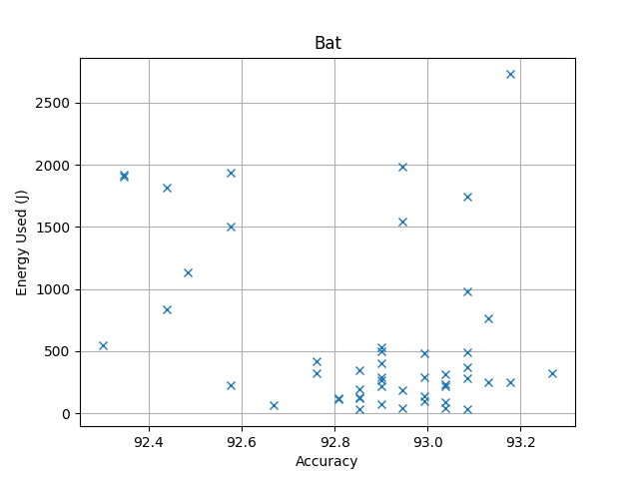

***Fig#1.1 Bat Energy Vs Accuracy***

***T#2.3 Bat Top 10 Values***

|  |  |  |  |  |  |  |  |
| --- | --- | --- | --- | --- | --- | --- | --- |
| **ID** | **Time Taken(s)** | **Total Energy(J)** | **CPU(J)** | **Monitor(J)** | **Disk(J)** | **Base(J)** | **Power Consumption (w)** |
| BAT-0042 | 100 | 323.19999999999993 | 177.19999999999993 | 0.0 | 0.0 | 150.0 | 3.2319999999999998 |
| BAT-0034 | 793 | 2728.300000000002 | 1561.6 | 0.0 | 0.1 | 1189.5 | 3.440479192938212 |
| BAT-0008 | 76 | 247.1 | 136.39999999999998 | 0.0 | 0.0 | 114.0 | 3.251315789473684 |
| BAT-0029 | 230 | 761.9000000000007 | 427.1999999999999 | 0.0 | 0.0 | 345.0 | 3.3126086956521767 |
| BAT-0011 | 78 | 251.7999999999999 | 138.5 | 0.0 | 0.0 | 117.0 | 3.228205128205127 |
| BAT-0017 | 533 | 1741.1 | 964.3000000000026 | 0.0 | 0.0 | 799.5 | 3.266604127579737 |
| BAT-0003 | 306 | 980.2000000000008 | 535.4000000000004 | 0.0 | 0.0 | 459.0 | 3.203267973856212 |
| BAT-0040 | 150 | 490.0000000000003 | 270.7999999999998 | 0.0 | 0.0 | 225.0 | 3.2666666666666684 |
| BAT-0016 | 115 | 371.60000000000014 | 203.9999999999999 | 0.0 | 0.0 | 172.5 | 3.231304347826088 |
| BAT-0020 | 9 | 29.4 | 16.4 | 0.0 | 0.0 | 13.5 | 3.2666666666666666 |

**NIA Camel Algorithm**

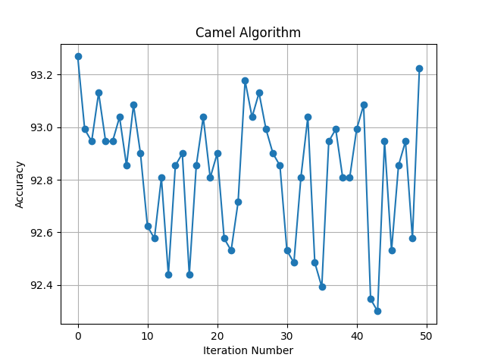

***Fig#2.0 Camel Algorithm Iterations***

***T#3.0 Camel Algorithm Main Result***

|  |  |  |  |  |
| --- | --- | --- | --- | --- |
| **ID** | **Accuracy** | **Time Taken (s)** | **Energy Used (J)** | **Equivalent CO2 Emission (mg)** |
| CAM-0000 | 93.26878745965884 | 164 | 527.0000000000003 | 124.43055555555564 |
| CAM-0001 | 92.99216228676808 | 831 | 2666.499999999992 | 629.5902777777757 |
| CAM-0002 | 92.94605809128632 | 81 | 261.99999999999994 | 61.86111111111109 |
| CAM-0003 | 93.13047487321346 | 164 | 529.0000000000003 | 124.90277777777786 |
| CAM-0004 | 92.94605809128632 | 133 | 434.4000000000002 | 102.5666666666667 |
| CAM-0005 | 92.94605809128632 | 66 | 214.5999999999999 | 50.66944444444442 |
| CAM-0006 | 93.03826648224988 | 53 | 172.79999999999995 | 40.79999999999999 |
| CAM-0007 | 92.85384970032273 | 104 | 336.2 | 79.38055555555555 |
| CAM-0008 | 93.08437067773168 | 19 | 61.3 | 14.473611111111111 |
| CAM-0009 | 92.89995389580452 | 99 | 319.80000000000007 | 75.50833333333335 |
| CAM-0010 | 92.6233287229138 | 589 | 1897.399999999999 | 447.997222222222 |
| CAM-0011 | 92.577224527432 | 14 | 45.1 | 10.64861111111111 |
| CAM-0012 | 92.80774550484094 | 88 | 285.6 | 67.43333333333334 |
| CAM-0013 | 92.43891194098664 | 582 | 1897.4999999999973 | 448.0208333333328 |
| CAM-0014 | 92.85384970032273 | 47 | 151.8 | 35.84166666666667 |
| CAM-0015 | 92.89995389580452 | 170 | 553.4000000000002 | 130.66388888888892 |
| CAM-0016 | 92.43891194098664 | 333 | 1065.400000000001 | 251.552777777778 |
| CAM-0017 | 92.85384970032273 | 71 | 228.1 | 53.85694444444444 |
| CAM-0018 | 93.03826648224988 | 248 | 789.9000000000005 | 186.5041666666668 |
| CAM-0019 | 92.80774550484094 | 46 | 149.09999999999997 | 35.20416666666666 |
| CAM-0020 | 92.89995389580452 | 81 | 261.1999999999999 | 61.67222222222219 |
| CAM-0021 | 92.577224527432 | 104 | 337.20000000000005 | 79.61666666666667 |
| CAM-0022 | 92.5311203319502 | 18 | 59.7 | 14.095833333333331 |
| CAM-0023 | 92.71553711387736 | 29 | 93.5 | 22.07638888888889 |
| CAM-0024 | 93.17657906869525 | 222 | 708.4000000000004 | 167.2611111111112 |
| CAM-0025 | 93.03826648224988 | 124 | 398.5999999999999 | 94.11388888888884 |
| CAM-0026 | 93.13047487321346 | 97 | 313.79999999999984 | 74.09166666666663 |
| CAM-0027 | 92.99216228676808 | 96 | 312.7000000000001 | 73.83194444444446 |
| CAM-0028 | 92.89995389580452 | 90 | 292.5999999999999 | 69.0861111111111 |
| CAM-0029 | 92.85384970032273 | 72 | 231.79999999999995 | 54.73055555555554 |
| CAM-0030 | 92.5311203319502 | 226 | 729.8000000000004 | 172.31388888888898 |
| CAM-0031 | 92.48501613646842 | 398 | 1279.9 | 302.1986111111111 |
| CAM-0032 | 92.80774550484094 | 26 | 84.50000000000001 | 19.951388888888893 |
| CAM-0033 | 93.03826648224988 | 840 | 2695.7999999999915 | 636.5083333333313 |
| CAM-0034 | 92.48501613646842 | 78 | 252.49999999999991 | 59.618055555555536 |
| CAM-0035 | 92.39280774550484 | 631 | 2041.2999999999968 | 481.9736111111105 |
| CAM-0036 | 92.94605809128632 | 148 | 479.10000000000014 | 113.12083333333337 |
| CAM-0037 | 92.99216228676808 | 880 | 2824.499999999991 | 666.8958333333312 |
| CAM-0038 | 92.80774550484094 | 112 | 362.49999999999983 | 85.59027777777773 |
| CAM-0039 | 92.80774550484094 | 13 | 43.00000000000001 | 10.15277777777778 |
| CAM-0040 | 92.99216228676808 | 716 | 2309.2999999999943 | 545.2513888888875 |
| CAM-0041 | 93.08437067773168 | 38 | 123.7 | 29.20694444444444 |
| CAM-0042 | 92.34670355002304 | 77 | 249.1 | 58.81527777777776 |
| CAM-0043 | 92.30059935454128 | 157 | 504.4 | 119.09444444444443 |
| CAM-0044 | 92.94605809128632 | 330 | 1059.8000000000009 | 250.23055555555567 |
| CAM-0045 | 92.5311203319502 | 267 | 858.600000000001 | 202.72500000000025 |
| CAM-0046 | 92.85384970032273 | 308 | 1002.8000000000006 | 236.77222222222235 |
| CAM-0047 | 92.94605809128632 | 23 | 74.70000000000002 | 17.637500000000003 |
| CAM-0048 | 92.577224527432 | 421 | 1361.799999999998 | 321.53611111111064 |
| CAM-0049 | 93.22268326417704 | 704 | 2264.0000000000005 | 534.5555555555557 |

***T#3.1 Camel Algorithm Parameters***

|  |  |  |  |  |  |  |  |  |  |  |  |
| --- | --- | --- | --- | --- | --- | --- | --- | --- | --- | --- | --- |
| **ID** | **population_size** | **burden_factor** | **death_rate** | **visibility** | **supply_init** | **endurance_init** | **min_temperature** | **max_temperature** | **n_estimator** | **criterion** | **max_feature** |
| CAM-0000 | 45 | 0.8917689509621813 | 0.1574105080560471 | 0.3395135843376285 | 556.3241207828955 | 439.25496574370027 | -7.857737014738504 | 76.33105126957706 | 528 | entropy | sqrt |
| CAM-0001 | 29 | 0.2467377051902176 | 0.9056761446063374 | 0.6698120059714505 | 340.43479935024084 | 864.1309972100481 | -42.299384908307466 | 97.57636874894732 | 536 | entropy | nan |
| CAM-0002 | 83 | 0.3769517731710098 | 0.3689814633457428 | 0.5497261056577791 | 123.09406136530002 | 557.3159322079924 | -30.941571553040248 | 98.4836083645137 | 550 | gini | log2 |
| CAM-0003 | 84 | 0.9134086125420942 | 0.1239863903698378 | 0.2614220763610579 | 588.9075790917148 | 489.4912124285041 | -42.30435629963133 | 93.296077594611 | 529 | entropy | sqrt |
| CAM-0004 | 35 | 0.80957692540074 | 0.8839855641660145 | 0.8371037202205149 | 562.5633177409916 | 470.6864470301778 | -0.956493560741805 | 18.589496699663822 | 518 | entropy | log2 |
| CAM-0005 | 20 | 0.9502850914815713 | 0.5517841693321563 | 0.514481763996164 | 429.033302276099 | 923.103502815024 | -7.218378665341632 | 38.57734280161233 | 443 | gini | log2 |
| CAM-0006 | 34 | 0.7607996563043902 | 0.1593953398412659 | 0.2356659111712253 | 551.0287405546053 | 150.28863766980083 | -8.871211136353324 | 63.29805245469342 | 355 | gini | log2 |
| CAM-0007 | 47 | 0.9430898741023136 | 0.3627557721385803 | 0.1388757950015687 | 549.4647864539018 | 206.75805648692287 | -68.59711566965127 | 47.804686220099576 | 334 | entropy | sqrt |
| CAM-0008 | 86 | 0.580246621086023 | 0.4093601467559316 | 0.6768649565236758 | 299.9019008688672 | 850.2995943068054 | -8.675493798085554 | 82.37551959004898 | 60 | entropy | sqrt |
| CAM-0009 | 65 | 0.9047870661549404 | 0.5883129902785321 | 0.979440355310594 | 839.064754315762 | 809.5110023205153 | -98.2433558266894 | 29.882381521635917 | 386 | entropy | log2 |
| CAM-0010 | 95 | 0.4395267203270667 | 0.4400666676164132 | 0.3845304835023363 | 946.0961760230967 | 856.2969397052201 | -1.8634372098746184 | 91.10018901516533 | 524 | gini | nan |
| CAM-0011 | 33 | 0.7896095433203657 | 0.5891473581806405 | 0.5498069278009239 | 806.6840108641693 | 344.9548422283768 | -75.29060769299723 | 84.64952580044942 | 74 | gini | sqrt |
| CAM-0012 | 31 | 0.6854827573576056 | 0.9395326057953914 | 0.9897259912388008 | 89.32743963212671 | 200.08076066162997 | -28.69310723763141 | 2.470475349470092 | 482 | gini | sqrt |
| CAM-0013 | 16 | 0.7696430703654394 | 0.8419430741092682 | 0.9823317758016064 | 540.8549971354333 | 473.4232105876093 | -13.156243324421323 | 79.8000571184147 | 516 | gini | nan |
| CAM-0014 | 27 | 0.4123937722601745 | 0.9369378663694417 | 0.8184584456438545 | 674.2627260707087 | 440.9495823079437 | -29.260285045480927 | 40.12086301770953 | 316 | gini | log2 |
| CAM-0015 | 31 | 0.4187395524713073 | 0.295124474547312 | 0.4753433418767984 | 731.8825789534 | 906.2333121056502 | -60.62462726086303 | 51.15190070883384 | 546 | entropy | sqrt |
| CAM-0016 | 74 | 0.3730554577637117 | 0.2490520876958518 | 0.4972823920369027 | 262.3485504282263 | 213.69187918367928 | -87.93085003744272 | 83.67072114825568 | 295 | gini | nan |
| CAM-0017 | 11 | 0.9286589009744552 | 0.2389185576312431 | 0.1070458160521445 | 228.4407108553033 | 233.35364591361352 | -21.192374956532063 | 2.144705750722099 | 477 | gini | log2 |
| CAM-0018 | 13 | 0.2403213280299349 | 0.1454359611656469 | 0.9791180111349198 | 136.98025982926998 | 646.9494422074062 | -40.68291953045152 | 10.527146081384602 | 161 | entropy | nan |
| CAM-0019 | 99 | 0.2856341621587696 | 0.3325616586067756 | 0.7343557362388795 | 627.0229194826939 | 606.3648070506616 | -14.209726280085704 | 13.85648467950936 | 309 | gini | log2 |
| CAM-0020 | 27 | 0.2676837810476811 | 0.5449125748596525 | 0.3278068029376643 | 875.3708777209383 | 288.3317044132352 | -77.89927256179432 | 55.612526169862 | 545 | gini | log2 |
| CAM-0021 | 53 | 0.6395986568694544 | 0.3059803223158595 | 0.4558049940995878 | 798.8746035901117 | 52.31042164168498 | -14.041789330570069 | 86.80844591265479 | 337 | entropy | sqrt |
| CAM-0022 | 60 | 0.3644091733533651 | 0.6360367094436612 | 0.8034612547072137 | 867.6679943400783 | 825.7191844364302 | -84.06572446698506 | 25.81915809603864 | 118 | gini | log2 |
| CAM-0023 | 84 | 0.3077604420610202 | 0.6443946722898031 | 0.7366424288090097 | 91.53507797438328 | 606.1505033313621 | -70.90824851949449 | 45.70539205877513 | 192 | gini | log2 |
| CAM-0024 | 71 | 0.4604848929366398 | 0.9813481761021314 | 0.1569392479305228 | 182.88089394376453 | 923.3394522956472 | -90.48941652956287 | 75.19757177339068 | 144 | entropy | nan |
| CAM-0025 | 35 | 0.680739827110035 | 0.7074454863545705 | 0.9087797316334744 | 990.4355835542674 | 580.3327952965132 | -88.9855468065863 | 52.676067387327095 | 401 | entropy | sqrt |
| CAM-0026 | 16 | 0.4224115055461069 | 0.4423843689436527 | 0.5761976514244636 | 244.2205837588592 | 482.5951098580259 | -80.85770490140594 | 79.53619867610762 | 538 | gini | sqrt |
| CAM-0027 | 14 | 0.9950401295530116 | 0.7371741762356608 | 0.5985378624965391 | 585.931911934741 | 428.0963881186934 | -96.05983688191692 | 93.00053575255453 | 525 | gini | sqrt |
| CAM-0028 | 60 | 0.7944430747907847 | 0.1443581066649819 | 0.8906044166183108 | 516.1423412302189 | 325.193772526986 | -77.2040015946551 | 19.62337862322764 | 495 | gini | sqrt |
| CAM-0029 | 21 | 0.3101715073642999 | 0.8706008334526455 | 0.9728644244714748 | 743.5584086841657 | 276.9107653790146 | -78.14912270635166 | 14.699167007225826 | 487 | gini | log2 |
| CAM-0030 | 35 | 0.601313256583943 | 0.7114266746049118 | 0.9071422391820326 | 352.1644183080739 | 919.857071372821 | -7.434984315242389 | 10.375074788331034 | 200 | gini | nan |
| CAM-0031 | 82 | 0.6281175571275495 | 0.2691275231337721 | 0.6905259738850692 | 790.3009953987568 | 619.5232987512902 | -5.684483257638036 | 80.21547059916223 | 353 | gini | nan |
| CAM-0032 | 71 | 0.2249891533764577 | 0.6084060856067435 | 0.4268845694679861 | 184.01029772687812 | 476.4430904852582 | -64.32087417656152 | 6.791382682372594 | 179 | gini | log2 |
| CAM-0033 | 94 | 0.7798845240478768 | 0.1003793486376239 | 0.8545645402646658 | 813.3682768123901 | 281.59984435074136 | -95.47166140168136 | 10.756956098713813 | 544 | entropy | nan |
| CAM-0034 | 70 | 0.382911238142898 | 0.5484645849601852 | 0.1704539271049565 | 606.2089697173184 | 319.3331755688681 | -57.68600218657129 | 5.426450662730014 | 68 | gini | nan |
| CAM-0035 | 64 | 0.97170832288421 | 0.7932439775400973 | 0.6291832006565957 | 955.6611163362262 | 342.17022994408075 | -71.21002305390347 | 99.85873623642328 | 559 | gini | nan |
| CAM-0036 | 34 | 0.1186944153156435 | 0.5740664669040253 | 0.6985226279379863 | 278.4994292139168 | 773.6619901837016 | -46.48436714286126 | 1.9918635033143817 | 480 | entropy | sqrt |
| CAM-0037 | 97 | 0.8749921420687178 | 0.2962857359406272 | 0.2340023285871453 | 321.43337092909576 | 986.1071795817968 | -78.1833835969771 | 26.345390034239657 | 569 | entropy | nan |
| CAM-0038 | 84 | 0.2351569415987549 | 0.6555897858453605 | 0.711312383624066 | 216.95646157563797 | 633.9906236887061 | -46.87202720234331 | 6.127237002764722 | 436 | entropy | log2 |
| CAM-0039 | 65 | 0.7563914599536303 | 0.5123690061195515 | 0.8731840584236166 | 282.82357560754224 | 543.376846578537 | -41.9842721513482 | 10.27977027948683 | 83 | gini | log2 |
| CAM-0040 | 40 | 0.4904427148552368 | 0.8175587732206904 | 0.1503424474683955 | 525.4937942698891 | 708.7853176572105 | -39.54197613637637 | 18.437265302852555 | 463 | entropy | nan |
| CAM-0041 | 87 | 0.145381620593803 | 0.8507814906607828 | 0.1829170626835375 | 150.84075299389835 | 24.810346284198538 | -37.5892917920115 | 26.053324303014342 | 122 | entropy | sqrt |
| CAM-0042 | 56 | 0.2925350112001413 | 0.5318732851651565 | 0.5777533877083783 | 727.0266075748797 | 369.357707548431 | -91.3612442812333 | 42.84147362425472 | 68 | gini | nan |
| CAM-0043 | 43 | 0.6729723826580212 | 0.8444450824124794 | 0.8132990657298977 | 496.4343334921011 | 9.703478458913503 | -61.42897822273095 | 78.50782169823337 | 139 | gini | nan |
| CAM-0044 | 32 | 0.8236425062854004 | 0.2719713367896243 | 0.9918474318514252 | 444.0770180167378 | 577.2684486485081 | -95.08011829711708 | 98.37993793694208 | 214 | entropy | nan |
| CAM-0045 | 28 | 0.5412069803582148 | 0.6594055061330226 | 0.3808593796861865 | 903.0614939149224 | 591.9051793709859 | -37.74873343432833 | 56.85517996031078 | 236 | gini | nan |
| CAM-0046 | 39 | 0.8498143663556713 | 0.7650726552555416 | 0.9151323741334526 | 659.4163091879759 | 965.3959226786574 | -91.14604103034736 | 8.451608962632044 | 198 | entropy | nan |
| CAM-0047 | 97 | 0.1680363262557032 | 0.1381643853948666 | 0.89256575739282 | 665.8748656674042 | 531.8941378175209 | -88.63594963960317 | 8.815649450005365 | 128 | gini | sqrt |
| CAM-0048 | 46 | 0.5294833177005931 | 0.815579366157009 | 0.9715630744427872 | 980.2086703212478 | 958.6472491171372 | -80.06114484009763 | 8.770059908756771 | 373 | gini | nan |
| CAM-0049 | 83 | 0.611322627867953 | 0.1108088816433491 | 0.1852880857628611 | 835.3958130138794 | 283.5373438908974 | -97.1763860906489 | 75.28453466624765 | 455 | entropy | nan |

***T#3.2 Camel Algorithm Energy Distribution***

|  |  |  |  |  |  |  |
| --- | --- | --- | --- | --- | --- | --- |
| **ID** | **Time Taken(s)** | **Total Energy(J)** | **CPU(J)** | **Monitor(J)** | **Disk(J)** | **Base(J)** |
| CAM-0000 | 164 | 527.0000000000003 | 287.29999999999984 | 0.0 | 0.3 | 246.0 |
| CAM-0001 | 831 | 2666.499999999992 | 1457.7000000000005 | 0.0 | 0.0 | 1246.5 |
| CAM-0002 | 81 | 261.99999999999994 | 143.69999999999993 | 0.0 | 0.0 | 121.5 |
| CAM-0003 | 164 | 529.0000000000003 | 289.3999999999999 | 0.0 | 0.0 | 246.0 |
| CAM-0004 | 133 | 434.4000000000002 | 240.6999999999999 | 0.0 | 0.1 | 199.5 |
| CAM-0005 | 66 | 214.5999999999999 | 118.19999999999996 | 0.0 | 0.0 | 99.0 |
| CAM-0006 | 53 | 172.79999999999995 | 95.69999999999996 | 0.0 | 0.0 | 79.5 |
| CAM-0007 | 104 | 336.2 | 184.2999999999999 | 0.0 | 0.0 | 156.0 |
| CAM-0008 | 19 | 61.3 | 33.5 | 0.0 | 0.0 | 28.5 |
| CAM-0009 | 99 | 319.80000000000007 | 176.39999999999995 | 0.0 | 0.0 | 148.5 |
| CAM-0010 | 589 | 1897.399999999999 | 1037.9000000000035 | 0.0 | 0.4 | 883.5 |
| CAM-0011 | 14 | 45.1 | 24.4 | 0.0 | 0.0 | 21.0 |
| CAM-0012 | 88 | 285.6 | 156.8 | 0.0 | 0.0 | 132.0 |
| CAM-0013 | 582 | 1897.4999999999973 | 1048.500000000004 | 0.0 | 0.0 | 873.0 |
| CAM-0014 | 47 | 151.8 | 83.90000000000002 | 0.0 | 0.0 | 70.5 |
| CAM-0015 | 170 | 553.4000000000002 | 306.09999999999974 | 0.0 | 0.1 | 255.0 |
| CAM-0016 | 333 | 1065.400000000001 | 580.600000000001 | 0.0 | 0.0 | 499.5 |
| CAM-0017 | 71 | 228.1 | 125.30000000000004 | 0.0 | 0.0 | 106.5 |
| CAM-0018 | 248 | 789.9000000000005 | 429.6000000000004 | 0.0 | 0.0 | 372.0 |
| CAM-0019 | 46 | 149.09999999999997 | 81.89999999999999 | 0.0 | 0.0 | 69.0 |
| CAM-0020 | 81 | 261.1999999999999 | 144.3999999999999 | 0.0 | 0.0 | 121.5 |
| CAM-0021 | 104 | 337.20000000000005 | 185.8 | 0.0 | 0.0 | 156.0 |
| CAM-0022 | 18 | 59.7 | 33.3 | 0.0 | 0.0 | 27.0 |
| CAM-0023 | 29 | 93.5 | 51.20000000000001 | 0.0 | 0.0 | 43.5 |
| CAM-0024 | 222 | 708.4000000000004 | 384.0999999999999 | 0.0 | 0.0 | 333.0 |
| CAM-0025 | 124 | 398.5999999999999 | 218.49999999999983 | 0.0 | 0.0 | 186.0 |
| CAM-0026 | 97 | 313.79999999999984 | 172.59999999999997 | 0.0 | 0.0 | 145.5 |
| CAM-0027 | 96 | 312.7000000000001 | 171.79999999999987 | 0.0 | 0.0 | 144.0 |
| CAM-0028 | 90 | 292.5999999999999 | 161.8 | 0.0 | 0.0 | 135.0 |
| CAM-0029 | 72 | 231.79999999999995 | 125.99999999999996 | 0.0 | 0.0 | 108.0 |
| CAM-0030 | 226 | 729.8000000000004 | 400.9000000000002 | 0.0 | 0.0 | 339.0 |
| CAM-0031 | 398 | 1279.9 | 699.2000000000005 | 0.0 | 0.5 | 597.0 |
| CAM-0032 | 26 | 84.50000000000001 | 46.8 | 0.0 | 0.0 | 39.0 |
| CAM-0033 | 840 | 2695.7999999999915 | 1474.9999999999984 | 0.0 | 0.6 | 1260.0 |
| CAM-0034 | 78 | 252.49999999999991 | 138.89999999999995 | 0.0 | 0.0 | 117.0 |
| CAM-0035 | 631 | 2041.2999999999968 | 1124.200000000002 | 0.0 | 0.0 | 946.5 |
| CAM-0036 | 148 | 479.10000000000014 | 263.69999999999993 | 0.0 | 0.0 | 222.0 |
| CAM-0037 | 880 | 2824.499999999991 | 1542.499999999997 | 0.0 | 0.0 | 1320.0 |
| CAM-0038 | 112 | 362.49999999999983 | 199.59999999999985 | 0.0 | 0.0 | 168.0 |
| CAM-0039 | 13 | 43.00000000000001 | 24.1 | 0.0 | 0.0 | 19.5 |
| CAM-0040 | 716 | 2309.2999999999943 | 1265.600000000002 | 0.0 | 0.0 | 1074.0 |
| CAM-0041 | 38 | 123.7 | 69.10000000000001 | 0.0 | 0.0 | 57.0 |
| CAM-0042 | 77 | 249.1 | 136.19999999999996 | 0.0 | 0.0 | 115.5 |
| CAM-0043 | 157 | 504.4 | 276.3999999999998 | 0.0 | 0.0 | 235.5 |
| CAM-0044 | 330 | 1059.8000000000009 | 578.9000000000005 | 0.0 | 0.1 | 495.0 |
| CAM-0045 | 267 | 858.600000000001 | 470.19999999999993 | 0.0 | 0.0 | 400.5 |
| CAM-0046 | 308 | 1002.8000000000006 | 555.6000000000006 | 0.0 | 0.0 | 462.0 |
| CAM-0047 | 23 | 74.70000000000002 | 41.6 | 0.0 | 0.0 | 34.5 |
| CAM-0048 | 421 | 1361.799999999998 | 749.2000000000023 | 0.0 | 0.0 | 631.5 |
| CAM-0049 | 704 | 2264.0000000000005 | 1241.1000000000015 | 0.0 | 0.0 | 1056.0 |

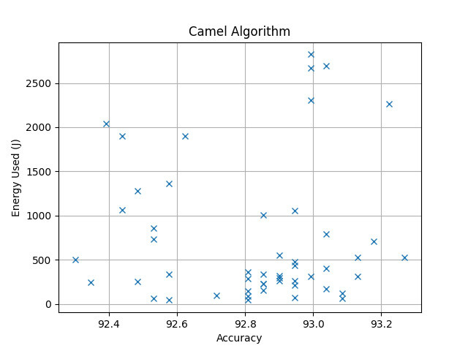

***Fig#2.1 Camel Algorithm Energy Vs Accuracy***

***T#3.3 Camel Algorithm Top 10 Values***

|  |  |  |  |  |  |  |  |
| --- | --- | --- | --- | --- | --- | --- | --- |
| **ID** | **Time Taken(s)** | **Total Energy(J)** | **CPU(J)** | **Monitor(J)** | **Disk(J)** | **Base(J)** | **Power Consumption (w)** |
| CAM-0000 | 164 | 527.0000000000003 | 287.29999999999984 | 0.0 | 0.3 | 246.0 | 3.213414634146344 |
| CAM-0049 | 704 | 2264.0000000000005 | 1241.1000000000015 | 0.0 | 0.0 | 1056.0 | 3.215909090909092 |
| CAM-0024 | 222 | 708.4000000000004 | 384.0999999999999 | 0.0 | 0.0 | 333.0 | 3.190990990990993 |
| CAM-0003 | 164 | 529.0000000000003 | 289.3999999999999 | 0.0 | 0.0 | 246.0 | 3.225609756097563 |
| CAM-0026 | 97 | 313.79999999999984 | 172.59999999999997 | 0.0 | 0.0 | 145.5 | 3.235051546391751 |
| CAM-0008 | 19 | 61.3 | 33.5 | 0.0 | 0.0 | 28.5 | 3.226315789473684 |
| CAM-0041 | 38 | 123.7 | 69.10000000000001 | 0.0 | 0.0 | 57.0 | 3.255263157894737 |
| CAM-0033 | 840 | 2695.7999999999915 | 1474.9999999999984 | 0.0 | 0.6 | 1260.0 | 3.2092857142857043 |
| CAM-0025 | 124 | 398.5999999999999 | 218.49999999999983 | 0.0 | 0.0 | 186.0 | 3.214516129032257 |
| CAM-0006 | 53 | 172.79999999999995 | 95.69999999999996 | 0.0 | 0.0 | 79.5 | 3.2603773584905653 |

**NIA Cuckoo Search**

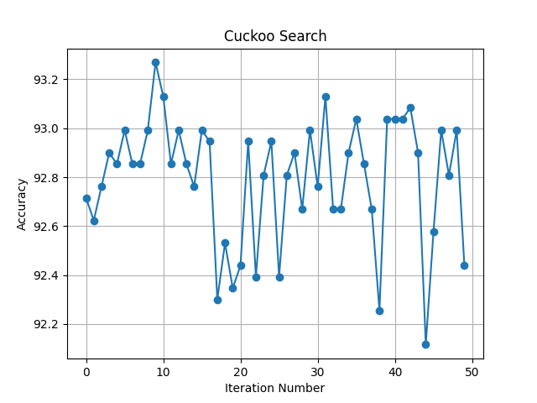

***Fig#3.0 Cuckoo Search Iterations***

***T#4.0 Cuckoo Search Main Result***

|  |  |  |  |  |
| --- | --- | --- | --- | --- |
| **ID** | **Accuracy** | **Time Taken (s)** | **Energy Used (J)** | **Equivalent CO2 Emission (mg)** |
| CUC-0000 | 92.71553711387736 | 73 | 233.89999999999995 | 55.22638888888888 |
| CUC-0001 | 92.6233287229138 | 590 | 1902.299999999998 | 449.15416666666624 |
| CUC-0002 | 92.76164130935916 | 54 | 175.0 | 41.31944444444444 |
| CUC-0003 | 92.89995389580452 | 71 | 228.40000000000003 | 53.92777777777778 |
| CUC-0004 | 92.85384970032273 | 12 | 38.5 | 9.090277777777777 |
| CUC-0005 | 92.99216228676808 | 12 | 38.1 | 8.995833333333334 |
| CUC-0006 | 92.85384970032273 | 77 | 246.29999999999995 | 58.15416666666665 |
| CUC-0007 | 92.85384970032273 | 9 | 29.6 | 6.988888888888889 |
| CUC-0008 | 92.99216228676808 | 16 | 53.3 | 12.584722222222222 |
| CUC-0009 | 93.26878745965884 | 16 | 51.10000000000001 | 12.06527777777778 |
| CUC-0010 | 93.13047487321346 | 84 | 269.3 | 63.58472222222223 |
| CUC-0011 | 92.85384970032273 | 14 | 45.0 | 10.625 |
| CUC-0012 | 92.99216228676808 | 59 | 190.7999999999999 | 45.049999999999976 |
| CUC-0013 | 92.85384970032273 | 10 | 32.1 | 7.579166666666667 |
| CUC-0014 | 92.76164130935916 | 14 | 46.400000000000006 | 10.955555555555556 |
| CUC-0015 | 92.99216228676808 | 712 | 2291.699999999998 | 541.0958333333328 |
| CUC-0016 | 92.94605809128632 | 69 | 225.79999999999995 | 53.31388888888888 |
| CUC-0017 | 92.30059935454128 | 493 | 1736.7999999999986 | 410.07777777777744 |
| CUC-0018 | 92.5311203319502 | 534 | 1752.499999999999 | 413.784722222222 |
| CUC-0019 | 92.34670355002304 | 549 | 1769.299999999998 | 417.7513888888884 |
| CUC-0020 | 92.43891194098664 | 525 | 1694.4999999999984 | 400.0902777777774 |
| CUC-0021 | 92.94605809128632 | 31 | 100.6 | 23.752777777777776 |
| CUC-0022 | 92.39280774550484 | 122 | 392.6000000000001 | 92.69722222222224 |
| CUC-0023 | 92.80774550484094 | 136 | 439.5000000000001 | 103.77083333333336 |
| CUC-0024 | 92.94605809128632 | 66 | 211.5 | 49.9375 |
| CUC-0025 | 92.39280774550484 | 364 | 1169.300000000001 | 276.0847222222225 |
| CUC-0026 | 92.80774550484094 | 74 | 241.49999999999991 | 57.020833333333314 |
| CUC-0027 | 92.89995389580452 | 89 | 288.19999999999993 | 68.0472222222222 |
| CUC-0028 | 92.66943291839556 | 150 | 489.2000000000002 | 115.5055555555556 |
| CUC-0029 | 92.99216228676808 | 13 | 41.8 | 9.869444444444444 |
| CUC-0030 | 92.76164130935916 | 557 | 1809.099999999999 | 427.1486111111109 |
| CUC-0031 | 93.13047487321346 | 264 | 852.8000000000005 | 201.35555555555567 |
| CUC-0032 | 92.66943291839556 | 229 | 739.7000000000002 | 174.65138888888893 |
| CUC-0033 | 92.66943291839556 | 373 | 1202.3000000000009 | 283.8763888888891 |
| CUC-0034 | 92.89995389580452 | 103 | 336.19999999999993 | 79.38055555555553 |
| CUC-0035 | 93.03826648224988 | 40 | 130.0 | 30.694444444444443 |
| CUC-0036 | 92.85384970032273 | 41 | 132.29999999999998 | 31.2375 |
| CUC-0037 | 92.66943291839556 | 257 | 830.500000000001 | 196.09027777777803 |
| CUC-0038 | 92.25449515905947 | 298 | 961.4000000000012 | 226.9972222222225 |
| CUC-0039 | 93.03826648224988 | 63 | 206.2999999999999 | 48.7097222222222 |
| CUC-0040 | 93.03826648224988 | 612 | 1978.4999999999973 | 467.1458333333328 |
| CUC-0041 | 93.03826648224988 | 258 | 832.0000000000009 | 196.44444444444463 |
| CUC-0042 | 93.08437067773168 | 678 | 2185.099999999998 | 515.9263888888884 |
| CUC-0043 | 92.89995389580452 | 85 | 273.99999999999994 | 64.69444444444443 |
| CUC-0044 | 92.11618257261412 | 6 | 19.6 | 4.627777777777778 |
| CUC-0045 | 92.577224527432 | 554 | 1809.5 | 427.24305555555554 |
| CUC-0046 | 92.99216228676808 | 84 | 273.6 | 64.6 |
| CUC-0047 | 92.80774550484094 | 74 | 240.79999999999995 | 56.85555555555554 |
| CUC-0048 | 92.99216228676808 | 69 | 222.3999999999999 | 52.51111111111109 |
| CUC-0049 | 92.43891194098664 | 190 | 614.3000000000001 | 145.04305555555555 |

***T#4.1 Cuckoo Search Parameters***

|  |  |  |  |  |  |
| --- | --- | --- | --- | --- | --- |
| **ID** | **population_size** | **pa** | **n_estimator** | **criterion** | **max_feature** |
| CUC-0000 | 38 | 0.4953294691693303 | 47 | entropy | nan |
| CUC-0001 | 45 | 0.2596529552928612 | 523 | gini | nan |
| CUC-0002 | 39 | 0.3536874177475291 | 47 | gini | nan |
| CUC-0003 | 41 | 0.4697112784736025 | 46 | entropy | nan |
| CUC-0004 | 42 | 0.4370854917455083 | 45 | entropy | log2 |
| CUC-0005 | 42 | 0.6677456145428671 | 48 | entropy | log2 |
| CUC-0006 | 44 | 0.4228569748771231 | 50 | entropy | nan |
| CUC-0007 | 44 | 0.6689209238965844 | 47 | gini | sqrt |
| CUC-0008 | 42 | 0.5831269001194772 | 50 | entropy | sqrt |
| CUC-0009 | 41 | 0.5183220488253266 | 53 | entropy | sqrt |
| CUC-0010 | 41 | 0.816726719184001 | 54 | entropy | nan |
| CUC-0011 | 43 | 0.7860365725127323 | 53 | entropy | log2 |
| CUC-0012 | 40 | 0.2482392378297097 | 52 | gini | nan |
| CUC-0013 | 40 | 0.7543717667449508 | 55 | gini | sqrt |
| CUC-0014 | 42 | 0.4698993164718423 | 53 | entropy | log2 |
| CUC-0015 | 61 | 0.9157731409121947 | 457 | entropy | nan |
| CUC-0016 | 57 | 0.1665939695561264 | 462 | gini | log2 |
| CUC-0017 | 94 | 0.2642561544111848 | 414 | gini | nan |
| CUC-0018 | 85 | 0.389992546650089 | 465 | gini | nan |
| CUC-0019 | 61 | 0.2583728260993092 | 485 | gini | nan |
| CUC-0020 | 37 | 0.5951622777011842 | 464 | gini | nan |
| CUC-0021 | 73 | 0.4860867279883155 | 119 | entropy | log2 |
| CUC-0022 | 10 | 0.5369812295627355 | 108 | gini | nan |
| CUC-0023 | 86 | 0.4923946012519314 | 531 | entropy | log2 |
| CUC-0024 | 87 | 0.2538920283948578 | 209 | entropy | sqrt |
| CUC-0025 | 39 | 0.4479034243349682 | 321 | gini | nan |
| CUC-0026 | 64 | 0.2208800880773575 | 239 | entropy | sqrt |
| CUC-0027 | 40 | 0.3404337120144953 | 286 | entropy | sqrt |
| CUC-0028 | 98 | 0.6753288521333073 | 478 | entropy | sqrt |
| CUC-0029 | 10 | 0.9598950391596024 | 82 | gini | log2 |
| CUC-0030 | 93 | 0.8972010678062589 | 494 | gini | nan |
| CUC-0031 | 47 | 0.7922334344546738 | 169 | entropy | nan |
| CUC-0032 | 18 | 0.2301616994295371 | 203 | gini | nan |
| CUC-0033 | 27 | 0.685719789368267 | 330 | gini | nan |
| CUC-0034 | 10 | 0.4950840282894556 | 567 | gini | sqrt |
| CUC-0035 | 98 | 0.6101960134378634 | 268 | gini | log2 |
| CUC-0036 | 82 | 0.7532204675936485 | 277 | gini | log2 |
| CUC-0037 | 16 | 0.279827570694344 | 228 | gini | nan |
| CUC-0038 | 49 | 0.7899437382869932 | 263 | gini | nan |
| CUC-0039 | 24 | 0.9163187143901852 | 348 | gini | sqrt |
| CUC-0040 | 55 | 0.5576437198830669 | 392 | entropy | nan |
| CUC-0041 | 73 | 0.1357073842195424 | 166 | entropy | nan |
| CUC-0042 | 77 | 0.5135023731377653 | 436 | entropy | nan |
| CUC-0043 | 51 | 0.2734633096253558 | 468 | gini | sqrt |
| CUC-0044 | 67 | 0.5796525370157818 | 23 | entropy | log2 |
| CUC-0045 | 22 | 0.9032344698512054 | 488 | gini | nan |
| CUC-0046 | 76 | 0.4704737233375671 | 462 | gini | sqrt |
| CUC-0047 | 40 | 0.737190610436478 | 500 | gini | log2 |
| CUC-0048 | 98 | 0.4038663792793349 | 268 | entropy | log2 |
| CUC-0049 | 47 | 0.9466701217357532 | 169 | gini | nan |

***T#4.2 Cuckoo Search Energy Distribution***

|  |  |  |  |  |  |  |
| --- | --- | --- | --- | --- | --- | --- |
| **ID** | **Time Taken(s)** | **Total Energy(J)** | **CPU(J)** | **Monitor(J)** | **Disk(J)** | **Base(J)** |
| CUC-0000 | 73 | 233.89999999999995 | 127.7 | 0.0 | 0.0 | 109.5 |
| CUC-0001 | 590 | 1902.299999999998 | 1044.5000000000025 | 0.0 | 0.4 | 885.0 |
| CUC-0002 | 54 | 175.0 | 96.3 | 0.0 | 0.0 | 81.0 |
| CUC-0003 | 71 | 228.40000000000003 | 125.5 | 0.0 | 0.0 | 106.5 |
| CUC-0004 | 12 | 38.5 | 21.0 | 0.0 | 0.0 | 18.0 |
| CUC-0005 | 12 | 38.1 | 20.6 | 0.0 | 0.0 | 18.0 |
| CUC-0006 | 77 | 246.29999999999995 | 133.99999999999997 | 0.0 | 0.0 | 115.5 |
| CUC-0007 | 9 | 29.6 | 16.5 | 0.0 | 0.0 | 13.5 |
| CUC-0008 | 16 | 53.3 | 29.700000000000003 | 0.0 | 0.0 | 24.0 |
| CUC-0009 | 16 | 51.10000000000001 | 27.700000000000003 | 0.0 | 0.0 | 24.0 |
| CUC-0010 | 84 | 269.3 | 146.49999999999994 | 0.0 | 0.0 | 126.0 |
| CUC-0011 | 14 | 45.0 | 24.700000000000003 | 0.0 | 0.0 | 21.0 |
| CUC-0012 | 59 | 190.7999999999999 | 104.9 | 0.0 | 0.0 | 88.5 |
| CUC-0013 | 10 | 32.1 | 17.3 | 0.0 | 0.0 | 15.0 |
| CUC-0014 | 14 | 46.400000000000006 | 25.9 | 0.0 | 0.0 | 21.0 |
| CUC-0015 | 712 | 2291.699999999998 | 1256.0999999999997 | 0.0 | 0.0 | 1068.0 |
| CUC-0016 | 69 | 225.79999999999995 | 124.79999999999995 | 0.0 | 0.0 | 103.5 |
| CUC-0017 | 493 | 1736.7999999999986 | 1008.9999999999987 | 0.0 | 0.3 | 739.5 |
| CUC-0018 | 534 | 1752.499999999999 | 972.3000000000036 | 0.0 | 0.0 | 801.0 |
| CUC-0019 | 549 | 1769.299999999998 | 969.8000000000036 | 0.0 | 0.0 | 823.5 |
| CUC-0020 | 525 | 1694.4999999999984 | 930.1000000000024 | 0.0 | 0.2 | 787.5 |
| CUC-0021 | 31 | 100.6 | 55.3 | 0.0 | 0.0 | 46.5 |
| CUC-0022 | 122 | 392.6000000000001 | 214.89999999999995 | 0.0 | 0.0 | 183.0 |
| CUC-0023 | 136 | 439.5000000000001 | 241.1999999999997 | 0.0 | 0.0 | 204.0 |
| CUC-0024 | 66 | 211.5 | 115.39999999999996 | 0.0 | 0.0 | 99.0 |
| CUC-0025 | 364 | 1169.300000000001 | 639.6000000000008 | 0.0 | 0.0 | 546.0 |
| CUC-0026 | 74 | 241.49999999999991 | 133.6 | 0.0 | 0.0 | 111.0 |
| CUC-0027 | 89 | 288.19999999999993 | 158.2 | 0.0 | 0.0 | 133.5 |
| CUC-0028 | 150 | 489.2000000000002 | 269.8999999999997 | 0.0 | 0.0 | 225.0 |
| CUC-0029 | 13 | 41.8 | 23.1 | 0.0 | 0.0 | 19.5 |
| CUC-0030 | 557 | 1809.099999999999 | 995.6000000000026 | 0.0 | 0.3 | 835.5 |
| CUC-0031 | 264 | 852.8000000000005 | 468.3000000000003 | 0.0 | 0.0 | 396.0 |
| CUC-0032 | 229 | 739.7000000000002 | 407.4000000000001 | 0.0 | 0.0 | 343.5 |
| CUC-0033 | 373 | 1202.3000000000009 | 661.9000000000013 | 0.0 | 0.0 | 559.5 |
| CUC-0034 | 103 | 336.19999999999993 | 185.89999999999995 | 0.0 | 0.0 | 154.5 |
| CUC-0035 | 40 | 130.0 | 71.90000000000002 | 0.0 | 0.0 | 60.0 |
| CUC-0036 | 41 | 132.29999999999998 | 72.19999999999999 | 0.0 | 0.0 | 61.5 |
| CUC-0037 | 257 | 830.500000000001 | 457.0999999999999 | 0.0 | 0.0 | 385.5 |
| CUC-0038 | 298 | 961.4000000000012 | 527.1000000000004 | 0.0 | 0.0 | 447.0 |
| CUC-0039 | 63 | 206.2999999999999 | 114.50000000000004 | 0.0 | 0.0 | 94.5 |
| CUC-0040 | 612 | 1978.4999999999973 | 1086.700000000003 | 0.0 | 0.1 | 918.0 |
| CUC-0041 | 258 | 832.0000000000009 | 455.3 | 0.0 | 0.0 | 387.0 |
| CUC-0042 | 678 | 2185.099999999998 | 1198.3000000000022 | 0.0 | 0.0 | 1017.0 |
| CUC-0043 | 85 | 273.99999999999994 | 150.29999999999993 | 0.0 | 0.0 | 127.5 |
| CUC-0044 | 6 | 19.6 | 10.999999999999998 | 0.0 | 0.0 | 9.0 |
| CUC-0045 | 554 | 1809.5 | 1002.3000000000028 | 0.0 | 0.1 | 831.0 |
| CUC-0046 | 84 | 273.6 | 151.29999999999998 | 0.0 | 0.0 | 126.0 |
| CUC-0047 | 74 | 240.79999999999995 | 132.89999999999998 | 0.0 | 0.0 | 111.0 |
| CUC-0048 | 69 | 222.3999999999999 | 122.39999999999996 | 0.0 | 0.0 | 103.5 |
| CUC-0049 | 190 | 614.3000000000001 | 337.4000000000001 | 0.0 | 0.0 | 285.0 |

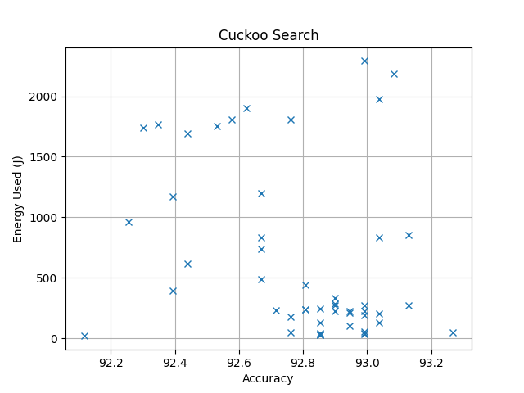

***Fig#3.1 Cuckoo Search Energy Vs Accuracy***

***T#4.3 Cuckoo Search Top 10 Values***

|  |  |  |  |  |  |  |  |
| --- | --- | --- | --- | --- | --- | --- | --- |
| **ID** | **Time Taken(s)** | **Total Energy(J)** | **CPU(J)** | **Monitor(J)** | **Disk(J)** | **Base(J)** | **Power Consumption (w)** |
| CUC-0009 | 16 | 51.10000000000001 | 27.700000000000003 | 0.0 | 0.0 | 24.0 | 3.1937500000000005 |
| CUC-0031 | 264 | 852.8000000000005 | 468.3000000000003 | 0.0 | 0.0 | 396.0 | 3.230303030303032 |
| CUC-0010 | 84 | 269.3 | 146.49999999999994 | 0.0 | 0.0 | 126.0 | 3.205952380952381 |
| CUC-0042 | 678 | 2185.099999999998 | 1198.3000000000022 | 0.0 | 0.0 | 1017.0 | 3.2228613569321505 |
| CUC-0035 | 40 | 130.0 | 71.90000000000002 | 0.0 | 0.0 | 60.0 | 3.25 |
| CUC-0040 | 612 | 1978.4999999999973 | 1086.700000000003 | 0.0 | 0.1 | 918.0 | 3.2328431372548976 |
| CUC-0041 | 258 | 832.0000000000009 | 455.3 | 0.0 | 0.0 | 387.0 | 3.224806201550391 |
| CUC-0039 | 63 | 206.2999999999999 | 114.50000000000004 | 0.0 | 0.0 | 94.5 | 3.274603174603173 |
| CUC-0046 | 84 | 273.6 | 151.29999999999998 | 0.0 | 0.0 | 126.0 | 3.2571428571428576 |
| CUC-0048 | 69 | 222.3999999999999 | 122.39999999999996 | 0.0 | 0.0 | 103.5 | 3.2231884057971 |

**NIA Fire Fly**

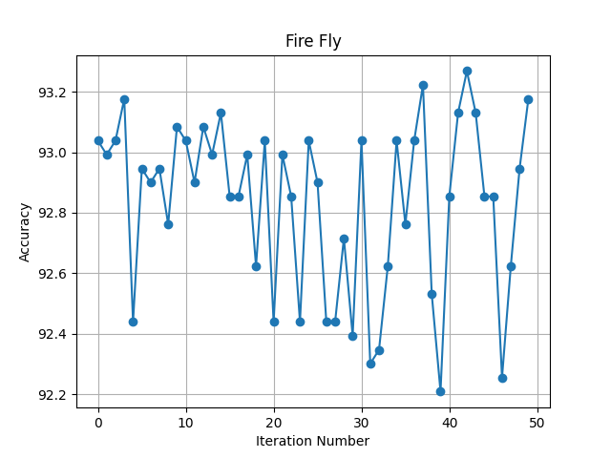

***Fig#4.0 Fire Fly Iterations***

***T#5.0 Fire Fly Main Result***

|  |  |  |  |  |
| --- | --- | --- | --- | --- |
| **ID** | **Accuracy** | **Time Taken (s)** | **Energy Used (J)** | **Equivalent CO2 Emission (mg)** |
| FIR-0000 | 93.03826648224988 | 92 | 295.69999999999993 | 69.81805555555553 |
| FIR-0001 | 92.99216228676808 | 60 | 194.8 | 45.99444444444444 |
| FIR-0002 | 93.03826648224988 | 150 | 485.7 | 114.67916666666666 |
| FIR-0003 | 93.17657906869525 | 933 | 3013.3999999999915 | 711.4972222222202 |
| FIR-0004 | 92.43891194098664 | 670 | 2161.4999999999977 | 510.3541666666661 |
| FIR-0005 | 92.94605809128632 | 95 | 309.7 | 73.1236111111111 |
| FIR-0006 | 92.89995389580452 | 154 | 497.30000000000007 | 117.41805555555555 |
| FIR-0007 | 92.94605809128632 | 113 | 367.2999999999998 | 86.72361111111105 |
| FIR-0008 | 92.76164130935916 | 680 | 2187.8 | 516.5638888888888 |
| FIR-0009 | 93.08437067773168 | 119 | 386.5 | 91.25694444444444 |
| FIR-0010 | 93.03826648224988 | 138 | 445.8000000000001 | 105.25833333333335 |
| FIR-0011 | 92.89995389580452 | 40 | 129.2 | 30.50555555555556 |
| FIR-0012 | 93.08437067773168 | 86 | 280.1999999999999 | 66.1583333333333 |
| FIR-0013 | 92.99216228676808 | 94 | 303.00000000000006 | 71.54166666666667 |
| FIR-0014 | 93.13047487321346 | 74 | 238.5 | 56.31249999999999 |
| FIR-0015 | 92.85384970032273 | 47 | 155.9 | 36.80972222222222 |
| FIR-0016 | 92.85384970032273 | 39 | 127.1 | 30.00972222222222 |
| FIR-0017 | 92.99216228676808 | 191 | 613.8000000000002 | 144.92500000000004 |
| FIR-0018 | 92.6233287229138 | 318 | 1036.3000000000006 | 244.68194444444453 |
| FIR-0019 | 93.03826648224988 | 193 | 623.9000000000005 | 147.30972222222235 |
| FIR-0020 | 92.43891194098664 | 686 | 2206.9999999999964 | 521.0972222222214 |
| FIR-0021 | 92.99216228676808 | 99 | 321.2 | 75.83888888888889 |
| FIR-0022 | 92.85384970032273 | 163 | 528.6 | 124.80833333333334 |
| FIR-0023 | 92.43891194098664 | 195 | 631.8000000000004 | 149.1750000000001 |
| FIR-0024 | 93.03826648224988 | 194 | 626.7000000000006 | 147.97083333333347 |
| FIR-0025 | 92.89995389580452 | 89 | 289.69999999999993 | 68.40138888888887 |
| FIR-0026 | 92.43891194098664 | 317 | 1100.5000000000002 | 259.8402777777778 |
| FIR-0027 | 92.43891194098664 | 273 | 1008.6 | 238.14166666666668 |
| FIR-0028 | 92.71553711387736 | 89 | 358.89999999999986 | 84.74027777777775 |
| FIR-0029 | 92.39280774550484 | 124 | 449.9 | 106.22638888888888 |
| FIR-0030 | 93.03826648224988 | 61 | 217.20000000000005 | 51.28333333333335 |
| FIR-0031 | 92.30059935454128 | 272 | 946.1 | 223.3847222222222 |
| FIR-0032 | 92.34670355002304 | 8 | 28.4 | 6.705555555555555 |
| FIR-0033 | 92.6233287229138 | 215 | 742.9999999999999 | 175.43055555555551 |
| FIR-0034 | 93.03826648224988 | 20 | 66.30000000000001 | 15.654166666666669 |
| FIR-0035 | 92.76164130935916 | 35 | 115.19999999999996 | 27.199999999999992 |
| FIR-0036 | 93.03826648224988 | 91 | 296.5999999999999 | 70.03055555555554 |
| FIR-0037 | 93.22268326417704 | 218 | 709.1000000000013 | 167.4263888888892 |
| FIR-0038 | 92.5311203319502 | 408 | 1335.8999999999996 | 315.42083333333323 |
| FIR-0039 | 92.20839096357768 | 413 | 1274.2999999999995 | 300.8763888888888 |
| FIR-0040 | 92.85384970032273 | 65 | 203.00000000000003 | 47.93055555555557 |
| FIR-0041 | 93.13047487321346 | 129 | 397.6999999999998 | 93.90138888888885 |
| FIR-0042 | 93.26878745965884 | 340 | 1045.8999999999978 | 246.94861111111047 |
| FIR-0043 | 93.13047487321346 | 527 | 1623.0000000000016 | 383.2083333333337 |
| FIR-0044 | 92.85384970032273 | 123 | 378.5999999999999 | 89.39166666666664 |
| FIR-0045 | 92.85384970032273 | 273 | 841.9999999999984 | 198.8055555555552 |
| FIR-0046 | 92.25449515905947 | 459 | 1410.6999999999996 | 333.08194444444433 |
| FIR-0047 | 92.6233287229138 | 75 | 233.4000000000001 | 55.10833333333335 |
| FIR-0048 | 92.94605809128632 | 14 | 42.3 | 9.9875 |
| FIR-0049 | 93.17657906869525 | 93 | 288.2 | 68.04722222222222 |

***T#5.1 Fire Fly Parameters***

|  |  |  |  |  |  |  |  |  |
| --- | --- | --- | --- | --- | --- | --- | --- | --- |
| **ID** | **population_size** | **alpha** | **beta0** | **gamma** | **theta** | **n_estimator** | **criterion** | **max_feature** |
| FIR-0000 | 92 | 0.8917689509621813 | 75.21115868102953 | 0.4953294691693303 | 0.8911943611104965 | 458 | gini | sqrt |
| FIR-0001 | 51 | 0.8958647271396394 | 57.02195515335964 | 0.2881207427211892 | 0.7857829646462213 | 223 | entropy | log2 |
| FIR-0002 | 94 | 0.8756219559119393 | 75.81083312931621 | 0.3153985157576881 | 0.6927513415286395 | 456 | entropy | sqrt |
| FIR-0003 | 98 | 0.422274742098485 | 12.56144876187138 | 0.4711983349810433 | 0.9763147931213136 | 596 | entropy | nan |
| FIR-0004 | 14 | 0.4603457160232521 | 3.068088835112797 | 0.7459307844687939 | 0.2305468237587804 | 595 | gini | nan |
| FIR-0005 | 99 | 0.3973297788360634 | 54.265362801727264 | 0.3190557697903967 | 0.5331071877197201 | 574 | gini | log2 |
| FIR-0006 | 100 | 0.8449769032525553 | 0.01 | 0.1 | 1.0 | 557 | entropy | log2 |
| FIR-0007 | 50 | 0.667891150181334 | 95.82957976005396 | 0.1641579089567748 | 0.1502096249872363 | 430 | entropy | log2 |
| FIR-0008 | 89 | 0.9520373642102818 | 26.66165391014103 | 0.4157094188095089 | 0.9203563071406872 | 435 | entropy | nan |
| FIR-0009 | 99 | 0.5758341944221438 | 34.42811050128377 | 0.6782640892768879 | 0.8886932878089117 | 599 | gini | sqrt |
| FIR-0010 | 99 | 0.4093627631996008 | 99.21802510758889 | 0.4377065256965773 | 0.614922472203909 | 501 | entropy | log2 |
| FIR-0011 | 55 | 0.561732986115319 | 53.646058697238665 | 0.6334899012233465 | 0.7611802316727646 | 143 | entropy | log2 |
| FIR-0012 | 20 | 0.9311948182616286 | 95.90949761652574 | 0.1139620030751014 | 0.9808067825594784 | 274 | entropy | sqrt |
| FIR-0013 | 69 | 0.9402685984101146 | 94.08265797053024 | 0.9999133862450804 | 0.5399541735331832 | 288 | entropy | sqrt |
| FIR-0014 | 10 | 0.8667153534244392 | 51.97077321151332 | 0.9197346931864658 | 0.6526749194197828 | 288 | entropy | log2 |
| FIR-0015 | 11 | 0.1237822201672044 | 75.34141324338253 | 0.9818593976635764 | 0.8023269496899562 | 321 | gini | log2 |
| FIR-0016 | 17 | 0.6042000528711239 | 46.76616338245668 | 0.636378362103652 | 0.287355357602032 | 260 | gini | log2 |
| FIR-0017 | 82 | 0.2331703287436039 | 14.365595621656592 | 0.5023014802368023 | 0.1673728940016364 | 594 | entropy | sqrt |
| FIR-0018 | 21 | 0.2247525348795887 | 73.10759569199193 | 0.5757740444221321 | 0.7218968725605734 | 283 | gini | nan |
| FIR-0019 | 95 | 0.1707983816875665 | 15.430241283301909 | 0.4022326134907085 | 0.3013935841329833 | 589 | entropy | sqrt |
| FIR-0020 | 97 | 0.5970865515844359 | 6.228590699166084 | 0.2054352073709703 | 0.2558591861447088 | 599 | gini | nan |
| FIR-0021 | 98 | 0.5515736077969372 | 34.092142716097484 | 0.6595889885132442 | 0.5815430313840249 | 597 | gini | log2 |
| FIR-0022 | 97 | 0.189701793852941 | 12.047515377998453 | 0.923624534543346 | 0.5294419213547551 | 598 | entropy | log2 |
| FIR-0023 | 54 | 0.2123447743857329 | 84.36629942966935 | 0.4551822312561766 | 0.3469266488422984 | 170 | gini | nan |
| FIR-0024 | 95 | 0.3031899343150886 | 15.033998036620416 | 0.769292716567537 | 0.3913812390832617 | 596 | entropy | sqrt |
| FIR-0025 | 12 | 0.960454649221884 | 47.3530448023767 | 0.2193896055955569 | 0.2593776666042864 | 285 | entropy | sqrt |
| FIR-0026 | 23 | 0.9377478746528976 | 96.68153766422016 | 0.1596855923101182 | 0.2756309808467675 | 274 | gini | nan |
| FIR-0027 | 53 | 0.8902556838622868 | 55.81908186903236 | 0.7543036843842355 | 0.5274362530434262 | 224 | gini | nan |
| FIR-0028 | 13 | 0.2025828952643224 | 73.53995810516889 | 0.9527360937058914 | 0.9615773496536146 | 293 | entropy | log2 |
| FIR-0029 | 29 | 0.4205662759633127 | 23.483760240569065 | 0.6887833979847012 | 0.8325590476680745 | 102 | gini | nan |
| FIR-0030 | 49 | 0.2218330114533548 | 8.592493680815718 | 0.5191861318692734 | 0.4350763935141402 | 177 | entropy | sqrt |
| FIR-0031 | 14 | 0.9792323049123052 | 67.75171294835995 | 0.166177079888397 | 0.6426816011811248 | 232 | gini | nan |
| FIR-0032 | 76 | 0.7240198871085062 | 86.93689988914234 | 0.1058626534024828 | 0.5274824713848081 | 12 | gini | log2 |
| FIR-0033 | 19 | 0.7063699828773052 | 65.93764584444818 | 0.82983947242195 | 0.7243529184010246 | 184 | gini | nan |
| FIR-0034 | 24 | 0.4974246567610503 | 8.207688729404648 | 0.1662460826030311 | 0.4397614686013957 | 108 | gini | sqrt |
| FIR-0035 | 18 | 0.1151005791783722 | 4.396715464806173 | 0.8924985230409058 | 0.462908837306812 | 22 | entropy | nan |
| FIR-0036 | 23 | 0.4973512432978328 | 6.026751550291324 | 0.6870452700206068 | 0.7870830880367512 | 290 | entropy | sqrt |
| FIR-0037 | 63 | 0.5727765001909958 | 69.05665202085524 | 0.3976752479360185 | 0.5298348527059816 | 138 | entropy | nan |
| FIR-0038 | 24 | 0.8243308753943239 | 60.65317591842814 | 0.5053009222338155 | 0.2745070714564406 | 364 | gini | nan |
| FIR-0039 | 92 | 0.6888614162029947 | 52.18801682220773 | 0.3188231352805478 | 0.9250069727230008 | 363 | gini | nan |
| FIR-0040 | 55 | 0.1606627337729007 | 0.6469258792573198 | 0.2806062545346521 | 0.7822116288237752 | 426 | gini | log2 |
| FIR-0041 | 40 | 0.6121495647691023 | 87.30565687503099 | 0.3608122647114476 | 0.4582542699971555 | 500 | entropy | log2 |
| FIR-0042 | 65 | 0.3914980994222482 | 89.57259985699528 | 0.7218275244887356 | 0.650181569750993 | 220 | entropy | nan |
| FIR-0043 | 56 | 0.3328306685833605 | 22.899077676448663 | 0.8620015808522545 | 0.7278263809733048 | 343 | entropy | nan |
| FIR-0044 | 59 | 0.4439572176635709 | 48.25901825048486 | 0.8775222975073923 | 0.3671095378197826 | 470 | entropy | log2 |
| FIR-0045 | 53 | 0.6253701253943761 | 24.603379639126803 | 0.8748386088495188 | 0.9492025535101696 | 176 | entropy | nan |
| FIR-0046 | 53 | 0.5478858869077894 | 96.84788123912465 | 0.3434916587926501 | 0.999034806069366 | 410 | gini | nan |
| FIR-0047 | 50 | 0.827508448797785 | 79.71210135548466 | 0.8229969676686423 | 0.1355609221298807 | 47 | entropy | nan |
| FIR-0048 | 41 | 0.7860477323777897 | 32.765462396721055 | 0.3533740256318564 | 0.1296967008576448 | 39 | entropy | sqrt |
| FIR-0049 | 96 | 0.2516367853464829 | 70.13790805268793 | 0.1978297661607377 | 0.244846408795388 | 471 | gini | sqrt |

***T#5.2 Fire Fly Energy Distribution***

|  |  |  |  |  |  |  |
| --- | --- | --- | --- | --- | --- | --- |
| **ID** | **Time Taken(s)** | **Total Energy(J)** | **CPU(J)** | **Monitor(J)** | **Disk(J)** | **Base(J)** |
| FIR-0000 | 92 | 295.69999999999993 | 162.2 | 0.0 | 0.0 | 138.0 |
| FIR-0001 | 60 | 194.8 | 107.5 | 0.0 | 0.0 | 90.0 |
| FIR-0002 | 150 | 485.7 | 266.5999999999999 | 0.0 | 0.0 | 225.0 |
| FIR-0003 | 933 | 3013.3999999999915 | 1654.0999999999992 | 0.0 | 0.0 | 1399.5 |
| FIR-0004 | 670 | 2161.4999999999977 | 1189.0000000000036 | 0.0 | 0.1 | 1005.0 |
| FIR-0005 | 95 | 309.7 | 171.8999999999999 | 0.0 | 0.0 | 142.5 |
| FIR-0006 | 154 | 497.30000000000007 | 272.2 | 0.0 | 0.0 | 231.0 |
| FIR-0007 | 113 | 367.2999999999998 | 202.29999999999984 | 0.0 | 0.0 | 169.5 |
| FIR-0008 | 680 | 2187.8 | 1199.5000000000016 | 0.0 | 0.0 | 1020.0 |
| FIR-0009 | 119 | 386.5 | 212.29999999999984 | 0.0 | 0.0 | 178.5 |
| FIR-0010 | 138 | 445.8000000000001 | 244.3999999999997 | 0.0 | 0.0 | 207.0 |
| FIR-0011 | 40 | 129.2 | 70.89999999999999 | 0.0 | 0.0 | 60.0 |
| FIR-0012 | 86 | 280.1999999999999 | 154.69999999999996 | 0.0 | 0.0 | 129.0 |
| FIR-0013 | 94 | 303.00000000000006 | 165.5999999999999 | 0.0 | 0.0 | 141.0 |
| FIR-0014 | 74 | 238.5 | 131.49999999999997 | 0.0 | 0.0 | 111.0 |
| FIR-0015 | 47 | 155.9 | 87.40000000000003 | 0.0 | 0.0 | 70.5 |
| FIR-0016 | 39 | 127.1 | 70.3 | 0.0 | 0.0 | 58.5 |
| FIR-0017 | 191 | 613.8000000000002 | 336.3999999999998 | 0.0 | 0.0 | 286.5 |
| FIR-0018 | 318 | 1036.3000000000006 | 573.6000000000005 | 0.0 | 0.0 | 477.0 |
| FIR-0019 | 193 | 623.9000000000005 | 343.6 | 0.0 | 0.0 | 289.5 |
| FIR-0020 | 686 | 2206.9999999999964 | 1207.6000000000024 | 0.0 | 0.0 | 1029.0 |
| FIR-0021 | 99 | 321.2 | 177.39999999999992 | 0.0 | 0.0 | 148.5 |
| FIR-0022 | 163 | 528.6 | 290.79999999999995 | 0.0 | 0.0 | 244.5 |
| FIR-0023 | 195 | 631.8000000000004 | 347.8999999999999 | 0.0 | 0.0 | 292.5 |
| FIR-0024 | 194 | 626.7000000000006 | 343.3999999999998 | 0.0 | 0.0 | 291.0 |
| FIR-0025 | 89 | 289.69999999999993 | 159.39999999999992 | 0.0 | 0.0 | 133.5 |
| FIR-0026 | 317 | 1100.5000000000002 | 634.4 | 0.0 | 0.0 | 475.5 |
| FIR-0027 | 273 | 1008.6 | 604.3999999999999 | 0.0 | 0.0 | 409.5 |
| FIR-0028 | 89 | 358.89999999999986 | 227.30000000000004 | 0.0 | 0.0 | 133.5 |
| FIR-0029 | 124 | 449.9 | 266.2 | 0.0 | 0.0 | 186.0 |
| FIR-0030 | 61 | 217.20000000000005 | 127.49999999999996 | 0.0 | 0.0 | 91.5 |
| FIR-0031 | 272 | 946.1 | 544.2 | 0.0 | 0.0 | 408.0 |
| FIR-0032 | 8 | 28.4 | 16.8 | 0.0 | 0.0 | 12.0 |
| FIR-0033 | 215 | 742.9999999999999 | 424.8000000000001 | 0.0 | 0.0 | 322.5 |
| FIR-0034 | 20 | 66.30000000000001 | 37.3 | 0.0 | 0.0 | 30.0 |
| FIR-0035 | 35 | 115.19999999999996 | 64.2 | 0.0 | 0.0 | 52.5 |
| FIR-0036 | 91 | 296.5999999999999 | 164.49999999999994 | 0.0 | 0.0 | 136.5 |
| FIR-0037 | 218 | 709.1000000000013 | 388.80000000000007 | 0.0 | 0.0 | 327.0 |
| FIR-0038 | 408 | 1335.8999999999996 | 731.7000000000011 | 0.0 | 0.0 | 612.0 |
| FIR-0039 | 413 | 1274.2999999999995 | 671.7999999999992 | 0.0 | 0.0 | 619.5 |
| FIR-0040 | 65 | 203.00000000000003 | 108.7 | 0.0 | 0.0 | 97.5 |
| FIR-0041 | 129 | 397.6999999999998 | 209.50000000000009 | 0.0 | 0.0 | 193.5 |
| FIR-0042 | 340 | 1045.8999999999978 | 551.1999999999994 | 0.0 | 0.0 | 510.0 |
| FIR-0043 | 527 | 1623.0000000000016 | 855.7999999999993 | 0.0 | 0.0 | 790.5 |
| FIR-0044 | 123 | 378.5999999999999 | 199.6 | 0.0 | 0.0 | 184.5 |
| FIR-0045 | 273 | 841.9999999999984 | 445.1999999999996 | 0.0 | 0.0 | 409.5 |
| FIR-0046 | 459 | 1410.6999999999996 | 742.3999999999988 | 0.0 | 0.0 | 688.5 |
| FIR-0047 | 75 | 233.4000000000001 | 123.80000000000004 | 0.0 | 0.1 | 112.5 |
| FIR-0048 | 14 | 42.3 | 22.1 | 0.0 | 0.0 | 21.0 |
| FIR-0049 | 93 | 288.2 | 152.8 | 0.0 | 0.0 | 139.5 |

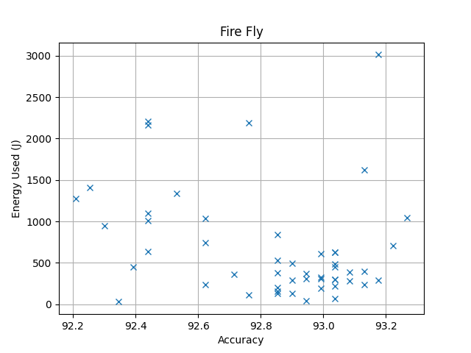

***Fig#4.1 Fire Fly Energy Vs Accuracy***

***T#5.3 Fire Fly Top 10 Values***

|  |  |  |  |  |  |  |  |
| --- | --- | --- | --- | --- | --- | --- | --- |
| **ID** | **Time Taken(s)** | **Total Energy(J)** | **CPU(J)** | **Monitor(J)** | **Disk(J)** | **Base(J)** | **Power Consumption (w)** |
| FIR-0042 | 340 | 1045.8999999999978 | 551.1999999999994 | 0.0 | 0.0 | 510.0 | 3.076176470588229 |
| FIR-0037 | 218 | 709.1000000000013 | 388.80000000000007 | 0.0 | 0.0 | 327.0 | 3.252752293577988 |
| FIR-0003 | 933 | 3013.3999999999915 | 1654.0999999999992 | 0.0 | 0.0 | 1399.5 | 3.229796355841363 |
| FIR-0049 | 93 | 288.2 | 152.8 | 0.0 | 0.0 | 139.5 | 3.0989247311827954 |
| FIR-0043 | 527 | 1623.0000000000016 | 855.7999999999993 | 0.0 | 0.0 | 790.5 | 3.07969639468691 |
| FIR-0041 | 129 | 397.6999999999998 | 209.50000000000009 | 0.0 | 0.0 | 193.5 | 3.082945736434107 |
| FIR-0014 | 74 | 238.5 | 131.49999999999997 | 0.0 | 0.0 | 111.0 | 3.222972972972973 |
| FIR-0009 | 119 | 386.5 | 212.29999999999984 | 0.0 | 0.0 | 178.5 | 3.2478991596638656 |
| FIR-0012 | 86 | 280.1999999999999 | 154.69999999999996 | 0.0 | 0.0 | 129.0 | 3.2581395348837194 |
| FIR-0000 | 92 | 295.69999999999993 | 162.2 | 0.0 | 0.0 | 138.0 | 3.214130434782608 |

**NIA Particle Swarm**

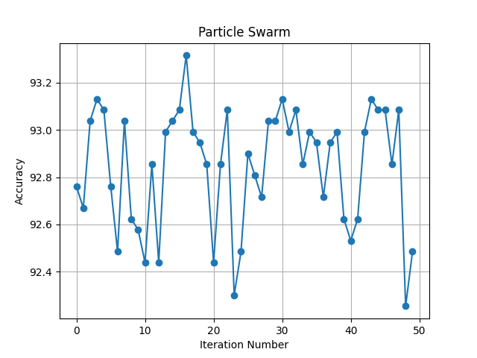

***Fig#5.0 Particle Swarm Iterations***

***T#6.0 Particle Swarm Main Result***

|  |  |  |  |  |
| --- | --- | --- | --- | --- |
| **ID** | **Accuracy** | **Time Taken (s)** | **Energy Used (J)** | **Equivalent CO2 Emission (mg)** |
| PAR-0000 | 92.76164130935916 | 86 | 315.2000000000001 | 74.42222222222225 |
| PAR-0001 | 92.66943291839556 | 478 | 1710.2999999999988 | 403.820833333333 |
| PAR-0002 | 93.03826648224988 | 184 | 615.2000000000002 | 145.2555555555556 |
| PAR-0003 | 93.13047487321346 | 168 | 551.7000000000003 | 130.26250000000007 |
| PAR-0004 | 93.08437067773168 | 87 | 285.69999999999976 | 67.45694444444439 |
| PAR-0005 | 92.76164130935916 | 20 | 65.50000000000001 | 15.46527777777778 |
| PAR-0006 | 92.48501613646842 | 211 | 686.1000000000003 | 161.9958333333334 |
| PAR-0007 | 93.03826648224988 | 39 | 126.89999999999998 | 29.962499999999995 |
| PAR-0008 | 92.6233287229138 | 207 | 668.6000000000007 | 157.86388888888905 |
| PAR-0009 | 92.577224527432 | 528 | 1716.2999999999984 | 405.2374999999996 |
| PAR-0010 | 92.43891194098664 | 451 | 1488.0000000000016 | 351.3333333333337 |
| PAR-0011 | 92.85384970032273 | 950 | 3483.5 | 822.4930555555555 |
| PAR-0012 | 92.43891194098664 | 153 | 527.2000000000004 | 124.47777777777786 |
| PAR-0013 | 92.99216228676808 | 149 | 488.1000000000002 | 115.24583333333338 |
| PAR-0014 | 93.03826648224988 | 714 | 2332.8999999999965 | 550.8236111111103 |
| PAR-0015 | 93.08437067773168 | 33 | 107.9 | 25.476388888888888 |
| PAR-0016 | 93.3148916551406 | 186 | 609.6000000000004 | 143.93333333333342 |
| PAR-0017 | 92.99216228676808 | 51 | 166.99999999999997 | 39.43055555555555 |
| PAR-0018 | 92.94605809128632 | 47 | 153.7 | 36.290277777777774 |
| PAR-0019 | 92.85384970032273 | 32 | 104.9 | 24.76805555555556 |
| PAR-0020 | 92.43891194098664 | 304 | 990.700000000002 | 233.91527777777824 |
| PAR-0021 | 92.85384970032273 | 135 | 441.80000000000007 | 104.3138888888889 |
| PAR-0022 | 93.08437067773168 | 116 | 380.2000000000001 | 89.76944444444446 |
| PAR-0023 | 92.30059935454128 | 196 | 637.9000000000004 | 150.61527777777786 |
| PAR-0024 | 92.48501613646842 | 502 | 1709.900000000001 | 403.7263888888891 |
| PAR-0025 | 92.89995389580452 | 30 | 117.3 | 27.695833333333333 |
| PAR-0026 | 92.80774550484094 | 21 | 77.3 | 18.251388888888886 |
| PAR-0027 | 92.71553711387736 | 86 | 307.3 | 72.55694444444444 |
| PAR-0028 | 93.03826648224988 | 136 | 483.1999999999999 | 114.08888888888886 |
| PAR-0029 | 93.03826648224988 | 77 | 272.6 | 64.36388888888888 |
| PAR-0030 | 93.13047487321346 | 75 | 268.99999999999994 | 63.51388888888887 |
| PAR-0031 | 92.99216228676808 | 810 | 2704.3999999999937 | 638.5388888888874 |
| PAR-0032 | 93.08437067773168 | 153 | 493.5000000000001 | 116.52083333333336 |
| PAR-0033 | 92.85384970032273 | 186 | 610.1 | 144.05138888888888 |
| PAR-0034 | 92.99216228676808 | 82 | 272.69999999999993 | 64.38749999999999 |
| PAR-0035 | 92.94605809128632 | 110 | 362.1000000000002 | 85.49583333333338 |
| PAR-0036 | 92.71553711387736 | 30 | 99.3 | 23.445833333333336 |
| PAR-0037 | 92.94605809128632 | 483 | 1569.1999999999991 | 370.50555555555536 |
| PAR-0038 | 92.99216228676808 | 69 | 254.3 | 60.043055555555554 |
| PAR-0039 | 92.6233287229138 | 346 | 1206.3999999999996 | 284.8444444444444 |
| PAR-0040 | 92.5311203319502 | 373 | 1251.9999999999995 | 295.611111111111 |
| PAR-0041 | 92.6233287229138 | 251 | 842.0000000000002 | 198.8055555555556 |
| PAR-0042 | 92.99216228676808 | 66 | 215.8999999999999 | 50.97638888888886 |
| PAR-0043 | 93.13047487321346 | 21 | 67.90000000000002 | 16.03194444444445 |
| PAR-0044 | 93.08437067773168 | 61 | 200.79999999999995 | 47.4111111111111 |
| PAR-0045 | 93.08437067773168 | 64 | 207.2 | 48.92222222222221 |
| PAR-0046 | 92.85384970032273 | 63 | 203.29999999999995 | 48.00138888888887 |
| PAR-0047 | 93.08437067773168 | 682 | 2332.600000000002 | 550.7527777777783 |
| PAR-0048 | 92.25449515905947 | 268 | 895.2000000000012 | 211.36666666666693 |
| PAR-0049 | 92.48501613646842 | 282 | 913.6000000000004 | 215.7111111111112 |

***T#6.1 Particle Swarm Parameters***

|  |  |  |  |  |  |  |  |  |  |  |
| --- | --- | --- | --- | --- | --- | --- | --- | --- | --- | --- |
| **ID** | **population_size** | **c1** | **c2** | **w** | **min_velocity** | **max_velocity** | **repair** | **n_estimator** | **criterion** | **max_feature** |
| PAR-0000 | 89 | 3.518973115387473 | 3.008347181959377 | 0.5558800007836792 | -2.390802902062923 | 3.199892658814274 | limit_inverse | 553 | gini | log2 |
| PAR-0001 | 44 | 0.1240354906685619 | 3.5165894110128817 | 0.7738633495492911 | -3.3758170337110838 | 0.8663142063114215 | reflect | 382 | gini | nan |
| PAR-0002 | 89 | 0.5502908206217634 | 1.8156910493326364 | 0.6489923514070706 | -3.149275600858573 | 2.679379060695506 | rand | 553 | entropy | sqrt |
| PAR-0003 | 38 | 1.1080381527622367 | 2.698011401728184 | 0.1830043487302162 | -1.2574781610061674 | 8.006845924453234 | limit_inverse | 518 | entropy | sqrt |
| PAR-0004 | 27 | 2.8868978523858204 | 0.0574393458799149 | 0.4828291131527956 | -6.465164039480151 | 4.91815682621942 | limit_inverse | 263 | entropy | sqrt |
| PAR-0005 | 68 | 0.1453623961295349 | 2.6396419702483715 | 0.2328851509677504 | -1.893134202119196 | 5.0190155679524215 | limit_inverse | 61 | entropy | sqrt |
| PAR-0006 | 43 | 3.805783973742792 | 1.8966188632795284 | 0.3025073413532441 | -4.055351672249205 | 3.653406243641263 | reflect | 184 | gini | nan |
| PAR-0007 | 71 | 3.3216725899860933 | 0.0995280121395478 | 0.6941618447805683 | -4.639031613734888 | 9.886629424982164 | reflect | 202 | gini | sqrt |
| PAR-0008 | 45 | 2.8020056970385867 | 3.965759242742152 | 0.3945547712368543 | -9.968937859741656 | 2.324951678665388 | limit | 180 | gini | nan |
| PAR-0009 | 35 | 1.8775571854011923 | 2.4318449669655022 | 0.9509187323849438 | -4.123550040001921 | 3.2842933327728185 | reflect | 460 | gini | nan |
| PAR-0010 | 82 | 2.248812581242101 | 0.941741894862433 | 0.6407532820759305 | -0.6552118797735105 | 1.181506280323403 | limit_inverse | 391 | gini | nan |
| PAR-0011 | 46 | 3.9254625116050152 | 3.489022595447349 | 0.95022644287311 | -5.625444997810836 | 3.1614498166926253 | limit | 556 | entropy | nan |
| PAR-0012 | 53 | 0.8744299743617647 | 2.270847082589731 | 0.7120636819341785 | -2.9710843617821734 | 1.9458981337470471 | wang | 127 | gini | nan |
| PAR-0013 | 22 | 0.8382513594996297 | 1.894513557598986 | 0.9191655231706238 | -6.383270117755277 | 6.3387797564173285 | limit_inverse | 452 | entropy | sqrt |
| PAR-0014 | 33 | 3.55001484302982 | 1.7730892425144682 | 0.3276082080961623 | -8.602584609909016 | 1.237928888070351 | wang | 438 | entropy | nan |
| PAR-0015 | 41 | 0.9976220255316496 | 2.858010039522185 | 0.2957705034488579 | -0.1149559840237746 | 2.4112702238712167 | wang | 127 | entropy | log2 |
| PAR-0016 | 76 | 3.118596083721385 | 3.3021110543244547 | 0.6234529014586783 | -1.6954642986655717 | 3.4284811865354614 | rand | 569 | entropy | sqrt |
| PAR-0017 | 60 | 2.5182401703437893 | 3.0887270583901905 | 0.183268736983684 | -4.922673157766141 | 8.28879775346249 | limit_inverse | 193 | entropy | log2 |
| PAR-0018 | 31 | 0.3481735788957047 | 1.6902330561627532 | 0.1262240550228265 | -2.202076745677905 | 5.96617047993395 | rand | 314 | gini | log2 |
| PAR-0019 | 65 | 3.28472530524626 | 3.354364847195117 | 0.6271643179645877 | -0.3894799436487819 | 6.094034762974259 | limit | 118 | entropy | log2 |
| PAR-0020 | 18 | 2.262423473293144 | 1.4283325603689074 | 0.1331489086950966 | -9.444589400688503 | 4.244857641571407 | rand | 267 | gini | nan |
| PAR-0021 | 92 | 0.9981423577590038 | 0.5113021438538676 | 0.6445110102534299 | -4.278186575158704 | 5.344901667618234 | limit_inverse | 414 | entropy | sqrt |
| PAR-0022 | 56 | 1.383262722119777 | 1.6038613695715354 | 0.4607794259610277 | -1.6701504920064618 | 8.425347625463274 | rand | 431 | entropy | log2 |
| PAR-0023 | 88 | 2.0100168028851897 | 0.5534251213489001 | 0.3294699147164133 | -7.936531709151247 | 9.935628445657454 | reflect | 171 | gini | nan |
| PAR-0024 | 23 | 1.2850547272464845 | 2.7212482405899148 | 0.6178421724778226 | -6.583825456767154 | 8.101963848444631 | limit_inverse | 422 | gini | nan |
| PAR-0025 | 88 | 1.4600458770119946 | 1.512761174421326 | 0.8582747510845202 | -2.6660182712500973 | 9.953542111583936 | wang | 183 | gini | log2 |
| PAR-0026 | 85 | 1.7505705515541914 | 0.6607261493183536 | 0.9907139510014524 | -1.4115929254853476 | 9.531452676165337 | wang | 124 | gini | log2 |
| PAR-0027 | 90 | 0.4095741902046184 | 1.9184208379475352 | 0.3668928504470998 | -0.6831036641805728 | 8.853430867764533 | reflect | 296 | entropy | log2 |
| PAR-0028 | 31 | 3.906548143888592 | 0.0738327135799608 | 0.9881518783518752 | -0.4962331954364209 | 8.631427603337995 | limit | 481 | entropy | log2 |
| PAR-0029 | 30 | 3.6965181605527673 | 3.335582894380441 | 0.1397311318997899 | -1.458633283150471 | 6.988818915992226 | limit_inverse | 469 | gini | log2 |
| PAR-0030 | 28 | 2.738183776860986 | 3.750088392201436 | 0.8672969001143065 | -9.4581992856201 | 3.0710823062613346 | rand | 219 | entropy | sqrt |
| PAR-0031 | 29 | 1.034134615404322 | 2.5897559159463355 | 0.5296588411561688 | -9.100438685338045 | 1.8956172089582968 | wang | 501 | entropy | nan |
| PAR-0032 | 26 | 0.1356190090057705 | 2.57773107904454 | 0.57566095852194 | -4.774467641998265 | 2.011903067065947 | reflect | 484 | entropy | sqrt |
| PAR-0033 | 55 | 3.835539130876525 | 3.381573234572304 | 0.5479317223677445 | -9.035261522283204 | 8.436365770721665 | limit_inverse | 118 | entropy | nan |
| PAR-0034 | 83 | 1.0860543277333905 | 2.9400242215975974 | 0.9495227132824736 | -5.24885121989956 | 8.463393099976614 | wang | 446 | gini | sqrt |
| PAR-0035 | 54 | 2.574832782940028 | 0.4720528408890914 | 0.7372082142537014 | -4.526300243537803 | 2.733726407532786 | limit_inverse | 347 | entropy | sqrt |
| PAR-0036 | 79 | 2.9419556489287197 | 2.3875906719417754 | 0.5356977779862641 | -3.9326613899168734 | 3.347561280033524 | rand | 105 | entropy | log2 |
| PAR-0037 | 52 | 3.103894582966148 | 3.2693096293981423 | 0.3062618711780417 | -3.96075250296846 | 3.360117023825389 | reflect | 307 | entropy | nan |
| PAR-0038 | 82 | 1.1798168945644636 | 3.218394712065094 | 0.6170902642276427 | -2.368126544628982 | 6.246598090767039 | rand | 205 | entropy | sqrt |
| PAR-0039 | 32 | 1.145337995815717 | 0.5314874609450224 | 0.4921666478422632 | -1.2287083091722977 | 1.77079256180527 | rand | 291 | gini | nan |
| PAR-0040 | 97 | 3.48637736076165 | 3.190731641721087 | 0.8931415381840049 | -9.592953257530382 | 3.972747300118869 | limit | 320 | gini | nan |
| PAR-0041 | 95 | 3.308712754318638 | 1.77731899126595 | 0.5451183359850342 | -7.521277526432513 | 2.489155922482029 | wang | 221 | gini | nan |
| PAR-0042 | 57 | 1.5047868437812617 | 2.441022044360515 | 0.0375574638832458 | -8.11857890439778 | 2.3627872015113827 | limit | 358 | gini | sqrt |
| PAR-0043 | 50 | 0.7851518564060482 | 3.0409968429542524 | 0.6831846755205776 | -4.821562040254761 | 4.357392178442902 | reflect | 118 | gini | sqrt |
| PAR-0044 | 48 | 0.0775854448806425 | 1.968582201396471 | 0.2792690270110005 | -1.905258008667124 | 5.646849719632088 | rand | 338 | gini | sqrt |
| PAR-0045 | 17 | 3.94451426284564 | 1.228681975422277 | 0.6451811843723128 | -6.957763460576539 | 3.73016256170886 | limit | 241 | entropy | log2 |
| PAR-0046 | 64 | 1.6156496627320869 | 1.2533626152844135 | 0.1149455767415975 | -6.304244524233869 | 1.8398096416429175 | wang | 244 | entropy | log2 |
| PAR-0047 | 69 | 3.166234811510315 | 2.499001452481806 | 0.4441801458677716 | -3.8001503100663134 | 7.782927998488518 | limit_inverse | 416 | entropy | nan |
| PAR-0048 | 85 | 1.3621676894814247 | 2.407680792053856 | 0.7167606670378115 | -9.680462408101418 | 5.344605172896433 | limit_inverse | 232 | gini | nan |
| PAR-0049 | 15 | 2.070492906705724 | 3.2177609157003206 | 0.8216420582955141 | -1.5363309639553222 | 4.091693185808821 | limit_inverse | 250 | gini | nan |

***T#6.2 Particle Swarm Energy Distribution***

|  |  |  |  |  |  |  |
| --- | --- | --- | --- | --- | --- | --- |
| **ID** | **Time Taken(s)** | **Total Energy(J)** | **CPU(J)** | **Monitor(J)** | **Disk(J)** | **Base(J)** |
| PAR-0000 | 86 | 315.2000000000001 | 187.8 | 0.0 | 0.0 | 129.0 |
| PAR-0001 | 478 | 1710.2999999999988 | 1001.699999999998 | 0.0 | 2.0 | 717.0 |
| PAR-0002 | 184 | 615.2000000000002 | 346.6999999999998 | 0.0 | 0.5 | 276.0 |
| PAR-0003 | 168 | 551.7000000000003 | 307.6999999999999 | 0.0 | 0.0 | 252.0 |
| PAR-0004 | 87 | 285.69999999999976 | 159.29999999999993 | 0.0 | 0.0 | 130.5 |
| PAR-0005 | 20 | 65.50000000000001 | 36.3 | 0.0 | 0.0 | 30.0 |
| PAR-0006 | 211 | 686.1000000000003 | 379.5 | 0.0 | 0.0 | 316.5 |
| PAR-0007 | 39 | 126.89999999999998 | 70.50000000000001 | 0.0 | 0.0 | 58.5 |
| PAR-0008 | 207 | 668.6000000000007 | 368.3999999999999 | 0.0 | 0.0 | 310.5 |
| PAR-0009 | 528 | 1716.2999999999984 | 946.900000000002 | 0.0 | 0.0 | 792.0 |
| PAR-0010 | 451 | 1488.0000000000016 | 831.4000000000019 | 0.0 | 0.3 | 676.5 |
| PAR-0011 | 950 | 3483.5 | 2088.2000000000016 | 0.0 | 0.9000000000000001 | 1425.0 |
| PAR-0012 | 153 | 527.2000000000004 | 302.5 | 0.0 | 0.0 | 229.5 |
| PAR-0013 | 149 | 488.1000000000002 | 270.0999999999998 | 0.0 | 0.0 | 223.5 |
| PAR-0014 | 714 | 2332.8999999999965 | 1295.000000000001 | 0.0 | 0.4 | 1071.0 |
| PAR-0015 | 33 | 107.9 | 59.50000000000001 | 0.0 | 0.0 | 49.5 |
| PAR-0016 | 186 | 609.6000000000004 | 338.9 | 0.0 | 0.0 | 279.0 |
| PAR-0017 | 51 | 166.99999999999997 | 92.6 | 0.0 | 0.0 | 76.5 |
| PAR-0018 | 47 | 153.7 | 85.89999999999999 | 0.0 | 0.0 | 70.5 |
| PAR-0019 | 32 | 104.9 | 58.6 | 0.0 | 0.0 | 48.0 |
| PAR-0020 | 304 | 990.700000000002 | 548.5000000000005 | 0.0 | 0.0 | 456.0 |
| PAR-0021 | 135 | 441.80000000000007 | 245.39999999999984 | 0.0 | 0.0 | 202.5 |
| PAR-0022 | 116 | 380.2000000000001 | 211.09999999999988 | 0.0 | 0.1 | 174.0 |
| PAR-0023 | 196 | 637.9000000000004 | 352.1 | 0.0 | 0.0 | 294.0 |
| PAR-0024 | 502 | 1709.900000000001 | 974.500000000001 | 0.0 | 0.2 | 753.0 |
| PAR-0025 | 30 | 117.3 | 73.0 | 0.0 | 0.0 | 45.0 |
| PAR-0026 | 21 | 77.3 | 46.10000000000001 | 0.0 | 0.0 | 31.5 |
| PAR-0027 | 86 | 307.3 | 180.2 | 0.0 | 0.0 | 129.0 |
| PAR-0028 | 136 | 483.1999999999999 | 282.1000000000001 | 0.0 | 0.0 | 204.0 |
| PAR-0029 | 77 | 272.6 | 158.79999999999998 | 0.0 | 0.0 | 115.5 |
| PAR-0030 | 75 | 268.99999999999994 | 157.5 | 0.0 | 0.3 | 112.5 |
| PAR-0031 | 810 | 2704.3999999999937 | 1519.699999999998 | 0.0 | 0.3 | 1215.0 |
| PAR-0032 | 153 | 493.5000000000001 | 270.8999999999999 | 0.0 | 0.0 | 229.5 |
| PAR-0033 | 186 | 610.1 | 338.49999999999983 | 0.0 | 0.2 | 279.0 |
| PAR-0034 | 82 | 272.69999999999993 | 152.49999999999997 | 0.0 | 0.0 | 123.0 |
| PAR-0035 | 110 | 362.1000000000002 | 202.89999999999984 | 0.0 | 0.0 | 165.0 |
| PAR-0036 | 30 | 99.3 | 55.5 | 0.0 | 0.0 | 45.0 |
| PAR-0037 | 483 | 1569.1999999999991 | 865.1000000000023 | 0.0 | 0.0 | 724.5 |
| PAR-0038 | 69 | 254.3 | 152.20000000000007 | 0.0 | 0.0 | 103.5 |
| PAR-0039 | 346 | 1206.3999999999996 | 694.8999999999996 | 0.0 | 0.0 | 519.0 |
| PAR-0040 | 373 | 1251.9999999999995 | 705.1000000000013 | 0.0 | 0.0 | 559.5 |
| PAR-0041 | 251 | 842.0000000000002 | 476.5000000000001 | 0.0 | 0.7000000000000001 | 376.5 |
| PAR-0042 | 66 | 215.8999999999999 | 119.99999999999996 | 0.0 | 0.0 | 99.0 |
| PAR-0043 | 21 | 67.90000000000002 | 37.8 | 0.0 | 0.0 | 31.5 |
| PAR-0044 | 61 | 200.79999999999995 | 111.79999999999995 | 0.0 | 0.0 | 91.5 |
| PAR-0045 | 64 | 207.2 | 114.4 | 0.0 | 0.0 | 96.0 |
| PAR-0046 | 63 | 203.29999999999995 | 111.7 | 0.0 | 0.0 | 94.5 |
| PAR-0047 | 682 | 2332.600000000002 | 1329.599999999999 | 0.0 | 0.2 | 1023.0 |
| PAR-0048 | 268 | 895.2000000000012 | 501.10000000000025 | 0.0 | 0.0 | 402.0 |
| PAR-0049 | 282 | 913.6000000000004 | 504.8000000000002 | 0.0 | 0.0 | 423.0 |

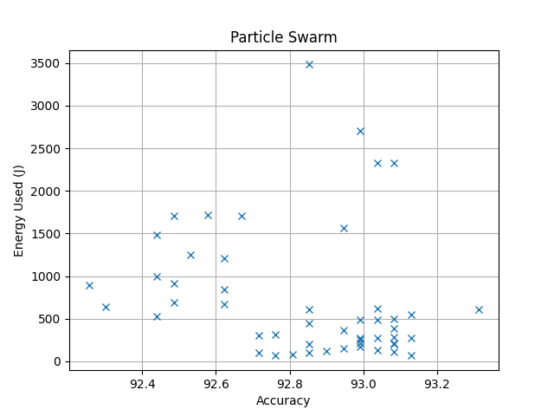

***Fig#5.1 Particle Swarm Energy Vs Accuracy***

***T#6.3 Particle Swarm Top 10 Values***

|  |  |  |  |  |  |  |  |
| --- | --- | --- | --- | --- | --- | --- | --- |
| **ID** | **Time Taken(s)** | **Total Energy(J)** | **CPU(J)** | **Monitor(J)** | **Disk(J)** | **Base(J)** | **Power Consumption (w)** |
| PAR-0016 | 186 | 609.6000000000004 | 338.9 | 0.0 | 0.0 | 279.0 | 3.277419354838712 |
| PAR-0043 | 21 | 67.90000000000002 | 37.8 | 0.0 | 0.0 | 31.5 | 3.2333333333333343 |
| PAR-0030 | 75 | 268.99999999999994 | 157.5 | 0.0 | 0.3 | 112.5 | 3.586666666666666 |
| PAR-0003 | 168 | 551.7000000000003 | 307.6999999999999 | 0.0 | 0.0 | 252.0 | 3.283928571428573 |
| PAR-0022 | 116 | 380.2000000000001 | 211.09999999999988 | 0.0 | 0.1 | 174.0 | 3.2775862068965527 |
| PAR-0004 | 87 | 285.69999999999976 | 159.29999999999993 | 0.0 | 0.0 | 130.5 | 3.2839080459770087 |
| PAR-0045 | 64 | 207.2 | 114.4 | 0.0 | 0.0 | 96.0 | 3.2375 |
| PAR-0044 | 61 | 200.79999999999995 | 111.79999999999995 | 0.0 | 0.0 | 91.5 | 3.291803278688524 |
| PAR-0032 | 153 | 493.5000000000001 | 270.8999999999999 | 0.0 | 0.0 | 229.5 | 3.225490196078432 |
| PAR-0015 | 33 | 107.9 | 59.50000000000001 | 0.0 | 0.0 | 49.5 | 3.26969696969697 |

***Aggregated Analysis Results of Top 10***

***T#8 Aggregated Average***

|  |  |  |  |  |  |  |  |
| --- | --- | --- | --- | --- | --- | --- | --- |
| **Algorithm** | **Time Taken(s)** | **Total Energy(J)** | **CPU(J)** | **Monitor(J)** | **Disk(J)** | **Base(J)** | **Power Consumption (w)** |
| Bat | 239.0 | 792.4600000000004 | 443.1800000000002 | 0.0 | 0.01 | 358.5 | 3.269911858886457 |
| Camel Algorithm | 242.5 | 779.4399999999994 | 426.63 | 0.0 | 0.09 | 363.75 | 3.2246734167712687 |
| Cuckoo Search | 216.8 | 700.1099999999997 | 384.2900000000006 | 0.0 | 0.01 | 325.2 | 3.231545054453598 |
| Fire Fly | 261.1 | 827.8199999999991 | 447.2899999999998 | 0.0 | 0.0 | 391.65 | 3.1763434084614555 |
| Particle Swarm | 96.4 | 317.35 | 176.88999999999993 | 0.0 | 0.04 | 144.6 | 3.296733262360477 |

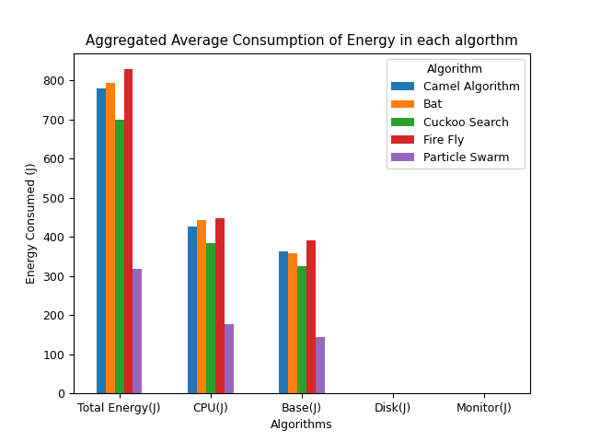

***Fig#7 Aggregated Average Energy Consumption based distribution***

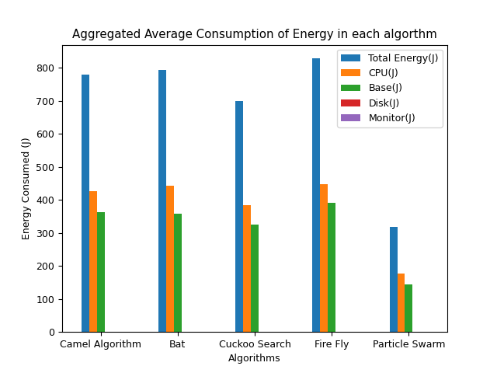

***Fig#8 Aggregated Average Algorithm based distribution***

***T#9 CPU Energy Consumption as compaired to PSO***

|  |  |  |
| --- | --- | --- |
| **Algorithm** | **CPU(J)** | **Ratio Comparison to PSO** |
| Bat | 443.1800000000002 | 2.505 |
| Camel Algorithm | 426.63 | 2.412 |
| Cuckoo Search | 384.2900000000006 | 2.172 |
| Fire Fly | 447.2899999999998 | 2.529 |
| Particle Swarm | 176.88999999999993 | 1.0 |

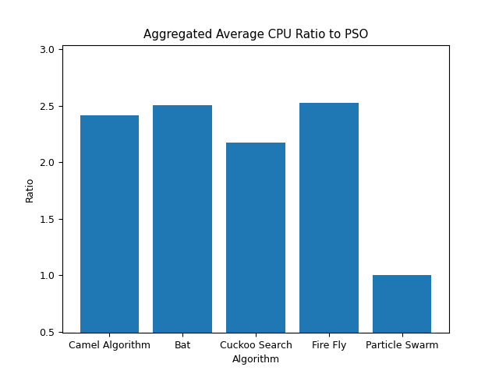

***Fig#9 CPU Energy Consumption Raito***

***T#10 Total(all parts) Energy Consumption as compaired to PSO***

|  |  |  |
| --- | --- | --- |
| **Algorithm** | **Total Energy(J)** | **Ratio Comparison to PSO** |
| Bat | 792.4600000000004 | 2.497 |
| Camel Algorithm | 779.4399999999994 | 2.456 |
| Cuckoo Search | 700.1099999999997 | 2.206 |
| Fire Fly | 827.8199999999991 | 2.609 |
| Particle Swarm | 317.35 | 1.0 |

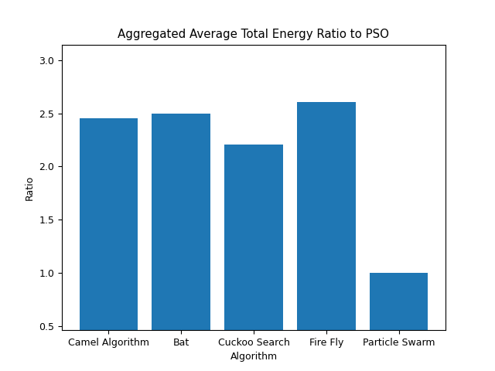

***Fig#10 Total(all parts) Energy Consumption Raito***

***T#11 Time Taken as compaired to PSO***

|  |  |  |
| --- | --- | --- |
| **Algorithm** | **Time Taken(s)** | **Ratio Comparison to PSO** |
| Bat | 239.0 | 2.479 |
| Camel Algorithm | 242.5 | 2.516 |
| Cuckoo Search | 216.8 | 2.249 |
| Fire Fly | 261.1 | 2.709 |
| Particle Swarm | 96.4 | 1.0 |

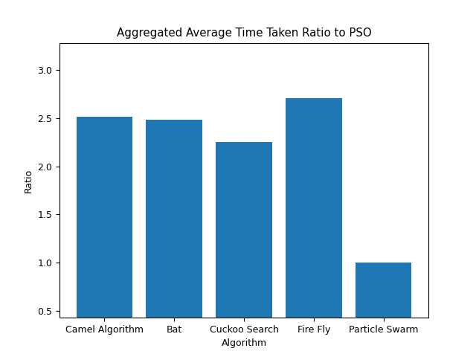

***Fig#11 Time Taken Raito***

***T#12 Average Power Consumption as compaired to PSO***

|  |  |  |
| --- | --- | --- |
| **Algorithm** | **Power Consumption (w)** | **Ratio Comparison to PSO** |
| Bat | 3.269911858886457 | 0.992 |
| Camel Algorithm | 3.2246734167712687 | 0.978 |
| Cuckoo Search | 3.231545054453598 | 0.98 |
| Fire Fly | 3.1763434084614555 | 0.963 |
| Particle Swarm | 3.296733262360477 | 1.0 |

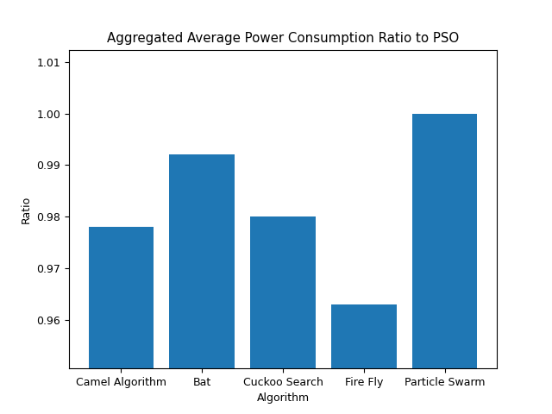

***Fig#12 Average Power Consumption Raito***

***T#13 Main Result (Average)***

|  |  |  |  |  |
| --- | --- | --- | --- | --- |
| **Keys** | **Avg Accuracy** | **Avg Time Taken (s)** | **Avg Energy Used (J)** | **Avg Equivalent CO2 Emission (mg)** |
| ['BAT-0042', 'BAT-0034', 'BAT-0008', 'BAT-0029', 'BAT-0011', 'BAT-0017', 'BAT-0003', 'BAT-0040', 'BAT-0016', 'BAT-0020'] | 93.13047487321349 | 239.0 | 792.4600000000004 | 187.1086111111112 |
| ['CAM-0000', 'CAM-0049', 'CAM-0024', 'CAM-0003', 'CAM-0026', 'CAM-0008', 'CAM-0041', 'CAM-0033', 'CAM-0025', 'CAM-0006'] | 93.12125403411711 | 242.5 | 779.4399999999994 | 184.03444444444423 |
| ['CUC-0009', 'CUC-0031', 'CUC-0010', 'CUC-0042', 'CUC-0035', 'CUC-0040', 'CUC-0041', 'CUC-0039', 'CUC-0046', 'CUC-0048'] | 93.07514983863533 | 216.8 | 700.1099999999997 | 165.30374999999992 |
| ['FIR-0042', 'FIR-0037', 'FIR-0003', 'FIR-0049', 'FIR-0043', 'FIR-0041', 'FIR-0014', 'FIR-0009', 'FIR-0012', 'FIR-0000'] | 93.14430613185802 | 261.1 | 827.8199999999991 | 195.45749999999975 |
| ['PAR-0016', 'PAR-0043', 'PAR-0030', 'PAR-0003', 'PAR-0022', 'PAR-0004', 'PAR-0045', 'PAR-0044', 'PAR-0032', 'PAR-0015'] | 93.12125403411711 | 96.4 | 317.35 | 74.92986111111114 |

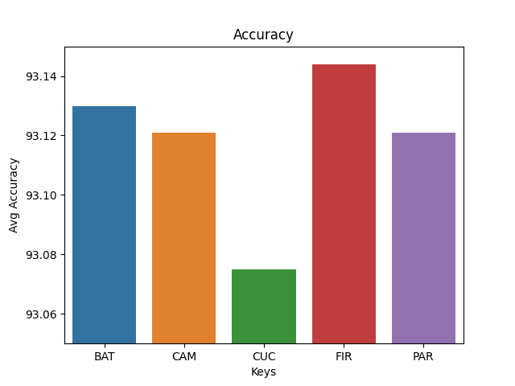

***Fig#13 Accuracy***

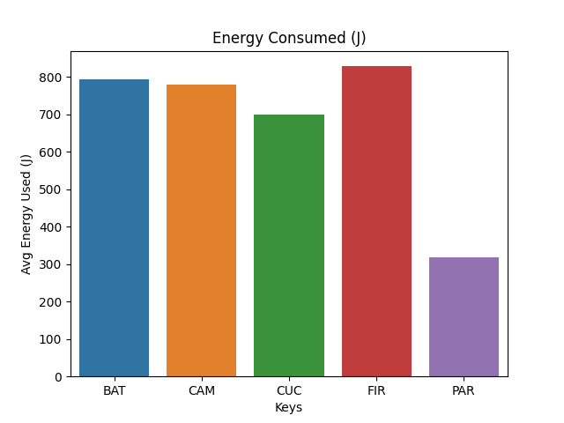

***Fig#14 Energy Consumed***

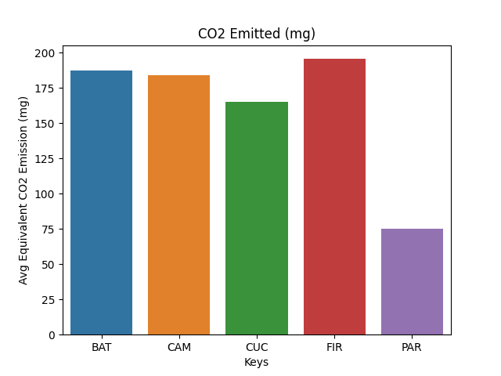

***Fig#15 CO2 Emittion***

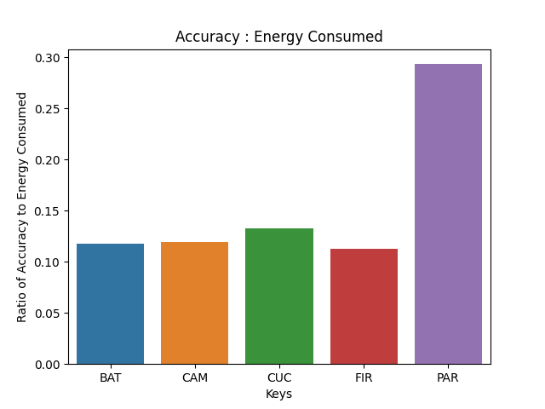

***Fig#16 Accuracy : Energy Consumed***