**Table T1: NIO Compare for 50 decision trees**

|  |  |  |  |  |  |  |  |  |
| --- | --- | --- | --- | --- | --- | --- | --- | --- |
|  | Algo Name | Time Taken | Accuracy | Total Energy (J) | Base Energy (J) | CPU Energy (J) | Monitor Energy (J) | Disk Energy (J) |
| 0 | Grey Wolf Optimizer | 9 | 70.22 | 40.8 | 13.5 | 27.3 | 0 | 0 |
| 1 | Bat Algorithm | 11 | 70.09 | 42.2 | 16.5 | 25.7 | 0 | 0 |
| 2 | Hybrid Bat Algorithm | 9 | 71.29 | 37.2 | 15 | 22.5 | 0 | 0 |
| 3 | Firefly Algorithm | 12 | 71.86 | 48.7 | 19.5 | 29.4 | 0 | 0 |
| 4 | Hybrid Self Adaptive Bat Algorithm | 11 | 71.61 | 46.5 | 18 | 28.8 | 0 | 0 |

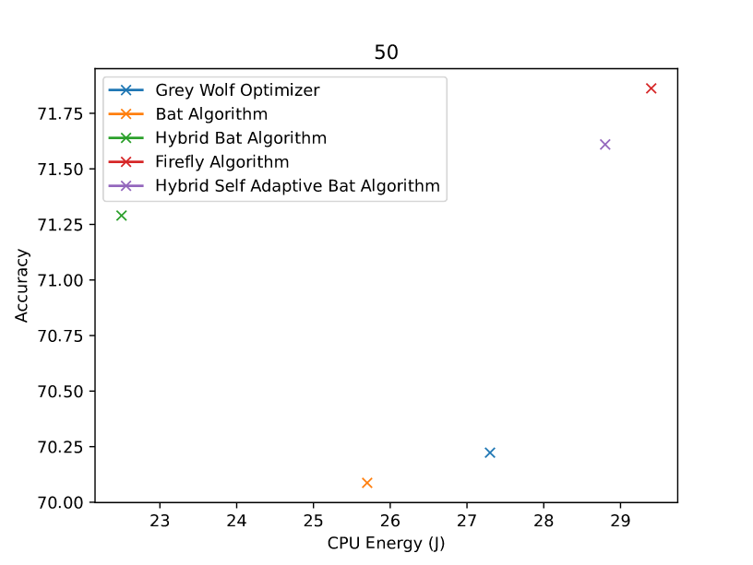

*Figure F1: 50 decision trees*

**Table T2: NIO Compare for 100 decision trees**

|  |  |  |  |  |  |  |  |  |
| --- | --- | --- | --- | --- | --- | --- | --- | --- |
|  | Algo Name | Time Taken | Accuracy | Total Energy (J) | Base Energy (J) | CPU Energy (J) | Monitor Energy (J) | Disk Energy (J) |
| 0 | Grey Wolf Optimizer | 16 | 72.07 | 68.8 | 24 | 45.2 | 0 | 0 |
| 1 | Bat Algorithm | 18 | 72.4 | 67 | 27 | 40.5 | 0 | 0 |
| 2 | Hybrid Bat Algorithm | 19 | 72.12 | 76.6 | 30 | 47.1 | 0 | 0 |
| 3 | Firefly Algorithm | 19 | 71.44 | 68.9 | 28.5 | 40.6 | 0 | 0 |
| 4 | Hybrid Self Adaptive Bat Algorithm | 18 | 71.94 | 66.4 | 27 | 40 | 0 | 0 |

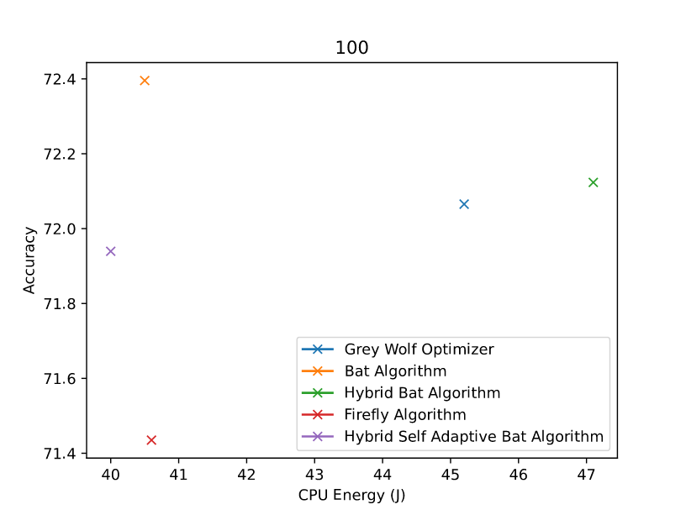

*Figure F2 100 decision trees*

**Table T3: NIO Compare for 150 decision trees**

|  |  |  |  |  |  |  |  |  |
| --- | --- | --- | --- | --- | --- | --- | --- | --- |
|  | Algo Name | Time Taken | Accuracy | Total Energy (J) | Base Energy (J) | CPU Energy (J) | Monitor Energy (J) | Disk Energy (J) |
| 0 | Grey Wolf Optimizer | 25 | 71.73 | 93.7 | 37.5 | 56.7 | 0 | 0 |
| 1 | Bat Algorithm | 28 | 72.21 | 102.3 | 42 | 61.4 | 0 | 0 |
| 2 | Hybrid Bat Algorithm | 28 | 71.96 | 106.5 | 43.5 | 63.4 | 0 | 0 |
| 3 | Firefly Algorithm | 29 | 72.05 | 106.6 | 43.5 | 63.6 | 0 | 0 |
| 4 | Hybrid Self Adaptive Bat Algorithm | 29 | 71.75 | 109.9 | 45 | 65.5 | 0 | 0 |

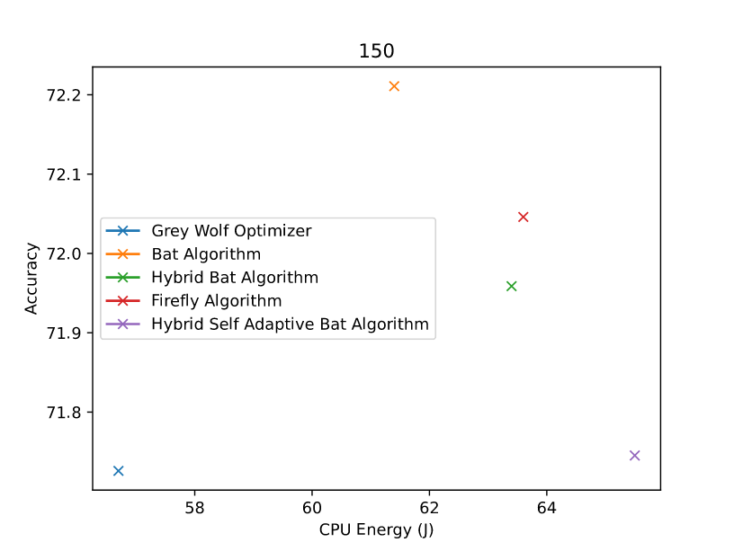

*Figure F3 150 decision trees*

**Table T4: NIO Compare for 200 decision trees**

|  |  |  |  |  |  |  |  |  |
| --- | --- | --- | --- | --- | --- | --- | --- | --- |
|  | Algo Name | Time Taken | Accuracy | Total Energy (J) | Base Energy (J) | CPU Energy (J) | Monitor Energy (J) | Disk Energy (J) |
| 0 | Grey Wolf Optimizer | 36 | 72.7 | 136.7 | 54 | 83.3 | 0 | 0 |
| 1 | Bat Algorithm | 37 | 71.74 | 137 | 57 | 80.7 | 0 | 0 |
| 2 | Hybrid Bat Algorithm | 37 | 71.71 | 139.3 | 55.5 | 84.2 | 0 | 0 |
| 3 | Firefly Algorithm | 40 | 71.44 | 148 | 60 | 88.7 | 0 | 0 |
| 4 | Hybrid Self Adaptive Bat Algorithm | 40 | 72.77 | 151.8 | 60 | 92.7 | 0 | 0 |

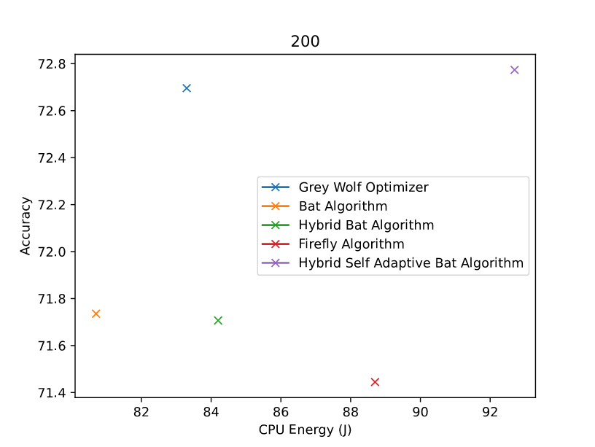

*Figure F4 200 decision trees*

**Table T5: NIO Compare for 250 decision trees**

|  |  |  |  |  |  |  |  |  |
| --- | --- | --- | --- | --- | --- | --- | --- | --- |
|  | Algo Name | Time Taken | Accuracy | Total Energy (J) | Base Energy (J) | CPU Energy (J) | Monitor Energy (J) | Disk Energy (J) |
| 0 | Grey Wolf Optimizer | 45 | 72.43 | 169.8 | 67.5 | 102.7 | 0 | 0 |
| 1 | Bat Algorithm | 46 | 71.65 | 171.7 | 69 | 103.7 | 0 | 0 |
| 2 | Hybrid Bat Algorithm | 48 | 72.23 | 177.3 | 72 | 105.1 | 0 | 0.5 |
| 3 | Firefly Algorithm | 48 | 72.2 | 192.1 | 72 | 120.8 | 0 | 0 |
| 4 | Hybrid Self Adaptive Bat Algorithm | 46 | 71.98 | 165.7 | 69 | 97.7 | 0 | 0 |

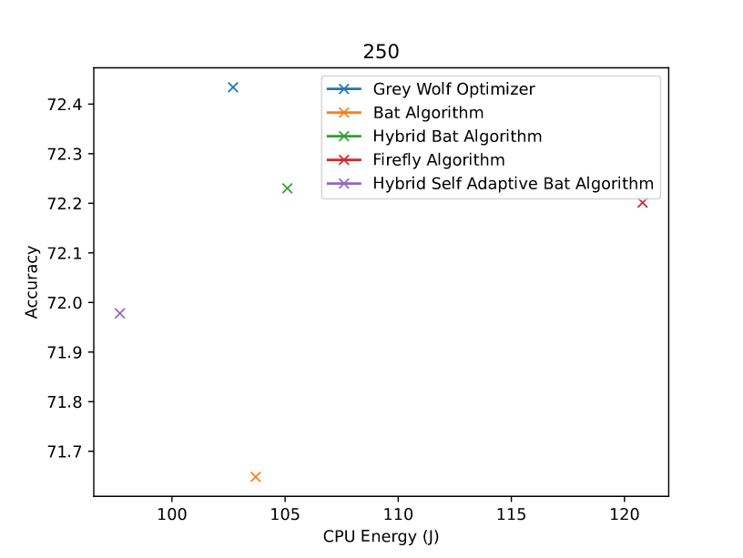

Figure F5 250 decision trees

**Table T6: NIO Compare for 300 decision trees**

|  |  |  |  |  |  |  |  |  |
| --- | --- | --- | --- | --- | --- | --- | --- | --- |
|  | Algo Name | Time Taken | Accuracy | Total Energy (J) | Base Energy (J) | CPU Energy (J) | Monitor Energy (J) | Disk Energy (J) |
| 0 | Grey Wolf Optimizer | 53 | 72.23 | 198.3 | 79.5 | 119.8 | 0 | 0 |
| 1 | Bat Algorithm | 55 | 72.01 | 202.1 | 81 | 122.6 | 0 | 0 |
| 2 | Hybrid Bat Algorithm | 56 | 72.08 | 208.7 | 84 | 125.7 | 0 | 0 |
| 3 | Firefly Algorithm | 57 | 72.12 | 208.4 | 87 | 123.1 | 0 | 0 |
| 4 | Hybrid Self Adaptive Bat Algorithm | 56 | 71.98 | 206.6 | 84 | 123.6 | 0 | 0 |

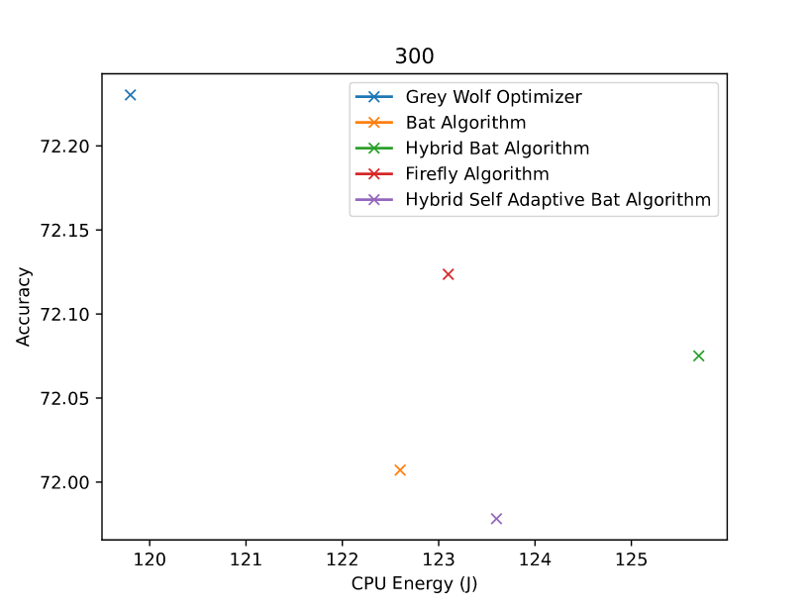

*Figure F6 300 decision trees*

**Table T7: NIO Compare for 350 decision trees**

|  |  |  |  |  |  |  |  |  |
| --- | --- | --- | --- | --- | --- | --- | --- | --- |
|  | Algo Name | Time Taken | Accuracy | Total Energy (J) | Base Energy (J) | CPU Energy (J) | Monitor Energy (J) | Disk Energy (J) |
| 0 | Grey Wolf Optimizer | 63 | 71.85 | 236.2 | 94.5 | 143.3 | 0 | 0 |
| 1 | Bat Algorithm | 64 | 72.2 | 234.9 | 96 | 140.7 | 0 | 0 |
| 2 | Hybrid Bat Algorithm | 62 | 71.94 | 217.9 | 93 | 126.8 | 0 | 0 |
| 3 | Firefly Algorithm | 67 | 71.86 | 244.4 | 100.5 | 145.5 | 0 | 0 |
| 4 | Hybrid Self Adaptive Bat Algorithm | 63 | 71.99 | 223 | 96 | 129.1 | 0 | 0 |

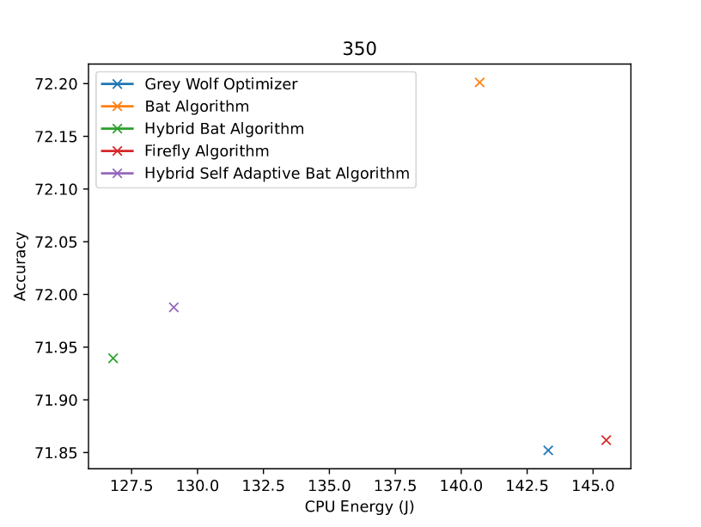

*Figure F7 350 decision trees*

**Table T8: NIO Compare for 400 decision trees**

|  |  |  |  |  |  |  |  |  |
| --- | --- | --- | --- | --- | --- | --- | --- | --- |
|  | Algo Name | Time Taken | Accuracy | Total Energy (J) | Base Energy (J) | CPU Energy (J) | Monitor Energy (J) | Disk Energy (J) |
| 0 | Grey Wolf Optimizer | 75 | 71.94 | 281.6 | 112.5 | 170.7 | 0 | 0 |
| 1 | Bat Algorithm | 73 | 72.03 | 267.6 | 109.5 | 159.5 | 0 | 0 |
| 2 | Hybrid Bat Algorithm | 71 | 72.14 | 256.6 | 106.5 | 152.8 | 0 | 0.2 |
| 3 | Firefly Algorithm | 76 | 72.42 | 284.9 | 115.5 | 171.1 | 0 | 0 |
| 4 | Hybrid Self Adaptive Bat Algorithm | 73 | 71.99 | 244.8 | 108 | 140.1 | 0 | 0 |

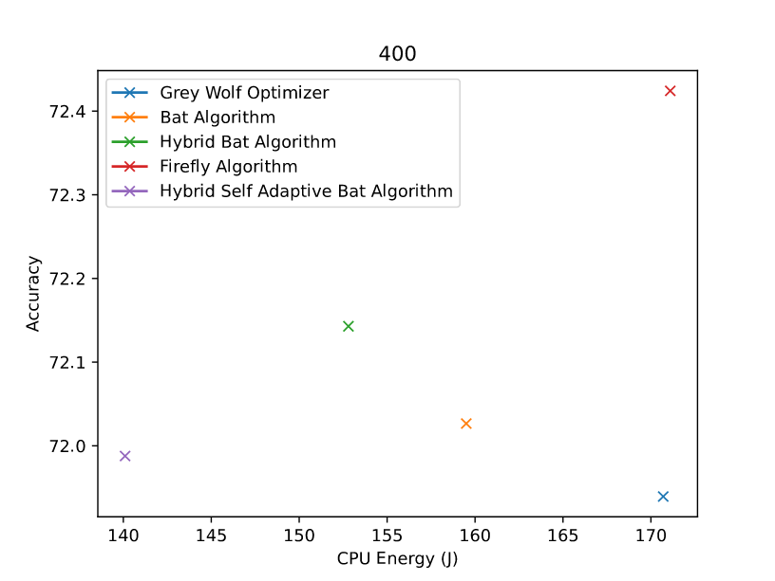

*Figure F8 400 decision trees*

**Table T9: NIO Compare for 450 decision trees**

|  |  |  |  |  |  |  |  |  |
| --- | --- | --- | --- | --- | --- | --- | --- | --- |
|  | Algo Name | Time Taken | Accuracy | Total Energy (J) | Base Energy (J) | CPU Energy (J) | Monitor Energy (J) | Disk Energy (J) |
| 0 | Grey Wolf Optimizer | 81 | 71.97 | 291 | 121.5 | 171.9 | 0 | 0 |
| 1 | Bat Algorithm | 84 | 72.19 | 308.6 | 126 | 184.4 | 0 | 0 |
| 2 | Hybrid Bat Algorithm | 79 | 72.26 | 267.6 | 117 | 154.6 | 0 | 0 |
| 3 | Firefly Algorithm | 85 | 71.44 | 309.4 | 127.5 | 184.2 | 0 | 0 |
| 4 | Hybrid Self Adaptive Bat Algorithm | 80 | 71.76 | 282.9 | 120 | 166.1 | 0 | 0 |

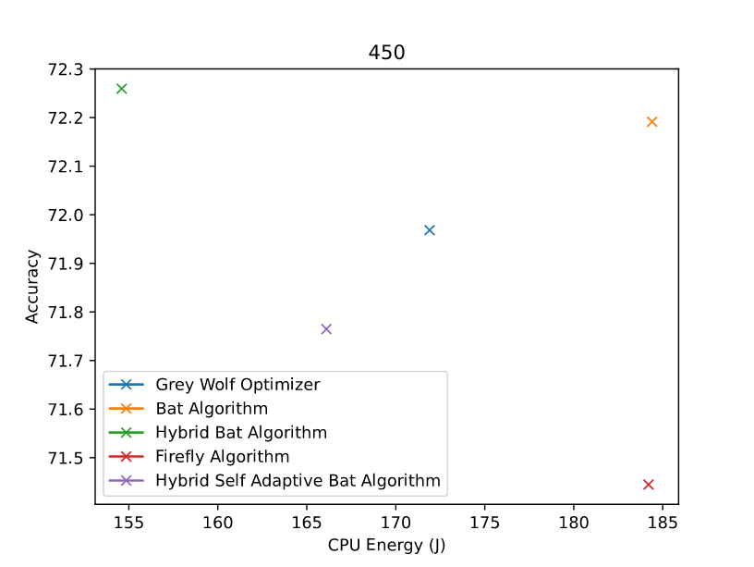

*Figure F9 450 decision trees*

**Table T10: NIO Compare for 500 decision trees**

|  |  |  |  |  |  |  |  |  |
| --- | --- | --- | --- | --- | --- | --- | --- | --- |
|  | Algo Name | Time Taken | Accuracy | Total Energy (J) | Base Energy (J) | CPU Energy (J) | Monitor Energy (J) | Disk Energy (J) |
| 0 | Grey Wolf Optimizer | 91 | 72.53 | 335.8 | 138 | 199.6 | 0 | 0 |
| 1 | Bat Algorithm | 92 | 72.27 | 335.5 | 138 | 199.2 | 0 | 0 |
| 2 | Hybrid Bat Algorithm | 88 | 71.91 | 304.1 | 132 | 175.1 | 0 | 0.1 |
| 3 | Firefly Algorithm | 92 | 72.34 | 333.3 | 138 | 197.1 | 0 | 0 |
| 4 | Hybrid Self Adaptive Bat Algorithm | 94 | 71.94 | 344.5 | 141 | 205.3 | 0 | 0 |

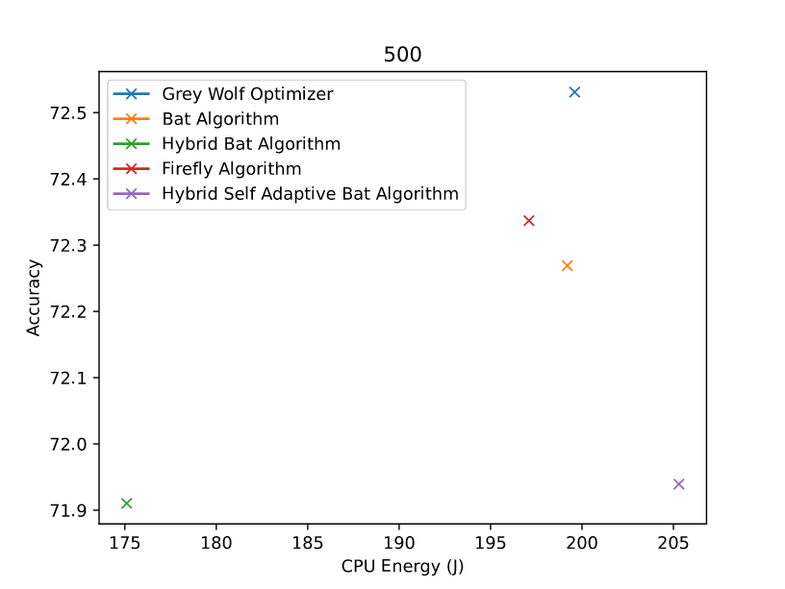

*Figure F10 500 decision trees*

**Table T11 : Bat Algorithm Iterations**

|  |  |  |  |  |  |  |  |  |
| --- | --- | --- | --- | --- | --- | --- | --- | --- |
|  | n_estimators | Time Taken | Accuracy | Total Energy (J) | Base Energy (J) | CPU Energy (J) | Monitor Energy (J) | Disk Energy (J) |
| 0 | 50 | 11 | 70.09 | 42.2 | 16.5 | 25.7 | 0 | 0 |
| 1 | 100 | 18 | 72.4 | 67 | 27 | 40.5 | 0 | 0 |
| 2 | 150 | 28 | 72.21 | 102.3 | 42 | 61.4 | 0 | 0 |
| 3 | 200 | 37 | 71.74 | 137 | 57 | 80.7 | 0 | 0 |
| 4 | 250 | 46 | 71.65 | 171.7 | 69 | 103.7 | 0 | 0 |
| 5 | 300 | 55 | 72.01 | 202.1 | 81 | 122.6 | 0 | 0 |
| 6 | 350 | 64 | 72.2 | 234.9 | 96 | 140.7 | 0 | 0 |
| 7 | 400 | 73 | 72.03 | 267.6 | 109.5 | 159.5 | 0 | 0 |
| 8 | 450 | 84 | 72.19 | 308.6 | 126 | 184.4 | 0 | 0 |
| 9 | 500 | 92 | 72.27 | 335.5 | 138 | 199.2 | 0 | 0 |

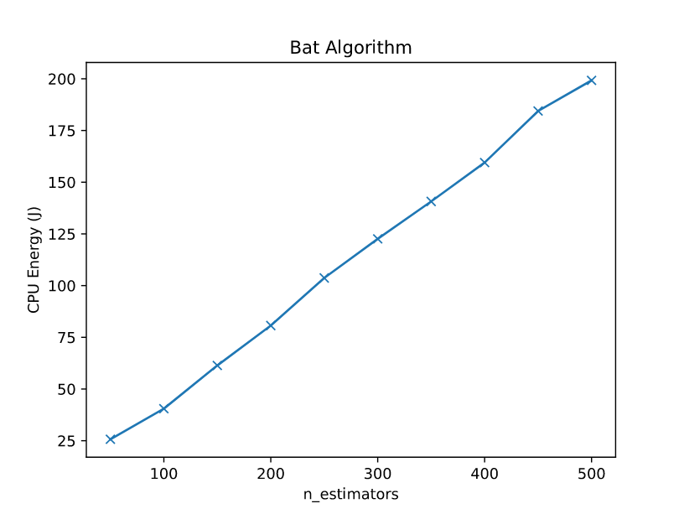

*Figure F11 Bat Algorithm*

**Table T12 : FireFly Algorithm Iterations**

|  |  |  |  |  |  |  |  |  |
| --- | --- | --- | --- | --- | --- | --- | --- | --- |
|  | n_estimators | Time Taken | Accuracy | Total Energy (J) | Base Energy (J) | CPU Energy (J) | Monitor Energy (J) | Disk Energy (J) |
| 0 | 50 | 12 | 71.86 | 48.7 | 19.5 | 29.4 | 0 | 0 |
| 1 | 100 | 19 | 71.44 | 68.9 | 28.5 | 40.6 | 0 | 0 |
| 2 | 150 | 29 | 72.05 | 106.6 | 43.5 | 63.6 | 0 | 0 |
| 3 | 200 | 40 | 71.44 | 148 | 60 | 88.7 | 0 | 0 |
| 4 | 250 | 48 | 72.2 | 192.1 | 72 | 120.8 | 0 | 0 |
| 5 | 300 | 57 | 72.12 | 208.4 | 87 | 123.1 | 0 | 0 |
| 6 | 350 | 67 | 71.86 | 244.4 | 100.5 | 145.5 | 0 | 0 |
| 7 | 400 | 76 | 72.42 | 284.9 | 115.5 | 171.1 | 0 | 0 |
| 8 | 450 | 85 | 71.44 | 309.4 | 127.5 | 184.2 | 0 | 0 |
| 9 | 500 | 92 | 72.34 | 333.3 | 138 | 197.1 | 0 | 0 |

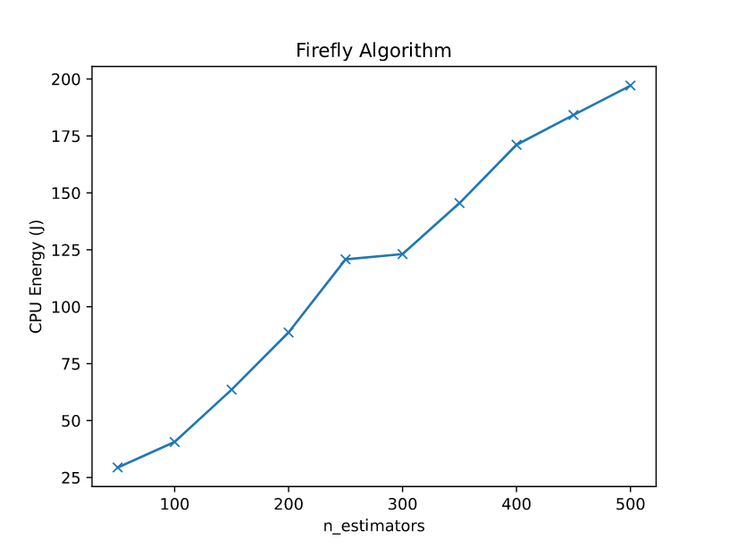

*Figure F12 FireFly Algorithm*

**Table T13 : Grey Wolf Optimization Algorithm Iterations**

|  |  |  |  |  |  |  |  |  |
| --- | --- | --- | --- | --- | --- | --- | --- | --- |
|  | n_estimators | Time Taken | Accuracy | Total Energy (J) | Base Energy (J) | CPU Energy (J) | Monitor Energy (J) | Disk Energy (J) |
| 0 | 50 | 9 | 70.22 | 40.8 | 13.5 | 27.3 | 0 | 0 |
| 1 | 100 | 16 | 72.07 | 68.8 | 24 | 45.2 | 0 | 0 |
| 2 | 150 | 25 | 71.73 | 93.7 | 37.5 | 56.7 | 0 | 0 |
| 3 | 200 | 36 | 72.7 | 136.7 | 54 | 83.3 | 0 | 0 |
| 4 | 250 | 45 | 72.43 | 169.8 | 67.5 | 102.7 | 0 | 0 |
| 5 | 300 | 53 | 72.23 | 198.3 | 79.5 | 119.8 | 0 | 0 |
| 6 | 350 | 63 | 71.85 | 236.2 | 94.5 | 143.3 | 0 | 0 |
| 7 | 400 | 75 | 71.94 | 281.6 | 112.5 | 170.7 | 0 | 0 |
| 8 | 450 | 81 | 71.97 | 291 | 121.5 | 171.9 | 0 | 0 |
| 9 | 500 | 91 | 72.53 | 335.8 | 138 | 199.6 | 0 | 0 |

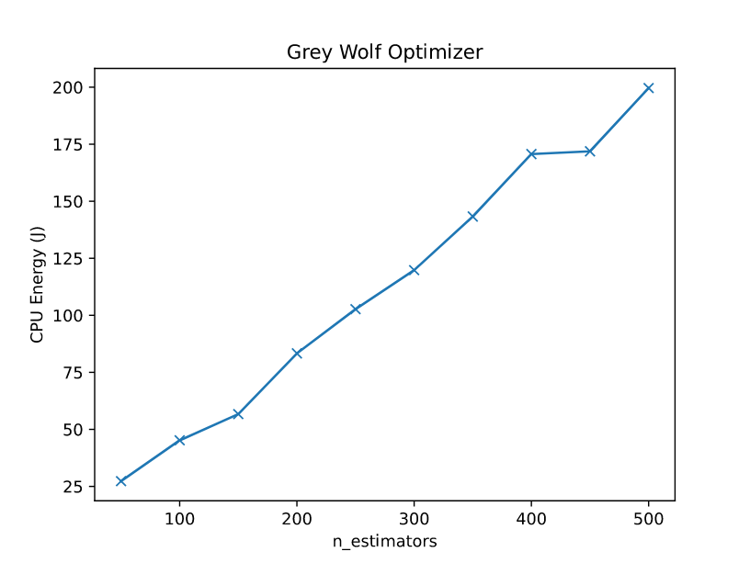

*Figure F13 Grey Wolf Optimization Algorithm*

**Table T14 : Hybrid Bat Algorithm Iterations**

|  |  |  |  |  |  |  |  |  |
| --- | --- | --- | --- | --- | --- | --- | --- | --- |
|  | n_estimators | Time Taken | Accuracy | Total Energy (J) | Base Energy (J) | CPU Energy (J) | Monitor Energy (J) | Disk Energy (J) |
| 0 | 50 | 9 | 71.29 | 37.2 | 15 | 22.5 | 0 | 0 |
| 1 | 100 | 19 | 72.12 | 76.6 | 30 | 47.1 | 0 | 0 |
| 2 | 150 | 28 | 71.96 | 106.5 | 43.5 | 63.4 | 0 | 0 |
| 3 | 200 | 37 | 71.71 | 139.3 | 55.5 | 84.2 | 0 | 0 |
| 4 | 250 | 48 | 72.23 | 177.3 | 72 | 105.1 | 0 | 0.5 |
| 5 | 300 | 56 | 72.08 | 208.7 | 84 | 125.7 | 0 | 0 |
| 6 | 350 | 62 | 71.94 | 217.9 | 93 | 126.8 | 0 | 0 |
| 7 | 400 | 71 | 72.14 | 256.6 | 106.5 | 152.8 | 0 | 0.2 |
| 8 | 450 | 79 | 72.26 | 267.6 | 117 | 154.6 | 0 | 0 |
| 9 | 500 | 88 | 71.91 | 304.1 | 132 | 175.1 | 0 | 0.1 |

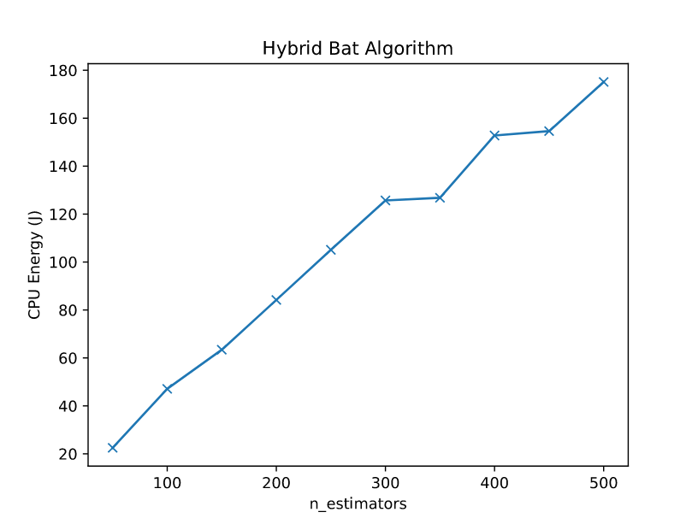

*Figure F14 Hybrid Bat Algorithm*

**Table T15: Self Adaptive Hybrid Bat Algorithm Iterations**

|  |  |  |  |  |  |  |  |  |
| --- | --- | --- | --- | --- | --- | --- | --- | --- |
|  | n_estimators | Time Taken | Accuracy | Total Energy (J) | Base Energy (J) | CPU Energy (J) | Monitor Energy (J) | Disk Energy (J) |
| 0 | 50 | 11 | 71.61 | 46.5 | 18 | 28.8 | 0 | 0 |
| 1 | 100 | 18 | 71.94 | 66.4 | 27 | 40 | 0 | 0 |
| 2 | 150 | 29 | 71.75 | 109.9 | 45 | 65.5 | 0 | 0 |
| 3 | 200 | 40 | 72.77 | 151.8 | 60 | 92.7 | 0 | 0 |
| 4 | 250 | 46 | 71.98 | 165.7 | 69 | 97.7 | 0 | 0 |
| 5 | 300 | 56 | 71.98 | 206.6 | 84 | 123.6 | 0 | 0 |
| 6 | 350 | 63 | 71.99 | 223 | 96 | 129.1 | 0 | 0 |
| 7 | 400 | 73 | 71.99 | 244.8 | 108 | 140.1 | 0 | 0 |
| 8 | 450 | 80 | 71.76 | 282.9 | 120 | 166.1 | 0 | 0 |
| 9 | 500 | 94 | 71.94 | 344.5 | 141 | 205.3 | 0 | 0 |

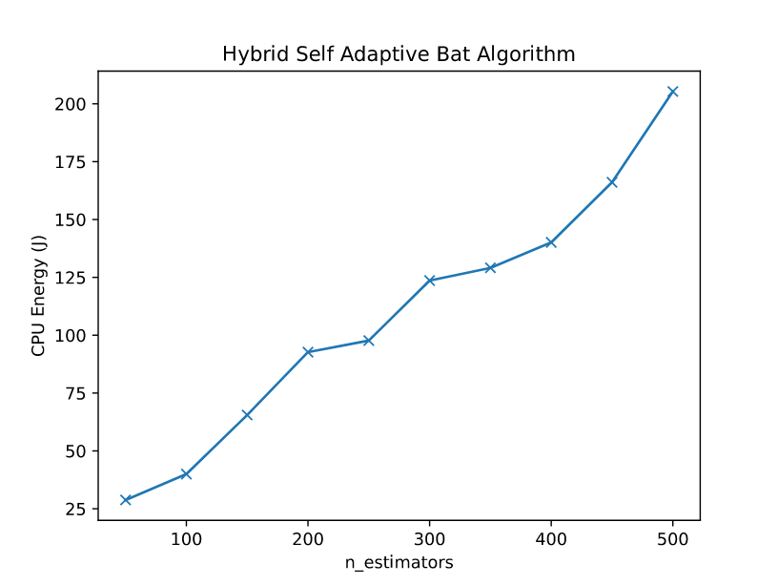

*Figure F15 Self Adaptive Hybrid Bat Algorithm*