LAB MANUAL OF
COMPUTER ORGANIZATION
AND
ARCHITECTURE
ETCS 260



Maharaja Agrasen Institute of Technology, PSP area,
Sector – 22, Rohini, New Delhi – 110085
( Affiliated to Guru Gobind Singh Indraprastha University, New Delhi )
-by Chander Jindal

MAHARAJA AGRASEN INSTITUTE OF TECHNOLOGY
VISION
To nurture young minds in a learning environment of high academic value and imbibe spiritual and ethical values with technological and management competence.
MISSION
The Institute shall endeavor to incorporate the following basic missions in the teaching methodology:
Engineering Hardware – Software Symbiosis
Practical exercises in all Engineering and Management disciplines shall be carried out by Hardware equipment as well as the related software enabling deeper understanding of basic concepts and encouraging inquisitive nature.
Life – Long Learning
The Institute strives to match technological advancements and encourage students to keep updating their knowledge for enhancing their skills and inculcating their habit of continuous learning.
Liberalization and Globalization
The Institute endeavors to enhance technical and management skills of students so that they are intellectually capable and competent professionals with Industrial Aptitude to face the challenges of globalization.
Diversification
The Engineering, Technology and Management disciplines have diverse fields of studies with different attributes. The aim is to create a synergy of the above attributes by encouraging analytical thinking.
Digitization of Learning Processes
The Institute provides seamless opportunities for innovative learning in all Engineering and Management disciplines through digitization of learning processes using analysis, synthesis, simulation, graphics, tutorials and related tools to create a platform for multi-disciplinary approach.
Entrepreneurship
The Institute strives to develop potential Engineers and Managers by enhancing their skills and research capabilities so that they become successful entrepreneurs and responsible citizens.

MAHARAJA AGRASEN INSTITUTE OF TECHNOLOGY

COMPUTER SCIENCE & ENGINEERING DEPARTMENT

VISION
To Produce “Critical thinkers of Innovative Technology”

MISSION
To provide an excellent learning environment across the computer science discipline to inculcate professional behavior, strong ethical values, innovative research capabilities and leadership abilities which enable them to become successful entrepreneurs in this globalized world.
- To nurture an excellent learning environment that helps students to enhance their problem solving skills and to prepare students to be lifelong learners by offering a solid theoretical foundation with applied computing experiences and educating them about their professional, and ethical responsibilities.
- To establish Industry-Institute Interaction, making students ready for the industrial environment and be successful in their professional lives.
- To promote research activities in the emerging areas of technology convergence.
- To build engineers who can look into technical aspects of an engineering solution thereby setting a ground for producing successful entrepreneur.
Lab Objective

To understand the basic organization of computer system including concept of memory, addressing, stack implementation in memory, register size and data handling using 8085 assembly instruction code and programming techniques. Objective of the lab is that the students are able to write an assembly code using mnemonics for the 8085 microprocessor.

Course Outcomes

At the end of the course, a student will be able to:
CO.260.1:Work efficiently on the simulator GNU sim8085 and will also be able to identify the basic elements and architecture of 8085.
CO.260.2: Analyze the basic instruction set of 8085 microprocessor.
CO.260.3: Write an assembly language code dealing with the data transfers within the registers, memory and the stack.
CO.260.4: Write an assembly language code using the arithmetic instructions of 8085 microprocessor instruction set to solve various problems.
CO.260.5: Write an assembly language code to solve various problems using logical Instructions of 8085 microprocessor instruction set.
CO.260.6: Write an assembly language code to solve various problems using branching Instruction of 8085 microprocessor instruction set.

INDEX OF THE CONTENTS
S.no. | Date | Name of Experiment | Remarks
1 | 22/3 | To draw and explain  Block diagram and pin diagram of 8085.  Instruction set of 8085.
2 | 5/4 | Write a program to perform:  Addition of two 8 bit numbers without carry.  Addition of two 8 bit numbers with carry.
3 | 19/4 | Write a program to perform:  Subtraction of two 8 bit numbers without borrows.  Subtraction of two 8 bit numbers with borrows.
4 | 3/5 | Write a program to find 1‘s complement of an 8 bit number.
5 | 10/5 | Write a program to find 2‘s complement of an 8 bit number.
6 | 24/5 | Write a program to perform Multiplication of two 8 bit numbers.
7 | 24/5 | Write a program to perform Division of two 8 bit numbers.
8
9

Experiment 1
Aim: To draw and explain
i. Block diagram and pin diagram of 8085.
ii. Instruction set of 8085.

Theory:
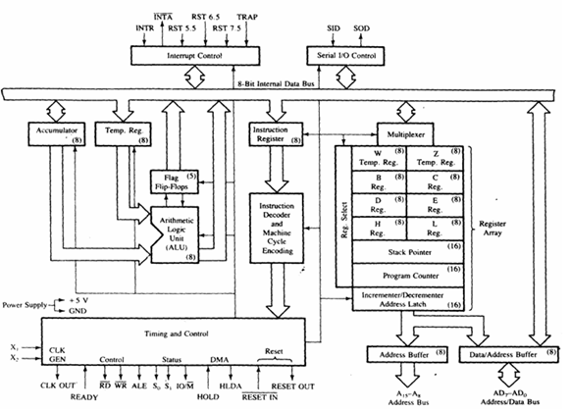

List of registers used in 8085 to perform various operations:

Accumulator:-It is a 8-bit register which is used to perform arithmetical and logical operation. It stores the output of any operation. It also works as registers for i/o accesses.
It can be one of the operand in the instruction.
Temporary Register:-It is a 8-bit register which is used to hold the data on which the accumulator is computing operation. It is also called as operand register because it provides operands to ALU.
Registers:-These are general purposes registers. Microprocessor consists 6 general purpose registers of 8-bit each named as B,C,D,E,H and L. Generally theses registers are not used for storing the data permanently. It carries the 8-bits data. These are used only during the execution of the instructions.
These registers can also be used to carry the 16 bits data by making the pair of 2 registers. The valid register pairs available are BC,DE HL. We cannot use other pairs except BC,DEand HL. These registers are programmed by user.

Flag Registers:-It consists of 5 flip flop which changes its status according to the result stored in an accumulator. It is also known as status registers. It is connected to the ALU.
There are five flip-flops in the flag register are as follows:
The bit position of the flip flop in flag register is:

All of the three flip flop set and reset according to the stored result in the accumulator.
1.Sign- If D7 of the result is 1 then sign flag is set otherwise reset. As we know that a number on the D7 always desides the sign of the number.
if D7 is 1: the number is negative.
if D7 is 0: the number is positive.
2.Zeros(Z)-If the result stored in an accumulator is zero then this flip flop is set as 1 otherwise it is reset and also if the result of any arithmetic or logical operation is zero its set as 1( The result of this operation can be in any registers).
3.Auxiliary carry(AC)-If any carry goes from D3 to D4 in the output then it is set otherwise it is reset.
4.Parity(P)-If the no of 1's is even in the output stored in the accumulator then it is set otherwise it is reset for the odd.
5.Carry(C)-If the result stored in an accumulator generates a carry in its final output then it is set otherwise it is reset.
6.Instruction registers(IR):-It is a 8-bit register. When an instruction is fetched from memory then it is stored in this register.

Description of other components of 8085:
Instruction Decoder: - Instruction decoder identifies the instructions. It takes the information from instruction register and decodes the instruction to be performed.
Program Counter:-It is a 16 bit register used as memory pointer. It stores the memory address of the next instruction to be executed. So we can say that this register is used to sequencing the program. Generally the memory has 16 bit addresses so that it has 16 bit memory.
The program counter is set to 0000H.
Stack Pointer:-It is also a 16 bit register used as memory pointer. It points to the memory location called stack. Generally stack is a reserved portion of memory where information can be stores or taken back together.
Timing and Control Unit:-It provides timing and control signal to the microprocessor to perform the various operation. It has three control signals. It controls all external and internal circuits. It operates with reference to clock signal. It synchronizes all the data transfers.
There are three control signal:
1.ALE-Airthmetic Latch Enable, It provides control signal to synchronize the components of microprocessor.
2.RD- This is active low used for reading operation.
3.WR-This is active low used for writing operation.
There are three status signal used in microprocessor S0, S1 and IO/M. It changes its status according the provided input to these pins.
Serial Input Output Control-There are two pins in this unit. This unit is used for serial data communication.
Interrupt Unit-There are 6 interrupt pins in this unit. Generally an external hardware is connected to these pins. These pins provide interrupt signal sent by external hardware to microprocessor and microprocessor sends acknowledgement for receiving the interrupt signal. Generally INTA is used for acknowledgement.

PIN DIAGRAM OF 8085
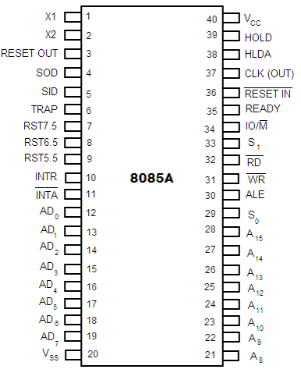

description
- Higher Order Address pins- A₁₅ – A₈
- The address bus has 8 signal lines A8 – A15 which are unidirectional.
- Lower Order Address/ Data Pins- AD₇-AD₀
- These are time multiplexed pins and are de-multiplexed using the pin ALE
- So, the bits AD0 – AD7 are bi-directional and serve as A0 – A7 and D0 – D7 at the same time.
- During the execution of the instruction, these lines carry the address bits during the early part, then during the late parts of the execution, they carry the 8 data bits.
- In order to separate the address from the data, we can use a latch to save the value before the function of the bits changes.
- Control Pins – RD, WR
- These are active low Read & Write pins
- Status Pins – ALE, IO/M (active low), S₁, S₀
- ALE (Address Latch Enable)-Used to de-multiplex AD₇-AD₀
- IO/M – Used to select I/O or Memory operation
- S₁,S₀ – Denote the status of data on data bus

- Interrupt Pins – TRAP, RST7.5, RST 6.5, RST 5.5, INTR, INTA
- These are hardware interrupts used to initiate an interrupt service routine stored at predefined locations of the system memory.
- Serial I/O pins – SID (Serial Input Data), SOD (Serial Output Data)
  - These pins are used to interface 8085 with a serial device.
  - Clock Pins- X₁, X₂, CLK(OUT)
  - X₁, X₂– These are clock input pins. A crystal is connected between these pins such that f_{crystal}= 2f₈₀₈₅ where f_{crystal}= crystal frequency & f₈₀₈₅ = operating frequency of 8085
  - CLK(OUT) – This is an auxiliary clock output source
  - Reset Pins – Reset In (active low), Reset Out
  - Reset In is used to reset 8085 whereas Reset Out can be used to reset other devices in the system
  - DMA (Direct Memory Access) pins – HOLD, HLDA
  - These pins are used when data transfer is to be performed directly between an external device and the main memory of the system.
  - Power Supply Pins – +V_{CC}, V_{SS}

Procedure:
Starting with GNU sim 8085
Step1: open GNU Sim 8085 above window will open. Now click on close button highlighted in the above screen shot.


Step2: start writing the code after start: nop in load me at 10 that is at load me at 11.
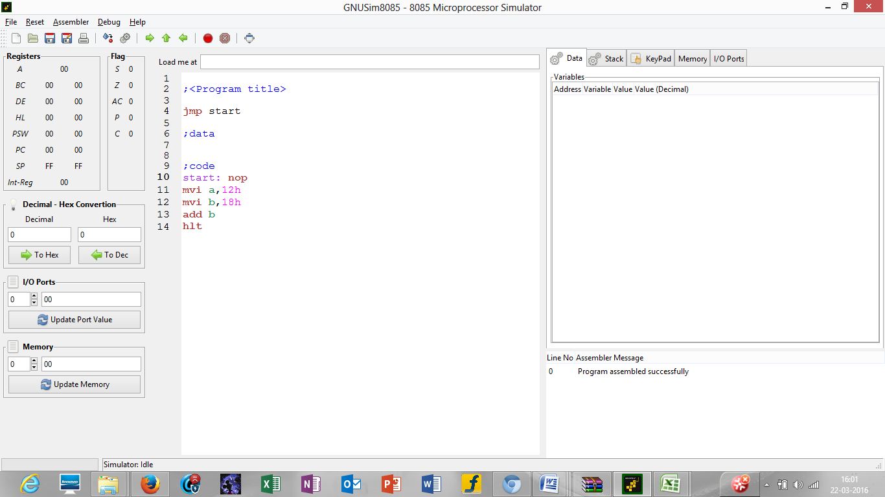
Step 3: click on reset and reset all the registers by clicking on reset all.

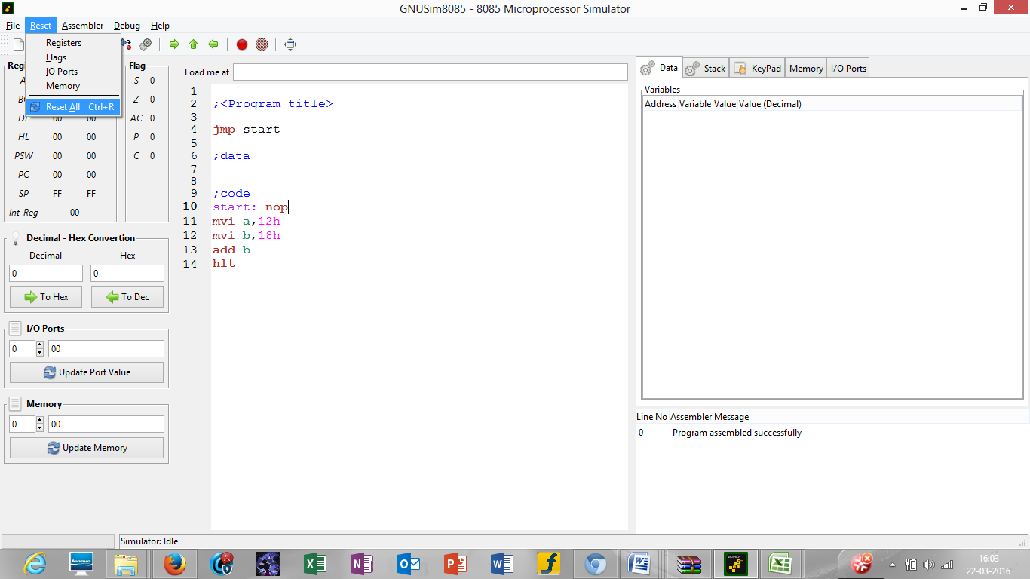

Step 4: click on the highlighted button to execute the code
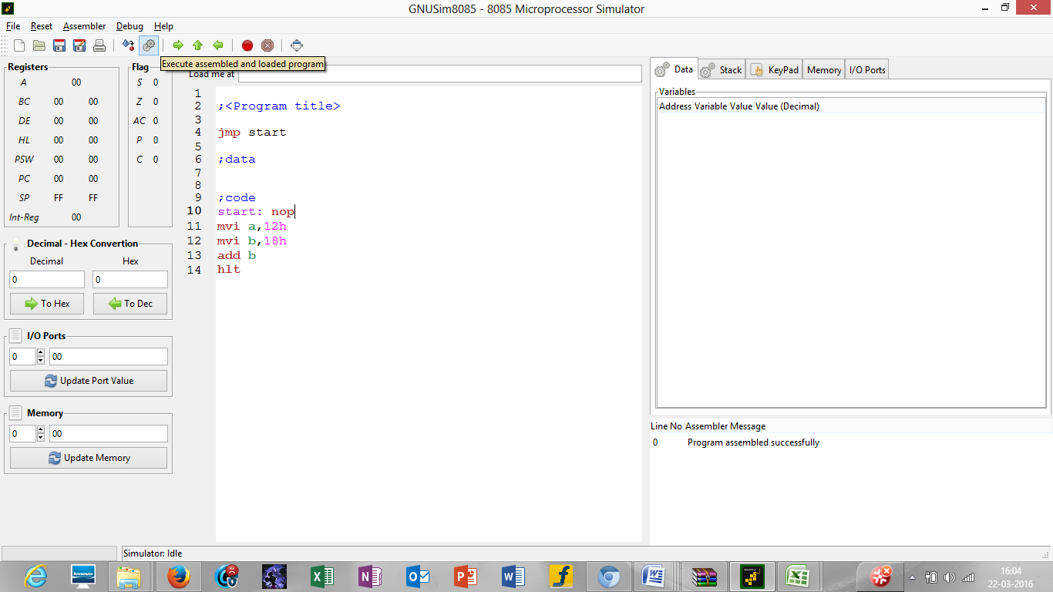

Step 5: after you execute the code mention the name your program by writing the name in the name section as mentioned in the screen shot in picture 5 and the drive where you want to save it. After that click on save.

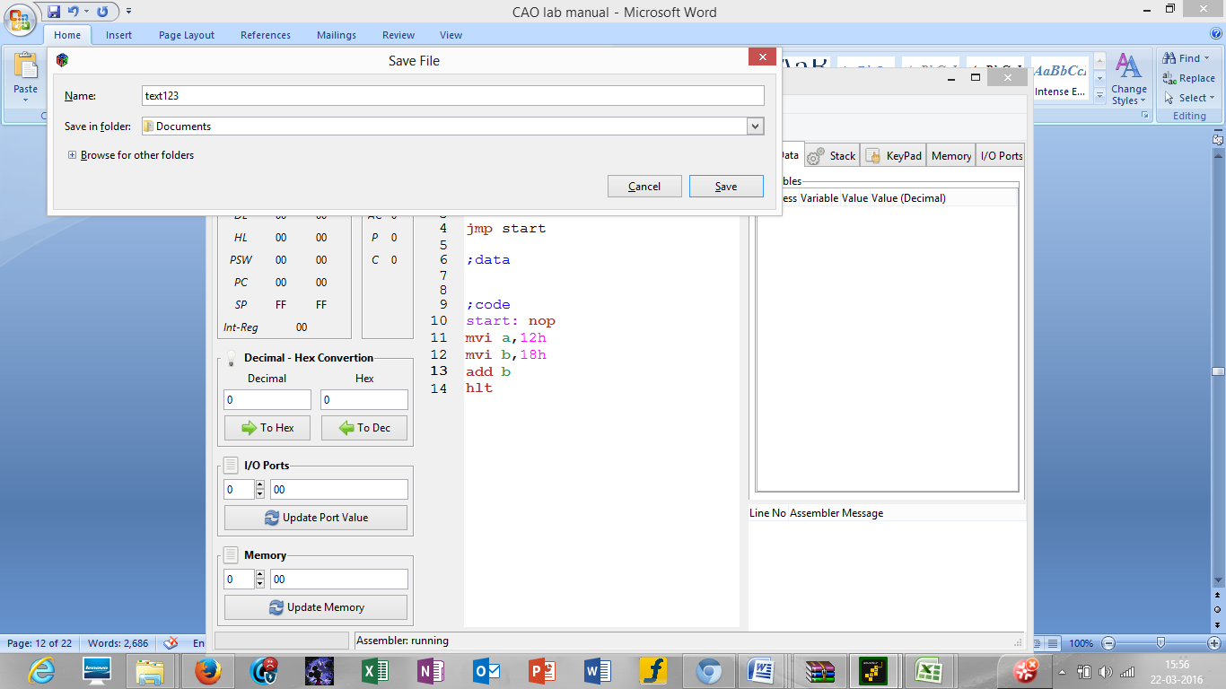
Step 6: after this you will see the result of the instructions in the respective registers as seen in the above picture 6.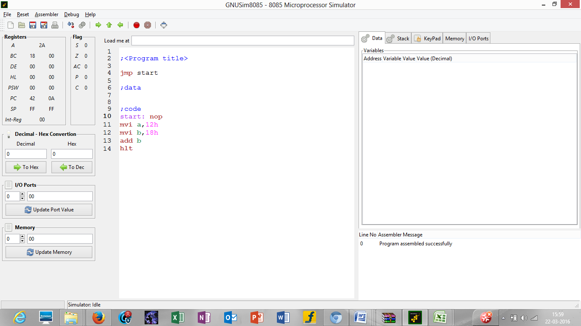
Output
Experiment-2
Aim: Write a program to perform:
i. Addition of two 8 bit numbers without carry.
ii. Addition of two 8 bit numbers with carry.
Theory: Add without Carry using mvi
• First Load “Zero” value into accumulator and the memory location where the final answer is to be stored.
• Load a couple of Numbers in registers
• Add the values of registers into the Accumulator one at a time using “ADD”
• Using “sta” load the value in the accumulator into a memory location
• The memory location has the sum of two numbers
#Code

;<Adding two numbers no carry>

jmp start

;data

;code

start: nop
mvi A, 00H
sta 001H
mvi B, 16H
mvi C, 20H
ADD B
ADD C
sta 001H
hlt
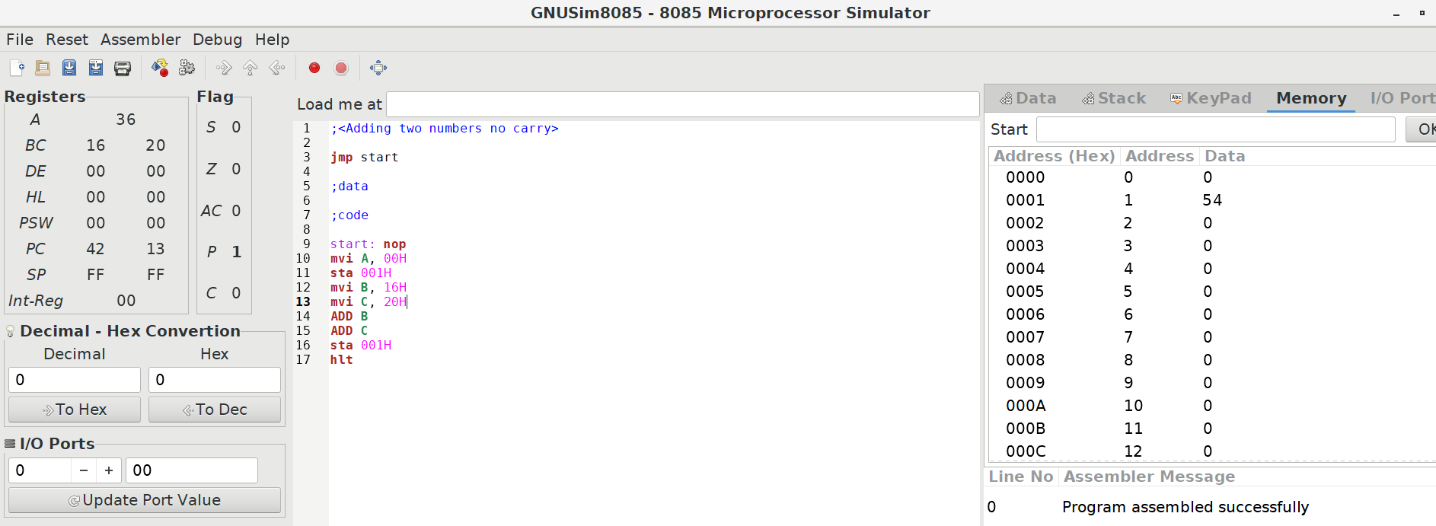

Theory: Add without Carry using lxi
• First make sure that accumulator and the memory location where answer is to be stored are set to Zero
• Load values from memory locations using lxi and store them into registers (earlier half)
• One at a time add the values of registers in accumulator
• Store the now value of accumulator into a desired memory location

#Code
;<Adding two numbers using lxi>

jmp start

;data

;code
start: nop
mvi a,00h
lxi b,01h
lxi d,02h
add c
add e
sta 0003h
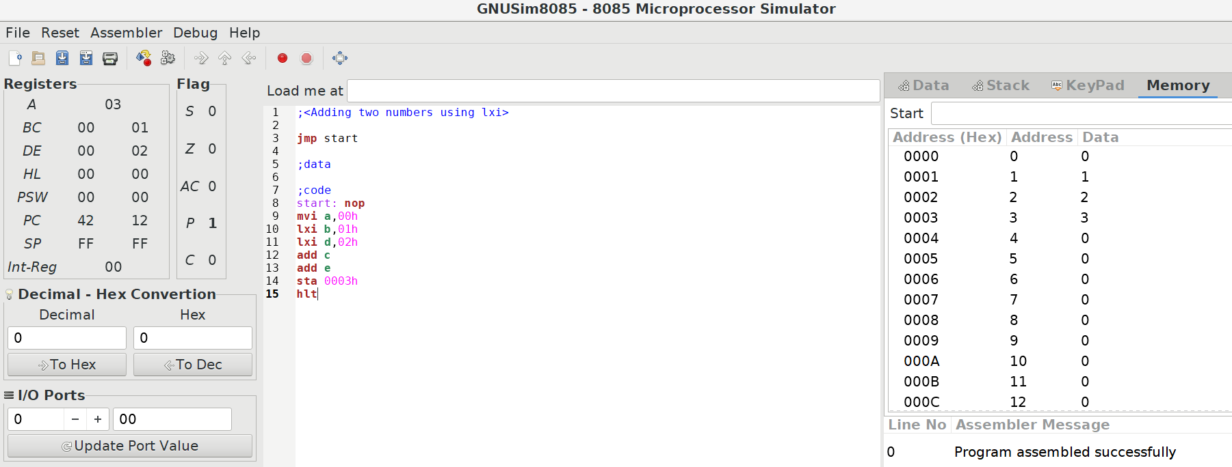
hlt

#Output

Theory: Add with Carry
• First Load “Zero” value into the memory location where the final answer is to be stored.
• Load a couple of Numbers in registers/Accumulator.
• Add the values of registers into the Accumulator one at a time using “ADD”.
• If in-case there is any Carry the C Flag will take note of it, and then the value has to be increase, else the increase command is to be skipped.
• Using “sta” load the value in the accumulator into a memory location
• The memory location has the sum of two numbers

#Code
;<Addition with carry>

jmp start

;data

;code
start: nop
mvi a, 10h
mvi b, 15h
add b
jnc skip
inr c
skip: sta 001
hlt

#Code
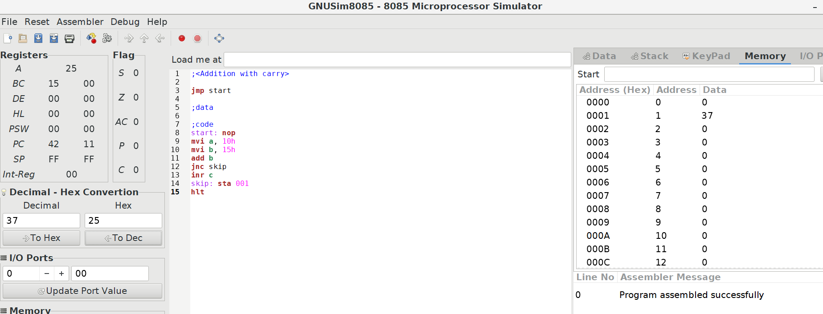
Please note that the value in the memory location is that of decimal, which has a hexa-value of 25 as shown by the Converter.

Experiment 3

Aim: Write a program to perform:
i. Subtraction of two 8 bit numbers without borrows.
ii. Subtraction of two 8 bit numbers with borrows.

Theory: Subtraction without Carry
- Load some Value into the registers/accumulator
- First add the Larger value into the Accumulator using “ADD”
- Subtract the other Value from the Accumulator using “SUB”
- Using “STA” you can load the answer into a desired memory location(which was set to zero before hand)
#Code
;<Subtract without Carry>
jmp start

;data

;code
start: nop
mvi a, 15h
mvi b, 10h
sub b
sta 001
hlt
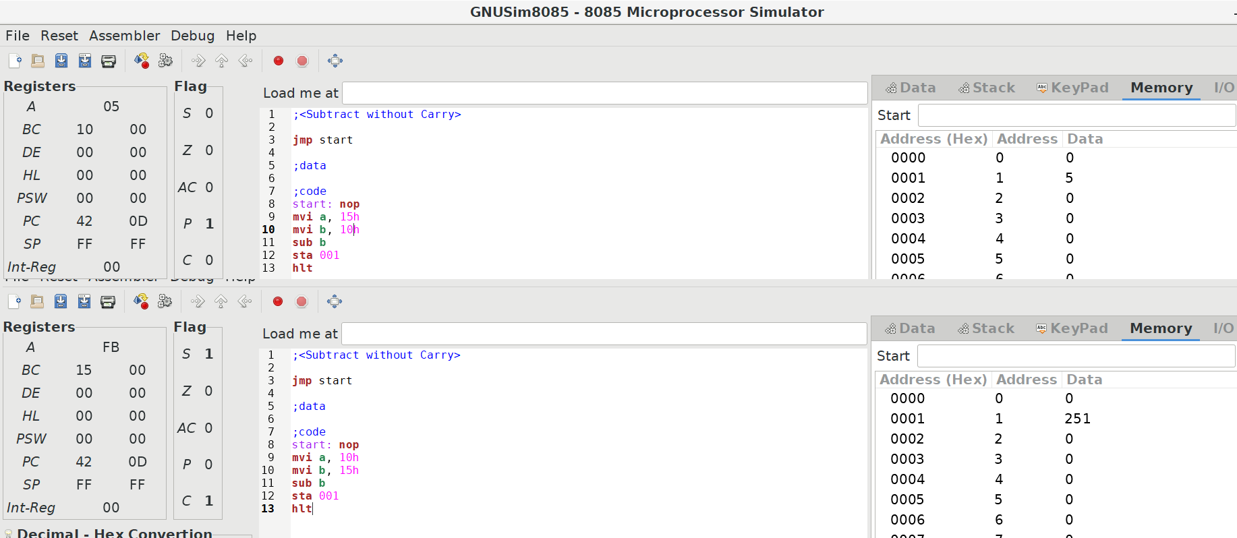
Please note that if the smaller value is loaded first then the value will be wrapped around.

Theory: Subtraction with Carry
- Load some value into the accumulator/registers.
- Add one value into the accumulator if it’s empty.
- Subtract the other value from the accumulator.
- If there is a carry it’s caught by C-Flag.
- Take complement of the value in accumulator
- Increase the value of accumulator and C register by one
- Store the answer in a memory location.
#Code
;<Subtract without Carry>

jmp start

;data

;code
start: nop
mvi a, 10h
mvi b, 15h
sub b
jnc skip
cma
inr a
inr c
skip: sta 01
hlt

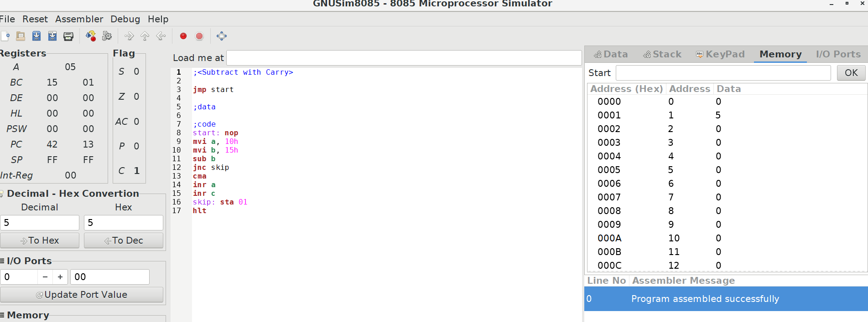
#Output

Experiment 4

Aim: Write a program to find 1‘s complement of an 8 bit number.

Theory:
There is an inbuilt function for 1’s complement, it’s “cma”.
- Load some value into the accumulator.
- Use the command “cma”
- Store the Answer into a memory location
Other Method
- First load 0FFH(Maximum value) in accumulator.
- Subtract the value who’s one’s complement is to be evaluated.
- The value in Accumulator is 1’s complement of that value.
#Code
;<1's Complement>

jmp start

;data

;code
start: nop
mvi a , 00h
mvi b , 0fh
mvi a , 0ffh
sub b
sta 01 ; Answer of First Method stored here
mvi a , 0fh
cma
sta 02 ; Answer of In-built function stored here
hlt
#Code
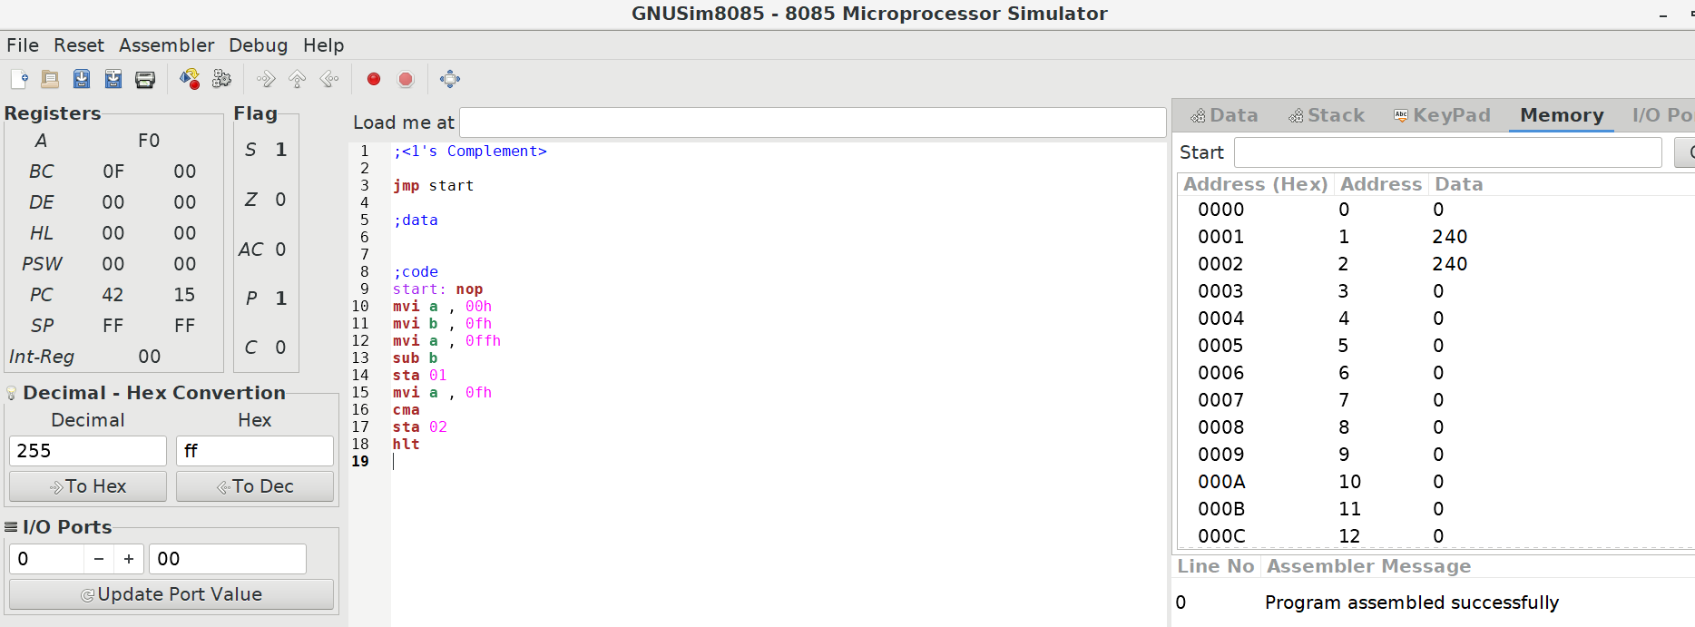
Experiment 5

Aim: Write a program to find 2‘s complement of an 8 bit number.

Theory:
To find 2’s complement first calculate 1’s complement of the number then increase the value by 1 to obtain 2’s compliment.
- Load some value into the accumulator.
- Find the complement of that value using “cma”.
- Using inr increase the value of accumulator by one.
- Store the Answer into a memory location.
#Code
;<2's Complement>

jmp start

;data

;code
start: nop
mvi a , 0fh
cma
inr a
sta 01
hlt
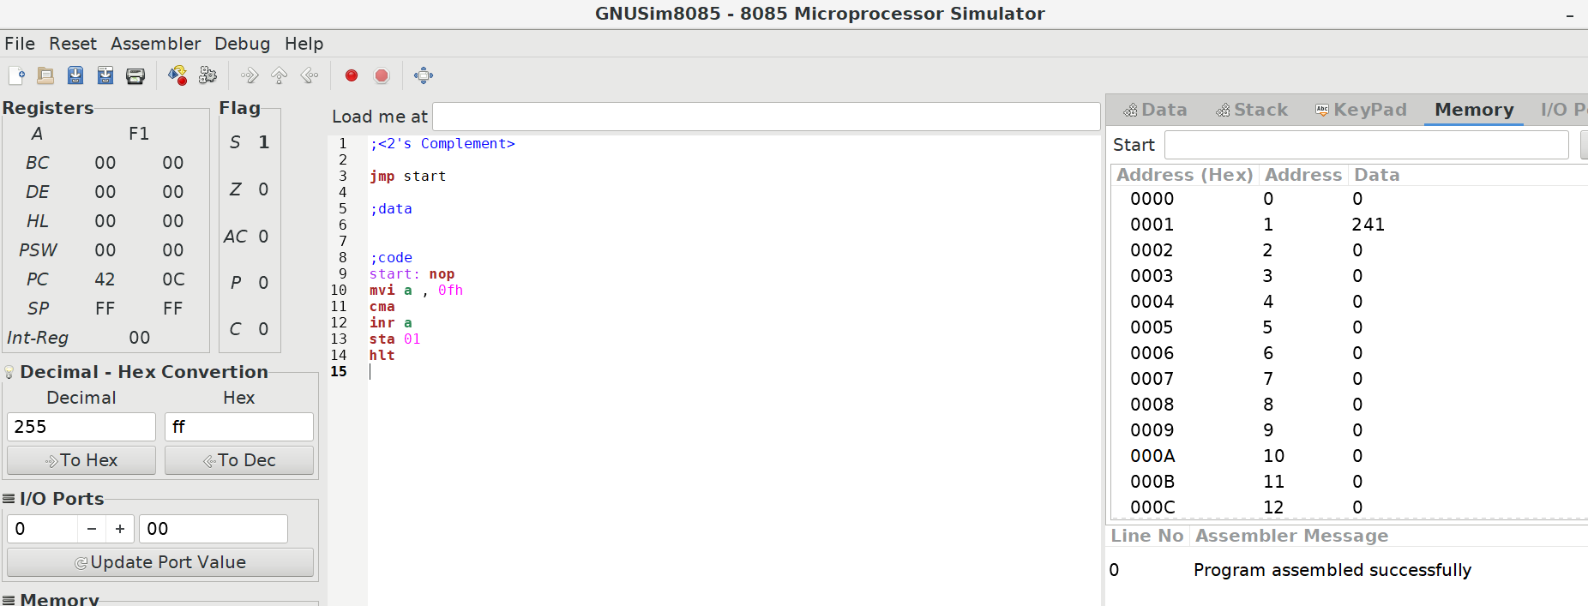
#Output

Experiment 6

Aim: Write a program to perform Multiplication of two 8 bit numbers.

Theory:
- Make sure that the accumulator and the desired memory location to store the values and final answer are initially set to Zero.
- Load two numbers to be multiplied into the registers.
- Make a loop where you keep on adding one of the two values into the accumulator, while you gradually decrease the other value.
- As long as the other value is not zero repeat the loop.
- When the loop ends store the value into the desired memory location.
#Code
;<Multiplication of 2 8-bit numbers>

jmp start

;data

;code
start: nop

mvi a, 00h
mvi b, 09h
mvi c, 10h
loop: add b
dcr c
jnz loop

sta 00h
hlt
#Output
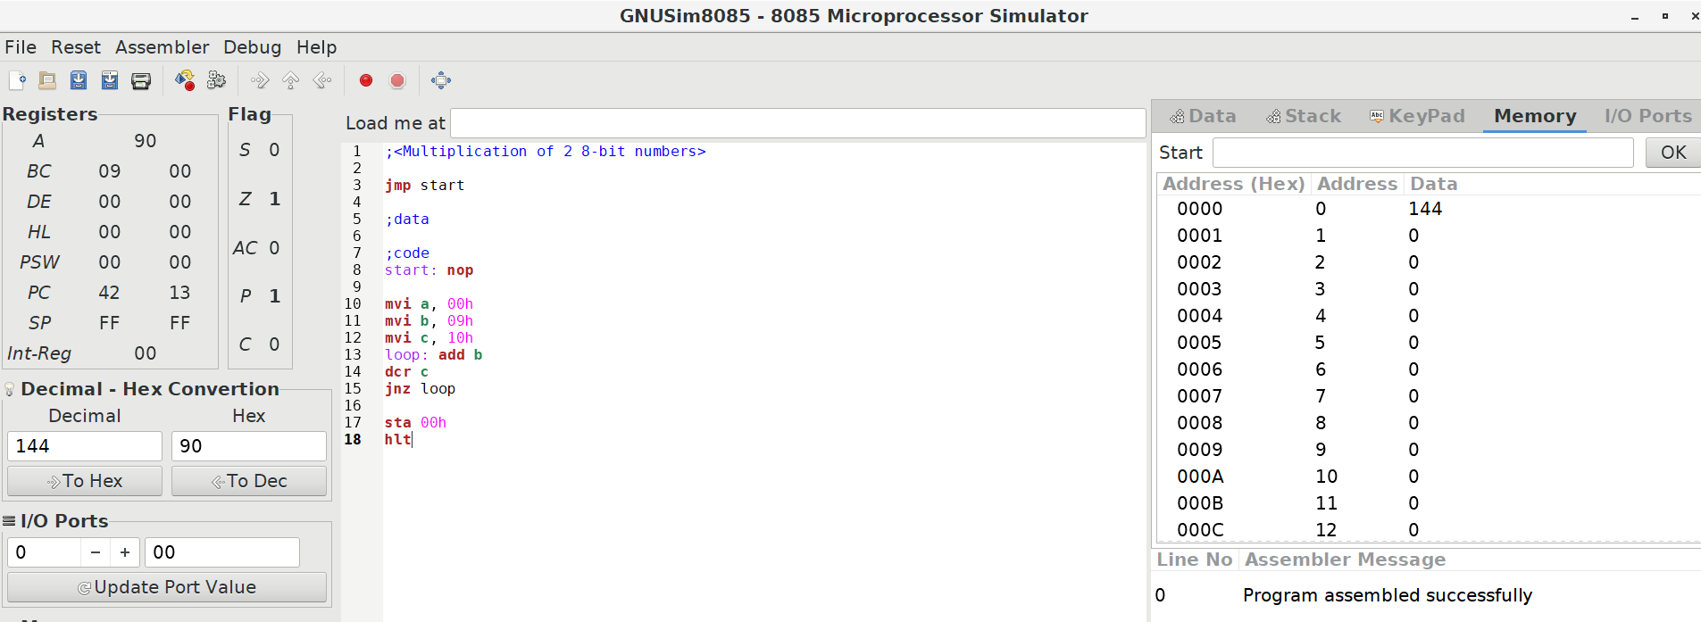
Please note that the value in the memory location is of 144 (Decimal) which is 90(Hexa - decimal) as shown by the converter.

Experiment 7

Aim: Write a program to perform Division of two 8 bit numbers.

Theory:
- Load the first value to accumulator.
- Start a loop where you subtract the second value from the accumulator and keep a tally of the iterations in an initially empty register.
- Keep on comparing the second value with the value in accumulator, if the value in accumulator is higher then that of second value there will be no carry flag, and thus, keep on repeating the loop.
If the values in second register is equal to that of in accumulator (at that time, the zero flag will be true, but not carry flag). Only when Value in accumulator is less than second value carry flag will be true, then terminate the loop.
- The then value in accumulator is the remainder in division.
- The then value in the initially Zero register where the tally was kept contains the Quotient of division.
- Store them separately in memory locations.
#Code
;<Division of two 8-bit numbers>

jmp start

;data

;code
start: nop
mvi a ,00h
mvi b ,0fh
mvi c ,05h
mvi d ,00h
add b
loop: sub c
inr d
cmp c
jnc loop
sta 00h
mov a ,d
sta 01h

hlt

#Output
