OPERATING SYSTEMS LAB

(ETCS 352)

***Mrs. Shallu***

(Faculty)

Chander Jindal

06514802719

6th Semester



#### Maharaja Agrasen Institute of Technology, PSP area,

Sector – 22, Rohini, New Delhi – 110085

( Affiliated to Guru Gobind Singh Indraprastha University, New Delhi )

***Beyond The Syllabus Experiments***

**Experiment-1**

**i) Write a script to find the greatest of three numbers (numbers passed as command line parameters)**

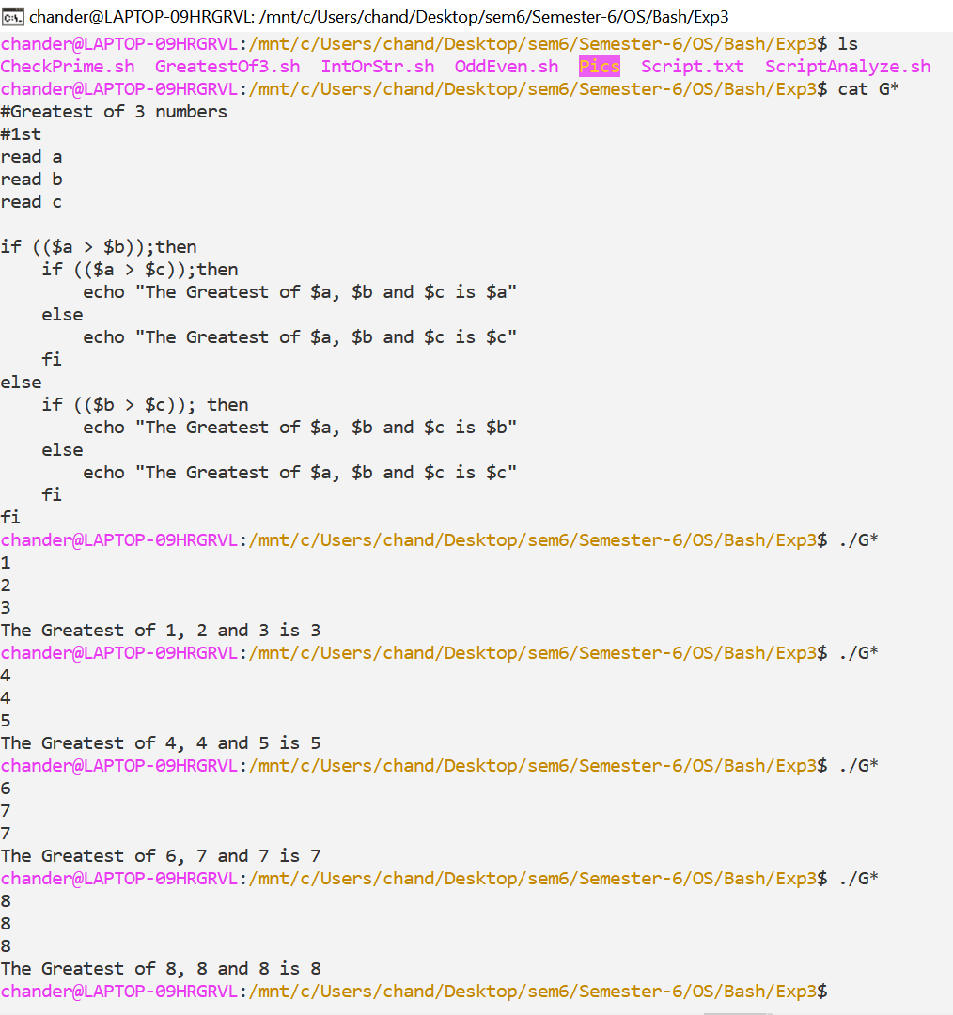

**ii) Write a script to check whether the given no. is even / odd**

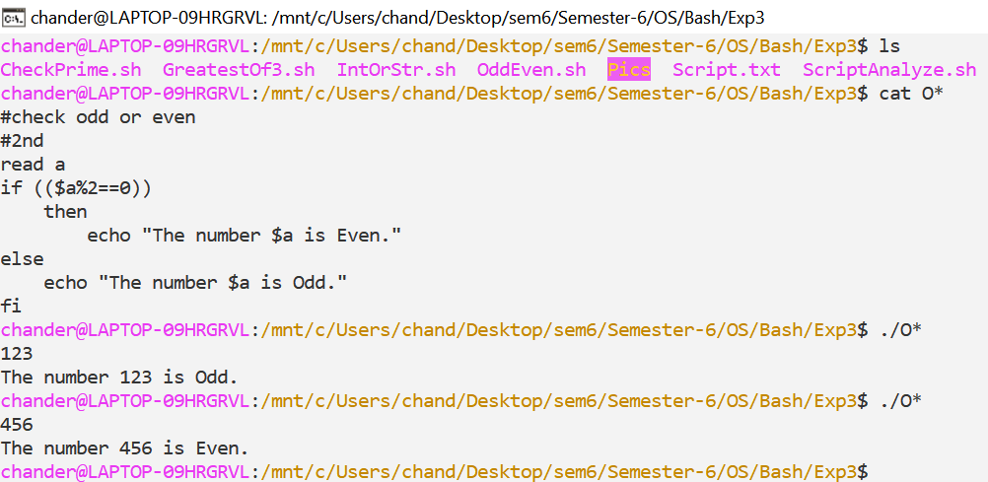

**iii) Write a script to check whether the given number is prime or not**

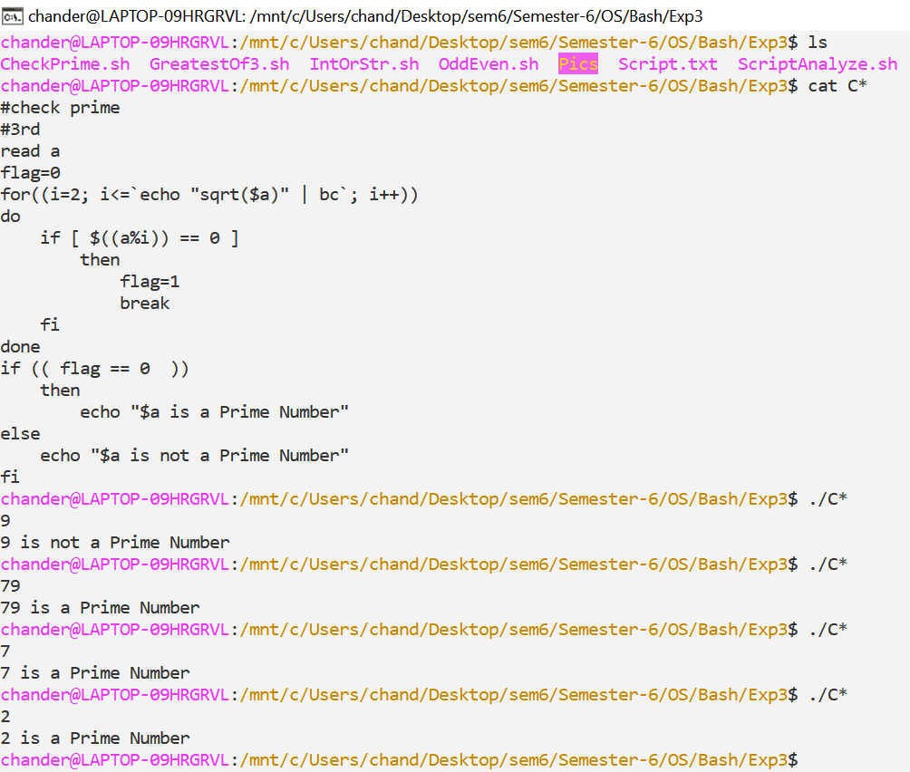

**iv) Write a script to check whether the given input is a number or a string**

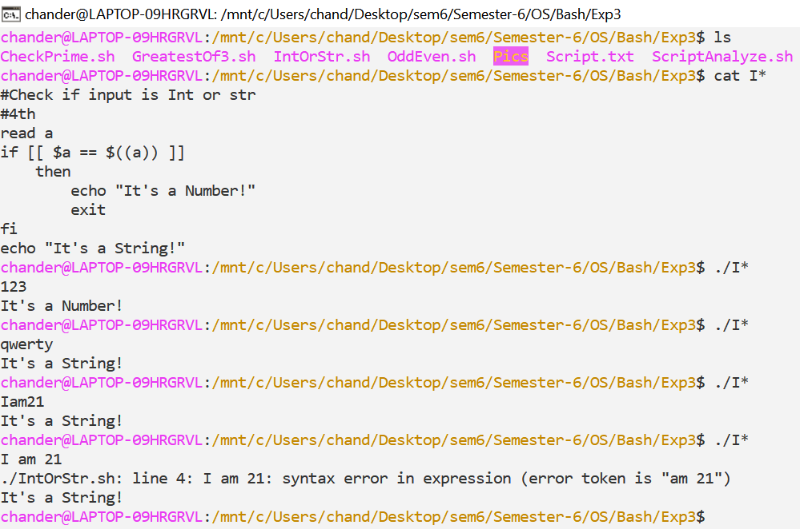

**Write a script to compute no. of characters and words in each line of given file**

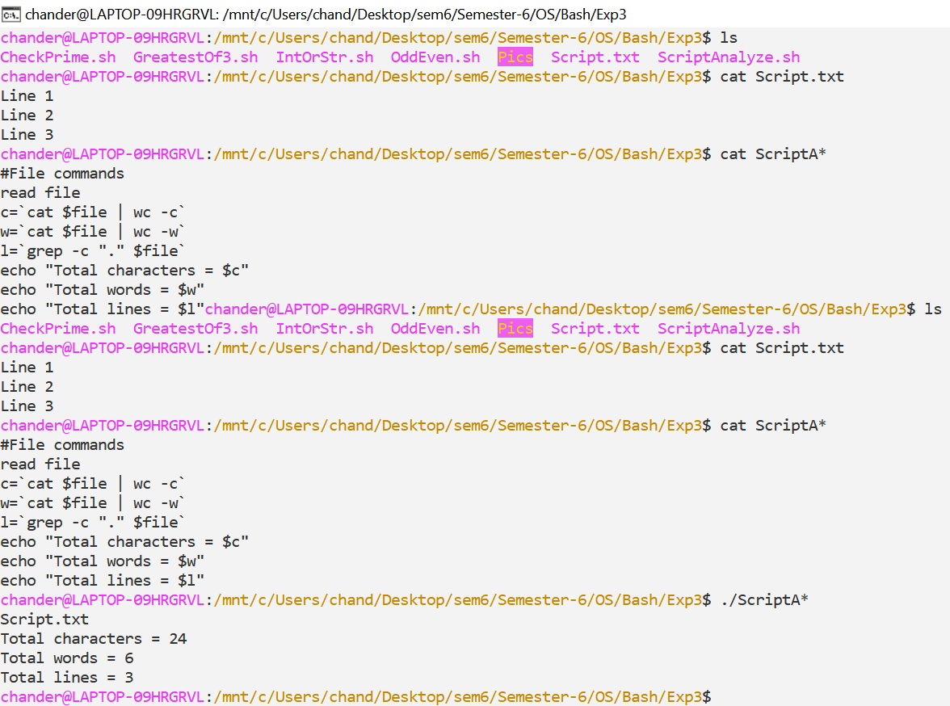

***Experiment – 2***

**i) Write a script to calculate the average of n numbers**

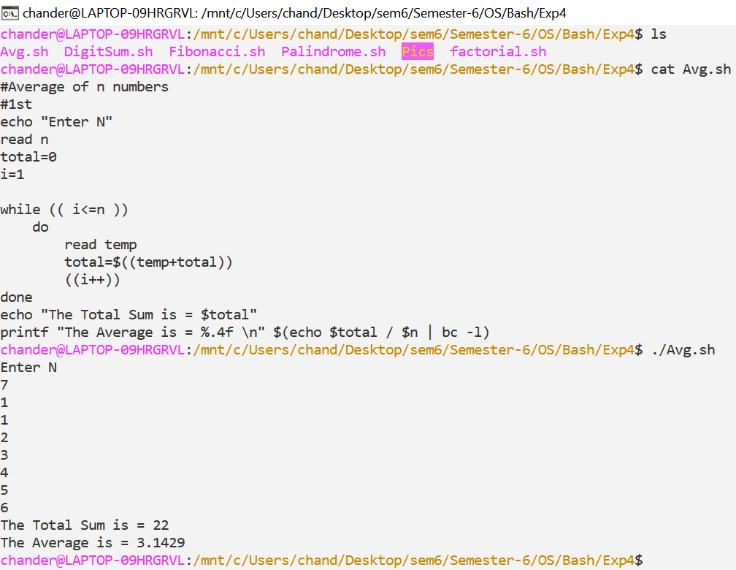

**ii) Write a script to print the 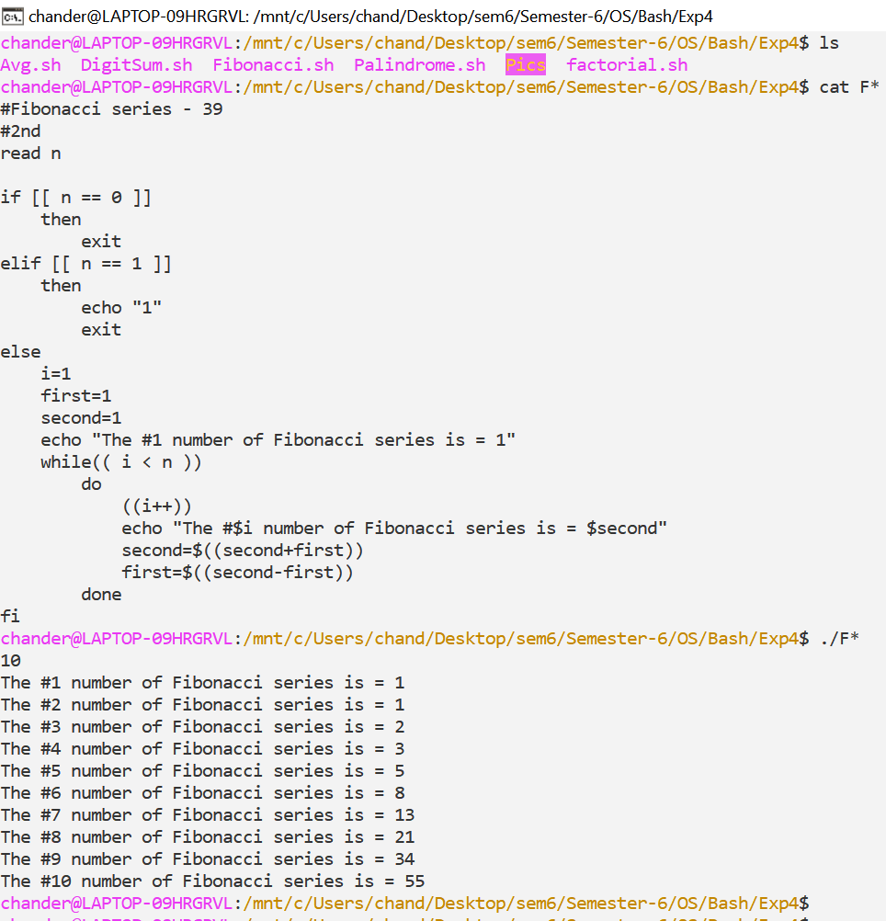Fibonacci series up to n terms**

**iii) Write a script to calculate the factorial of a given 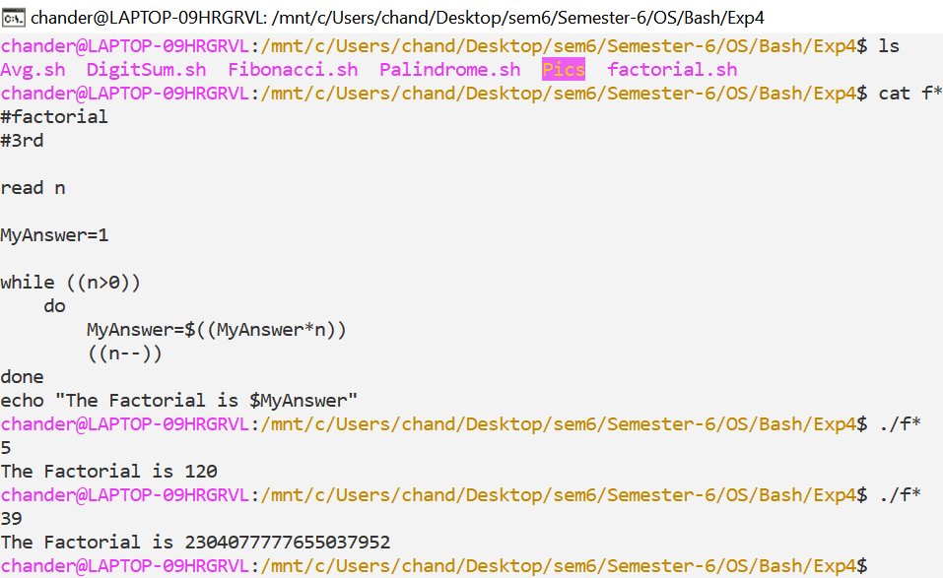number**

**iv) Write a script to calculate the sum of digits of the given 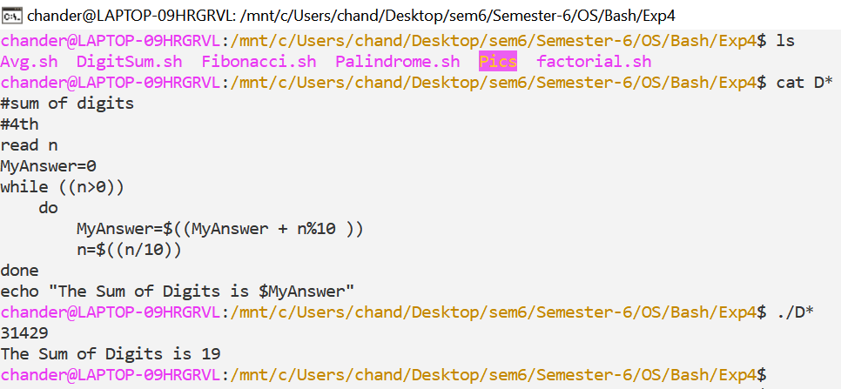number**

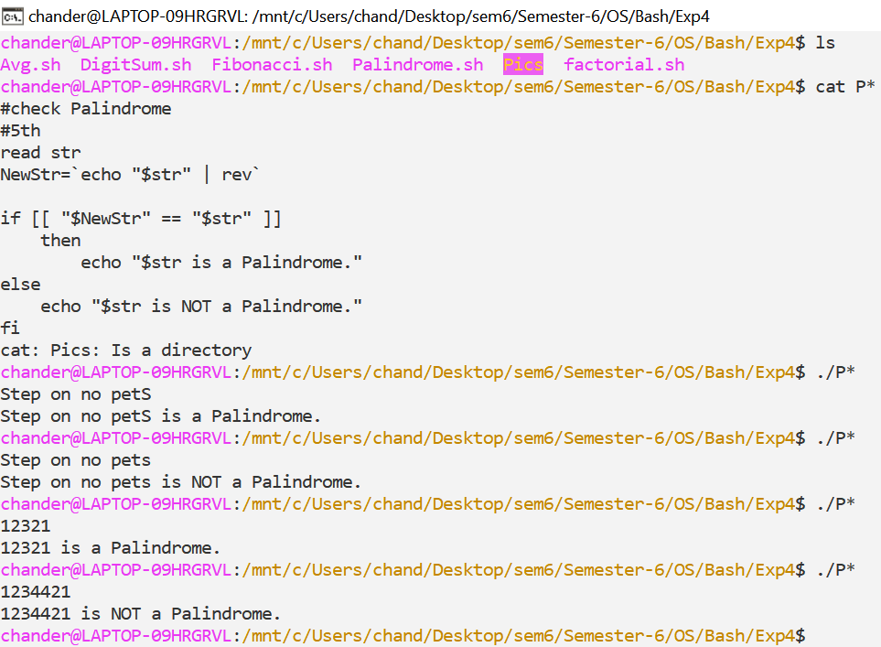**v)Write a script to check whether the given string is a palindrome**

***Index***

|  |  |  |  |
| --- | --- | --- | --- |
| **S.NO.** | **Experiment** | **Date** | **Signature** |
| 1 | Write a program to implement CPU scheduling for first come first serve. | 4/3/2022 |  |
| 2 | Write a program to implement CPU scheduling for shortest job first. | 4/3/2022 |  |
| 3 | Write a program to perform priority scheduling. | 11/3/2022 |  |
| 4 | Write a program to implement CPU scheduling for Round Robin. | 11/3/2022 |  |
| 5 | Write a program for page replacement policy using a) LRU b) FIFO c) Optimal. | 25/3/2022 |  |
| 6 | Write a program to implement first fit, best fit and worst fit algorithm for memory management. | 1/4/2022 |  |
| 7 | Write a program to implement reader/writer problem using semaphore. | 22/4/2022 |  |
| 8 | Write a program to implement Banker’s algorithm for deadlock avoidance. | 6/5/2022 |  |
| ***Beyond The Syllabus*** | | | |
| 1 | i) Write a script to find the greatest of three numbers (numbers passed as command line parameters)  ii) Write a script to check whether the given no. is even / odd  iii) Write a script to check whether the given number is prime or not  iv) Write a script to check whether the given input is a number or a string  v) Write a script to compute no. of characters and words in each line of given file | 13/5/2022 |  |
| 2 | i) Write a script to calculate the average of n numbers  ii) Write a script to print the Fibonacci series up to n terms  iii) Write a script to calculate the factorial of a given number  iv) Write a script to calculate the sum of digits of the given number  v) Write a script to check whether the given string is a palindrome | 20/5/2022 |  |