WEB TECHNOLOGY
LAB File

FACULTY NAME :- Mr. Ajay Tiwari STUDENT NAME :- Chander Jindal

Roll No :- 06514802719

Semester :- 6th

Group: :- 6C4



Maharaja Agrasen Institute of Technology, PSP Area, Sector – 22, Rohini,
Delhi-110085
WEB TECHNOLOGY

PRACTICAL RECORD
PAPER CODE : ETCS-356
Name of the student : Chander Jindal
University Roll No. 06514802719
Branch : CSE
Section/ Group : 6C4
PRACTICAL DETAILS

Exp. no | Experiment Name | Date | Signature
1 | Installation of xampp | 9/3
2 | Design a Static Home Page using HTML Tags | 16/3
3(a) | write a program to design table using basic html tags | 23/3
3(b) | write a program to design form using basic html tags | 23/3
4 | write a program to design webpages using:-  - Internal CSS  - External CSS  - Embedded CSS | 30/3
5 | Design an XML Catalogue.  (Design an XML Catalogue of your choice to understand the working structure of XML You may choose a food menu,CD database or any other to understand the child-parent relationship in XML) | 6/4
6 | Design a webpage that display current date and time using javascript | 11/4
7 | Design a simple form that includes Email,Password and Phone Number as a field and use javascript to validate the email address(for proper structure),phone number(to follow 10-digit norms) and password(to include at least one alphanumeric and one number). | 18/4
8 | Configure the CMS and choose addons to improve upon the aesthetics for improving the visual appeal of the website. | 25/4
9 | Deploy a content management system (CMS) and prepare a stepwise instruction on how to configure the CMS on Apache / XAMPP. | 25/4

Experiment – 1

Aim : Installation of xampp

Theory:
XAMPP is the most popular software package which is used to set up a PHP development environment for web services by providing all the required software components. During the process of software deployment, most of the web servers use almost similar components, so use of XAMPP provides easy transition from local server to live
server. XAMPP is a AMP stack which stands for Cross
platform, Apache, MySQL, PHP, perl with some additional administrative software tools such as PHPMyAdmin (for database access), FileZilla FTP server, Mercury mail server and JSP Tomcat server.
Other commonly known software packages like XAMPP are WAMP, LAMP, and others. The XAMPP server is used to test PHP pages. It works as local server. It contains a MySQL database to manage or save data on a local server

Advantages of XAMPP:
- It is free and easy to use and easily available for Windows, Linux and Mac OS .
- It is a beginners friendly solution package for full stack web development.
- It is a open source software package which gives a easy installation experience.
- It is very simple and lightweight to create set up for development, testing and deployment.
- It is a time-saver and provides several ways for managing configuration changes.
- It handles many administrative tasks like checking the status and security.

Software components of XAMPP:
  - Apache plays the role of processing the HTTP request. It is the actual default web server application. It is the most popular web servers maintained by Apache Software Foundation.
  - MySQL The role of database management system in XAMPP is played by MySQL. It helps to store and manage collected data very efficiently. It is an open-source and most popular.
  - PHP is the server-side scripting language which stand for Hypertext Preprocessor. It is embedded with HTML code which interacts with the webserver. It is an open-source and work well with MySQL and has become a common choice for web developers.
  - Perl is the high-level programming language designed for text editing which serves purpose like web development and network programming

Steps to install XAMPP on Windows:
Step 1: In the web browser, visit https://www.apachefriends.org/ and download XAMPP installer .

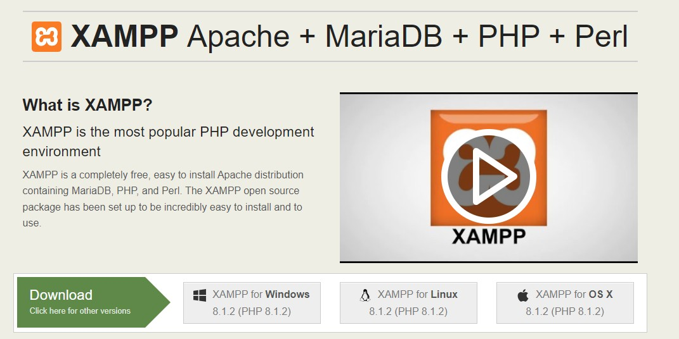

Step 2: After downloading xampp run the setup and click on next

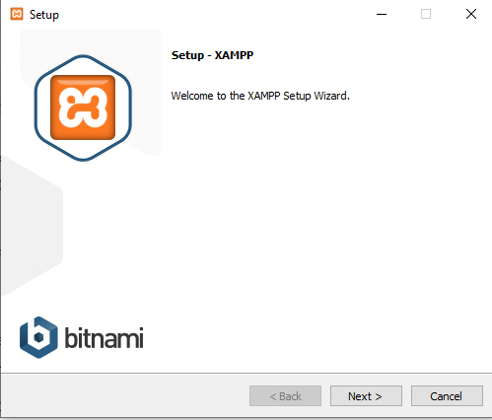
Step 3: During the installation process, select the required components like MySQL,
FileZilla ftp server, PHP, phpMyAdmin or leave the default options and click the Next button.
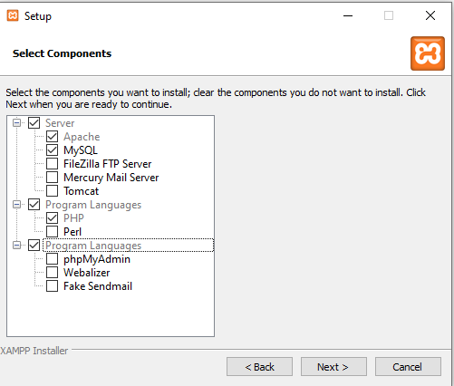

Step 4: Choose the root directory path to set up the htdocs folder for our applications. For example ‘C:\xampp’.

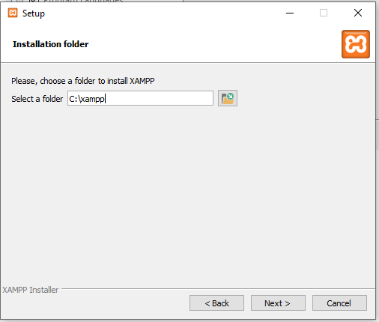

Step 5 : Select the Language and then click on next button

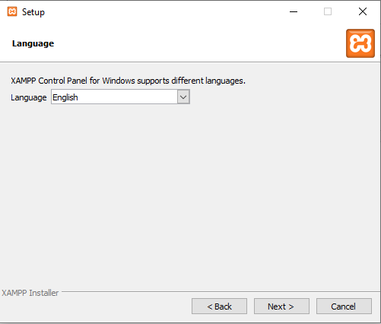

Step 6: Again click on next button
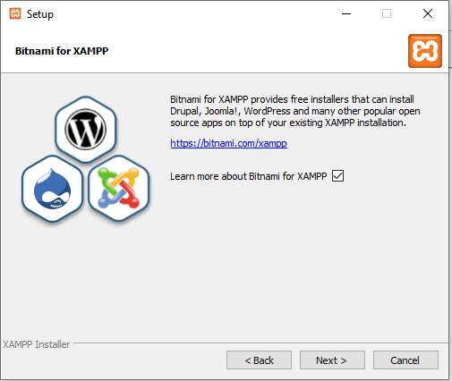
step 7: xampp will start installing
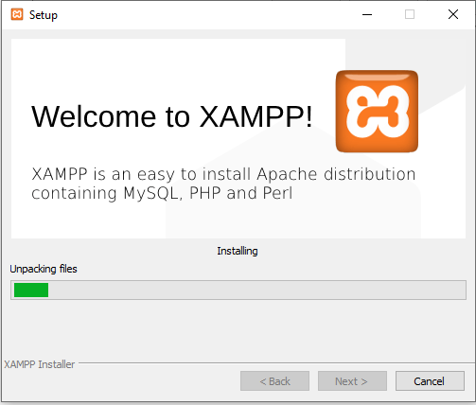

Step 8 : After completion of above step click on finish button
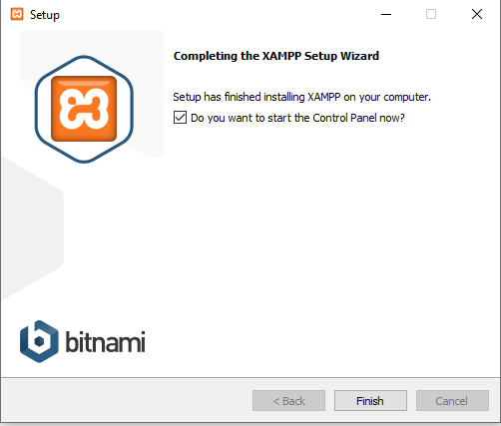

Experiment –2

Aim : Design a static home page using Html Tags

#Code:
<html>
<head>
<title>
Interesting Facts!
</title>
<link rel="icon" href="https://avatars.githubusercontent.com/u/72246687?s=400&v=4" type="image/icon type">
</head>
<body>
<h1><u>FACTS!</u></h1>
<p>1) Bubbles are Rain in Negative.</p>
<br>
<p>2) Ice Melts itself to Death.</p>
<br>
<p>3) The kid in the Parle G ad is older than your Dad.</p>
</body>
</html>

Output:

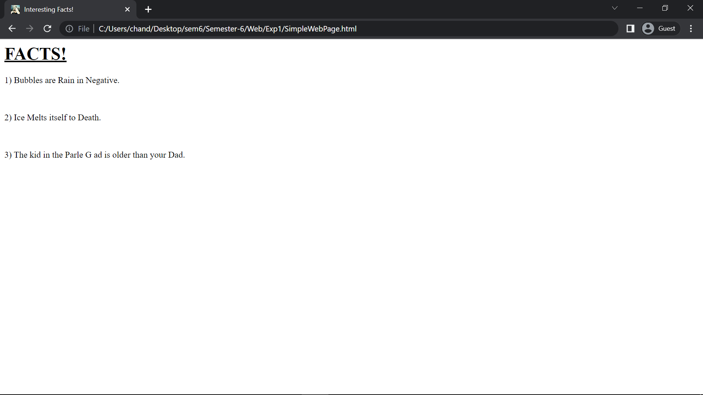
Experiment - 3(a)

Aim: write a program to design table using basic html tags

#Code:

<html>
<head>
<title>
Interesting Facts in a Table.
</title>
<link rel="icon" href="https://avatars.githubusercontent.com/u/72246687?s=400&v=4" type="image/icon type">
<style>
table{
border: 2px solid black;
padding: 1%;
}
td{
border: 1px solid saddlebrown;
}
</style>
</head>
<body>
<h1><u>FACTS!</u></h1>
<table>
<tr>
<td>S.No.</td>
<td>Fact</td>
</tr>
<tr>
<td>01</td>
<td>Every baby has held the recourd of Youngest Person Alive.</td>
</tr>
<tr>
<td>02</td>
<td>The Number of People Older than you will never change.</td>
</tr>
<tr>
<td>03</td>
<td>There is probably someone going to bed right now, who wouldn't wake up.</td>
</tr>
</table>
</body>
</html>

Output:

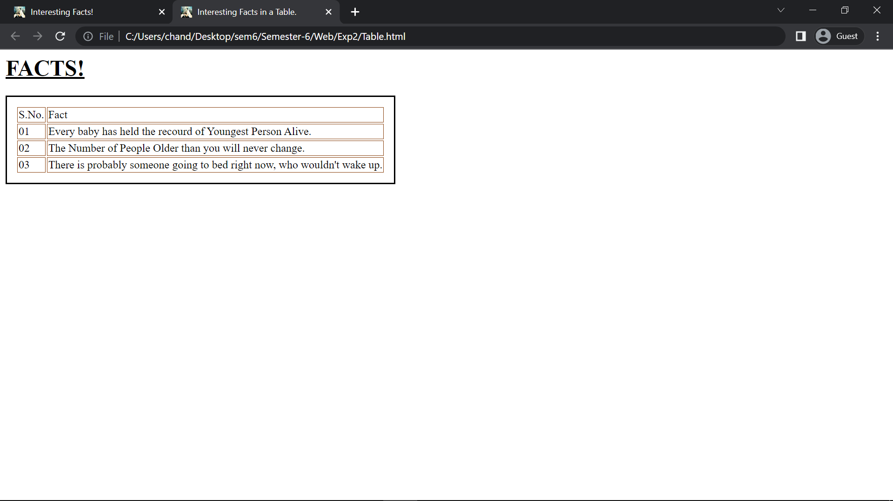

Experiment - 3(b)

Aim: write a program to design form using basic html tags
#Code:

<html>
<head>
<title>Form</title>
<link rel="icon" href="https://avatars.githubusercontent.com/u/72246687?s=400&v=4" type="image/icon type">
</head>
<body>
<h3> Form</h3>
<form>
Enter Some Text:-
<input type="text"><br>
Enter Some Text to be Hidden:-
<input type="password"><br>
Wanna Click a Button?
<input type="button" value="Button"><br>
A CheckBox!
<input type="checkbox"><br>
A Circular CheckBox!
<input type="radio"><br>
Mix!
<input type="radio" name = "cirle1" value = "one1" id = "click">
<input type="checkbox" name = "Square" value = "two2" id = "click">
<br>
<input type="radio" name = "cirle" value = "one" id = "click1">
<input type="radio" name = "cirle" value = "two" id = "click2">
<br>
Start again?
<input type="reset"><br>
Submit it!
<a href="https://www.w3schools.com/html/html_form_elements.asp">
<input type="submit">
</a>
<br>
Select Something!
<select>
<option value="Option#1"> Option#1 </option>
<option value="Option#2"> Option#2 </option>
<option value="Option#3"> Option#3 </option>
</select>
<br>
<textarea>
This is Text Area. Type something!
</textarea>
</form>

</body>
</html>

OUTPUT

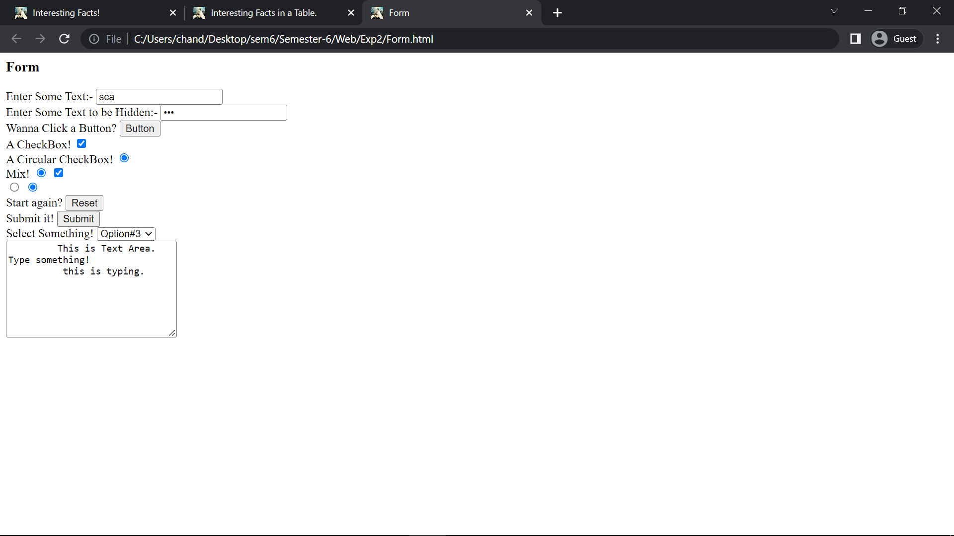
Experiment - 4

Aim: write a program to design webpages using:-

- Internal CSS
#Code:
<html>
<head>
<title>
Interesting Facts!
</title>
<link rel="icon" href="https://avatars.githubusercontent.com/u/72246687?s=400&v=4" type="image/icon type">
</head>
<body>
<h1 style="color: blue; font-family: 'Times New Roman', Times, serif; font-size: larger;"><u>FACTS!</u></h1>
<p style="color: brown;">1) The Voice inside your head grows with you.</p>
<br>
<p style="color:chocolate;">2) The voice in your head doesn't need to take a breadth while talking.</p>
<br>
<p style="color:blueviolet;">3) The voice in your head can take any voice you can think of.</p>
</body>
</html>

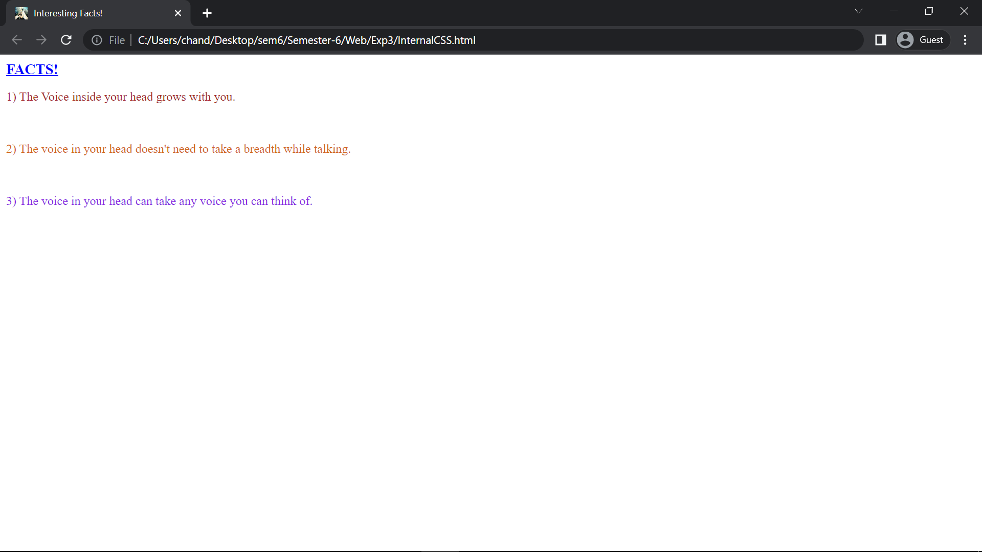
- External CSS

#Code

(Html File)

<html>
<head>
<title>
Interesting Facts!
</title>
<link rel="stylesheet" type="text/css" href="ExternalCSS.css">
<link rel="icon" href="https://avatars.githubusercontent.com/u/72246687?s=400&v=4" type="image/icon type">
</head>
<body>
<h1><u>FACTS!</u></h1>
<p>1) The Voice inside your head grows with you.</p>
<br>
<p>2) The voice in your head doesn't need to take a breadth while talking.</p>
<br>
<p>3) The voice in your head can take any voice you can think of.</p>
</body>
</html>

(CSS FILE)

h1{
color: blue ;
font-family: 'Times New Roman', Times, serif;
font-size: larger;
}
p{
color: chocolate;
}
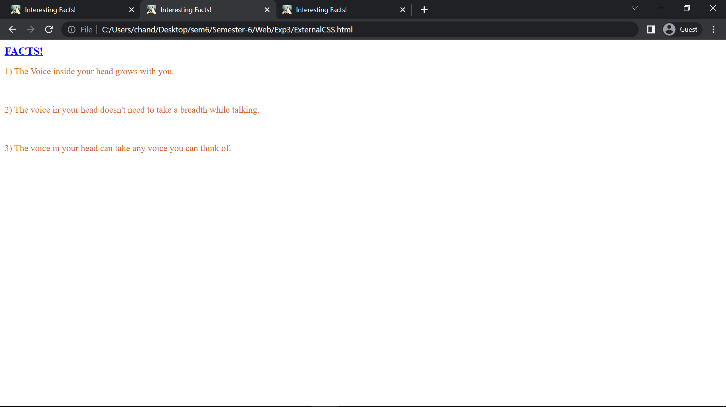

- Embedded CSS

#Code

<html>
<head>
<title>
Interesting Facts!
</title>
<style>
h1{
color: blue ;
font-family: 'Times New Roman', Times, serif;
font-size: larger;
}
p{
color: chocolate;
}
</style>
<link rel="icon" href="https://avatars.githubusercontent.com/u/72246687?s=400&v=4" type="image/icon type">
</head>
<body>
<h1><u>FACTS!</u></h1>
<p>1) The Voice inside your head grows with you.</p>
<br>
<p>2) The voice in your head doesn't need to take a breadth while talking.</p>
<br>
<p>3) The voice in your head can take any voice you can think of.</p>
</body>
</html>

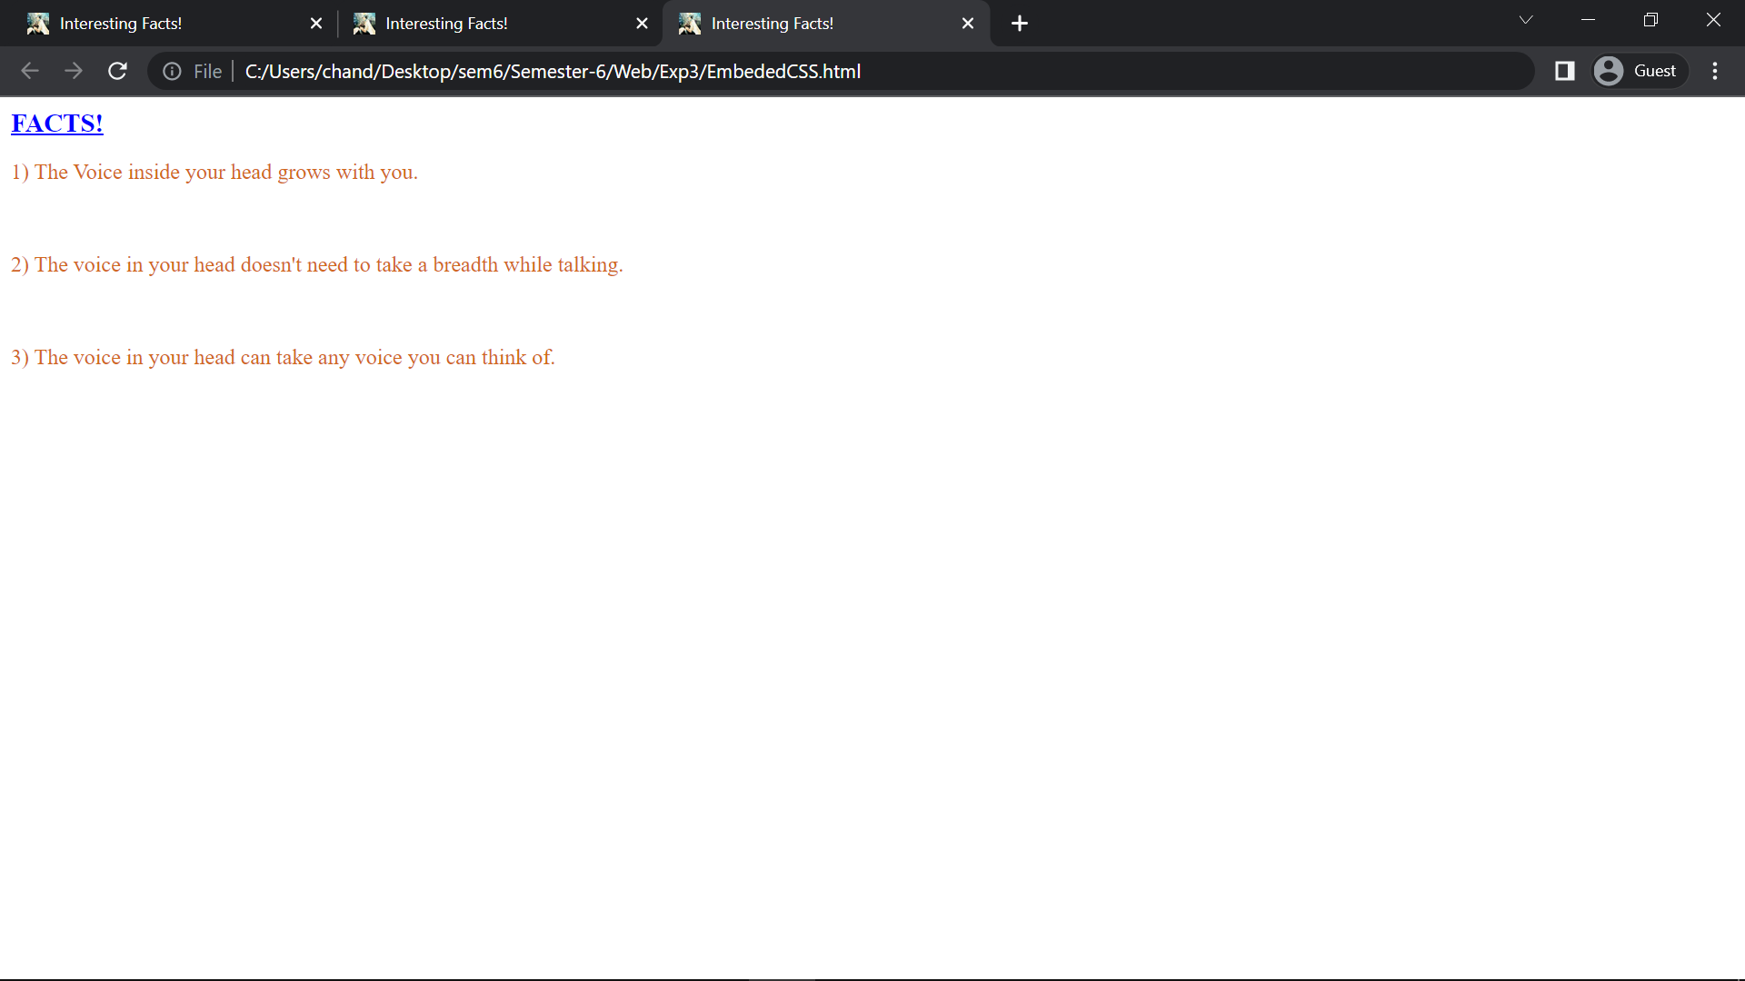
Experiment - 5

Aim - Design an XML Catalogue of your choice to understand the working structure of XML You may choose a food menu,CD database or any other to understand the child-parent relationship in XML

Source code -

<food_menu>
<ftypetname="Snacks, Starters And Light Bites">
<food>Soup of the Day</food>
<food>Catch of the Day</food>
<food>Food#1</food>
<food>Food#2</food>
</ftype>
<ftypetname="Kids Meals">
<food>Kid's Food#1</food>
<food>Kid's Food#2</food>
<food>Kid's Food#3</food>
</ftype>
<ftypetname="Traditional Homemade Meals">
<food>Homemade Food#1</food>
<food>Homemade Food#2</food>
<food>Homemade Food#3</food>
</ftype>

<ftypetname="Burgers">
<food>Burger#1</food>
<food>Burger#1</food>
<food>Burger#1</food>
</ftype>
<ftypetname="Sides">
<food>Side#1</food>
<food>Side#2</food>
<food>Side#3</food>
</ftype>

</ftype>
<ftypetname="Dips">
<food>Dip#1</food>
<food>Dip#2</food>
<food>Dip#3</food>
</ftype>
</food_menu>

#CODE2.0

<?xml version="1.0" encoding="UTF-8"?>
<CATALOG>

<CD>
<TITLE>Up All Night</TITLE>
<ARTIST>One Direction</ARTIST>
<LABEL>Syco, Columbia</LABEL>
<YEAR>2011</YEAR>
</CD>

<CD>
<TITLE>Take Me Home</TITLE>
<ARTIST>One Direction</ARTIST>
<LABEL>Syco, Columbia</LABEL>
<YEAR>2012</YEAR>
</CD>

<CD>
<TITLE>Midnight Memories</TITLE>
<ARTIST>One Direction</ARTIST>
<LABEL>Syco, Columbia</LABEL>
<YEAR>2013</YEAR>
</CD>

<CD>
<TITLE>Four</TITLE>
<ARTIST>One Direction</ARTIST>
<LABEL>Syco, Columbia</LABEL>
<YEAR>2014</YEAR>
</CD>

<CD>
<TITLE>Made In The A.M.</TITLE>
<ARTIST>One Direction</ARTIST>
<LABEL>Syco, Columbia</LABEL>
<YEAR>2015</YEAR>
</CD>

<CD>
<TITLE>Taylor Swift</TITLE>
<ARTIST>Taylor Swift</ARTIST>
<LABEL>Big Machine</LABEL>
<YEAR>2006</YEAR>
</CD>

<CD>
<TITLE>Fearless</TITLE>
<ARTIST>Taylor Swift</ARTIST>
<LABEL>Big Machine</LABEL>
<YEAR>2008</YEAR>
</CD>

<CD>
<TITLE>Speak Now</TITLE>
<ARTIST>Taylor Swift</ARTIST>
<LABEL>Big Machine</LABEL>
<YEAR>2010</YEAR>
</CD>

<CD>
<TITLE>Red</TITLE>
<ARTIST>Taylor Swift</ARTIST>
<LABEL>Big Machine</LABEL>
<YEAR>2012</YEAR>
</CD>

<CD>
<TITLE>1989</TITLE>
<ARTIST>Taylor Swift</ARTIST>
<LABEL>Big Machine</LABEL>
<YEAR>2014</YEAR>
</CD>

<CD>
<TITLE>Lights</TITLE>
<ARTIST>Ellie Goulding</ARTIST>
<LABEL>Big Machine</LABEL>
<YEAR>2014</YEAR>
</CD>

<CD>
<TITLE>Halycon</TITLE>
<ARTIST>Ellie Goulding</ARTIST>
<LABEL>Big Machine</LABEL>
<YEAR>2014</YEAR>
</CD>

<CD>
<TITLE>Delirium</TITLE>
<ARTIST>Ellie Goulding</ARTIST>
<LABEL>Big Machine</LABEL>
<YEAR>2014</YEAR>
</CD>

<CD>
<TITLE>Kiss And Tell</TITLE>
<ARTIST>Selena Gomez and The Scene</ARTIST>
<LABEL>Hollywood</LABEL>
<YEAR>2009</YEAR>
</CD>

<CD>
<TITLE>A Year Without Rain</TITLE>
<ARTIST>Selena Gomez and The Scene</ARTIST>
<LABEL>Hollywood</LABEL>
<YEAR>2010</YEAR>
</CD>

<CD>
<TITLE>When The Sun Goes Down</TITLE>
<ARTIST>Selena Gomez and The Scene</ARTIST>
<LABEL>Hollywood</LABEL>
<YEAR>2011</YEAR>
</CD>

<CD>
<TITLE>Stars Dance</TITLE>
<ARTIST>Selena Gomez</ARTIST>
<LABEL>Hollywood</LABEL>
<YEAR>2013</YEAR>
</CD>

<CD>
<TITLE>Revival</TITLE>
<ARTIST>Selena Gomez</ARTIST>
<LABEL>Hollywood</LABEL>
<YEAR>2015</YEAR>
</CD>

<CD>
<TITLE>Don't Forget</TITLE>
<ARTIST>Demi Lovato</ARTIST>
<LABEL>Hollywood</LABEL>
<YEAR>2008</YEAR>
</CD>

<CD>
<TITLE>Here We Go Again</TITLE>
<ARTIST>Demi Lovato</ARTIST>
<LABEL>Hollywood</LABEL>
<YEAR>2009</YEAR>
</CD>

<CD>
<TITLE>Unbroken</TITLE>
<ARTIST>Demi Lovato</ARTIST>
<LABEL>Hollywood</LABEL>
<YEAR>2011</YEAR>
</CD>

<CD>
<TITLE>Demi</TITLE>
<ARTIST>Demi Lovato</ARTIST>
<LABEL>Hollywood</LABEL>
<YEAR>2014</YEAR>
</CD>

<CD>
<TITLE>Confident</TITLE>
<ARTIST>Demi Lovato</ARTIST>
<LABEL>Hollywood, Island, Safehouse</LABEL>
<YEAR>2015</YEAR>
</CD>

</CATALOG>

Output:

1st
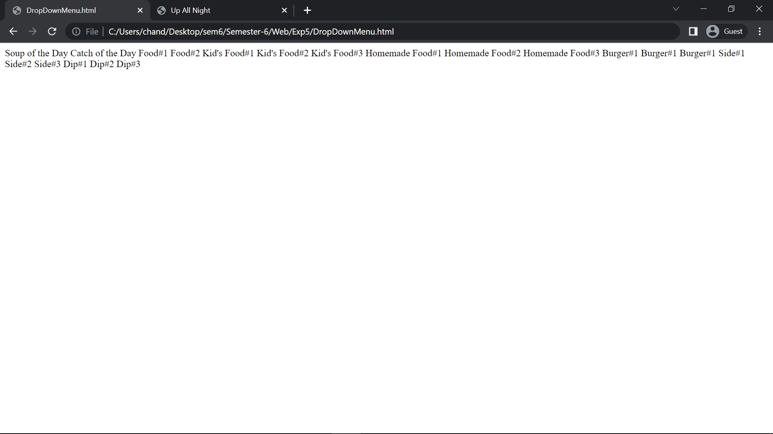

2nd
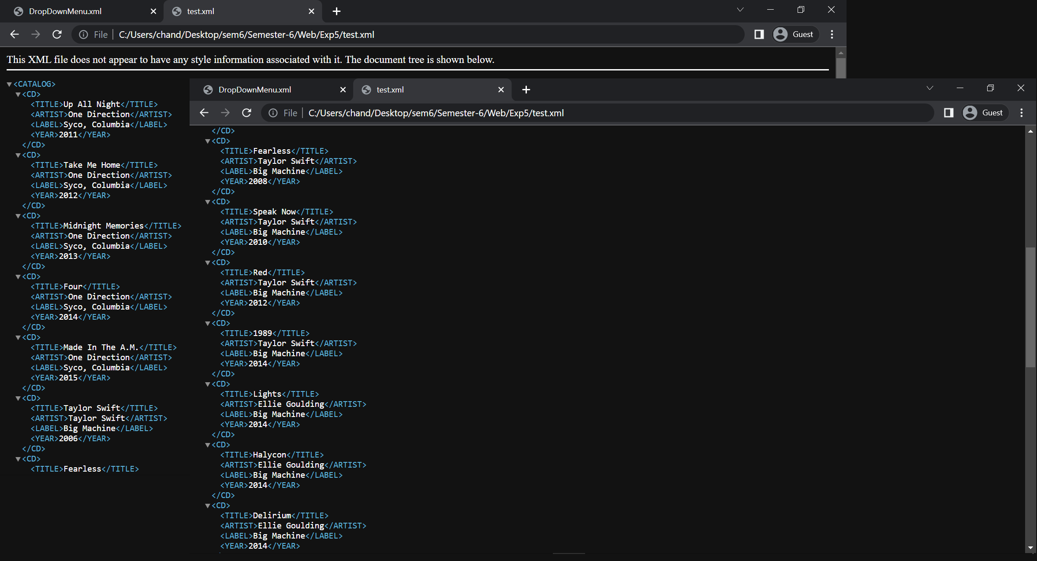

Experiment - 6

Aim – Design a webpage that display current date and time using javascript

Source code-

<!DOCTYPE html>
<html>
<body>
<h1>Current Date and Time is <span id='datetime'>var</span>.
</h1>
<script>
(function updateTime() {
var time = (new Date()).toLocaleString({
hour12: true,
});

document.getElementById('datetime').innerHTML = time;

requestAnimationFrame(updateTime);
})();

</script>
</body>
</html>

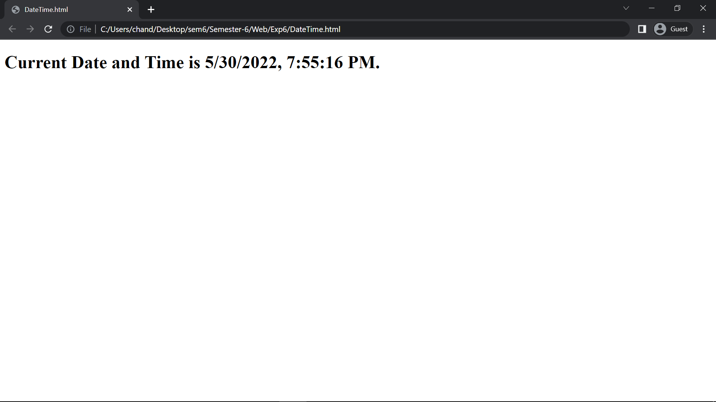

Experiment - 7

Aim – Design a simple form that includes Email,Password and Phone Number as a field and use javascript to validate the email address(for proper structure),phone number(to follow 10-digit norms) and password(to include at least one alphanumeric and one number).

#code

(Html File)

<html>
<head>
<title> Form Validation</title>
<script src="Exp7.js"></script>
</head>
<body>
<h2>JavaScript Form Validation</h2>
<br><br>
Email:
<input type='text' id='email'><br><br>
<p id="p1"></p>
<br><br>
Password:
<input type='text' id='password'><br><br>
<p id="p2"></p>
<br><br>
Phone Number:
<input type='text' id='number'><br><br>
<p id="p3"></p>
<br><br>
<button onclick="formValidation()">Validate Form</button><br><br>
</body>
</html>

(JavaScript File)

function formValidation(){

var email = document.getElementById('email');
var password = document.getElementById('password');
var number = document.getElementById('number');

emailVal(email, "* Please enter a valid email address like abc@xyz *")
passVal(password, "* Please enter a valid password, please use atleast one number, one UpperCase and one LowerCase Alphabet *");
numberVal(number, "* Please enter a valid 10-digit phone number *")
}

function emailVal(inputtext, alertMsg){

var emailExp = /^[\w\-\.\+]+\@[a-zA-Z0-9\.\-]+\.[a-zA-z0-9]{2,4}$/;
if(inputtext.value.match(emailExp))
alertMsg = "*Email Is Valid *";
document.getElementById('p1').innerText = alertMsg;
}

function passVal(inputtext, alertMsg){

var LetterDigitExp = "^(?=.*[A-Z])(?=.*[a-z])(?=.*[0-9])[a-zA-Z0-9]+$";
if(inputtext.value.match(LetterDigitExp))
alertMsg = "*Password Is Valid *";
document.getElementById('p2').innerText = alertMsg;
}

function numberVal(inputtext, alertMsg){

var numericExpression = /^[0-9]+$/;
if(inputtext.value.match(numericExpression)&&inputtext.value.length==10)
alertMsg = "*Phone Number Is Valid *";
document.getElementById('p3').innerText = alertMsg;
}

OUTPUT
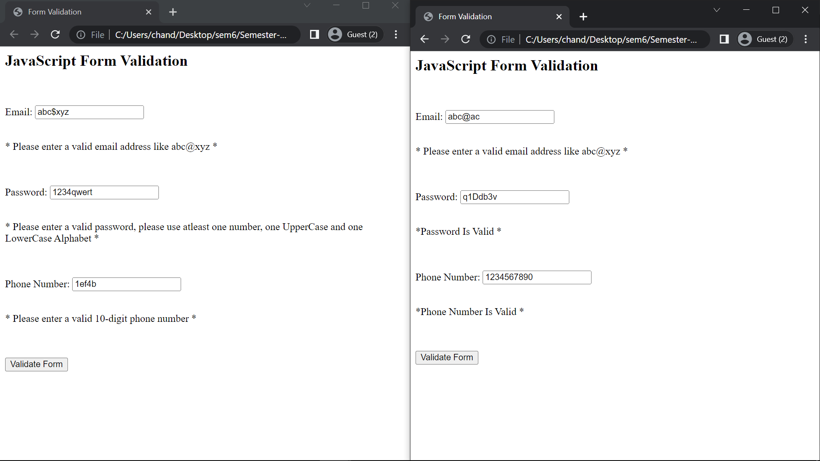

Experiment – 8

Aim: Configure the CMS and choose addons to improve upon the aesthetics for improving the visual appeal of the website.

To improve the visual aesthetics of our website, we can choose to change themes. In order to browse themes, first login to the CMS using the credentials when we installed.
Go to Appearance -> Themes from the sidebar and click on Add New Theme.
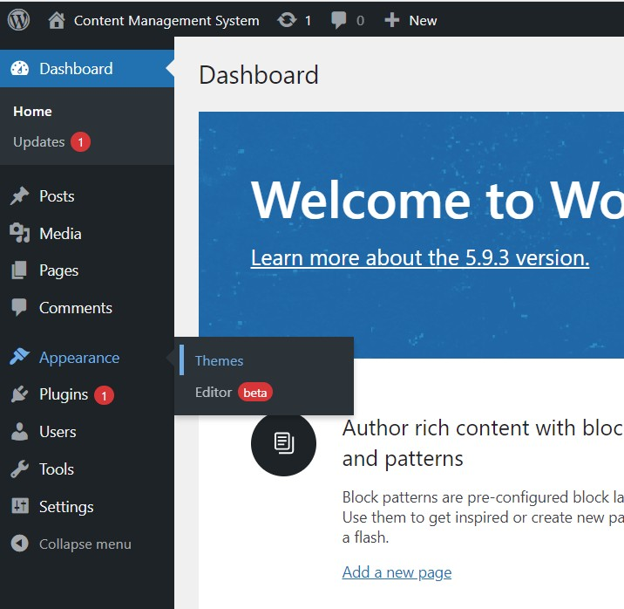

You can browse themes from the themes explorer, there are many free as well as paid themes available. You can choose to install any theme, and Wordpress will automatically download it from their repository and apply to this CMS. You can also choose to add your own custom CSS or JavaScript in the Theme’s editor.

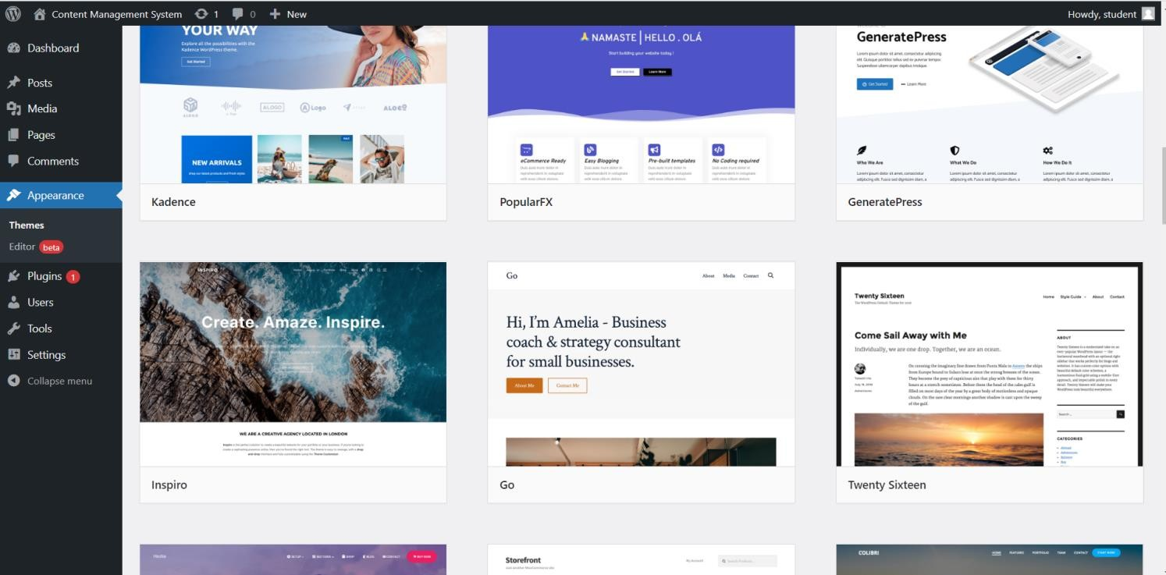

Once you activate the theme, it shows up like this.

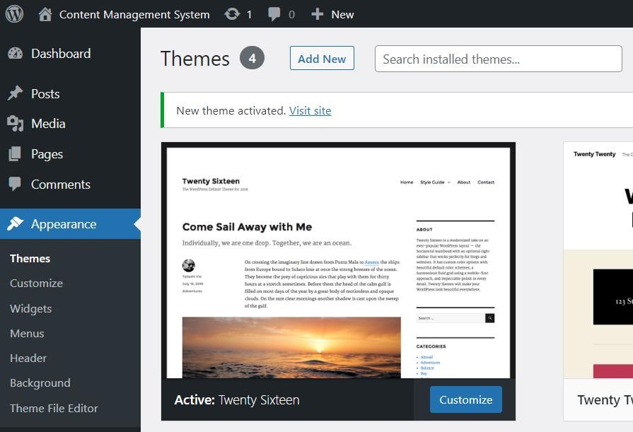

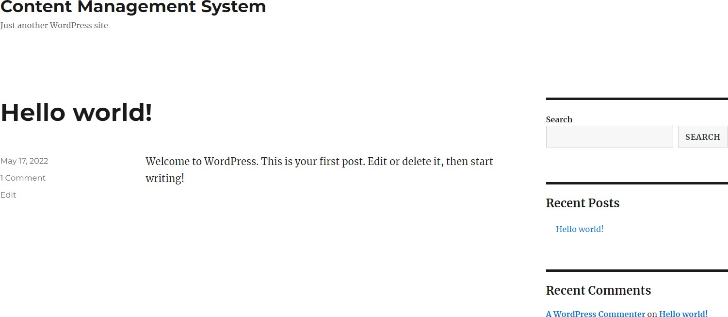

As we can see, our site’s visuals have been changed by adding the theme from the WordPress repository.

Experiment – 9

Aim: Deploy a content management system (CMS) and prepare a stepwise instruction on how to configure the CMS on Apache / XAMPP.

Step 1 : Download Wordpress code from wordpress.org and extract it under the htdocs directory, and rename it to cms.

Step 2 : Create a database via phpMyAdmin named wordpress.

Step 3 : Go to http://localhost/cms in the web browser. The Wordpress installation screen will now appear.
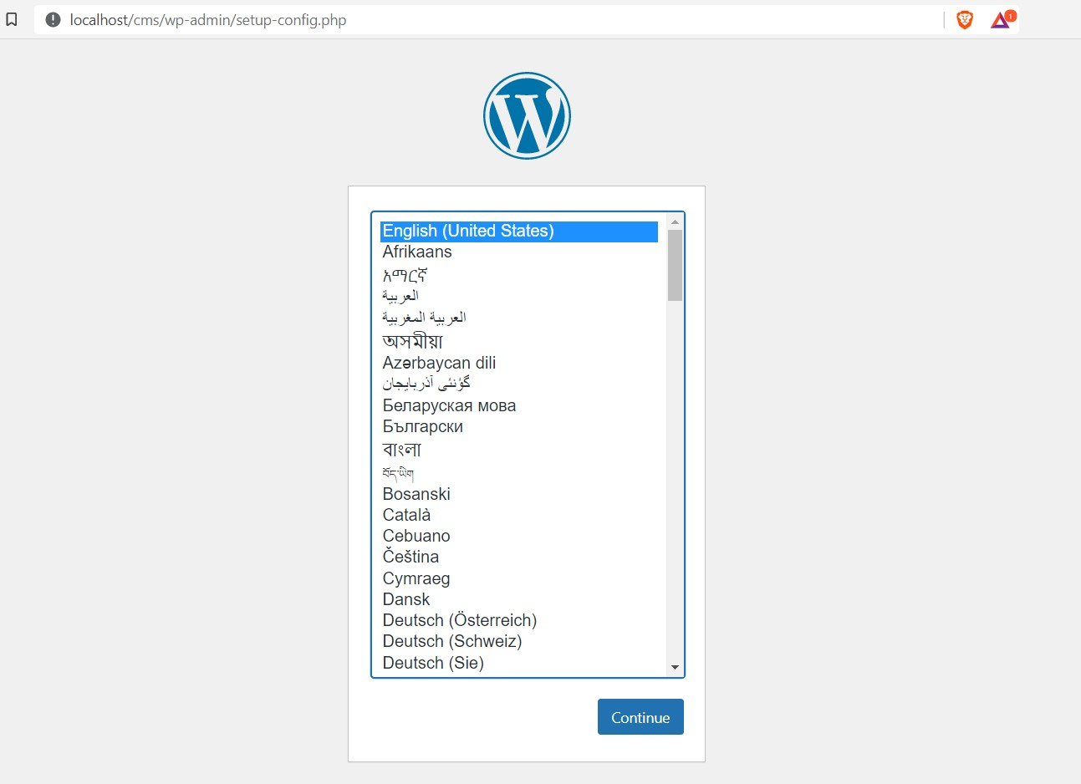

Step 3 : Enter the provided database credentials and click on submit, on the next page enter your site title and admin user information. Note your username and password as that will be required to login to the CMS in the future.

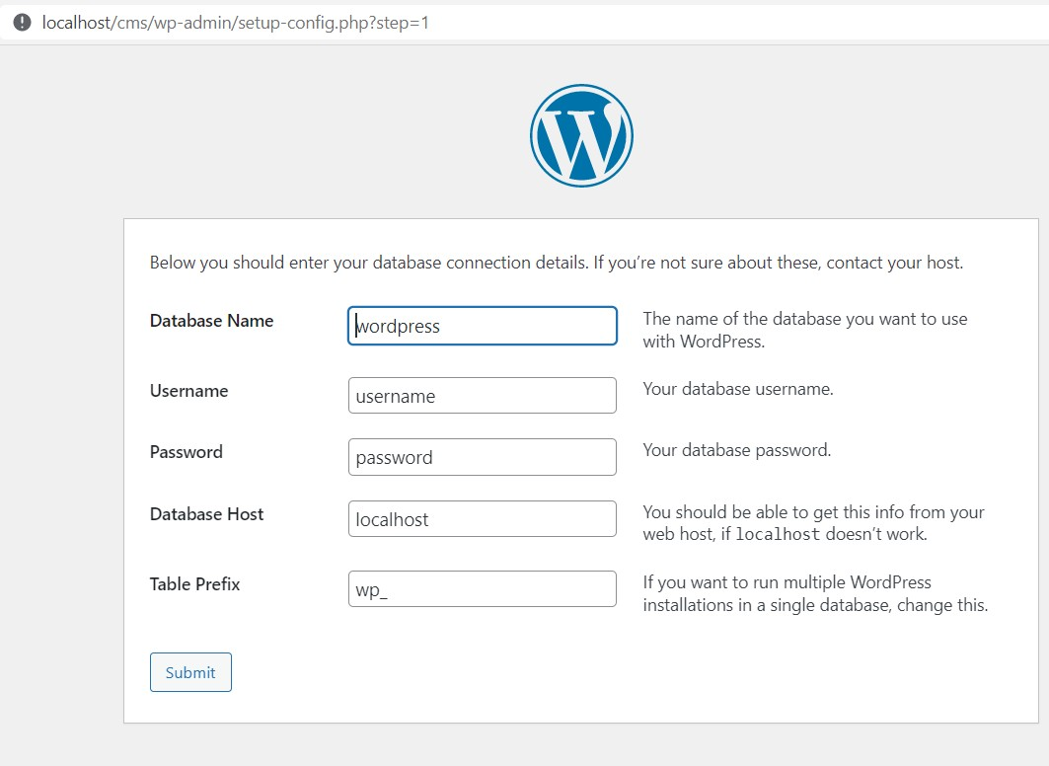

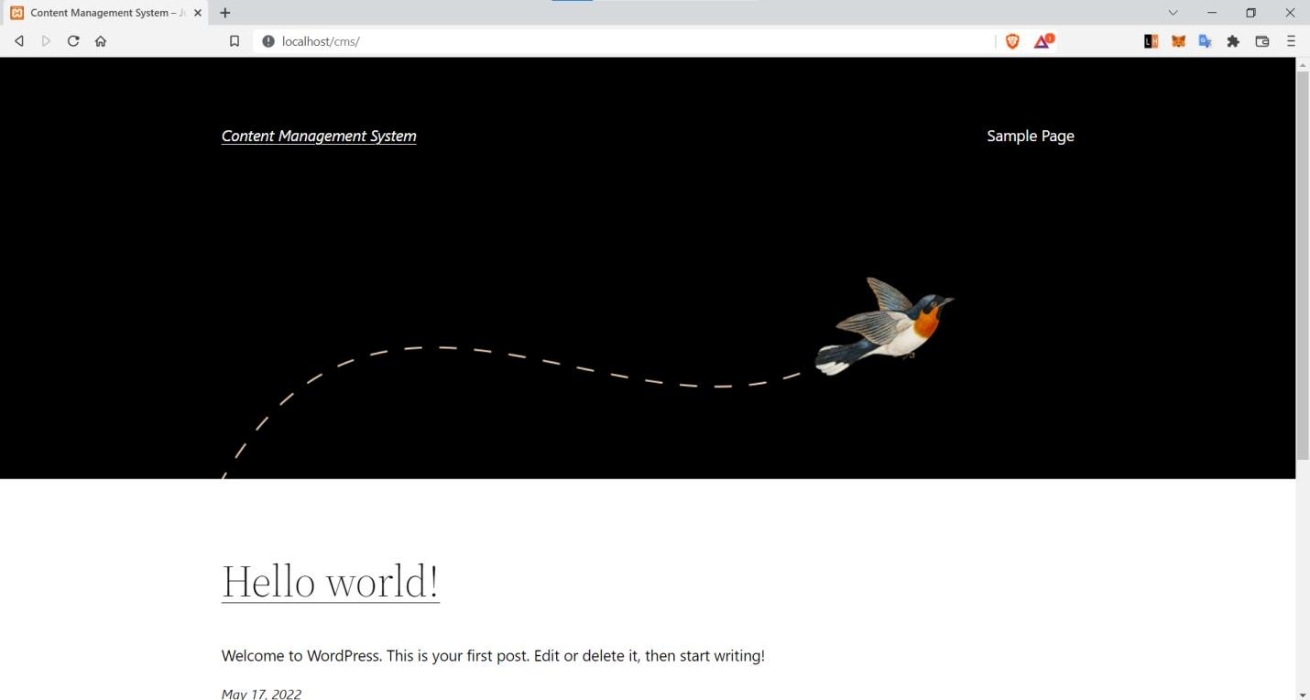

Wordpress has been installed

