Applied Mathematics -IV Lab

ETCS-211



Maharaja Agrasen Institute of Technology, PSP area,
Sector – 22, Rohini, New Delhi – 110085
( Affiliated to Guru Gobind Singh Indraprastha University, New Delhi )

-by Chander Jindal
(06514802719)
4C4

INDEX OF THE CONTENTS

S.no. | Date | Name of Experiment | Remarks
1 | 23/3/2021 | Write a program to perform  - Addition of two matrices.  - Multiplication of two matrices.  - Transpose of a matrix
2 | 30/3/2021 | Write a program to find inverse of a matrix using Gauss Jordan Method.
3 | 6/4/2021 | Write a program to find Eigen Values and Eigen Vectors of a given 2*2 matrix.
4 | 13/4/2021 | Write a program to find mean, standard deviation and first r moments about mean of given grouped data.
5 | 20/4/2021 | To fit a straight line for given n pairs of values (x,y)
6 | 4/5/2021 | Write a program to plot  - unit step function  - square wave function
7 | 11/5/2021 | Write a program to find solution of a non-linear equation using  - Bisection method  - Newton - Raphson method
8 | 18/5/2021 | Write a program to evaluatea definite integral using  - Trapezoidal rule  - Simpson’s one third rule  - Simpson’s three eighth rule
9 | 25/5/2021 | Write a program to find the initial value problem using Euler’s method
10 | 25/5/2021 | Write a program to find the solution of initial value using Runge-Kutta method of fourth order

Experiment - 1a

Aim - Write a program to perform
• Addition of two matrices.
• Multiplication of two matrices.
• Transpose of a matrix
#Code
(Addition of two matrices.)

r=input('Enter The Number Of Rows:')
c=input('Enter The Number Of Columns:')
A=zeros(r,c); B=zeros(r,c); C=zeros(r,c)
disp('Enter the elements of first matrix row wise:')
for i=1:r for j=1:c
A(i,j)=input('')
end end
disp('Enter the elements of second matrix row wise')
for i=1:r for j=1:c
B(i,j)=input('')
end end
for i=1:r for j=1:c
C(i,j)=A(i,j)+B(i,j)
end end
disp('First Matrix==>')

disp(A)
disp('Second Matrix==>')
disp(B)
disp('Sum Of Above Two Matrices==>')
disp(C)

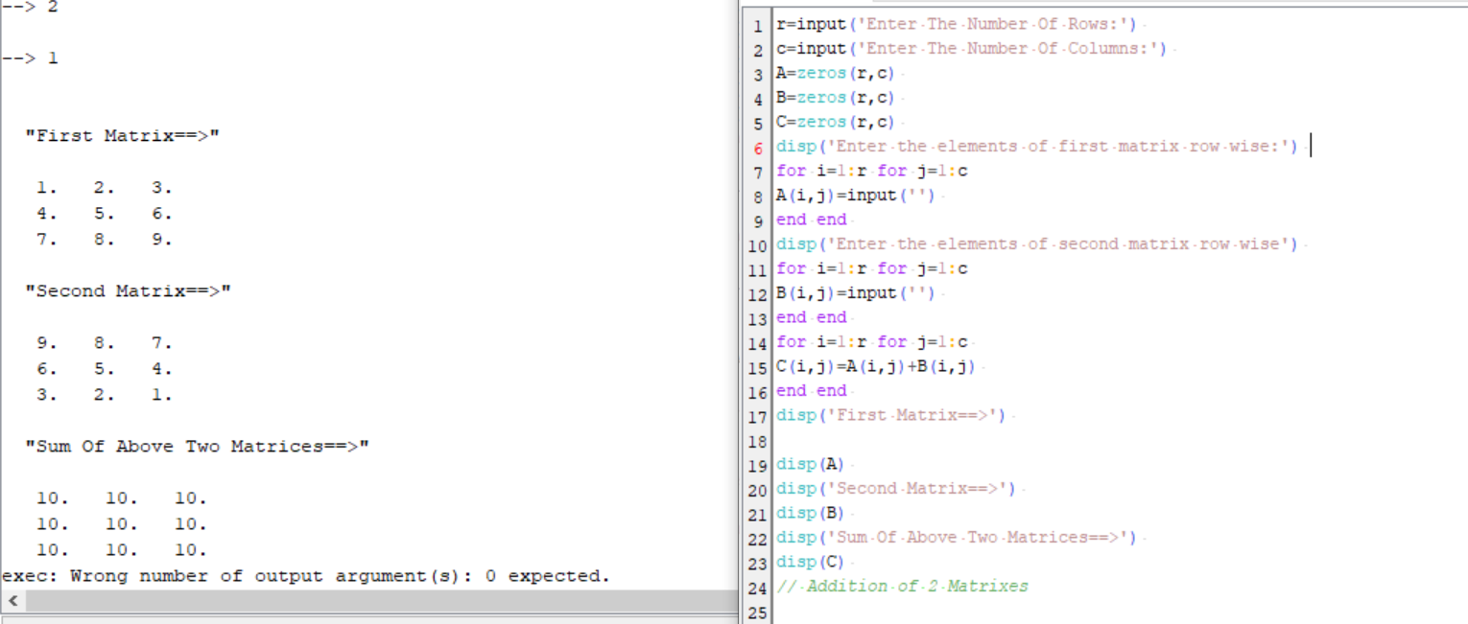
OUTPUT:

#Code
(Multiplication of two matrices)

//matrix multiplication
r=input('Enter The Number Of Rows:')
c=input('Enter The Number Of Columns:')
A=zeros(r,c) B=zeros(r,c) C=zeros(r,c)
disp('Enter the elements of first matrix row wise:')
for i=1:r for j=1:c
A(i,j)=input('')
end end
disp('Enter the elements of second matrix row wise')
for i=1:r for j=1:c
B(i,j)=input('')
end end
C=A*B
disp('First Matrix==>')
disp(A)
disp('Second Matrix==>')
disp(B)
disp('Product Of Above Two Matrices==>')
disp©

OUTPUT:
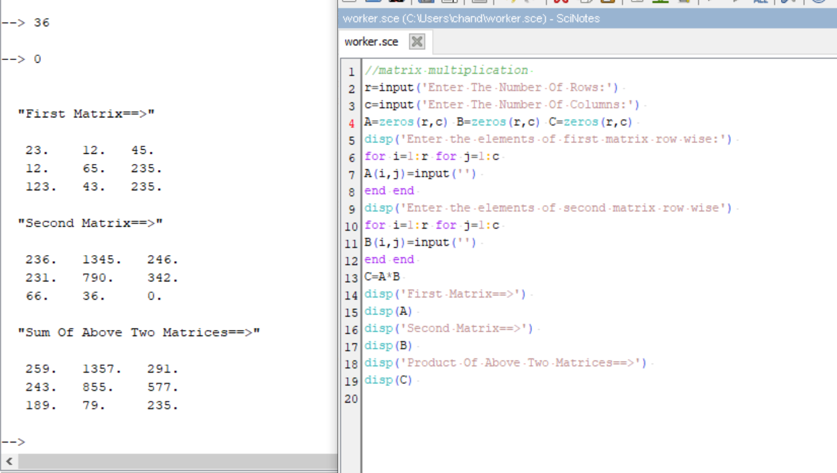

#Code
(Transpose of a matrix)

//matrix transpose
r=input('Enter The Number Of Rows:')
c=input('Enter The Number Of Columns:')
A=zeros(r,c); B=zeros(r,c)
disp('Enter the elements of first matrix row wise:')
for i=1:r for j=1:c
A(i,j)=input('')
end end
B=A'
disp('Matrix==>')

disp(A)
disp('Transpose Of The Matrix==>')
disp(B)

OUTPUT:
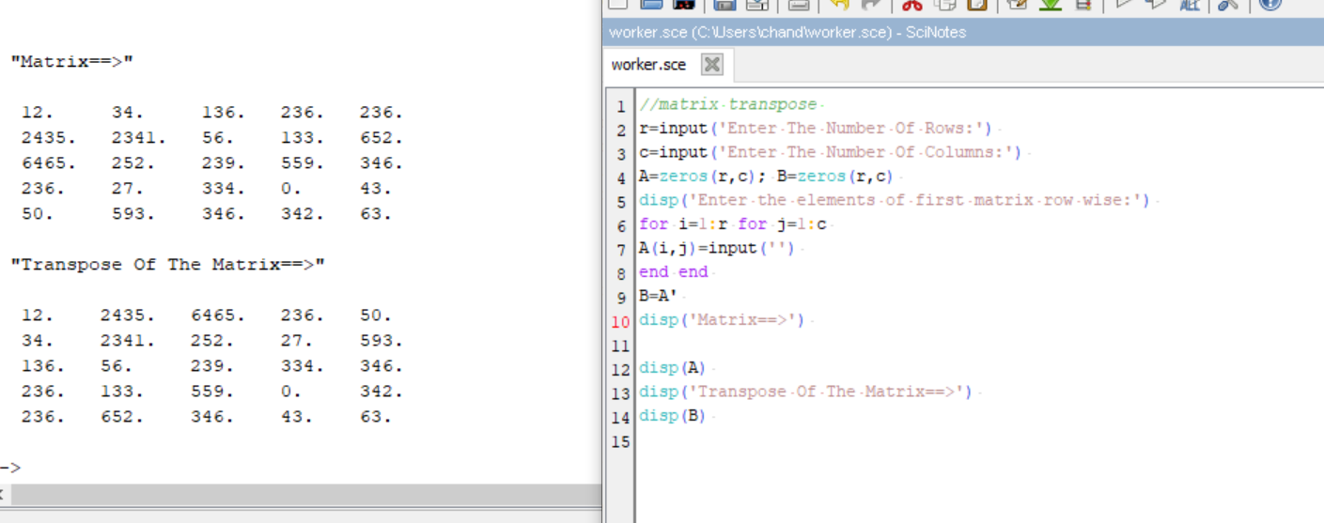

Experiment - 2
Aim - Write a program to find inverse of a matrix using Gauss Jordan Method

#Code

// Inverse of a 3 by 3 matrix using gauss jordan Method
disp('Enter a 3 by 3 matrix row-wise, make sure that diagonal elements are non -zeros')
for i=1:3
for j=1:3
A(i,j)=input('\');
end
end
disp('Entered Matrix is')
disp(A)
if det(A)==0
disp('Matrix is singular, Inverse does not exist')
break;
end
//Taking the augmented matrix [A|I],
B=[A eye(3,3)]
disp('Augumented matrix is:')
disp(B)
//Making B(1,1)=1
B(1,:) = B(1,:)/B(1,1);
//Making B(2,1) and B(3,1)=0
B(2,:) = B(2,:) - B(2,1)*B(1,:);
B(3,:) = B(3,:) - B(3,1)*B(1,:);
//Making B(2,2)=1 and B(1,2), B(3,2)=0
B(2,:) = B(2,:)/B(2,2);
B(1,:) = B(1,:) - B(1,2)*B(2,:);
B(3,:) = B(3,:) - B(3,2)*B(2,:);
// Making B(3,3)=1 and B(1,3), B(2,3)=0
B(3,:) = B(3,:)/B(3,3);
B(1,:) = B(1,:) - B(1,3)*B(3,:);
B(2,:) = B(2,:) - B(2,3)*B(3,:);
disp('Augumented matrix after row operations is:')
disp(B)
B(:,1:3)=[]
disp('Inverse of the Matrix is')
disp(B)

OUTPUT:
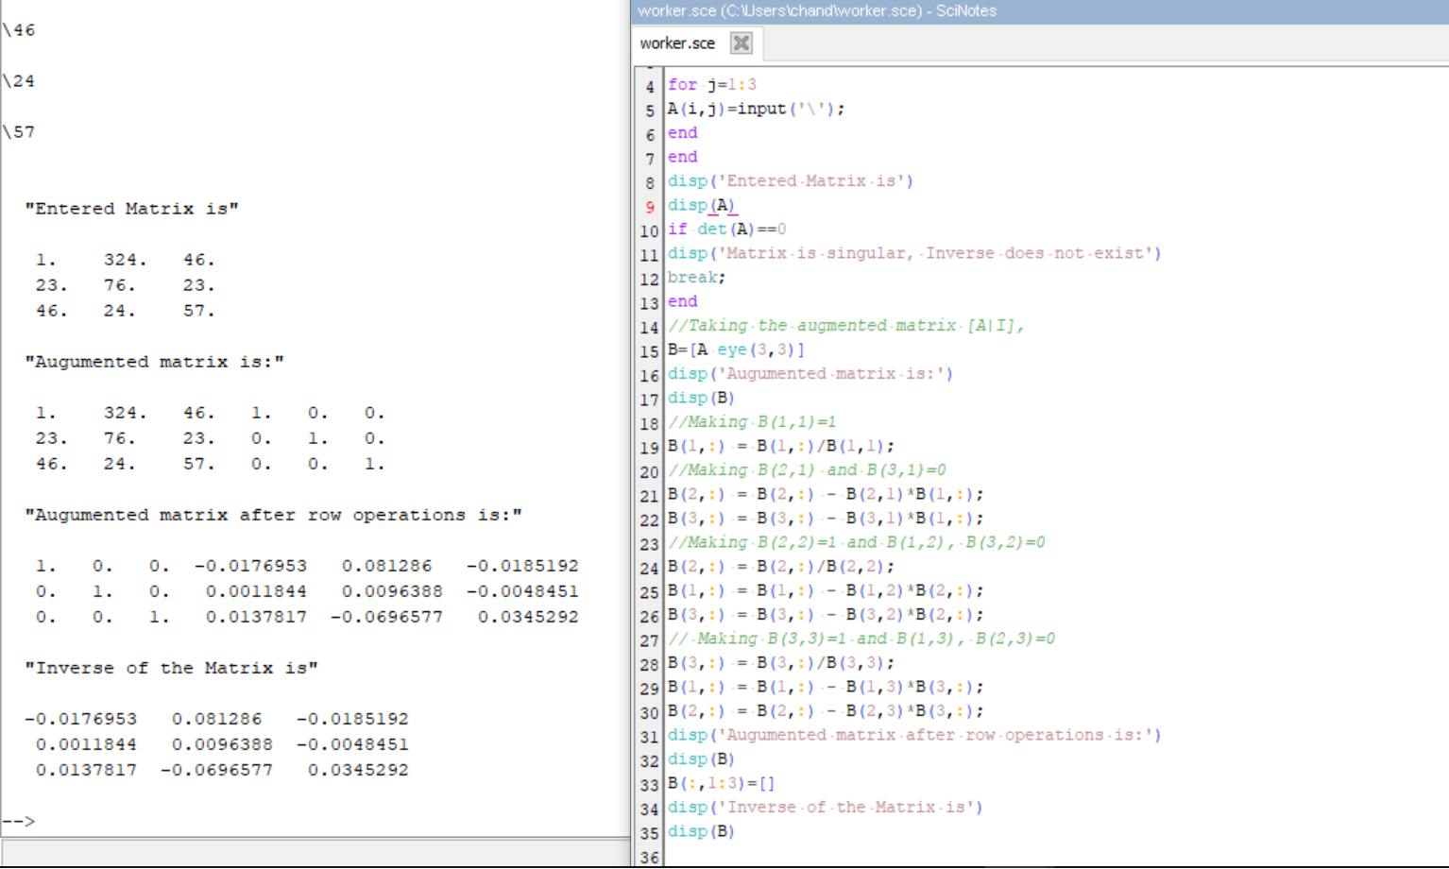

Experiment - 3
Aim - Write a program to find Eigen Values and Eigen Vectors of a given 2*2 matrix
#Code
//Eigen values and Eigen vectors
disp('Enter the 2x2 matrix:')
for i=1:2 for j=1:2
A(i,j)=input('\');
end end
disp('The Matrix entered is :')
disp(A)
b=A(1,1)+A(2,2);
c=A(1,1)*A(2,2)-A(1,2)*A(2,1);
disp('The characteristic equation is:')
disp(['e^2+' string(-b) '*e+' string(c) '=0'])
e1=(b+sqrt(b^2-4*c))/2; e2=(b-sqrt(b^2-4*c))/2;
if A(1,2)~=0 then
v1=[A(1,2);e1-A(1,1)]; v2=[A(1,2);e2-A(1,1)];
else if A(2,1)~=0
v1=[e1-A(2,2);A(2,1)]; v2=[e2-A(1,2);A(2,1)];
else
v1=[1;0]; v2=[0;1];
end end
disp('First Eigen value is:');
disp(e1);
disp('First Eigen vector is:');
disp(v1);
disp('Second Eigen value is:');
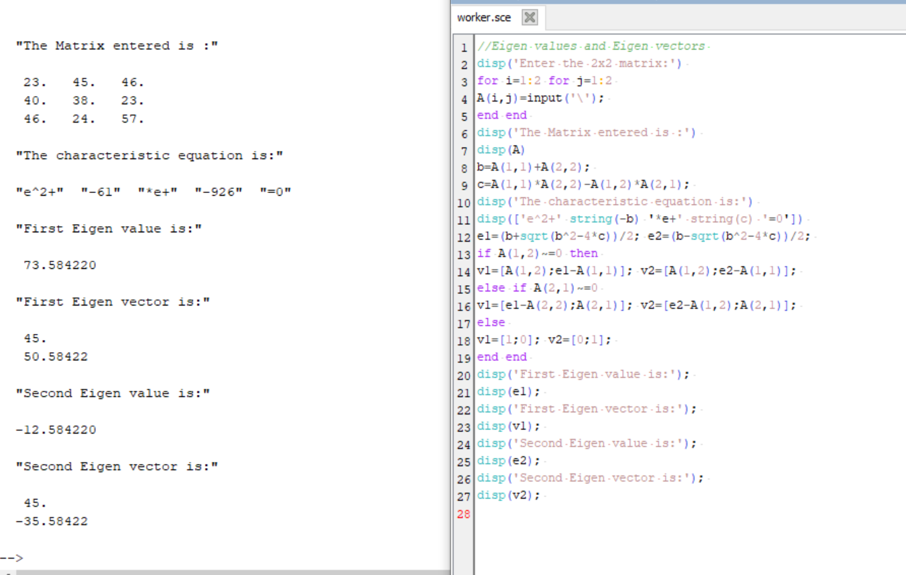
disp(e2);
disp('Second Eigen vector is:');
disp(v2);

Experiment - 4
Aim - Write a program to find mean, standard deviation and first r moments about mean of given grouped data.
#Code
//Program to find mean, standard deviation and first r moments about mean of given grouped data
n=input('Enter the number of observations:');
disp('Enter the values of xi==>');
for i=1:n
x(i)=input('\');
end;
disp('Enter thecorresponding frequencies fi==>');
sum3=0; for i=1:n
f(i)=input('\');
sum3=sum3+f(i);
end;
r=input('Enter the number of moments to be caculated:');
sum1=0; for i=1:n
sum1=sum1+f(i)*x(i);
end;
A=sum1/sum3; //calculation of mean
printf('Mean=%f\n',A);
for j=1:r
sum2=0; for i=1:n

y(i)=f(i)*(x(i)-A)^j;
sum2=sum2+y(i);
end;
M(j)=(sum2/sum3); //calculation of moments
printf('Moment about mean M(%d)=%f\n',j,M(j));
end;
sd=sqrt(M(2)); //calculation of standard deviation
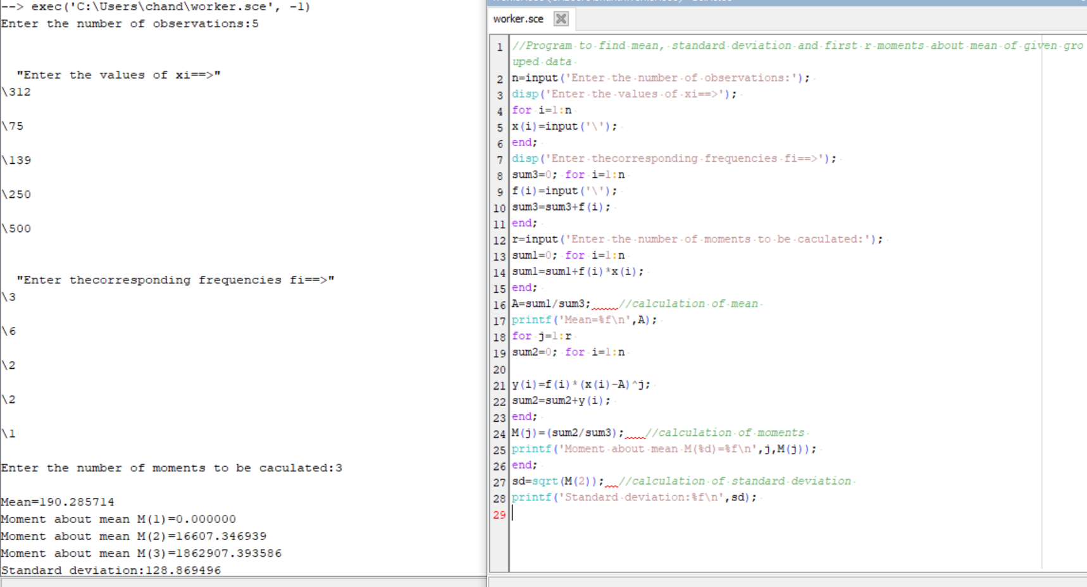
printf('Standard deviation:%f\n',sd);

Experiment - 5

Aim - To fit a straight line for given n pairs of values (x,y)

#Code

//Program of straight line fitting for n given pairs of values
n=input('Enter the number of pairs of input(x,y):');
s1=0; s2=0; s3=0; s4=0;
disp('Enter the values of x:')
for i=1:n
x(i)=input('\');
s1=s1+x(i);
s2=s2+x(i)*x(i);
end
disp('Enter coressponding values of y:')
for i=1:n
y(i)=input('\');
s3=s3+y(i);
end
for i=1:n
s4=s4+x(i)*y(i);
end
m=(s1*s3-n*s4)/(s1*s1-n*s2); c=(s1*s4-s2*s3)/(s1*s1-n*s2);
printf('The fitted line is y=%gx+(%g)',m,c)

OUTPUT:
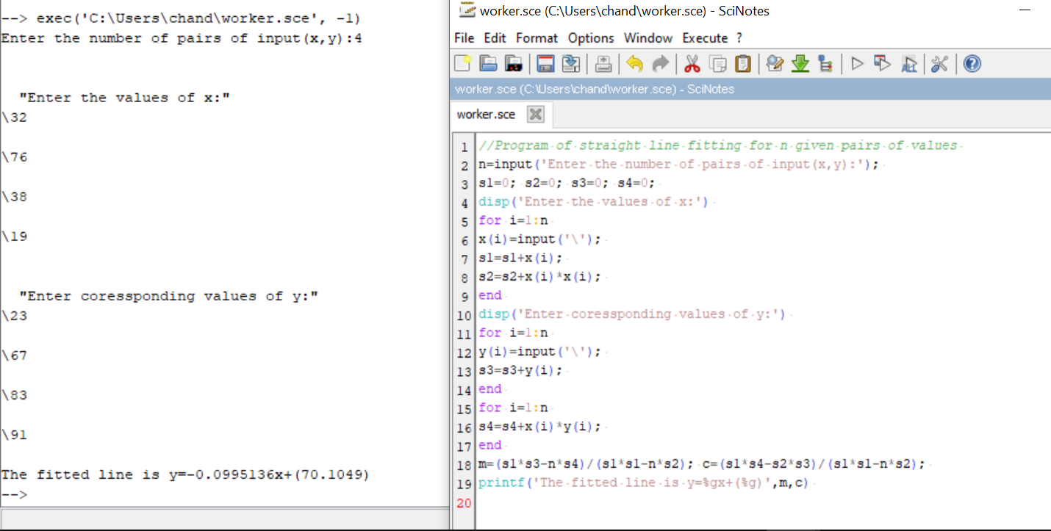

Experiment - 6

Aim - Write a program to plot
• unit step function
• square wave function

#Code
(unit step function)

t = -6:0.01:6;
u = ones ( t ).*( t >=0) ;
plot (t ,u ) ;
xgrid (4 ,1 ,7) ;
xlabel (" t","fontsize",4) ;
ylabel ("u(t)","fontsize" ,4) ;
title ("Unitstep","fontsize",4) ;

OUTPUT:
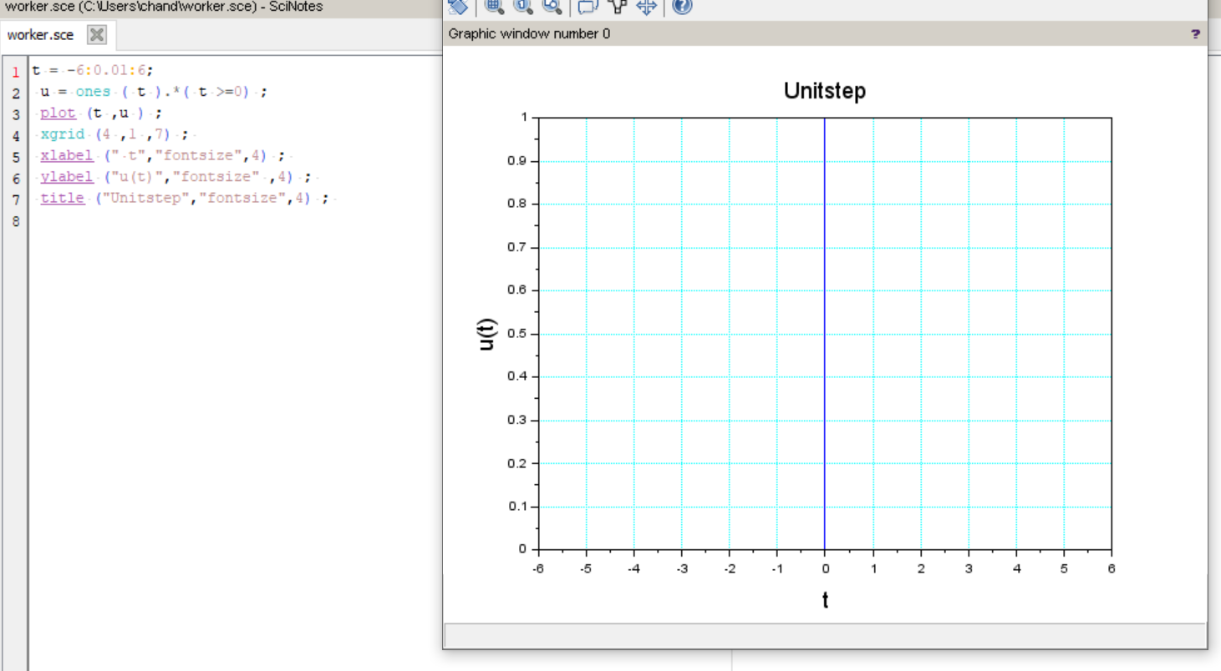

#Code
(square wave function)

//Program to generate a square wave
x=[0 1 2 3 4 5 6 7 8 9 10 11 12 13 14 15 16 17 18 19 20];
y=[0 1 1 0 0 1 1 0 0 1 1 0 0 1 1 0 0 1 1 0 0];
plot2d2(x,y);
xgrid (4 ,1 ,7) ;
xlabel (" t ->","fontsize",4) ;
ylabel ("f(t) ->","fontsize" ,4) ;
title ("Square wave","fontsize",4) ;

OUTPUT:

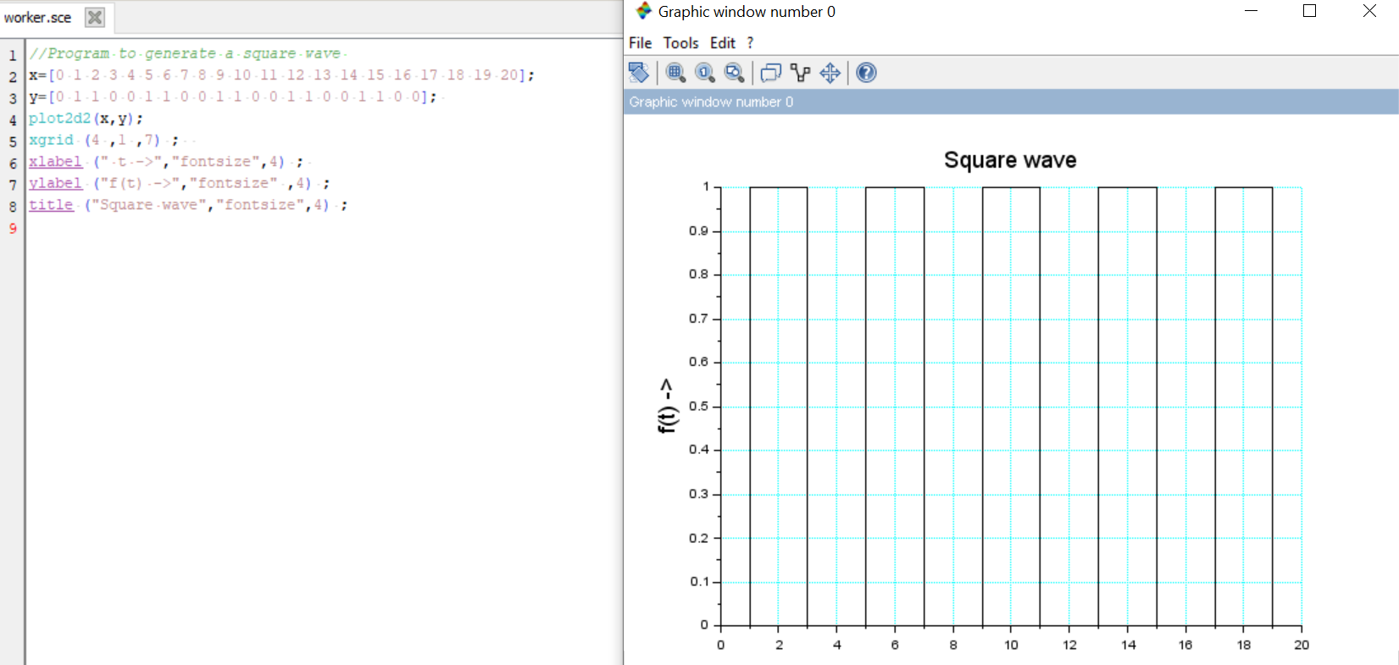

Experiment - 7

Aim - Write a program to find solution of a non-linear equation using
  - Bisection method
  - Newton - Raphson method

#Code
(Bisection method)

//Bisection Method
deff('y=f(x)','y=x^3-9*x+19')
x1=-4; x2=-3;
e=0.001;
i=0;
printf('f(x)=x^3-9*x+19\n')
printf('Iteration\tx1\t\tx2\t\tz\t\tf(z)\n')
while abs(x1-x2)>2*e
z=(x1+x2)/2
printf(' %i\t\t%f\t%f\t%f\t%f\n',i,x1,x2,z,f(z))
if f(z)*f(x1)>0
x1=z else
x2=z
end
i=i+1
end
printf('\n\nThe solution of f(x) is %g after %i iterations',z,i-1)

OUTPUT:
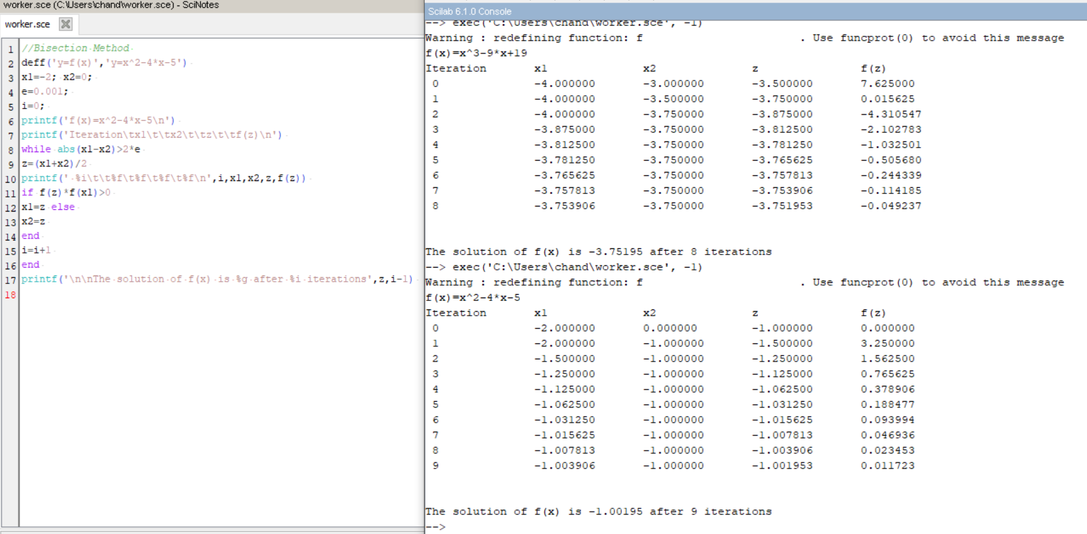

#Code
(using Newton - Raphson)

//Newton-Raphson Method
deff('y=f(x)','y=2*x^3+5*x^2-2*x-4')
deff('y=f1(x)','y=6*x^2+10*x-2')
disp('')
x(1)=input('For eq. y=2*x^3+5*x^2-2*x-4 Waht is your initial guess :');
e=input(" answer correct upto : ");
for i=1:100
x(i+1)=x(i)-((f(x(i))/df(x(i))));
err(i)=abs((x(i+1)-x(i))/x(i));
if err(i)<e
break;
end
end
printf('the solution is %f',x(i))

OUTPUT:

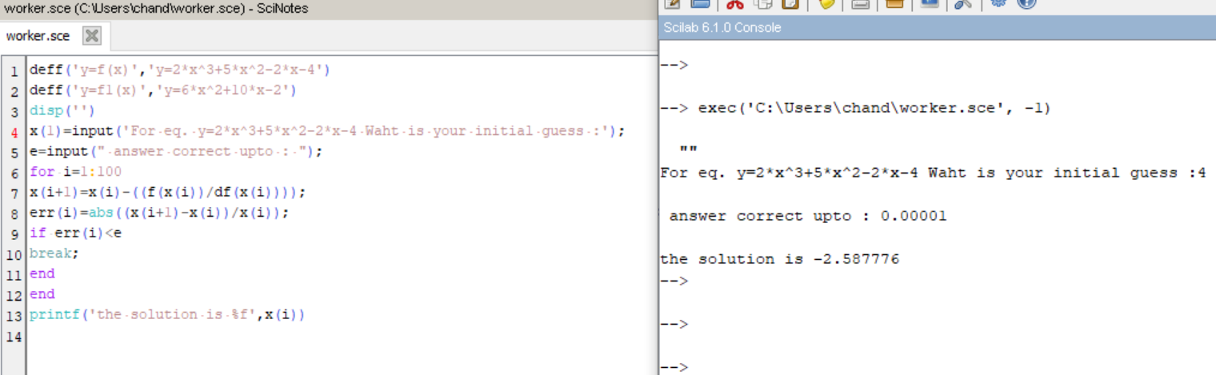

Experiment - 8

Aim - Write a program to evaluate a definite integral using
  - Trapezoidal rule
  - Simpson’s one third rule
  - Simpson’s three eighth rule
#Code
(Trapezoidal rule)

//Program to find value of integral using Trapezoidal rule
deff('y=f(x)','y=2/(1+x^2)')
printf('Integration of y=2/(1+x^2) from 0 to 6')
x0=0; xn=6;
n=6;
h=(xn-x0)/n;
s=0;
for i=1:n
s=s+f(x0+(i-1)*h)+f(x0+i*h);
end
integral=(h*s)/2;
printf('\nThe value of integral is %g\n',integral)
OUTPUT:
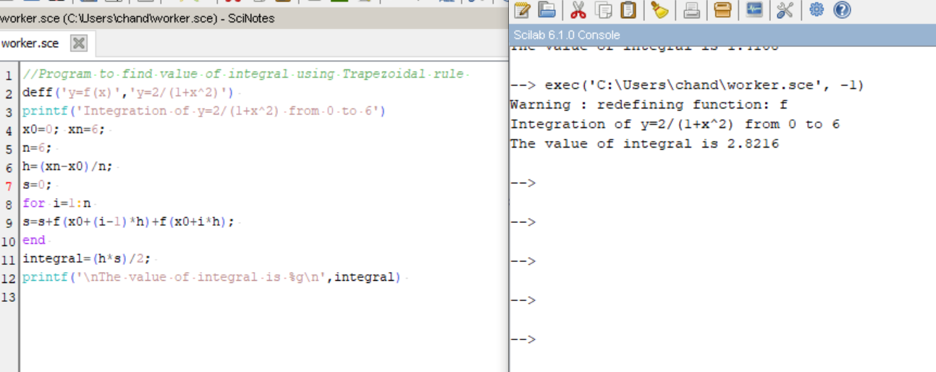
#Code
(using Simpson's one third rule)

//Program to find value of integral using Simpson's one third rule
deff('y=f(x)','y=2/(1+x^2)')
x0=0;
xn=6
printf('Integration of y=2/(1+x^2) from 0 to 6');
n=10; // even n req.
h=(xn-x0)/n;
s=0;
for i=1:2:n
s=s+f(x0+(i-1)*h)+4*f(x0+i*h)+f(x0+(i+1)*h);
end
integral=(h*s)/3;
printf('\nThe value of integral is=%g\n',integral)
OUTPUT:
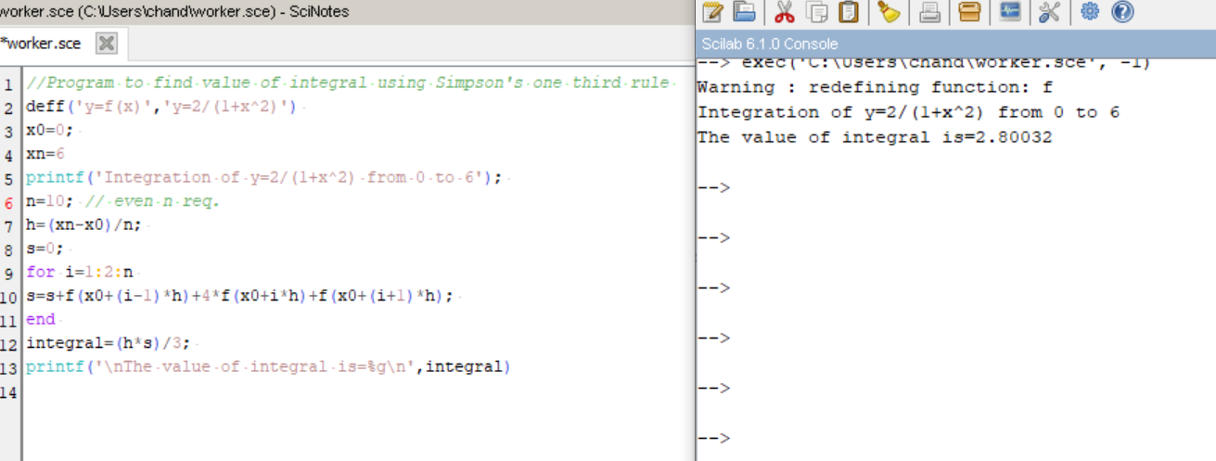
#Code
( using Simpson's three eighth rule)

//Program to find value of integral using Simpson's three eighth rule
deff('y=f(x)','y=2/(1+x^2)')
x0=0; xn=6;
printf('Integration of y=2/(1+x^2) from 0 to 6');
n=6; //n | 3
h=(xn-x0)/n;
s=0;
for i=1:3:n
s=s+f(x0+(i-1)*h)+3*f(x0+i*h)+3*f(x0+(i+1)*h)+f(x0+(i+2)*h);
end
integral=(3*h*s)/8;
printf('\nThe value of integral is=%g\n',integral)

OUTPUT:

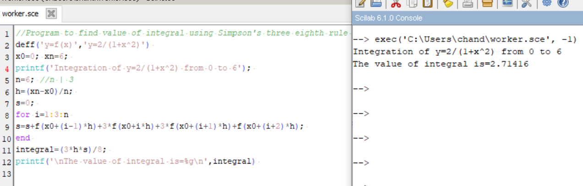
Experiment - 9

Aim - Write a program to find the initial value problem using Euler's method

#Code

function ydot=fun(t, y)
ydot=y^3-y*sin(t)+cos(t)
endfunction
y0=0;
t0=0;
t=0:0.1:%pi;
y = ode(y0,t0,t,fun);
plot(t,y)

OUTPUT:

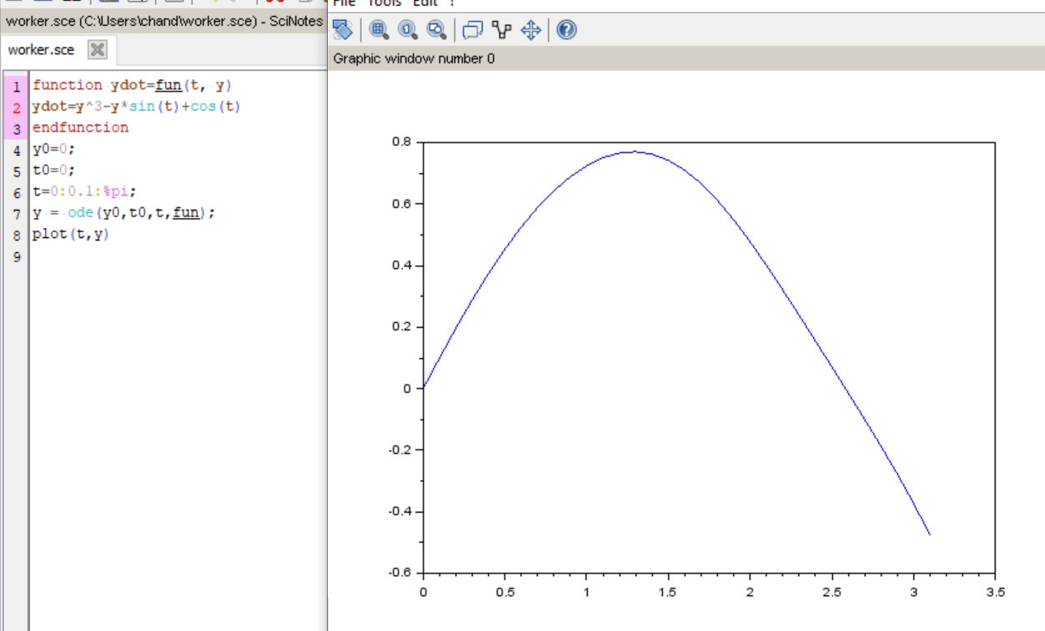

Experiment - 10

Aim - Write a program to find the solution of initial value using Runge-Kutta method of fourth
order

#Code

//Program to solve the equation y'=f(x,y);y(x0)=y0 for y(xn) using Runge-Kutta method of fourth order
deff('z=f(x,y)','z=x*x-y')
x0=0; y0=1;
xn=0.5;
h=0.1;
x=x0;
y=y0;
lst_x = []
lst_y = []
while x~=xn
k1=h*f(x,y);
k2=h*f(x+h/2,y+k1/2); k3=h*f(x+h/2,y+k2/2);
k4=h*f(x+h,y+k3);
k=(k1+(k2+k3)*2+k4)/6;
x=x+h; y=y+k;
lst_x($+1) = x;
lst_y($+1) = y;
printf('\nWhen x=%g,y=%g\n',x,y)
end
plot2d(lst_x,lst_y)

OUTPUT:
