Python & Bash — DevOps Assignment
Cross-checked against the latest uploaded source files
Student name: __________________________

Cross-check summary
The latest uploaded grade checker and student dictionary scripts are syntactically correct and implement the requested core logic. The latest file-writing script prompts for text, writes that input to student.txt, then writes a second fixed line. The supplied student.txt contains the welcome message and the student-grades sentence.
Limitations: the grade checker accepts only integer input and does not validate a 0–100 range. The dictionary script accepts any grade text and keeps changes only in memory during that run. These are not blockers for the basic assignment as written.

1. Grade Checker — assignment2_1.py
Uses input(), int(), and if/elif/else to map scores to grades. Tested with 95 (A) and 75 (C). For full boundary coverage, also test 90, 80, 70, 60 and 59.
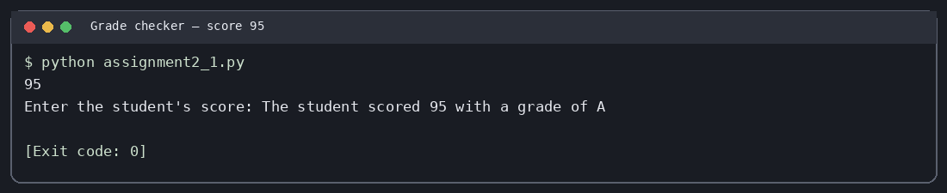
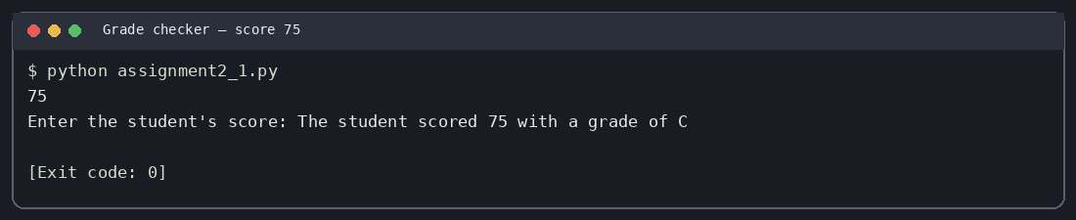

2. Student Grades — assignment2_2.py
Uses a dictionary with Alice, Bob and Charlie. If the name exists, it updates the grade; otherwise it adds a new student. It then iterates through .items() and prints all entries. Changes are not persisted after the program exits.
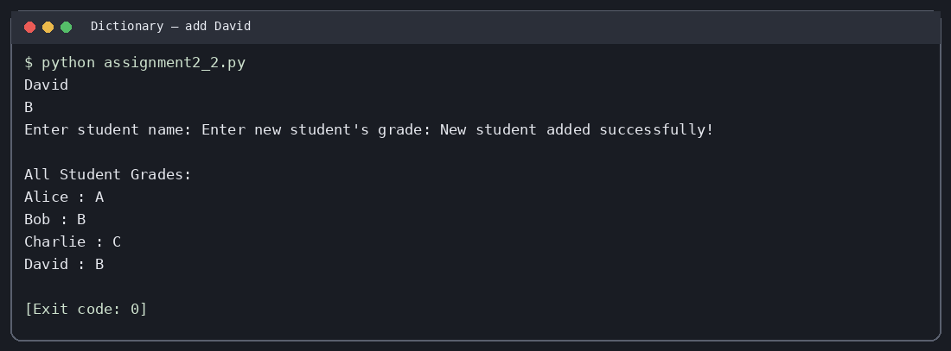
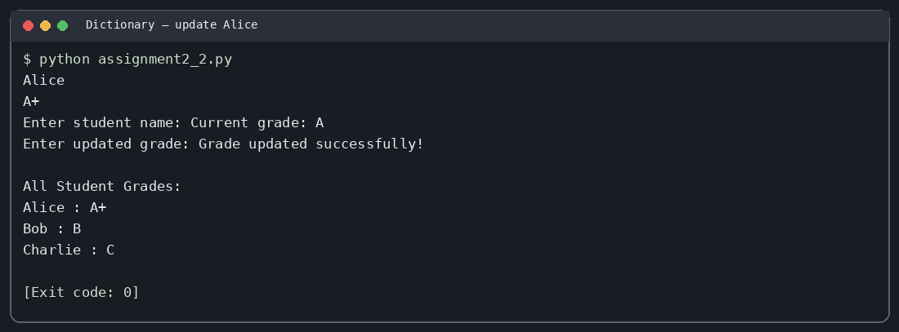

3. Write to a File — assignment2_3.py
Opens student.txt in write mode, prompts for content, writes the supplied text, and then writes a newline and the fixed sentence. Write mode overwrites the existing file. The program ran successfully in testing.
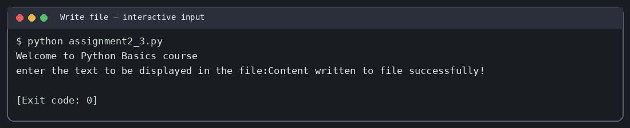

4. Read from a File — assignment2_4.py
This reader script was missing from the uploaded set, so it has been added. It opens student.txt in read mode, calls file.read(), and displays the complete content. Run the writer first if you want to regenerate the file.
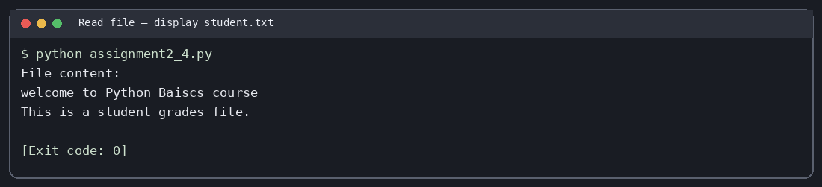

Run commands
- python assignment2_1.py
- python assignment2_2.py
- python assignment2_3.py
- python assignment2_4.py
Run from inside the project folder. Use python3 instead of python if that is the command available on your system.

Execution test summary
Grade checker — score 95: exit code 0.
Grade checker — score 75: exit code 0.
Dictionary — add David: exit code 0.
Dictionary — update Alice: exit code 0.
Write file — interactive input: exit code 0.
Read file — display student.txt: exit code 0.
The included screenshots are generated terminal-style captures of actual local process output; they are not photographs of a physical terminal.

GitHub repository
Repository URL: ADD_YOUR_GITHUB_REPOSITORY_URL_HERE
Replace the placeholder with the actual GitHub repository URL after you create/push the repository.

Final submission checklist
- All four task scripts are included.
- student.txt is included.
- Documentation and screenshots are included.
- Replace YourName in the folder and ZIP names.
- Replace the GitHub placeholder with the real repository URL.

