Flask & MongoDB — DevOps Assignment
JSON API • Flask form • MongoDB Atlas
Student: Chanderdeep Singh Sandhu

Project overview
This project implements both assignment tasks in a single Flask application. GET /api reads the JSON list from backend_data.json and returns it as JSON. The frontend form submits a name, email, and optional message to MongoDB Atlas. A successful insert redirects to /success. Validation and database/configuration errors are shown on the original form page.

Included files
- app.py — API endpoint, form validation, MongoDB insert, and success/error response logic.
- backend_data.json — sample JSON list used by GET /api.
- templates/index.html and templates/success.html — frontend form and success page.
- static/styles.css and static/app.js — reused styling from the supplied project, with corrected redirect/error behavior.
- requirements.txt, .env.example, .gitignore — dependencies and safe configuration handling.
- tests/test_app.py, preflight_check.py, and test_results.txt — unit tests, dependency-free checks, and verification notes.
- screenshots/ — terminal-style captures of actual local preflight and JSON data command output.

Security adjustment
The supplied version collected and stored passwords as plaintext. This project removes the password field because authentication is not required by the assignment. It does not package a real .env or database credentials. If a real Atlas password was shared in an earlier file or committed to GitHub, rotate it before publishing.

Task 1 — JSON API route
GET /api reads backend_data.json beside app.py, parses it using json.load(), checks that the top-level value is a list, and returns it through Flask jsonify(). If the data file is missing, invalid, or unreadable, the route returns a JSON error response instead of exposing an unhandled exception.
Run the application with python app.py, then open http://127.0.0.1:5000/api.
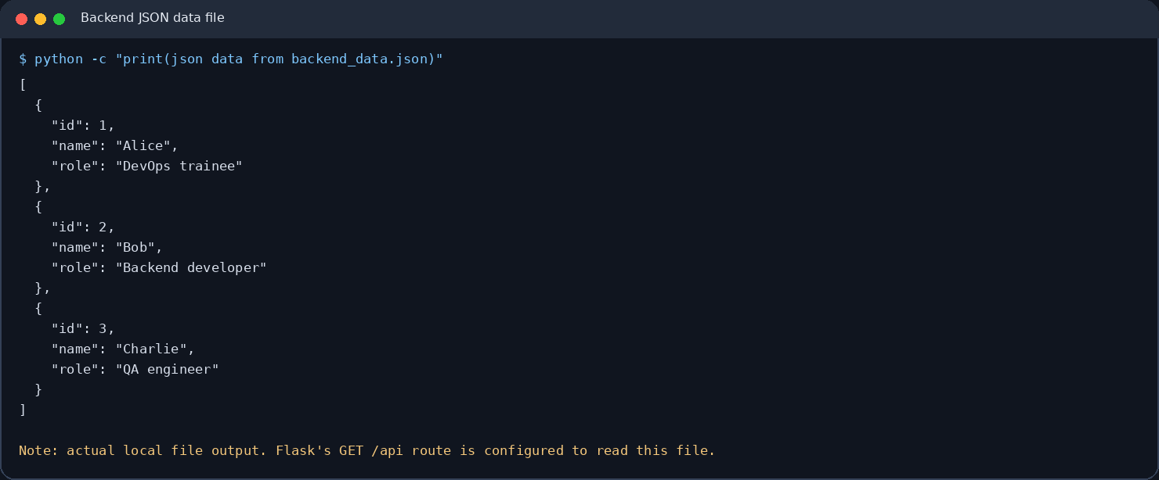
Figure 1. Actual local command output from reading the JSON data file used by the /api route.

Task 2 — Frontend form and MongoDB Atlas
The homepage contains fields for name, email, and an optional message. POST /submit validates required fields and basic email format, adds a UTC timestamp, and inserts the submission into the configured MongoDB database/collection.
Success: a normal form request receives HTTP 303 to /success. The success page displays the exact required message “Data submitted successfully”. When JavaScript is available, the endpoint returns a redirect URL and the frontend navigates there.
Error: validation errors remain on the form with an explanatory message. Missing Atlas configuration or a PyMongo error also remains on the same form page; AJAX requests receive JSON errors that the frontend displays inline. These paths do not redirect.
The included unit tests mock database insertion for success and failure-path checks. They do not write to a live Atlas cluster.

Setup and run commands
Run these commands in Windows PowerShell from the project folder:
py -m venv .venv
.\.venv\Scripts\Activate.ps1
python -m pip install -r requirements.txt
Copy-Item .env.example .env
python app.py
Edit .env and supply your own MONGO_URI. In MongoDB Atlas, ensure the database user exists and the current public IP is allowed by Network Access. Keep .env private and never commit it.
Open http://127.0.0.1:5000/ for the form and http://127.0.0.1:5000/api for the JSON array.

Verification
Run python preflight_check.py for dependency-free source/configuration checks. During package preparation, all 13 checks passed. Then run python -m unittest discover -s tests -v after installing dependencies.
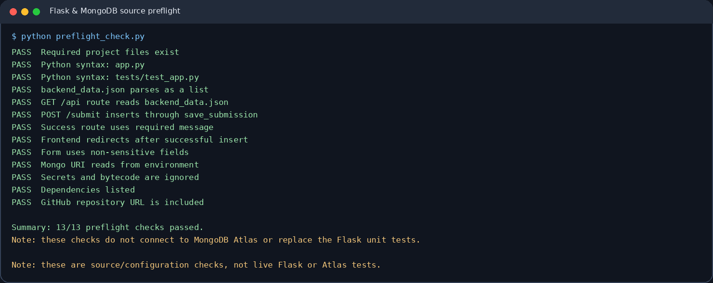
Figure 2. Captured output of python preflight_check.py showing 13/13 source/configuration checks passing.

Verification limitations and final checklist
Flask and PyMongo could not be installed in the artifact-preparation environment because package repository access was unavailable. Therefore, the Flask test-client suite was not executed here. No live MongoDB Atlas insertion was performed because a valid Atlas URI was not supplied. The package does not claim those tests passed.
- Install requirements.txt and configure your own .env.
- Open /api and confirm it returns a JSON array sourced from backend_data.json.
- Submit valid form data and confirm redirect to /success with “Data submitted successfully”.
- Test missing/invalid fields and a failed Atlas connection; confirm errors remain on the form page.
- Capture genuine browser/terminal screenshots of the live success and error paths after testing against Atlas.

GitHub repository
Repository URL: https://github.com/Chanderdeep22/PythonFlask
This URL was supplied by the student and is included in this document and README. The remote repository has not been verified as updated with this final package; ensure the final files and screenshots are pushed before submission.

Package status
The ZIP contains application source, JSON backend data, templates, static assets, tests, requirements, configuration example, screenshots, README, and this documentation. It excludes actual .env secrets and Python bytecode.

