参考 Junran Peng - Homepage

- 简要信息


Hanying Zou
邹瀚影
Lecturer

Beijing, China
USTB
Email hyzou@ustb.edu.cn

- About Me

I am currently a lecturer in the School of Energy and Environmental Engineering, University of Science and Technology Beijing. I obtained my B.E and Ph.D degrees from USTB, under the supervision of Prof. Yanhui Feng and Prof. Lin Qiu. My research interests focus on heat transfer mechanisms in materials, include thermal simulation of nanoscale, thermal design of carbon materials and AI for materials.

- Join Us

If you are interested in our projects on heat transfer mechanisms in materials, please feel free to contact me for potential collaboration or exchange. You can reach out via email.

- News
2025.10: One paper accepted by Chemical Engineering Journal
2025.10: Oral for the 14th Asian Thermophysical Properties Conference (ATPC)

- Selected Publications

Interfacial heat conduction enhancement mechanism between CNTs encapsulated with LCC [paper]
Hanying Zou, Yanhui Feng, Lin Qiu
Chemical Engineering Journal
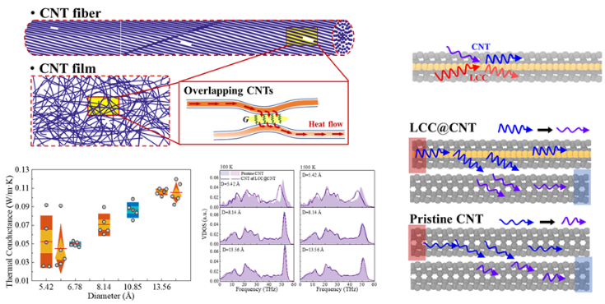

Interfacial thermal conduction mechanism of polypyrrole/carbon nanotube composites [paper]
Hanying Zou, Yanhui Feng, Xiaolong Tang, Xinxin Zhang, Lin Qiu
Composites Science and Technology
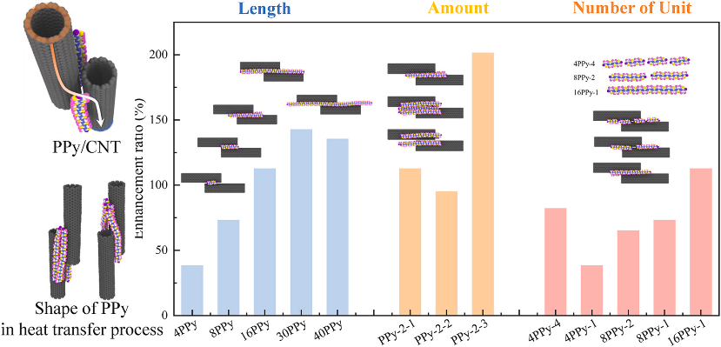

Extraordinary thermal conductivity for carbon nanotube encapsulated linear carbon chain [paper]
Hanying Zou, Yanhui Feng, Xiaolong Tang, Xinxin Zhang, Lin Qiu
International Journal of Heat and Mass Transfer
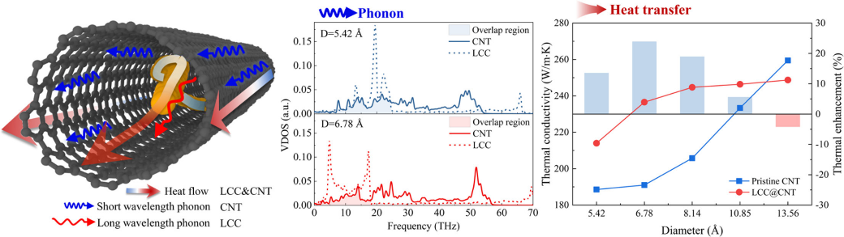

Enhancing mechanism of CNT-CNT interface by metal nanoparticle and nanowire effect on the inside and outside of CNT [paper]
Hanying Zou, Yanhui Feng, Xinxin Zhang, Taku Ohara, Lin Qiu
International Journal of Thermal Sciences
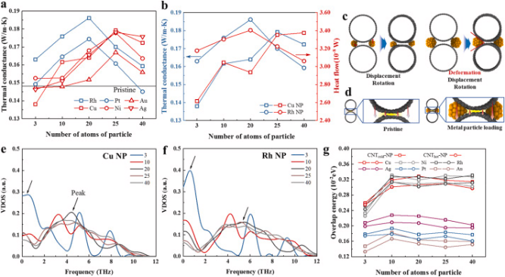

Polypyrrole coated carbon nanotube aerogel composite phase change materials with enhanced thermal conductivity, high solar-/electro-thermal energy conversion and storage [paper]
Zhang Tao, Hanying Zou, Min Li, Shibing Ren, Jianhang Xu, Jing Lin, Mu Yang, Yanhui Feng, Ge Wang
Journal of Colloid and Interface Science

Excellent heat transfer enhancement of CNT-metal interface by loading carbyne and metal nanowire into CNT [paper]
Hanying Zou, Yanhui Feng, Lin Qiu
International Journal of Heat and Mass Transfer
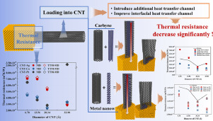

Thermal conductance control of non-bonded interaction between loaded halogen molecules and carbon nanotubes: A molecular dynamics study [paper]
Hanying Zou, Yanhui Feng, Lin Qiu, Xinxin Zhang
International Journal of Heat and Mass Transfer

