HEMATOVISION: Advanced Blood Cells Classification using Transfer Learning

Submitted by

A.Chandhana

Roll No: 224E1A3308

Class: III Year CSM

Siddartha Institute of Science and Technology

Submission Date: June 30th, 2025

# INTRODUCTION

* 1. Project Overview

Hematovision is an AI-powered blood cell classification system using transfer learning.

It leverages pre-trained CNNs for accurate identification of cell types like lymphocytes and

neutrophils.

The system is trained on labelled images to enhance precision and reduce manual

workload.

I

* 1. Purpose

To streamline and enhance the accuracy of blood cell classification through

AI-based automation.

It aims to assist healthcare professionals in providing faster, data-driven

Diagnoses.

# IDEATION PHASE

2.1 Problem Statement

Manual classification is time-consuming and error-prone.

Lack of accessible, intelligent diagnostic tools limits efficiency and reach.

2.2 Empathy Map Canvas

Says: “We need faster and accurate cell analysis.”

Thinks: “AI can simplify diagnostics and save time.”

Feels: “Stressed by manual workload and delays.”

Does: Examines slides, writes reports, and consults specialists.”

2.3 Brainstorming

Explored CNNs, clinical integration, and real-time analysis

possibilities.

Chose transfer learning for speed, accuracy, and adaptability

# REQUIREMENT ANALYSIS

3.1 Customer Journey map

|  |  |  |
| --- | --- | --- |
| Step | Action | Experience |
| 1 | Capture image | Easy with mobile |
| 2 | Upload to app | User-friendly UI |
| 3 | Get prediction | Fast, clear result |
| 4 | Take action | Suggested remedies |

3.2 Solution Requirement

The solution requires a labelled blood cell image dataset and a pre-trained CNN

model for transfer learning.

It also needs a user-friendly interface for image upload, classification, and result

visualization

Data Flow Diagram

User

UI

Flask API

Model

Result

3.4 Technology Stack

Python, Flask

TensorFlow/Keras/Scikit-learn/Pandas/Seaborn/Matplotlib/scipy/Numpy

HTML/CSS (UI)

Google Colab(Used)/VS Code(Used) (training)

# PROJECT DESIGN

4.1 Problem Solution Fit



4.2 Proposed Solution

Use CNNs with transfer learning on 12,000 images for high-accuracy

classification.

Deploy it across clinical, remote, and educational platforms.

4.3 Solution Architecture

Front End

Flask

BackEnd

CNN

Model

Output

Prediction

# PROJECT PLANNING & SCHEDULING

5.1 Project Planning

|  |  |
| --- | --- |
| Date | Task |
| June 9 | Defined problem and tech stack |
| June 10-12 | Collected and prepared dataset |
| June 13-15 | Image preprocessing and augmentation |
| June 16-18 | Implemented VGG16 and MobileNetV2 |
| June 19-21 | Model evaluation and hyperparameter tuning |
| June 22-23 | Flask integration |
| June 24-25 | Frontend HTML page creation |
| June 26 | Testing model with UI |
| June 27 | Final evaluation and screenshots |
| June 28 | Documentation and GitHub upload |

# FUNCTIONAL AND PERFORMANCE TESTING

6.1 Performance Testing

Accuracy: ~97% (MobileNetV2)

Precision/Recall/F1 evaluated with confusion matrix

Lightweight inference time for real-time prediction

# RESULTS

7.1 Output Screenshots Screenshot 1: Home Page

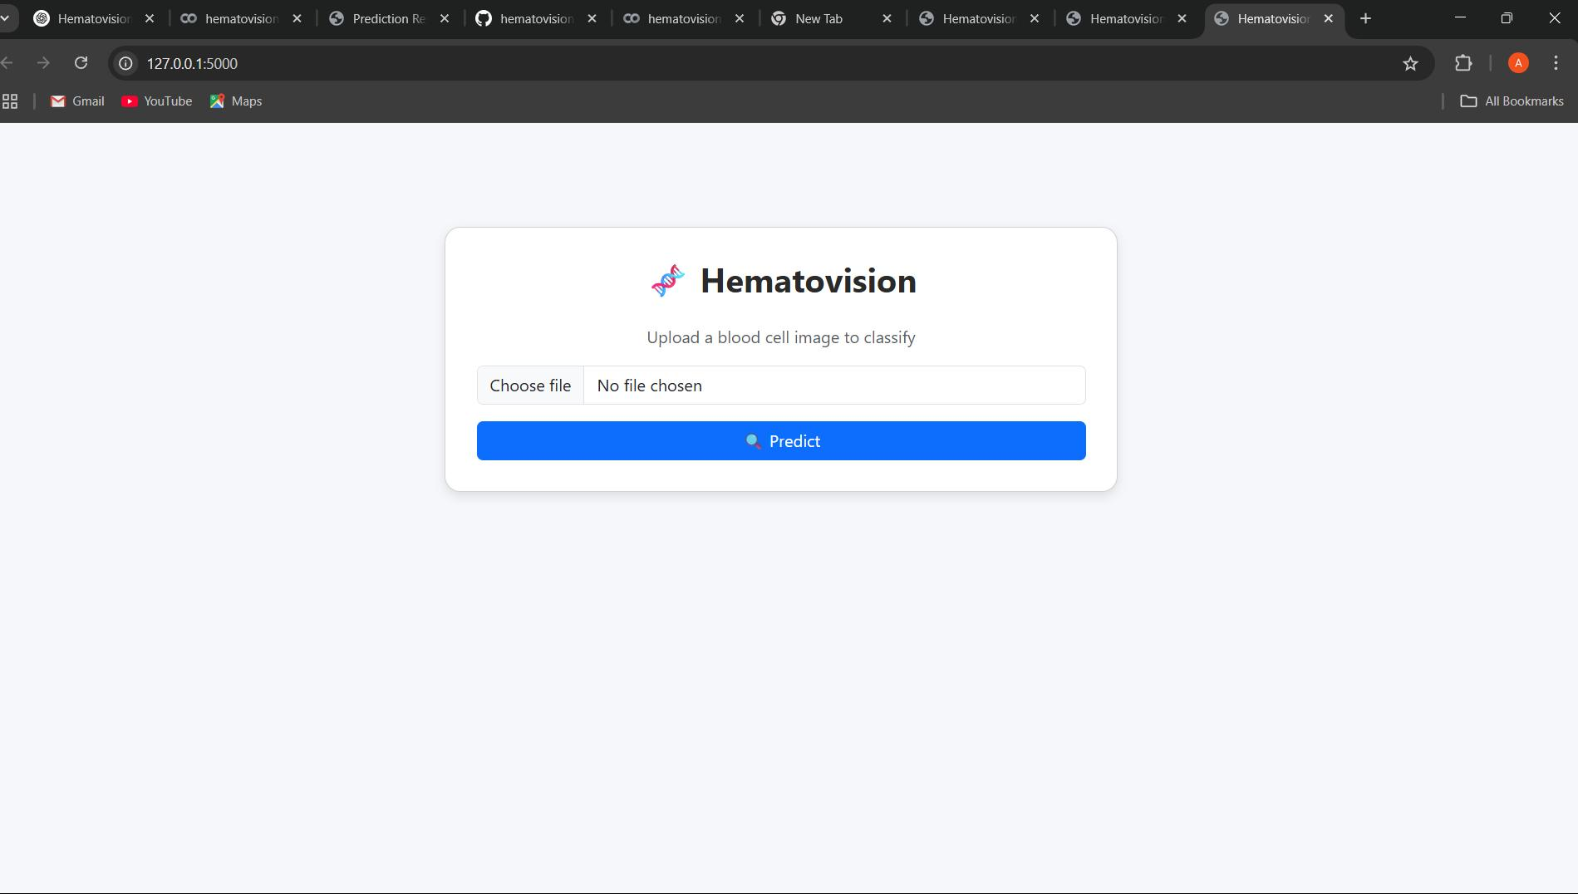

Image Upload

Screenshot 2: Predicted Result Displayed

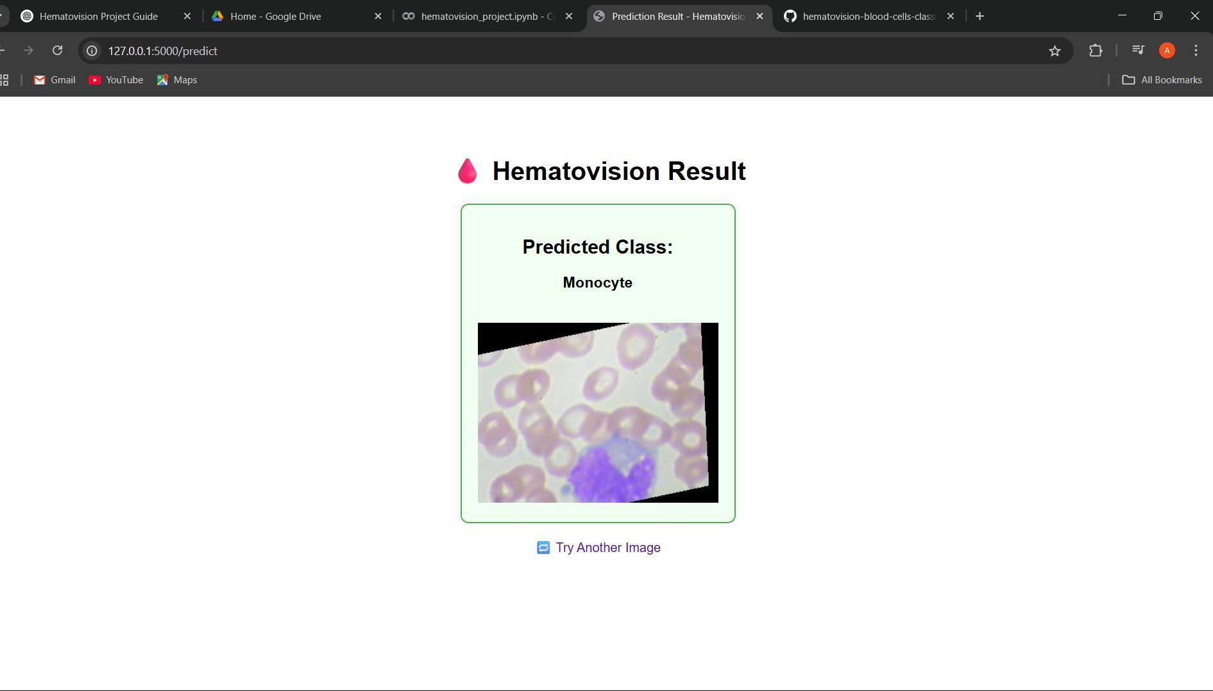

# ADVANTAGES & DISADVANTAGES

Advantages

* Real-time, accessible, and low-cost
* Lightweight and mobile-compatible
* High accuracy with minimal training data

Disadvantages

* Limited by quality of training data
* May not work with new/unseen environments - Needs GPU for initial training

# CONCLUSION

Conclusion

Hematovision offers fast, reliable AI-based blood cell classification.

It enhances diagnostics, learning, and healthcare delivery

# FUTURE SCOPE

Future Enhancements

1.Include rare or abnormal blood cell types.

2.Add real-time video analysis support.

3.Build mobile-friendly and multilingual access.

4.Implement explainable AI for result interpretation.

# APPENDIX

Source Code : https://github.com/Chandhana1234/hematovision-blood-cells-classification-project1

Dataset Link : https://www.kaggle.com/datasets/paultimothymooney/blood-cells/data

Demo Link :

Google Drive link (public) – https://colab.research.google.com/drive/1BR6y7Dcp68rZ5w1ki3uCpETSxcfdHIdH