Tasks Detail:

Task 1: System Monitoring Setup

Objective: Configure a monitoring system to ensure the development environment’s health, performance, and capacity planning.

Scenario:
- The development server is reporting intermittent performance issues.
- New developers need visibility into system resource usage for their tasks.
- System metrics must be consistently tracked for effective capacity planning.

Requirements:
- Install and configure monitoring tools (htop or nmon) to monitor CPU, memory, and process usage.
- Set up disk usage monitoring to track storage availability using df and du.
- Implement process monitoring to identify resource-intensive applications.
- Create a basic reporting structure (e.g., save outputs to a log file for review).

First updating my Ubuntu machine by using command sudo apt update
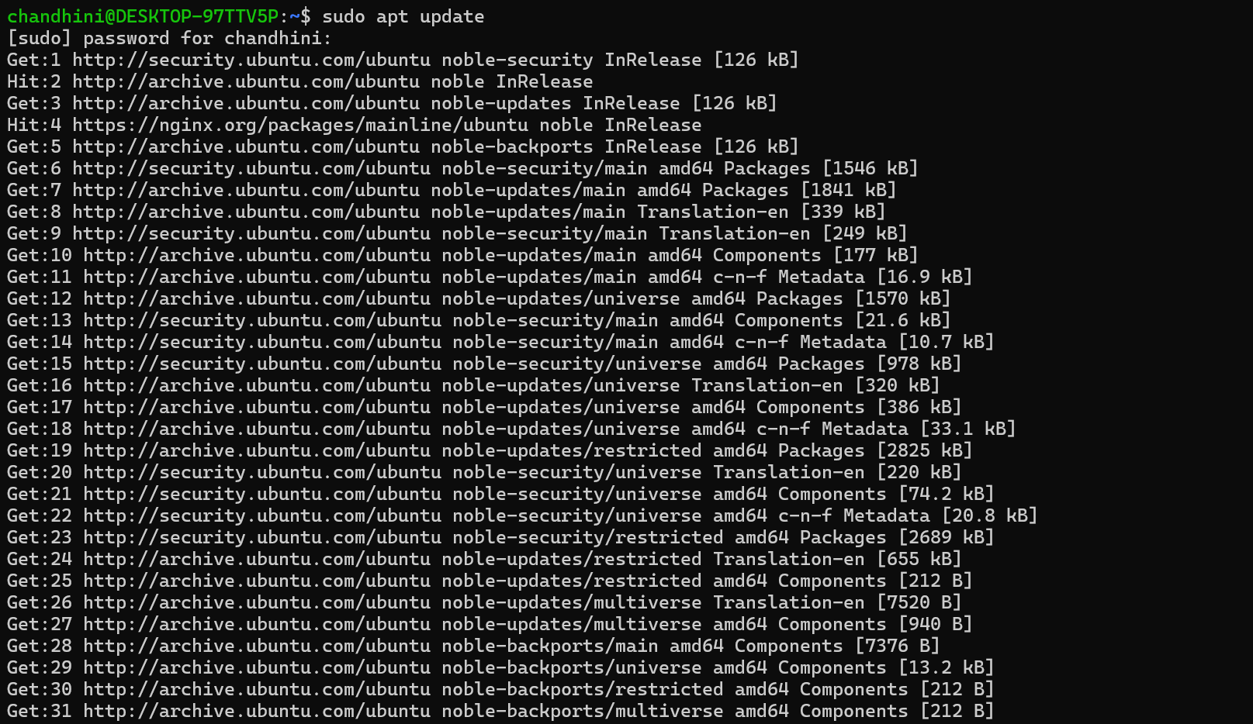
Install htop or nmon (It’s a monitoring tool)
htop → interactive, user-friendly process viewer
nmon → detailed performance monitoring for advanced usage
Command used : sudo apt install htop –y
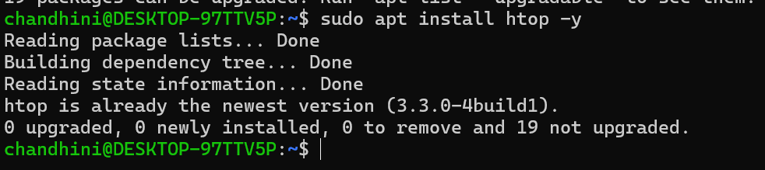

After typing htop
We get list of all the process which is running and exhibit cpu%,memory% and process Id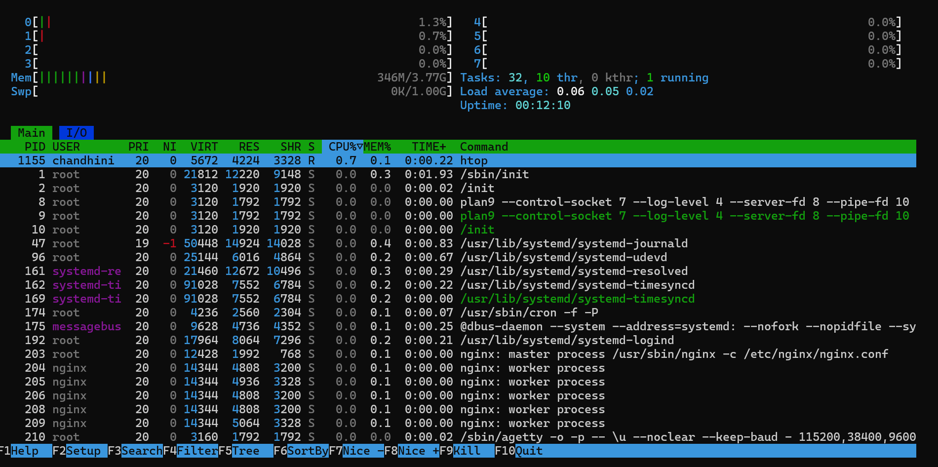
Press F10 to quit from displaying or Ctrl+C
To Verify the overall size of the disk in human readable format use
df -h = shows used/free disk space
df –h
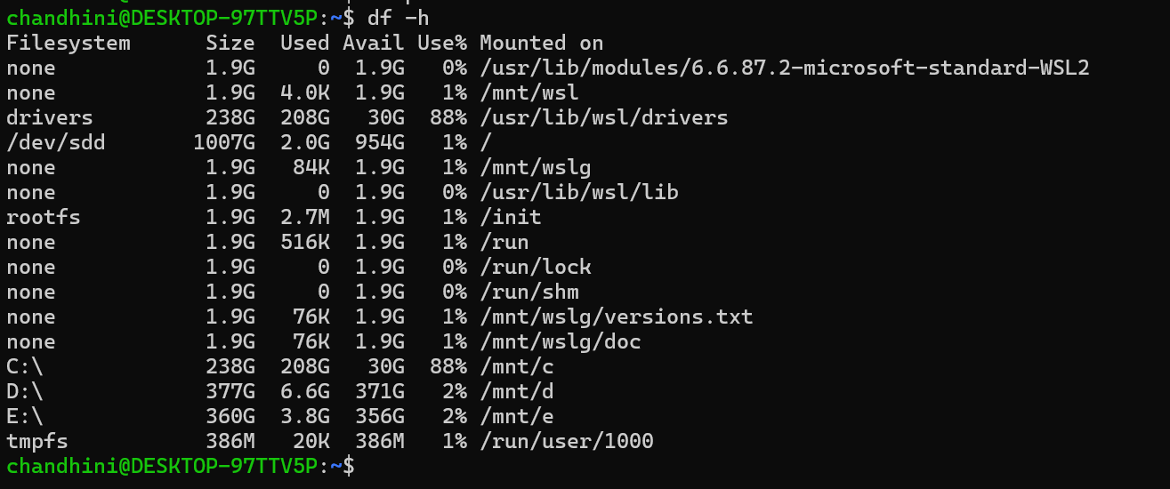
Top Command will list all the process
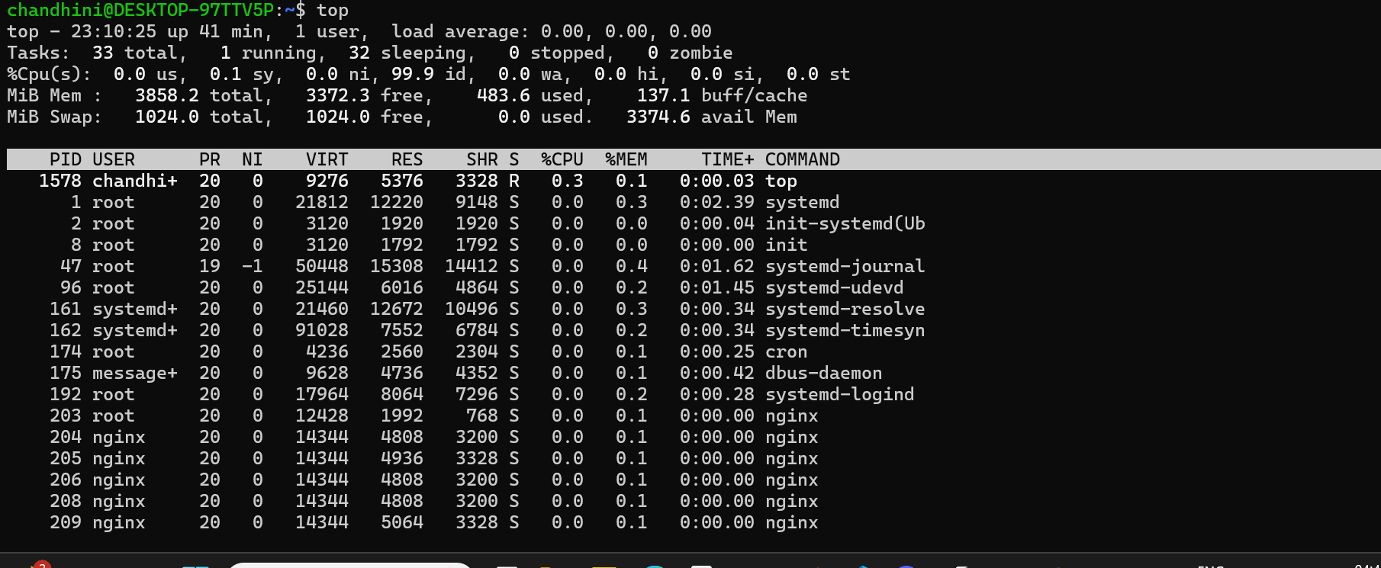
But to identify resource intensive process use below command
ps aux --sort=-%cpu | head -10
psdisplay current running process
aux:
aShows process for all users
u gives detailed information of various metrics such as %CPU,%mem
x Includes processes not attached to a terminal (like daemons)
sort:
sort sorts the list in either ascending or descending ord(er
-(minus symbol) Gives results in descending order
-%cpugives result of CPU in order specified
head -10 gives top 10 CPU consuming processes
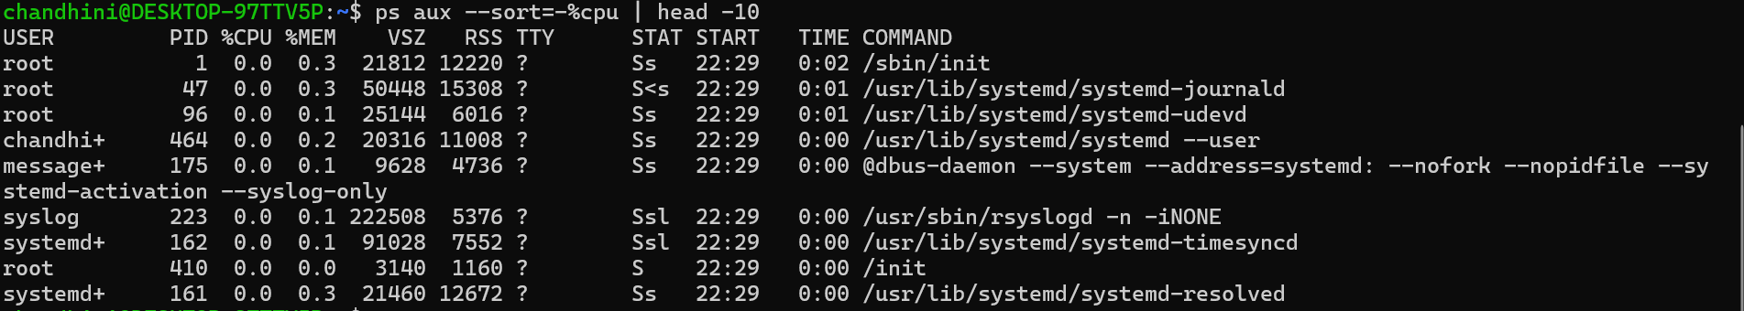

Creating a monitoring code
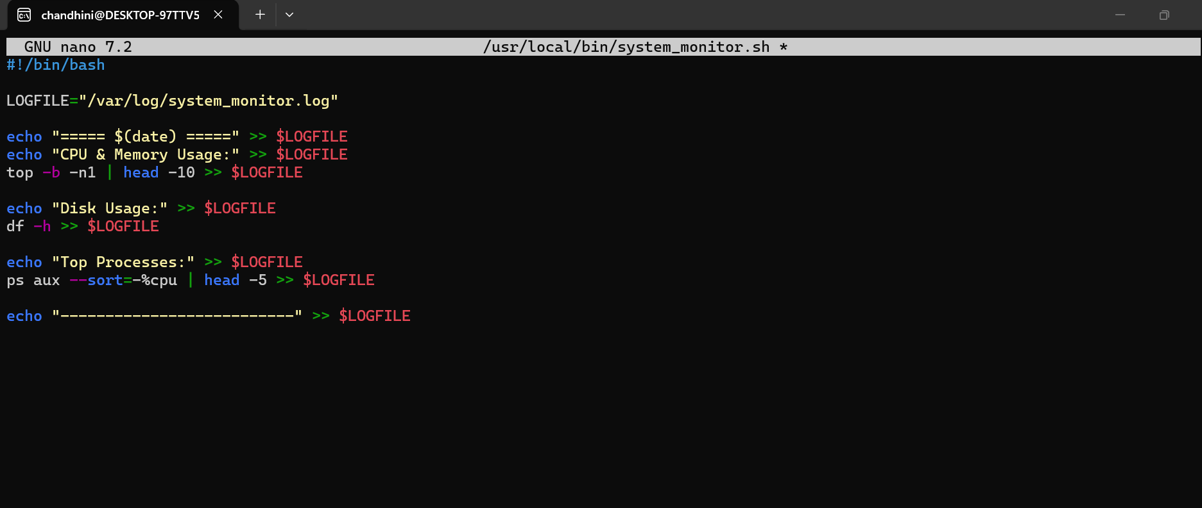

To make it executable use command chmod + x <path>
Automating logging with cron which runs every 10 minutes
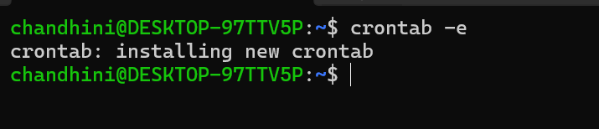

• */10 in the minutes field → Every 10 minutes (i.e., 0, 10, 20, 30, 40, 50).
- * in the hours field → Every hour.
- * in the day-of-month field → Every day of the month.
- * in the month field → Every month.
- * in the day-of-week field → Every day of the week.
What It Does
- Runs the script located at /usr/local/bin/system_monitor.sh.
For more info we can check : Crontab.guru - The cron schedule expression generator
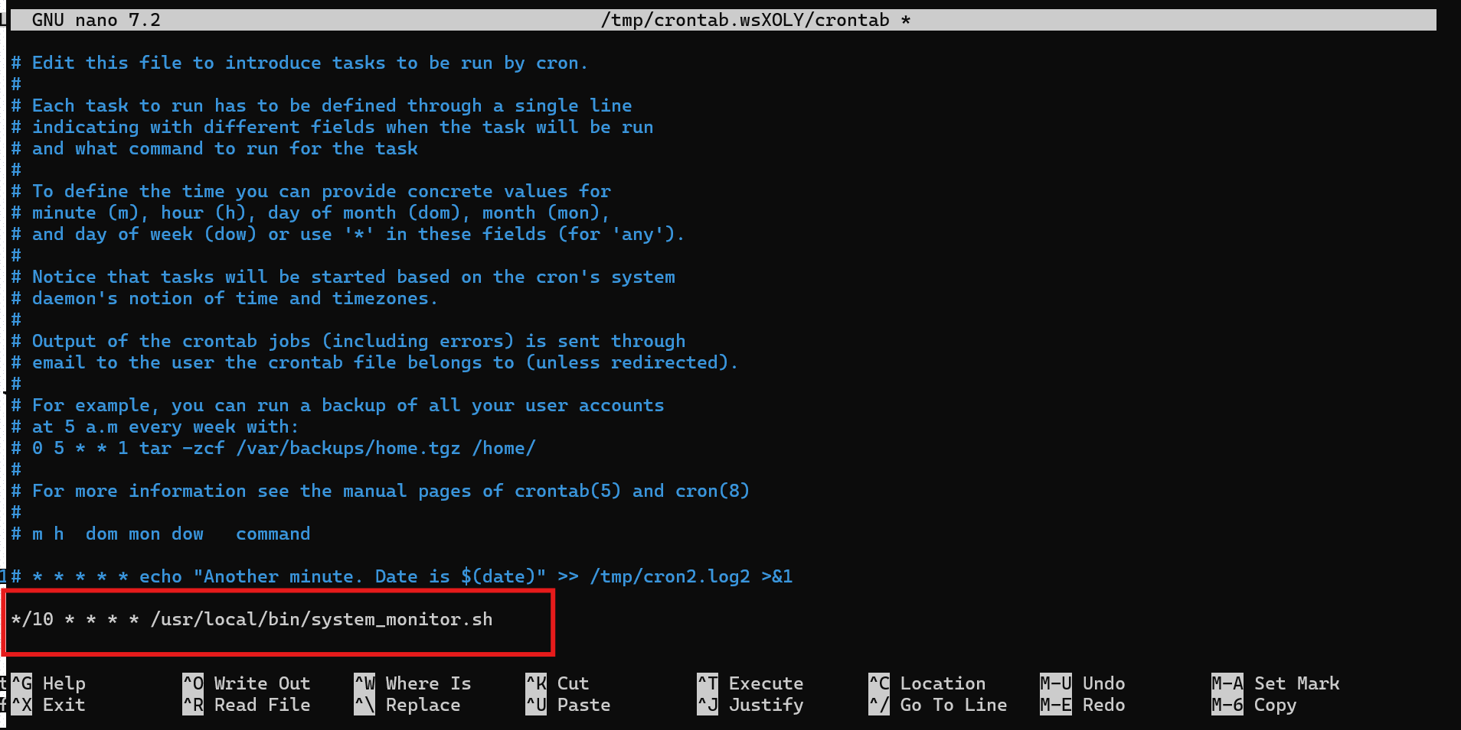
To list all the crontab , use crontab –l
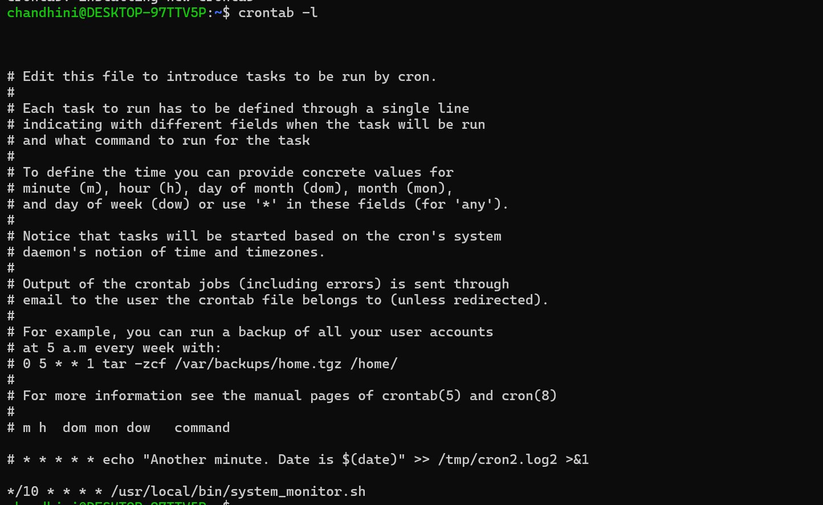
To check status of cron use command systemctl status cron
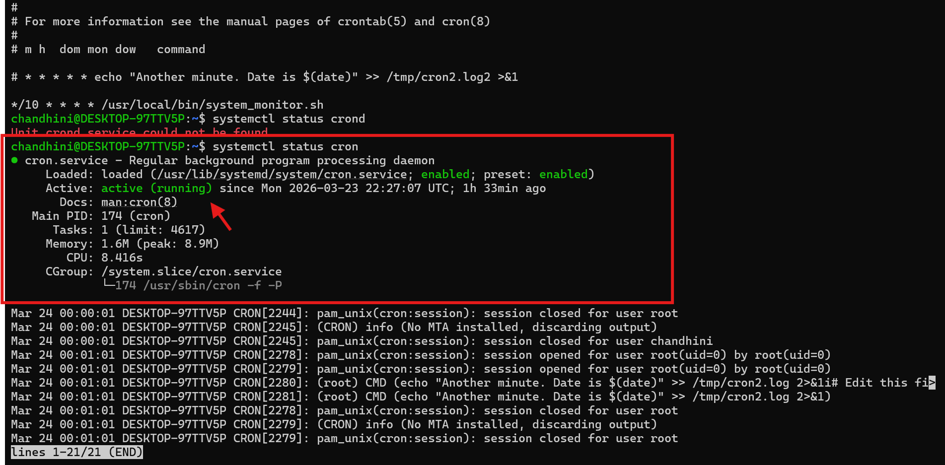
To check the logs
use command grep system_monitor.sh /var/log/syslog
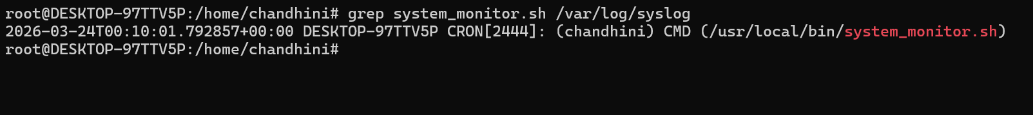
To verify if this has run based on the logic
Command : tail –f /var/log/syslog
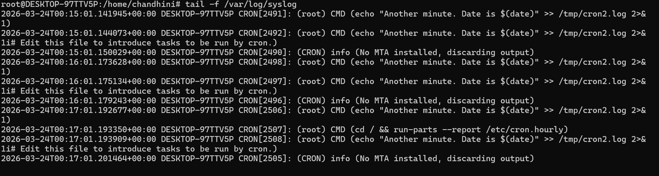
By giving command : cat system_monitor.log
We get below output where it contains system metrics and which helps in performance analysis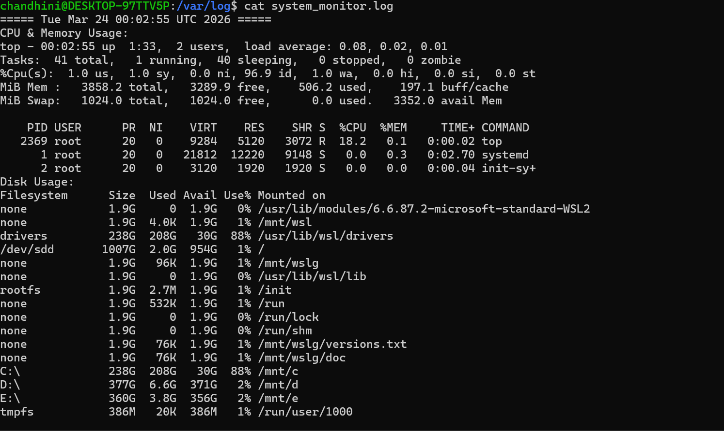
Task 2: User Management and Access Control
Objective: Set up user accounts and configure secure access controls for the new developers.

Scenario:
- Two new developers, Sarah and Mike, require system access.
- Each developer needs an isolated working directory to maintain security and confidentiality.
- Security policies must ensure proper password management and access restrictions.
Requirements:

Create user accounts for Sarah and Mike with secure passwords
- Set up dedicated directories:
- Sarah: /home/Sarah/workspace
- Mike: /home/mike/workspace
- Ensure only the respective users can access their directories using appropriate permissions.
- Implement a password policy to enforce expiration and complexity (e.g., passwords expire every 30 days).

Solution:
Step 1: Create User Accounts
Create accounts for Sarah and Mike:
Using below command
sudo useradd -m -s /bin/bash Sarah
sudo useradd -m -s /bin/bash mike
Where :
-m → creates home directory (/home/Sarah, /home/mike)
-s /bin/bash → assigns bash shell
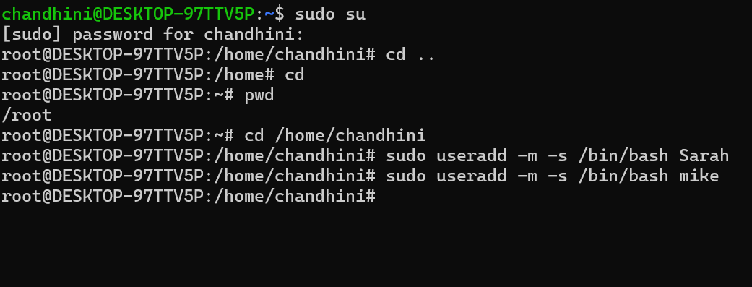
to check whether user added use command ll in home directorly
ll -> this list all folder ,user

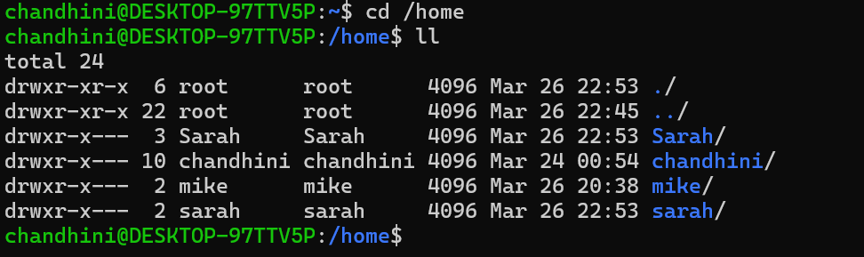
Create password for the user
sudo passwd Sarah
Sudo passwd mike 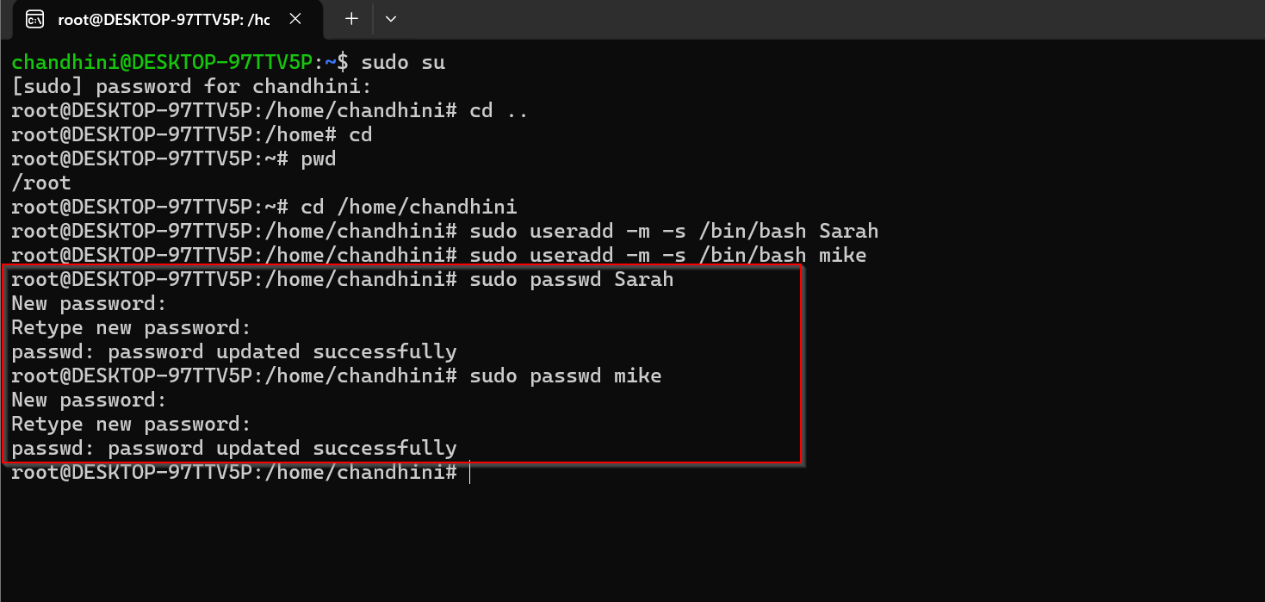
Create Isolated Directories
Tried to create folder inside Sara ,since sara is not in sudoers list couldn’t create , so as a next step moved to another sudo user and from there created folder
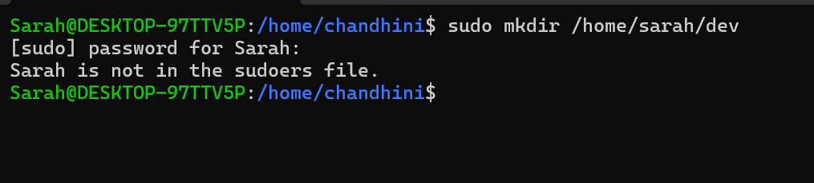
Switched to my root user and used below commands to create a folder
sudo mkdir /home/sarah/dev
sudo mkdir /home/mike/dev
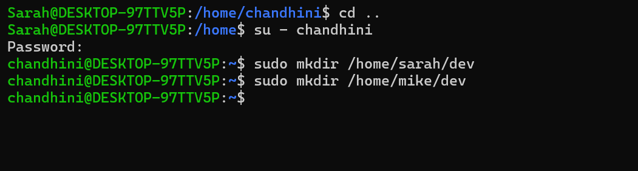
Assigning Ownership:
sudo chown sarah:sarah /home/sarah/dev
sudo chown mike:mike /home/mike/dev
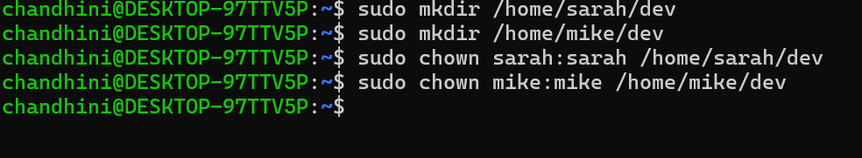
Set permissions:
Sudo chmod 700 /home/sarah/dev
sudo chmod 700 /home/mike/dev
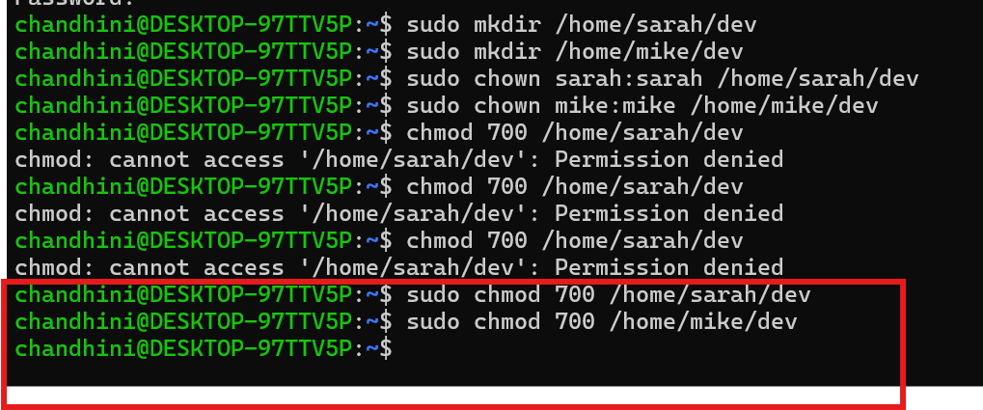
Enforce Password Policy:
Commands used : sudo nano /etc/login.defs
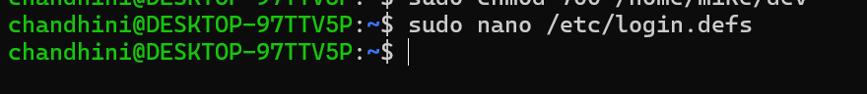

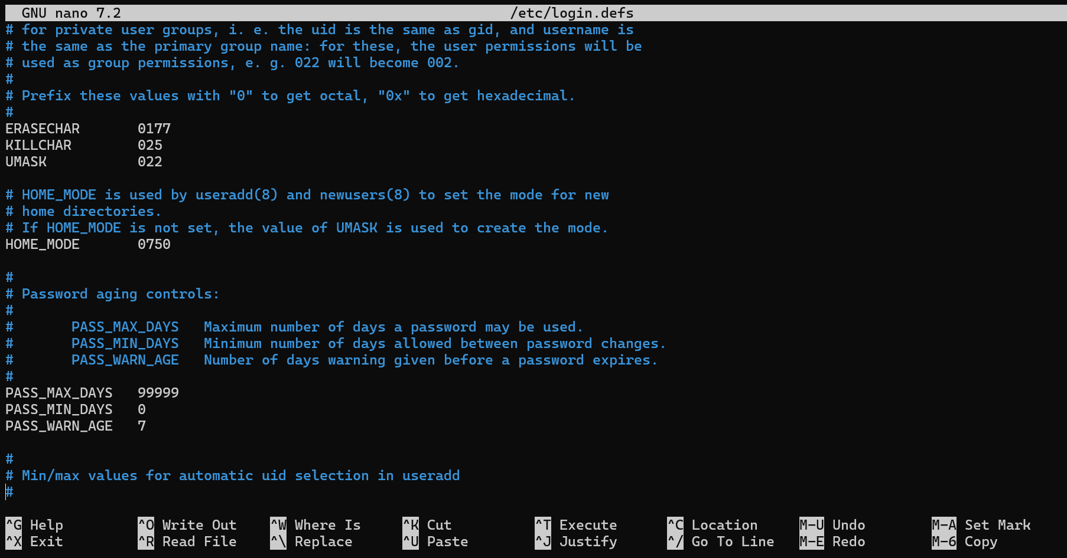
Changed the password policy :
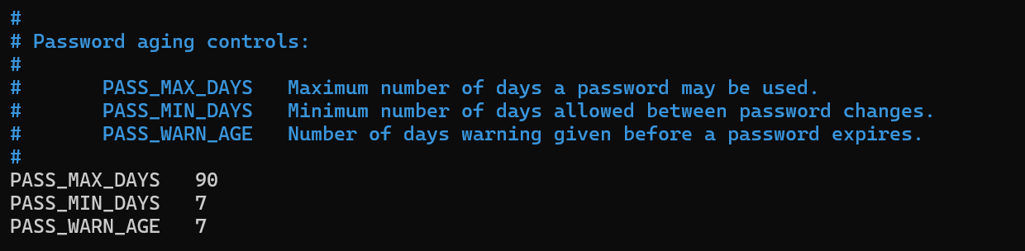
Password Complexity:
Install:
sudo apt install libpam-pwquality -y 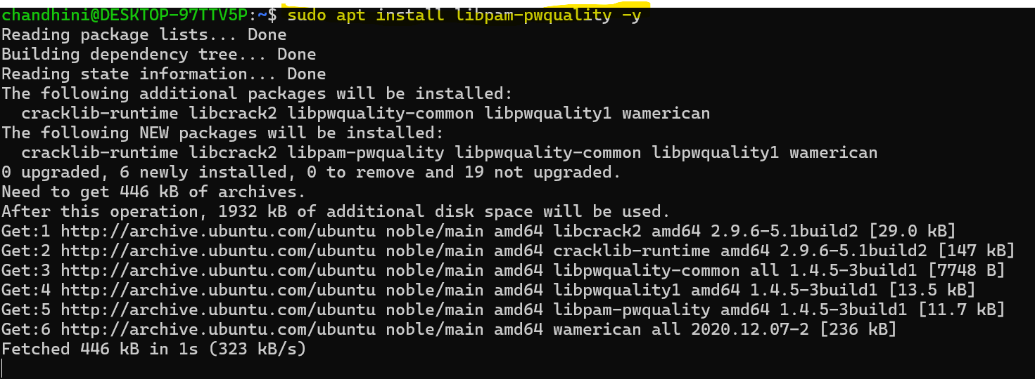
Edit:
sudo nano /etc/pam.d/common-password 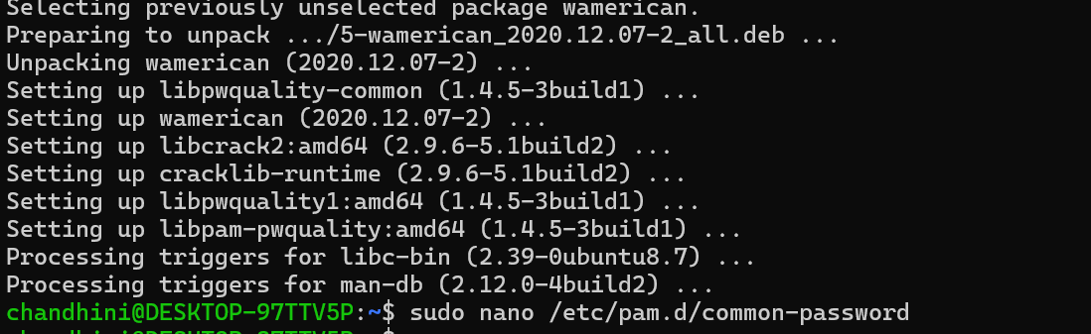

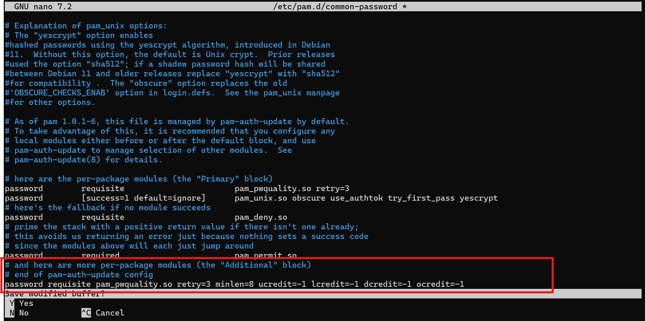

Task 3: Backup Configuration for Web Servers
Create Backup Script:
sudo nano /usr/local/bin/backup.sh
Enter the below code:
#!/bin/bash
DATE=$(date +%Y-%m-%d)
BACKUP_DIR="/backup"
mkdir -p $BACKUP_DIR
# Apache backup
tar -czvf $BACKUP_DIR/apache_backup_$DATE.tar.gz /etc/httpd/ /var/www/html
# Nginx backup
tar -czvf $BACKUP_DIR/nginx_backup_$DATE.tar.gz /etc/nginx/ /usr/share/nginx/html/
# Log
echo "Backup completed on $DATE" >> /var/log/backup.log
Make Script Executable:
sudo chmod +x /usr/local/bin/backup.sh

Use crontab –e to create a cron jo which takes backup every Tuesday at 12 am
0 0 * * 2 /usr/local/bin/backup.sh
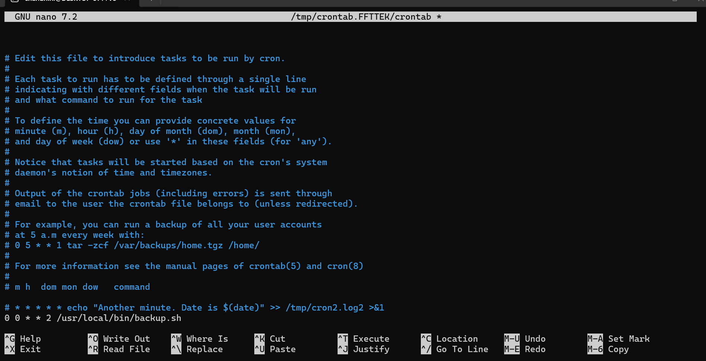
To check whether backup file is present or not use command - ll
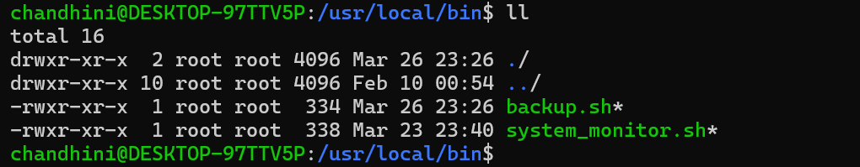

To run script manually
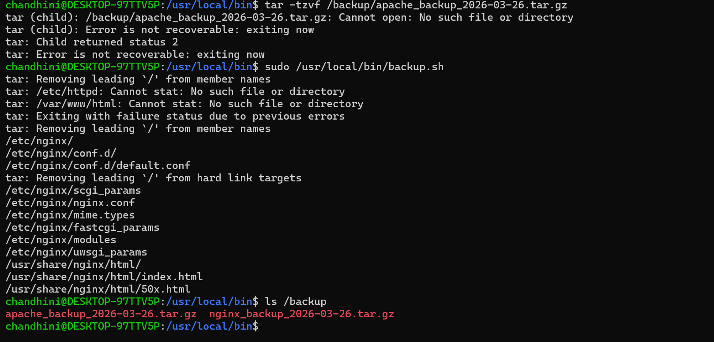

Verify Script is Working
Check log: cat /var/log/backup.log
