Travelmemory Question:
provide me solution and step by step explantion for below assignment
Description
Introduction:
The Travel Memory application has been developed using the MERN stack. Your challenge is to deploy this application on an Amazon EC2 instance. This will provide you with hands-on experience in deploying full-stack applications, working with cloud platforms, and ensuring scalable architecture.
Project Repository:
Access the complete codebase of the TravelMemory application from the provided GitHub link: https://github.com/UnpredictablePrashant/TravelMemory
Objective:
- Set up the backend running on Node.js.
- Configure the front end designed with React.
- Ensure efficient communication between the front end and back end.
- Deploy the full application on an EC2 instance.
- Facilitate load balancing by creating multiple instances of the application.
- Connect a custom domain through Cloudflare.
Tasks:
- Backend Configuration:
- Clone the repository and navigate to the backend directory.
- The backend runs on port 3000. Set up a reverse proxy using nginx to ensure smooth deployment on EC2.
- Update the .env file to incorporate database connection details and port information.
- Frontend and Backend Connection:
- Navigate to the urls.js in the frontend directory.
- Update the file to ensure the front end communicates effectively with the backend.
- Scaling the Application:
- Create multiple instances of both the frontend and backend servers.
- Add these instances to a load balancer to ensure efficient distribution of incoming traffic.
- Domain Setup with Cloudflare:
- Connect your custom domain to the application using Cloudflare.
- Create a CNAME record pointing to the load balancer endpoint.
- Set up an A record with the IP address of the EC2 instance hosting the front end.
- Documentation:
- Prepare comprehensive documentation detailing each step of the deployment process. Include relevant screenshots to make the process clear and reproducible.
- Design a deployment architecture diagram using draw.io to visualize the flow and connections.
Expected Deliverables:
- A fully functional Travel Memory application hosted on an EC2 instance, accessible via a custom domain.
- Detailed documentation of the deployment process with appropriate screenshots.
- A deployment architecture diagram.
Evaluation Criteria:
- Accuracy and effectiveness of the deployment.
- Clarity and comprehensiveness of the documentation.
- Adherence to best practices in terms of security, scalability, and resilience.
Hints:
While setting up with Cloudflare, remember that a CNAME record is essential for linking the load balancer endpoint. An A record, on the other hand, connects the EC2 instance via its IP address.

Architecture Diagram:
✅ Quick Reference Summary
Component | Purpose | Key Tool
EC2 | Host the MERN app | AWS EC2
Nginx | Reverse proxy | nginx
PM2 | App process manager | pm2
Cloudflare | Domain + SSL | Cloudflare
Load Balancer | Handles scaling and redundancy | AWS ALB
MongoDB Atlas | Cloud DB | MongoDB Atlas

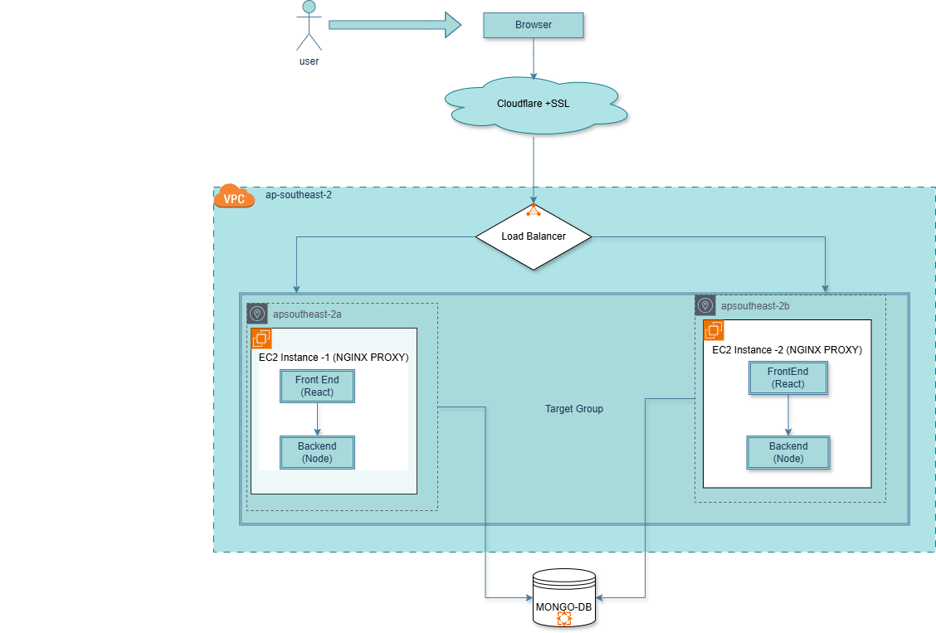

To start with Creation of an Ec2 instance
Succesfully launched an instance
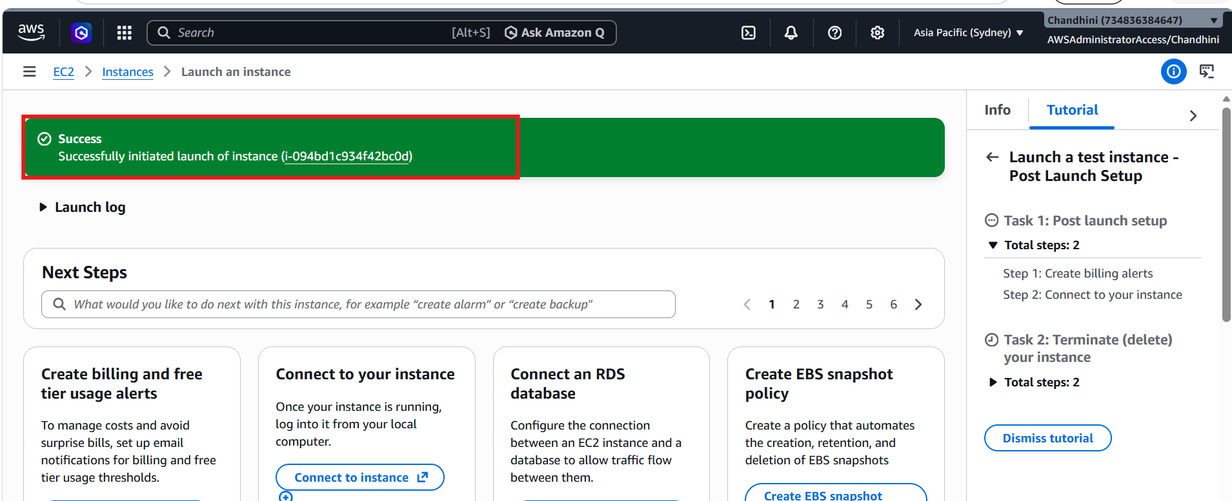

Conecting via putty: 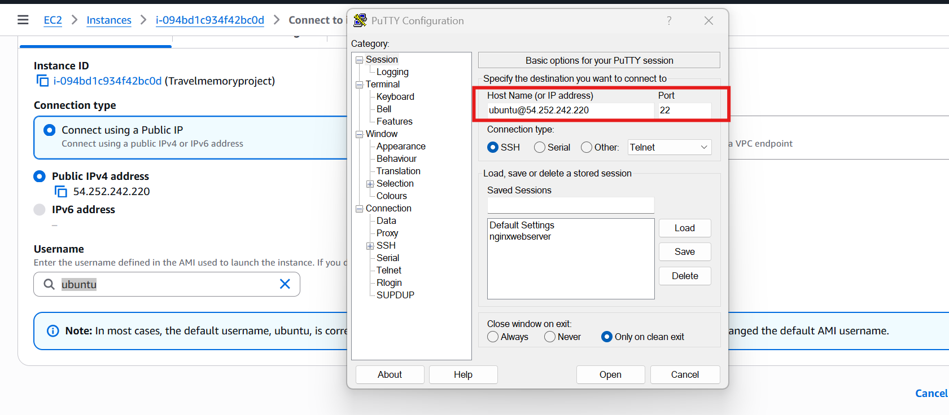
Succesfully connected via putty: 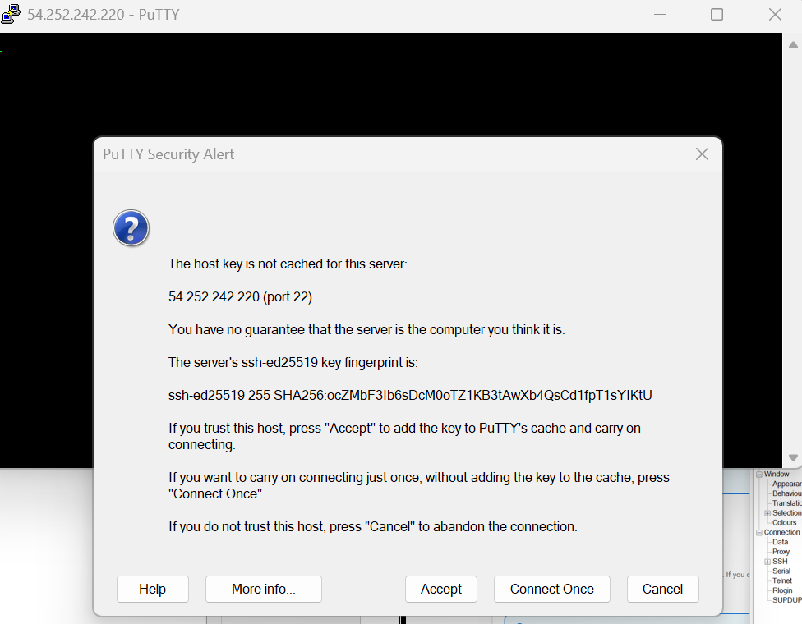

After logging into ec2 giving below command
sudo apt install -y git nginx curl
where sudo – gives admin privilege
apt install – used in ubuntu or debian to install packages
-y – automatically answer yes to installation prompts
Git – install git used for cloning and pulling code updates for this travel memory assignmen
Nginx – for making an ec2 instance in to a web server
Curl – used to downloading files,calling api’s and installing node.js scripts
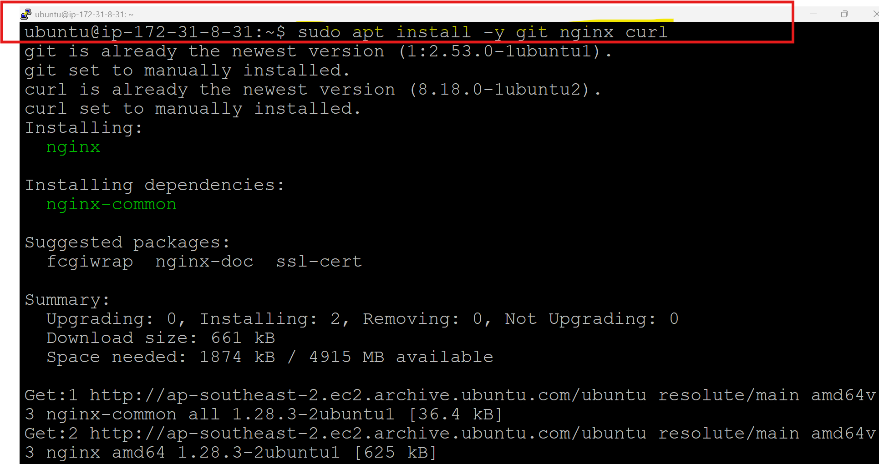
To install node.js used below command:
curl -fsSL https://deb.nodesource.com/setup_18.x | sudo -E bash -
what above command does?
• downloads the NodeSource setup script for Node.js 18.
• | sudo -E bash - → pipes the script into bash with root privileges.
To install nodejs and node package manager use below command:
sudo apt install -y nodejs npm
But while running got below errors 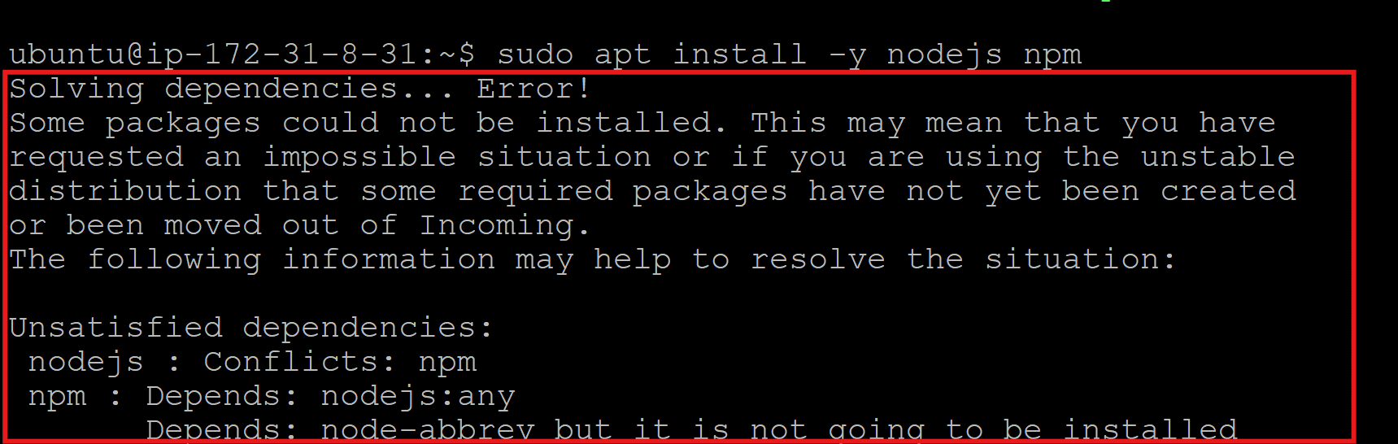
err This happens when mixing NodeSource packages with Ubuntu’s default npm package.
To fix used below commands
so it Remove any existing Node.js/npm:
sudo apt purge -y nodejs npm
since Npm is not installed not removed
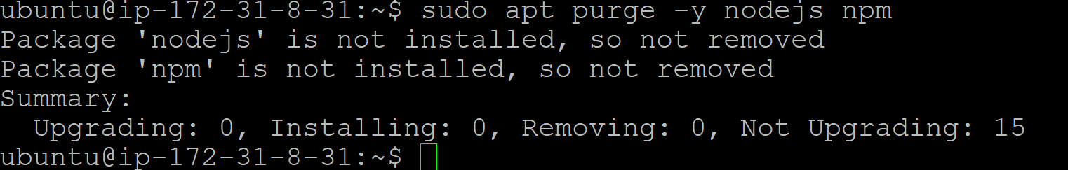
Installing Nodejs again:
sudo apt install -y nodejs
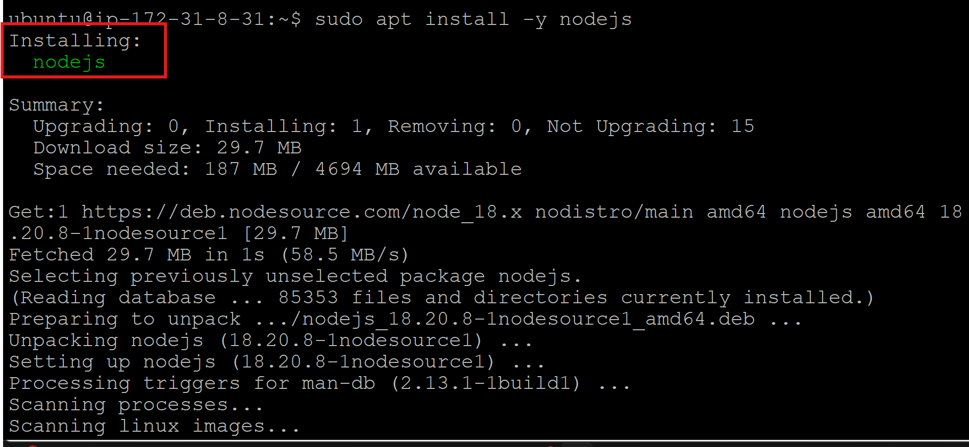

To avoid conflict entirely:used beow ommand
curl -o- https://raw.githubusercontent.com/nvm-sh/nvm/v0.39.7/install.sh | bash
source ~/.bashrc
nvm install 18
nvm use 18
What the above line of code does?
• nvm lets you switch between Node versions easily.
• It installs npm automatically with Node.js
• curl -o- https://raw.githubusercontent.com/nvm-sh/nvm/v0.39.7/install.sh | bash
- Downloads the official nvm installation script from GitHub.
- Pipes it directly into bash to install nvm in your home directory.
• source ~/.bashrc
- Reloads your shell configuration so the new nvm command is available immediately.
• nvm install 18
- Installs Node.js version 18 using nvm.
- Automatically sets up npm alongside Node.js.
• nvm use 18
- Switches your shell to use Node.js 18 as the active version.

sudo apt update && sudo apt upgrade -y 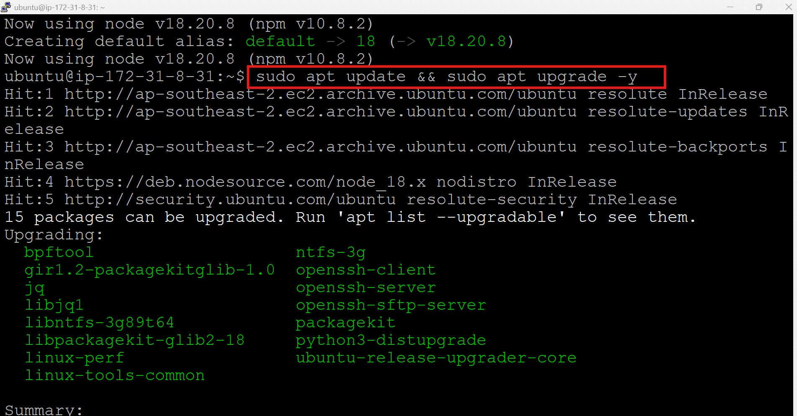
Progressing : 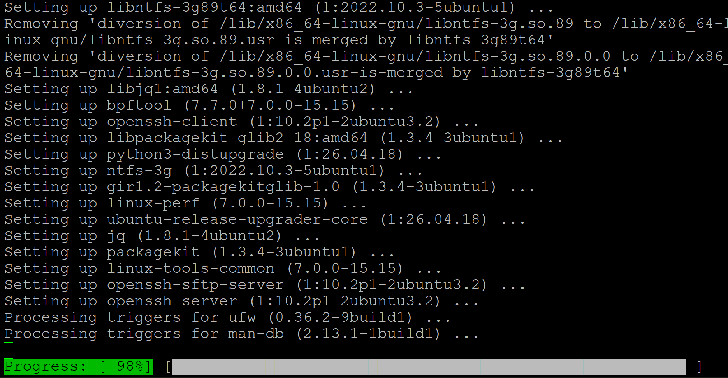
Checking If there is required depedency before cloning:
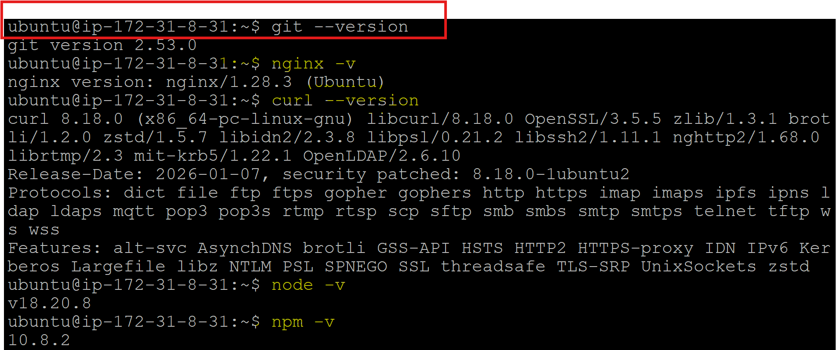

Cloning git :
Git clone https://github.com/UnpredictablePrashant/TravelMemory
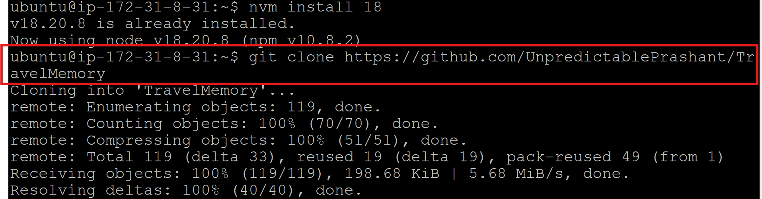

Start and enable nginx status:
sudo systemctl start nginx
sudo systemctl enable nginx
Validating Nginx status to proceed further:
sudo systemctl status nginx
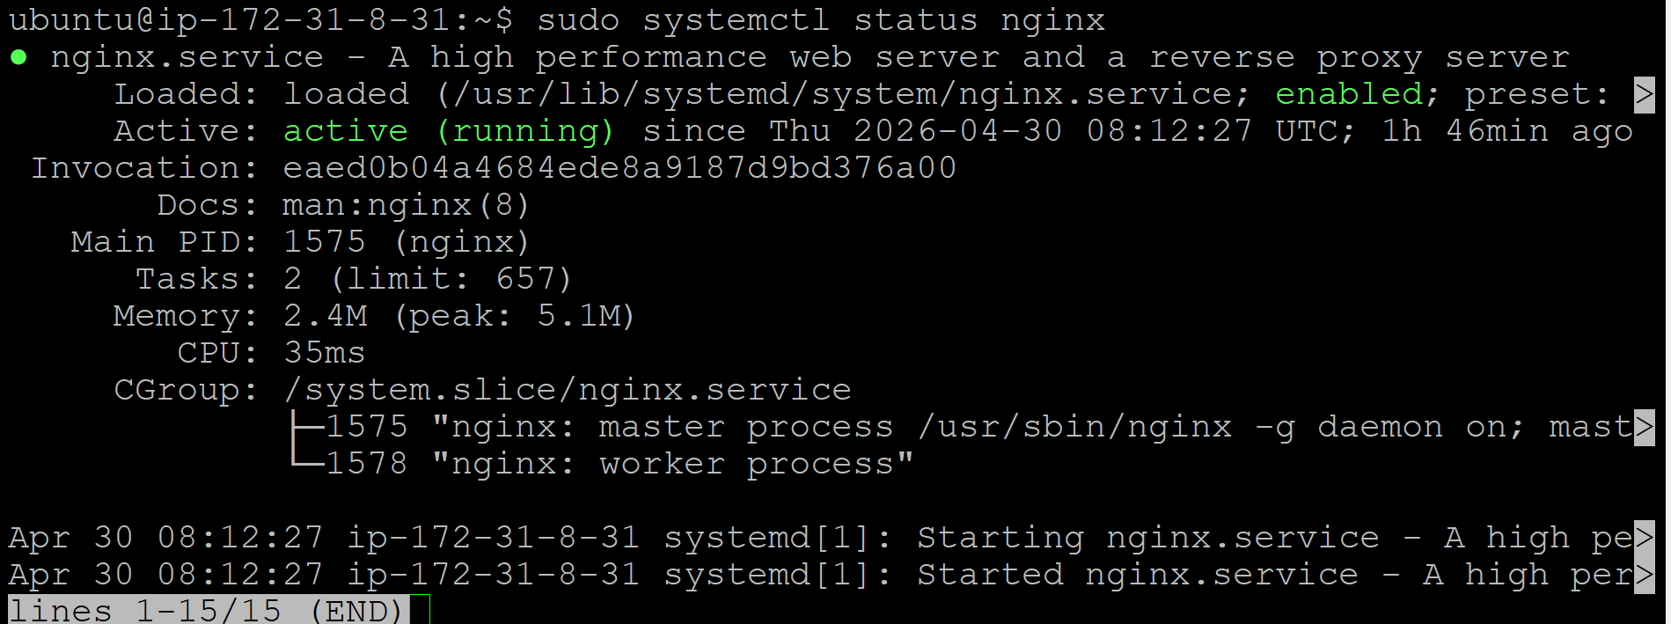
UI Confirmation: 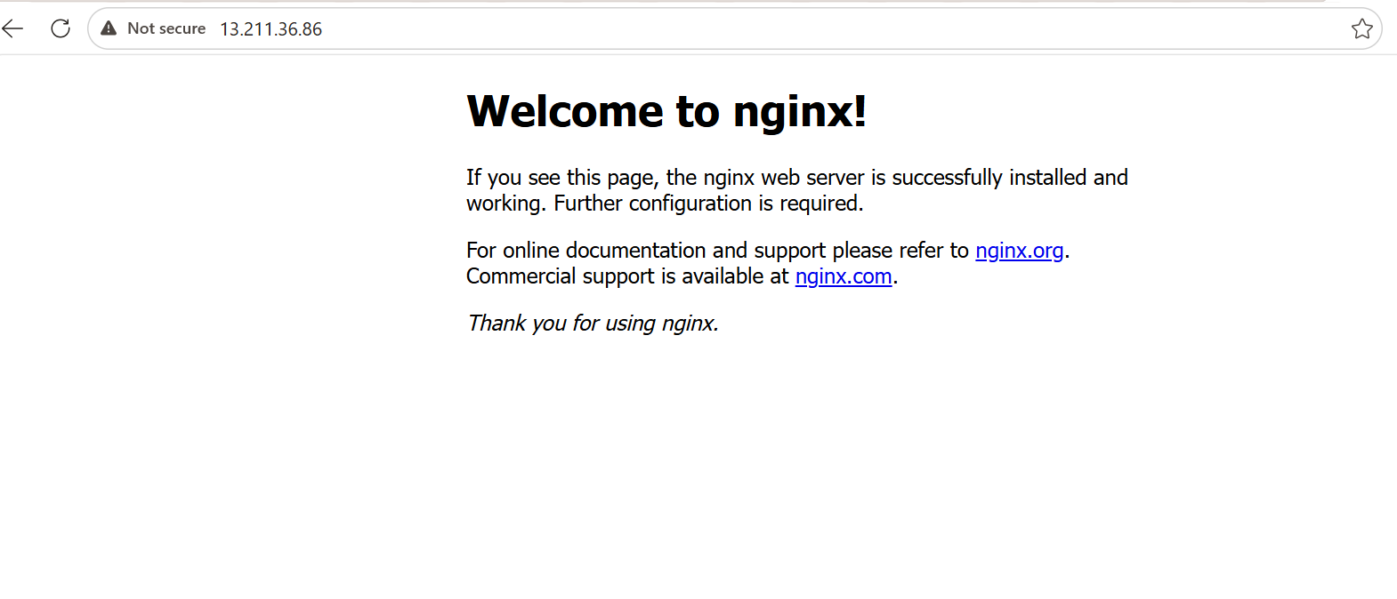
Installing pm2
sudo npm install -g pm2
PM2 keeps Node applications running forever.
Once installed checking version with command : npm -v
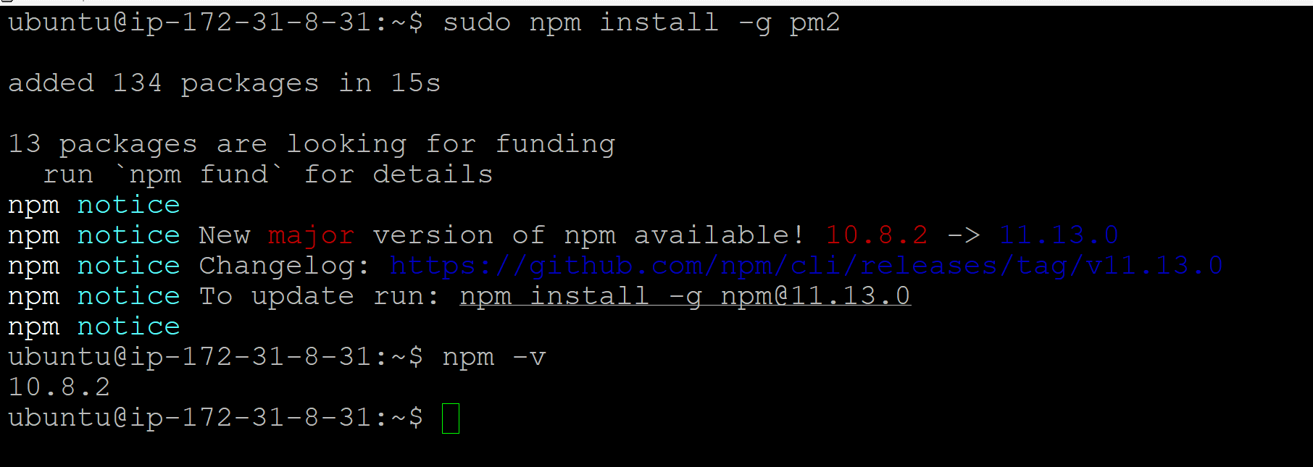

Move in to the project:
cd TravelMemory
Navigate to backend:
cd backend 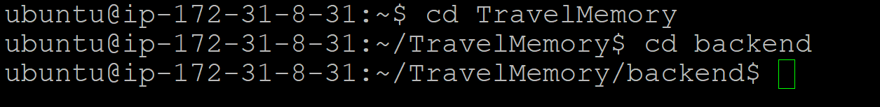
Installing npm in backend
npm install
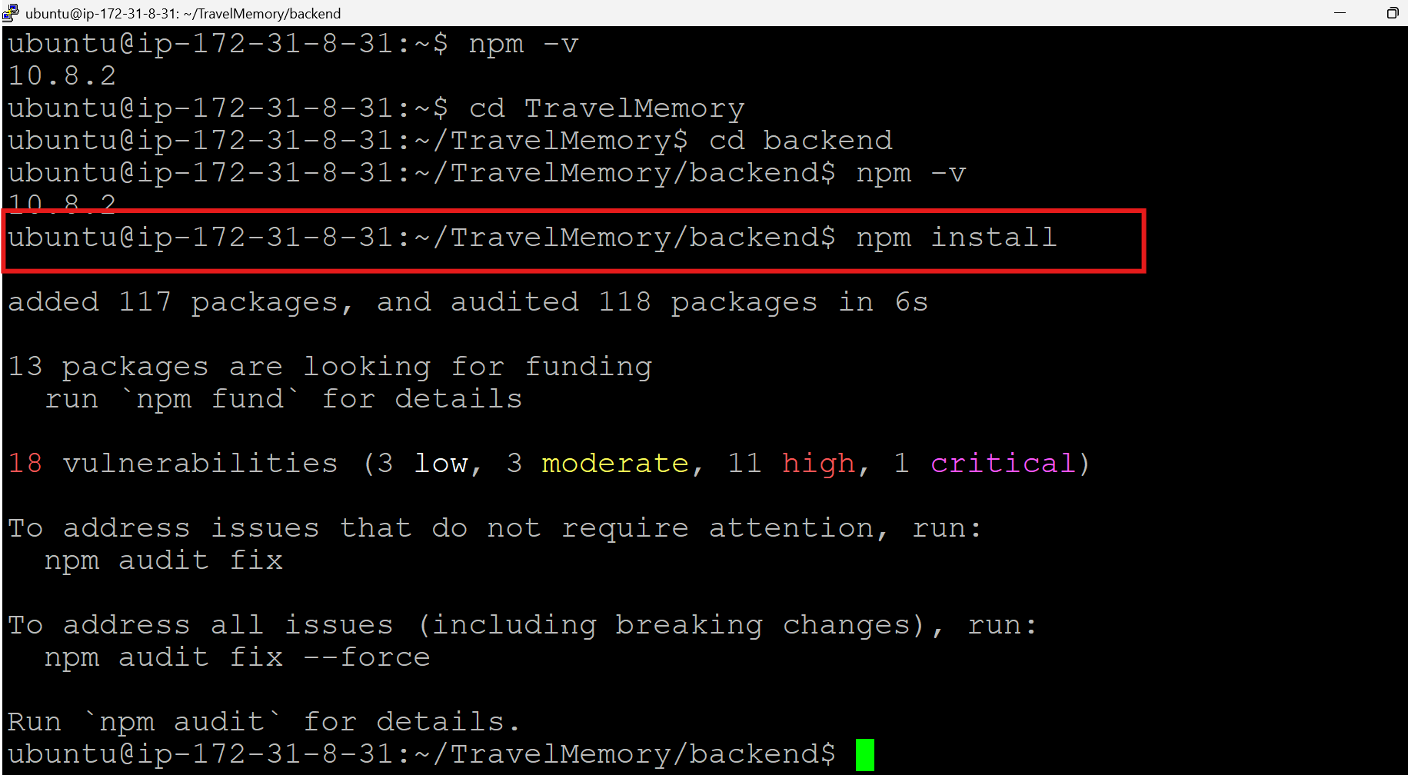
Need to configure environmental varibles
So creating environmental file usin nano editor
Verifying
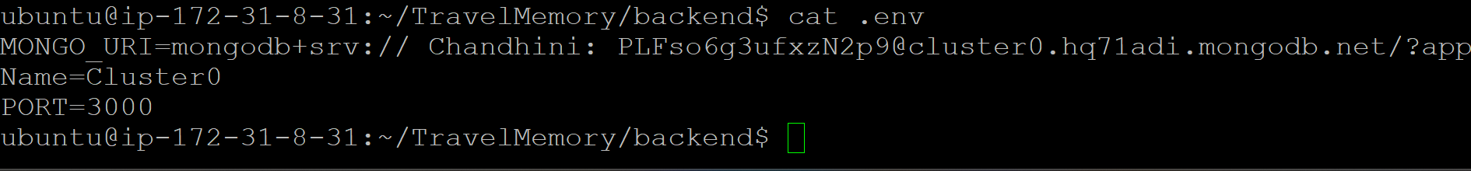
Travel memory mongo db uri- mongodb://localhost:27017

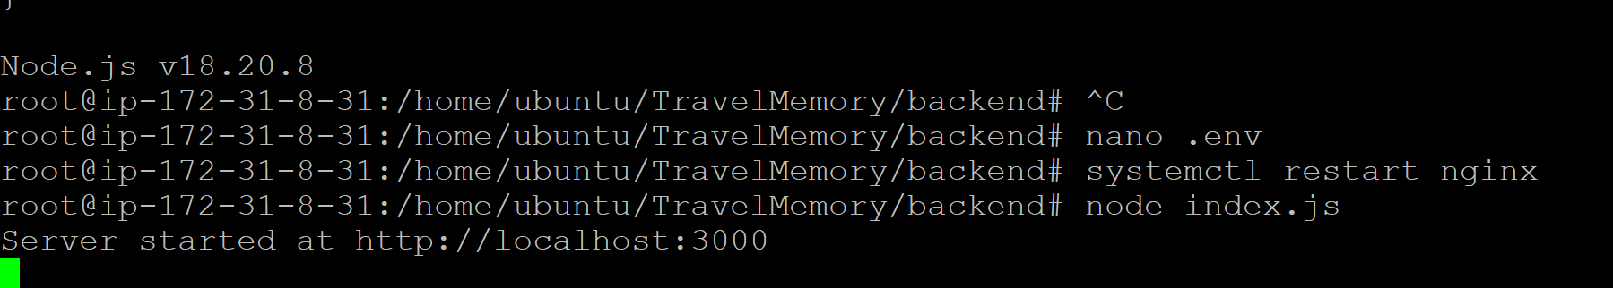
Run backend using pm2:
Command used : pm2 start index.js –name backend
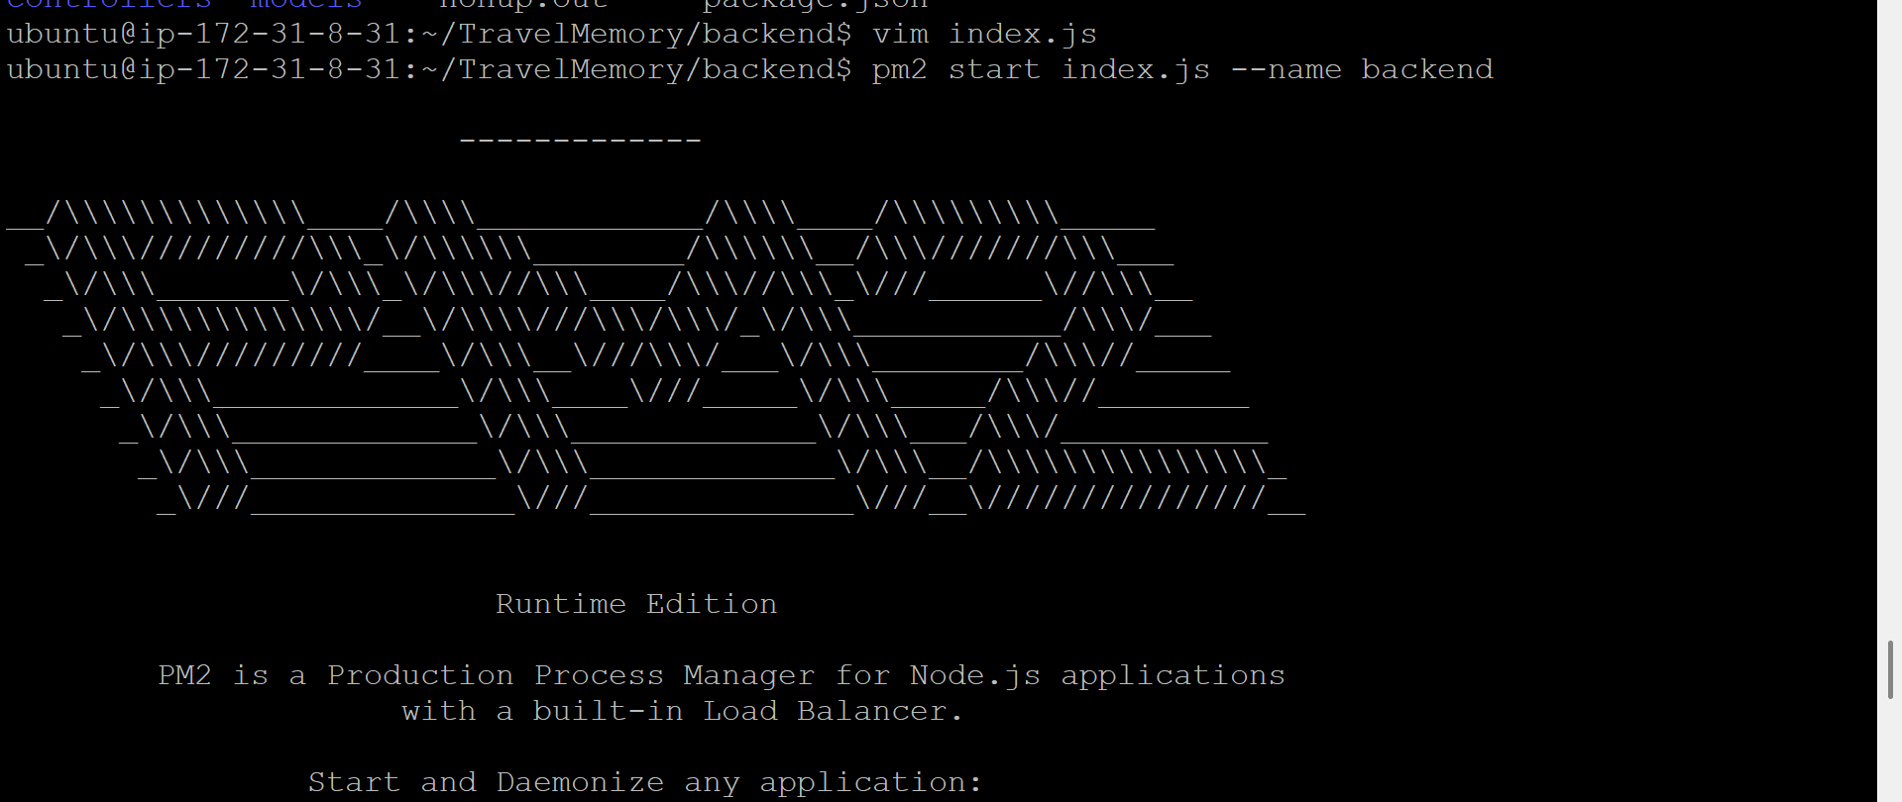
Validating if pm2 command sruns fine
Commands : pm2 list
Saving the pm2
Command : pm2 save
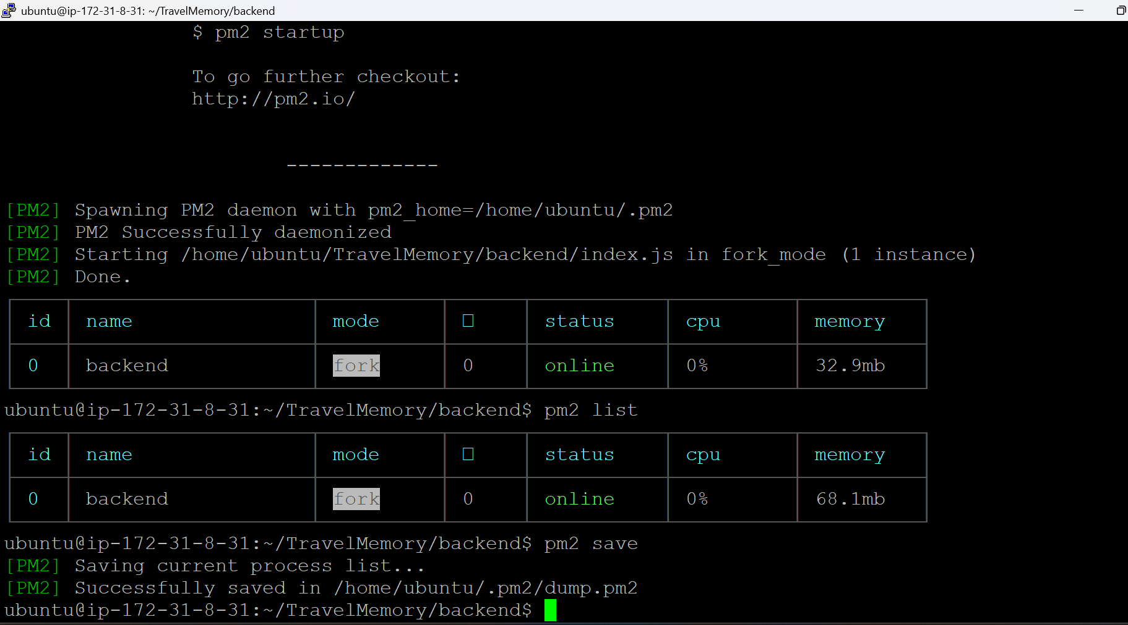
Enable startup:
Command : pm2 startup 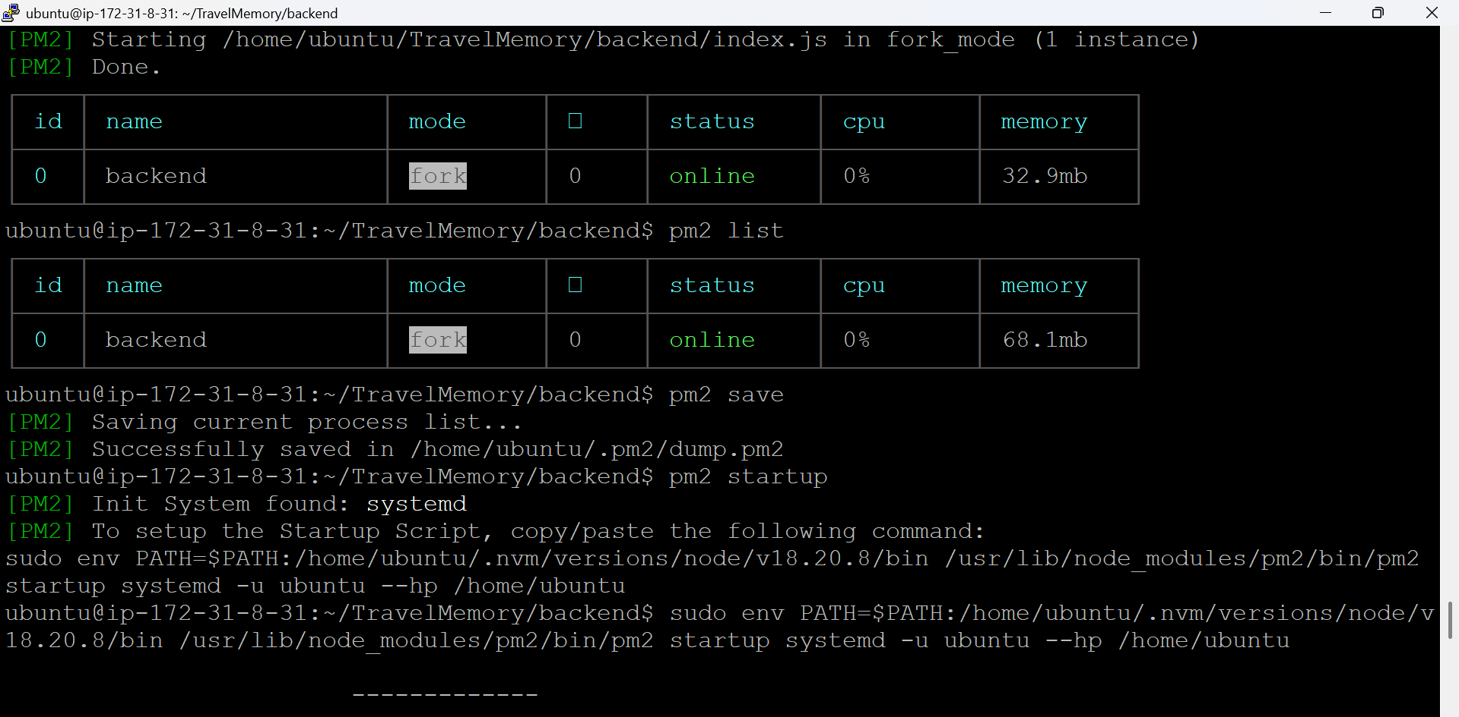

Need to configure nginx default file:
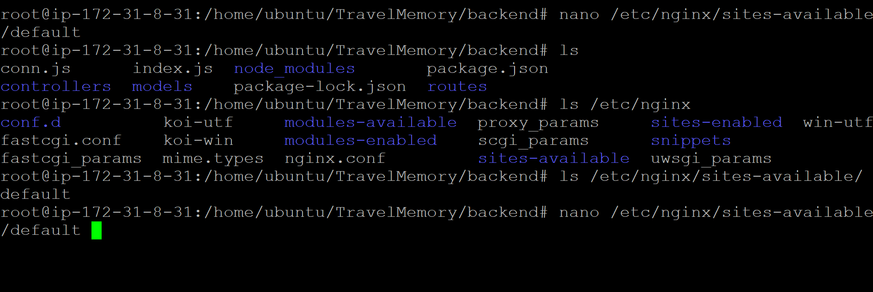
Add below lines for nginx setup
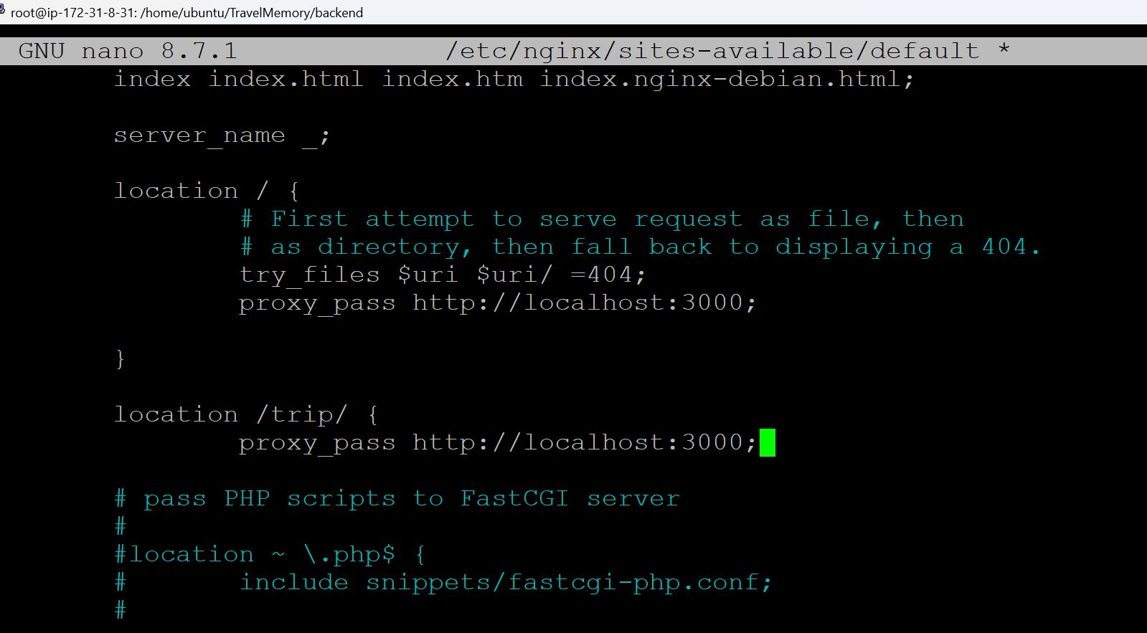
Dry run to confirm syntax is fine
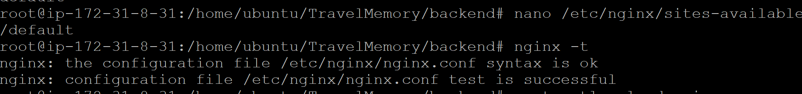
Make necesssary changes/add below line of code :
Path: /etc/nginx/sites-available/default
# --------------------------------------------------
# NGINX CONFIGURATION - TRAVEL MEMORY PROJECT
# --------------------------------------------------

# Upstream backend servers
upstream backend_servers {

# EC2 Public IPs (optional for load balancing)
# server 54.252.182.210;
# server 3.27.228.142;

# Local backend server
server localhost:3000;
}

# --------------------------------------------------
# DEFAULT SERVER CONFIGURATION
# --------------------------------------------------

server {

# Listening Ports
listen 80 default_server;
listen [::]:80 default_server;

# Root Directory
root /var/www/html;

# Default Index Files
index index.html index.htm index.nginx-debian.html;

# Server Name
server_name _;

# --------------------------------------------------
# FRONTEND CONFIGURATION (React App)
# --------------------------------------------------

location / {

# Try serving requested file first,
# otherwise fallback to React index.html

try_files $uri /index.html $uri/ =404;

# Optional proxy
# proxy_pass http://backend_servers;
}

# --------------------------------------------------
# BACKEND API ROUTES
# --------------------------------------------------

location /trip {

proxy_pass http://backend_servers;

proxy_http_version 1.1;

proxy_set_header Upgrade $http_upgrade;
proxy_set_header Connection 'upgrade';

proxy_set_header Host $host;

proxy_cache_bypass $http_upgrade;
}

# --------------------------------------------------
# TEST ROUTE
# --------------------------------------------------

location /test {

proxy_pass http://localhost:3000;
}

# --------------------------------------------------
# PHP CONFIGURATION (COMMENTED)
# --------------------------------------------------

# location ~ \.php$ {
#
# include snippets/fastcgi-php.conf;
#
# # PHP-FPM Socket
# fastcgi_pass unix:/run/php/php7.4-fpm.sock;
#
# # TCP Socket Alternative
# # fastcgi_pass 127.0.0.1:9000;
# }

# --------------------------------------------------
# SECURITY RULES
# --------------------------------------------------

# location ~ /\.ht {
# deny all;
# }
}

# --------------------------------------------------
# OPTIONAL VIRTUAL HOST CONFIGURATION
# --------------------------------------------------

# server {
#
# listen 80;
# listen [::]:80;
#
# server_name example.com;
#
# root /var/www/example.com;
#
# index index.html;
#
# location / {
# try_files $uri $uri/ =404;
# }
# }

# --------------------------------------------------
# END OF CONFIGURATION
# --------------------------------------------------
Switch to frontend 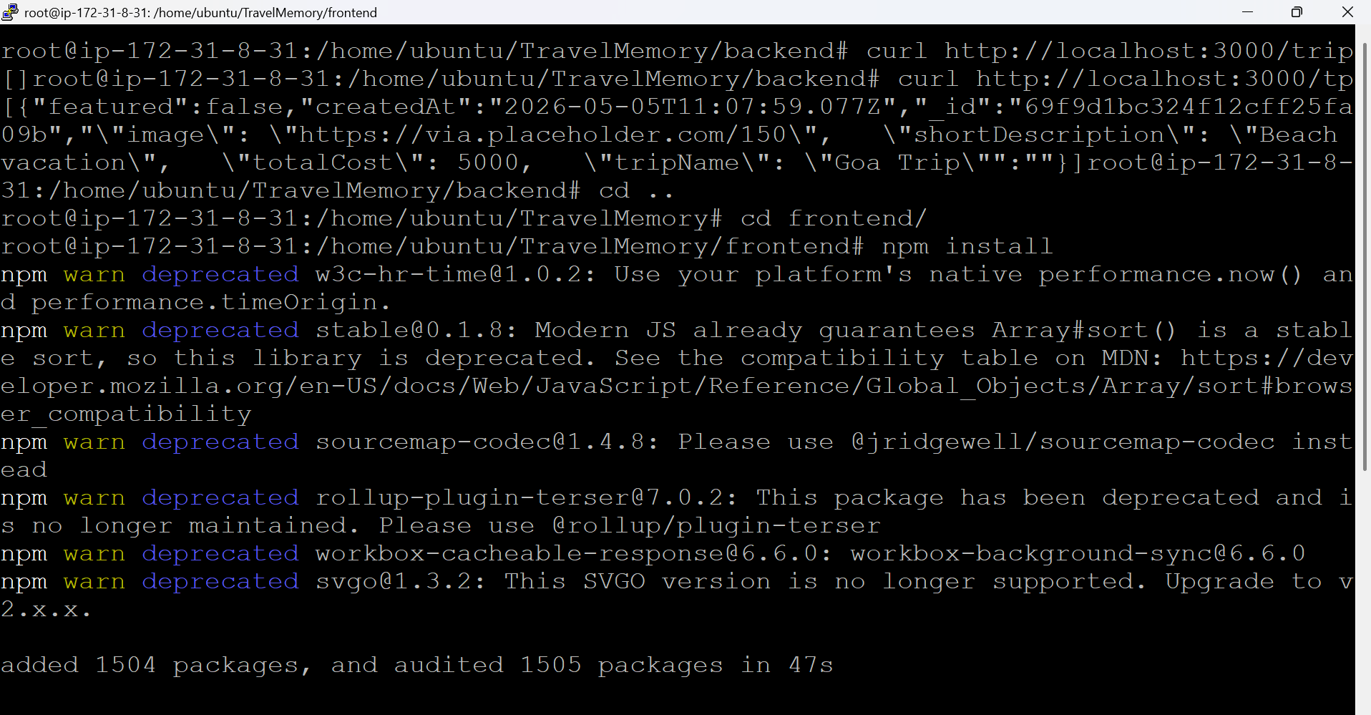
npm run build - creates a executable websites
Add this in nano src/url.js file
export const baseUrl = process.env.REACT_APP_BACKEND_URL || "http://localhost:3000";
Since Reverse proxy does the job forwarding traffic later it src/uel.js file was updated like below
export const baseUrl = "";
Command : npm run build to build react app
Removing from the build file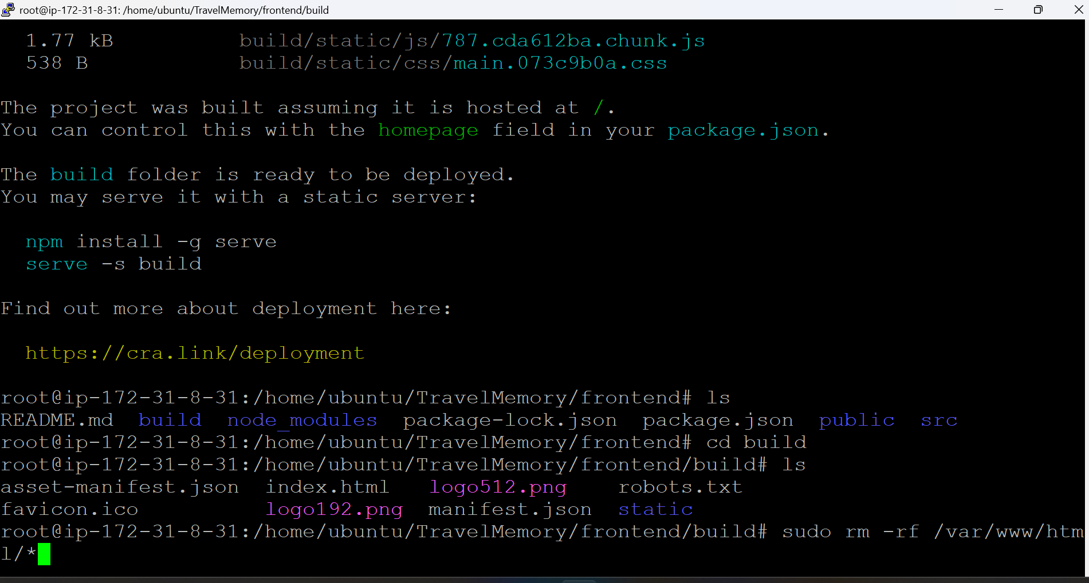
copying to nginx logs 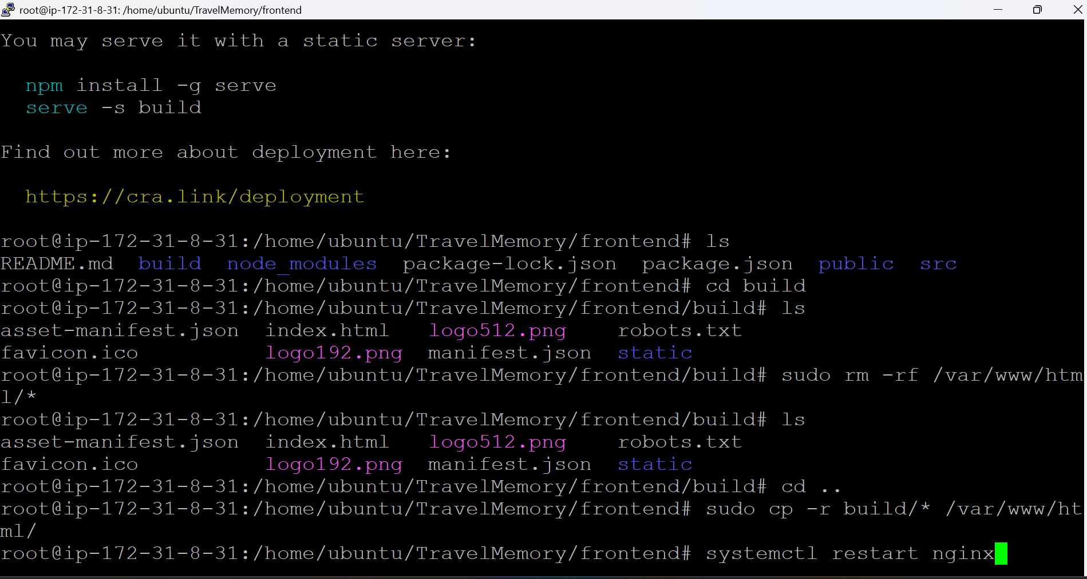
If we want to having multiple backend then we can use below process to scale , I scaled and later removed to make the port free
Scaling the Application:
Commands used :
PORT=3000 pm2 start index.js --name backend1
PORT=3001 pm2 start index.js --name backend2
PORT=3002 pm2 start index.js --name backend3
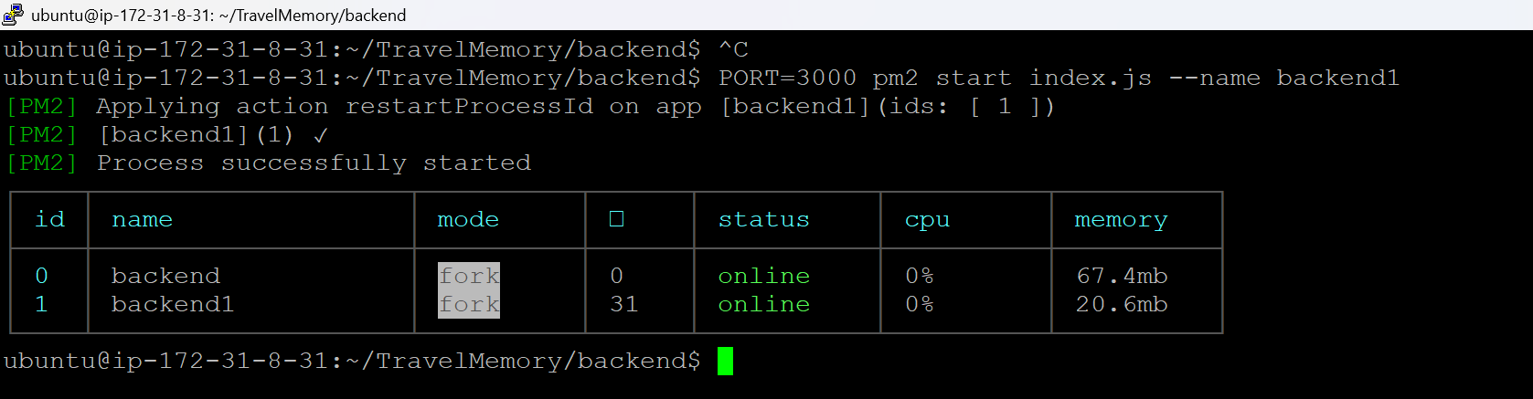
Pm2 list to see the backend
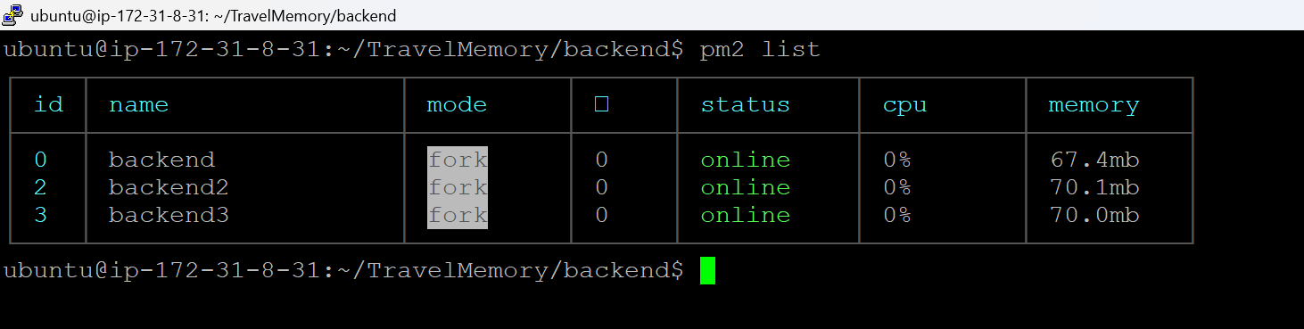
Navigate to the below path to configure backend server
After doing the configuration do the dry run:
Command : nginx -t
Restart nginx:
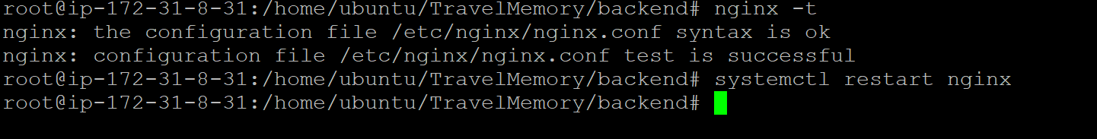
added to confirm api checks in index.js in backend:
ubuntu@ip-172-31-8-31:~/TravelMemory$ cd backend/
ubuntu@ip-172-31-8-31:~/TravelMemory/backend$ ls
conn.js index.js node_modules package-lock.json routes
controllers models nohup.out package.json
ubuntu@ip-172-31-8-31:~/TravelMemory/backend$ cat index.js
const express = require('express')
const cors = require('cors')
require('dotenv').config()

const app = express()
PORT = process.env.PORT
const conn = require('./conn')
app.use(express.json())
app.use(cors())

const tripRoutes = require('./routes/trip.routes')

app.use('/trip', tripRoutes) // http://localhost:3001/trip --> POST/GET/GET by ID

app.get('/hello', (req,res)=>{
res.send('Hello World!')
})

app.listen(PORT, ()=>{
console.log(`Server started at http://localhost:${PORT}`)
})

app.get("/", (req, res) => {
res.send("Backend is running successfully.");
res.send(`Response from PORT ${process.env.PORT}`);
});

app.get('/test', (req, res) => {
res.send("Response from Server 1");
});
Creating another Ec2 instances of above configuration :
Create a image of the previously configured ec2 instance and create a new instance 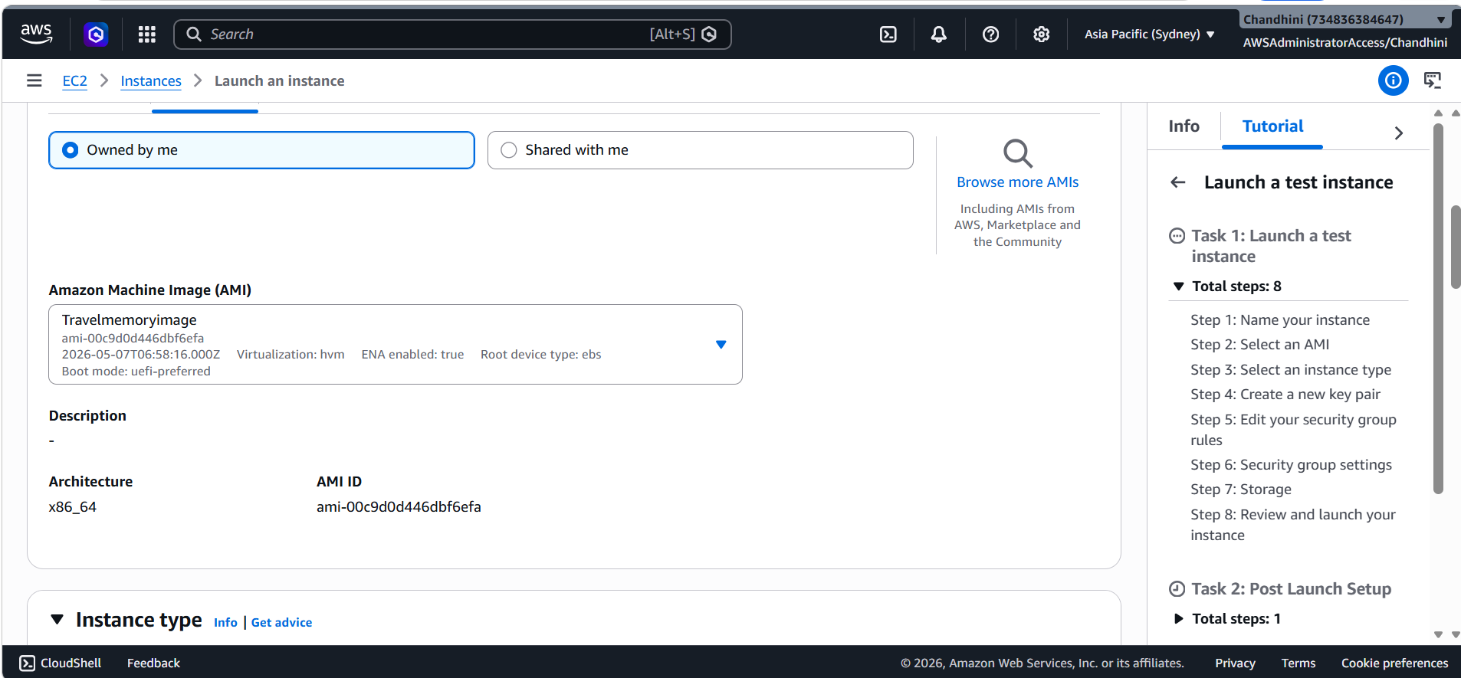
Create a Target group:
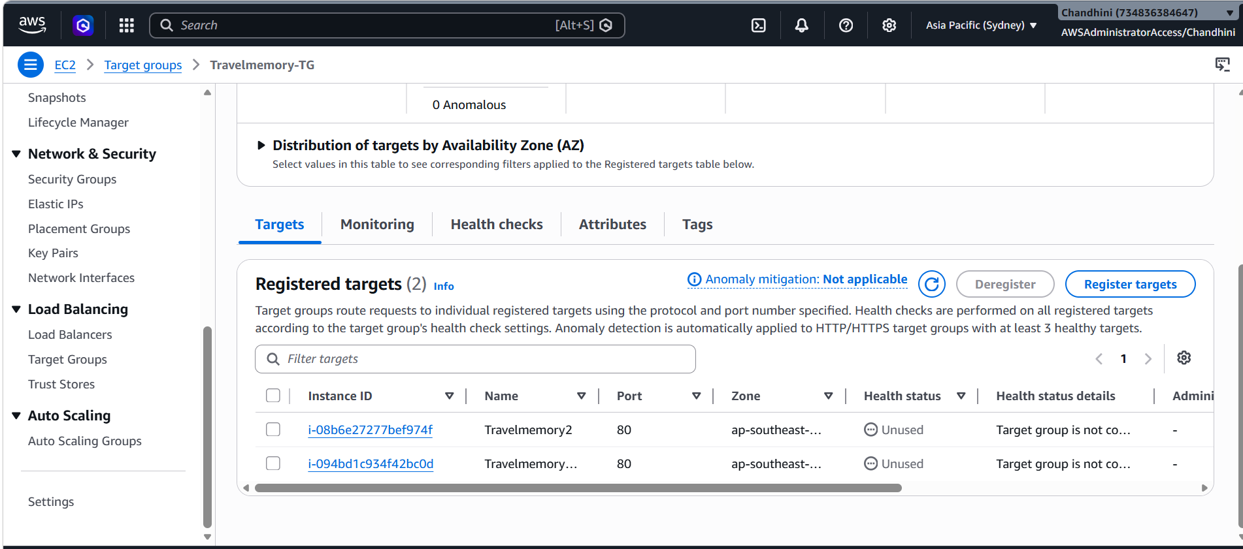
After creating a target group associate with a load balancer 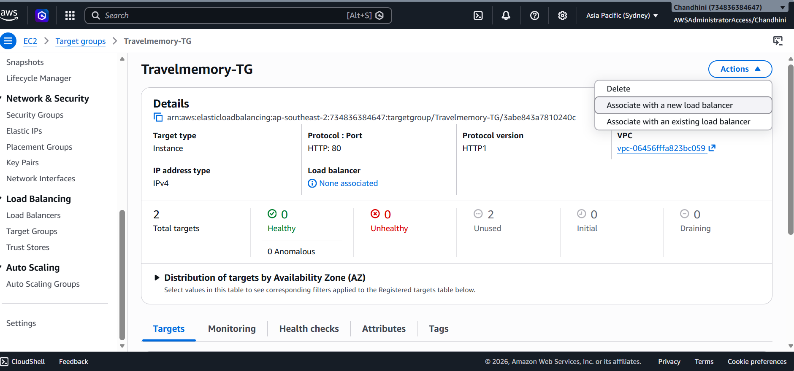
Create a loadbalancer with below listed configuartions:
Configure with below values :
Where Type : Internet-facing
Listener : HTTP:80
TargetGroup: Ec2 Instances
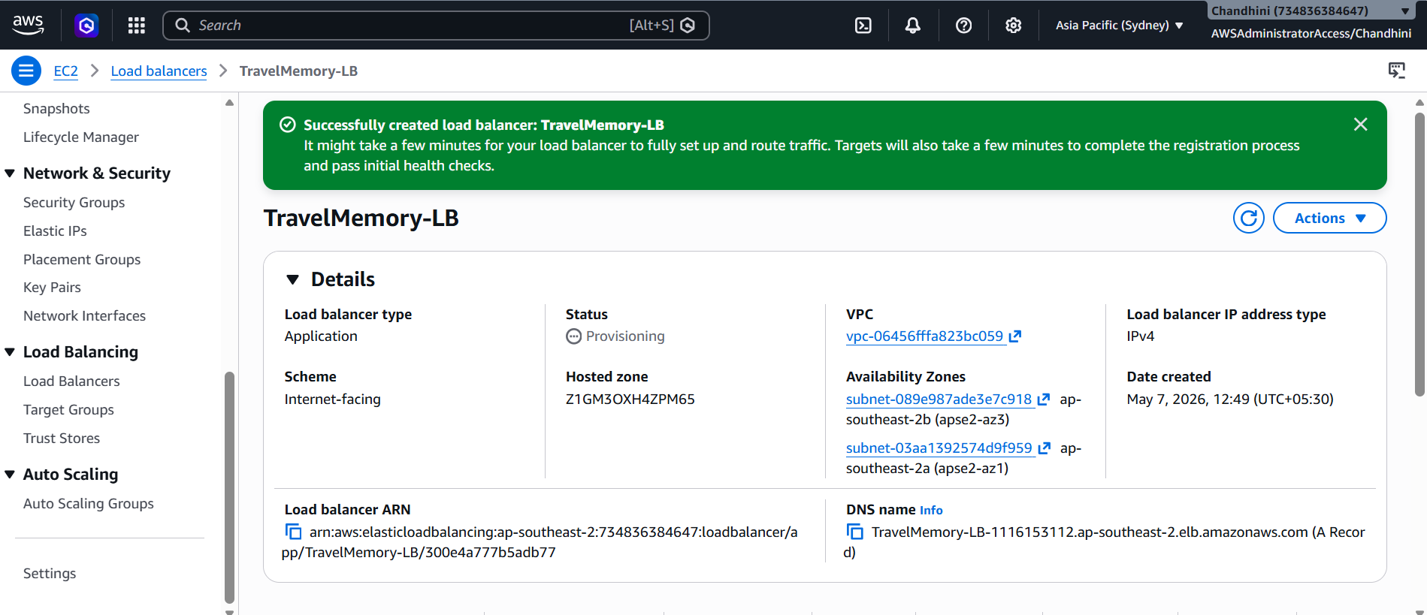
Purchase a domain from Namecheap website:
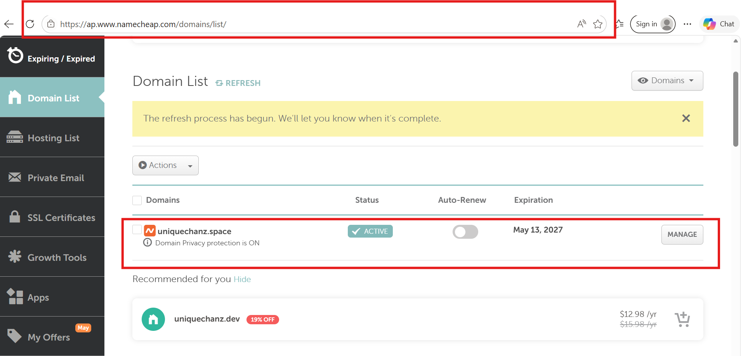
Cloud flare setup :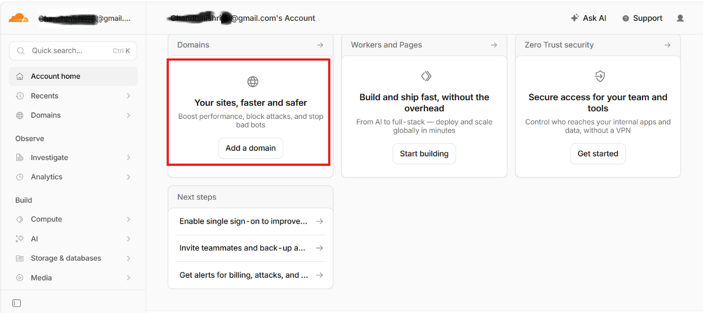
connect a domain:
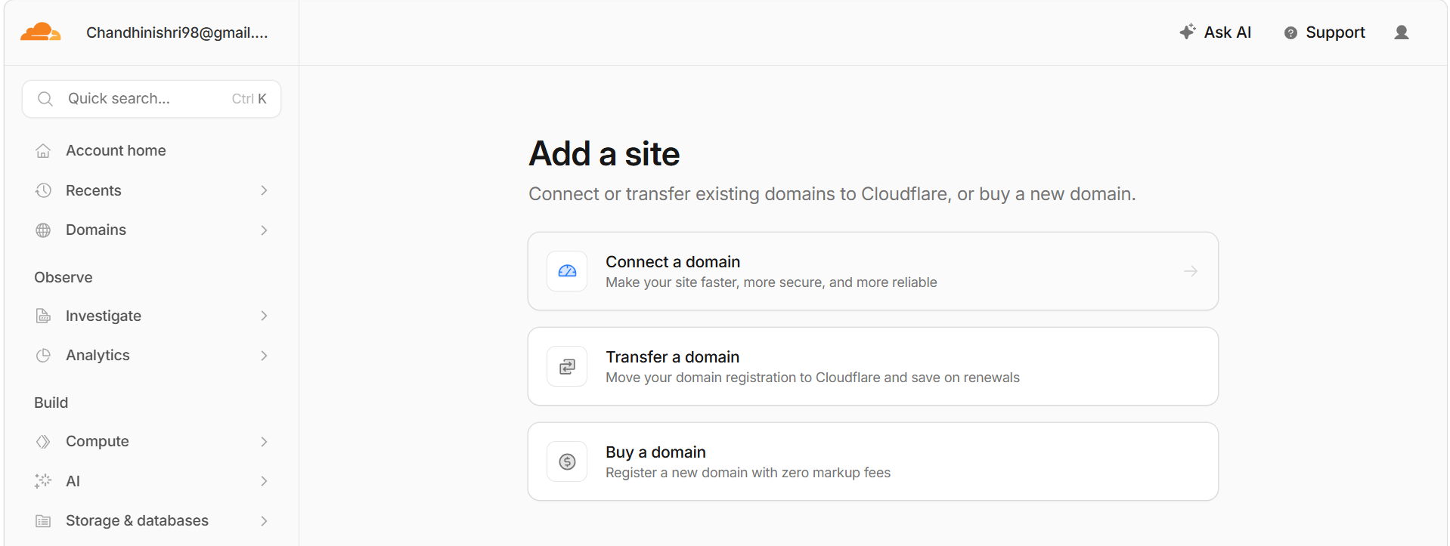
Added Both Ip : 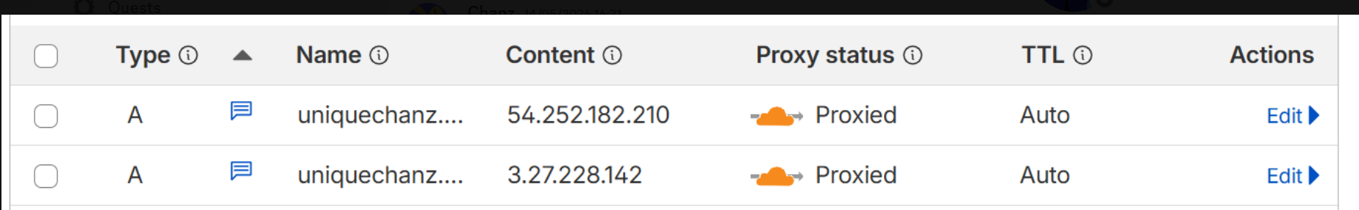
Also added along with Load balancer dns name: 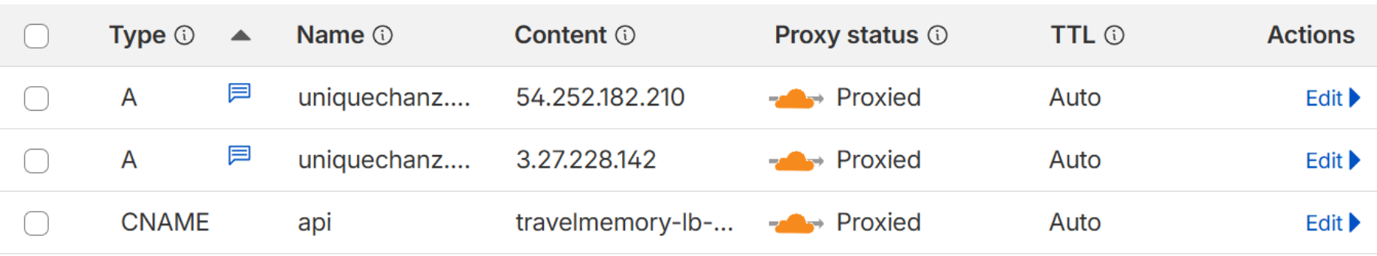
SSL & TLS setup: 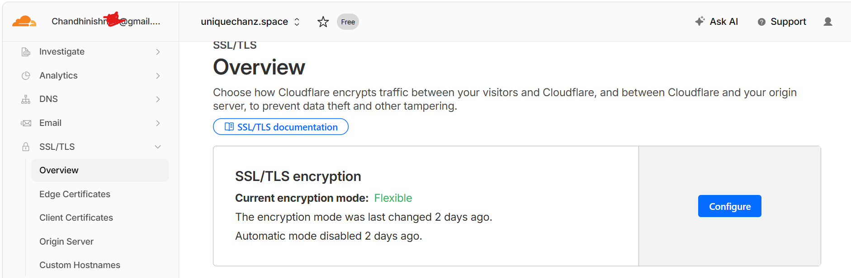
Status of cloudflare is active: 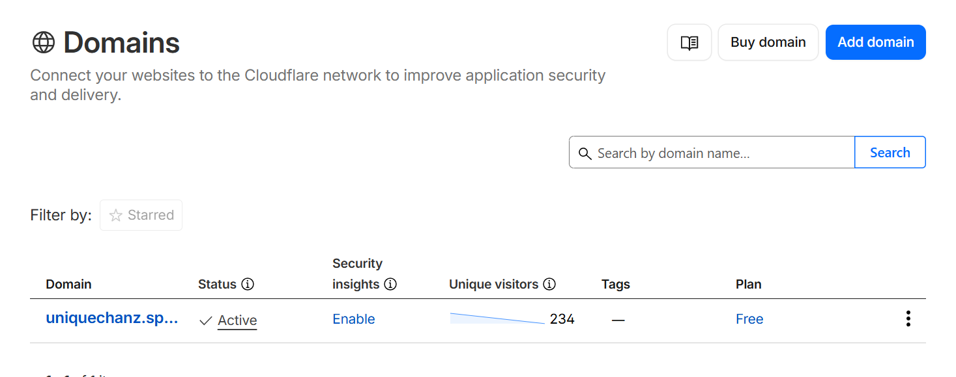
Challenges faced while doing this project:
1. I was getting only Loading while I check with domain name , but it was working fine while using ec2 ip . since ec2ip are dynamic after every restart of the machine and I want everyone to check/use my domain with their local host so removed ip value under upstream and replaced with local host
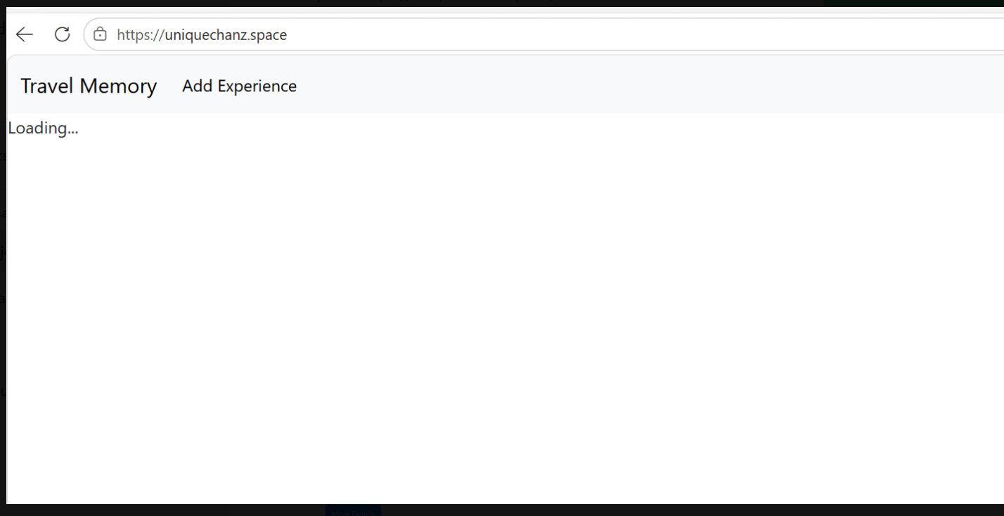
Path: /etc/nginx/sites-available/default:
# Upstream backend servers
upstream backend_servers {

# EC2 Public IPs (optional for load balancing)
# server 54.252.182.210;
# server 3.27.228.142;

# Local backend server
server localhost:3000;
}
2. The below challenge was resolve by deleting duplicate A records
An A, AAAA, or CNAME record with that host already exists. For more details, refer to <https://developers.cloudflare.com/dns/manage-dns-records/troubleshooting/records-with-same-name/>.

3.Invalid username error was rectified by copying the cloudflare provided new anme server and navigating to namecheap website
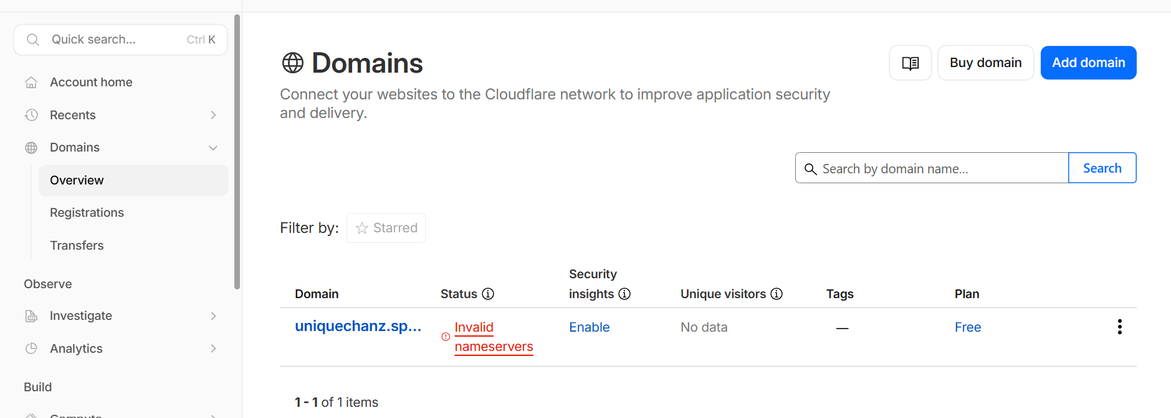
Under name cheap website followed below step :
1. Navigated to the Domain list and selected manage button and added cloudflare provided name server under customDNS section and waited for 2 -5 minutes in cloud flare to see thw status active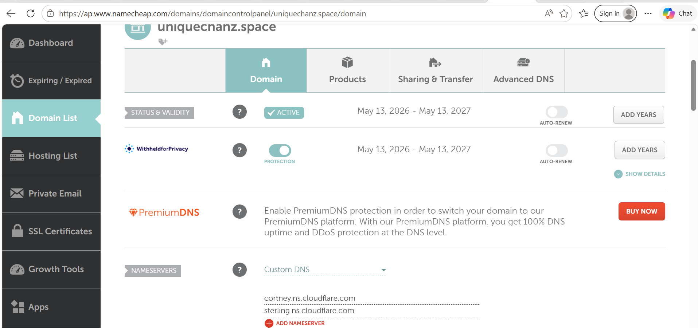

Custom domain: 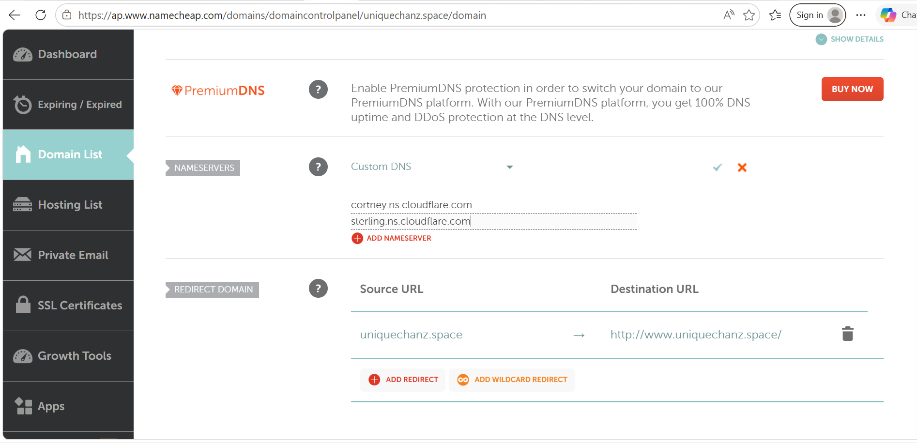
4. This web server down error was handled by turning on the instance and clearing browser cache .
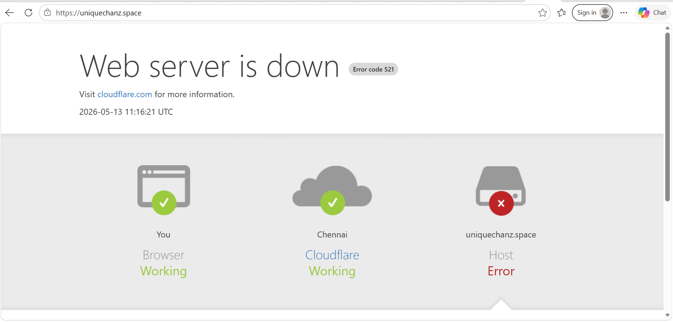
Final Record of my cloud flare account for my domain to work
Cloud flare: 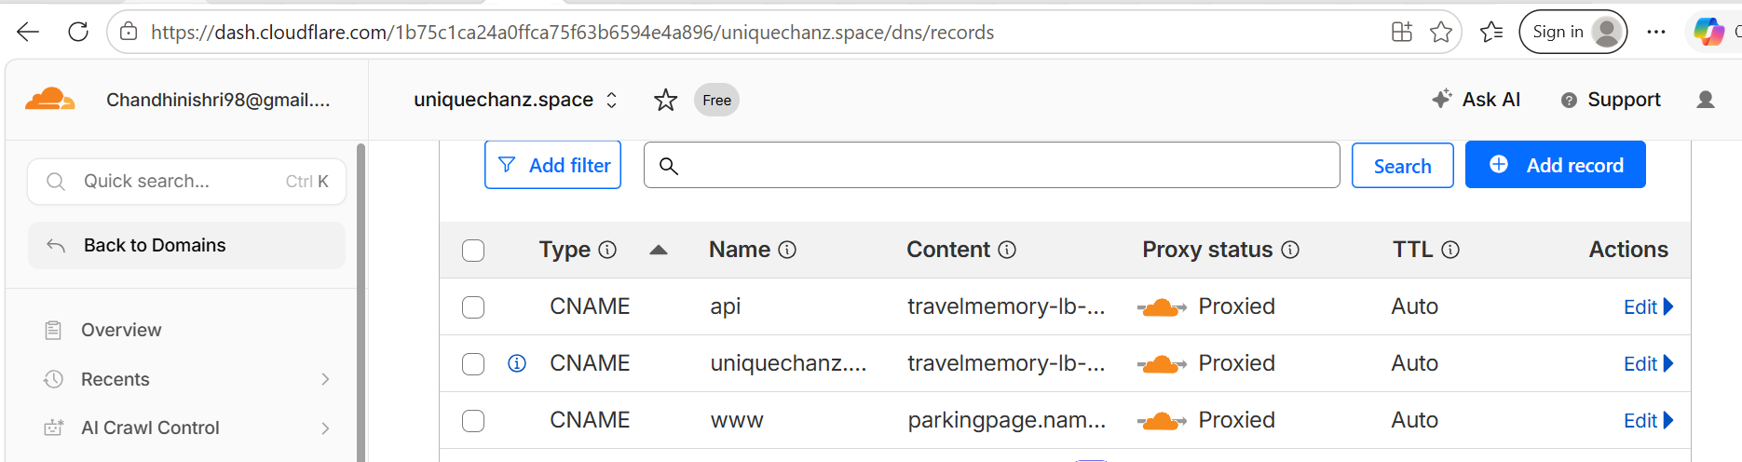
Output verification to check loadbalances
Verification for server 1:
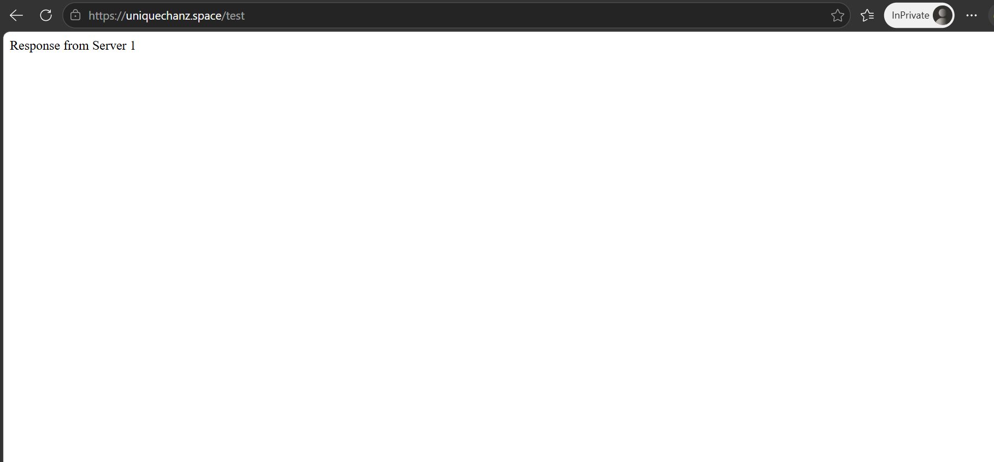
Verfication from server 2:
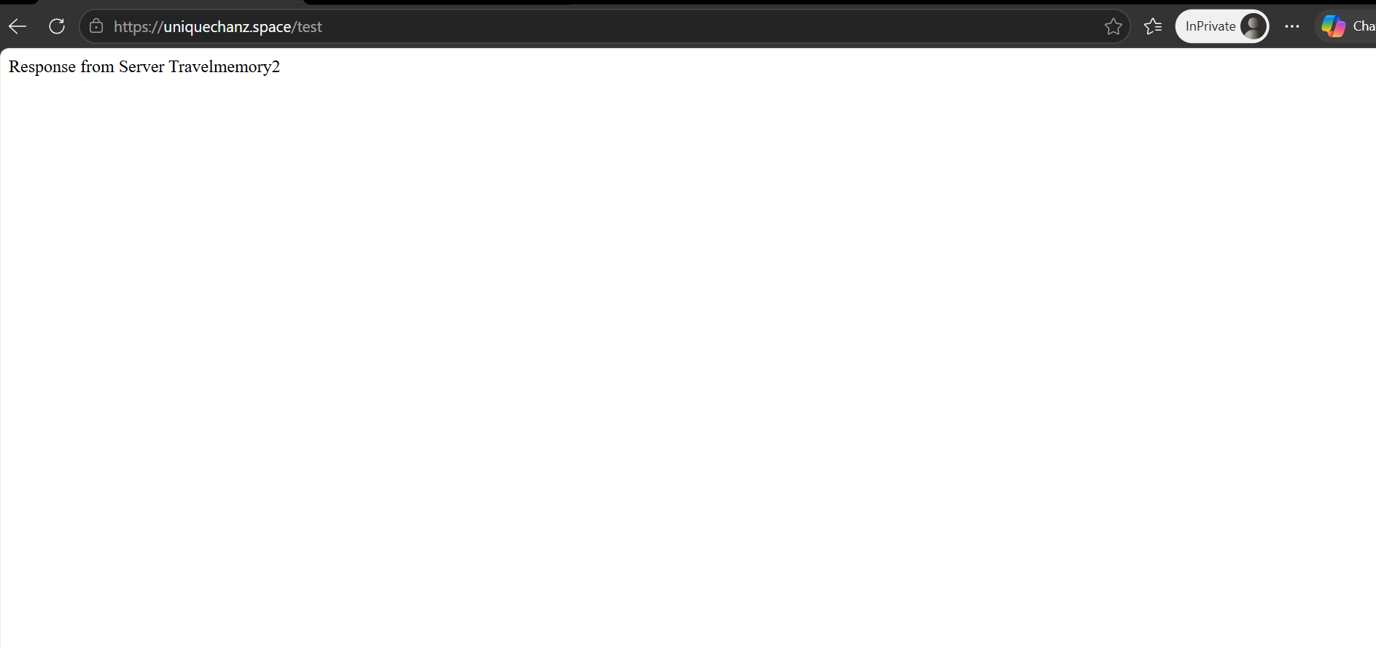

Mongo DB Verification: 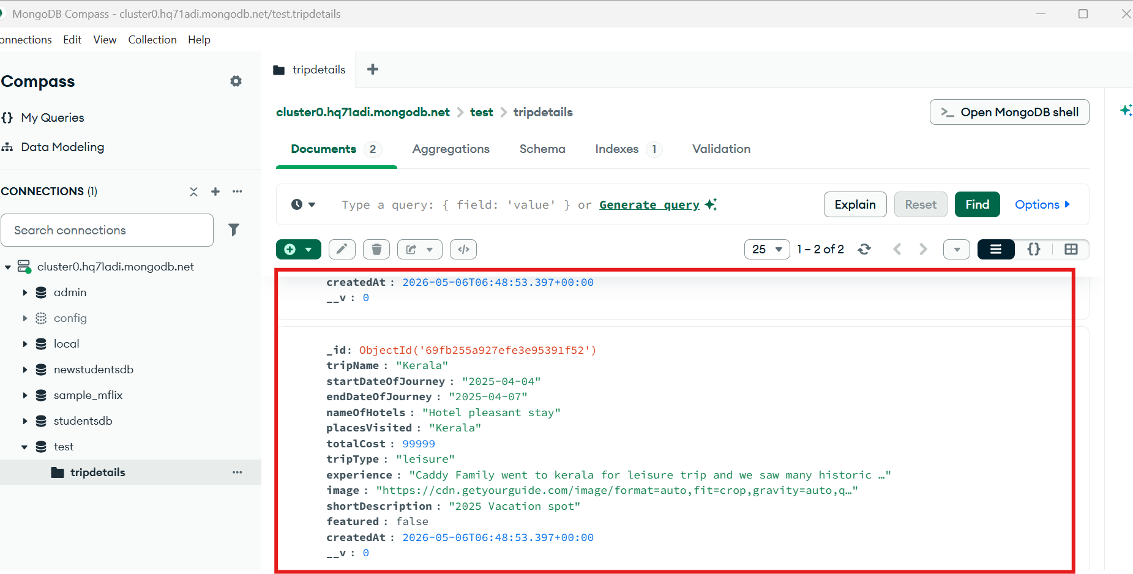
From UI: 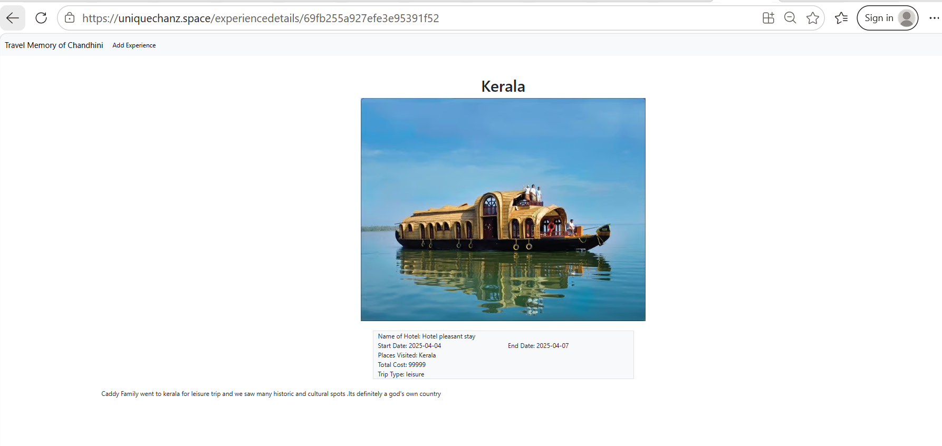
Overview of my website: 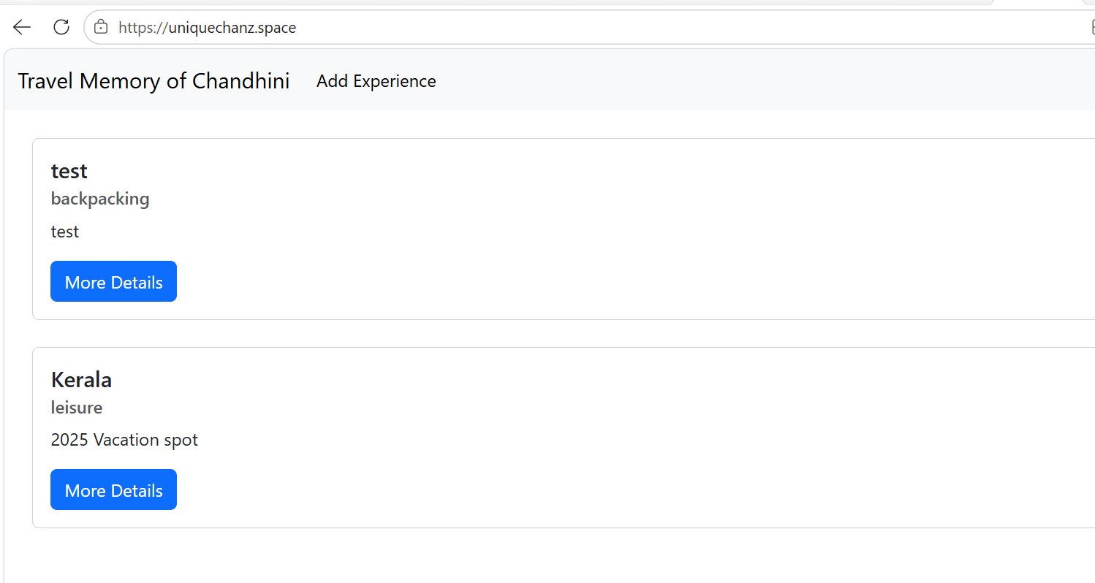
Thus, a Travel Memory website was successfully developed using a Node.js backend and a React frontend, secured with Cloudflare SSL.
