SuperMarket Data Analytics
ChandhraShekhar
IBM SkillsBuild Data Analytics with AI Academic Internship Program
BharatCares in association with AICTE

Executive Summary
This project converts the supplied supermarket transaction table into business information and actions. The source contains 500 records from 2026-01-01 to 2026-07-01. After validation, 500 records were used for analysis. Total Sales is 244,411.08, average transaction value is 488.82, and average customer rating is 3.99.

Problem Statement
A supermarket needs a concise view of sales performance, category and product contribution, branch and city differences, payment behavior, and customer ratings. Raw transactions alone do not explain which areas deserve attention or what action should be considered next.

Business Objective
The objective is to follow DATA → INFORMATION → INSIGHT → DECISION → ACTION. The analysis emphasizes supported KPIs, trends, drivers, risks, opportunities, and practical actions rather than an excessive number of charts.

Dataset Description
The dataset was extracted from the supplied PDF and saved as dataset/supermarket_data.csv. It contains 500 rows and 13 columns: Invoice ID, Date, Branch, City, Customer Type, Gender, Product, Category, Quantity, Unit Price, Payment, Rating, Sales. The PDF did not provide a source URL; this remains a manual documentation item.

Data Cleaning
Validation found 0 missing cells, 0 duplicate rows, 0 duplicate invoice IDs, and 0 Sales formula mismatches beyond 0.01. Dates were parsed, positive quantities and prices were retained, ratings were constrained to 0–5, and date-derived features were created. The original extracted CSV is preserved.

Feature Engineering
The notebook creates Year, Month, Month Name, Day, and Day of Week from Date. Sales is retained as the supplied transaction value and checked against Quantity × Unit Price.

KPI Analysis
KPI | Result
Total Sales | 244,411.08
Transactions | 500
Total Quantity | 2,768
Average Transaction | 488.82
Average Rating | 3.99

Exploratory Data Analysis
Beverages is the leading category by Sales at 56,108.24. Cheese is the leading product at 27,906.30. Mumbai is the leading city/branch grouping at 72,469.45. UPI is the most frequent payment method.

Monthly sales trend

Sales contribution by category

Sales by city and branch

Business Insights: Fact → Insight → Opportunity/Risk → Action
- FACT: Beverages generated the highest category Sales. INSIGHT: category contribution is uneven. OPPORTUNITY/RISK: the leading category is an inventory and execution priority, but concentration creates exposure. ACTION: monitor availability and benchmark lower-performing categories against the leader.
- FACT: Mumbai generated the highest city/branch Sales grouping. INSIGHT: location-level performance differs in the supplied sample. OPPORTUNITY/RISK: local practices may be worth comparing, but the dataset does not establish causation. ACTION: compare the leading location with lower-performing locations using the same KPIs.
- FACT: Sales matches Quantity × Unit Price by construction. INSIGHT: Sales prediction would reproduce an existing formula. OPPORTUNITY/RISK: a Sales model would add little predictive intelligence and could mislead stakeholders. ACTION: use descriptive Sales analytics and evaluate another target only when it represents a real future outcome.

Predictive Analytics
The model predicts customer Rating rather than Sales. Rating is modeled from transaction context using an 80/20 train/test split, one-hot encoded categorical features, and a Random Forest regressor. This is exploratory because the dataset is a static transaction extract and does not prove causal relationships.
Metric | Result
Baseline MAE | 0.4725
Model MAE | 0.4925
Model RMSE | 0.5740
Model R² | -0.1915

Permutation importance for Rating prediction

Recommended Actions
Use the leading category and location as operational benchmarks. Review lower-performing segments before shifting inventory or campaign attention. Improve customer feedback capture and collect longer-term customer history before treating rating prediction as an operational decision tool.

Limitations
The dataset is a static PDF extract covering a limited period. It has no inventory, margin, promotion, or longitudinal customer fields. The model is not a causal model and should not be used to make unsupported claims about customer behavior.

Conclusion
The project demonstrates a complete analytics workflow from extracted data to validated KPIs, trends, business insights, and actions. The model is included only after rejecting leakage-prone Sales prediction as a meaningful target.

Actual Web Application Screenshot
The following screenshot shows the completed supermarket-specific dashboard running with the validated dataset, including the calculated KPI cards, data-quality status, filters, and charts.
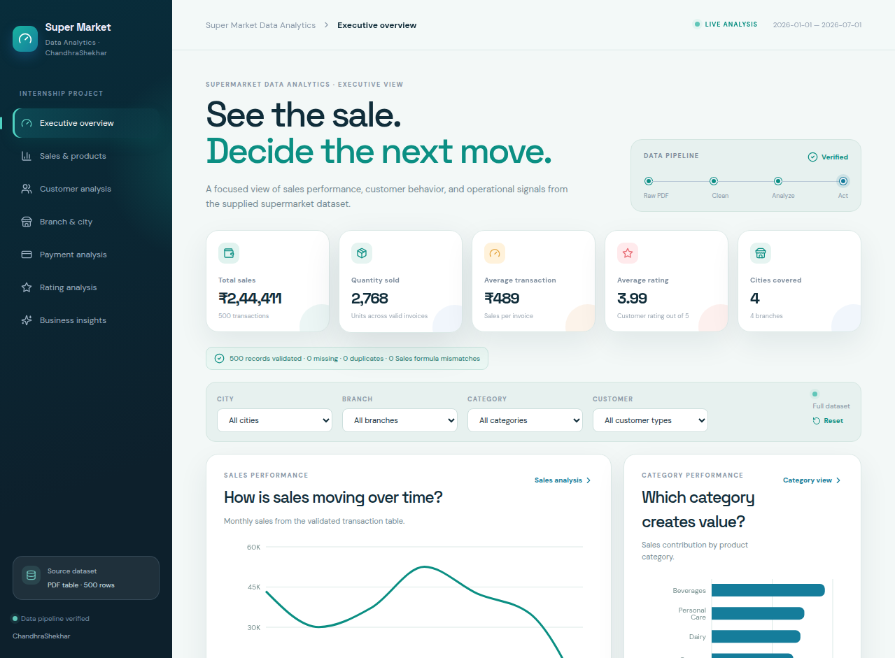

Technologies Used
Python, pandas, NumPy, scikit-learn, Matplotlib, Seaborn, Jupyter Notebook, React, TypeScript, Vite, Recharts, and Lucide icons.

Future Scope
Future work could add validated inventory and margin fields, payment-failure data, a longer customer history, a date-range control, and a genuine future outcome target before introducing predictive modeling.

