**MOTHERBOARD**

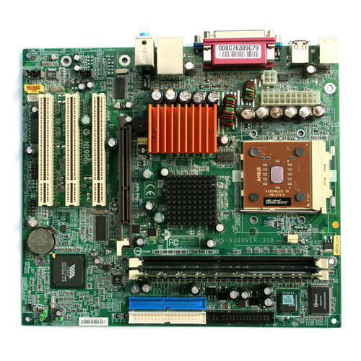

The motherboard is mounted inside the case and is securely attached via small screws through pre-drilled holes. Motherboard contains ports to connect all of the internal components. It provides a single socket for CPU, whereas for memory, normally one or more slots are available. Motherboards provide ports to attach the floppy drive, hard drive, and optical drives via ribbon cables. Motherboard carries fans and a special port designed for power supply.

**RAM MODULES**

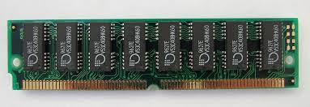

In computing, a memory module or RAM (random-access memory) stick is **a printed circuit board on which memory integrated circuits are mounted**. Memory modules permit easy installation and replacement in electronic systems, especially computers such as personal computers, workstations, and servers.

**DAUGHTER CARD**

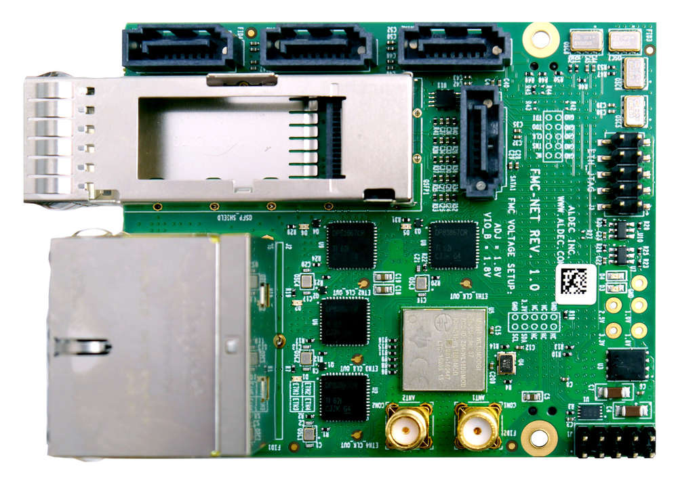

A daughtercard or daughterboard is **a type of circuit board that gets added to an existing one**. Its name is appropriate for its use, since it is connected to a “motherboard” or “main board.” The motherboard is the primary circuit board for a device. It is usually in the device as it is shipped from the factory.

**BUS SLOT**

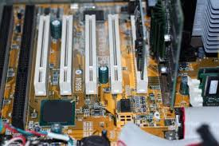

Alternatively known as a bus slot or expansion port, an expansion slot is **a connection or port inside a computer on the motherboard or riser card**. It provides an installation point for a hardware expansion card to be connected.

**SMPS**

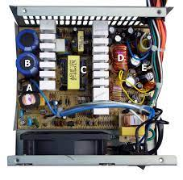

SMPS is **an electronic power supply system that makes use of a switching regulator to transfer electrical power effectively**. It is a PSU (power supply unit) and is usually used in computers to change the voltage to the appropriate range for the computer

**INTERNAL STORAGE DEVICE**

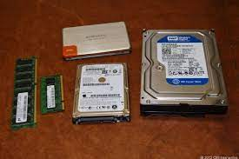

Most computers have some form of internal storage. The most common type of internal storage is the **hard disk**. At the most basic level, internal storage is needed to hold the operating system so that the computer is able to access the input and output devices.

**INTER FACING PORT**

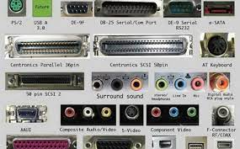

The ports are the physical docking points present in the computer through which the external devices are connected using cables. Or in other words, **a port is an interface between the motherboard and an external device of the computer**. There are different types of ports available: Serial port.