**Name:** Ananya jain **UID:** 22BCS15407

**Section:** 22BCS_IOT_620-B **Date:** 19 DEC 2024

**DOMAIN WINTER WINNING CAMP**

1. **Sum of Natural Numbers up to N Code:**

#include <iostream> using namespace std;

int main() { int n;

cout << "Enter a number: "; cin >> n;

cout << "Sum of natural numbers up to " << n << " is: " << (n * (n + 1)) / 2 << endl;

return 0;

**Output:**

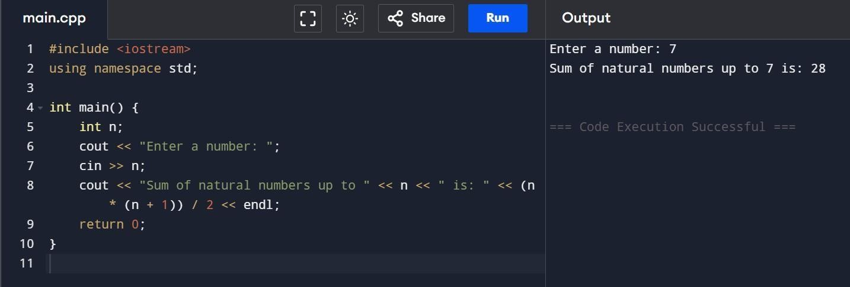

1. **Count Digits in a Number**

#include <iostream> using namespace std;

int countDigits(int n) { int count = 0; while (n > 0) {

n /= 10; // Remove the last digit count++;

}

return count;

}

int main() { int n;

cout << "Enter a positive integer: "; cin >> n;

if (n > 0) {

int digitCount = countDigits(n);

cout << "The number of digits in " << n << " is: " << digitCount << endl;

} else {

cout << "Please enter a positive integer!" << endl;

}

return 0;

}

**Output:**

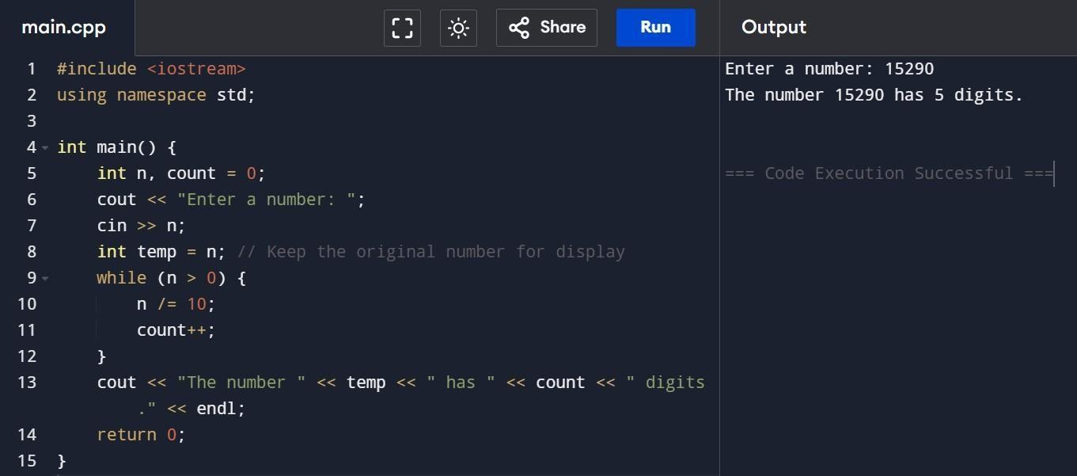

1. **Function overloading for Area calculation**

#include <iostream> using namespace std;

float area(float radius) {

return 3.14159 * radius * radius;

}

float area(float length, float breadth) { return length * breadth;

}

float area(float base, float height, bool triangle) {

return 0.5 * base * height;

}

int main() {

float radius, length, breadth, base, height;

cout << "Enter the radius of the circle: "; cin >> radius;

cout << "Circle Area: " << area(radius) << endl;

cout << "Enter the length and breadth of the rectangle: "; cin >> length >> breadth;

cout << "Rectangle Area: " << area(length, breadth) << endl;

cout << "Enter the base and height of the triangle: "; cin >> base >> height;

cout << "Triangle Area: " << area(base, height, true) << endl;

return 0;

}

**Output:**

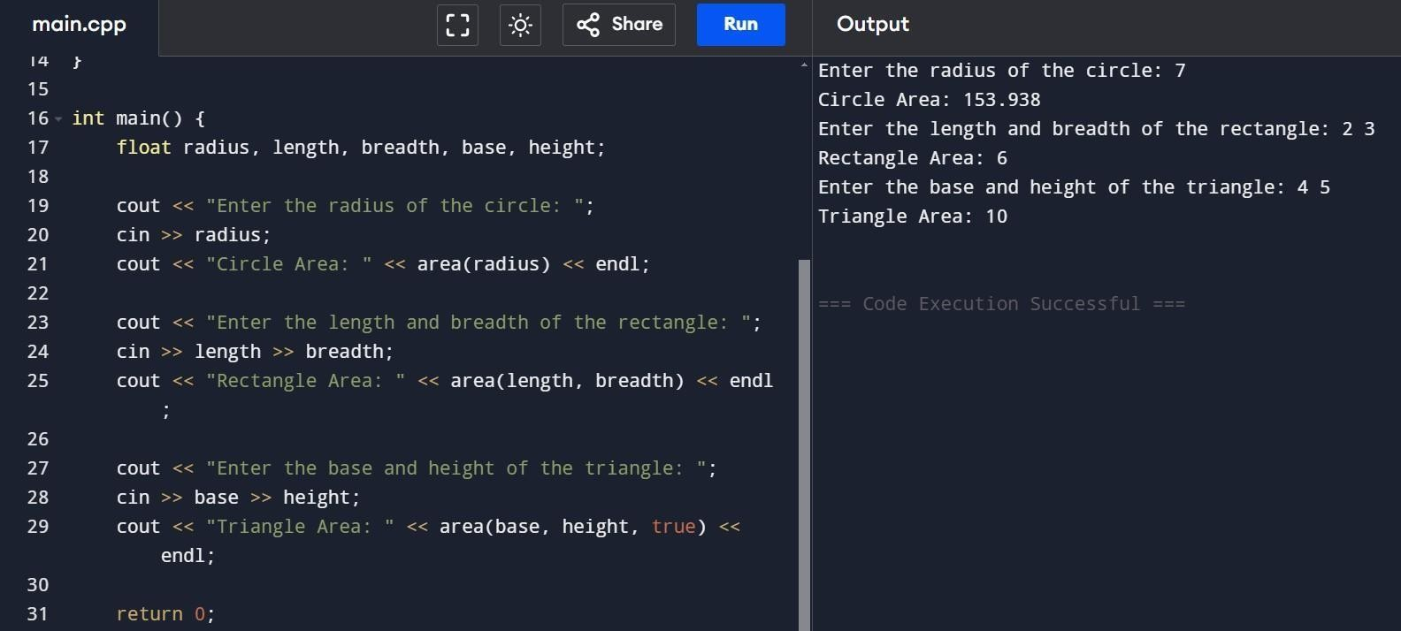

1. **Polymorphism with shape Area Calculations .**

#include <iostream> using namespace std;

class Shape { public:

virtual float calculateArea() = 0;

};

class Circle : public Shape { float radius;

public:

Circle(float r) : radius(r) {} float calculateArea() override {

return 3.14159 * radius * radius;

}

};

class Rectangle : public Shape { float length, breadth;

public:

Rectangle(float l, float b) : length(l), breadth(b) {} float calculateArea() override {

return length * breadth;

}

};

class Triangle : public Shape { float base, height;

public:

Triangle(float b, float h) : base(b), height(h) {} float calculateArea() override {

return 0.5 * base * height;

}

};

int main() {

float radius, length, breadth, base, height;

cout << "Enter the radius of the circle: "; cin >> radius;

Shape* circle = new Circle(radius);

cout << "Enter the length and breadth of the rectangle: "; cin >> length >> breadth;

Shape* rectangle = new Rectangle(length, breadth);

cout << "Enter the base and height of the triangle: "; cin >> base >> height;

Shape* triangle = new Triangle(base, height);

cout << "Circle Area: " << circle->calculateArea() << endl;

cout << "Rectangle Area: " << rectangle->calculateArea() << endl; cout << "Triangle Area: " << triangle->calculateArea() << endl;

delete circle; delete rectangle; delete triangle;

return 0;

}

**Output:**

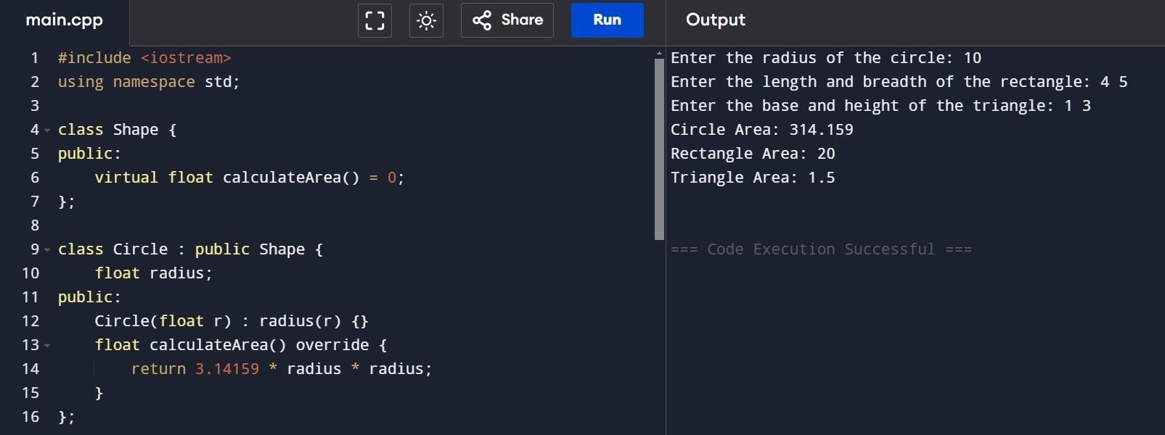

1. **Multi-level inheritance for vehicle simulation**

#include <iostream> using namespace std;

class Vehicle { protected:

string brand, model; double mileage;

public:

Vehicle(string b, string m, double mil) : brand(b), model(m), mileage(mil) {} virtual void displayDetails() {

cout << "Brand: " << brand << ", Model: " << model << ", Mileage: " << mileage << " miles" << endl;

}

};

class Car : public Vehicle { protected:

double fuel, distance; public:

Car(string b, string m, double mil, double f, double d) : Vehicle(b, m, mil), fuel(f), distance(d) {}

double calculateFuelEfficiency() { return distance / fuel;

}

void displayDetails() override { Vehicle::displayDetails();

cout << "Fuel Efficiency: " << calculateFuelEfficiency() << " miles/gallon" << endl;

}

};

class ElectricCar : public Car {

double batteryCapacity, efficiency; public:

ElectricCar(string b, string m, double mil, double bc, double eff)

: Car(b, m, mil, 0, 0), batteryCapacity(bc), efficiency(eff) {} double calculateRange() {

return batteryCapacity * efficiency;

}

void displayDetails() override { Vehicle::displayDetails();

cout << "Range: " << calculateRange() << " miles" << endl;

}

};

int main() {

string brand, model;

double mileage, fuel, distance, batteryCapacity, efficiency;

cout << "Enter Car details:\nBrand: "; cin >> brand;

cout << "Model: ";

cin >> model;

cout << "Mileage (miles): "; cin >> mileage;

cout << "Fuel (gallons): ";

cin >> fuel;

cout << "Distance Covered (miles): "; cin >> distance;

Car car(brand, model, mileage, fuel, distance); car.displayDetails();

cout << "\nEnter Electric Car details:\nBrand: "; cin >> brand;

cout << "Model: "; cin >> model;

cout << "Mileage (miles): "; cin >> mileage;

cout << "Battery Capacity (kWh): "; cin >> batteryCapacity;

cout << "Efficiency (miles/kWh): "; cin >> efficiency;

ElectricCar eCar(brand, model, mileage, batteryCapacity, efficiency); eCar.displayDetails();

return 0;

}

**Output:**

