**Student Name: Ananya Jain**

**DAY 4**

**UID: 22BCS15407**

**Branch: BE-CSE Section/Group: 620 - b Date of Performance:24/12/24**

# Problem 1

1. **Aim: Design a stack that supports push, pop, top, and retrieving the minimum element in constant time.**
2. **Code:**

#include <stack> #include <limits> class MinStack { private:

std::stack<int> mainStack; // Stack to store the actual elements std::stack<int> minStack; // Stack to store the minimum elements

public:

MinStack() {

}

void push(int val) { mainStack.push(val);

// If minStack is empty or the current value is less than or equal to the top of minStack

if (minStack.empty() || val <= minStack.top()) { minStack.push(val); // Push the new minimum onto minStack

}

}

void pop() {

if (mainStack.empty()) return; // Check if the stack is empty int topValue = mainStack.top();

mainStack.pop();

if (topValue == minStack.top()) { minStack.pop();

}

}

int top() {

return mainStack.top(); // Return the top element of the main stack

}

int getMin() {

return minStack.top(); // Return the top element of the min stack

}

};

int main() {

MinStack minStack; minStack.push(-2); minStack.push(0); minStack.push(-3);

std::cout << minStack.getMin() << std::endl; // return -3 minStack.pop();

std::cout << minStack.top() << std::endl; // return 0 std::cout << minStack.getMin() << std::endl; // return -2 return 0;

}

1. 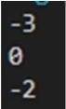**Output:**

# Problem 2

1. **Aim: The school cafeteria offers circular and square sandwiches at lunch break, referred to by numbers 0 and 1 respectively. All students stand in a queue. Each student either prefers square or circular sandwiches**
2. **Code:**

#include <iostream> #include <vector> #include <queue> using namespace std;

int countStudentsUnableToEat(vector<int>& students, vector<int>& sandwiches) {

queue<int> studentQueue; for (int student : students) {

studentQueue.push(student);

}

int sandwichIndex = 0; int n = sandwiches.size();

while (!studentQueue.empty() && sandwichIndex < n) { int currentStudent = studentQueue.front(); studentQueue.pop();

if (currentStudent == sandwiches[sandwichIndex]) { sandwichIndex++;

} else {

studentQueue.push(currentStudent);

}

if (studentQueue.size() == students.size()) { break;

}

}

return studentQueue.size();

}

int main() {

vector<int> students = {1, 1, 0, 0};

vector<int> sandwiches = {0, 1, 0, 1};

int result = countStudentsUnableToEat(students, sandwiches); cout << "Number of students unable to eat: " << result << endl; return 0;

}

1. **Output:**



# Problem 3

1. **Aim: Given a circular integer array nums (i.e., the next element of nums[nums.length - 1] is nums[0]), return the next greater number for every element in nums.**
2. **Code:**

#include <iostream> #include <vector> #include <stack>

std::vector<int> nextGreaterElements(std::vector<int>& nums) { int n = nums.size();

std::vector<int> result(n, -1); std::stack<int> s;

for (int i = 0; i < 2 * n; ++i) { int currentIndex = i % n;

while (!s.empty() && nums[currentIndex] > nums[s.top()]) { int index = s.top();

s.pop();

result[index] = nums[currentIndex];

}

if (i < n) { s.push(currentIndex);

}

}

return result;

}

int main() {

std::vector<int> nums = {1, 2, 1};

std::vector<int> result = nextGreaterElements(nums); for (int num : result) {

std::cout << num << " ";

}

std::cout << std::endl; return 0;

}

1. **Output:**



# Problem 4

1. **Aim: You are given an array of integers nums, there is a sliding window of size k which is moving from the very left of the array to the very right. You can only see the k numbers in the window. Each time the sliding window moves right by one position.**
2. **Code:**

#include <iostream> #include <vector> #include <deque> using namespace std;

vector<int> maxSlidingWindow(const vector<int>& nums, int k) { vector<int> result;

if (nums.empty() || k <= 0) return result;

deque<int> dq;

for (int i = 0; i < nums.size(); i++) {

if (!dq.empty() && dq.front() < i - k + 1) { dq.pop_front();

}

while (!dq.empty() && nums[dq.back()] < nums[i]) { dq.pop_back();

}

dq.push_back(i); if (i >= k - 1) {

result.push_back(nums[dq.front()]);

}

}

return result;

}

int main() {

vector<int> nums = {1,3,-1,-3,5,3,6,7}; int k = 3;

vector<int> result = maxSlidingWindow(nums, k); cout << "Maximum values in each sliding window: "; for (int maxVal : result) {

cout << maxVal << " ";

}

cout << endl; return 0;

}

1. **Output:**



# Problem 5

1. **Aim: WAP to implement a stack using array and linked list include operations like push pop peak isempty and isfully**
2. **Code:**

class ArrayStack { private:

int top;

int maxSize; int* stackArray;

public:

ArrayStack(int size) { maxSize = size;

stackArray = new int[maxSize]; top = -1;

}

~ArrayStack() { delete[] stackArray;

}

void push(int value) { if (isFull()) {

cout << "Stack is full. Cannot push " << value << endl; return;

}

stackArray[++top] = value;

}

int pop() {

if (isEmpty()) {

cout << "Stack is empty. Cannot pop." << endl; return -1; // or throw an exception

}

return stackArray[top--];

}

int peek() {

if (isEmpty()) {

cout << "Stack is empty. Cannot peek." << endl; return -1; // or throw an exception

}

return stackArray[top];

}

bool isEmpty() { return top == -1;

}

bool isFull() {

return top == maxSize - 1;

}

};

int main() { ArrayStack stack(5); stack.push(10); stack.push(20); stack.push(30);

cout << "Top element is: " << stack.peek() << endl; cout << "Popped element is: " << stack.pop() << endl; cout << "Top element is: " << stack.peek() << endl; return 0;

}

class Node { public:

int data; Node* next;

Node(int value) { data = value; next = nullptr;

}

};

class LinkedListStack { private:

Node* top;

public:

LinkedListStack() { top = nullptr;

}

~LinkedListStack() { while (!isEmpty()) {

pop();

}

}

void push(int value) {

Node* newNode = new Node(value); newNode->next = top;

top = newNode;

}

int pop() {

if (isEmpty()) {

cout << "Stack is empty. Cannot pop." << endl; return -1; // or throw an exception

}

Node* temp = top;

int poppedValue = top->data; top = top->next;

delete temp;

return poppedValue;

}

int peek() {

if (isEmpty()) {

cout << "Stack is empty. Cannot peek." << endl; return -1; // or throw an exception

}

return top->data;

}

bool isEmpty() {

return top == nullptr;

}

};

int main() { LinkedListStack stack; stack.push(10); stack.push(20); stack.push(30);

cout << "Top element is: " << stack.peek() << endl; // 30 cout << "Popped element is: " << stack.pop() << endl; // 30 cout << "Top element is: " << stack.peek() << endl; // 20 return 0;

}

1. 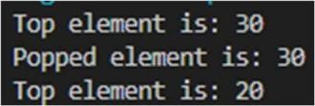**Output:**

# Problem 6

1. **Aim: given a string use the stack to reverse the string**
2. **Code:**

string reverseString(const string& str) { stack<char> charStack;

for (char ch : str) { charStack.push(ch);

}

string reversedStr;

while (!charStack.empty()) { reversedStr += charStack.top(); charStack.pop();

}

return reversedStr;

}

int main() {

string input;

cout << "Enter a string to reverse: "; getline(cin, input);

string reversed = reverseString(input);

cout << "Reversed string: "<<reversed<<endl; return 0;

}

1. 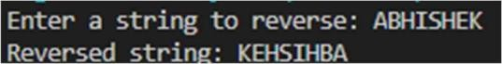**Output:**

# Problem 7

1. **Aim: implementation of stack using two queue**
2. **Code:**

class StackUsingQueues { private:

queue<int> q1; queue<int> q2;

public:

void push(int x) { q2.push(x);

while (!q1.empty()) {

q2.push(q1.front()); q1.pop();

}

swap(q1, q2);

}

void pop() {

if (!q1.empty()) { q1.pop();

}

}

int top() {

if (!q1.empty()) { return q1.front();

}

throw out_of_range("Stack is empty");

}

bool isEmpty() { return q1.empty();

}

int size() {

return q1.size();

}

};

int main() { StackUsingQueues stack; stack.push(1); stack.push(2); stack.push(3);

cout <<"Top element: "<<stack.top()<<endl; stack.pop();

cout <<"Top element after pop: "<<stack.top()<<endl;

cout<<"Is stack empty? "<<(stack.isEmpty() ? "Yes" : "No")<<endl; stack.pop();

stack.pop();

cout<<"Is stack empty after popping all elements? "<<(stack.isEmpty()

? "Yes" : "No")<<endl; return 0;

}

1. 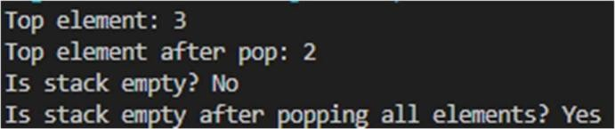**Output:**

# Problem 8

1. **Aim: GIVEN A STRING find the first non-repeating character and return its index value, if it does not exist return -1 value**
2. **Code:**

int firstNonRepeatingCharacter(const string& str) { unordered_map<char, int> charCount;

for (char ch : str) { charCount[ch]++;

}

for (int i = 0; i < str.length(); i++) { if (charCount[str[i]] == 1) {

return i;

}

}

return -1;

}

int main() { string input;

cout << "Enter a string: "; getline(cin, input);

int index = firstNonRepeatingCharacter(input); if (index != -1) {

cout << "The first non-repeating character is at index: "<<index<<endl;

} else {

cout << "No non-repeating character found." << std::endl;

}

return 0;

}

1. **Output:**

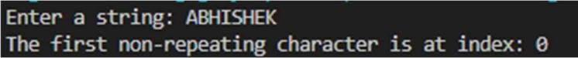

# Problem 9

1. **Aim: CHECK THE MINIMUM VALUE OF STACK AFTER PUSH AND POP OPERATIONS**
2. **Code:**

int main()

{

stack<int> s;

int arr[] = { 18, 19,29,16,15};

int n = sizeof(arr)/sizeof(arr[0]); for (int i = 0; i < n; i++)

{

s.push(arr[i]);

}

cout<<" the minimum stack is : "<<arr[0]<<endl; return 0;

}

1. **Output:**



# Problem 10

1. **Aim: There are a number of plants in a garden. Each of the plants has been treated with some amount of pesticide. After each day, if any**

**plant has more pesticide than the plant on its left, being weaker than the left one, it dies.**

1. **Code:**

#include <iostream> #include <vector> #include <stack> #include <algorithm> using namespace std;

int poisonousPlants(vector<int>& p) { int n = p.size();

vector<int> days(n, 0); stack<int> s;

for (int i = 0; i < n; ++i) {

while (!s.empty() && p[i] > p[s.top()]) {

days[i] = max(days[i], days[s.top()] + 1); s.pop();

}

s.push(i);

}

return *max_element(days.begin(), days.end());

}

int main() { int n;

cout << "Enter the number of plants: "; cin >> n;

vector<int> p(n);

cout << "Enter the pesticide levels: "; for (int i = 0; i < n; ++i) {

cin >> p[i];

}

int result = poisonousPlants(p);

cout << "Number of days until no plants die: " << result << endl; return 0;

}

1. 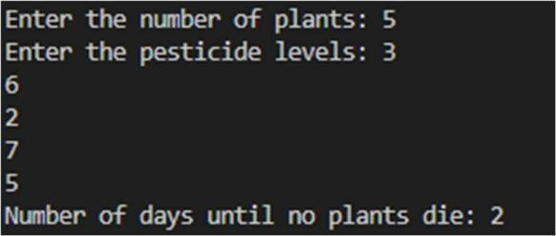**Output:**