

**Continuous Assessment 2**

**Individual Assignment**

Course:

Object Oriented Analysis and Design - ICT2133

Due Date: 30.05.2023

Finished by

TG/2020/674 – M.P.C. Priyamantha

Faculty of Technology

University of Ruhuna

1. Question one – Activity Diagram

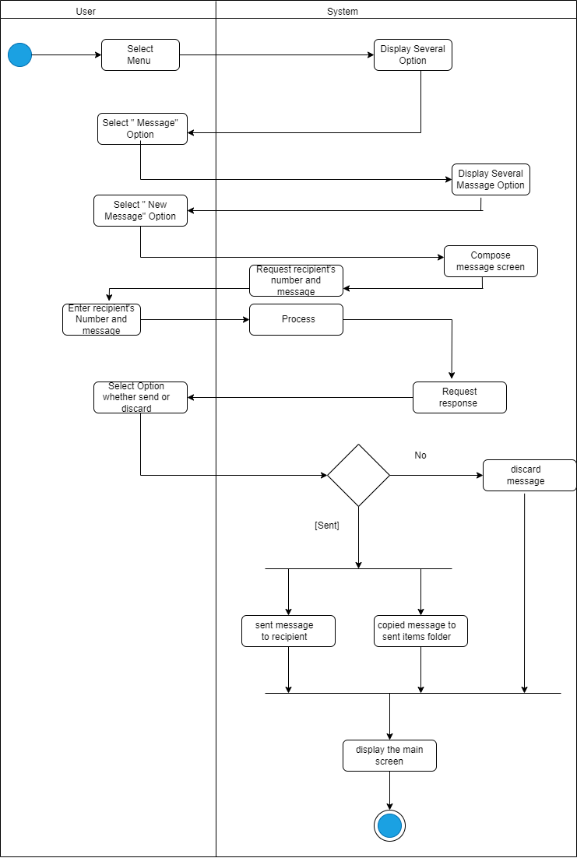

2. Question two – Use case Diagram

