

**Continuous Assessment 1**

**Individual Assignment**

Course:

Object Oriented Analysis and Design - ICT2133

Due Date: 28.02.2023

Finished by

TG/2020/674 – M.P.C. Priyamantha

Faculty of Technology

University of Ruhuna

1. Question one – Use Case Diagram

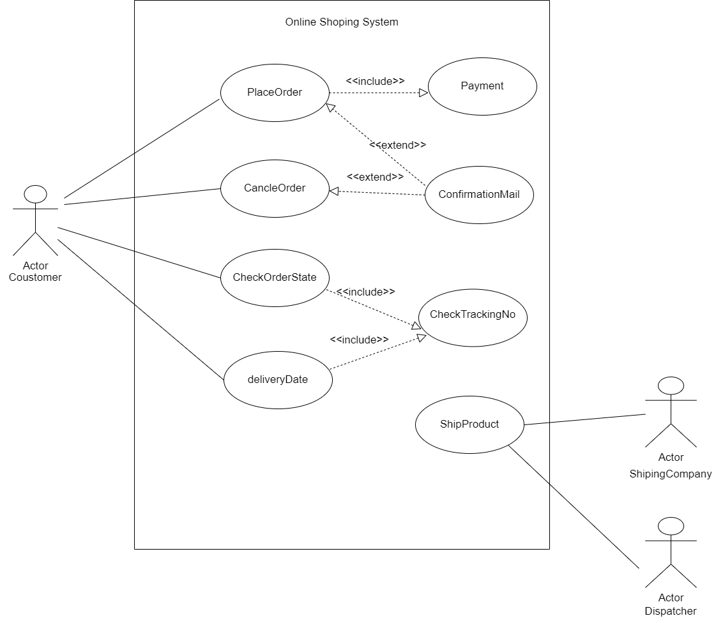

2. Question two – Activity Diagram

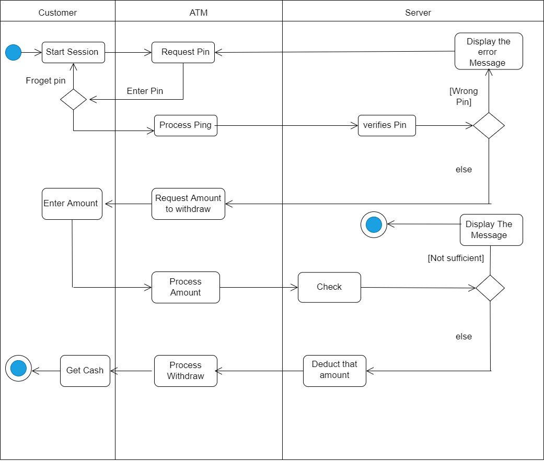

Important: - Assumptions

01. Customers can enter the Debit/Credit card through the start Session. Card also is authorized by the system.

02. After redirect into home page, Customer must start the money withdraw process from starch. That mean from the start Session.