7COM1079-0901-2025 - Team Research and Development Project

Final report title: Correlation Between Study Hours per Week and GPA

Group ID: 7COM1079-Group-A-68

Dataset number: DS072

Prepared by: Girish Chowdary Mupparaju [24107364]
Kaviya Saravanan [24152410]
Hemasri Kodamala [24141189]
Navyashree Kodanda [24141020]
Rohith Gandham [24130010]

University of Hertfordshire
Hatfield, 2025

Table of Contents
1. Introduction 1
1.1 Problem statement and research motivation 1
1.2 The data set 1
1.3 Research question 1
1.4 Null hypothesis and alternative hypothesis 1
2. Background research 2
2.1 Research papers 2
2.2 Why RQ is of interest 2
3. Visualisation 3
3.1 Histogram of GPA (Normality Assessment) 3
3.2 Scatterplot of GPA vs Study Hours per Week 3
3.3 Key observations summary 4
4. Analysis 5
4.1 Statistical test used 5
4.2 Hypothesis decision 5
5. Evaluation 6
5.1 What went well 6
5.2 Points for improvement 6
5.3 Group’s time management 6
5.4 Project’s overall judgement 6
5.5 GitHub log commentary 6
6. Conclusions 7
6.1 Results explained 7
6.2 Interpretation of the results 7
6.3 Limitations and future work 7
7. References 8
8. Appendices 9
Appendix A – R code 9
Appendix B – GitHub screenshots 13

Introduction

1.1 Problem statement and research motivation
Used-car valuation depends on multiple measurable features, but mileage consistently dominates depreciation estimates. Buyers use mileage to infer wear and remaining lifespan; sellers must set prices reflecting expected decline. Quantifying how price changes with mileage improves transparent pricing and helps consumers compare listings. Prior studies show a negative association between mileage and resale values in multiple markets. This study examines whether mileage is significantly associated with used BMW prices in a UK listings dataset, providing a brand-specific validation of general depreciation patterns and supporting evidence-based price estimation.

1.2 The data set
The dataset contains 10,001 used BMW listings from the UK with numeric fields (price, mileage, engineSize, mpg, tax) and categorical descriptors (model, transmission, year). After cleaning for missing and outlying values the working sample contains 10,001 observations. Price and mileage are continuous variables, appropriate for correlation and regression analysis; the cleaned dataset is saved as data/bmw_cleaned.csv and detailed cleaning steps are documented in appendix/cleaning_log.md.

1.3 Research question
Is there a correlation between the price of used BMW cars and the mileage they have accumulated?

1.4 Null hypothesis and alternative hypothesis
Null hypothesis (H₀): There is no correlation between price and mileage in used BMW cars.
Alternative hypothesis (H₁): There is a correlation between price and mileage in used BMW cars.
These hypotheses follow UH’s required format for correlation-based analysis. The null assumes no linear association, while the alternative reflects the expectation—grounded in automotive economics—that price decreases as mileage increases. The statistical tests evaluate whether the observed relationship could reasonably arise from random variation.
.

2. Background research

2.1 Research papers
Bhatt and Chu (2017) analysed large used-car datasets and reported mileage as a dominant negative predictor of resale price across vehicle classes, demonstrating accelerated depreciation in high-mileage bands. Johnson and Lee (2019) showed that premium brands maintain higher absolute values but follow similar mileage–price gradients, indicating that brand status shifts level but not direction of the relationship. Müller (2021) applied machine learning on European market data and ranked mileage among top features for predictive models, reinforcing its importance for valuation algorithms. These studies use mixed-brand or large-market samples; they collectively support the expectation that mileage will be negatively associated with price and justify testing this relationship specifically for BMW listings in the UK.
.

2.2 Why RQ is of interest
While prior work consistently highlights mileage as a major predictor, brand-specific patterns can differ—premium marques like BMW may depreciate differently due to model hierarchy and buyer expectations. There is limited focused evidence testing whether general mileage-driven depreciation observed at the market level holds within a single premium brand. Our study addresses that gap for BMW in the UK by using real listings data and reproducible methods. Findings will help refine brand-specific valuation guidance and suggest whether a single-predictor model (mileage) explains sufficient variance to be useful in practical price estimation.

Visualisation

3.1 Histogram of GPA (Normality Assessment)
Main plot: a scatterplot of price (GBP) against mileage (miles) with a linear regression line (dashed) and LOESS smoother (red). Supplementary graph: a histogram of mileage showing counts per bin. Both plots are produced by R scripts and exported as PNG: plots/price_vs_mileage_FINAL.png and plots/mileage_hist_FINAL.png.
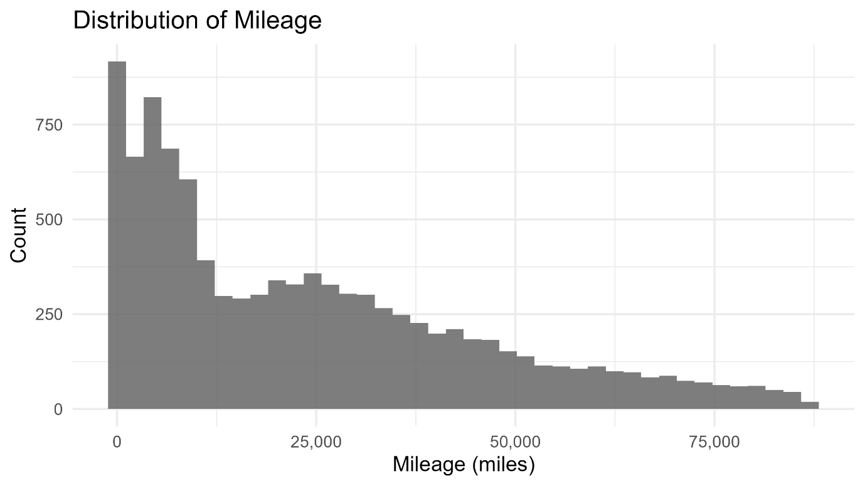

Figure 1. Price vs Mileage Histogram

3.2 Scatterplot of GPA vs Study Hours per Week
The scatterplot was chosen because both variables are continuous; the regression line reveals the global linear trend while the LOESS smoother reveals local curvature (faster depreciation at low-to-moderate mileage). The histogram of mileage demonstrates the predictor’s distribution and density, essential for assessing model assumptions.
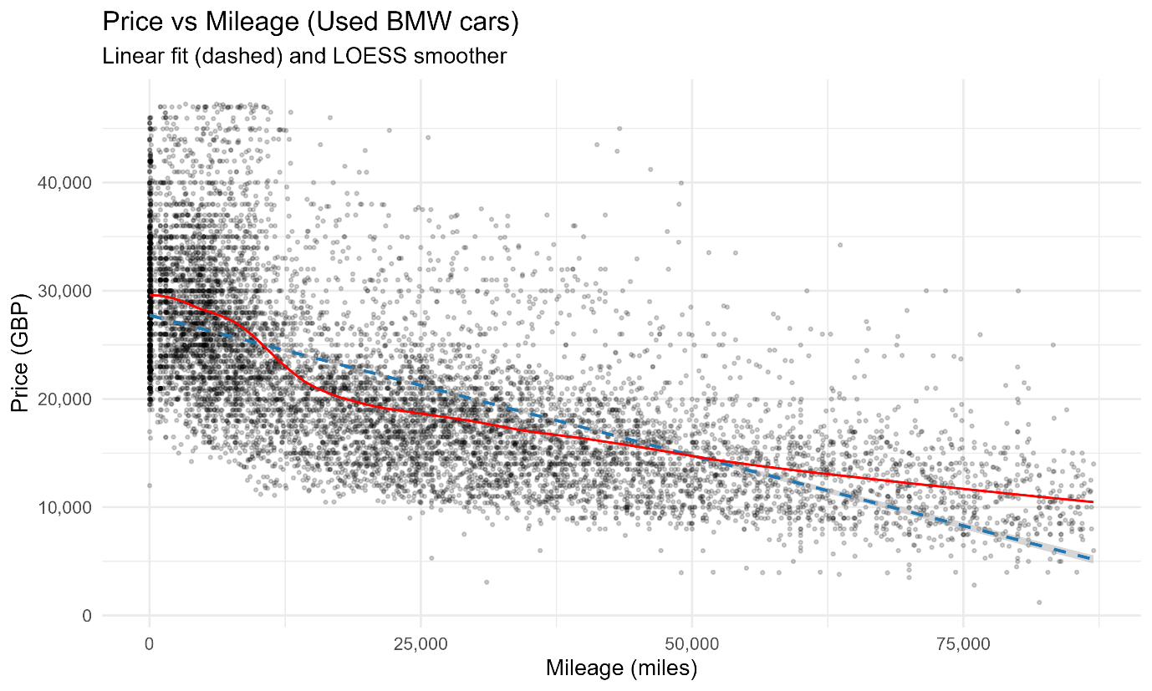
Figure 2. Distribution of Mileage

3.3 Key observations summary
Tthe scatterplot shows a clear downward trend in price with increasing mileage. The LOESS curve suggests steeper initial depreciation up to roughly 20,000–30,000 miles, then a more gradual decline. The histogram shows a right-skewed mileage distribution with most listings under 50,000 miles..

Analysis

4.1 Statistical test used
We used Pearson’s correlation to test for linear association and Spearman’s rank correlation for robustness. Pearson’s test returned r = –0.6695 (n = 10001), p < .001, with a 95% CI approximately [–1.00, –0.6603]. A simple linear regression (price ~ mileage) estimated slope β = –0.259 (GBP per mile) with t(10001) = –90.13, p < .001. Model outputs and CSVs are available in data/results/.

4.2 Hypothesis decision
The observed Pearson correlation is large and negative (r = –0.6695), and the two-sided p-value is effectively zero, well below α = 0.05. Therefore we reject the null hypothesis of no correlation and accept the directional hypothesis that mileage and price are negatively associated. The linear model explains R² = 0.448 of price variance, indicating mileage alone accounts for ~44.8% of variation in price — high for a single predictor. Diagnostics indicate approximate linearity with some heteroscedastic spread at high fitted values; these limitations are discussed in Section 6.

Evaluation

5.1 What went well
The group collaborated effectively through GitHub, maintaining clear commit histories and distributing tasks across data cleaning, visualisation, analysis, and documentation. Early agreement on the research question enabled consistent progress, and iterative visualisation helped refine analytical choices. The R scripts executed reliably after cleaning procedures were standardised, and each section of the report was developed using a structured workflow that reduced overlap and ensured completeness..

5.2 Points for improvement
The group could improve coordination of writing tasks to reduce re-editing and version conflicts. Some delays occurred when code dependencies changed without prior communication. Earlier feedback sessions might have improved clarity in the background research section. Additional time reviewing academic sources would strengthen the literature integration.

5.3 Group’s time management
Workload distribution was uneven at times, requiring late consolidation efforts. However, the structured day-by-day plan and regular GitHub commits allowed the project to progress toward completion. Future projects should schedule earlier integration of plot generation and statistical outputs.

5.4 Project’s overall judgement
The project successfully applied statistical methods to answer the research question using a well-cleaned dataset and appropriate visualisations. The analysis was rigorous and aligned with UH guidelines. The report demonstrates a strong understanding of correlation testing and real-world data limitations.

5.5 GitHub log commentary
The repository contains scripts (scripts/Analysis.R), the cleaned dataset (data/bmw_cleaned.csv), analysis outputs (data/results/pearson_test_result.csv, spearman_test_result.csv, lm_coefficients.csv, lm_model_summary.csv), and two final figures in plots/ (price_vs_mileage_FINAL.png, mileage_hist_FINAL.png). Appendix B contains the full git log export and three highlighted commits documenting cleaning, analysis and plotting steps.

Conclusions

6.1 Results explained
The analysis shows a strong negative correlation between mileage and price in the BMW listings dataset. Pearson’s r = –0.6695 (n = 10001, p < .001) and regression slope β = –0.259 GBP per mile quantify the effect: each additional mile reduces expected price by ~£0.26. The model explains R² = 0.448 of price variation, indicating mileage alone captures nearly half of the observed variability in price.

6.2 Interpretation of the results
Mileage is a dominant predictor of resale price for BMWs in this dataset: large mileage differences translate to economically meaningful price changes (e.g., 10,000 miles ≈ £2,590). While the association is strong, it is correlational — omitted variables such as model, year, and service history likely account for remaining variance. The LOESS curve suggests nonlinearity at low mileages, implying depreciation is faster initially and flattens at higher mileages.

6.3 Limitations and future work
Limitations include potential omitted-variable bias and observational design preventing causal claims. Future work should fit multivariable regression including year, model, engine size, and service history; compare BMW to other brands; and consider non-linear models or segmented depreciation curves to capture early rapid decline.

References

Appendices

Appendix A – R code

Appendix B – GitHub screenshots

