WAS
Difference between 8.5 and 9
WAS 9 supports JAVA EE7 and 8.5 supports JAVA EE6 and multiple security enhancements
latest was version – 8.5.5.27/9.0.5.24
Versions Of WAS currently using – 8.5.5.18 to 8.5.5.22/9.0.5.6 to 9.0.5.14
Versions of IBM HTTP Server – 8.5.5.13 to 8.5.5.26
Linux version – cat /etc/release (RHEL 7.9)
Tomcat version – 9.0.102
Apache – 2.4.53

latest was version – 8.5.5.27/9.0.5.24
Versions Of WAS currently using – 8.5.5.18 to 8.5.5.28/9.0.5.6 to 9.0.5.25
Versions of IBM HTTP Server – 9.0.5.25/8.5.5.28
Linux version – cat /etc/release (RHEL 8)
Tomcat version – 9.0.108
Apache – 2.4.63/65

Websphere is a platform which provides infrastructure to run business application. Middleware acts in between frontend/backend.

Difference between application server and webserver:
Webserver - http requests are handled by this. It provides security and mainly for static pages like webpages.
App server - handles tasks like processing client requests, facilitating communication with database etc.

Explain architecture of Websphere Application server and its component:
We have standalone and network deployment (ND):
Standalone means – single application server also known as single point of failure.
ND – It is clustered environment where multiple application servers are managed as single domain by Deployment manager. This architecture is used for large scale deployments particularly those requiring high availability.
Clustering: multiple app servers are grouped together to form cluster, allowing for load distribution. horizontal clustering refers to deploying multiple application servers across different physical machines (nodes) to increase scalability and availability. Vertical clustering, on the other hand, involves running multiple application servers on the same physical machine.

DMGR: A central administrative agent that manages entire cluster and provides a unified view of all managed nodes

Nodeagents: responsible for configuration synchronization between the Deployment Manager and the Node

cell: a logical grouping of one or more application servers, managed together by a central administration console

Nodes: They are individual physical or virtual machines where application servers reside

diff btw cell and cluster: A cell can contain multiple clusters and nodes. A WebSphere cluster is a group of two or more application servers that work together

+++++++++++++++++explain request flow?
whenever user makes request for example www.abc.com then request will be forwarded to DNS. DNS will forward request to LB. LB will send the request to webserver.
now if the request is looking for static content like html pages or images then webserver itself gets the response.
if it is looking for dynamic content then webserver routes that request to corresponding appserver with the help of plugin
at the time of webserver startup, it loads httpd.conf file and it contains path of plugincfg.xml file( route HTTP requests to the appropriate application server) this file contains all the details of app servers. so that webserver forwards request to app servers
app servers has 2 containers- web container and EJB containers--->if request is looking for web resources like servlets,html etc webcontainers itself generate response.
and if it is looking for ejb resources like session beans etc thatrequest will be forwarded to ejb container through jndi. if requestrequired database interaction then it will go to connection pool, connection object once transaction is completed then it will return to pool.
finally request forward from webcontainer to webserver and webserver to end user ++++++++++++++++++++++

Plugin-cfg.xml file path:
It consists of backend application server details that can handle requests, clusters, Virtual Host (Maps incoming requests to specific applications based on host and port), URI Routing Rules (Specifies which URIs should be routed to which application servers or clusters), Route Definitions (Connects URI groups to server clusters), Load Balancing and Failover Settings.

<Server Name="server1">
<Transport Hostname="appserver1.example.com" Port="9080" Protocol="http"/>
</Server>

Clusters:
<ServerCluster Name="Cluster1">
<Server Name="server1"/>
<Server Name="server2"/>
</ServerCluster>

<UriGroup Name="myAppURIs">
<Uri Name="/myApp/*"/>
</UriGroup>

<Route ServerCluster="Cluster1" UriGroup="myAppURIs" VirtualHostGroup="default_host"/>
<LoadBalanceWeight>2</LoadBalanceWeight>
<RetryInterval>60</RetryInterval>

Types of profiles:

profile: it defines the runtime environment. profile includes all the files that the server processes in run time env

Deployment management profile(DMGR profile): It uses DMGR template at the time of dmgr profile creation. Here we won’t get any server by default. Just will get a dmgr process and it is used to manage federated servers and applications.

cell profile: dmgr+ application profile

custom profile: it does not include default applications or a default server like app serverprofile. add the node to the deployment manager cell.then you can use the administrative interface of deployment manager to customize managed node by creating clusters and application servers.

application server profile: here we will get a server called server1 by default and we can use this server to deploy and run the applications. Used to configure applications.

Secure proxy profile: use secure proxy server to take requests from internet and forward them to application server resides in DMZ

Virtual Host:
maps hostnames and port numbers to web applications.
A Virtual Host in WAS does:
Determines which applications respond to which incoming HTTP requests.
Maps host:port combinations (like example.com:9080) to web modules.

How It Works
When a request comes in:
The Web Server Plug-in or IHS forwards the request to WAS.
WAS checks the host and port in the request.
It matches this to a Virtual Host.
If the virtual host is mapped to a web module, the request is routed to that application.

Httpd.conf: servername, port listen, server root, document root (static content), logs, virtual host (ssl, servername, port) kdb path, plugin path, load modules (ssl, plugin), {apache -proxy-reverse proxy) (apachectl - HTTPD=configuration path)
VirtualHost *:80>
ServerName www.example.com
DocumentRoot "/opt/IBM/HTTPServer/htdocs/example"
ErrorLog logs/example_error.log
CustomLog logs/example_access.log combined

<Directory "/opt/IBM/HTTPServer/htdocs/example">
Options Indexes FollowSymLinks
AllowOverride None
Require all granted
</Directory>
</VirtualHost>

Integrate it with Websphere plug-in:

<VirtualHost *:80>
ServerName app.example.com
DocumentRoot "/opt/IBM/HTTPServer/htdocs"

WebSpherePluginConfig /opt/IBM/HTTPServer/Plugins/config/webserver1/plugin-cfg.xml
</VirtualHost>

Configure virtual Host in the admin console:
Navigate to:
Environment → Virtual Hosts
You can:
Create new virtual hosts.
Add host aliases (host:port pairs).
Map virtual hosts to web modules in applications.

Also, in Deployment Descriptor. In web.xml or application.xml, you can reference a virtual host name, During deployment, you assign the application to a virtual host

Context Root:

A context root is the first part of a web application's URL that tells the server which application to route the request to.

If your app has a context root of /shop, then it will be accessed like this:
http://yourserver.com/shop

Common Issues with Context Root:
Problem: Two applications are deployed with the same context root (e.g., /app)
Effect: Only one application will respond; the other may fail to start or be unreachable
Fix: Ensure each application has a unique context root.

Problem: The context root is set incorrectly during deployment (e.g., / instead of /myApp)
Effect: Users can't access the application using the expected URL.
Fix: Update the context root in the Admin Console or during redeployment.

Problem: The web server (e.g., IBM HTTP Server) routes requests to a context root not defined in WAS.
Effect: 404 errors or routing failures.
Fix: Ensure the plugin-cfg.xml is regenerated and synchronized with the web server.
Outdated or Missing plugin-cfg.xml File --- This file tells the web server how to route requests to WAS. If it's not updated after deploying a new application or changing a context root, routing will fail

404 Not Found errors when accessing the application via the web server
Application works when accessed directly via WAS port (e.g., http://hostname:9080/app) but fails via the web server(e.g., http://hostname/app)
Error in logs:
[error] [client x.x.x.x] File does not exist: /opt/IBM/HTTPServer/htdocs/app

What causes the mismatch: incorrect virtual host mapping, plugin not generated, even if the context root is correct, if the application isn't associated with the virtual host used by the web server, the request won't reach the app

security constraints on a context root are rules that control who can access specific parts of a web application. These constraints are typically defined in the web.xml deployment descriptor of a web module (WAR files)
A security constraint specifies:
- Which URLs (context paths) are protected.
- What roles are allowed to access them.
- What HTTP methods (GET, POST, etc.) are restricted.

DAY TO DAY ACTIVITIES:

we mostly work on deployments, scheduled restarts, data source creations, configuration changes in tomcat, SSL renewals and troubleshooting.
I majorly take care of WAS Fix pack upgrades and tomcat upgrades.

Install WAS:

- update installer before WAS8
- WAS SETUP FROM THE SCRATCH
- Install IBMIM (root – /opt/ibm/installationanager/eclipse/tools)
Get the agent installer zip file and run the cmd : ./install -slient -acceptlicense -sP

[[[./install com.ibm.cic.agent -repositories ../repository.config -installationDirectory /export/local/opt/soft/IBMIM/installationmanager -dataLocation /export/local/opt/soft/IBMIM/datalocation -accessRights nonAdmin -acceptLicense -showVerboseProgress]]]

- Install WAS 8.5.5.0 base version on both the servers
/export/local/opt/soft/was85modl/WebSphere/AppServerBin
verify the version

- WAS FIXPACK 8.5.5.22 on both the servers(offering_ID with ProductID)
./imcl install com.ibm.websphere.ND.v85_8.5.5022.20220703_1123 -repositories /export/local/opt/soft/software/TEMP_WAS_FIXPACK_INSTALL/TEMP_WAS855_FIXPACK_INSTALL_130224050739/repository.config -installationDirectory /export/local/opt/soft/was85modl/WebSphere/AppServerBin -acceptLicense -showVerboseProgress
&& verify the version

- Creating DMGR on ftwlmscimw89
/export/local/opt/soft/was85modl/WebSphere/AppServerBin
./manageprofiles.sh -create -templatePath /export/local/opt/soft/was85modl/WebSphere/AppServerBin/profileTemplates/dmgr -profileName uwgp2_modl_dm -profilePath /export/local/opt/soft/was85modl/WebSphere/uwgp2_modl_dm -cellName uwgp2_modl_cell -nodeName uwgp2_modl_dm -hostName ftwlmscimw89.r1-core.r1.aig.net -isDefault=true -startingPort 60000 -validatePorts

/export/local/opt/soft/was85modl/WebSphere/uwgp2_modl_dm/logs/AboutThisProfile.txt
Node name: uwgp2_modl_dm
Cell name: uwgp2_modl_cell
Host name: ftwlmscimw89.r1-core.r1.aig.net
Enable administrative security (recommended): False
Administrative console port: 60000
Administrative console secure port: 60001
Management bootstrap port: 60002
Management SOAP connector port: 60003

Creating Node on ftwlmscimw89
/export/local/opt/soft/was85modl/WebSphere/AppServerBin
./manageprofiles.sh -create -templatePath /export/local/opt/soft/was85modl/WebSphere/AppServerBin/profileTemplates/managed -profileName uwgp2_modl_node -profilePath /export/local/opt/soft/was85modl/WebSphere/ uwgp2_modl_node -nodeName mw89_uwgp2_modl_node -hostName ftwlmscimw89.r1-core.r1.aig.net -isDefault=true -startingPort 60050 -validatePorts

- Creating Node on ftwlmscimw90
/export/local/opt/soft/was85modl/WebSphere/AppServerBin
./manageprofiles.sh -create -templatePath /export/local/opt/soft/was85modl/WebSphere/AppServerBin/profileTemplates/managed -profileName uwgp2_modl_node -profilePath /export/local/opt/soft/was85modl/WebSphere/uwgp2_modl_node -nodeName mw90_uwgp2_modl_node -hostName ftwlmscimw90.r1-core.r1.aig.net -isDefault=true -startingPort 60050 -validatePort

- Federation is called - adding application server node into cell.

Federate DMGR with node on ftwlmscimw89
start DMGR now and execute below steps
/export/local/opt/soft/was85modl/WebSphere/uwgp2_modl_node/bin
./addNode.sh ftwlmscimw89.r1-core.r1.aig.net 60003 -startingport 60050
Federate DMGR with node on ftwldscimw90
/export/local/opt/soft/was85modl/WebSphere/uwgp2_modl_node/bin
./addNode.sh ftwlmscimw89.r1-core.r1.aig.net 60003 -startingport 60050

7. cluster creation through jython scripts

Cluster is: dac
Server 1 is: dac_1
Node1 is: mw134_uwgp2_qa_node
Starting Port is: 60150
Host is: ftwldscimw134.r1-core.r1.aig.net
Server 2 is: dac_2
Node2 is: mw135_uwgp2_qa_node
Host is: ftwldscimw135.r1-core.r1.aig.net
Cluster logs directory: /opt/logs/was85/dac/qa
Virtual Host is: dac

Otherwise, we can create cluster from the console as well

soap.client.props
{xor}MihvaD47MjYx, 1800(timeout)

8.config changes: heap size, custom_properties, jdbc, data source(Add env variable jconn3.jar file path), virtual host
data source test connection.

IBM WAS Fixpack:
- Fixpack - 8.5.5.18 -8.5.5.22
- WAS85.22 doesn't support java 1.7
- Disk space check
- take backup of WAS profile
- Installation directory - /export/local/opt/soft/was85dev/WebSphere/AppServerBin/bin/ ./versionInfo.sh - version check
- ./managesdk.sh -listEnabledProfileAll - to check java versions supported by applications
- cd .
- cd etc/.ibm/registry/
- cat InstallationManager.dat - to get the imcl path
- cd /home/usradmin/IBM/InstallationManager/eclipse/tools/ - verify imcl is there or not
./imcl listInstalledPackages
- ps -ef | grep -i java | grep -i was855s | awk '{print $2}' | xargs kill -9] - stop all the services
- ./imcl uninstall 7.0.1.0-WS-WASJavaSDK7-LinuxS39064-IFPH34273_7.0.1000.20210210_1454 -installationDirectory /export/local/opt/soft/was85dev/WebSphere/AppServerBin -sVP
- ./imcl uninstall 7.1.0.0-WS-WASJavaSDK7-LinuxS39064-IFPH34272_7.1.0.20210210_1432 -installationDirectory /export/local/opt/soft/was85dev/WebSphere/AppServerBin -sVP
- ./imcl uninstall com.ibm.websphere.IBMJAVA.v70_7.0.10070.20200825_1806 -installationDirectory /export/local/opt/soft/was85dev/WebSphere/AppServerBin -sVP
- ./imcl uninstall com.ibm.websphere.IBMJAVA.v71_7.1.4070.20200910_1552 -installationDirectory /export/local/opt/soft/was85dev/WebSphere/AppServerBin -sVP
- ./imcl listInstalledPackages - verify if the 1.7 java packages are uninstalled
Now Upgrade the WAS version.
-->Error while executing versionInfo.sh/managesdk.sh
/export/local/opt/soft/was85dev/WebSphere/AppServerBin/bin/sdk/_setupSdk.sh: line 36: /export/local/opt/soft/ was85dev/WebSphere/AppServerBin/bin/sdk/_setupsdk1.7_64.sh: No such file or directory
Resolution -
ls -lrt /export/local/opt/soft/was85dev/WebSphere/AppServerBin/bin/sdk/_setupsdk1.7_64.sh
cd /export/local/opt/soft/was85dev_FP18/WebSphere/AppServerBin/properties/sdk/
grep -i 1.7 *.properties
export/local/opt/soft/was85dev/WebSphere/AppServerBin/properties/sdk/
cp -pr cmdDefaultSDK.properties cmdDefaultSDK.properties_bkp
vi cmdDefaultSDK.properties
change it COMMAND_DEFAULT_SDK=1.7_64 to COMMAND_DEFAULT_SDK=1.8_64_bundled
cd ../../bin/
./versionInfo.sh
./historyInfo.sh

- changing the java version with below cmd:
./managesdk.sh -enableProfile -profileName ocds_prod_node -sdkName 1.8_64

- FIXPACK - 9.0.5.6- 9.0.5.14
Prevalidation steps -
Need to check the disk space
cd ~ -> home directory
Need to check if imcl is present under installationManager/eclipse/tools/
Need to take backup of WAS profile
Place the FP zip file under any specific path, unzip the file and check the extracted repository.config for the latest version/offeringID
Stop the services by executing the kill cmd - [ref - ps -ef | grep -i java | grep -i was855 | awk '{print $2}' | xargs kill -9]
./stopNode.sh -stopservers -username mwadmin -password
imcl command -
./imcl install <<offering ID_Version>> -repositories <<repository.config file path>> -installationDirectory <<Installation directory>> -acceptLicense -showVerboseProgress
./imcl install com.ibm.websphere.ND.v85_8.5.5022.20220703_1123 -repositories /app/software/TEMP_WAS_FIXPACK_INSTALL/TEMP_WAS855_FIXPACK_INSTALL_080523082855/repository.config -installationDirectory /app/was85/WebSphere/AppServerBin -acceptLicense -showVerboseProgress –log /tmp/log.txt
offering id will be present in cd /home/usradmin/IBM/InstallationManager/eclipse/tools/ &&./imcl listInstalledPackages
Post validation -
Navigate to bin path
- check the version
./versionInfo.sh
- clear the cache
./clearClassCache.sh
./osgiCfgInit.sh
start the services

Pre-requisites:
backupprofile.sh / was85 folder bkp, jvm stop(stopnode.sh or kill), clearclasscache - 18 version cache / OSGcfgninit- conf initialization(best practice)(node-bin and dm-bin)- logs checks if nodegant is not up, IM -version issue 1.8 to 1.9

IHS – WAS INTEGRATION:

- IHS INSTALL:
./imcl install com.ibm.websphere.IHS.v85_8.5.5000.20130514_1044,arch.64bit -repositories /export/local/opt/soft/software/TEMP_IHS_INSTALL/TEMP_IHS855_INSTALL_021124045935/repository.config -installationDirectory /export/local/opt/soft/IBMIHS85 -properties user.ihs.httpPort=80,user.ihs.allowNonRootSilentInstall=true -acceptLicense -showVerboseProgress.

- IHS Fixpack command:
./imcl install com.ibm.websphere.IHS.v85_8.5.5026.20240702_1024 -repositories /app/software/TEMP_IHS_FIXPACK_INSTALL/TEMP_IHS855_FIXPACK_INSTALL_210525114506/repository.config -installationDirectory /app/soft/IBMIHS85 -acceptLicense -showVerboseProgress

- PLUGIN INSTALL COMMAND:
./imcl install com.ibm.websphere.PLG.v85_8.5.5000.20130514_1044,com.ibm.jre.6_64bit -repositories /export/local/opt/soft/software/TEMP_PLUGIN_INSTALL/TEMP_PLUGIN855_INSTALL_021124020626/repository.config -installationDirectory /export/local/opt/IBMIHS85_Plugins -acceptLicense -showVerboseProgress.

GenPluginCfg.sh -cell.name -output.file.name <path_to_output/plugin-cfg.xml>

This includes the plugin-cfg.xml generator and the plug-in module for IHS

- Configure webserver in admin console:
Servers → Server Types → Web Server
Click New and enter webserver name, type-ibm http, select node where ihs is installed, specify ihs config directory - /opt/ibm/httpserver/conf

- Update httpd.conf in ihs server
server name, port listen, server root, document root(static content), logs, virtual host(ssl,servername, port) kdb path, plugin path,load modules(ssl, plugin)

LoadModule was_ap22_module /opt/IBM/WebSphere/Plugins/bin/64bits/mod_was_ap22_http.so
WebSpherePluginConfig /opt/IBM/WebSphere/Plugins/config/webserver1/plugin-cfg.xml

ssl.conf -p12 file path: Private Key, p12, ssl engine ON,ciphers.

- Deploy applications then, generate and propagate plugin.

Servers → Web Servers → webserver

Click Generate Plug-in to create plugin-cfg.xml – this will create plugin
in dmgr profile.

Click Propagate Plug-in to copy it to the IHS directory

Cluster creation:
Provide clustername, membername*(jvm_name)

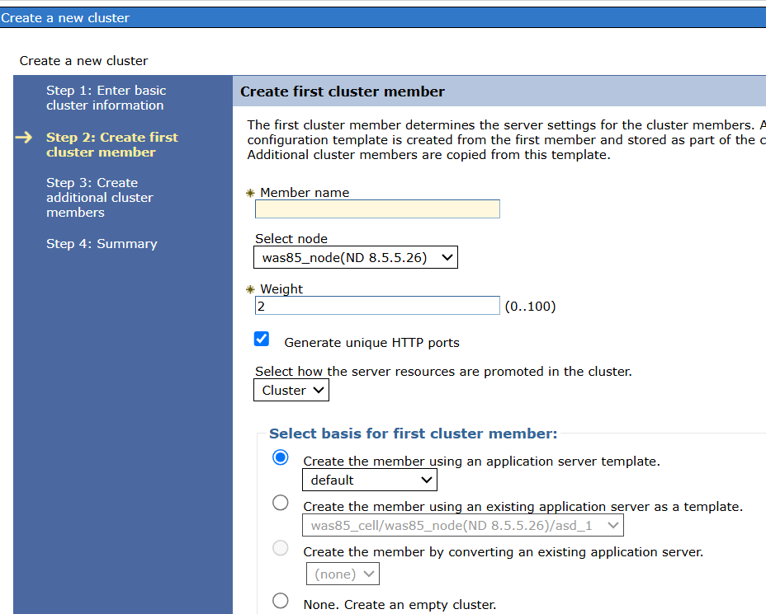

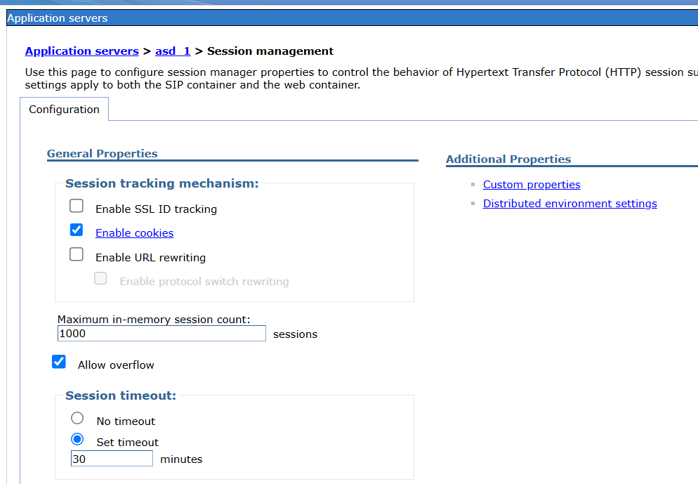

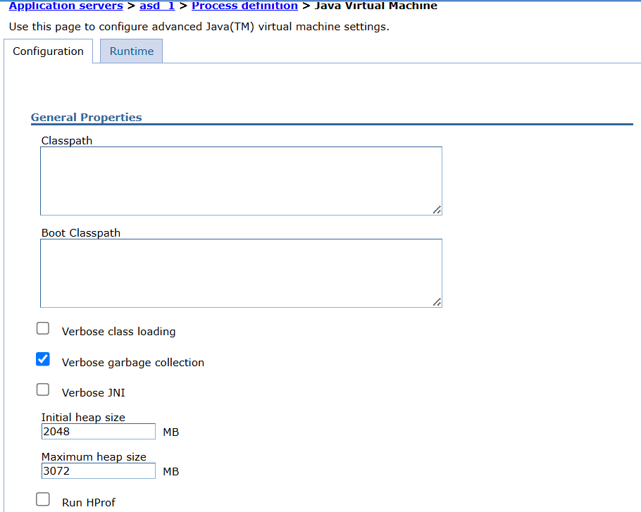

Generic JVM arguments:
-Xms1000m -Xmx1000m -XX:PermSize=256m -XX:MaxPermSize=256m -XX:MaxNewSize=500m -XX:NewSize=500m -XX:+PrintGCDetails -XX:+PrintGCTimeStamps -Xloggc:/home/sherpa/Sherpa/Server/log/gc.log -XX:+HeapDumpOnOutOfMemoryError -Dlog4j.configuration=file:/path/to/log4j.properties
-verbose:class
-XX:HeapDumpPath=/path/to/dump

We mention min and max heap, specifies garbage collection, enables debugging, system properties like -Dapp.env=prod, logging configuration, class loading and memory

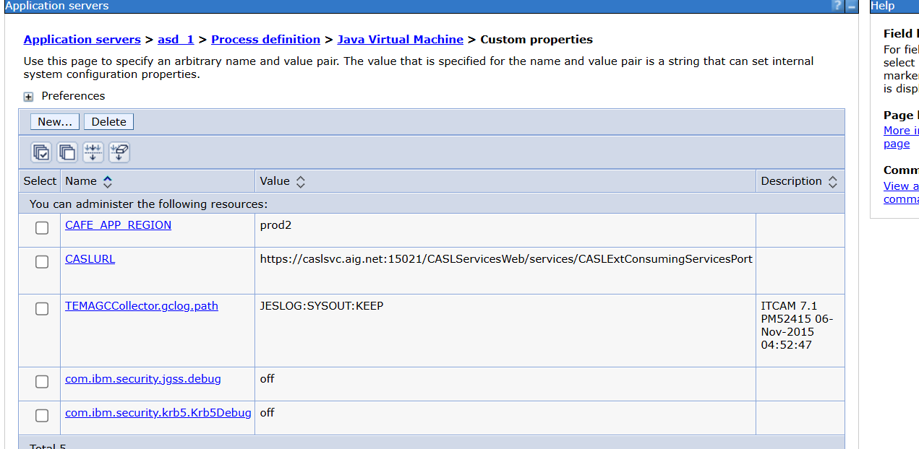

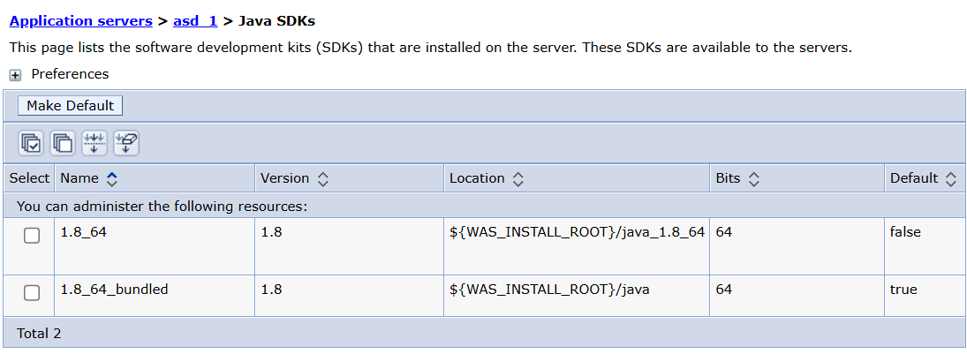
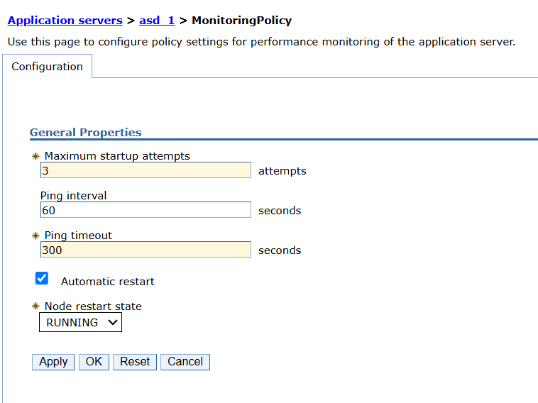

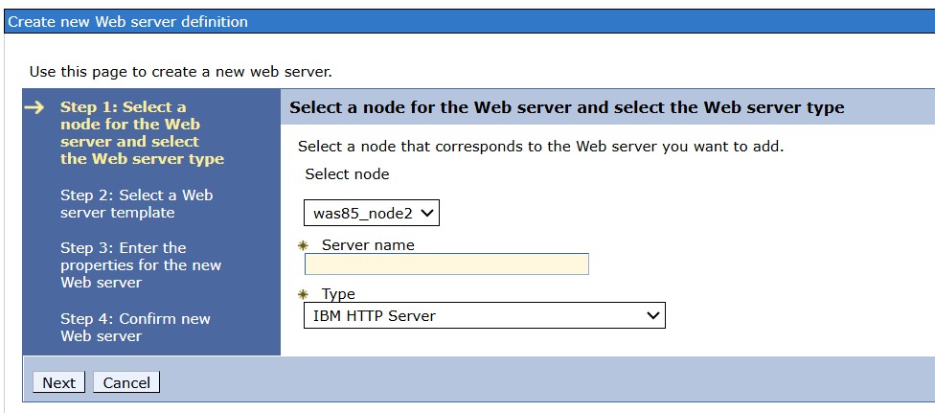
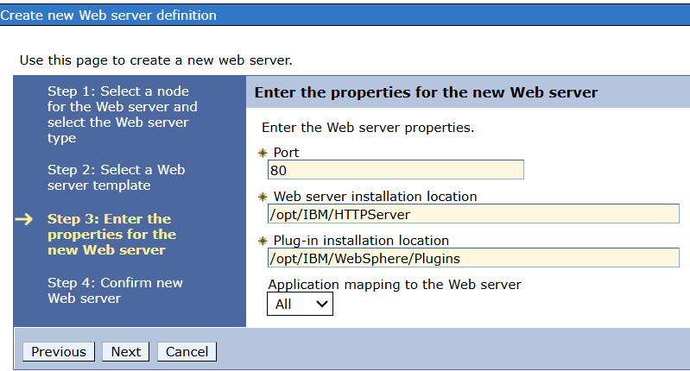

Types of jdbc drivers:
JDBC drivers are software components that enable WAS to connect to relational databases using the Java Database Connectivity (JDBC) API. These drivers act as a bridge between the application server and the database, allowing applications deployed on WAS to perform database operations.
IBM Db2 | db2jcc.jar (JCC driver)
Oracle | ojdbc8.jar or ojdbc11.jar
Microsoft SQL Server | mssql-jdbc.jar

Thin drivers (Converts JDBC calls directly into the database's native protocol using Java, No native libraries; platform-independent; easy to configure.)
, Network-protocol driver, JDBC-ODBC driver, Native-API driver. IT is recommended to use thin driver provides best performances. Mostly we use type2/4 drivers

Connection pool datasource is suitable for simple, non-transcational connectivity to a single resource manager
XA datasource provides transactional connectivity to multiple resource managers.

JDBC PROVIDER CREATION: to create pool of connections to that db.. you associate data source with jdbc provider.

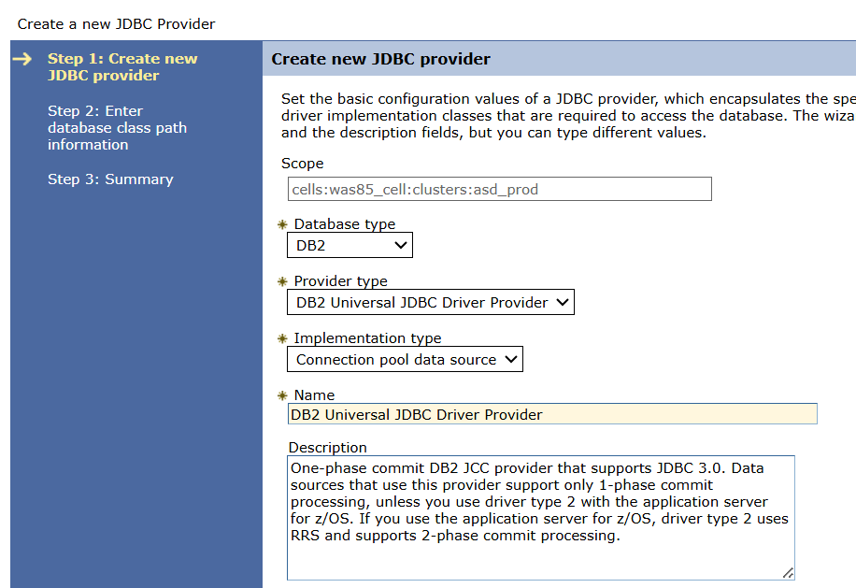
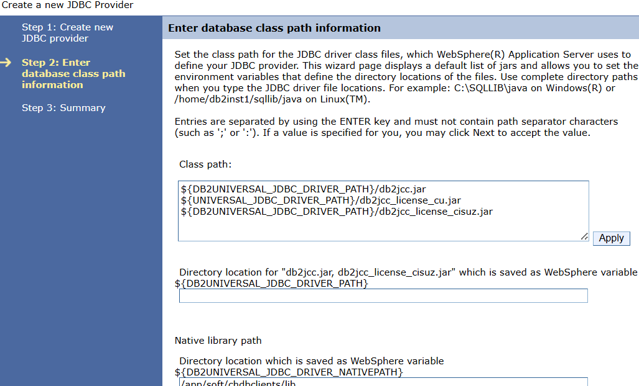

DATA SOURCE CREATION:

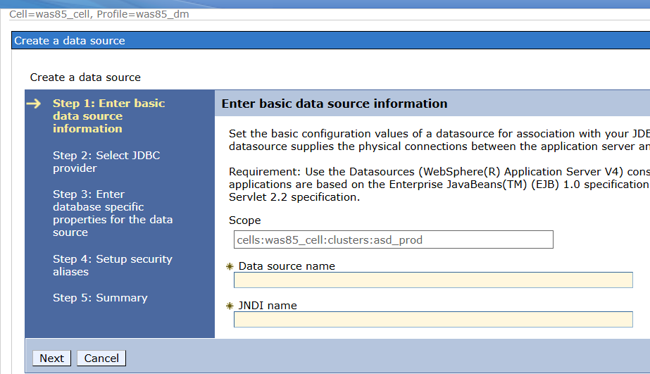

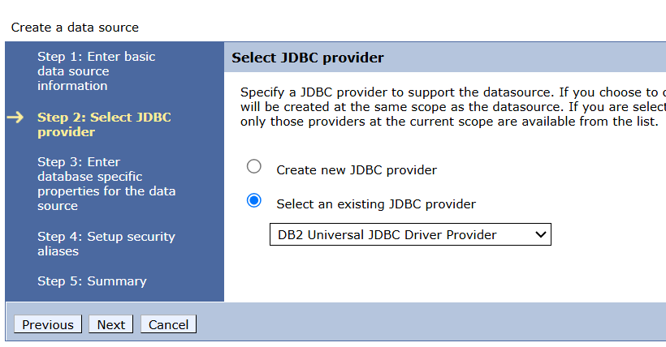

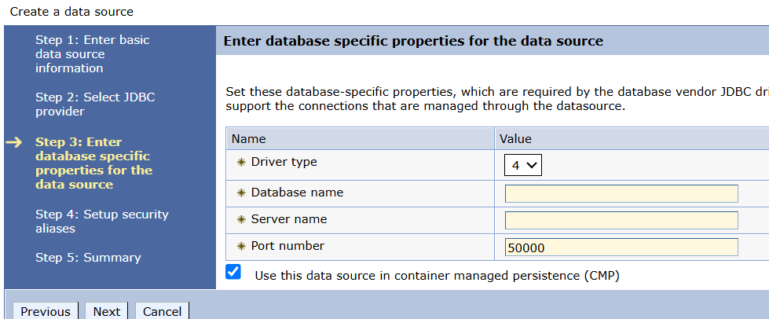

Virtual host:

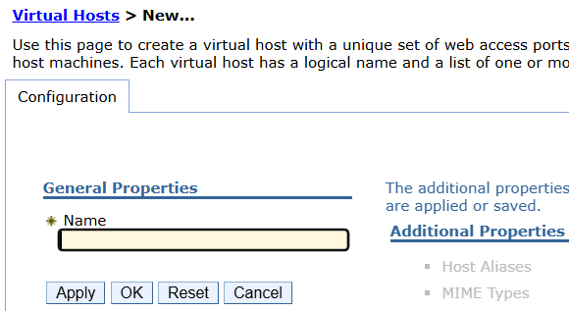

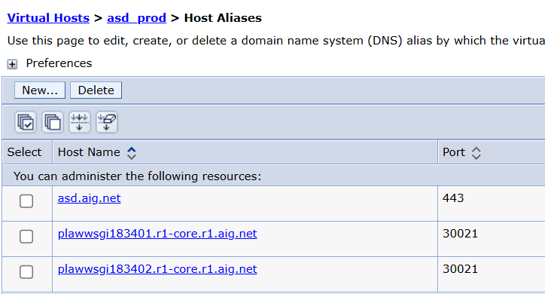

Websphere variables:
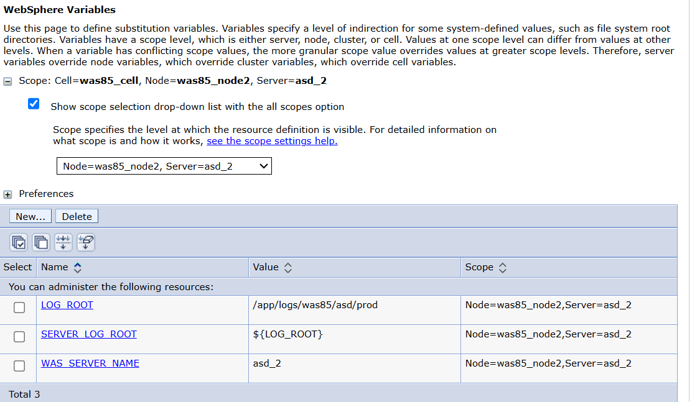

Configurations Files:

Resource.xml file (under profile/cluster): resource definitions(jdbc,jms)
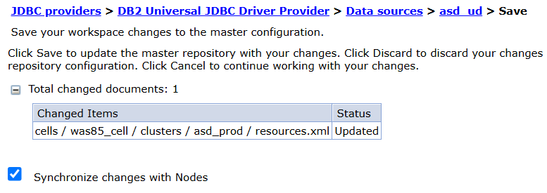

Virtualhosts.xml (under cell):

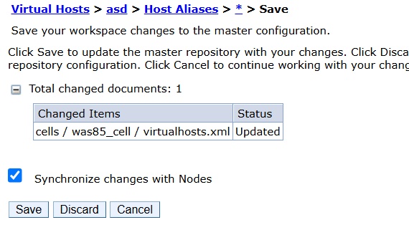

Variables.xml: env variables

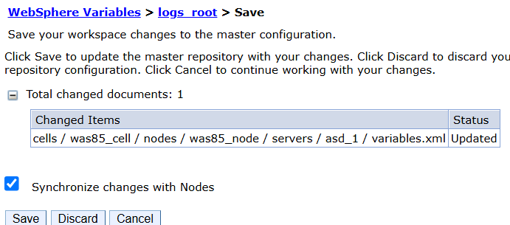

Security.xml: (cert update or db id and pswd) cell scope (/app/soft/was85/WebSphere/was85_node/config/cells/was85_cell)

Server.xml: (nodes scope) jvm setting
/app/soft/was85/WebSphere/was85_dm/config/cells/was85_cell/nodes/was85_node/servers/asd_1

Serverindex.xml (ports): node scope
/app/soft/was85/WebSphere/was85_dm/config/cells/was85_cell/nodes/was85_dm

Soap.client.properties(used for administrator communication between nodes and WAS cell)- to disable pswd for admin console, com.ibm.SOAP.securityEnabled property=false)
/app/soft/was85/WebSphere/was85_node/properties

Where as sas.client.props files to configure the security settings for administrative communication and client auth

Default ports of HTTP used by browser- 80,HTTPS-443, proxyport-8080, secure proxyport-8443, AJP port- 8009, SNMP(simple network management protocol -161, ldap -389(not secure),636(secure)

default http port for app-9080, default https port for app-9443
Admin console http- 9060, Admin console https:9043, SOAP connector port-8880 &Nodeagentport-8879,
Bootstrap -2809+1

Security Repositories:

LDAP registry: this uses external LDAP server to store user and group information
Federated Repository: allows integration of multiple security repositories such as LDAP or custom registries

Steps to configure security repositories:
First we get hostname, port number and certificates, bind Distuinguished Name, bind pswds. BASE DN
Secure port(636) , not secure port (389). Primary Failover hostnames

Admin console-security-global security- click on checkbox enable admin security-choose security realm (standalone ldap registry) – click on configure- specify connection information and credentials such as hostname,portnumber, cred for ldap server

Add group and user roles. Security.xml file gets updated after ldap changes and vimhosts files as well.

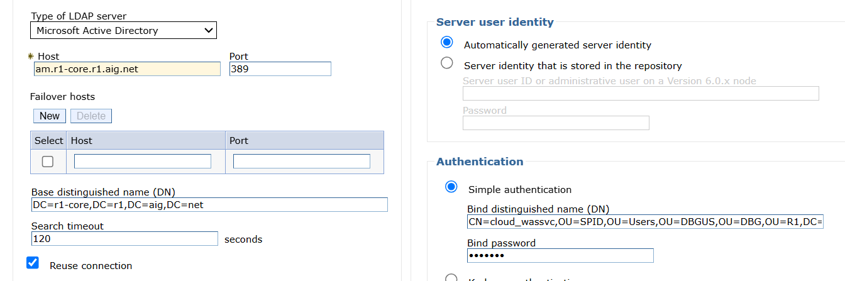

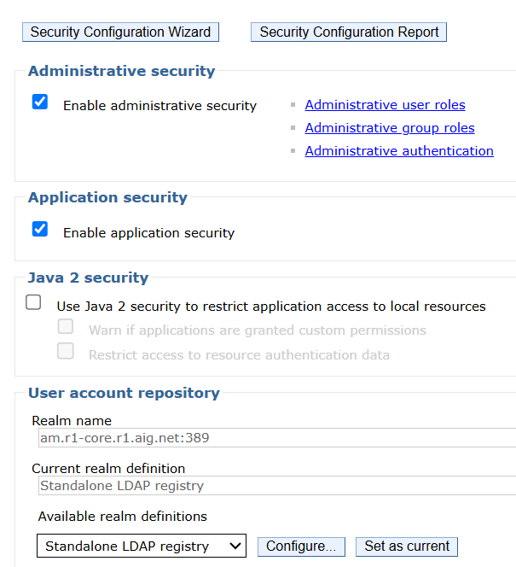

At last group roles & User roles creates - admin, operator, configurator, monitor

What are GC policies:

Automatic memory management process performed by JVM. It reclaims the memory used by objects that no longer needed.

Gencon - default GC policy in WAS. It is designed to minimize pause time. Suitable for large heaps that requires low pause
Other gc policies: Balanced,optthruput, incremental,genrt

Linux commands:

To create heap dump :
jmap -dump:format=b,file=/app/logs/ocuk_1/integ/tmp/heapdumps.hprof 507641

To create thread dump – kill -3 <PID>

To delete logs : find . -type f -name "*.log" -mtime +10 -exec gzip {} \;

tar -zcvf wp85prod_bkp_03122022.tar.gz wp85prod_bkp_03122022

telnet algsascs3655005.r1-core.r1.aig.net:8088

top(cpu), free -m (memory), swap memory-portion of hard disk that is used as virtual memory when physical RAM is fully used

Syncnode.sh

SSL/TLS/CIPHERS:

What is ssl(secure socket layer) : SSL cert is a digital certificate that authenticates identity of a website or application and encrypts sensitive info transmitted over the internet.

How do you install SSL certificate in IBM WAS? We need to create keystore and import the cert in keystore then you need add ssl configurations in WAS console.

What is keystore: a file contains of private keys and ssl certificates used to encrypt/decrypt the ssl traffic.

Diff between self-signed and CA signed: self signed is cert generated and signed by entity that owns private key. Where Certifcate Authority(CA) a third party will verify identity of cert holder

Renew cert in IHS – first generate CSR using the current private key and submit to CA. once CA issues new cert we can import it to CA.

Java/bin path - ./gskcmd -keydb -create -db <path/key.kdb> -pw <pswd> -type cms -expire 365 -dn “CN=his_servernanme,OU=org_unit” -size 2048 -label his-cert -default _cert yes -certreq -file /path/to/his_cert.arm – This will generate CSR store in the given path. Now once CA issue certificate we add in the server.

To add the cert - ./gskcmd -cert -add -db /path/to/key.kdb -pw <keystore-pswd> -label ihscert -target /path/to/his_cert.pem

/app/soft/IBMIHS85/bin/gskcmd -cert -details -label icorr.author.modl.npclaimsapp.us-east-1.aws.aig.net -db /app/soft/IBMIHS85/key_db/author_remote_qa/key.kdb -pw mw07admin

./gskcmd -cert -list -label <certificate_name> -db /opt/IBMIHS85/key_db/gceu_prod/key.kdb

Renew SSL in WAS:

To generate CSR in p12 files:
Keytool -certreq -alias mykey -keystore mykeystore.p12 -storetype PKcs12 -file mycsr.csr

To import signed cert into the keystore: before this when we get cert from PKI as pem file then we convert jks to p12 file:

Mostly we use ikeyman tool:

Get the existing p12 file and remove the old personal certificates.

To convert jks to p12 using keytool:
/app/soft/ocdsapac/SG_ClaimSvc/java/bin/keytool -importkeystore -srckeystore truststore.jks -srcstorepass changeit -destkeystore truststore.p12 -deststorepass changeit -deststoretype PKCS12

./keytool -importcert -keystore /app/tomcat9_1/apache-tomcat-9.0.48/key_db/truststore.jks -storepass XXXX -noprompt -alias omega-ws.aig.net_2023 -file /tmp/gayathri/omega-ws.aig.net.cer

SSL configure WAS:

1.First we have to create private key using keytool cmd.

Keytool -genkey -alias mykey -keyalg RSA -keysize 2048 -keystore mykeystore.p12

2. create certificate siging request (CSR)

Keytool -certreq -alias mykey -keystore mykeystore.jks -file mycsr.csr

3. CA authority provides certs and now we get the any keystore format (based on org. we will verify alias name, algorithm SHA256, DNS names

Key.p12 we created alias now CA gave different alias (same certs will not be there in single keystore, same alias)

Alias delete – CA keystore cert will import in generated p12 initialing

Keytool -delete -alias mydomain -keystore key.p12

Will rename alias name after importing cert in our generated key.p12

Keytool -importkeystore -srckeystore<> -destkeystore<> -deststoretype<>

-destalias

Refresh console gets reflected and dmgr restart, nodeagent,

SSL and TLS handshake:
Initial negotiation between client and server to establish secure connection
It includes series of steps such as establishing encryption also verifying certs and exchange session keys.

Client sends TLS versions supported , cipher suites , the server responds with chosen TLS version and server cert (public key). Client verifies server cert then session keys get exchanges.

SSl handshake error:

Protocol mistmatch, certificate issues -expired, ciphersuite mismatch

- TLS_ECDHE_ECDSA_WITH_AES_256_GCM_SHA384
- TLS_ECDHE_RSA_WITH_AES_256_GCM_SHA384
- TLS_ECDHE_ECDSA_WITH_AES_128_GCM_SHA256
- TLS_ECDHE_RSA_WITH_AES_128_GCM_SHA256
- TLS_ECDHE_RSA_WITH_CHACHA20_POLY1305_SHA256

Certificate which are not owned by

To add signer certs in truststore.jks:
./keytool -importcert -keystore /app/tomcat9_1/apache-tomcat-9.0.48/key_db/truststore.jks -storepass XXXX -noprompt -alias omega-ws.aig.net_2023 -file /tmp/gayathri/omega-ws.aig.net.cer

TROUBLESHOOTING THE ISSUES:

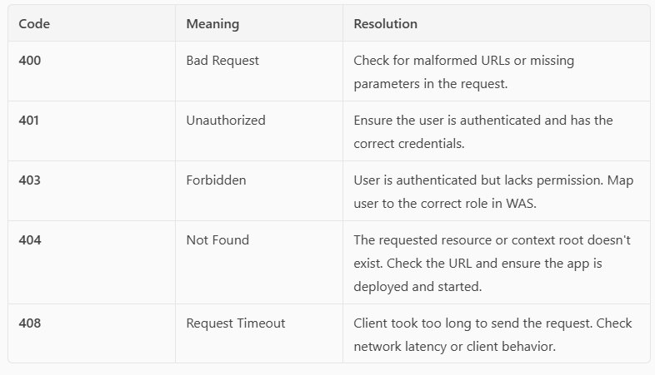

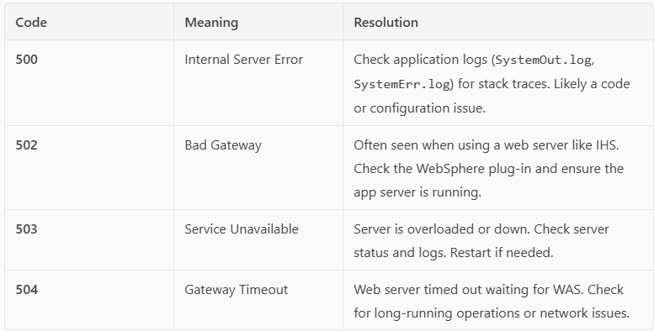

check the logs, virtual host mapping, context root, plugin generation for new application, application deployment, any recent changes, check the url with hostname port and if it is accessing, check jdbc or jms connectivity, if service is not running then check firewall is open for the port using telnet, network connectivity btw webserver and app server, servers down, OOM or hung threads/deadlocks/cpu utilization, application is down and not coming up, synchronizing the nodes, reboot happened/os patching/permissions for app related folders.

ClassNotFoundException, NullPointerException, or configuration error

How to Troubleshoot These Errors
- Check Logs:
  - SystemOut.log, SystemErr.log (WAS)
  - error_log, access_log (IBM HTTP Server)
- Verify Application Status:
  - Ensure the application is deployed and started in the Admin Console.
- Check plugin-cfg.xml:
  - Make sure it’s up to date and propagated to the web server.
- Validate Security Settings:
  - Ensure users have the correct roles and permissions.
- Use Browser Developer Tools:
  - Inspect request/response headers and payloads.

500 error code issues
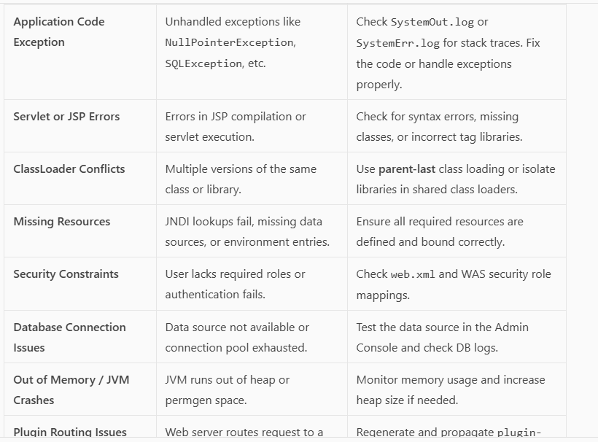
Logs:
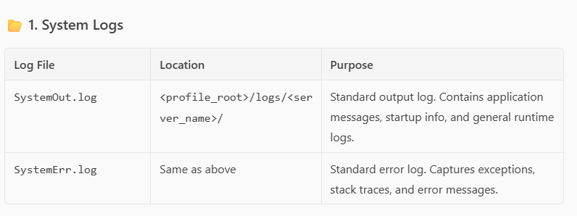
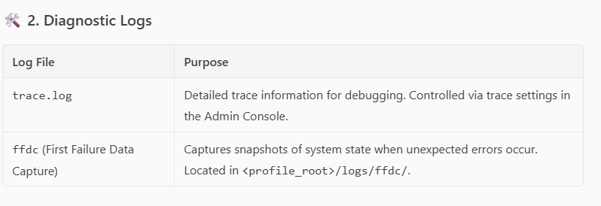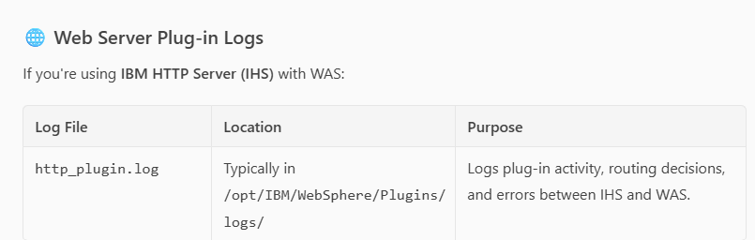
Set log levels:
Use the Admin Console:
Troubleshooting → Logs and Trace → Select server -> Click on Diagnostic Trace ->
Use *=info for general logging
*=all only for deep debugging
Common levels: fatal, severe, warning, audit, info, debug, fine, finer, finest, all,
off.

OUTOFMEMORY ISSUE:
->Memory leaks in application code
->Insufficient heap size for the workload
->Too many deployed applications or threads

Resolution:
- Increase JVM Heap Size
- Go to:
Servers → Server Types → WebSphere Application Servers → Your Server → Java and Process Management → Process Definition → Java Virtual Machine
- Update:
  - Initial heap size (-Xms1024m)
  - Maximum heap size (-Xmx2048m)

- Enable Verbose GC logging
Add to JVM arguments
-verbose:gc -Xloggc:/path/to/gc.log
- Analyze Heap Dumps
-XX:+HeapDumpOnOutOfMemoryError -XX:HeapDumpPath=/path/to/dumps
And Reduce session timeout.

Now, To generate heap dumps:
Through admin console:
- Path:
Servers → Server Types → WebSphere Application Servers → Your Server →
Java and Process Management → Process Definition → Java Virtual Machine
- Fields to set:
  - Initial heap size (-Xms)
  - Maximum heap size (-Xmx)
Through command:
jmap -dump:format=b,file=/tmp/heapdump.hprof <PID>

This creates a heap dump of the JVM process with PID 12345 and saves it to /tmp/heapdump.hprof

To generate Thread dumps:
Through command:
Kill -3 <PID>

- Log in to the Admin Console:
http://<hostname>:9060/ibm/console
- Navigate to:
Troubleshooting → Java Dump and Heap Dump
- Select the server (e.g., server1) from the list.
- Click "Dump Threads"/”Heap Dump”
- The thread dump will be generated and saved in the server's logs directory (usually under logs/<server_name>/).

Nodeagent not coming up:
- Check logs for port conflict issues. Check serverindex.xml for port usage. Use netstat to identify conflicts.
- Out of memory during startup. Increase heap size in nodeagent JVM settings
- Resync with deployment manager
Go to bin path, execute ./syncNode.sh <dmgrHostName> <soapconnectorport>
- File permission Issues
- Delete temp files
- Network or DNS issues: Ensure hostname resolution works and ports (e.g., 8879) are open and reachable
- application slowness

Hung thread – thread dumps

Application servers are not coming up:

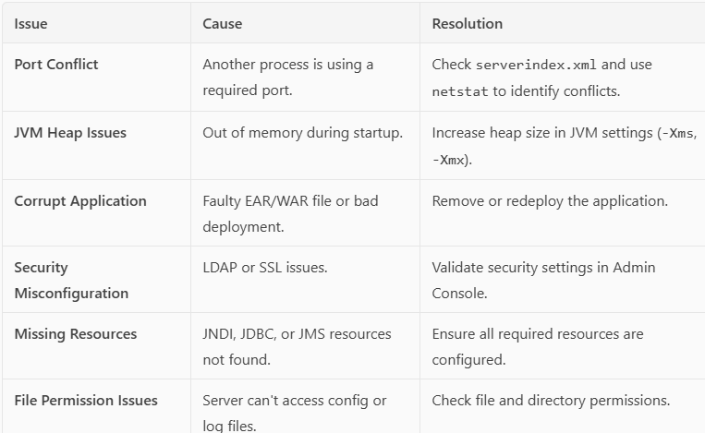

Applications are not coming up:
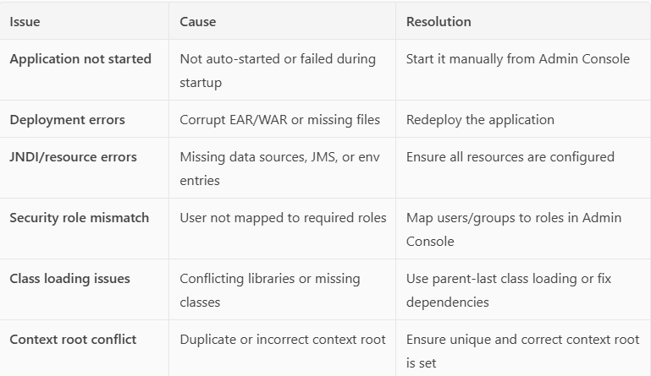

SSL related issues:

Issues you faced while working on fixpack upgrades:

Issues you faced and resolved recently

Application deployment issues: /app/soft/was85/WebSphere/was85_dm/config/cells/was85_cell
Cus and blas folders

Stale issues db error, full sync, jvm crash, ihs-was integration, generate and propagate plugin,s

  - fixpack jdk issue, cache clearance, setenv.sh – xloggc deprecated value, ibm http 8.5.5.26 is not compatible with tls 1.2
WAS 8.5 – jdk8 fixpack chesaka- application is not accessible because pega 6 lower version is running
  - tomcat webapps folder root we have application specific configurations but while upgrading the tomcat that was missed. So, application doesnot route to correct url
  - ClassNotFoundException or NoClassDefFoundError after redeployment. Avoid placing application libraries in lib/. Use WEB-INF/lib for app-specific JARs.
- Ldap configurations(which file gets changed), SSL renewal steps and commands, data sources(which file gets changed), tomcat main configuration files, plugin file and what it consists of, proxy&reverseproxy, how to do fixpack upgrades, types of clusters and its disadvantages, how to do datasource test connection in tomcat

INTERVIEW QUESTIONS FROM CO_PILOT:

WebSphere Basics
- Architecture of WebSphere Application Server
- Profiles: Cell, Node, Deployment Manager (DMGR), Application Server
- JVM tuning and heap management
- WebSphere directory structure
✅ Installation & Configuration
- Silent installation and response files
- Creating and managing profiles
- Federating nodes and managing cells
- Configuring JDBC providers and data sources
✅ Deployment & Troubleshooting
- EAR/WAR deployment methods (Admin Console, wsadmin, scripts)
- Troubleshooting deployment issues
- Log analysis: SystemOut.log, SystemErr.log, FFDC
- Thread dumps and heap dumps
✅ Security
- Configuring SSL and keystores
- LDAP integration
- Role-based access control
- Global security settings
✅ Scripting & Automation
- wsadmin scripting using Jython/JACL
- Automating deployments and configurations
- Backup and restore scripts
✅ Performance Tuning
- JVM tuning (heap size, GC policies)
- Connection pool tuning
- Thread pool tuning
- Monitoring tools (Tivoli, IBM Performance Monitoring Infrastructure)
✅ High Availability & Clustering
- Horizontal vs vertical clustering
- Load balancing and failover
- Session persistence

🔹 2. Behavioral & Situational Questions
Prepare for questions like:
- “Describe a time you resolved a critical production issue.”
- “How do you handle deployments with tight deadlines?”
- “Have you ever automated a repetitive task? How?”
Use the STAR method (Situation, Task, Action, Result) to structure your answers.

🔹 3. Sample Technical Questions
- How do you troubleshoot a hung WebSphere server?
- What is the difference between a node and a cell in WAS?
- How do you configure SSL in WebSphere?
- What are the steps to federate a node to a cell?
- How do you tune JVM settings for better performance?
- Explain the wsadmin tool and its use cases.
- How do you handle application deployment in a clustered environment?

🔹 4. Mock Interview Practice
Would you like to do a mock interview session where I ask you questions and give feedback on your answers?
Or would you prefer a customized study guide or flashcards to review key topics?
Let me know how you'd like to proceed!
You said:
Can you provide more technical questions?
Copilot said:
Copilot
Absolutely! Here’s a more comprehensive list of technical interview questions tailored for someone with 6 years of experience in WebSphere Application Server (WAS) administration. These are grouped by topic and include both conceptual and hands-on scenarios:

🔧 Installation & Configuration
- What are the different types of profiles in WebSphere? How do you create them?
- How do you perform a silent installation of WebSphere?
- What is the purpose of the Deployment Manager (DMGR)?
- How do you federate a node into a cell?
- What is the difference between managed and unmanaged nodes?

🚀 Application Deployment
- What are the steps to deploy an EAR file using the admin console?
- How do you deploy applications using wsadmin?
- How do you handle deployment in a clustered environment?
- What is the difference between hot deployment and cold deployment?
- How do you roll back a failed deployment?

🛠️ Troubleshooting & Logs
- How do you analyze a hung thread issue?
- What are FFDC logs and how are they useful?
- How do you generate and analyze a heap dump?
- What tools do you use to analyze thread dumps?
- How do you troubleshoot a slow-performing application?

🔐 Security
- How do you configure SSL in WebSphere?
- What is a keystore and truststore? How are they used?
- How do you integrate LDAP with WebSphere?
- What are the steps to enable global security?
- How do you restrict access to the admin console?

📈 Performance Tuning
- How do you tune JVM heap settings?
- What are the different garbage collection policies in WAS?
- How do you tune connection pools and thread pools?
- What monitoring tools have you used with WebSphere?
- How do you identify and resolve memory leaks?

🔄 Scripting & Automation
- What is wsadmin and what scripting languages does it support?
- Can you write a script to automate application deployment?
- How do you schedule regular backups of configuration?
- What is the difference between JACL and Jython?
- How do you use scripting to monitor server health?

🧩 Clustering & High Availability
- What is the difference between vertical and horizontal clustering?
- How do you configure session persistence?
- How does WebSphere handle failover?
- What is the role of the plugin-cfg.xml file?
- How do you configure load balancing in WebSphere?

🧪 Advanced Scenarios
- How do you migrate from one version of WebSphere to another?
- What are the steps to backup and restore a WebSphere environment?
- How do you handle zero-downtime deployments?
- How do you secure inter-node communication?
- What are the best practices for managing large-scale WebSphere environments?

1.introduce yourself:
Hi everyone, thank you for giving me this opportunity to be interviewed for this position today. My name is gayathri, I have completed my graduation in 2019.
I got job offer in campus placements right after my education. I have overall 6.5 years of IT experience. Previously i have worked as Websphere admin in wipro citibank as my client for almost 3 years. and from past 3 years i have been associated with cognizant as Tech Lead mainly focusing on WAS, tomcat administration.
My core responsibilities revolve around managing middleware infrastructure, ensuring high availability, and supporting enterprise applications in production and non-production environments. I have been involved in major WAS lift and shift migration from on prem to cloud servers. And also working on tomcat upgrades lately supporting all the BAU activities and troubleshooting the issues.
Having said that, I’m confident I have skills and qualities to excel in the role and I can manage significant workload.
I am excited about the opportunity to bring my expertise to your organization and support its middleware infrastructure.

  - The reason I am looking for a change is that I feel like now is the correct time to expand my scope of work. I have worked in my current company for a quite long time, and I am grateful for all the build experience I got. I still wanted to go beyond and explore more tools if possible also take up new challenges and responsibilities.

IBM WAS INSTALLATIONS, PROFILES CREATION, NODE FEDERATION, CLUSTER CREATION, JVM SETTINGS like heap size, JAVA SDK, JVM ARGUMENTS, SESSION MANAGEMENT, MONITORING POLICY etc, JDBC PROVIDERS , DATASOURCE CREATIONS, APPLICATION DEPLOYMENT(VIRTUAL HOST and CONTEXT ROOT), LDAP, SSL, TLS CIPHERS, HEAP & THREAD DUMPS, LOGS ROTATION and TRACE LOGS, LOG FILES & USES, FIXPACK UPGRADES, WAS ARCHITECTURE, PROJECT DETAILS, DEFAULT PORTS and MAIN CONFIGURATION FILES,

IHS INSTALLATIONS, PLUGIN FILE, CONFIGURE WEBSERVER IN ADMIN CONSOLE, CONFIGURATION FILES like http.conf, LOGS, STOP&START
LOAD MODULES, SSL

TOMCAT ARCHITECTURE, INSTALLATIONS, CONFIGURATION FILES, SSL, TOMCAT APACHE INTEGRATIONS, ISSUES.

VERSIONS OF ALL OF THEM

MQ RESTARTS, JBOSS RESTARTS, WEBLOGIC RESTART, ANSIBLE MODULES.

ROLLBACKS, ERROR STATUS CODE

-----------------------------------------------------------------------------------------------------------------------------

Certificate renewal of WAS:

--> We need to gather old certificate information from a tool in our project by searching with CN name and download the report.
--> Go to dmgr path under cells - we have the key.p12 and trust.p12 and view the certificate.
keytool -list -v -keystore -storepass
-->Raise CSR using the scripts and submit to PKI. we receive cert with key.p12. replace the old certificate using ikeymann tool. and place it in the dmgr path.

keytool -delete -alias mycert -storetype PKCS12 -keystore key.p12

keytool -importkeystore -srckeystore key.pfx -srcstoretype pkcs12 -destkeystore key.p12 -deststoretype pkcs12 -srcalias <aliasname taken from new pfx> -destalias <takenfrom oldcert> -srcstorepass -deststorepass

add new cert into key.kdb: gskcmd -cert -import -db key.pfx -pw -target <kdb> -target_pw
delete old cert: gskcmd -cert -delete -label -db -pw

now synchronize nodes and restart.

• Generate private key: openssl genrsa -out key.key 2048
• Generate CSR: openssl req -new -key key.key -out cert.csr
• View certificate: openssl x509 -in cert.crt -text -noout
🔹 keytool
• Generate keystore: keytool -genkeypair -alias mycert -keystore myKeystore.jks
• Import cert: keytool -import -alias mycert -file cert.crt -keystore myKeystore.jks
• List entries: keytool -list -keystore myKeystore.jks
🔹 gskcmd
• Create keystore: gskcmd -keydb -create -db myKeystore.kdb -pw mypassword -type cms -stash
• Create CSR: gskcmd -certreq -create -db myKeystore.kdb -pw mypassword -label mycert -dn "CN=yourhost"
• Import cert: gskcmd -cert -receive -file cert.crt -db myKeystore.kdb -pw mypassword

LoadModule ibm_ssl_module modules/mod_ibm_ssl.so

Listen 443
<VirtualHost *:443>
SSLEnable
SSLServerCert myCertLabel
</VirtualHost>
KeyFile /opt/IBM/HTTPServer/keys/ihs.kdb
SSLProtocolDisable SSLv2 SSLv3 TLSv1 TLSv1.1
SSLProtocolEnable TLSv1.2 TLSv1.3

