**1343. Number of Sub-arrays of Size K and Average Greater than or**

**Equal to Threshold**

**<https://leetcode.com/problems/number-of-sub-arrays-of-size-k->**

**[and-average-greater-than-or-equal-to-threshold/description/](https://leetcode.com/problems/number-of-sub-arrays-of-size-k-)**

**Solved this solution using 2 approaches.**

1. **O(n2) – Brute force**
2. **O(N)**

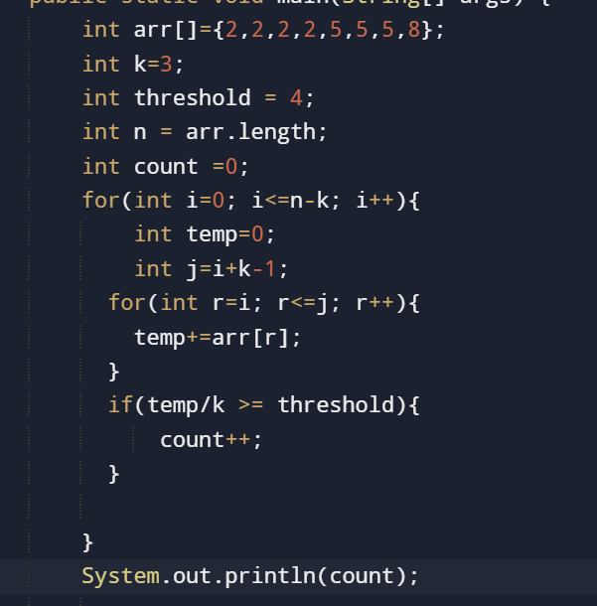

**2.**

