1. register a gmail account for imedbot

Username: [imedbot.project@gmail.com](mailto:imedbot.project@gmail.com)

1. 2-step verificaiton

Now the password of the gmail can not be directly used in program due to security reason. You need to use a method called 2-step verification.

I find this tutorial:

https://towardsdatascience.com/automate-sending-emails-with-gmail-in-python-449cc0c3c317

First, you need to enable 2-Step Verification. Just go to your Google Account > Security > Signing in to Google, and select 2-Step Verification and follow the instruction.

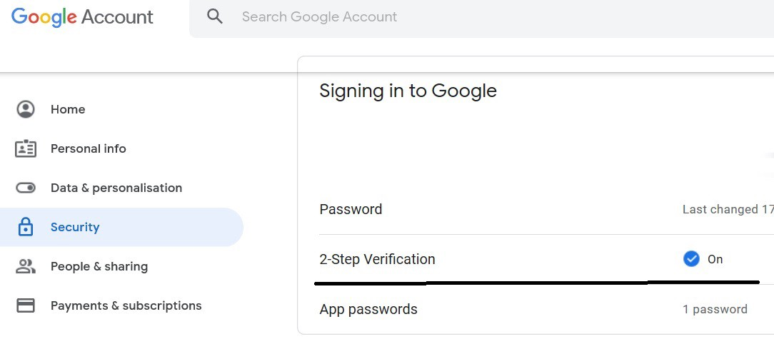

Next, create an app password. Just select ‘App passwords’ under ‘2-Step Verification’ and you will see a window as follows. Select ‘Other’ in the ‘Select app’ dropdown.

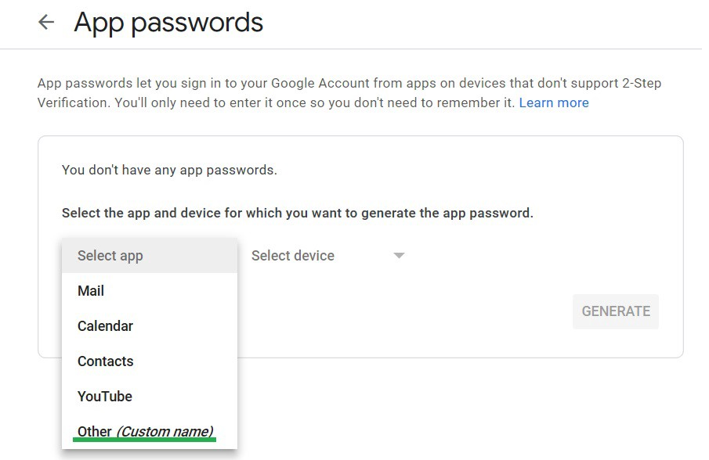

App password / Step 1

And enter a name, e.g. Python, and click ‘GENERATE’. Note this name has no link to the Python script and it could be anything.

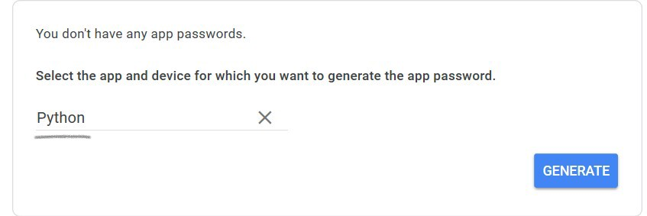

Then you will get a new app password. Copy and save the 16-character password without space, e.g. xnwbjmgvjeeevlgc, to use in your Python script.

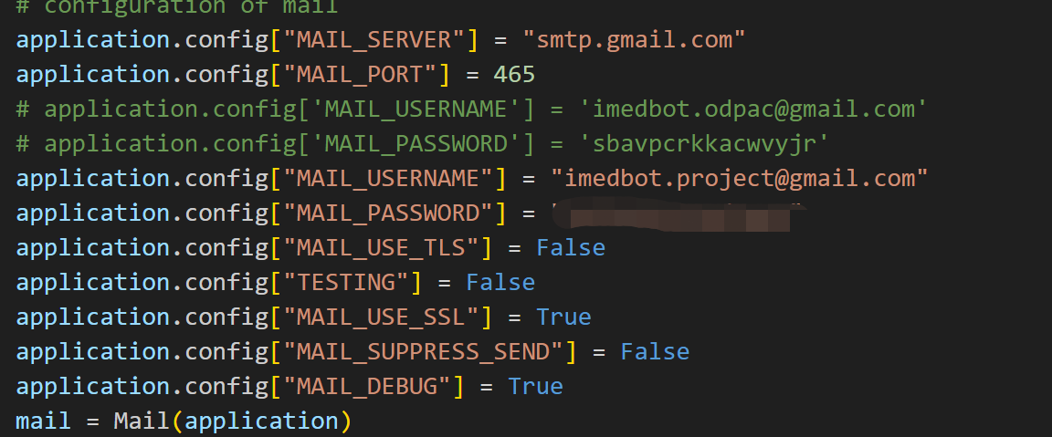

1. Send email in python

Import package for email with flask

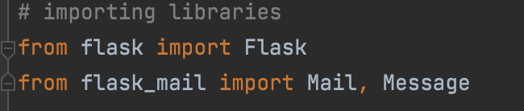

Set parameters:

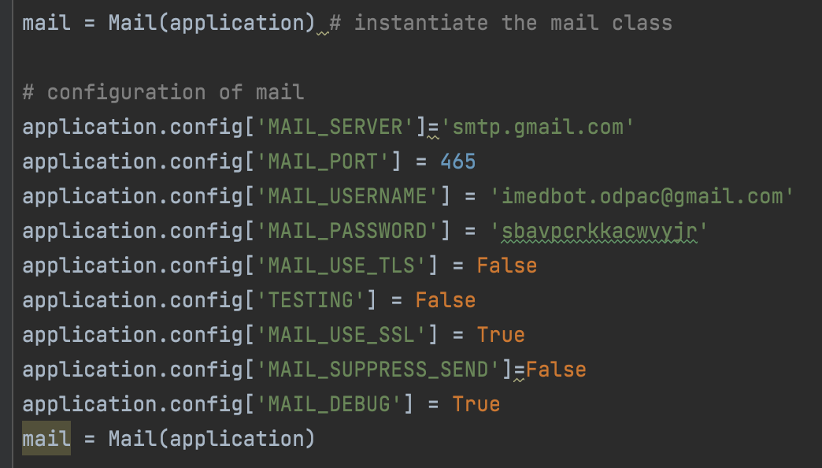

Here the password is the password for app which can be generated by step2.

Send email:

receiver=request.args.get('username')  
msg = Message('Verification code from iMedBot', sender='imedbot.odpac@gmail.com', recipients=[receiver])

msg.body = "This is your 6-digit verification code: "+pin

mail.send(msg)

Receiver is the receiver email address.

msg.body is the content of the email