1.

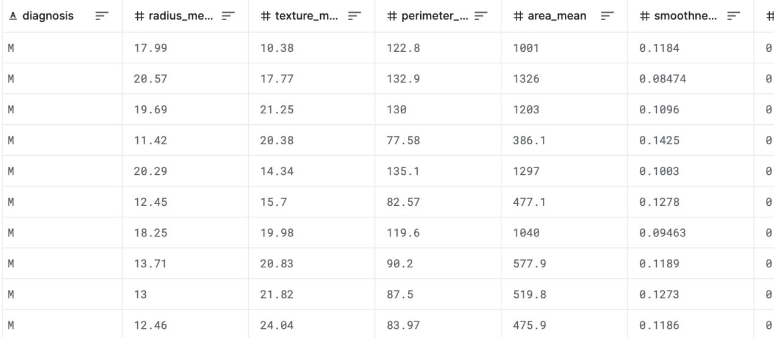

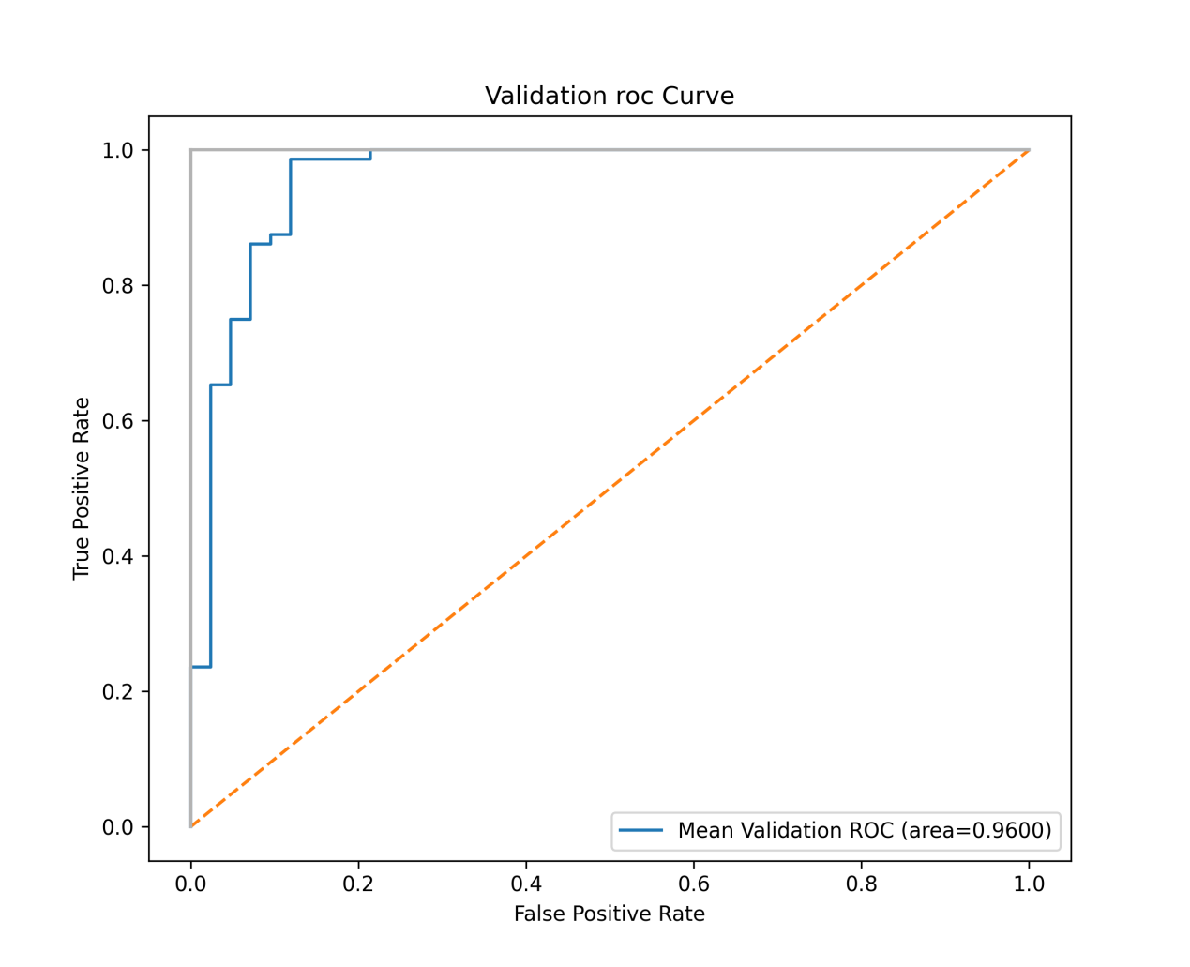

Problem:

The data is continuous and we currently support more of discrete value. Pre-processing is needed for better predicting a patient.

The target column consists by ‘M’ and ‘B’ so we need to turn it into number manually. Also, pre-processing is a must.

2.

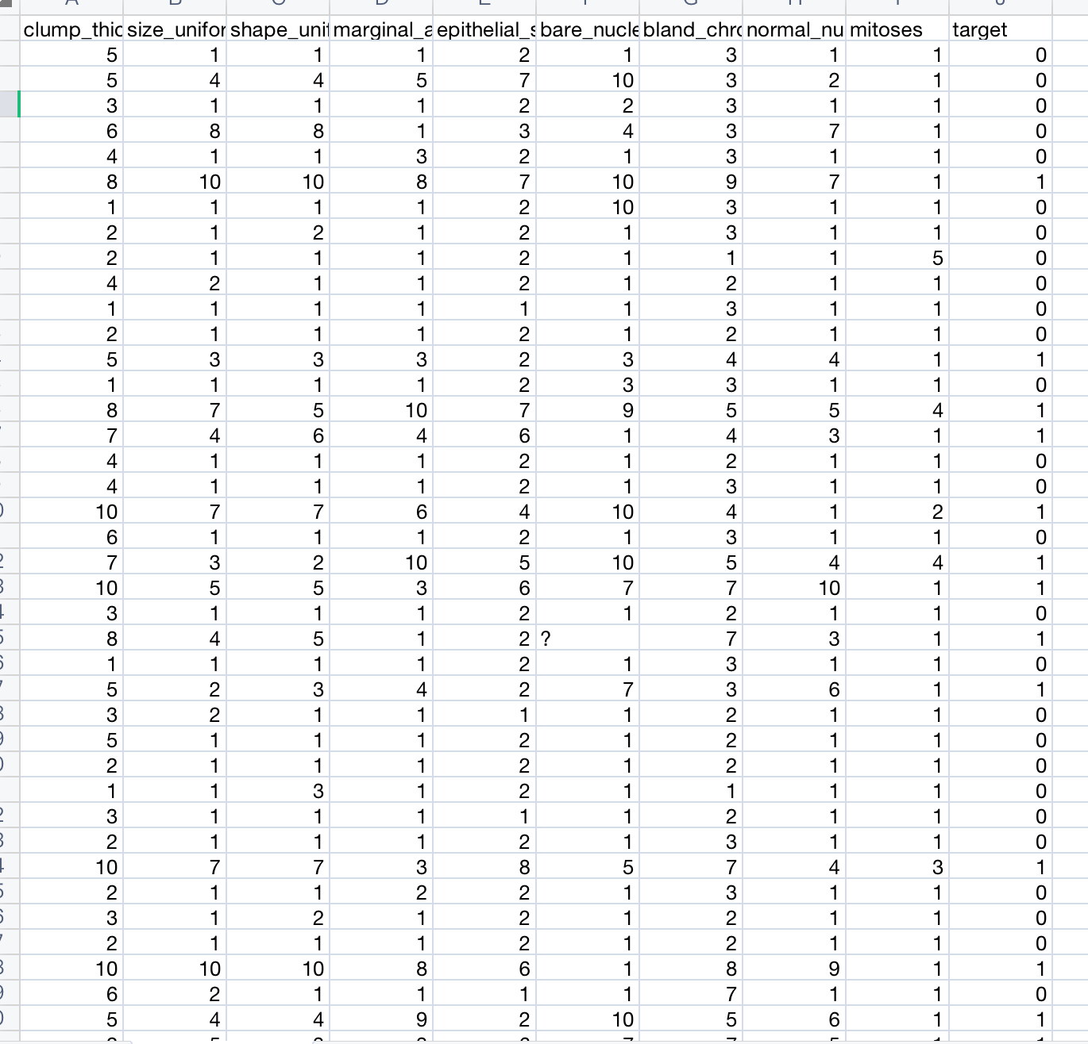

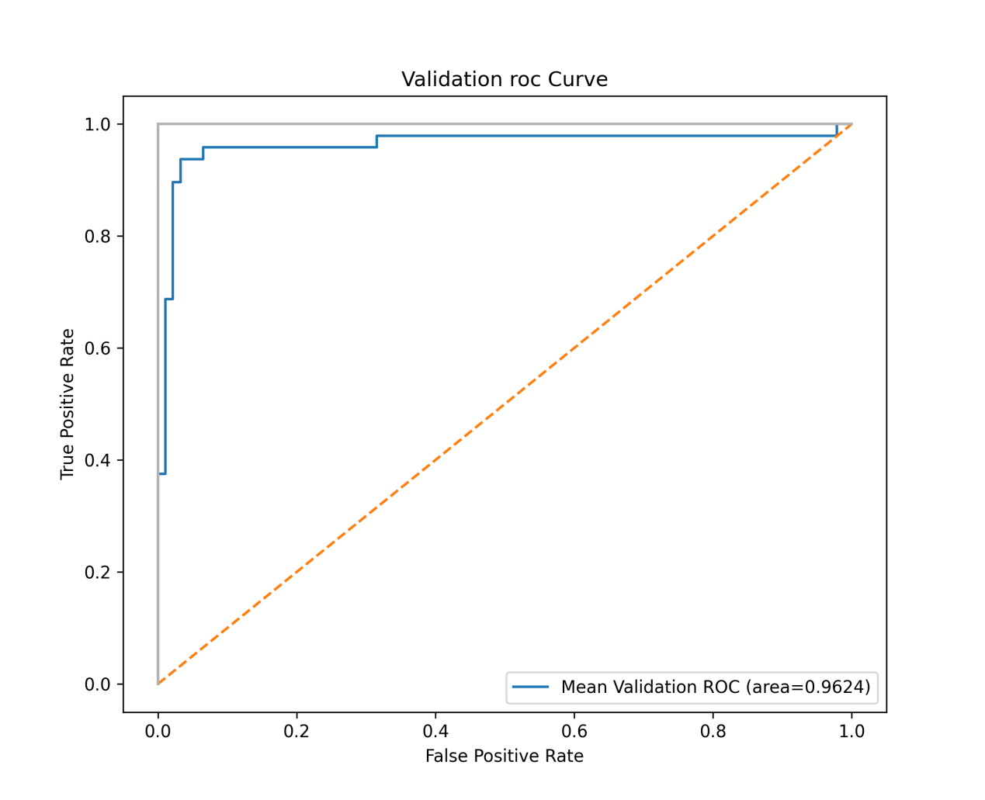

Problem:

This dataset has many empty values, so it raises an error in backend. I need to manually fill the empty value with reasonable values.

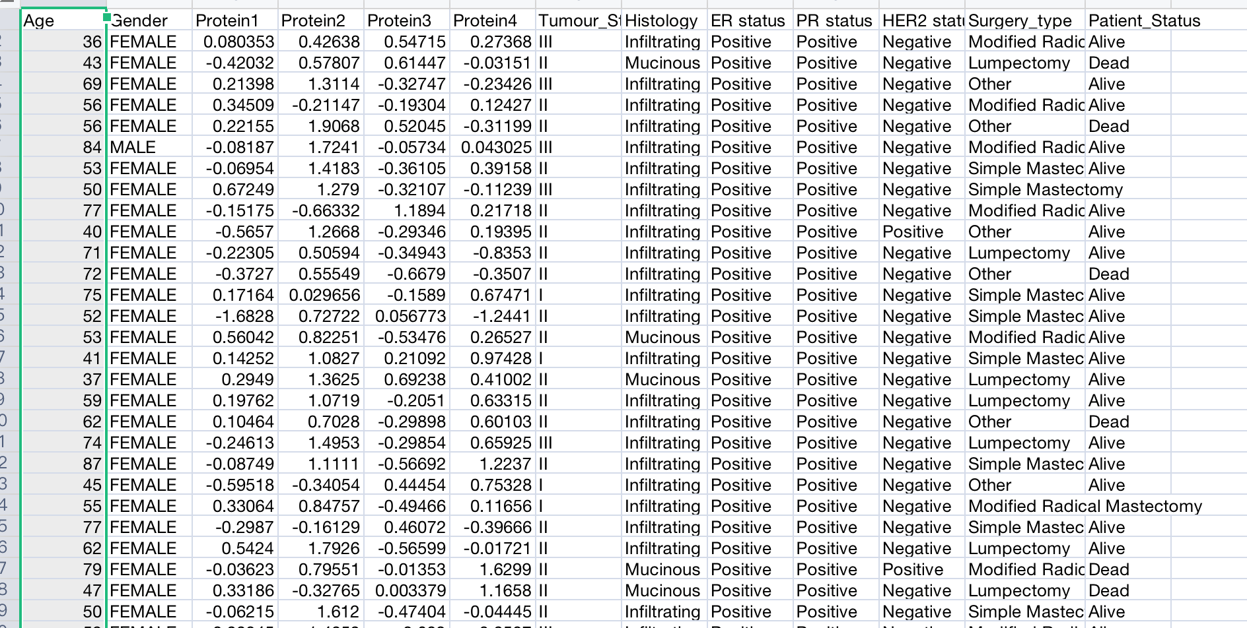

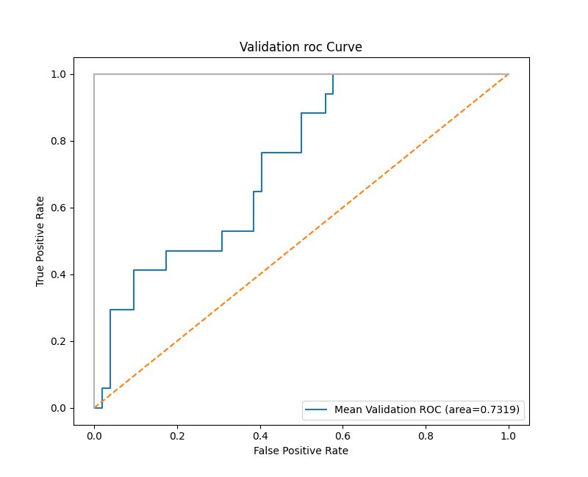

Problem:

I need to turn the discrete text into value and fill in the empty value manually.

4.

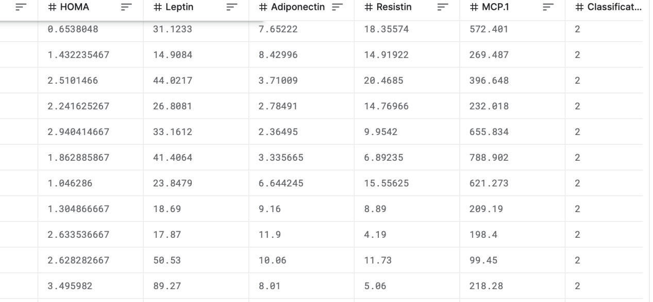

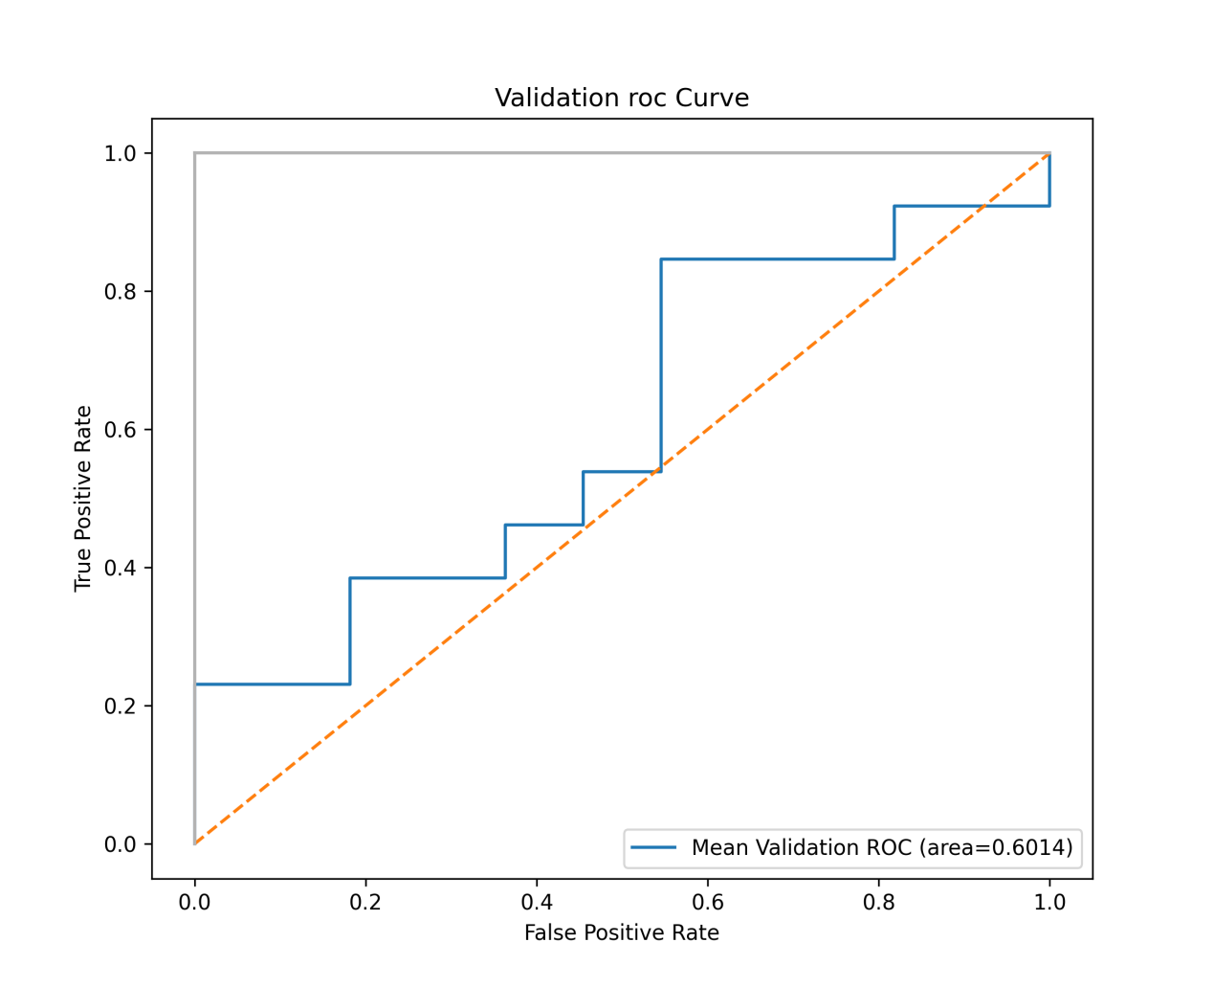

Problem:

The target column consists by 1 and 2 but our model accepts only [0,1] or [-1,1]. Also, I need to manually adjust it.

5.

