Procedure to Setup Website using AWS.

1. Choose the aws area

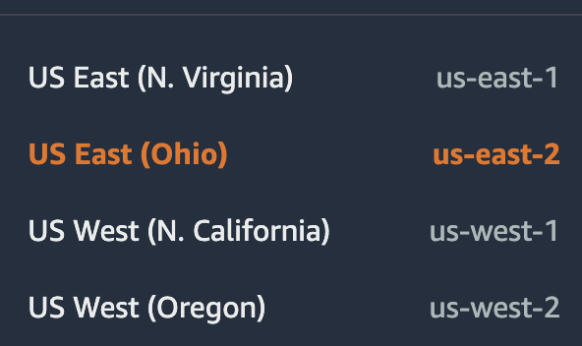

1. Create an application in Elastic Beanstalk
2. Go to application. Question: What is the difference between application and environment? Answer: Application can have multiple environments.

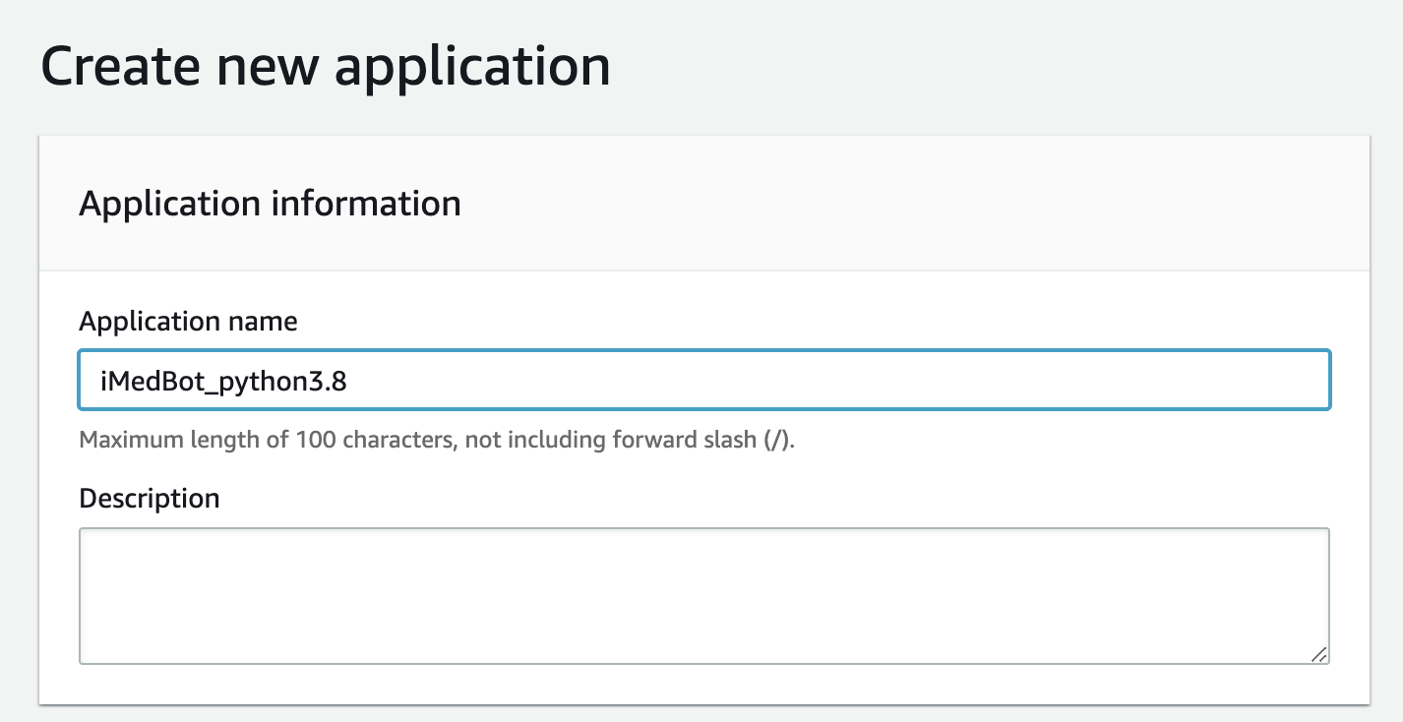

Tag is not necessary.

1. Once the application is created, click on the “Create a new enironment”.

It will create an environment automatically for this application, which includes an ec2 instance named as application name + “env”

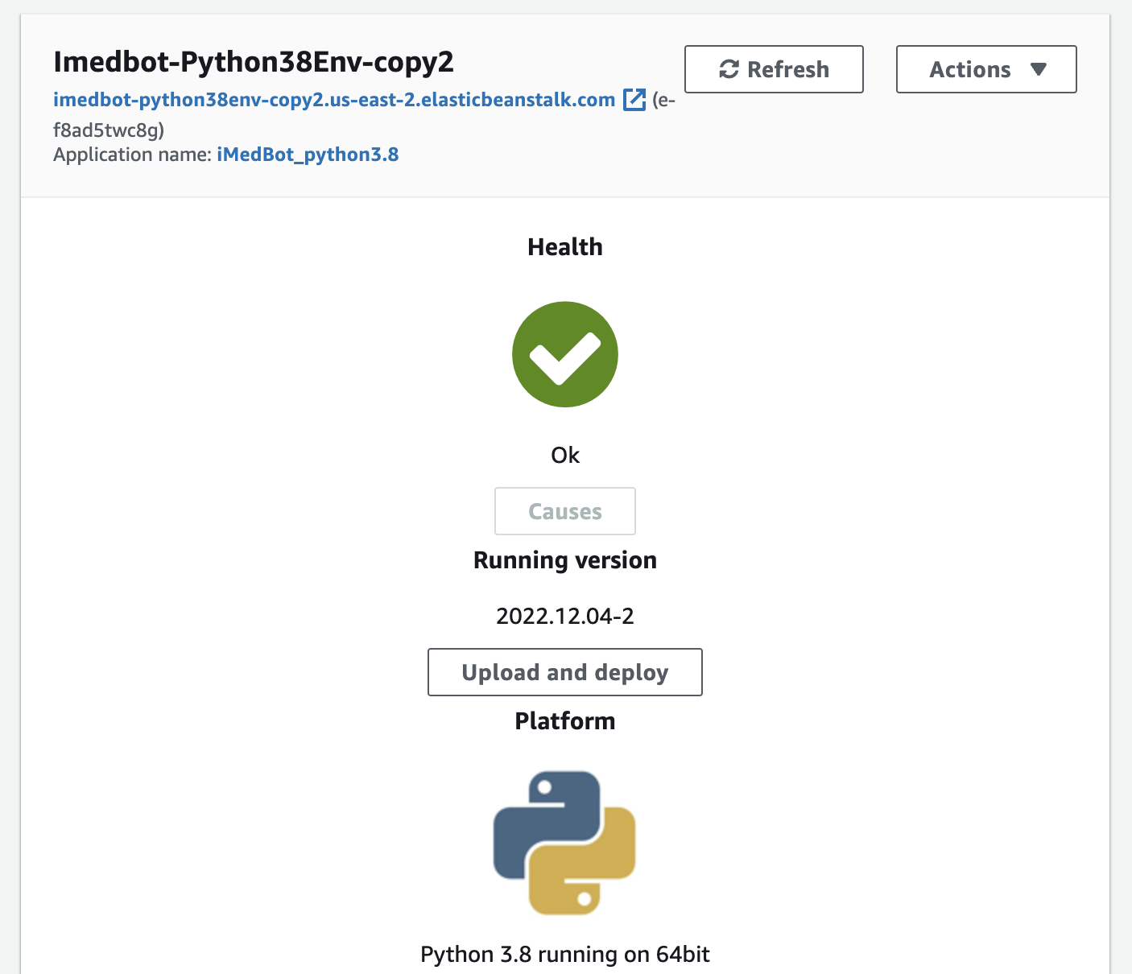

1. Go to configuration (in the environment, edit security) to add the key pair to the environment

Key pair

1. Upload code and deploy application in Elastic Beanstalk

A.click upload and deploy in application

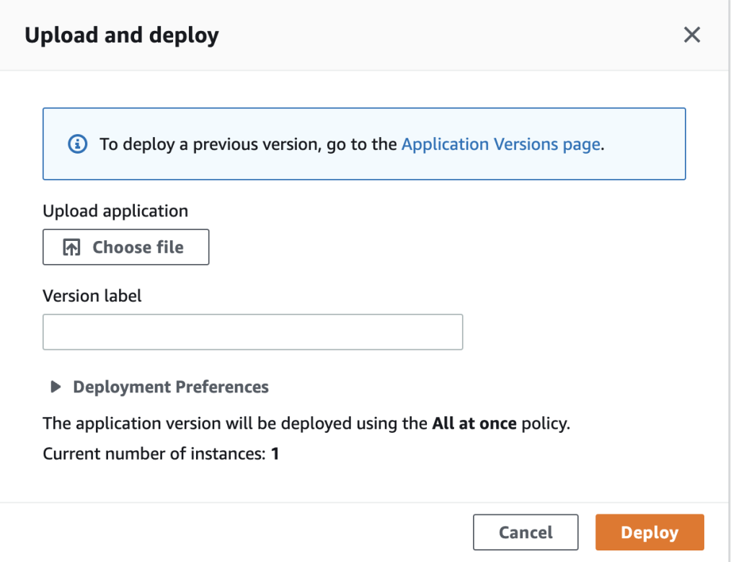

B.download the project from github(download zip)

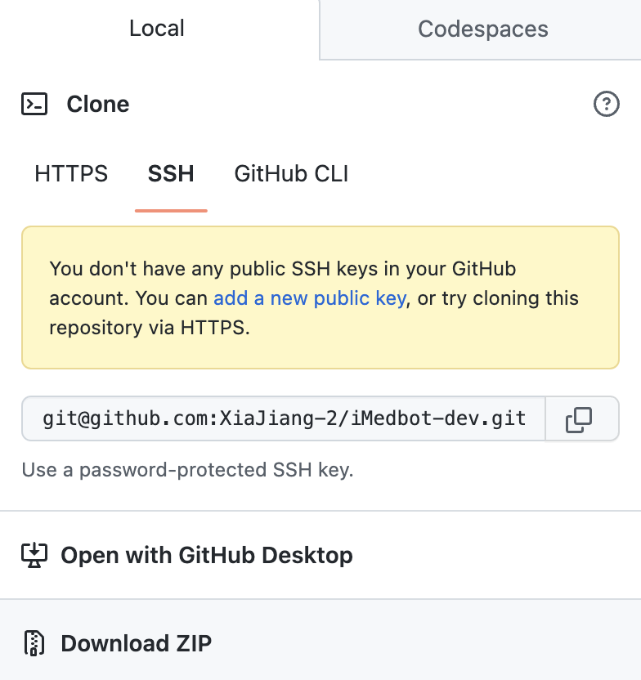

C.after downloading the whole project, unzip it and compress all the files under imedbot-dev directory(sometimes after unzip it extracts a folder which can not be directly uploaded to aws)

D. Edit the version label, the label should be unique and cannot be the same as previous version label of this application. 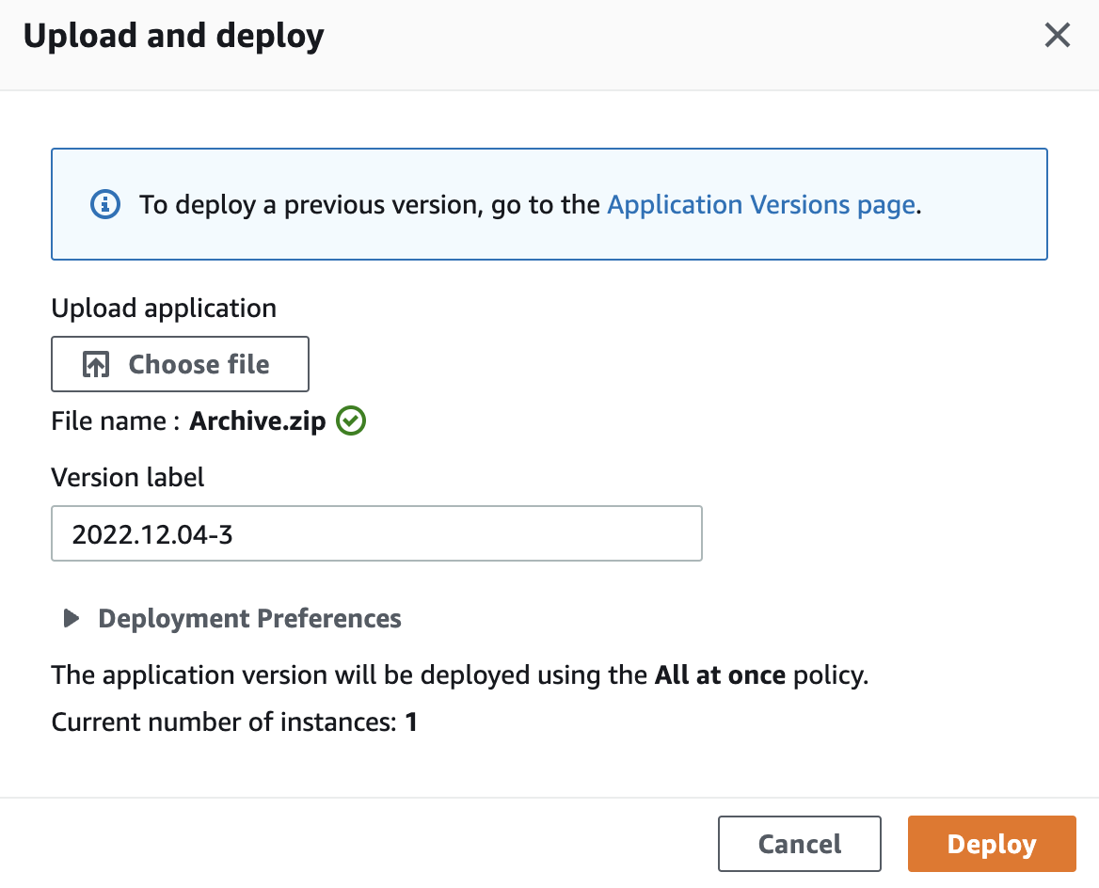

E.the application can be checked in Elastic Beanstalk in “go to environment”

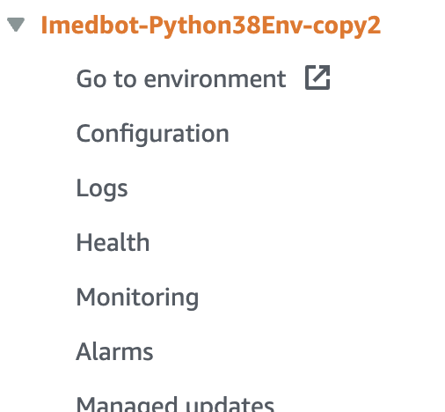

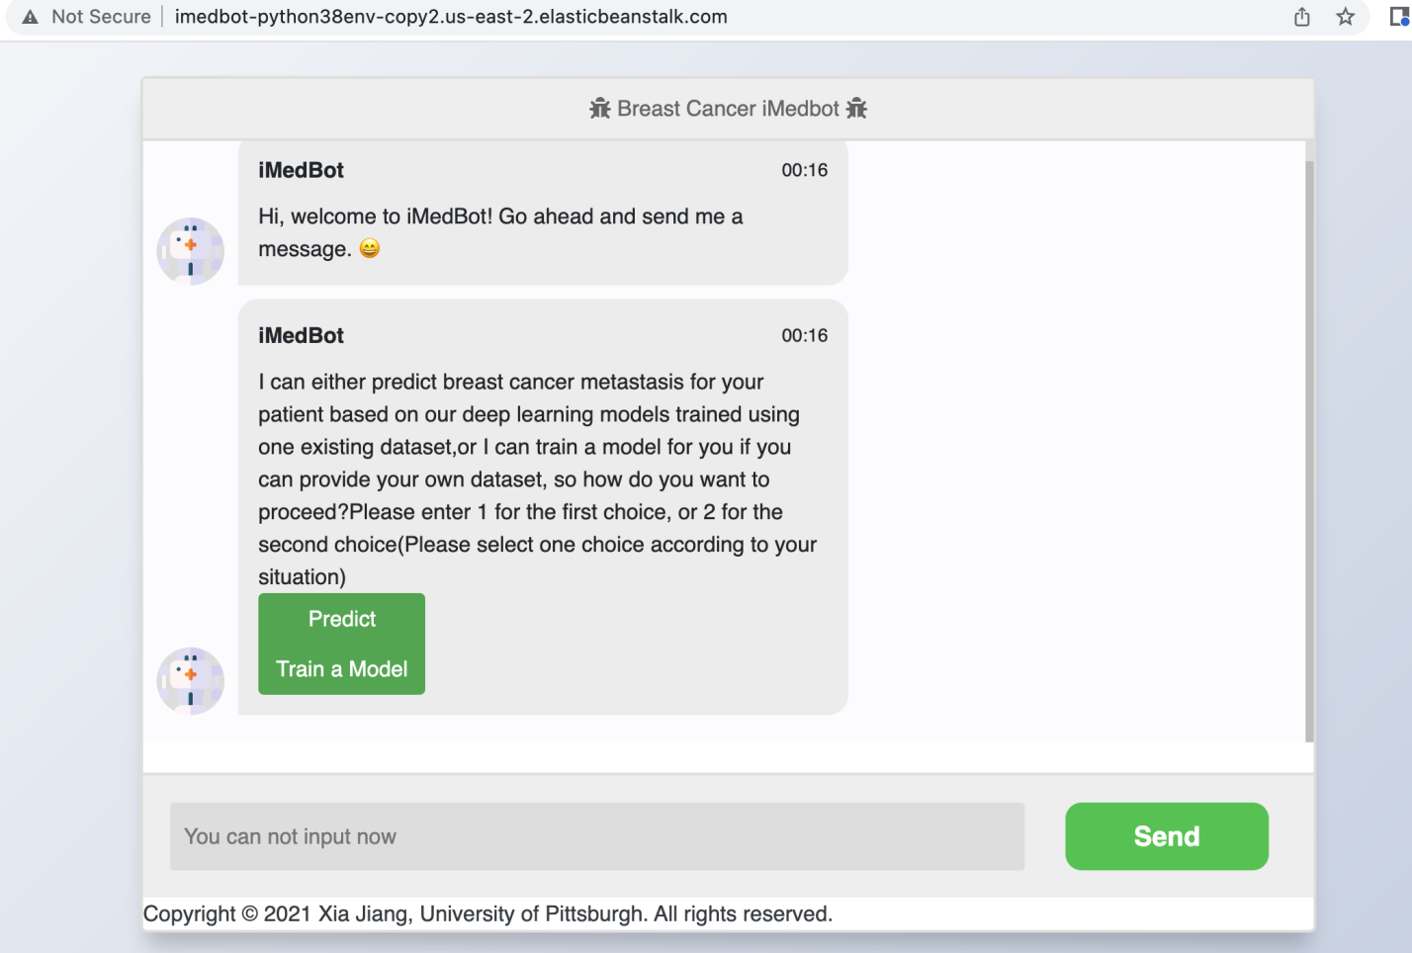

This url is a beanstalk url and it can be added to route53 later.

1. Connect the instance to domain in route53

Locate the hosted zones, then create record or edit existing record (in which case, you need to select the new environment).

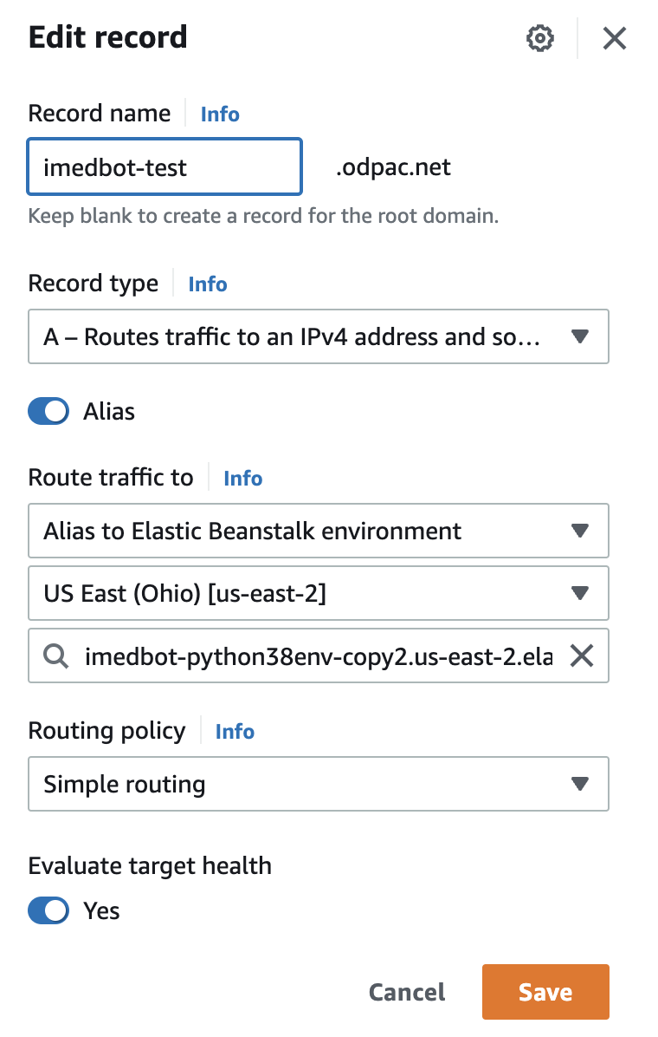

Link the record to application in Elastic Beanstalk

# Use ssh to open server and find out application

Go to EC2,

Find the instance for the current application,

Click the instance ID from the list, then click Connect.

Click the connect in the new window (See the second screenshot below) will lead to the ssh shell.

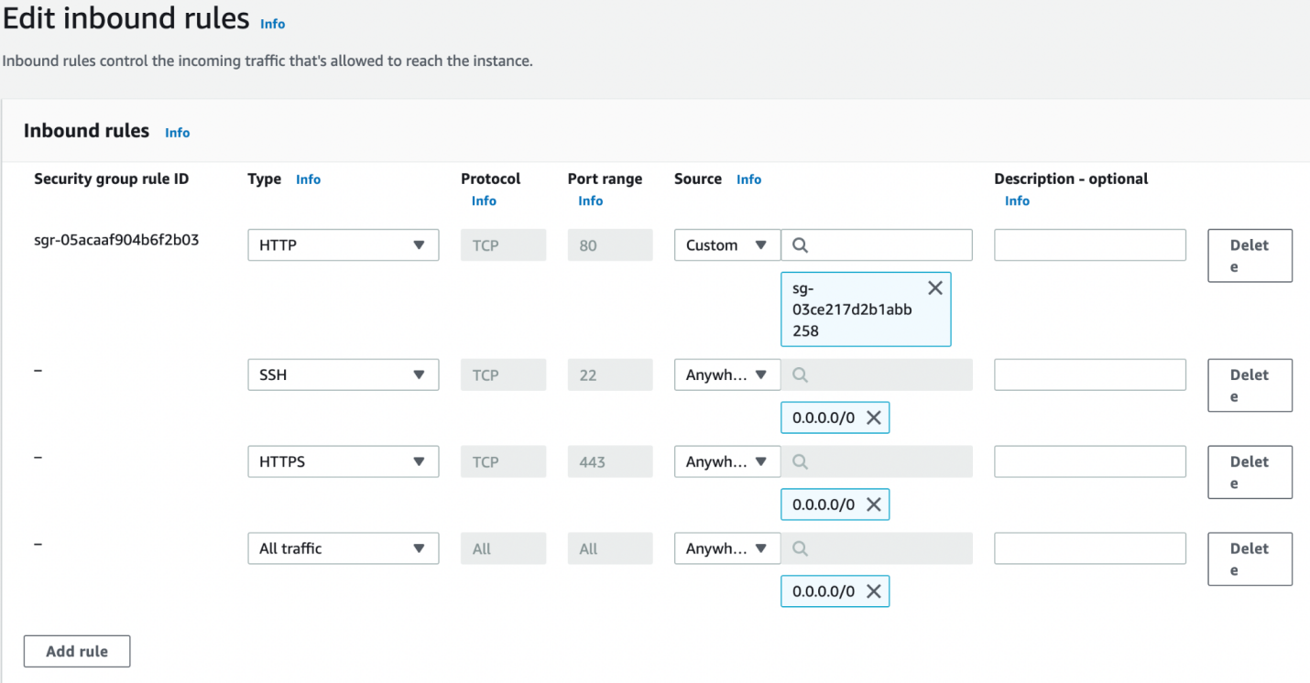

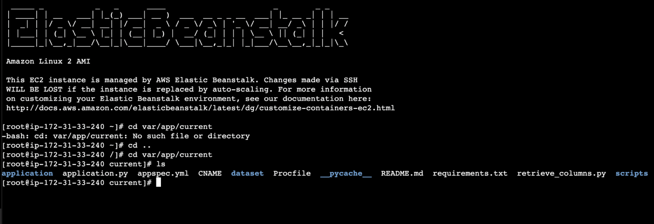

## Note: the commands in this terminal are tried lines, which are not required. See the commands useful in section B and C below.

## Use ssh to get access to ec2 instance

1. you can directly open terminal in aws. Open corresponding ec2 instance.

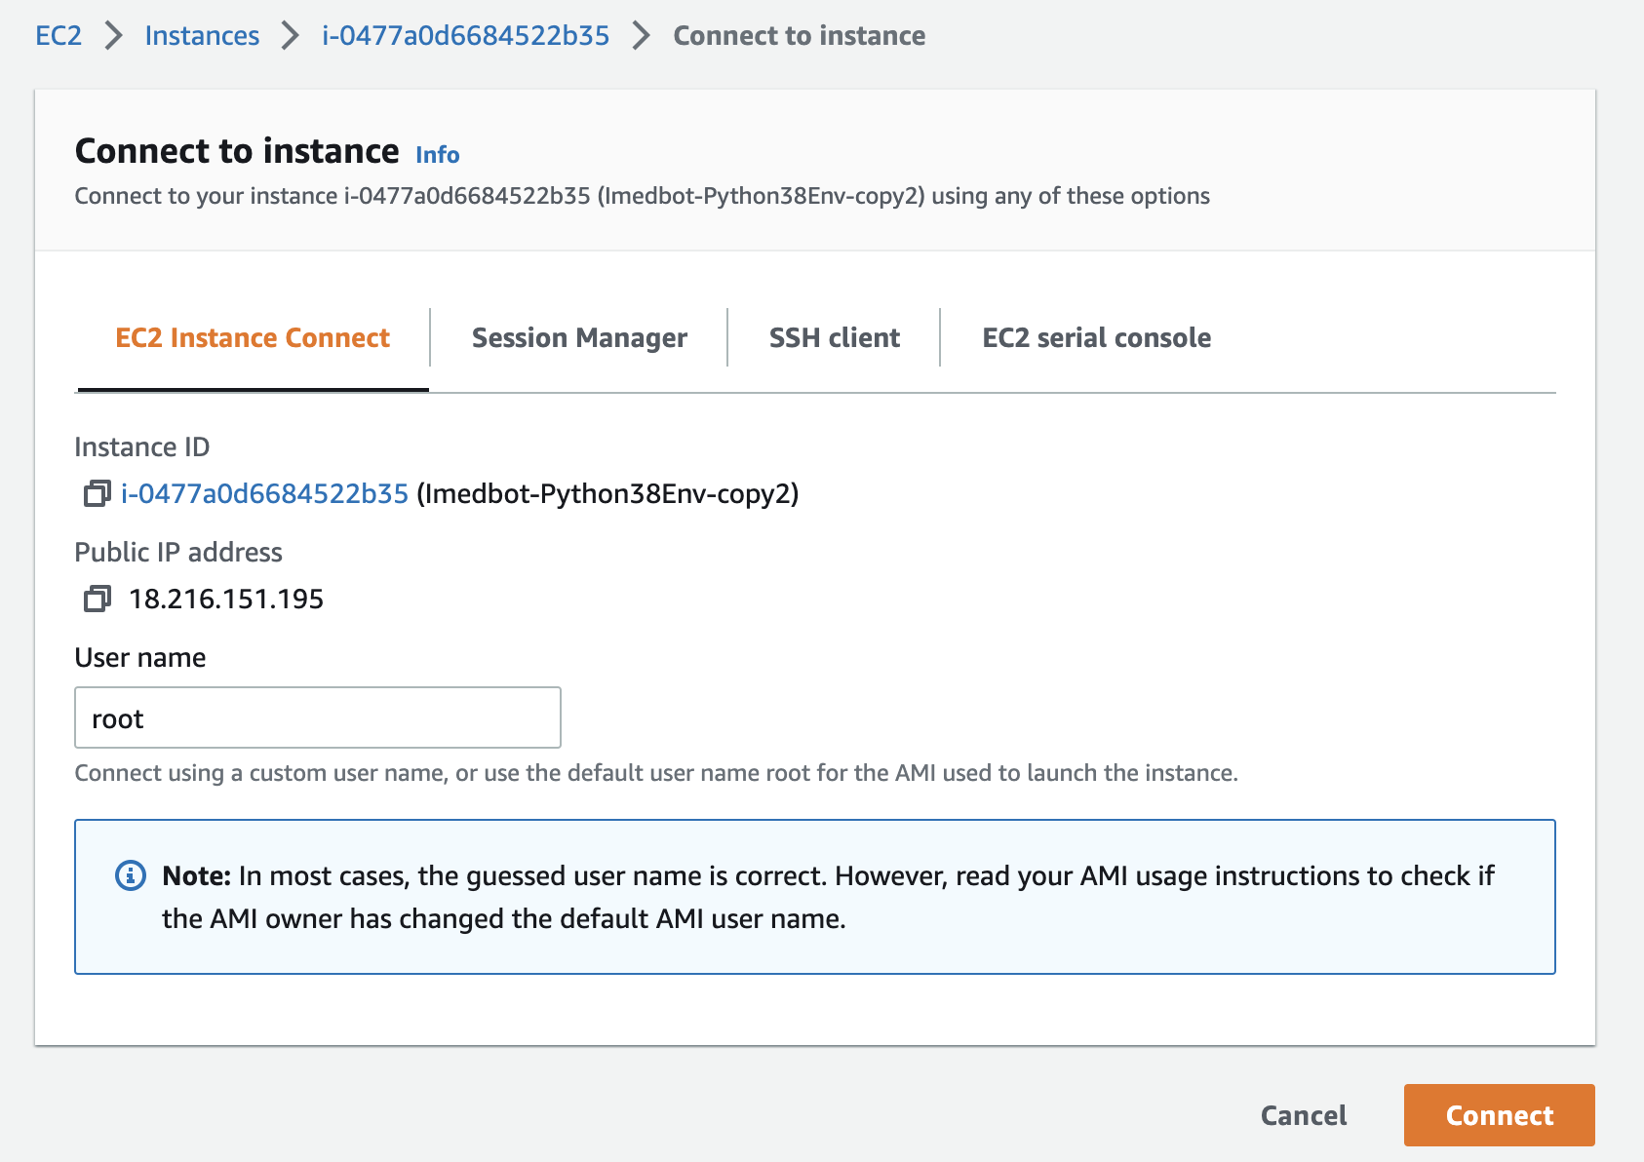

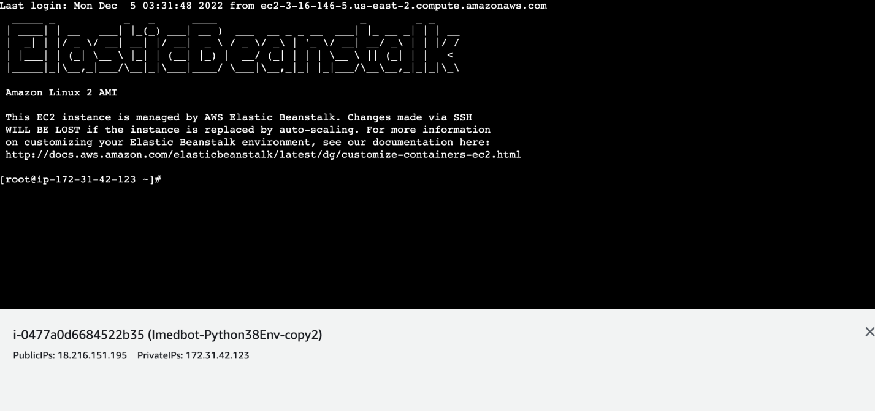

(this instance can open directly)

B. If you want to install python packages, activate the environment

You can find the PYTHONPATH from the configuration page from Elastic Beanstalk environments

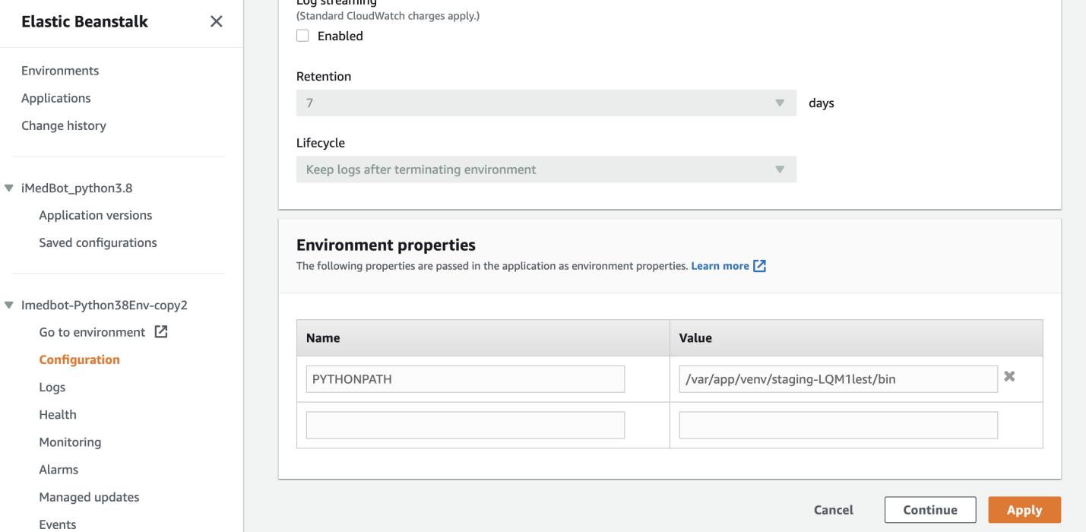

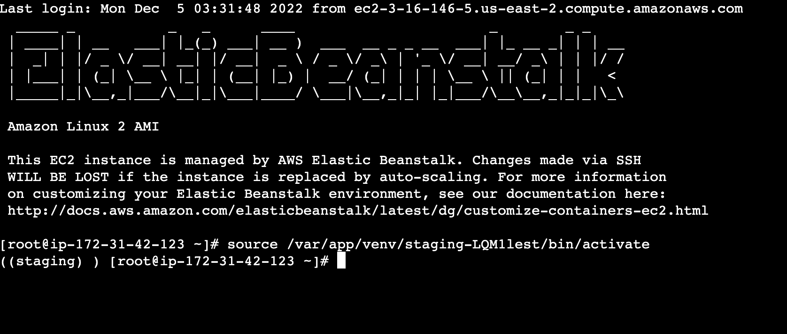

Then use pip install to install packages

C.if you want to see the code directly in ec2



The whole project is located in /var/app/current

If you want to see the code, use **nano application.py** to edit file in ec2

If you want to run the application in ec2, use **python application.py,** that will help to find the problem (why the internet is not working).

During the deployment during today’s meeting (2022.12.06), the iMedbot did not work, and we fixed the problem by going into the EC2 instance, following the procedure described above. See screenshot for the error we found and the fix. We first ran: python application.py, we found the following error.

We just ran the following code to fix it:

pip install dnspython