1. about the database I use:

I choose to use MongoDB Atlas

a. It is a cloud-based database. MongoDB Atlas is a fully-managed cloud database that handles all the complexity of deploying, managing, and healing your deployments on the cloud service provider of your choice (AWS , Azure, and GCP). MongoDB Atlas is the best way to deploy, run, and scale MongoDB in the cloud.

b. The project data does not have complex relations. It is easier to use the MongoDB because it is like the operation of json file

c. I create the cloud database for free

1. The structure of database:

a.I create the database called imedbot. Multiple collections can be created in MongoDB database. “A collection is a grouping of MongoDB documents. Documents within a collection can have different fields. A collection is the equivalent of a table in a relational database system.”

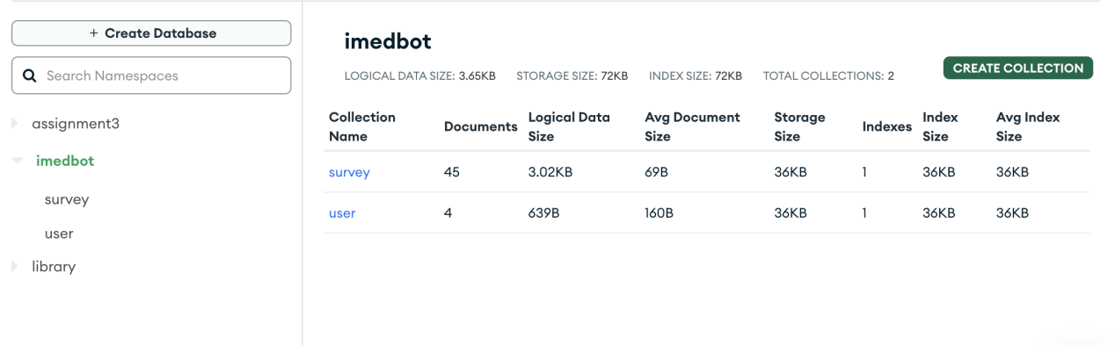

b. I create two collections. One is used for storing users’ survey and the other is used for storing users’ username and password.

For security reasons, I store the password by using encryption and cannot see the plaintext of password.

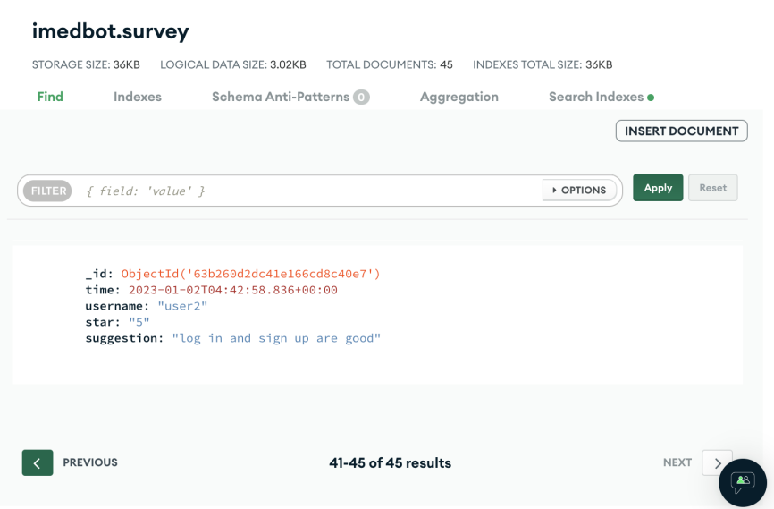

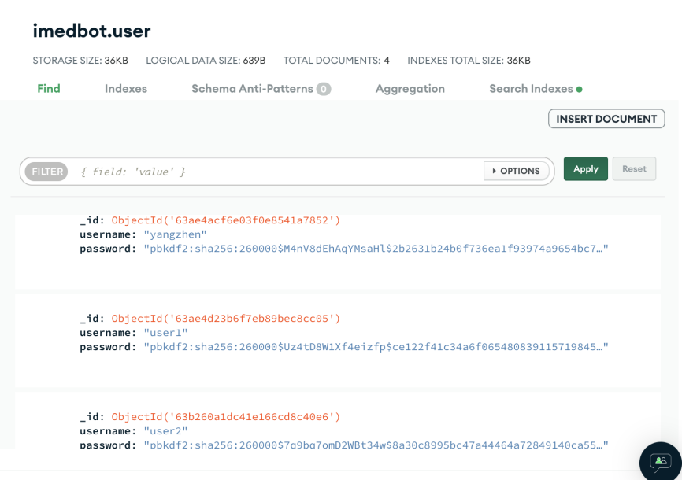

1. connecting to python project

The guide from MongoDB website:

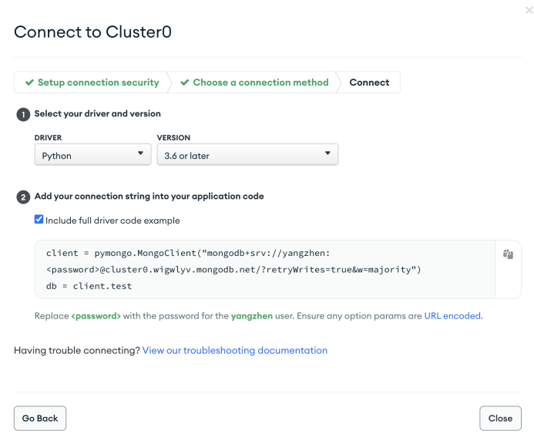

In pycharm:

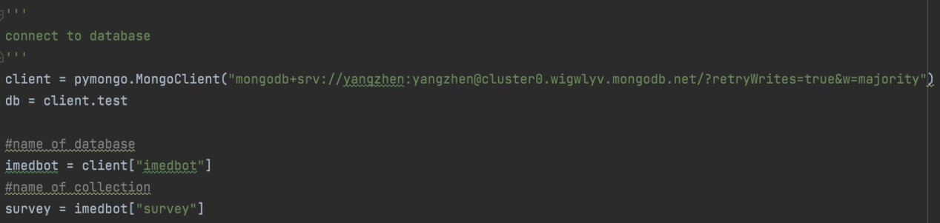

Finding:

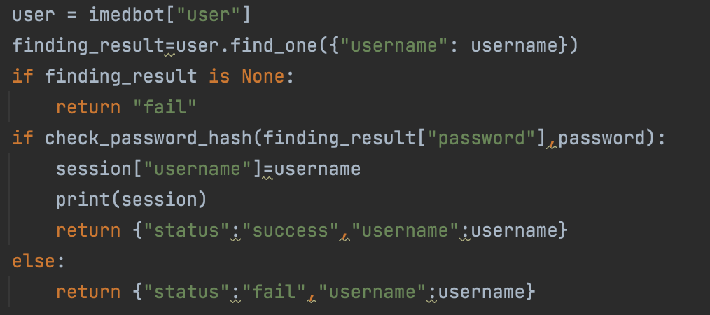

Inserting:

