Procedure to incorporate google analytics to the iMedBot.

1. open home page of google analytics.

1. create an account
2. click admin in the left

1. click create account

1. Select show advanced options in property set up and create a Universal Analytics property only

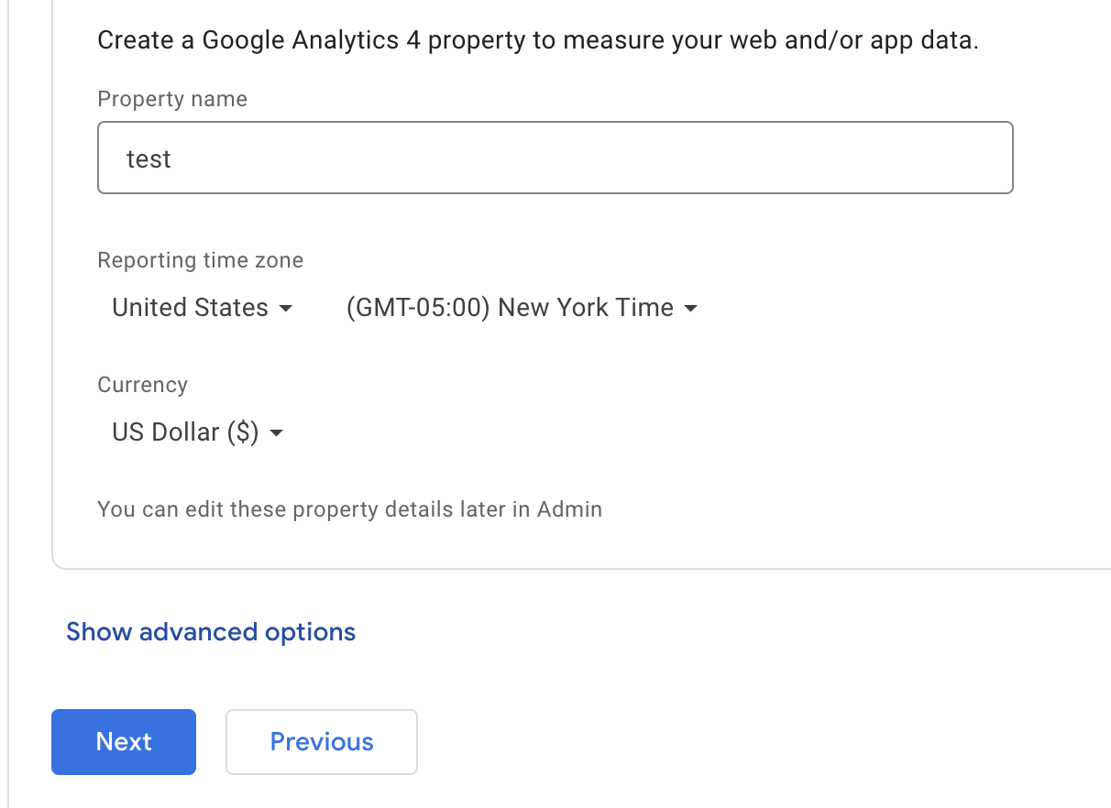

1. Select create a universal analytics property only

1. after creating an account

1. paste the tracking code to imedbot
2. you can see tracking code in property

1. paste the code to the project. Go to /templates/index.html and paste the tracking code right after <head>

1. deploy the project to aws ( which can be referenced in WorkWithAWS.docx)
2. create a view in google analytics

1. see your report
2. click realtime->overview

As you can see, the data has already transmitted to google analytics

1. save your report
2. go to the report you want to save

1. export the report and select the file type

1. open the report

2023.5.4

* + - 1. Create a group account (JiangProjectW81X) under XiaJiang’s gmail: [xiajiangw81x@gmail.com](mailto:xiajiangw81x@gmail.com)

Also set up properties called JiangLab (Google Analytics 4, the universal analytics will expire in 60 days).

The next step is to link it to our web application iMedbot.

1. Go to setting, and click on data streams, click on learn … to find instructions as show below.

1. Go to home, to add a data stream by clicking on “Web” (see below).

1. Set up a data stream:

1. Chose Install manually to get google tag (see below)

1. Copy google tag to “Index” page in the templates folder of our program.

* + - 1. Deploy iMedbot to AWS.

See “WorkWithAWS”