pip install chatterbot==1.0.4

pip install chatterbot-corpus

ERROR: Cannot uninstall 'PyYAML'. It is a distutils installed project and thus we cannot accurately determine which files belong to it which would lead to only a partial uninstall

pip install --ignore-installed PyYAML

change time.clock to time.time

pip install speechrecognition

if you use python 3.7, you need to install 2.7.1

pip install pyttsx3==2.71

pip install neuralintents

how to install pyaudio

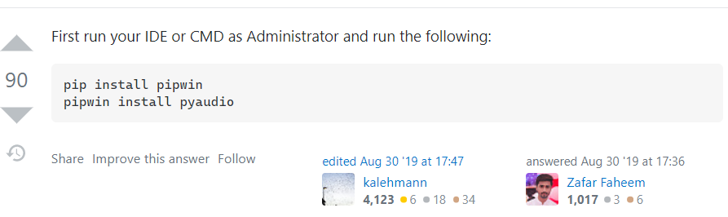

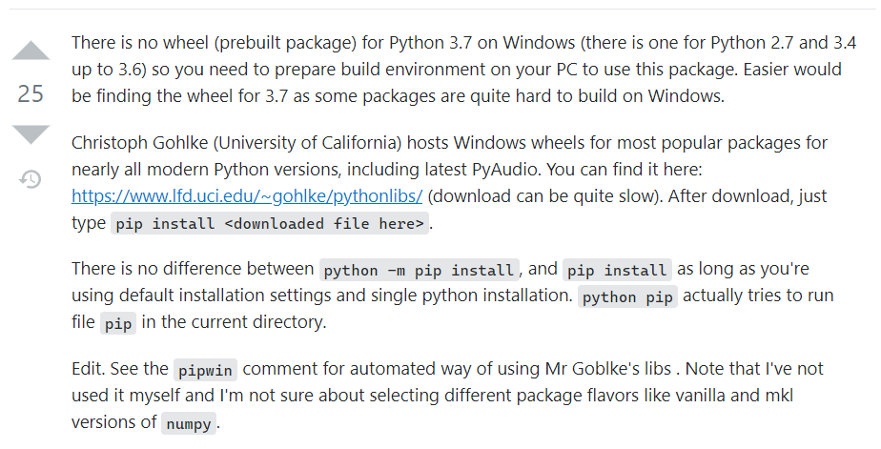

after install all package

run app.py file.

If you see this screen shoot, it means it works successfully!, then open the website.

