(to use “pip freeze > requirements.txt”)

pip install chatterbot==1.0.4

pip install chatterbot-corpus

if Error, see blow

ERROR: Cannot uninstall 'PyYAML'. It is a distutils installed project and thus we cannot accurately determine which files belong to it which would lead to only a partial uninstall

pip install --ignore-installed PyYAML

change time.clock to time.time

If no error, go here,

pip install speechrecognition

if you use python 3.7, you need to install 2.7.1

pip install pyttsx3==2.71

pip install pytz

# pip install neuralintents, no need for now.

how to install pyaudio

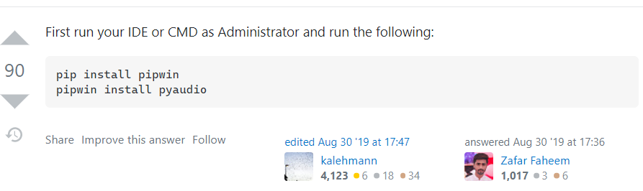

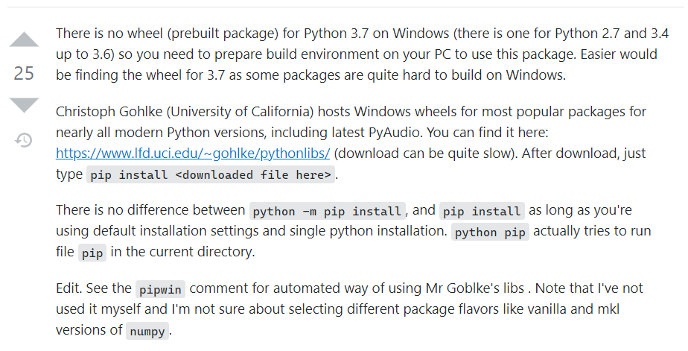

https://www.lfd.uci.edu/~gohlke/pythonlibs/

after install all package

run app.py file.

If you see this screen shoot, it means it works successfully!, then open the website.

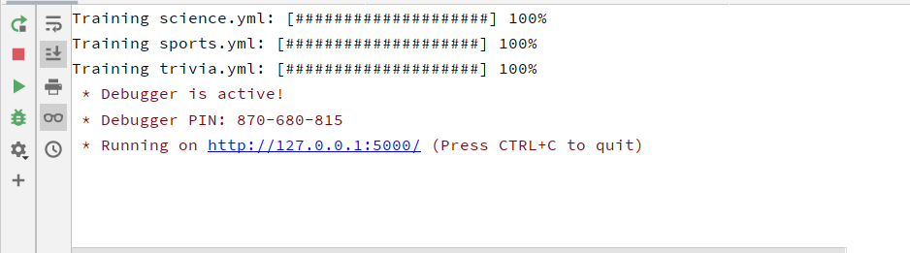



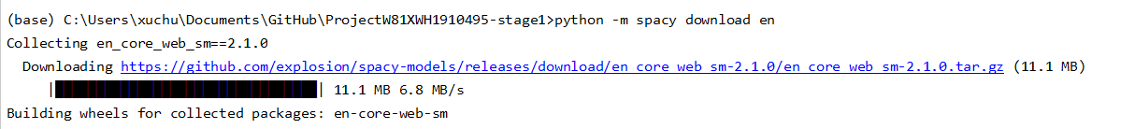

Some errors

If you can’t open the schema of database, you may need to download driver files and make you’re your database connected.

Right click database and click properties.

