**Progress made in the past week.**

1. Input and organize the references and literature that you previously found. Need to have this done ASAP. I have already added a bunch of references in the collaborative groups, which can serve as examples.

Done

1. Added more voice conversations to make chatbot become clever

I added some conversations according to this website

<https://www.cancer.org/cancer/breast-cancer/understanding-a-breast-cancer-diagnosis/questions-to-ask-your-doctor-about-breast-cancer.html>

1. Optimize the performance of the texting conversation, which currently can’t even carry on more than a couple of sensible message exchanges. (See my comments above).

I tried to achieve two ways, click the button or text answer, but if I just text 5 year, the robot will use their own package to analyze it and give related answers according to the input. So I added (please click the button) for every button conversation to remind users to click instead of texting.

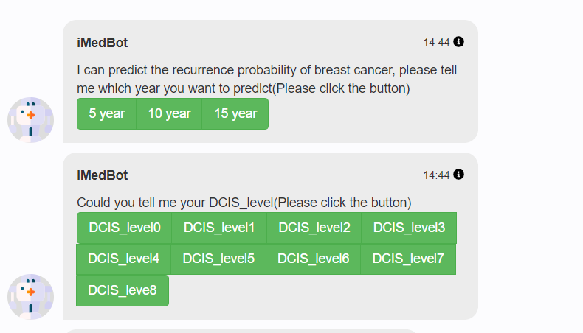

1. Method for deploying the tool. Meaning, how would we let common user to start and run the tool. We can’t expect that a user knows how to install and run python packages.

We can deploy our project to our server then buy a domain, so the users can get access to our project buy specific link.

The chatbot has been deployed to 45.79.177.166 server, but the voice function can’t work so far, still debugging

1. Server update. You can start by sending IT tickets for accessing the two servers (see ongoing tasks). Keep records of your IT tickets and copy me for all email communications with relevant personnel such as IT regarding this issue.

IT ticked was submitted on Monday (June 7, 2021)

No reply has been received.

**Issues/Questions**

**Comments**

Regarding the issue in Progress 3, I suggest that you take either of the following two approaches: 1) In case the iMedbot has provided selection buttons (such as 5 year, 10 year, and 15 year) for user to click, then disable (grey) the text input for that particular interaction. 2) If we choose not to disable the text input in that case, then we can change the logic/algorithm at the backend, so user text input be compared with one of the choices (such as 5 year, 10 year, and 15 year), if there is a match, then respond in the same way as a button being clicked, and if there is no match, then go to the database for a answer.

**Ongoing tasks that cover more than a week**

1. Machine learning with MBC
2. Literature search
3. Improving iMedBot

Upgrade two servers (dbgap and dbgap2)

**Specific tasks for the coming week**

1. Find out how the previous machine learning experiments (except deep learning) were done: with or without 80-20 split (level 1 validation)? If yes, then we are good. If no, then we need to rerun them by adding 80-20 split, then 5-fold CV with the 80%. Don’t delete the current functions.

The previous machine learning methods also used 20% as the validation dataset and then perform 5-fold CV with the rest 80%.

1. I will provide new datasets that you can use to do experiments, similarly to what you did with other MBC dataset: 1) running stage-1 tests that focus on finding the range of good hyperparameter values for each of the hyperparameters while fixing the values of other hyperparameters. 2) running stage-2 tests (grid search) based upon. results from 1). 3) Starting out with machine learning methods we used except for deep learning. In these experiments, don’t do 80-20 split.
2. Search for more papers pertaining to applications of machine learning/deep learning. If you already have some this type, please re-organize using the new private group that I created.
3. Improve iMedBot based what we discussed today at meeting.
4. The current task for servers is to upgrade the OS to the newest version because the current Windows NT server 2008r is no longer supported by Microsoft. Please consistently follow up with John (IT) for the work.

**Less urgent specific tasks**