**Progress made in the past week.**

1. **Added hint function for microphone**

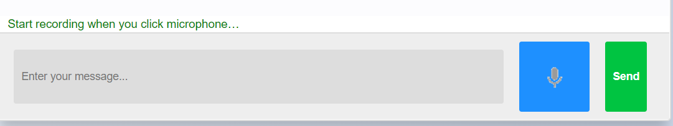

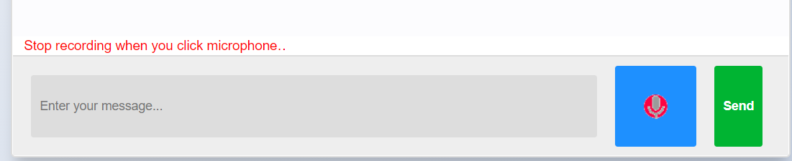

1. **Added hint function for medical options**

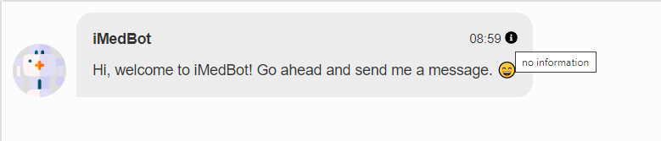

1. **Added auto complete input function**

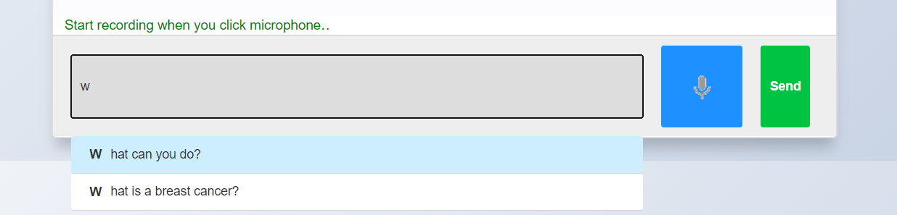

**Issues/Questions/Comments**

1. **Do we need to design some feedback form?**

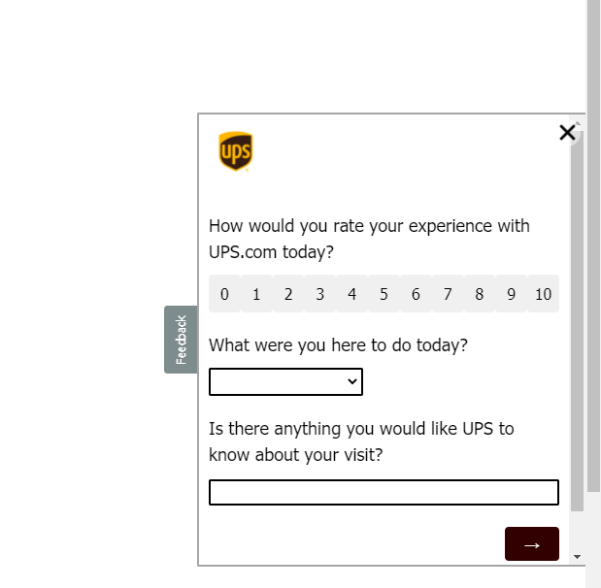

1. **Do we need to email transcript (chat history) to our customer?**

**Like this**

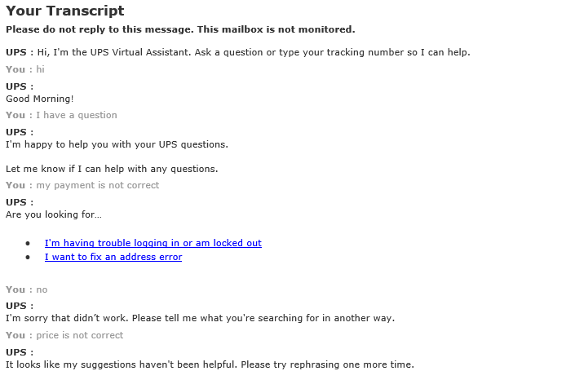

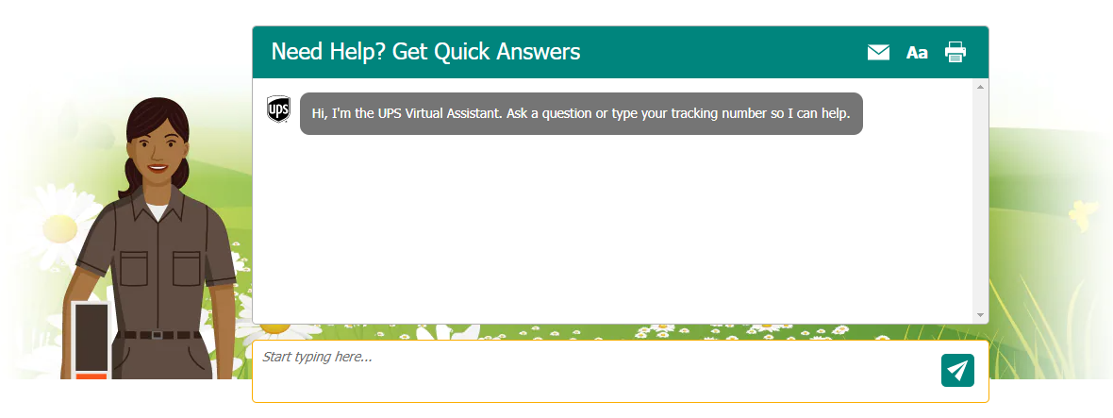

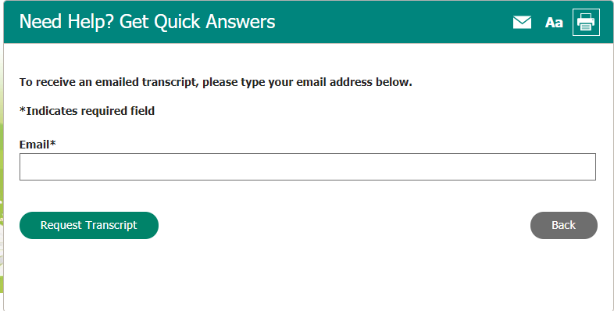

1. **We need to make our chatbot can move and can be resized by users**

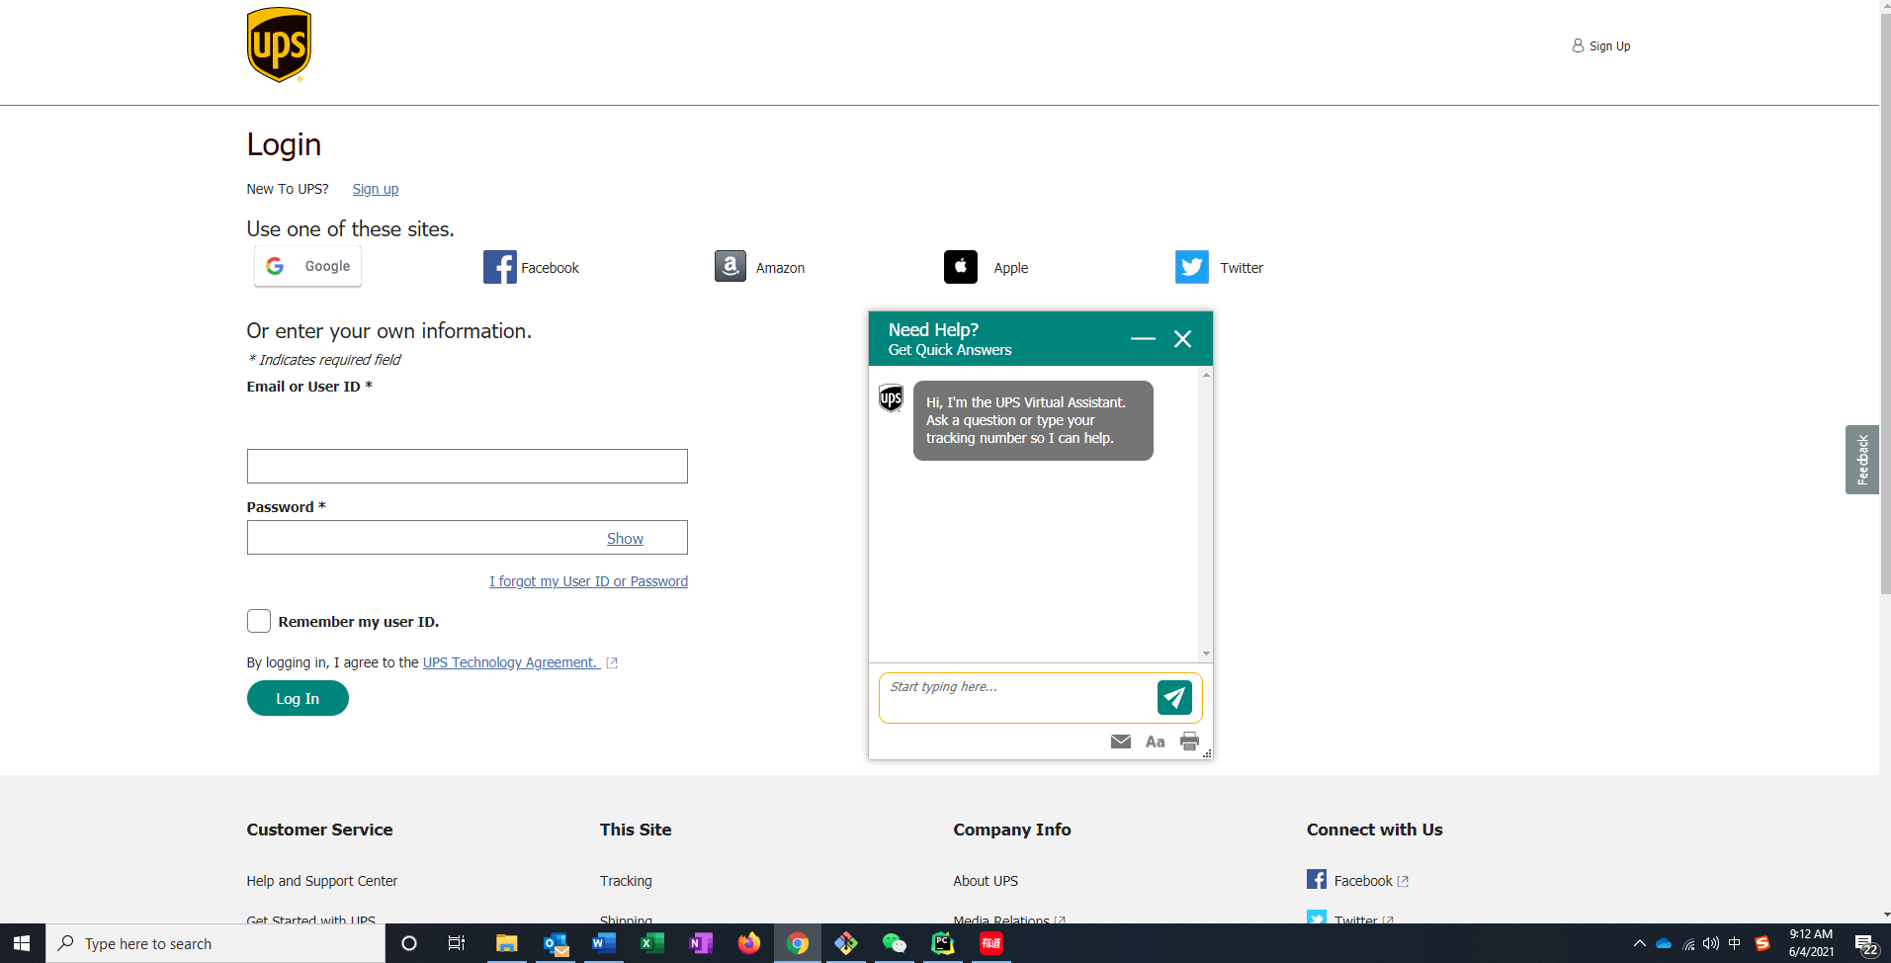

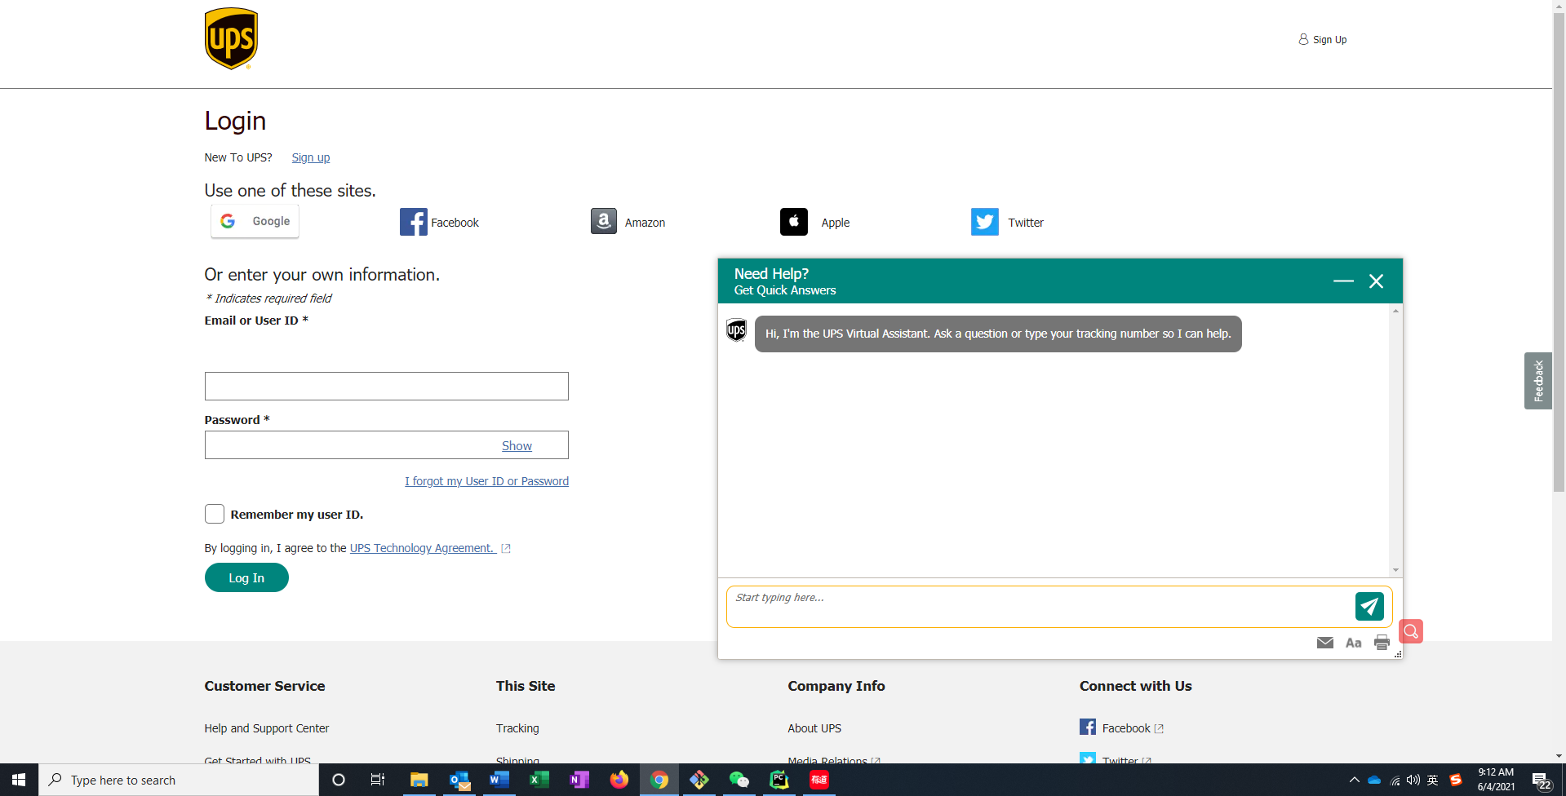

1. **FedEx online chat**
2. 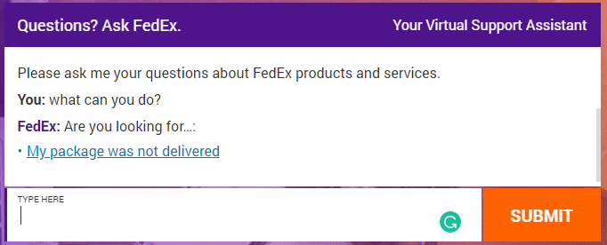

**Ongoing tasks that cover more than a week**

1. **Added more conversations to make chatbot become clever**

**Specific tasks for the coming week**

**Less urgent specific tasks**