**Meeting Time:** 2:00 -3:36 pm, Jan 30, 2023

**Attendees:** Xia Jiang, Zhen Yang

**Meeting agenda**

1. Discussed a test error obtained by Dr. Jiang last week and the importance of error handling in computer programming. When Dr. Jiang tested iMedbot sometime last week, she tested the “forget password” feature. The system behaved odd by claiming that she did not answer the verification questions but not providing opportunities to enter/create the verification question (see screenshot below). The explanation from Zhen Yang about this today is that her user account was created before the system requires verification questions and email addresses from a user. So in this case, error handling and developing solutions for “abnormal” situation liked what happened in this case is very important. Simply deleting these early-registered users is not a viable solution, rather we should take other approaches such as ask these users to update their profiles including creating verification questions and providing email addresses when they log on.

1. Tested iMedbot for new work done last week.
2. Tested the new MongoDB database for user information storage.
3. Provided feedbacks and written comments based testing.
4. Regular meeting time changed from 9 :00 to 2:00 pm due to time conflict with class.
5. New work assignment.

**Comments**

Feedbacks from Dr. Jiang based on the new test done today.

1. Logout button next to the user name worked, and user’s first name becomes a user name to show on the right corner of the page. Good! But I just notices that a user needs to click on “log out” twice (see screenshot below), which is not necessary.

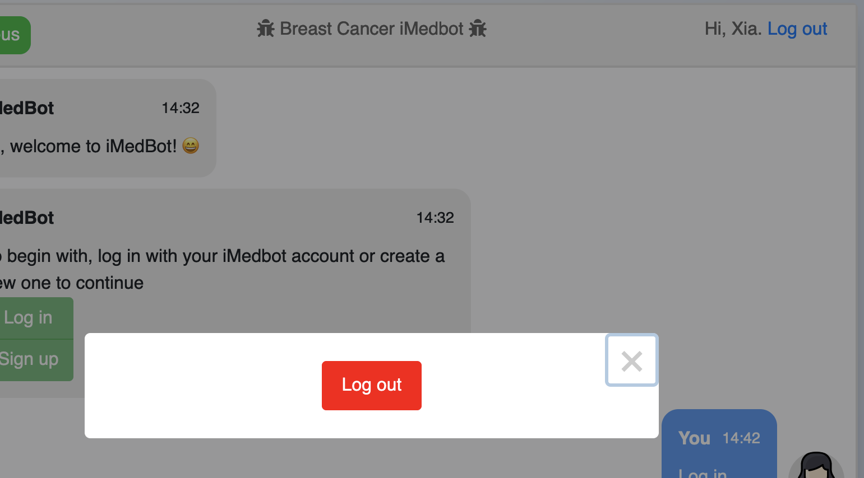

1. In terms of the “forget password” feature, I notice that requiring both “security question verification” and the 6-digit “pin code” from email we send can be two overwhelming to a user (see the screenshot below). Suggest that we let the user choose between email pin code retrieval or security question retrieval.

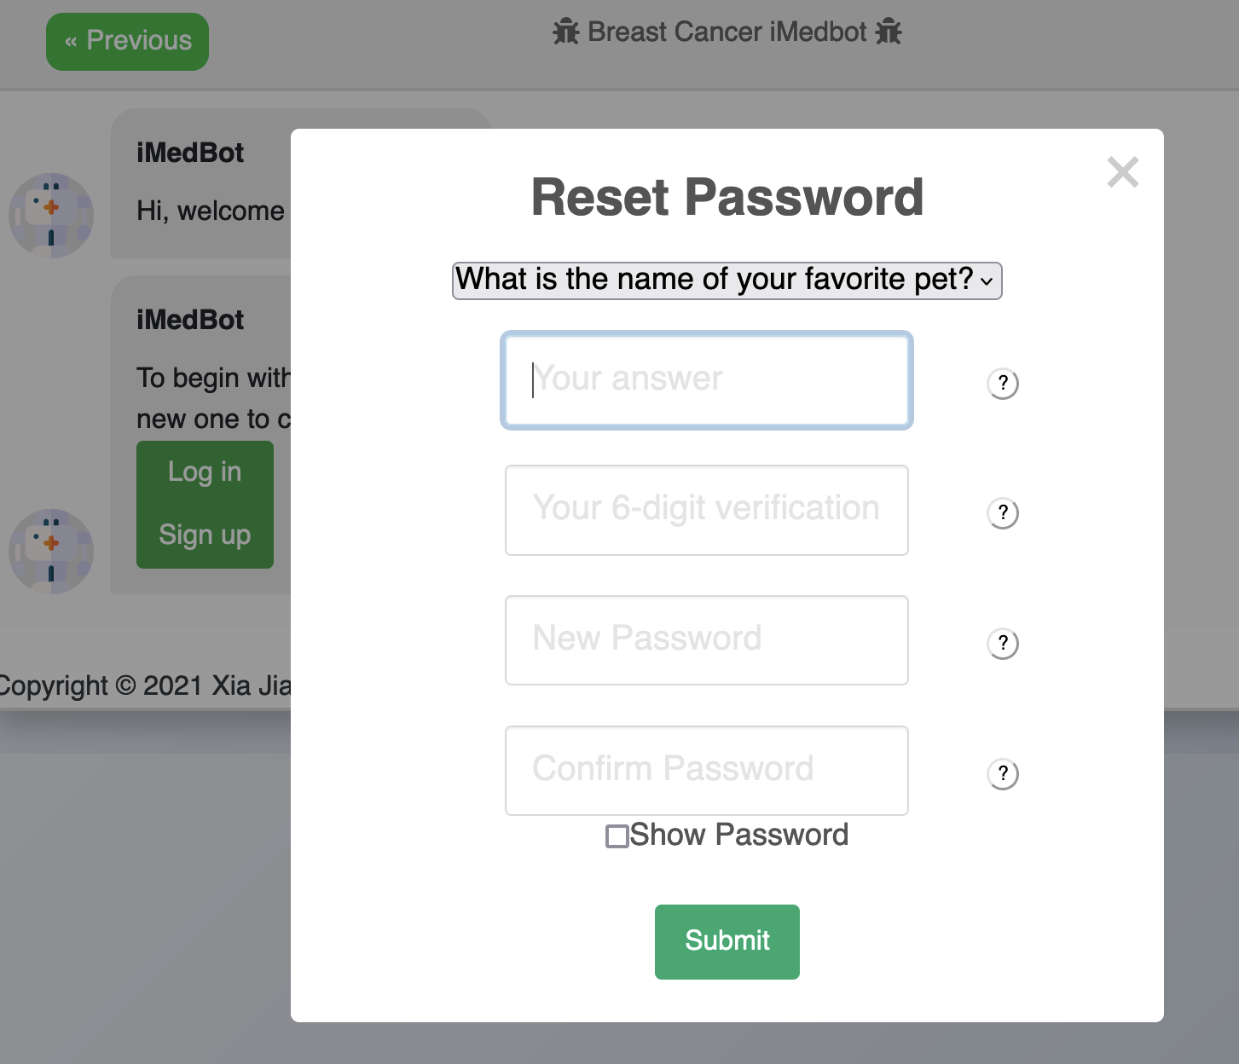

1. Based on my suggestion from last meeting, Zhen set up automatic logout in 20 minutes. I suggest that change to 10 minutes. In addition, after a user is idle for 9 minutes, we will bring a message box telling the user that she/he will be logged out in 1 minutes, adding a timer to countdown from 60 section, and asking whether user want to stay in this session.
2. Notice that the new “manual tool tip” (question mark with half circle) is more sensitive that the previous “automatic tool tip”.
3. Since my pitt email can’t be verified immediately due to the Pitt email setup, I was not able to create a user account using my pitt email address. Can we have a solution for this? Consider adding a reminder box telling the user that the verification email could go to the spam folder or being filtered by the email system, and giving the user suggestions in this case.

**Specific tasks before next meeting.**

1. Refining the system based on Dr. Jiang’s comments as show above, email Dr. Jiang immediately after they are done so she can do testing herself without using meeting time.
2. Enhance your tech notes about the email verification system and google analytics, and we will use them during the next meeting. Both should be transfer to the project rather than in your personal account.
3. Do more testing with the prediction and model training services using more datasets. Enhance the system in terms of prediction and training results accuracy and error handling. This is the core of the work. We will conduct more testing in the subsequence meetings in this perspective. For example, I might do a test with the Shap plot and ask you to explain the resulted figure.
4. Consider adding more types of Shap related figures for further explaining the prediction results.

**Less urgent tasks**