Document Title

A plain paragraph having some **bold** and some *italic.*

# Heading, level 1

Intense quote

* first item in unordered list

1. first item in ordered list

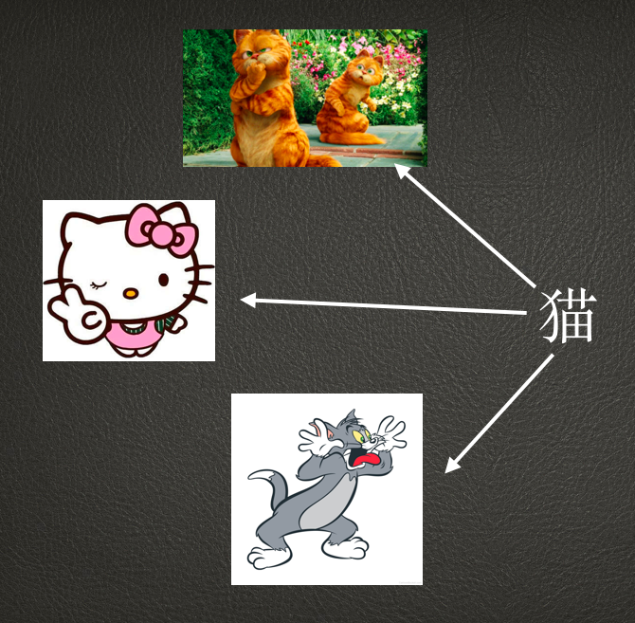

|  |  |  |
| --- | --- | --- |
| Qty | Name | Desc |
| 3 | Fish | Tom |
| 8 | Cheese | Jerry |
| 5 | Bacon | Garfield |



一个人的命运当然要靠自我奋斗，但是也要考虑到历史的进程。