**Prerequistes**:

1. Ensure dotnet 6.0 is installed in your system.
2. Clone the project from “https://gitlab.com/qt_pacttraining/SampleWebApplication” using the git command.

**git clone -b main <https://gitlab.com/qt_pacttraining/SampleWebApplication.git>**

**OR**

Download the project as zip file and extract it in your system.

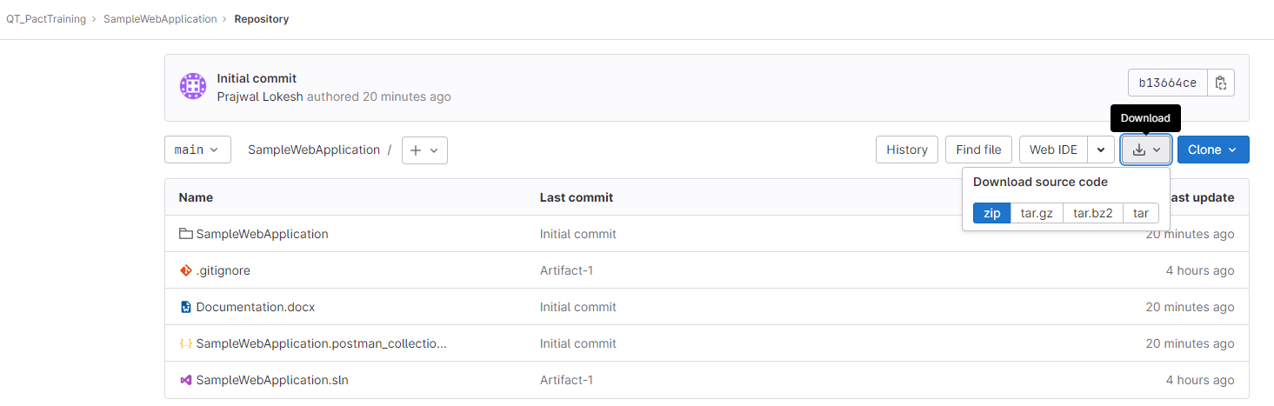

**Steps**:

1. Open command prompt where “SampleWebApplication.csproj” file is present
2. Run following commands
   1. **dotnet run**

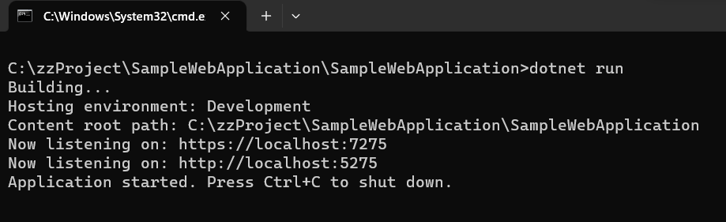

NOTE: The API’s are hosted in “https://localhost:7275”.

GET request: <https://localhost:7275/User/GetUserDetails/<id>>

POST request: <https://localhost:7275/User/CreateUser>

You can import “SampleWebApplication.postman_collection.json” into Postman and access the API’s.