**Prerequisites:**

1) Visual Studio 2022

2) dotnet 6.0

**Steps:**

1. Open "Visual Studio".

2) Click on "Create a new Project".

3) Search and select "ASP.NET Core Web API".

4) Change project name and solution name (Optional). In this example we’ll name it “SampleWebApplication” and click “Next”.

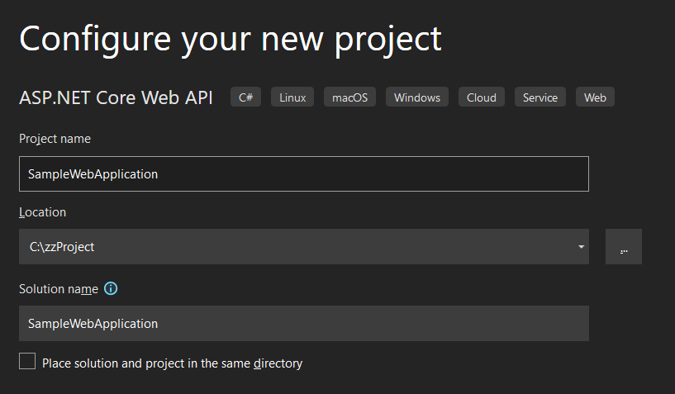

1. Ensure following options are selected .

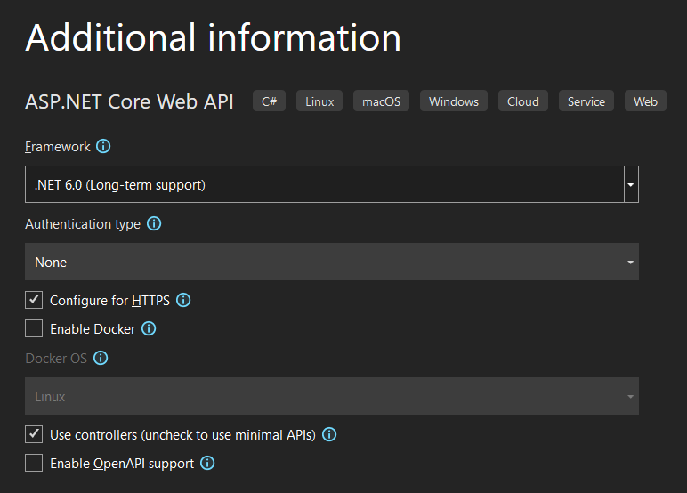

1. Click on create.
2. Once project is created, click on Run.



1. A new browser window will open pointing to the sample API (“/weatherforecast”).

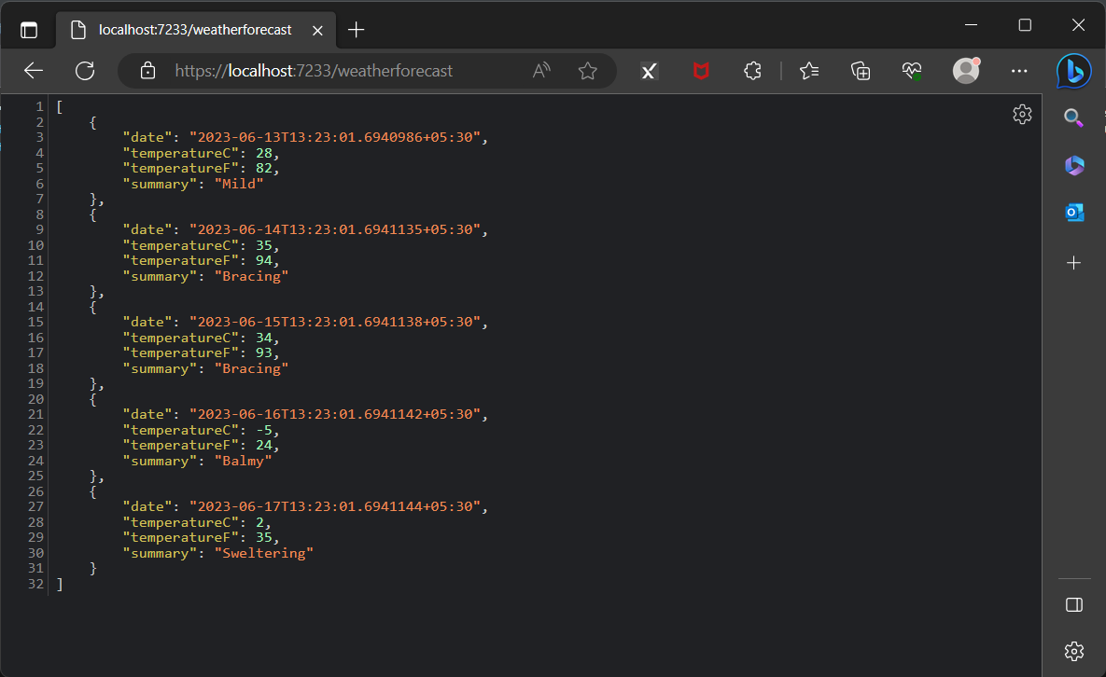

Use the URL from the browser (i.e [https://localhost:7233/weatherforecast)](https://localhost:7233weatherforecast)) in **Postman** to access the API.

**NOTE**: Please make sure to update the port number in URL to match the one specified in the browser in Step 8, as the port number will vary depending on the machine.