[1]

Smart Home Security System

Vrinda Parkhi, Chinmay Kshirsagar, Parth Kudal, Isha Lad, Chandni Mangwani

Department of SY Common Engineering

*Abstract* — *This paper aims at providing reliable and robust home security system that can detect the theft and notify the owner when someone breaks into shop or home. The hardware of this system included microcontroller board (Arduino UNO) , PIR sensor and Ultrasonic sensor for detecting motion or miss conduct , Ov7670 Camera Module for recording vedio and Bluetooth Module to generate alert message to the owner. System also consists of mobile App over which emergency alert was sent via Bluetooth Module . To make this application, MIT App Inventor was used. The proposed project also had an option to shutdown the complete system as per the requirement . For shutdown procedure, Keypad and LCD were connected to microcontroller to generate passcode.*

***Keywords****-* ***Arduino UNO , Bluetooth Module, PIR Sensor, Ultrasonic Sensor, Proteus.***

# INTRODUCTION

Nowdays, theft has become a big threat to people and their property. Securing and monitoring have become the main objective for controlling theft. CCTV camera systems are installed to protect home and shops from burglary and break-ins. But it is not possible to monitor it 24*7. This problem can be solved by the use of home security system. The proposed method provided a safe and secure environment designed in such a way that whenever the ultrasonic sensor and PIR sensor were triggered simultaneously by sensing the object motion nearby , the input signal was feed to Arduino UNO . When microcontroller received input signal from sensors , the camera module was activated for recording and microcontroller also generated an emergency alert on mobile App via Bluetooth module. Total system shutdown option is available by keypad-LCD system which takes code as an input from the owner and feed it to the microcontroller. The code is verified by the microcontroller and deactivates the entire system. This shutdown option can be made on whenever necessary. This reduces the unnecessary power consumption and also gives service at low cost.

The existing method uses various technologies for controlling theft and providing security for houses. Technologies such as GSM , ZigBee , WSN etc. are used. [1] Security Management for Controlling Theft Using Arduino Uno by S. Deepika and M. Nisha Angeline. The security system in this paper is designed to control theft at home, when there is a break-in or when they entered passcode is incorrect. In the case of any break-in, the Bluetooth connected to the controller sends a message to both the owner of the house and to the police station. [2] Development of GSM Based Advanced Alert Home Locker Safety Security System Using Arduino UNO by B.Rama Murthy , O.Jagadish , et.al. The project proposed by this paper is an advanced alert home security system with Fingerprint and Password authentication to open or close the door system and also sending the message if any miss operation will be performed by others using GSM Technology with smart mobile. [3] A Remote Home Security System Based on Wireless Sensor Network and GSM Technology by Huiping Haung, et.al. In this paper, a low-power consumption remote home security alarm system developed by applying WSN and GSM technology is presented. The system software can send a piece of alarm short message to the user's mobile phone when some dangerous condition has been detected. [4] Laser Based Security System for Home by Harshal Hemane and Debarati Sen.This proposed system uses laser light properties to build a security system. When any person or object crossover the laser line the security alarm starts ringing and turns “on” the focus light to focus the entrance of unauthorized person. [5] Home Security System Based On GSM and Voice Module by B.Lakshmi Prathyusha ,et.al. This paper presents the design of an embedded home security system that uses PIR sensor, LDR flame detector, and MQ6 gas sensor around ATMEGA328P microcontroller. When system detects any intruder is present or any gas leakage occurs or any fire accident takes place, then it alerts the owner through a call using GSM technology and Voice Module.

An effort has been done to develop an efficient and affordable Smart Home Security System using Proteus software for simulation.

# Literature Review

As stated in the paper [6] has reported, The techniques used for home security systems have changed from the traditional alarm based technique to the embedded systems. The team has used led, lcd, buzzer, GSM module and AVR microcontroller to design, implement and analyse the home security system within reasonable cost. [6]. As stated in the paper [7], has reported, The main objective was to build an integrated home security system using traditional magnetic switch equipped doors and windows. The system is made such that it monitors doors and windows of a house and sends an alerting signal to the nearby police station in case of an intrusion; and allows residents to enter with an ID card. [7]

As stated in the paper [8], has reported, The connectivity with technology, such as mobiles or laptops, can help in securing homes from a remote place. For this door lock security system with 2 high level security passwords, the team has used Arduino microcontroller and GSM module to send an alert message to the user. [8]. As stated in the paper [9], has reported, The increasing concern about home security is due to the increasing possibilities of intrusion and even when lot of security companies are available for protection, there is no guarantee that the house is safe. The team has mentioned that the main problem with current security systems is the higher cost and system using PIR sensor and ultrasonic sensor has a possibility of false intruder detection. The use of PIR sensor, temperature sensor and humidity sensor are done for this project, thus reducing the cost and increasing the accuracy. [9]

As stated in the paper [10], has reported, The need of home security system is crucial as any other safety need of humans. The sensor used in this system is camera, through which the intruder is detected using computer vision and an alert message is sent to the user while capturing the image of the intruder for further inspection. [10]. As stated in the paper [11], has reported, The main objective was to design a prototype for smart home system with low cost, user friendly interface and which is scalable and reliable; as many smart home systems have limitations in terms of the high cost, less functionality and difficulty of use. A temperature sensor and a motion sensor are utilized for this prototype. [11]. As stated in the paper [12], has reported, The use of wireless technology in security and control systems offers benefits along with the user friendly interface. This system is interfaced with various sensors using Zigbee and the message of intrusion is conveyed using GSM. [12]

# Methodology/Experimental

## Materials/Components/Flowchart/Block Diagram/Theory

**Components:**

1. **PIR(Passive Infrared) Sensor(HC-SR501):**

A PIR sensor is a sensor that measures IR radiations coming from the objects in its field of view. They are mostly used as motion detectors. PIR sensors are largely used in home and office security systems. They are used in appliances that are used for security purposes.

Fig.1: PIR Sensor

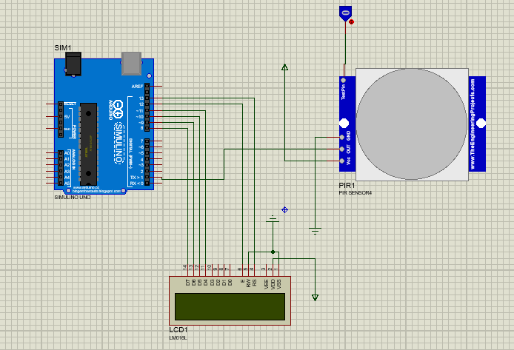

Fig.2: Implementation of PIR sensor in Proteus

1. **Ultrasonic Sensor(HC-SR04):**

HC-SR04 has two cylinders at the front, one is a transmitter and the other is a receiver. We set the Trig pin high for at least 10µs in order to generate a sonic burst. The sensor then creates a burst of 8 cycles of sonic sound at 40KHz.This sonic burst is deflected by the object in its path and is captured by the receiver. The echo pin then calculates the time duration in microseconds and thus we can measure the distance.

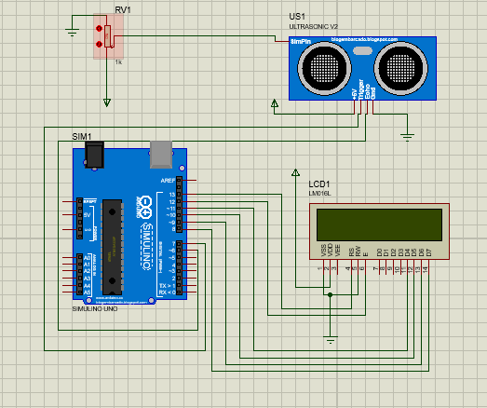

Fig.3: Implementation of Ultrasonic Sensor in Proteus

1. **Arduino UNO(R3 CH340G ATmega328p):**

Arduino UNO controller board has a ATMEGA328P microcontroller and is developed by Arduino.cc.circuits. This board has 20 pins. Arduino IDE is a cross platform application developed by the same organization to code and upload the program on the board. **A circuit board
**

Fig.4: Arduino UNO

1. **Bluetooth Module(HC-05):**

HC-05 is a bluetooth module used for wireless data transmission for the devices that are enabled with bluetooth. It communicates wirelessly using USART. This module sends and recieves signals of level 3.3V and arduino can detect this voltage so there is no need to amplify this signal.

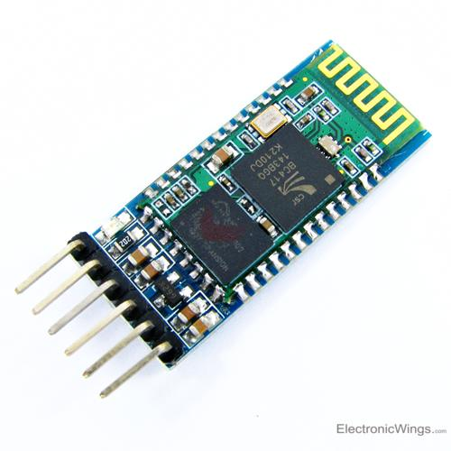

Fig.6: HC-05 module

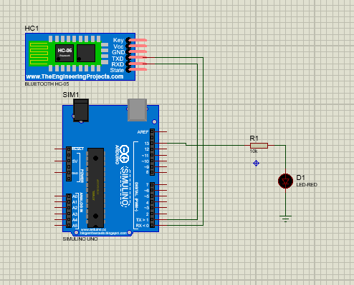

Fig.7: Implementation of HC-05 in Proteus

1. **Keypad:**

Keypad that is being used is nothing but the arrangement of buttons in vertical and horizontal directions. It has 4 rows and 4 columns (4X4) so a total of 16 keys.

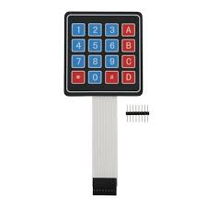

(Fig. 8: 4x4 Keypad)

(Fig.9: Implementation of keypad in proteus)

1. **LCD:**

Its abriviated as Liquid Crystal Display is built using Liquid Crystal Technology. It is a 16x2 module meaning it has 2 rows and 16 columns, so it can display upto 32 ASCII characters at a time.

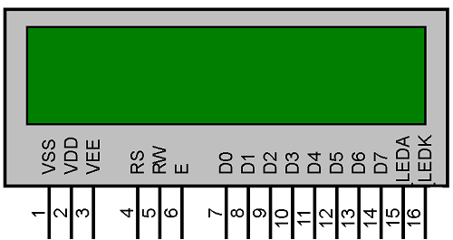

(Fig.10: 16x2 LCD display)

**Block Diagram:**

(Fig. 11: Block diagram)

## Synthesis/Algorithm/Design/Method

**Design:**

1. **Mobile App:**

This app is the interface between the hardware and the user, this app is in continuous connection with the Bluetooth module, and calling takes place via API calls.

This app is made using MIT App inventor.

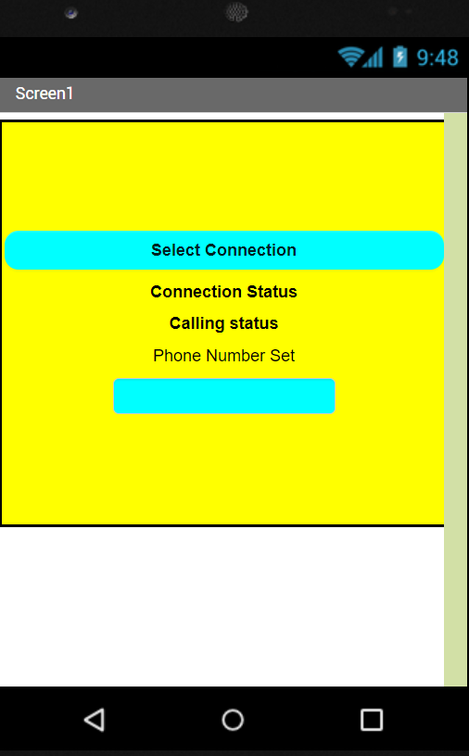

(fig.12: Home screen of the App)

1. **Circuit Diagram:**

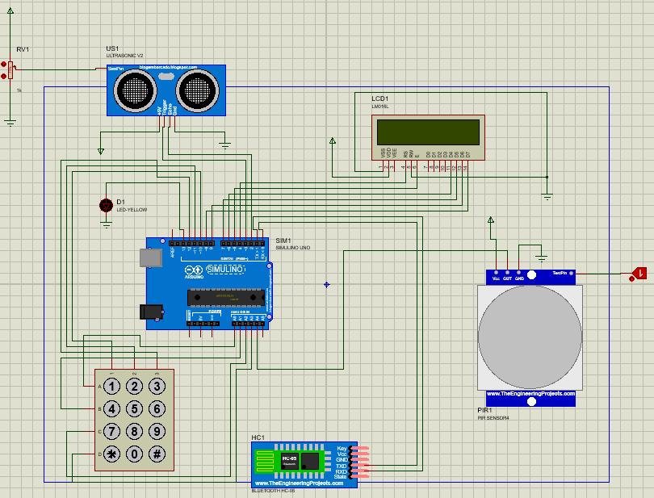

(fig.13: Circuit in Proteus)

1. In the circuit total there are 5 components connected with Arduino.
2. The Keypad and LCD are used in combination with each other, it is used for the purpose of authentication.
3. Here PIR sensor and Ultrasonic sensors are used for alarm detection, and their inputs are fed to Arduino.
4. Bluetooth module is used to stay connected with the user via App.

* **Algorithm for the Code:**

**Step 1:** First get the user authentication using Keypad & LCD.

**Step 2:** Get the ultrasonic and PIR sensors working/active so that they give some readings.

**Step 3:** Set some threshold to these values to trigger the alarm.

**Step 4:** Connect the mobile to Bluetooth, and once the thresholds are crossed send this message to phone via Bluetooth module.

**Step 5:** Give a call to the registered number.

## Characterization/Pseudo Code/ Testing

1. **Pseudo Code:**

**Arduino Code:**

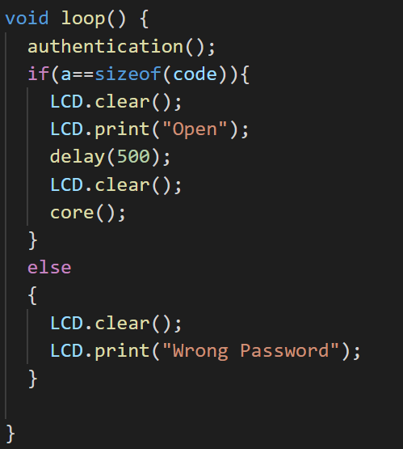

(fig.14: Code)

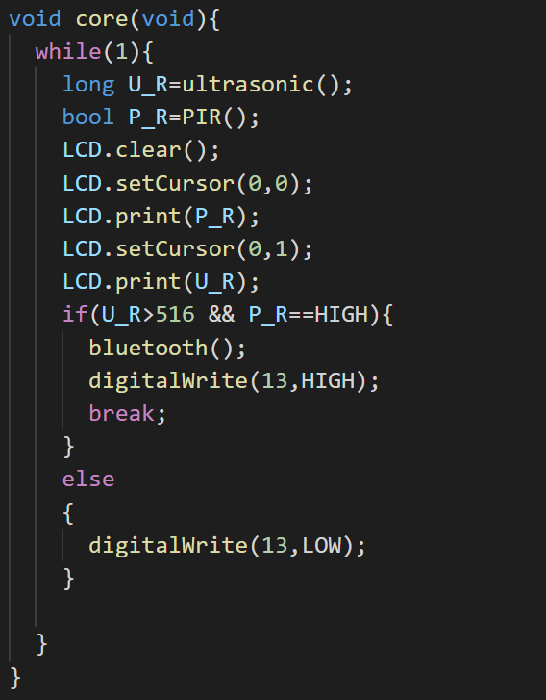

(fig.15: Code)

**Coding of the App:**

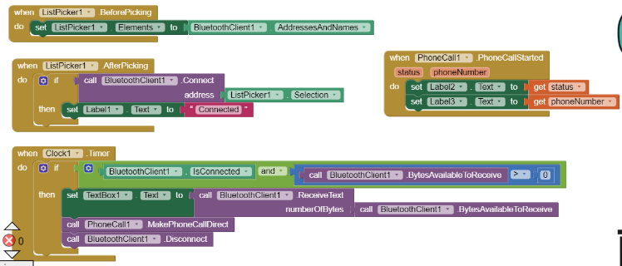

(fig.16: MIT App inventor coding)

1. **Testing:**

**Authenticating using Password**

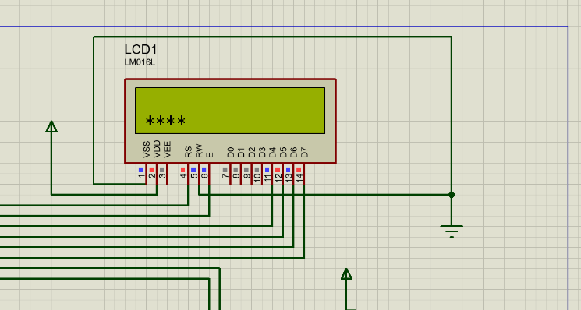

(fig.17: Unlocking the system)

Keypad was used to authenticate the system for first time use.

**Sensor Readings are displayed constantly**

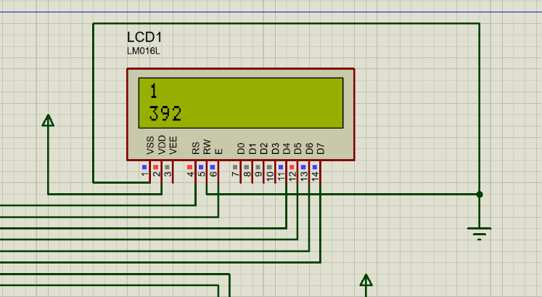

(fig.18: Readings)

First row is the reading from PIR sensor

Second row is the reading from Ultrasonic sensor

**Triggering the circuit**

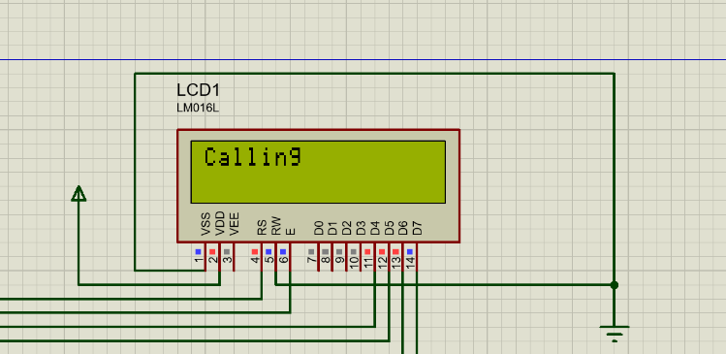

(fig.19: Call)

When both the sensors triggered a call is made to the registered number.

# Results and Discussions

1. Referring to the results obtained in testing, the system was subjected to various test cases to know its flexibility in different operating conditions.
2. Whenever both the sensors were triggered if a phone is connected to the Bluetooth module, a call was made to the designated number.
3. This number is hard coded while making the App.
4. If only one sensor is triggered then the call is not made to prevent false alarms.
5. When ever the sensor readings were beyond threshold values a call is received.

# Future Scope

1. The actual system operation can be verified through its physical implementation so that glitches can be removed, and performance can be improved.
2. Better Controller Board can be used.
3. The App can be built on a better platform like Android studio.

# Conclusion

1. With the help of these components and various softwares that are used a robust system is made.
2. The system was efficient enough to detect small changes in the sensors and make a decision based on that.
3. All the tests are done is a virtual environment not on physical system.
4. Its efficient and robust enough to keep homes/shops safe.

Acknowledgment

Honorable Director and our HOD, we would like to take the opportunity to express our heartfelt gratitude to our guide whose help and coordination has made this project a success.

References

1. Design and Implementation of Home Locker Security System based on Fingerprint Sensing circuit and RFID reader ",International journal of scientific & Technology Research Volume 4, issue 07,july2015
2. HlaMyoTun " Design and Implementation of Home Locker Security System based on Fingerprint Sensing circuit and RFID reader "
3. Aayush Agarwal, R.C. Joshi, "WSN and GSM based Remote Home Security System", International Conference on Recent Advances and Future Trends in Information Technology(iRAFIT2012) Proceedings published in International Journal of Computer Applications® (IJCA)
4. Jayashri Bangali, Arvind Shaligram "Design and Implementation of Security Systems for Smart Home based on GSM technology ", International Journal of Smart Home Vol.7, No.6 (2013), pp.201-208.
5. https://www.coursehero.com/file/37357202/IRJET-V5I1163pdf/, LASER BASED SECURITY SYSTEM FOR HOME Harshal Hemane1, Debarati Sen
6. Hasan, R., Khan, M.M., Ashek, A. and Rumpa, I.J. (2015) Microcontroller Based Home Security System with GSM Technology. Open Journal of Safety Science and Technology, 5, 55-62.
7. M. S. Islam, "Home security system based on PIC18F452 microcontroller," IEEE International Conference on Electro/Information Technology, Milwaukee, WI, 2014, pp. 202-205, doi: 10.1109/EIT.2014.6871762.
8. A. Sharma and A. Goen, "Smart Home Security System," 2018 International Conference on Advanced Computation and Telecommunication (ICACAT), Bhopal, India, 2018, pp. 1-4, doi: 10.1109/ICACAT.2018.8933780.
9. Suresh S., J. Bhavya, S. Sakshi, K. Varun and G. Debarshi, "Home Monitoring and Security system," 2016 International Conference on ICT in Business Industry & Government (ICTBIG), Indore, 2016, pp. 1-5, doi: 10.1109/ICTBIG.2016.7892665.
10. T. Juhana and V. G. Anggraini, "Design and implementation of Smart Home Surveillance system," 2016 10th International Conference on Telecommunication Systems Services and Applications (TSSA), Denpasar, 2016, pp. 1-5, doi: 10.1109/TSSA.2016.7871101.
11. A. Howedi and A. Jwaid, "Design and implementation prototype of a smart house system at low cost and multi-functional," 2016 Future Technologies Conference (FTC), San Francisco, CA, 2016, pp. 876-884, doi: 10.1109/FTC.2016.7821706.
12. A. W. Ahmad, N. Jan, S. Iqbal and C. Lee, "Implementation of ZigBee-GSM based home security monitoring and remote control system," 2011 IEEE 54th International Midwest Symposium on Circuits and Systems (MWSCAS), Seoul, 2011, pp. 1-4, doi: 10.1109/MWSCAS.2011.6026611.

1.