# Analysis of CPU Scheduling Algorithms

A Synopsis Submitted

in Partial Fulfillment of the Requirements

for the Course of

# Minor Project - I

In

Third year – Fifth Semester of

**Bachelor of Technology**

specialization

In

**Oil and Gas Informatics**

Under

**Dr. Kingshuk Srivastava**

By

**SAP ID ROLL.NO NAME**

# 500069579 R970218015 Chandranath Hazra

# 500069046 R970218032 Mansi Gupta

# 500068561 R970218038 Prashant Tiwari



DEPARTMENT OF INFORMATICS

SCHOOL OF COMPUTER SCIENCE

UNIVERSITY OF PETROLEUM AND ENERGY STUDIES, BIDHOLI, DEHRADUN, UTTRAKHAND, INDIA

# Jan, 2020

Synopsis

1. **Introduction**

Scheduling is a fundamental operating system property which allots a particular process to the CPU for execution while the other processes are in the ready queue. The program in execution is called a process. When there a number of processes in the queue the scheduling system comes into being, there are many factors which are considered like CPU utilization, throughput, waiting time, response time, turnaround time. The different operating systems use similar CPU scheduling algorithms to process the tasks in a particular sequence. The different algorithms used have various advantages and disadvantages; depending on the type of task to be performed the optimal algorithm is used. CPU scheduling is part of multi-programming operating systems. A process generally consists of two cycles of Burst I/O and CPU Burst performed alternatively until the process is complete.

The different algorithms show different average waiting time. The FCFS is better for a small burst time. The SJF is better if the process comes to processor simultaneously. The priority algorithm totally depends on the priority of the task. The Round Robin is better to adjust the average waiting time desired. All algorithms are potent, but the speed of the process depends on the load of the processor.

CPU scheduling deals with the problem of choosing a process from the ready queue to be executed by the CPU. The following CPU scheduling algorithms will be described:

**First come first serve-** It is the simplest of all scheduling algorithms. In this the process that requests CPU first, is allocated the CPU first. The implementation of FCFS is managed by FIFO queue. The non-preemptive nature of FCFS sometimes causes problems as the CPU is not shared at regular intervals by every process.

**Shortest job first-** It is also known as Shortest Job Next (SJN). It is very advantageous because of its simplicity and simultaneously it also reduces the average amount of time that each process has to wait until its execution is complete. The SJF is a disadvantage because if a short process is continually added, it takes a further long time for execution. And the other drawback that stands in the way is that the total execution of a process is to be known before the execution which is not possible.

**Priority Algorithm-** A priority algorithm includes a certain priority number (in integer) associated with each process and then the CPU is given a highest priority process. And if a case occurs where the priority of two or more processes is same then the processes are scheduled in FCFS order. A major problem with priority scheduling algorithms is that if a process that is ready to run but waiting for the CPU because of low priority, is said to be blocked and this condition is termed as indefinite blocking or starvation. In a high processing computer system, a steady stream of higher priority processes can prevent a low priority process from ever getting the CPU.

1. **Motivation**

As we know while doing shopping it takes more time to stand in queuefor paying bills even if we buy only 2 or 3 items so we thought to reduce the stress derived from waiting and to avoid this kind of frustrating situation we have implemented combinations of scheduling algorithm( **preemptive and non-preemptive)** like FCFC,SJF, Round Robin,priority which can be used to solve real world problems like smart grocery store.It will make the system efficient and fair as much as possible,giving respected priority on the basis of weight of product, type of item required , cost and number of products and also minimize the starvation of lower profit yielding customers.

1. **Related work**

In reference to the research paper ‘A comparative study of CPU scheduling algorithms’ by Mohd.Shoib and Mohd. Zeeshan Farooqui (2014) it shows the various advantages and disadvantages of each scheduling algorithm based on various constraints.

The other research paper ‘Billing queue scheduling’ by Nikita Parmar and Aastha Joshi (2018) shows the application of these CPU scheduling algorithms, making billing in a grocery store an easier task. The Shortest job first algorithm and priority algorithm are best for the billing option, coming across these research paper, it encouraged the smart grocery store idea of this minor project.

1. **Proposed Method (if any)**

# In this section we describe a way to solve the problemto reduce the waiting time for arrived process/customer and to complete the task in minimum time and to achieve these objective various algorithms are implemented-

# First come first serve (FCFS)

# Shortest Job First (SJF)

# Priority Algorithm

1. **Methodology**

Whenever the CPU becomes idle, the operating system must select another process to be scheduled in the ready queue; which process to be selected is decided by the CPU scheduler. The challenge is to make the overall system efficient and fair as much as possible, giving respected priority on the basis of weight of product, type of item required, cost and number of products.

The overall solving process includes:

**Step 1:** Detailed Study about different CPU scheduling algorithms.

**Step 2:** Understanding the basic concept and problems of scheduling.

**Step 3**: Identifying the algorithms which will be best implemented.

**Step 4**: Selection of algorithms which can solve the billing queue problem in most optimized way.

**Step 5:** Designing Flowcharts and algorithms of these optimization algorithms.

**Step 6:** Coding -Build the entire schedule by writing code using the C language.

**Step 7:** Testing-Test the developed algorithm by giving different inputs and if it gives correct output for different inputs, go to implementation phase.

**Step 8:** Implementation of these algorithms in different Environments.

**Step 9:** Comparative Study.

**Step 10:** Report.

1. **Plan of work**

As discussed with team, we will be following below schedule to complete project:

**CODE:-**

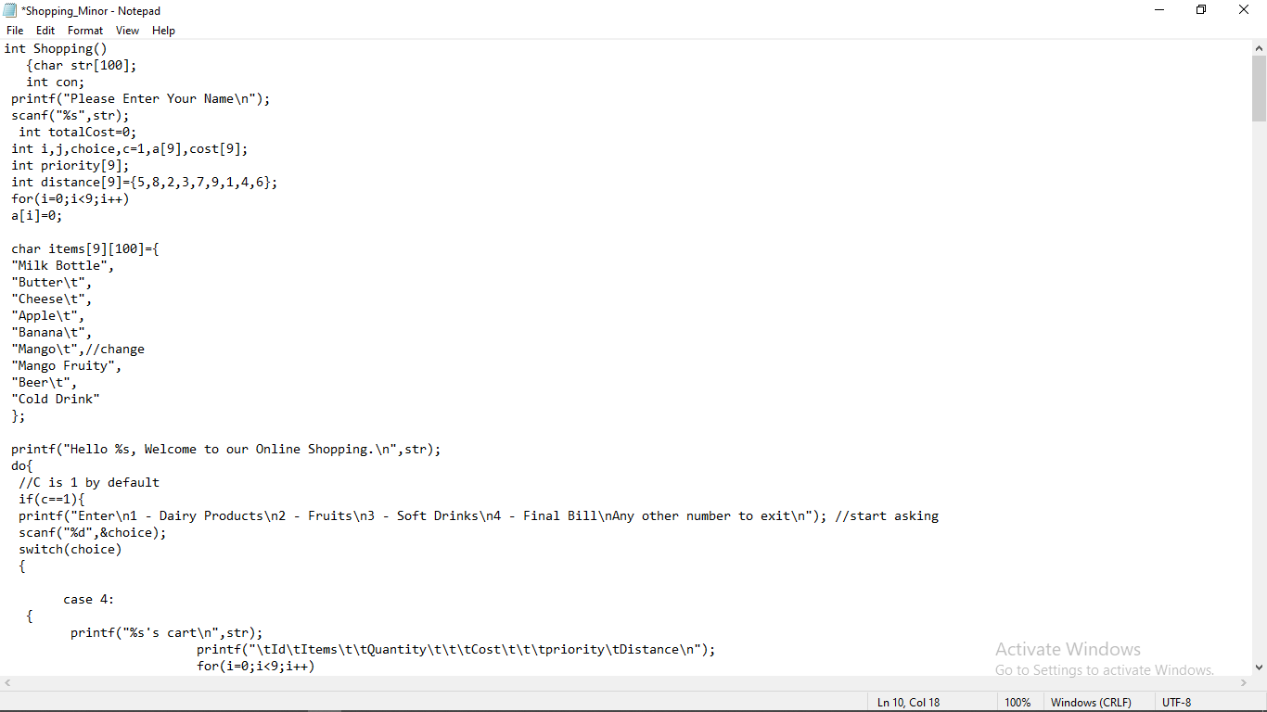

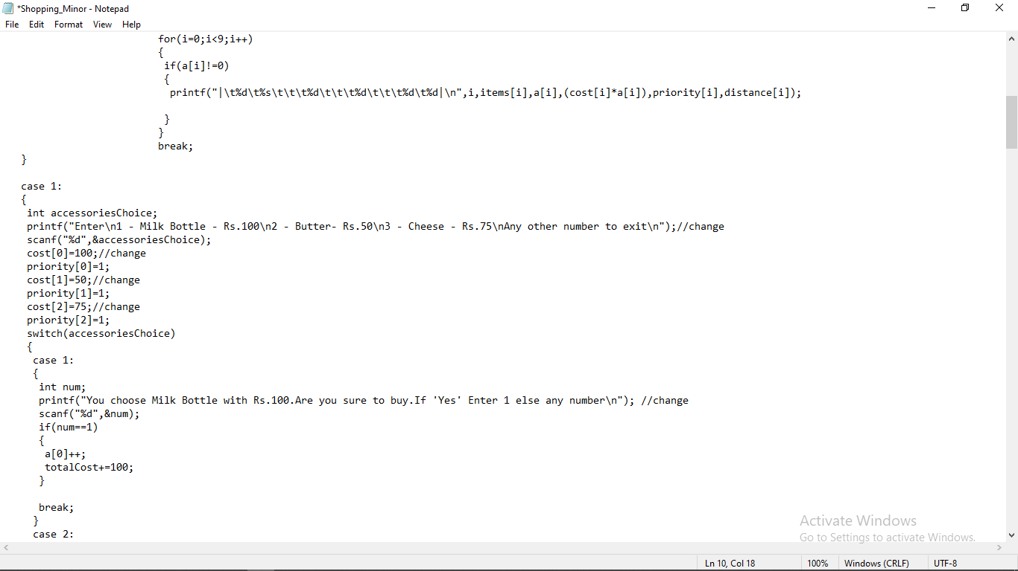

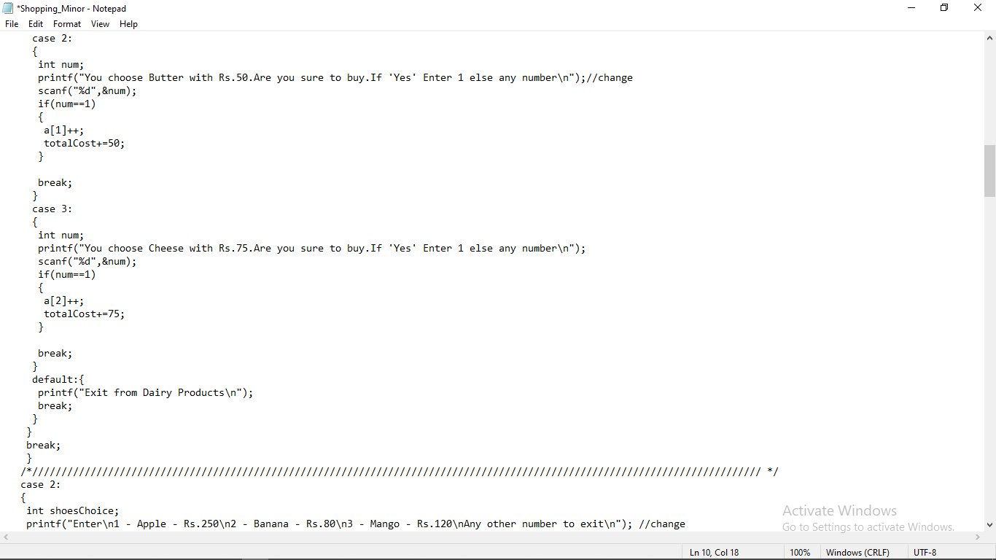

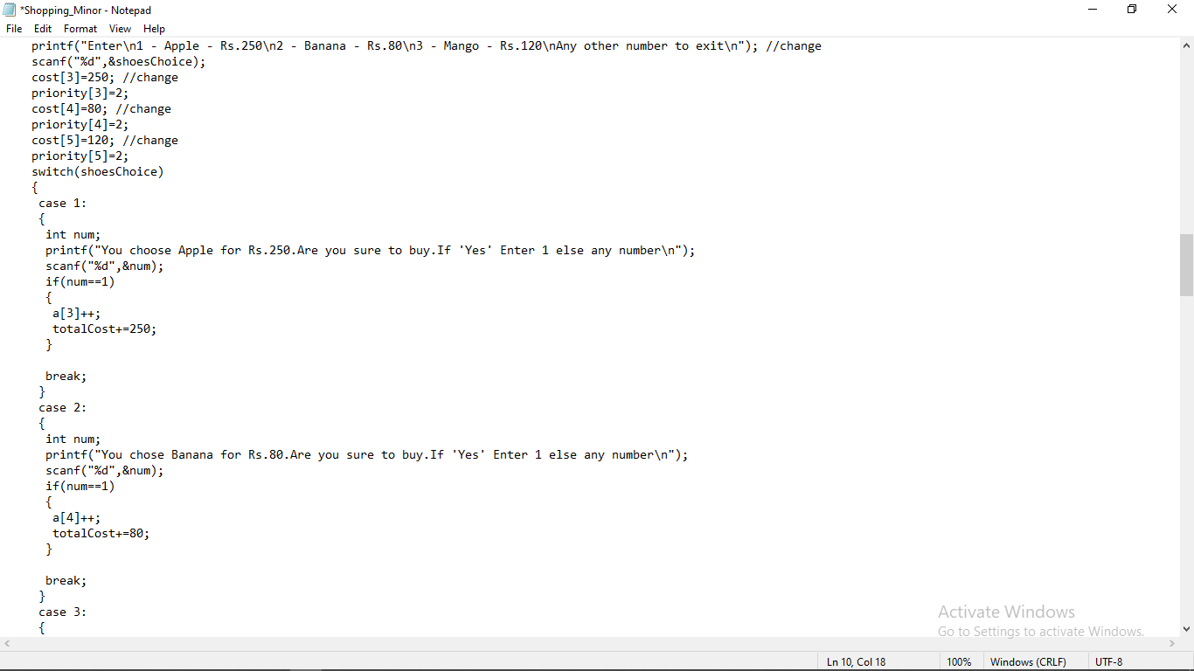

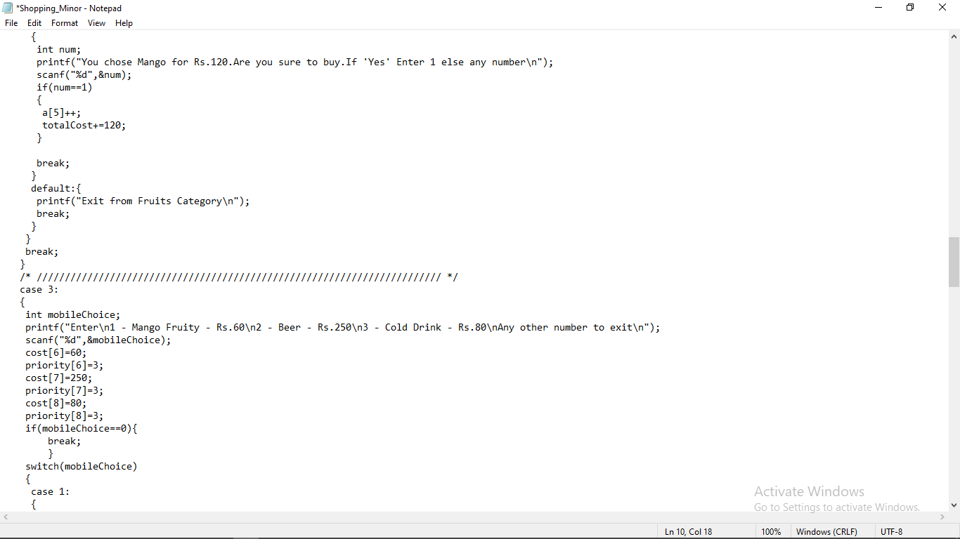

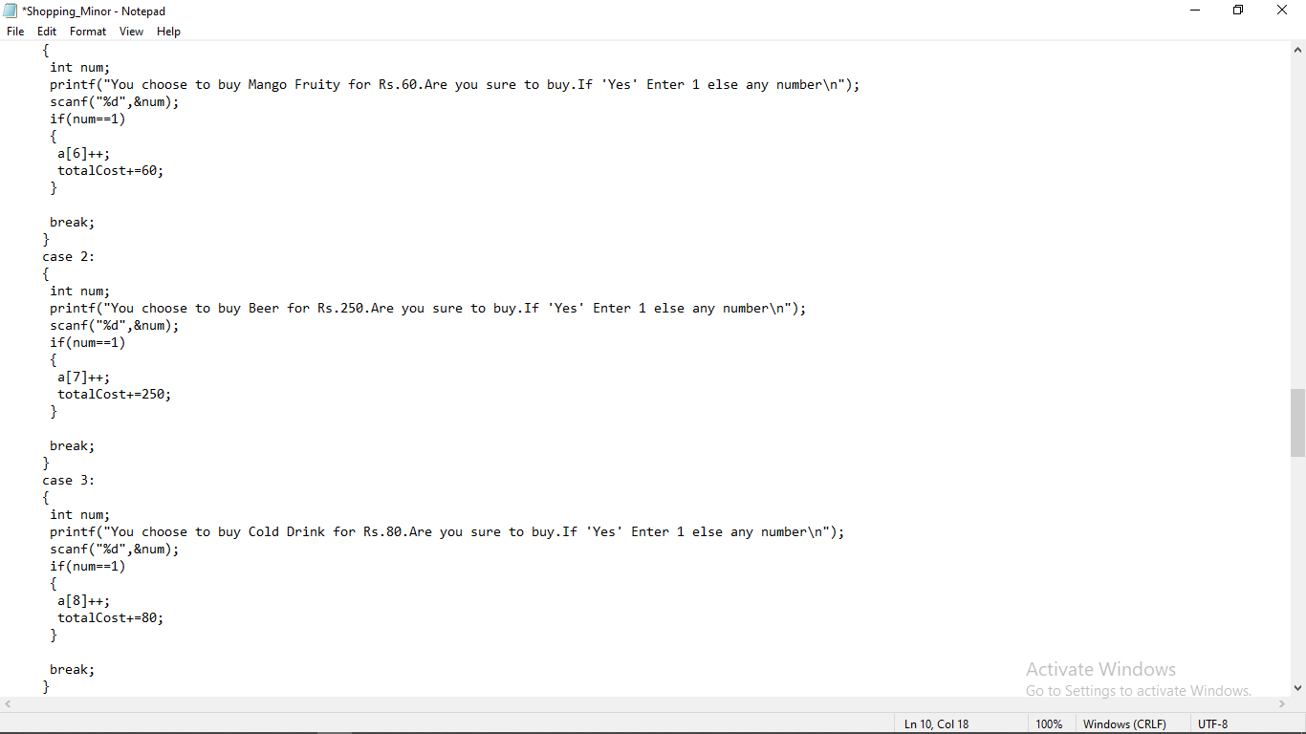

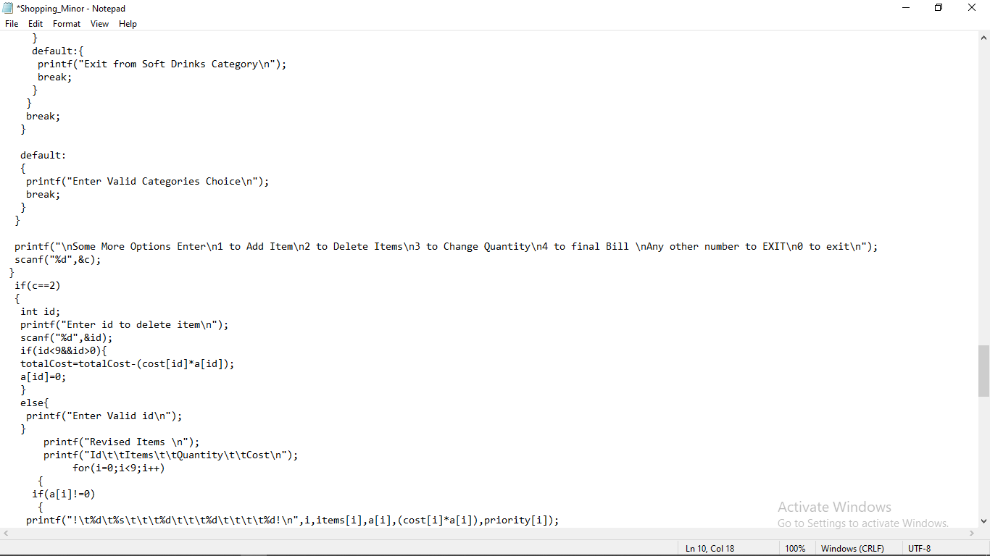

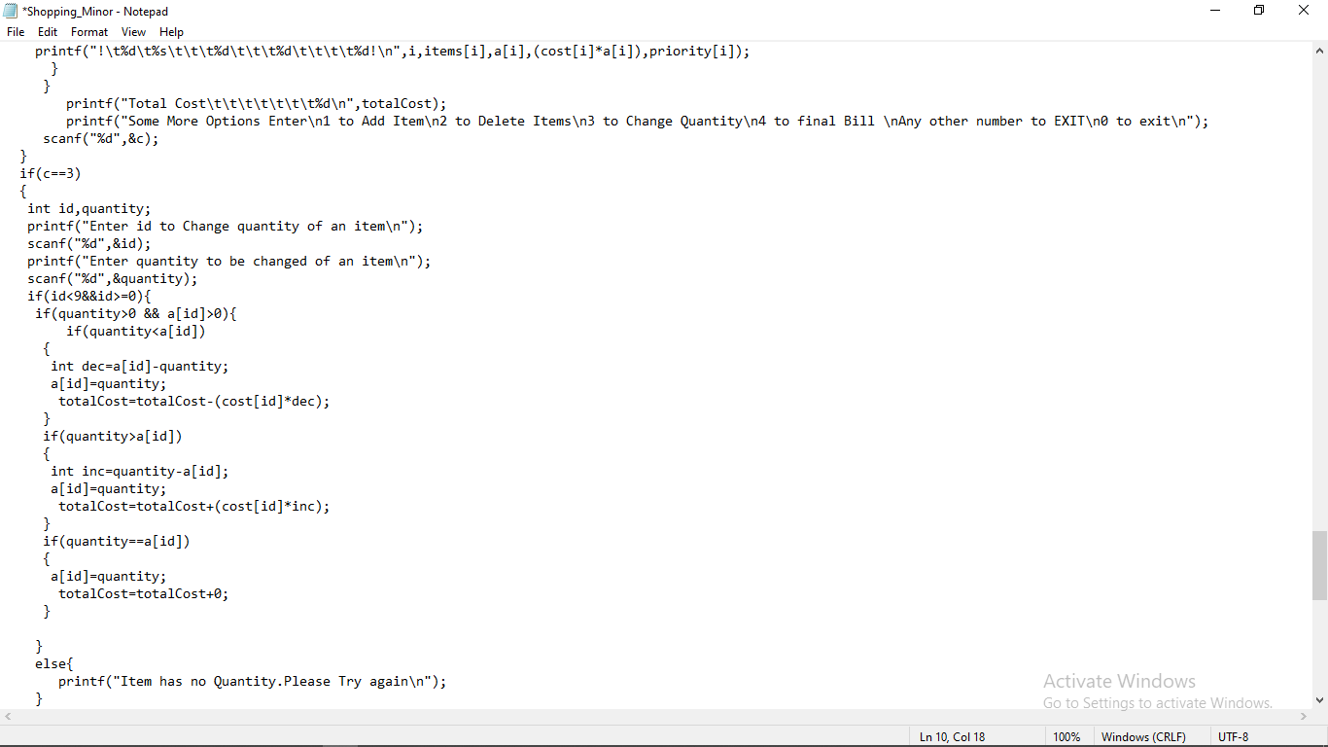

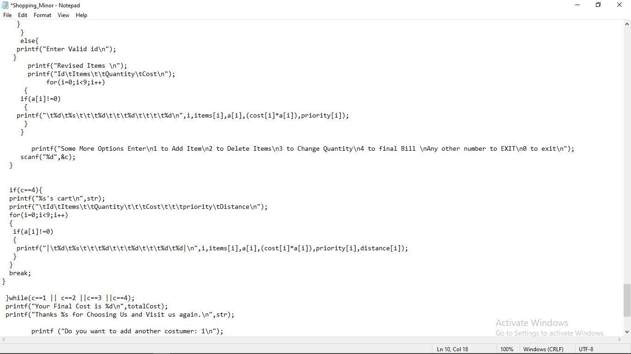

**References:-**

[1] In J. A. Storer and editors. M. Cohn, editors, Proc. 2000 IEEE Data Compression Conference, Los Alamitos, California, 2000. IEEE Computer Society Press.

[2] Calgary corpus. 2000. ftp://ftp.cpsc.ucalgary.ca/pub/projects/text.compression.corpus.

[3] http://www.cs.wisc.edu/niagara/data/.

[4] N. Abramson. Information Theory and Coding. McGraw-Hill, 1963.