Assignment : 1 -/>

Create ui following .

UI will have two parts left part will have div

The right part will have a button (Change Pic) .

on clicking the change pic button , the image should change .

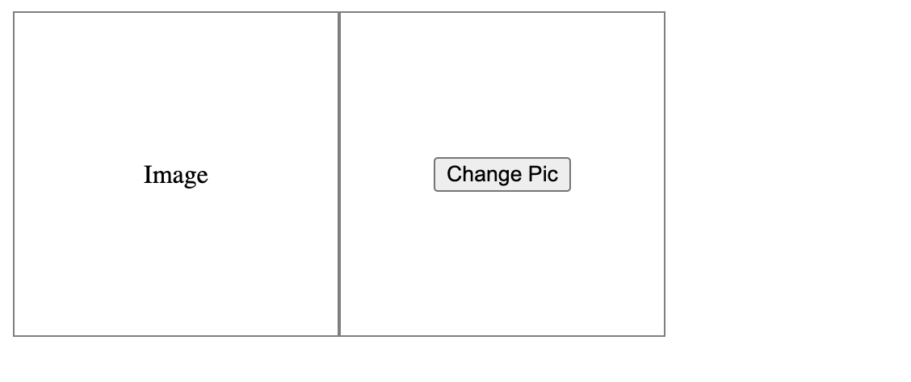

Assignment : 2 -/>

create a text area with a character limit of 100 .

Assignment : 3 -/>

create from as follows .

for signUp / register , we will be showing 4 fields -/> (firstName , lastName ,email and password)

for signIn / login -/> (email and password fields only)

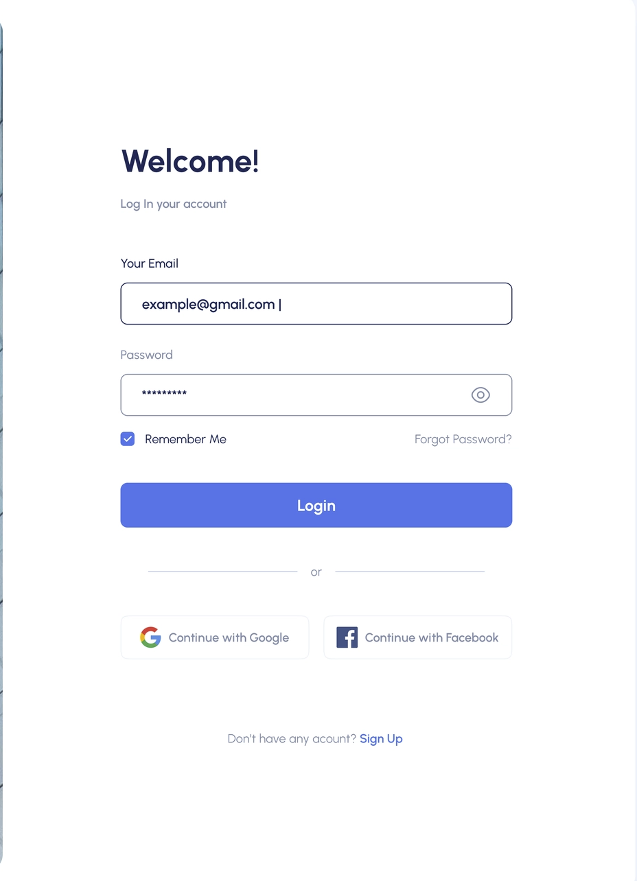

Instructions :

1. Keep the js and css file separate for each component .

2. Follow the design provided .

3. If design is not proper then only you guys can create design as per your thinking.

4. Don’t write all code in a single file and make components .

5. Create button components separately , pass css and data in that to design it .

6. Ignore icons for now . If you can explore on your own you guys can use react-icons package for icons or we will discuss this in the next session .

7. https://www.npmjs.com/package/react-icons (react icons)

**Media Query and css assignment - 20th March**

1. Use media query
2. Use module level css

Figma link : <https://dribbble.com/shots/17349283-Onclick-Task-Management>

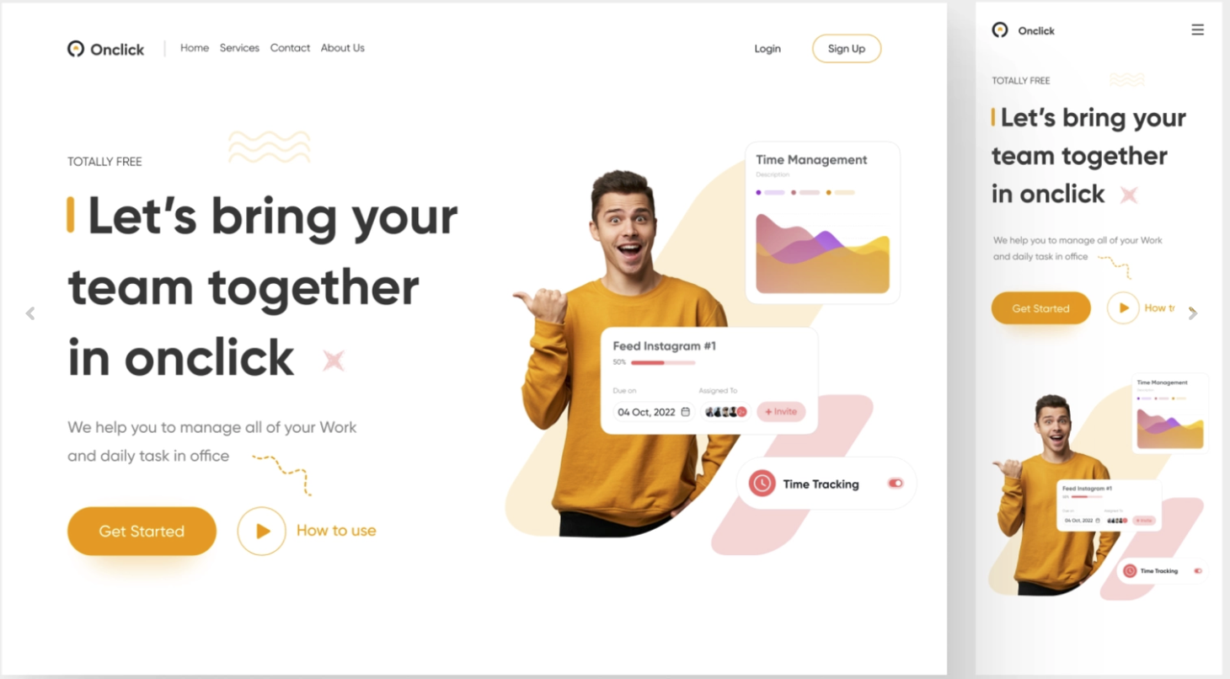

1. Create this design as shown in figma .
2. No need to create this design as it is as we have not gone so deep till now .
3. Make sure the header will be as it is as shown in figma in desktop and mobile both the view .
4. For header , In mobile view (menu) icon will be visible in header , on click that icon we will show our header options (home,services,contact , aboutUs and login , signUp … etc)
5. For section below the header no need to create as it is , just make sure left side will have some text and button and right side will have any image and manage this section in mobile view as shown in figma

**Assignment - 21st March 2023**

Horizontal scroller

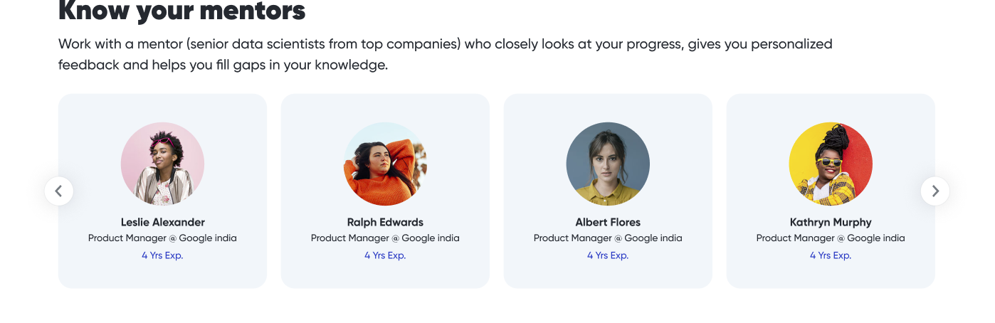

1. Ignore arrows for now
2. Create components as shown above .

Create tic-tac-toe- game

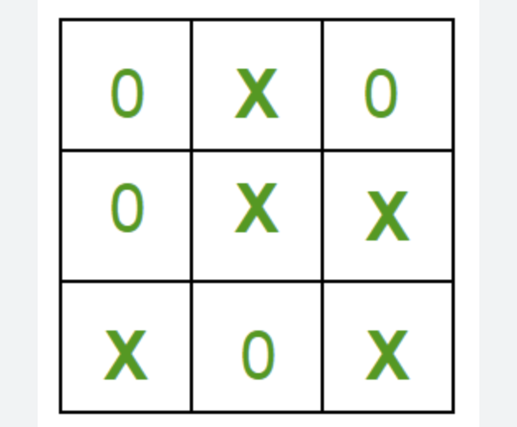

There will be two player .

If any winner is won show the winner name on screen and start button to start it again

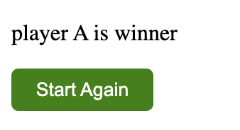

On click start again restart the game