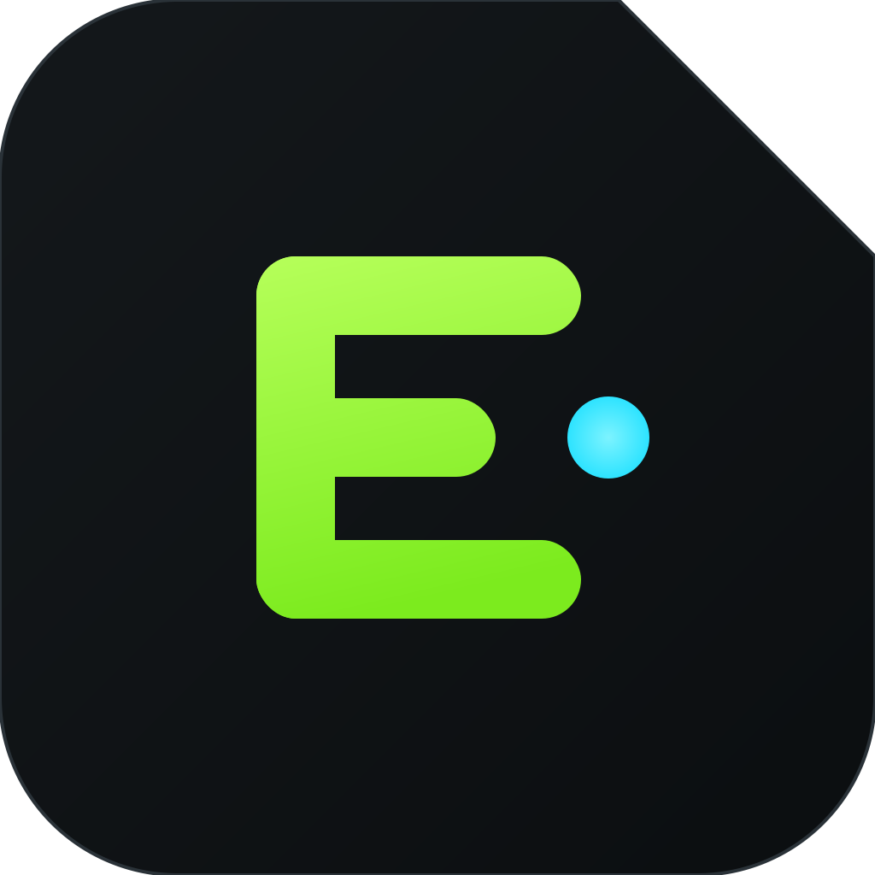
EdgeLM
The Android AI Runtime
Brand Book & Product Strategy
Run AI. Anywhere.
Concept brand & strategy document · 2026

Contents

01 — Brand Identity

The infrastructure layer for on-device AI
EdgeLM isn't an AI app. It's the runtime everything else is built on — a shared, system-level service that makes local intelligence a native capability of the phone.

Mission
To make on-device AI a native capability of every mobile platform — so any developer can ship intelligent, private, offline-first apps without shipping an inference engine or renting a cloud GPU.

Vision
A world where AI runs where your data lives. Billions of devices each running a shared local runtime — the "AI operating system" layer that sits between silicon and software, the way the graphics stack sits under every game.

Core values
- Local by default — the device is the datacenter. Cloud is an opt-in fallback, never a requirement.
- Privacy is architecture — data never leaves the device unless the user says so. The default topology is private.
- Infrastructure, not apps — we build the boring, load-bearing layer so others build the magic on top.
- Ruthless performance — every millisecond and milliamp counts; on mobile, efficiency is the product.
- Open standards — OpenAI-compatible, MCP-native, no lock-in. Interoperability earns trust.
- Developer-first — if it takes more than five minutes to first token, we failed.

Brand personality
Precise, calm, and quietly confident — the engineer in the room who has already solved the hard part. Technical without being cold. Premium without being flashy. EdgeLM behaves like a system primitive: dependable, invisible, and everywhere.

Brand voice
Clear, declarative, and benchmark-backed. Short sentences. Verbs over adjectives. We show numbers, not adjectives; code, not claims. We never hype — we demonstrate. Think Vercel’s clarity, Linear’s restraint, Stripe’s precision.

Positioning statement
For Android developers building AI-powered apps, EdgeLM is the on-device AI runtime that runs LLMs, vision, and speech models locally through a secure, OpenAI-compatible API — so unlike cloud APIs or embedded inference libraries, apps get private, offline, zero-cost intelligence without shipping their own engine.

One-line description
*EdgeLM is the Android AI Runtime — a shared, on-device platform that lets any app run AI models locally through a secure OpenAI-compatible API.*

Elevator pitch
Every app wants AI, but each one ships its own bloated inference engine or pipes user data to a cloud that costs money and leaks privacy. EdgeLM is a system-level runtime for Android — install once, and every app can call local LLMs, vision, speech, and embeddings through a familiar OpenAI-compatible API. It’s Docker + Ollama for the phone: one shared runtime, GPU-accelerated, battery-aware, private by default. Developers ship intelligence without shipping infrastructure.

Company manifesto
The last decade sent your data to the cloud. The next one brings intelligence back home.
Your phone is a supercomputer. It has a neural engine, a GPU, and gigabytes of memory that sit idle while a server farm on another continent answers questions about your own life — slowly, expensively, and by permission. We think that’s backwards. Intelligence should run where your data already is: on the device, in your pocket, under your control.
Building on-device AI today is brutal. Every team reinvents the same inference stack, fights the same memory limits, drains the same battery, and ships the same 400MB engine — five times, in five apps, on one phone. So we’re building the layer that should have existed already: a shared runtime that belongs to the platform, not the app. Install it once. Any app can use it. Models are downloaded once and shared. The GPU is scheduled fairly. The battery is respected. Permissions are enforced. And the API is one every developer already knows.
EdgeLM is the missing system service for the age of local AI. Run AI. Anywhere.

02 — Naming Analysis

Is "EdgeLM" a strong name?
Short answer: yes — for a developer-infrastructure brand. It’s technically credible, self-describing, and ownable, with one weakness we address deliberately.
Criterion | Verdict | Notes
Memorability | Strong | Two syllables of meaning: "Edge" (on-device) + "LM" (models). Sticks after one read.
Technical credibility | Very strong | "Edge" is the accepted term for on-device compute; "LM" signals the model era.
Scalability | Good | "LM" risks sounding text-only. Gloss it as "Local Models" to cover vision/speech/embeddings.
Consumer friendliness | Medium | Slightly technical for pure consumers — acceptable for a developer/infra brand.
Global pronunciation | Good | "Edge-L-M" is unambiguous across languages. No silent letters.
Future-proofing | Good | Reframe "LM" as "Local Models" and the name survives past the LLM wave.
Recommendation: Keep EdgeLM as the primary name. Officially gloss it as "Edge · Local Models" so it scales past text. Lock edgelm.dev / edgelm.ai and the @edgelm handles early.

20 alternatives (EdgeLM remains primary)
Localhost AI · Onnix/Onyx · Nomos · Corelet · Silica · Nucleus · Runlocal · Anvil · Substrate · Neuron OS · Portal · Kernel AI · Tensorhub · Modeld · Loco · Halo Runtime · Forge AI · Edged · Vertex Local · Pocket Runtime.

03 — Logo Concept

A chip die with a spark of local intelligence
The mark is a rounded chip tile with a single clipped corner — the silicon-die notch that gives EdgeLM its edge. Inside sits an E built from a stack of layers, with a cyan spark marking on-device inference.
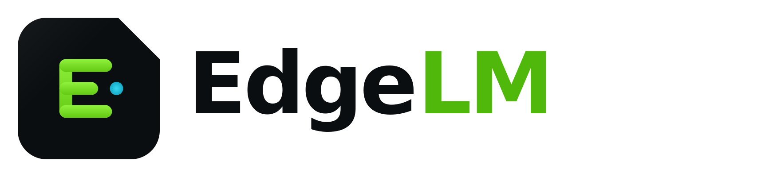

Symbolism & shapes
- Clipped corner = the silicon-die notch, signalling "edge" / on-device compute.
- Layered E = the runtime stack: models, runtime, apps.
- Cyan spark = a token generated locally — intelligence at the source.
- Rounded tile = an Android system-service / app-icon primitive.

Typography & construction
- Wordmark in a geometric grotesque, -3 letter-spacing, weight 700.
- "Edge" in ink/white, "LM" in Signal Green — the accent carries the meaning.
- Strict 8px grid; clear-space equals the height of the tile. Minimum: mark 24px, favicon 16px.

Icon system
  App icon | 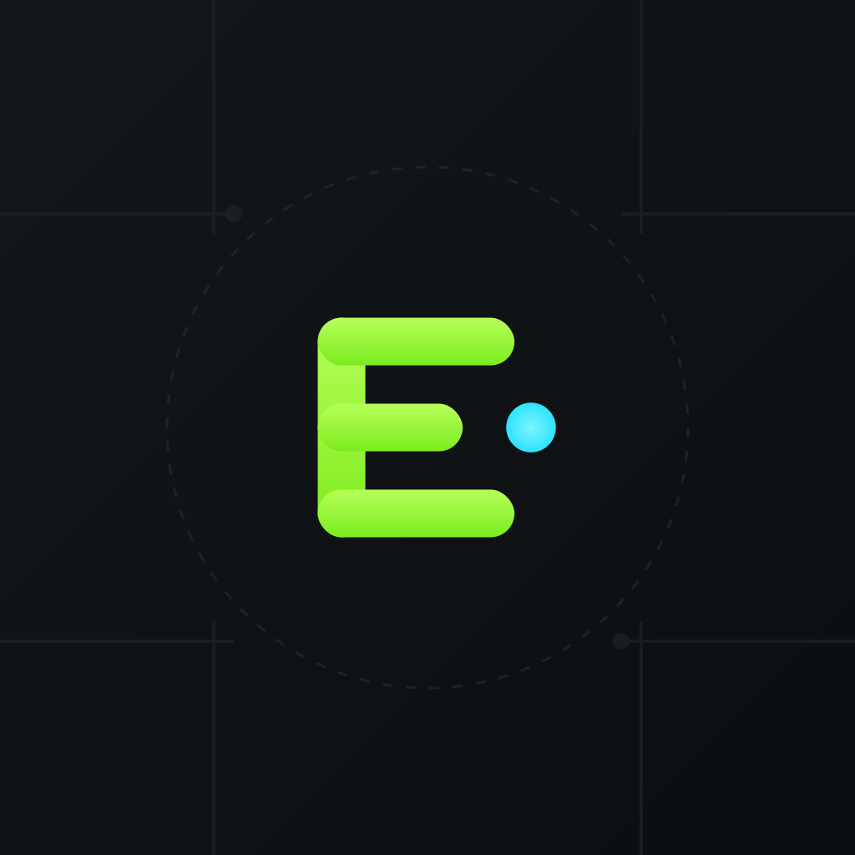  Adaptive (108dp safe-zone) |   Favicon (16–48px)

The adaptive icon ships as separate foreground (glyph, inside the 66dp safe circle) and background (carbon gradient + circuit texture) layers so Android can mask it to any device shape. The favicon drops the spark and thickens strokes to stay crisp at 16px.

04 — Visual Identity

Minimal, technical, premium
A dark-first design language inspired by Linear’s restraint, Vercel’s clarity, Raycast’s polish, and Material 3’s structure — engineered to feel like developer tooling, not a consumer app.

Color — primary & secondary
Obsidian  #0B0E10 | Carbon  #14181B | Slate  #1E262B | Signal Green  #9BFF3C | Volt Cyan  #2DE3FF | Mist  #F5F7F6

Signal Green is the hero — energy, "go," battery-efficient local compute. Volt Cyan is the secondary accent for links, sparks, and gradients. Neutrals (Obsidian → Carbon → Slate) build depth; Steel #7C8A93 and Fog #B9C4C9 handle muted and body text. Green is used sparingly — a highlighter, never a wall of paint.

Typography
- Headings: Inter Display, weights 700–800, tight (-1 to -3) tracking.
- Body: Inter, 400–500, 16–18px with generous line-height for docs.
- Code / API / benchmarks: JetBrains Mono, 400–600.

Components
- Buttons — 12px radius, mono labels; primary is Signal Green on ink, secondary is carbon with a Slate border, plus a ghost variant. Focus ring: green at 18% alpha.
- Cards — Carbon fill, 1px Slate border, 16px radius; hover lifts 2px and warms the border. No drop shadows in dark mode — depth comes from borders and elevation tint.
- Iconography — 1.5px stroke, 24px grid, rounded joins, monoline (Lucide-style). Diamonds and stacked layers recur as brand motifs.

Motion & animation
- Architecture diagram — tokens flow model → runtime → app along animated paths.
- Loading — a pulsing spark + streaming-token shimmer (mono characters typing in).
- Micro-interactions — 150–200ms ease-out; nothing bounces. Calm, mechanical.
- Signature moment — the spark "ignites" on first token, a single cyan pulse.

Illustrations & empty states
- Illustration — isometric circuit boards, chip dies, and layer stacks; technical blueprint over decorative.
- Empty states — a dim chip tile + one-line mono hint and a single primary action.
- Loading — skeleton blocks in Slate with a green sweep; a live token counter ticks up.

05 — Taglines

50+ launch-ready slogans
The hero line is "Run AI. Anywhere." Everything else supports a channel, audience, or moment.

Hero & positioning
Run AI. Anywhere. · The Android AI Runtime. · Your AI. Your Device. · Powering Local Intelligence. · The Engine Behind On-Device AI. · Intelligence, on device. · The runtime for local AI. · AI that runs where you do. · Local models. Native speed. · The missing AI system service.

Privacy & offline
No cloud required. · Private by default. · Your data never leaves. · Offline is a feature. · AI without the account. · Works on a plane. · Zero cloud. Zero leaks. · The cloud is now optional. · Nothing leaves the device. · Intelligence you own.

Developer
Ship intelligence, not infrastructure. · One API. Every model. · OpenAI-compatible. Fully local. · Five minutes to first token. · Stop shipping inference engines. · import edgelm — done. · The SDK for on-device AI. · Local endpoint. Familiar API. · Build AI apps. Skip the backend. · Your localhost, now intelligent.

Performance & hardware
GPU-accelerated. Battery-aware. · The chip was always ready. · Full-speed, on-device. · Every milliamp matters. · Native silicon, unlocked. · Inference at the edge of speed. · Fast, local, free. · The neural engine, finally used.

Vision & platform
The AI operating system for mobile. · A shared brain for every app. · The infrastructure layer for edge AI. · Install once. Every app gets AI. · Docker for on-device models. · The runtime the phone was missing. · One runtime. Every device. · Bring intelligence home.

Punchy / campaign
Cloud-free AI. · Local is faster. · On-device or bust. · The edge has an engine. · Models, meet metal. · Think local. · Pocket-sized inference. · Unplug the cloud. · Native AI. No strings. · The spark runs local.

06 — Landing Page

The website, section by section
A single, fast, dark-first marketing page engineered to convert developers in one scroll — proof over promises.
- Hero — "Run AI. Anywhere." + one-line subhead + $ install edgelm CTA + live token-streaming demo. Trust pills: on-device, GPU, private.
- Features — 8-card grid: Local LLMs, Vision, Speech, Embeddings, Agents & Tool Calling, MCP, Offline, OpenAI-compatible API.
- Architecture animation — interactive diagram: App → Local API → Runtime → GPU/NPU scheduler → shared model store; tokens animate through the pipeline.
- Performance — live counters: tokens/sec (flagship vs mid-range), cold-start ms, memory footprint, battery draw per 1k tokens.
- Developer API — tabbed code (cURL / Kotlin / JS) hitting localhost:1408/v1/chat/completions, copy-to-clipboard, "change one line from OpenAI."
- SDK — Android SDK highlight: dependency snippet, permissions model, model-pull API, streaming callbacks. "Add AI in 5 lines of Kotlin."
- Security — per-app permissions, sandboxed model access, on-device-only guarantee, signed registry, no telemetry by default.
- Benchmarks — sortable table: model × device × tokens/sec × RAM × TTFT, GPU/CPU toggle, methodology link.
- Testimonials — three fictional dev/founder quotes with avatars + app logos.
- Pricing — Runtime free & open · SDK Pro · Team · Enterprise. Clear "free forever for the runtime" promise.
- FAQ — devices, models, battery, offline, "how is it free," iOS, model licensing.
- Footer — docs, GitHub, Discord, X, status, changelog, security.txt, brand assets, careers.

07 — Developer Messaging

Talk to developers in code

Why EdgeLM?
Because you shouldn’t ship a 400MB inference engine, rent a GPU, or leak your users’ data to add a chat box. One shared runtime does it for every app — private, offline, free.

OpenAI compatibility & migration
If you can call OpenAI, you can call EdgeLM. Point your base URL at the local runtime and delete your API key — request and streaming shapes are identical.
# Migration: change one line.
- base_url = "https://api.openai.com/v1"
+ base_url = "http://localhost:1408/v1" # EdgeLM local runtime

curl http://localhost:1408/v1/chat/completions \
-H "Content-Type: application/json" \
-d '{"model":"llama-3.2-3b","messages":[{"role":"user",
"content":"Summarize this note offline."}],"stream":true}'

Android SDK — add AI in 5 lines of Kotlin
val edge = EdgeLM.client(context) // binds the shared runtime
edge.ensureModel("llama-3.2-3b") // pulled once, shared by all apps

val reply = edge.chat {
system("You are a helpful, offline assistant.")
user(prompt)
}.collectAsText() // streaming tokens, on-device

SDK benefits
- Streaming, tool-calling, and MCP built in.
- Shared model store — download once, every app reuses it.
- Battery- and thermal-aware scheduling handled for you.
- Typed Kotlin API plus raw OpenAI-compatible REST for any language.

Testimonials (fictional)
*"We deleted our inference backend and our cloud bill in the same afternoon."* — Priya N., founder, NoteFox
*"Our journaling app is now fully offline and private. Store rating jumped."* — Marcus L., Lead Android, Reflekt
*"One API for LLM, vision, and speech. It felt like a system service, not an SDK."* — Dana W., Staff Eng, FieldOps

08 — Launch Strategy

Becoming the standard runtime for Android AI
Win developers first, become a dependency, then let the ecosystem pull everyone else in. Standards are earned by being the path of least resistance.
Channel | Play
Product Hunt | Launch day: crisp 60s demo GIF, "OpenAI-compatible, 100% local," founder in comments. Aim #1 Product of the Day.
Hacker News | "Show HN: EdgeLM — a local, OpenAI-compatible AI runtime for Android." Lead with technical honesty, benchmarks, open-source runtime.
Reddit | r/LocalLLaMA, r/androiddev, r/MachineLearning — real benchmarks, real repos, no marketing voice.
GitHub | Open-source runtime + SDK as the center of gravity. Great README, examples, "good first issue." Stars are the scoreboard.
X / Twitter | Build-in-public threads: benchmark drops, model support, cloud-vs-local latency videos.
YouTube | "Add offline AI to your Android app in 5 minutes" + architecture deep-dives; partner with creators.
LinkedIn | Enterprise/privacy angle: on-device AI for regulated industries; founder essays on the shift back from cloud.
Android communities | Kotlin/Android Slacks, Droidcon talks, GDG meetups — the missing Jetpack-style system service.
AI communities | llama.cpp / GGUF / MLC circles; Hugging Face cards linking "Run on Android with EdgeLM."
The standard-setter playbook: (1) be the easiest way to add AI to an Android app, (2) be OpenAI-compatible so migration is one line, (3) open-source the runtime so it’s trustable and forkable, (4) build EdgeLM Hub so models "just work," (5) let shipped apps become the distribution.

09 — Open Source Strategy

Open core is the answer
Trust in infrastructure requires openness; sustainability requires revenue. Open core resolves the tension.
Model | Pros | Cons | Fit
Fully open source | Max trust & adoption; forkable; community moat | Hard to monetize; cloud/enterprise free-ride | Good for the runtime only
Open core ✓ | Open runtime builds trust; paid Pro/Enterprise fund it | Must draw the core/commercial line carefully | Recommended
Commercial / closed | Full control of monetization | Developers won’t adopt closed infra; no trust | Wrong for a runtime
Enterprise-only | High ACV | No bottom-up adoption; no standard | Later-stage layer
Dual license | Free for OSS, paid for commercial | Friction for indie devs; license confusion | Possible for the SDK
Recommendation: Runtime + core SDK under Apache-2.0 — free forever, the trust anchor and adoption engine. Monetize the layers around it: Hub Pro, Studio, Cloud fallback, enterprise management, and support. Open where trust matters, paid where value concentrates.

10 — Competitive Positioning

What makes EdgeLM different
Others give you an engine or a library. EdgeLM gives you a shared platform — a system service with an API, permissions, and a model store that every app draws from.
Player | What it is | Gap EdgeLM fills
Ollama | Great local-model runner for desktop/servers | Not an Android system service; no shared multi-app runtime, permissions, or battery scheduling on mobile
llama.cpp | The inference engine (the metal) | A library each app must embed & maintain — EdgeLM makes it a shared OS service with an API
MLC LLM | Compiler-based on-device inference | Powerful but low-level per app; EdgeLM adds the platform, API, hub, and cross-app sharing
Google AI Edge | Google’s on-device stack (MediaPipe / LiteRT) | Google-model-centric & fragmented; EdgeLM is model-agnostic, OpenAI-compatible, one runtime for all apps
Apple MLX | Apple-silicon ML framework | iOS/Mac only & framework-level; EdgeLM targets Android as a shared runtime + API

Three-line differentiation
- Shared, not embedded — install once; every app uses it; models downloaded once, not per app.
- OpenAI-compatible — migration is one line; no new mental model, no lock-in.
- A system service — permissions, GPU scheduling, and battery-awareness handled for you.

11 — Product Ecosystem

One runtime, a whole platform around it
Every product orbits the runtime — the free, open core that makes all the rest valuable.
Product | Role
EdgeLM Runtime | The open-source, on-device engine + local API. The center of gravity. Free forever.
EdgeLM SDK | Android/Kotlin + REST clients. Streaming, tools, MCP, permissions. The developer front door.
EdgeLM Hub | Signed, optimized, device-matched model registry. "It just works" model pulls.
EdgeLM Studio | Desktop app to test prompts, benchmark, quantize, and package models.
EdgeLM Cloud | Optional overflow/fallback + fleet model distribution. Local-first, cloud-when-asked.
EdgeLM Benchmark | Open leaderboard of model × device performance — the numbers everyone cites.
EdgeLM CLI | Pull, run, profile, and package models from the terminal; scriptable CI.
EdgeLM Desktop | The same runtime + API on Windows/Mac/Linux — write once, run on any edge.
EdgeLM Enterprise | Fleet management, policy, private registry, SSO, audit, support SLAs.
EdgeLM Marketplace | Third-party models, plugins, and agents — a revenue-shared ecosystem on Hub.
How it fits together: developers build with the SDK against the Runtime, pull models from the Hub, tune them in Studio, automate via CLI, trust the Benchmark numbers, extend to Desktop, scale with Cloud and Enterprise, and monetize through the Marketplace. The open runtime is the gravity well; everything else is value on top.

12 — Monetization

Sustainable, non-intrusive revenue
Free runtime drives adoption; money comes from teams, scale, and the ecosystem — never from ads in the inference path.
Stream | How it works
Enterprise SDK & support | Fleet management, private registry, SSO, audit, SLAs. The core ACV driver.
Model marketplace | Premium/optimized/licensed models with revenue share on every pull.
Cloud fallback | Metered overflow when a device can’t handle a model — local-first, cloud-billed.
Commercial licenses | Paid terms for closed-source embedding of premium components.
Developer subscriptions | Pro tier: private models, higher Hub limits, Studio Pro, priority builds.
Plugin marketplace | Agents, tools, and MCP integrations — revenue-shared with builders.
Analytics (opt-in) | Privacy-preserving, on-device performance analytics for teams. Never user data.
Enterprise deployment | On-prem model distribution, device-fleet policy, compliance tooling.
Certification & training | "Built on EdgeLM" certification + partner enablement for agencies.
Principle: monetize the layers around the runtime; keep the inference path free and ad-free. Adoption is the moat, and the moat funds itself through teams and the marketplace.

13 — Launch Roadmap

From MVP to AI operating system
Phase | Milestone | Goal
0 · MVP | Single-app LLM inference, GGUF support, GPU acceleration, basic local API + demo app & benchmarks. | It actually runs, and it’s fast.
1 · Beta | Multi-app shared service, model store, streaming, permissions, Android SDK; open-source the runtime. | 5-minute integration; first external apps live.
2 · v1.0 | Vision + speech + embeddings, tool calling, MCP, battery/thermal scheduling, EdgeLM Hub, docs. | Production apps depend on it.
3 · Developer Platform | Studio, CLI, Benchmark, Marketplace, plugins/agents, desktop runtime parity. | The default way to build on-device AI.
4 · Enterprise | Private registries, SSO, audit, SLAs, Cloud fallback, on-prem distribution. | Regulated & large orgs standardize on EdgeLM.
5 · AI Operating System | Cross-platform (Android, desktop, IoT, automotive, wearables), agent orchestration, on-device fine-tuning. | The standard runtime for local AI, everywhere.

Brand book & product strategy — concept document. Company, testimonials, benchmarks, and timelines are illustrative for branding purposes. Not affiliated with OpenAI, Google, Apple, Ollama, or any named project; "OpenAI-compatible" refers to API-shape compatibility only.

