Campaign Intelligence Hub
Project overview with examples
We built an application that brings campaign information together, compares results with goals and earlier campaigns, and creates a visual report for the analyst to review and present.

The problem we addressed
Campaign analysts spend time reading separate briefs, plans and results, checking numbers and building presentation slides. We brought these steps into one place.

What we did
We created sample campaign documents, made their information searchable, and connected them to a workspace where users select a client and campaign. The application finds relevant evidence, calculates comparisons and includes source references in its answers and reports.

Example of a campaign review
For Fictional Meridian Credit Union’s checking campaign, the application compares the plan with the actual results:
Measure | Planned | Actual result
Accounts | 180 | 230 — goal exceeded
Opening balances | $540,000 | $598,850
Campaign spend | $24,000 | $20,908 — within budget
The report explains the result simply: the campaign delivered 50 more accounts than planned while staying within its spending limit.
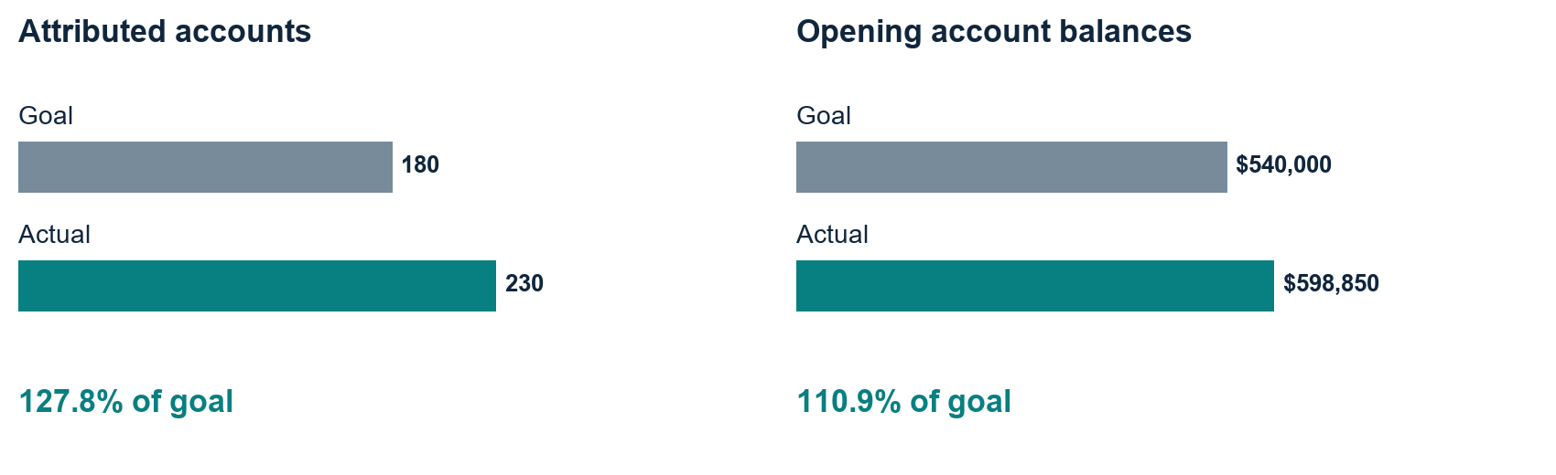
All examples use fictional demonstration data. Opening balances are balances at account opening, not revenue or net deposit growth.

How the application finds useful information

Why we split documents into chunks
We divide long documents into smaller passages, called chunks, so the search can find the information needed for a question.

Fixed chunking follows length
Fixed chunking cuts text into pieces of a set size, with some overlap. It is simple and inexpensive, but a cut can separate related details or mix two topics. Overlap reduces this risk without recognizing topic changes.

Semantic chunking follows changes in meaning
Semantic chunking compares the meaning of neighboring sentences or text units and splits where the topic changes. It aims to keep related evidence together, subject to a size limit. It does not merge separate documents or guarantee intact tables.

A simple example you can explain
Imagine a passage describing 230 accounts: 138 from direct mail and 92 from display. A fixed cut could separate the total from the breakdown. Semantic chunking aims to keep these details together and split when the topic changes. This is an illustration, not a recorded failure in our experiment.

What our test actually showed
We compared the same 27 test cases using hybrid search and no reranking. Only the chunking method changed. The measured averages were:
Measure | Fixed | Semantic
Relevant source precision | 30.6% | 34.6%
Expected source recall | 100% | 100%
Average processing time | 0.440 seconds | 0.481 seconds
How to explain the result: a larger share of semantic search results matched the expected source documents. That is higher precision. Both methods found all expected documents on average: equal recall. Semantic took about 0.04 seconds longer. These scores measure source retrieval, not answer accuracy or a universal advantage.

How this becomes an answer
Embeddings represent chunk meaning as numbers stored in ChromaDB. We compare a question with these chunks; hybrid search also checks matching words. Retrieved evidence supports the answer and citations. Client-report calculations use validated source tables.
Comparison evidence: saved three-chunking experiment, 27 cases per configuration. Semantic boundaries and retrieval settings affect results; this small fictional corpus does not establish a universal winner.

What users can do

Compare with earlier campaigns
We show whether a campaign is doing better or worse than comparable earlier campaigns for the same client. For example, direct mail cost $98.48 per account, below the earlier-campaign median of $114.88. Its account activation rate was 2.76%, below the earlier median of 3.48%. This gives a balanced story: lower cost, but a lower account activation rate.
This example uses only two earlier campaigns, so the comparison is descriptive rather than proof of a wider trend.

See where results came from
Selecting a client and campaign updates the map automatically. For example, Austin contributed 80 accounts across direct mail and display. Users can also see the opening balances associated with each location.

Apply the right measurement window
We count direct mail results within 60 days of the mail/drop date and display results within 30 days of exposure. For example, a response 45 days after a mail drop can qualify; a response 45 days after a display exposure falls outside that channel’s window.

Ask questions and generate a report
A user can ask, “What was the account goal?” The application finds the plan and answers “180 accounts,” with a source reference. The user can then generate an HTML report with goal comparisons, charts, historical context, learnings, recommendations, next steps and citations.

Review a clear story supported by evidence
We place insights beneath charts so the analyst can follow the story. Recommendations are presented as proposed actions. For example, the report suggests testing clearer eligibility language before changing campaign allocation; it does not promise an unmeasured improvement.

What is ready and what comes next
The demonstration supports campaign selection, maps, questions, historical comparisons and report generation. We check the figures against their sources and identify missing information. Real client document uploads, private client access and broader independent validation are next steps. The current data does not support financial ROI or monthly performance trends.
Try the application at https://campaign-intelligence.streamlit.app/
Example evidence: Meridian campaign brief, success plan and performance report for 2026-Q2, plus its two comparable historical campaigns. Results are reported as of 30 June 2026.

