Inheritance
- public class Manager extends Employee
{
added methods and fields
}
- The keyword extends indicates that you are making a new class that derives from an existing class.
- The existing class is called the superclass, base class, or parent class.
- The new class is called the subclass, derived class, or child class.
Overriding superclass methods
- public double getSalary()
{
double baseSalary = super.getSalary(); //call superclass method
return baseSalary + bonus;
}
- Manager boss = new Manager('Carl Cracker', 80000, 1987, 12, 15);
boss.setBonus(5000);
Subclass constructors
- since subclass cannot access private field from superclass.
- calls superclass constructor as n,s,year,month as parameter
- public Manager(String name, double salary, int year, int month, int day)
{
super(name, salary, year, month, day);
bonus = 0;
}
Inheritance hierarchy
- Inheritance need not stop at deriving one layer of classes. We could have an Executive class that extends Manager, for example. The collection of all classes extending a common superclass is called an inheritance hierarchy

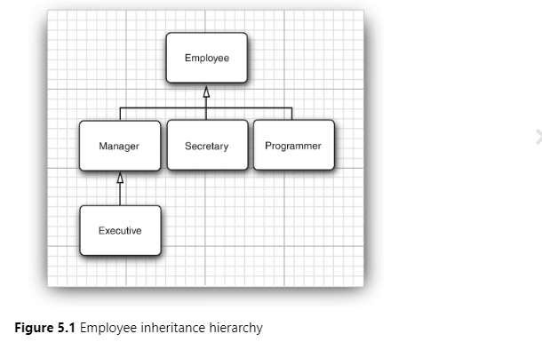
Polymorphism
- That principle states that you can use a subclass object whenever the program expects a superclass object.
- Employee e;
e = new Employee(. . .); //Employee object expected
e = new Manager(. . .); //OK, Manager can be used as well
- In the Java programming language, object variables are polymorphic. A variable of type Employee can refer to an object of type Employee or to an object of any subclass of the Employee class (such as Manager, Executive, Secretary and so on)
- Manager boss = new Manager(. . .);
Employee[] staff = new Employee[3];
staff[0] = boss;
- In this case, the variables staff[0] and boss refer to the same object. However, staff[0] is considered to be only an Employee object by the compiler.
- That means you can call
boss.setBonus(5000); // OK
- but you can’t call
staff[0].setBonus(5000); // ERROR
- The declared type of staff[0] is Employee, and the setBonus method is not a method of the Employee class.
- However, you cannot assign a superclass reference to a subclass variable. For example, it is not legal to make the assignment
- Manager m = staff[i]; // ERROR
Preventing Inheritance
- Prevent forming a subclass
- Classes that cannot be extended are called final class
- public final class Executive extends Manager
{
. . .
}
- If you do this, then no subclass can override that method
public class Employee
{
. . .
public final String getName()
{
return name;
}
. . .
}
- There is only one good reason to make a method or class final: to make sure its semantics cannot be changed in a subclass. For example, the getTime and setTime methods of the Calendar class are final. This indicates that the designers of the Calendar class have taken over responsibility for the conversion between the Date class and the calendar state. No subclass should be allowed to mess up this arrangement. Similarly, the String class is a final class. That means nobody can define a subclass of String. In other words, if you have a String reference, you know it refers to a String and nothing but a String.
Casting
- var staff = new Employee[3];
staff[0] = new Manager('Carl Cracker', 80000, 1987, 12, 15);
staff[1] = new Employee('Harry Hacker', 50000, 1989, 10, 1);
staff[2] = new Employee('Tony Tester', 40000, 1990, 3, 15);
- Manager boss = (Manager) staff[0];
- There is only one reason why you would want to make a cast—to use an object in its full capacity after its actual type has been temporarily forgotten. For example, in the ManagerTest class, the staff array had to be an array of Employee objects because some of its elements were regular employees. We would need to cast the managerial elements of the array back to Manager to access any of its new variables. (Note that in the sample code for the first section, I made a special effort to avoid the cast. I initialized the boss variable with a Manager object before storing it in the array. I needed the correct type to set the bonus of the manager.)
- To sum up:
You can cast only within an inheritance hierarchy.
Use instanceof to check before casting from a superclass to a subclass.
Instanceof
- if (staff[i] instanceof Manager)
{
Manager boss = (Manager) staff[i];
boss.setBonus(5000);
}
- Employee e;
if (e instanceof Manager m && m.getBonus() > 10000)
Protected Access

