Interface
- In the Java programming language, an interface is not a class but a set of requirements for the classes that want to conform to the interface.
- All methods of an interface are automatically public
- Default method
- Static and private method
- Interface properties
- interface callbacks
- Multiple interface
- Comparator interface
- Object cloning

Lambdas
- A lambda expression is a short block of code which takes in parameters and returns a value. Lambda expressions are similar to methods, but they do not need a name and they can be implemented right in the body of a method.
- Method reference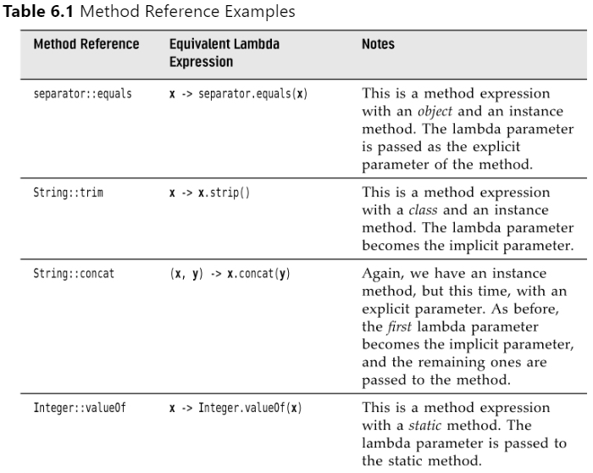
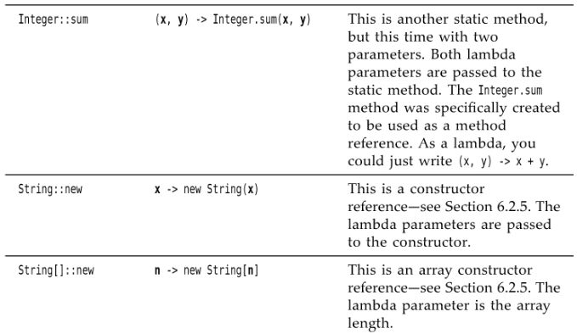
- Constructor reference
- Variable scope
- Common functional Interface
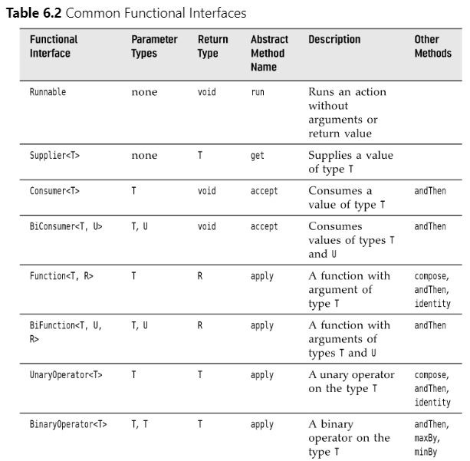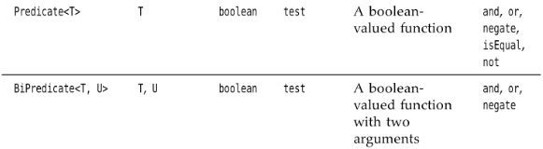
Inner classes
- An inner class is a class that is defined inside another class. Why would you want to do that? There are two reasons:
• Inner classes can be hidden from other classes in the same package.
• Inner class methods can access the data from the scope in which they are defined—including the data that would otherwise be private.
- Static inner class
- Anonymous inner class
- Local inner class
Service loaders
- Sometimes, you develop an application with a service architecture. There are platforms that encourage this approach, such as OSGi (http://osgi.org), which are used in development environments, application servers, and other complex applications.
Proxies
- In the final section of this chapter, we discuss proxies. You can use a proxy to create, at runtime, new classes that implement a given set of interfaces. Proxies are only necessary when you don’t yet know at compile time which interfaces you need to implement.

